MICRO-CHANNEL ARRAYS BY TWO PHOTON LITHOGRAPHY
FOR CANCER CELL MIGRATION STUDIES
Sara Micheli^{1,2}, Elisa Varaschin^{1,2}, Caterina Piunti^{1,2}, Elisa Cimetta^{1,2}*
¹Department of Industrial Engineering. University of Padua, Padua, ITALY;
²Fondazione Istituto di Ricerca Pediatrica Città della Speranza, Padua, ITALY
*Corresponding author E-Mail: elisa.cimetta@unipd.it
1. Introduction
The study of tumor cell migration is of paramount importance in biological and medical research, as it is a key event in cancer metastasis. [1]. Metastasis is a dynamic process in which cancer cells begin to move in the surrounding microenvironment, driven mainly by different mechanical and chemical stimuli. Nowadays, classical migration studies are performed in vitro in culture plates where aggregates and cell populations are treated. However, recent studies have shown that initial stage migration information with single-cell resolution plays an exclusive role in metastasis [2].
The new frontier of microfluidics plays here a fundamental role. This technology is based on the manipulation of fluids at the nano- and micro-metric scale [3]. Unlike in vitro cultures, these devices improve experimental times, can reproduce an environment more faithful to the in vivo one, and reduce the number of reagents and substances needed for studies [4]. For this reason, the construction of devices with an innovative technique of two-photon polymerization (2PP) combined with microfluidics is a promising science for studying cell culture in a specific and controlled environment [5]. These devices could be suitable for the study of the migration of Neuroblastoma (NB), an embryonal malignancy of early childhood. For this reason, the goal is to build a device that allows the study of cell migration at a single-cell resolution, with micro-channel arrays that recall the shape and size of the lymphatic vessels.
2. Methods
The master mold for the micro-channels array was designed through AutoCAD (2019, Autodesk) and the fluid-dynamic behavior was simulated using COMSOL Multiphysics. The optimized mold was fabricated using a 2PP-based NanoScribe Photonic Professional GT 3D printer (Nanoscribe, Eggenstein-Leopoldshafe, Germany). To verify the quality of the produced master, Scanning Electron Microscopy (FEI Quanta 400, Scanning Electron Microscopy) and 3D optical profilometer (Sensofar S Neox profilometer) analyses were performed. The final device was then produced via standard replica molding. Briefly, Polydimethylsiloxane (PDMS) (Dow Corning, Sylgard® 184) was prepared by adding a curing agent, 10:1 (w/w), poured over the master mold and then polymerized for 90 minutes at 70 °C in an oven. The cured PDMS layer was gently peeled off from the rigid master. To create the microfluidic chip the PDMS slab was attached to a microscope cover glass (Sigma-Aldrich, 24 x 25 x 1 mm) with plasma treatment (PDC-002-CE by Harrick Plasma). Both the microscope glass slide and PDMS layer are inserted in the Plasma Cleaner under vacuum conditions for 2 minutes. The hydraulic seal of the final platform was validated with colored tracers. The microfluidic platform was then biologically validated using a human NB cell line (SK-N-AS) and human Mesenchymal stem cells (hMSCs), representative of one of the main NB metastatic target sites. Finally, migration was observed using a fluorescence microscope (EVOS FL Cell Imaging System, Thermo Fisher Scientific) following cell positions for up to 48 hours of incubation.
3. Results and discussion
The general platform design consisted in two lateral channels and chambers used to introduce different solutions of cells and micro-channels that connect the lateral chambers (Figure 1a and b). The key element is the structure of the micro-channels that, designed with shrinkages and larger sections, recall the shape of lymphatic vessels, the main migration ducts. The hydraulic seal of the platform is validated with colorants (Figure 1c). This validation was favored by the optical properties of PDMS, as its transparency makes it easier to observe under the microscope.
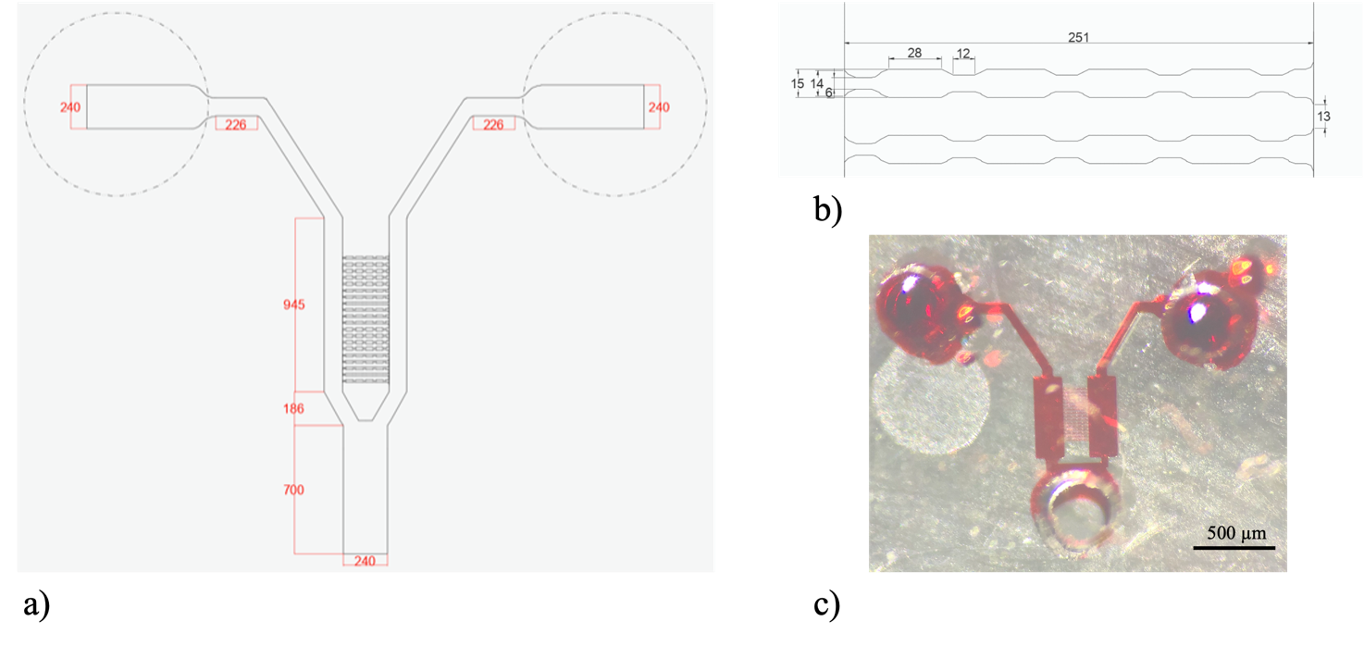
Figure 1. Platform layout: a) design of the platform; b) detail of the micro-channels; c) PDMS replica of the platform filled with red colorant. All dimensions are in μm.
To also verify the correct shape and size of all components, the platform was observed using Scanning Electron Microscopy (Figure 2).
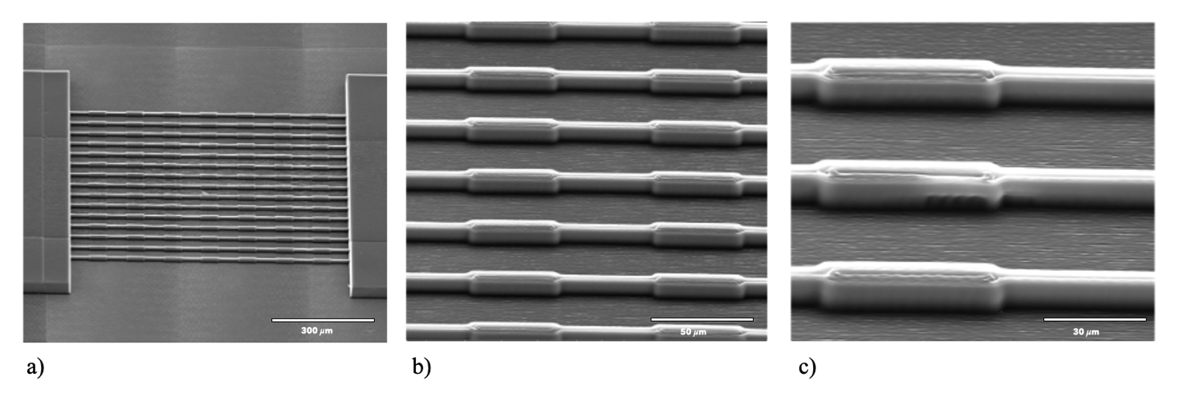
Figure 2. Scanning Electron Microscopy images of the platform, focusing on the micro-channels: a) 300x magnification; b) 1600x magnification; c) 3000x magnification.
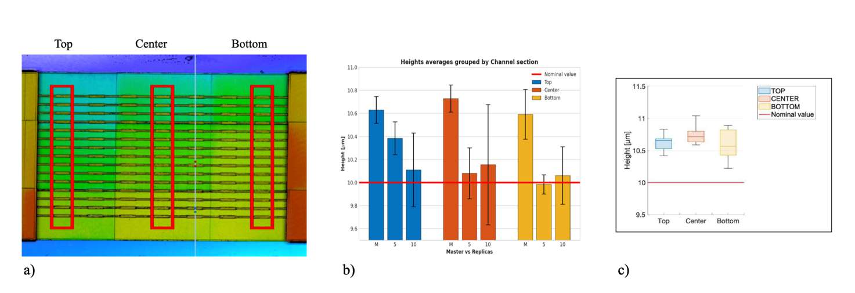
The results of the profilometer analysis are shown in Figure 3 where the heights of specific area of interest are studied with the Confocal mode. Every channel is divided in three sections: top, center and bottom. The bar chart illustrates the results of the metrological characterization, demonstrating that the heights of each printed channel are higher than the nominal value. This can be attributed to a systematic error of the printer or to the scattering effect that occurs when the sample is exposed to white light, altering its metrological measure. These differences are however not statistically different (Anova one-way Figure 3c).
Figure 3. Profilometer analysis: a) Section of interest used to carry out the profilometric analysis; b) Metrological characterization of the heights of all channels in the master compared to the replicas: in blue the measures of the micro-channel top, in orange the one of the micro-channel center and in yellow the measures of micro-channel bottom. In red the line of the comparison CAD value; c) Box plot of the heights of all channels: in blue the measures of the micro-channel top, in orange the one of the micro-channel center and in yellow the measures of micro-channel bottom. In red the line of the comparison CAD value.
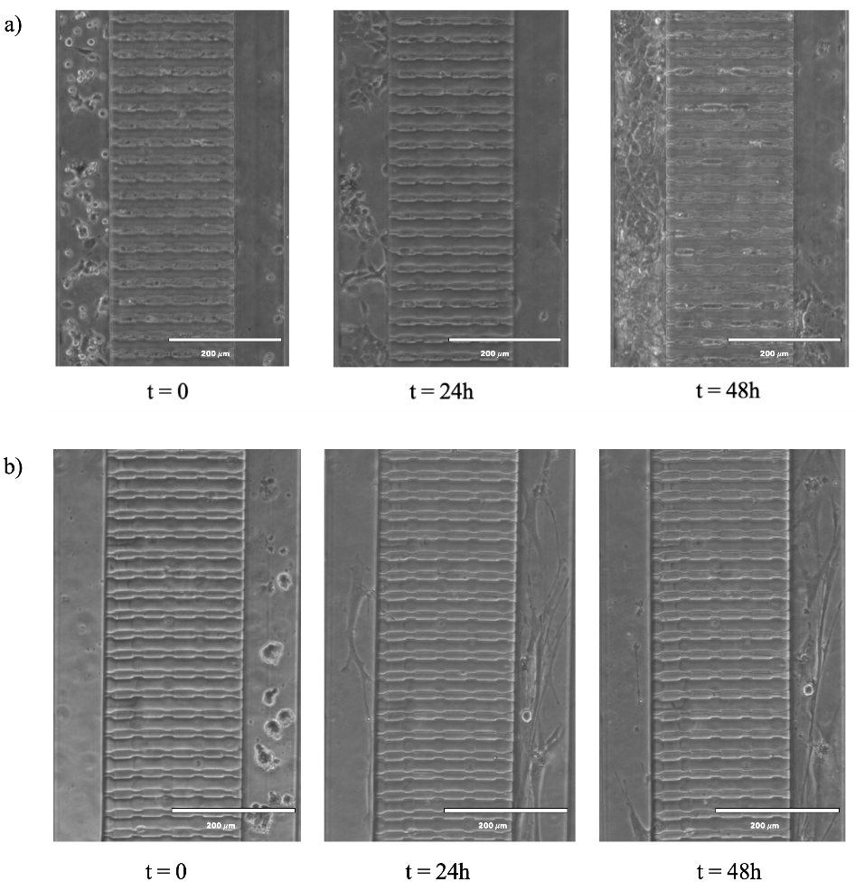
The platform was then biologically validated. To first fill the device with culture media inside all micro-channels and chamber, the device was kept under vacuum for 15 mins. SK-N-AS cells were resuspended in culture media to a concentration of 4x10⁴/μL and hMSCs of 1x10⁴/μL. Then, 1μL of these solutions was pipetted into each of the two main lateral channels, and the chip was put into the incubator. Figure 4 shows SK-N-AS and hMSCs seeded inside the platform at several time points. The cells are attached to the surface of the chamber demonstrating that this microfluidic chip is a favorable environment for cell culture.
Figure 4. Biological validation of the platform: a) Microscopy images of SK-N-AS cells at seeding time (t=0) and at 24 and 48 hours from seeding; b) Microscopy images of hMSCs at seeding time (t=0) and at 24 and 48 hours from seeding.

Finally, migration was observed using a fluorescence microscope investigating cell positions at several time points for up to 48 hours of incubation. To improve the imaging quality, SK-N-AS and hMSCs cells were stained by red and green fluorescent tracers (Invitrogen, DiO and DiI), respectively. A preliminary result is shown in Figure 5 where it is evident that the red SK-N-AS cells tend to move through the channels reaching the chamber where the green hMSC cells are located.
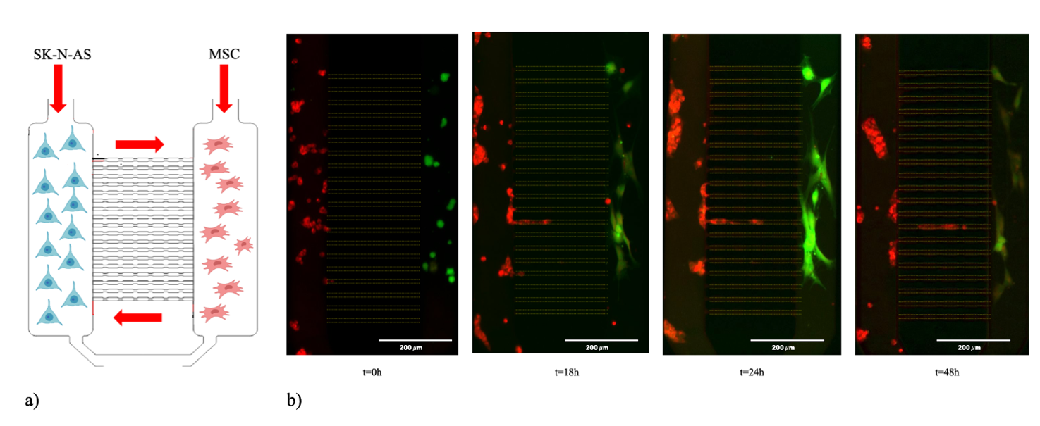
Figure 5. Preliminary migration studies: a) Schematic view of the experimental protocol; b) Fluorescence images of SK-N-AS (red) and hMSC (green) at seeding time (t=0) and at 18, 24 and 48 hours from seeding.

4. Conclusions
This work aimed to design an innovative microfluidic device that would allow studying the migration of cancer cells to a single-cell resolution and based on a novel production technology: two-photon polymerization. This new method resulted in a reduction of time, costs, and quantities of substances compared to established master production methods such as photolithography and micromilling. The result is a microfluidic platform, which successfully replicated the required micro- and nano-metric sizes and dimensions. With its excellent hydraulic sealing and very good cellular biocompatibility, this device can be, for all intents and purposes, a valuable tool for the study of cancer cell migration.
References
- Disanza, A. et al. Is cell migration a selectable trait in the natural evolution of cancer development? Philos. Trans. R. Soc. B Biol. Sci. 374, 20180224 (2019).
- Galarza, S., Kim, H., Atay, N., Peyton, S. R. & Munson, J. M. 2D or 3D? How cell motility measurements are conserved across dimensions in vitro and translate in vivo. Bioeng. Transl. Med. 5, (2020).
- Nguyen, N.-T. & Wereley, S. T. Fundamentals and applications of microfluidics. (Artech House, 2006).
- Breslauer, D. N., Lee, P. J. & Lee, L. P. Microfluidics-based systems biology. Mol. Biosyst. 2, 97 (2006).
- Campbell, J. H. et al. Three-dimensional printing and deformation behavior of low- density target structures by two-photon polymerization. Nanoengineering: Fabrication, Properties, Optics, and Devices XIV (eds. Campo, E. M., Dobisz, E. A. & Eldada, L. A.) 66 (SPIE, 2017)

