Multiscale modeling for the estimation of economic, energy and environmental indicators
Andrea Mio^{a,d*}, Elena Barbera^{b}, Alessandro Massi Pavan^{a,d}, Alberto Bertucco^{b,c},
Maurizio Fermeglia^{a,d}
a. Department of Engineering and Architecture, University of Trieste, Italy
b. Department of Industrial Engineering (DII), University of Padova, Italy
c. Centro Studi “Levi Cases” for Energy Economics and Technology, University of Padova, Italy
d. Center for Energy, Environment and Transport Giacomo Ciamician, University of Trieste, Italy
* Corresponding author e-mail: amio@units.it
1.Introduction
One of the major challenges of the design of new processes and new products is the evaluation of indicators to support decisions makers and investors. The ultimate choice of the best process or product to be developed should be based on economic, energy and environmental indicators internationally recognized as standard and relatively easy to be calculated at design time. Such indicators are based on properties strongly related to the molecular structure of the product and to the details of the production processes of interest.
Multiscale molecular modelling is used to provide basic information for the estimation of such indicators thus allowing comparison among different products for the same application and different production processes for the same product. On one hand, the multiscale molecular modelling paradigm provides a full collection of material properties, such as mechanical, thermal, electrical, magnetic, and toxicological properties [1] as well as all the data estimated from a material and energy balance of a given production process. Multiscale molecular modelling permits all phenomena to be captured at each scale, with the essential information being transferred to the upper scale until the macroscopic system is achieved [2]. Multiscale molecular modelling, by definition, involves the generation of computational models at several length and temporal scales, which are frequently unconnected theoretically. The variety of methods and models commonly employed in the multiscale modelling hierarchy are shown in Figure 1, where the estimation of indicators methodology has been introduced on its top right corner.
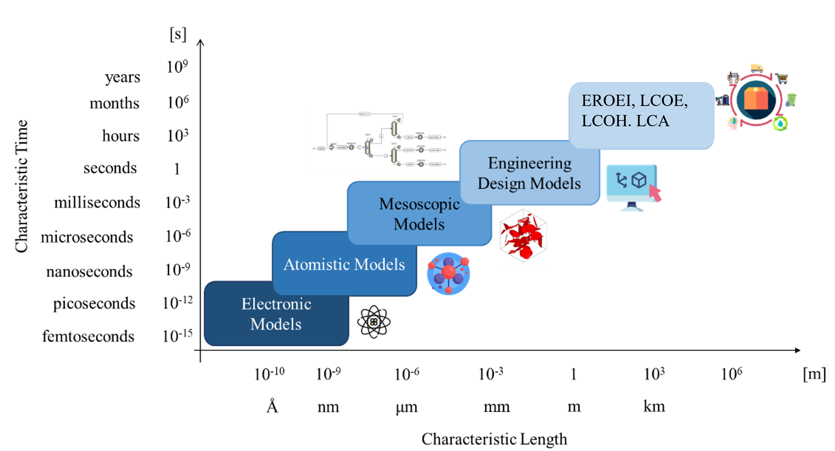
Figure 1. Multiscale molecular modelling scheme.
In the preliminary phase of the design of a new product or process, most of the relevant data for the calculation of the indicators are not available experimentally nor in the literature nor in the databases used for the estimation of the indicators. Furthermore, the accuracy of the data possibly present is missing or questionable: consequently, it is necessary to predict the properties of new products and perform material and energy balance for their production processes.
Despite the tremendous advances in the modelling of structural, thermal, mechanical and transport properties of products at the macroscopic level, there remains a high level of uncertainty about how to predict many critical properties related to advanced materials, which strongly depend on their structure.
Process simulators, an important component of the multiscale molecular modelling, emerged as powerful tools for solving the material and energy balances for any production process as well as for energy integration and costs evaluation. Specifically, they can deal with innovative processes for the production of new products involving batch operations, complex separations and reactions.
Collecting data for life cycle inventory, for instance, is generally a difficult task for practitioners. While reliable primary data is desirable, when case-specific information is lacking, it is standard practice to rely on recognized databases, such as ecoinvent [3] or Gabi [4]. However, even though current databases contain a wide range of information, data on innovative materials or unusual production methods is still lacking. In the event of insufficient data, ISO recommends using proxy inventories, i.e., the mass and energy balances of equivalent products/processes. Surely, the accuracy of the final outcomes is determined by the resemblance between the two systems. Therefore, several in-silico modelling approaches have been used to estimate LCI of products in order to reduce the inaccuracy of proxy data. Process modelling [5–6], dedicated frameworks [7], molecular structure-based models [8] or artificial neural networks [9] are some examples of computational approaches for generating raw materials inventories thus far. Similar difficulties apply also for the estimation of other indicators.
Aim of this paper is to propose a methodology for connecting the multiscale molecular modelling techniques to the main energy, economic and environmental indicators to be used for the selection of a process or a product. The methodology will be applied to two particularly relevant chemical process groups, namely the carbon capture and storage and the hydrogen production from methane steam reforming and from water electrolysis.
The paper is organized as follows: section 2 presents the methods used in this paper for the calculation of the EROEI, EROC, LCOE, LCOH and LCA; section 3 shows the results obtained with the methods previously described, applied to alternative production processes; lastly, some final considerations are reported in section 4.
2. Methods
Energy Return on Energy Invested (EROEI) and Energy Return on Carbon (EROC)
Several methods and indices can be used to assess the efficiency of production processes involving the generation of energy carriers (electricity and/or hydrogen), but the best method for comparing different energy production industries is Net Energy Analysis (NEA). The goal of NEA is to calculate whether the energy produced by any production process is greater than the energy required to build, operate and maintain the infrastructure. Among the possible indexes derived from NEA, the most suitable indicator for the processes of interest is the EROEI defined as:
 | $$EROEI=E_{out}/E_{in}$$ | (1)
where E_{out} is the available energy that the process provides (which for hydrogen is the energy stored in a given quantity of hydrogen) and E_{in} is defined as:
 | $$E_{in}=E_{cap}+E_{o\&m}+E_{f}$$ | (2)
In Eq. (2) E_{in} is the total energy that is provided and consumed during the production and operations periods of the plant and is made up of three contributions: E_{cap} is the capital energy embodied in the materials and used for construction and decommissioning of the plant; E_{o&m} is the energy needed for operating and maintaining the plant; E_{f} is the energy needed for procuring and distributing the fuels, which includes also the energy used for extracting, refining and transporting the fuels from the production well to the plant. All terms are expressed in GWh for consistency: the EROEI is thus dimensionless.
The Energy Return on Carbon (EROC) allows a comparison of processes under the constraint of climate change targets. The EROC is calculated as (C_{ef} is the carbon emission factor):
 | $$EROC= [((1-1/EROEI))/((C_{ef} ) )]$$ | (3)
Levelized cost of energy (LCOE) and levelized cost of hydrogen (LCOH)
The LCOE, which is a measure of the energy carrier generation cost, is used in order to compare different power technologies. The LCOE, which refers to electrical energy production, is calculated as follows:
 | $$LCOE=(OC∙P∙CRF∙FO\&MC)/(8760∙cf)+VO\&MC$$ | (4)
where OC [€/kW] is the overnight cost (cost per unit power produced), P [kW] is the net power output of the plant, CRF [-] the capital recovery factor, cf [-] the capacity factor, while FO&MC [€/kW/year] and VO&MC [€/kWh] are the fixed and the variable operation costs respectively. The overnight cost is calculated as the ratio between the total plant cost (TPC) and the net power output P. The CRF is:
 | $$CRF=\frac{i*{(i+1)}^{L}}{{(i+1)}^{L}-1}$$ | (5)
where i [%] is the interest rate and L [years] is the plant life time.
The levelized cost of hydrogen (LCOH), which is used for hydrogen production processes, is an indicator specifically derived for hydrogen as an energy carrier. It is calculated as follows:
$$LCOH=\frac{(Total Costs-Electrical Revenue)}{H_{2} Annual Production}$$ | (6)
Life Cycle Assessment
Following the International Standard Organization (ISO) 14040 and ISO 14044 guidelines, LCA enables practitioners to predict the potential emissions to environmental compartments (i.e., soil, water and atmosphere) coming from the system under investigation. The LCA procedure employs material and energy balances over the entire life cycle of the product system, taking into consideration the extraction of raw materials, manufacturing, use phase, end-of-life and the transportation between life cycle stages. The results of life cycle assessments are depicted by means of several impact categories, which are able to represent the entire range of ecological burdens associated with the product system, avoiding shifting the impact among environmental compartments. The LCA methodology prescribes the fulfillment of four stages as follows:
- Goal and scope definition: this stage requires to specify the aim of the study, the system boundaries, the quality of data source, the assumptions and limitations introduced and the functional.
- Life cycle inventory analysis (LCI): during this step, the practitioner needs to collect the mass and energy balances of the product system under investigation: the employment of primary data is preferred, since actual process data provide highest accuracy in comparison to secondary data.
- Life cycle impact assessment (LCIA): this phase assigns specific environmental impacts to inventory data through recognized characterization factors, which typify the contribution of each substance to a determined impact category, providing harmonization on a shared unit of measure.
- Life cycle interpretation: this stage provides an evaluation of the results obtained by previous steps: it embeds the overall LCA procedure including comments and recommendations. Usually, sensitivity analysis and uncertainty are assessed during this phase.
Table 1 summarizes the link between process simulation output and indicators’ calculation methods.
 |  | EROEI/EROC | LCOH | LCOE | LCA
Gross power output | kW | x | x | x | x
Power energy requirement | % | x |  |  | x
Thermal power requirement | % | x |  |  | x
Net power output | kW | x | x | x | x
Total plant cost (TPC) | € |  | x | x
Share of investment costs due to operation and maintenance (so&m) | % | x
Fixed operation and maintenance costs (FO&MC) | €/kW/y |  | x | x
Variable operation and maintenance costs (VO&MC) | €/kWh |  | x | x
Total amount of solvent (for CCS) | kg |  |  |  | x
Table 1: Summary of data retrieved from process simulation for the estimation of EROEI, LCOH, LCOE and LCA.
3. Results and discussion
Carbon Capture and Storage (CCS)
The goal of this work was to assess the energetic, economic and environmental performance of natural gas-fired power plants without and with a CCS system. We integrated detailed process simulation (PS) outcomes with an evaluation of the Energy Return on Energy Invested (EROEI), the actual Levelized Cost of Energy (LCOE) and a Life Cycle Assessment (LCA). The application of comprehensive process simulations of two CCS processes suited to a Natural Gas Combined Cycle (NGCC) plant, chosen as typical of electrical energy generation from natural gas, is coupled to the above described calculation methods of indicators. We investigated two CCS processes using AspenPlus™ process simulation software: (i) a traditional one using monoethanolamine (MEA) as solvent and (ii) an innovative one based on hot potassium carbonate (HPC). The inventories of these absorption plants were not available, since CCS has not been successfully implemented at industrial scale yet. Therefore, we needed to resort to process simulation to provide the material and energy balances required for the following sustainability assessment. To ensure the greatest possible quality of the models used to forecast physical properties, a comprehensive thermodynamic and kinetic study was undertaken. Since the rigorous simulation of the NGCC was not the focus of this work, data related to material and energy balances of the power plant was retrieved in literature [20]. The process flow diagram of carbon capture from flue gases using a HPC is shown in Figure 2a, while the compression and transportation of CO₂ to the storage site is shown in Figure 2b. A detailed description of the procedure and processes is reported in [5].
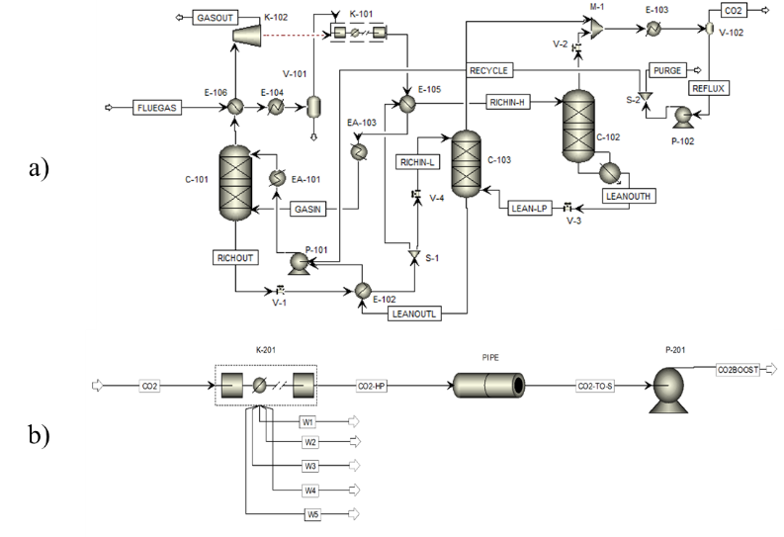
Figure 2: a) HPC carbon capture process flowsheet; b) CO2 transport process flowsheet
Table 2 shows the results obtained for economic and energy indicators. It can be clearly noticed that at constant capacity factor, the EROEI decreases strongly when CCS is used, particularly when HPC process is used, due to the much higher energy consumption required in this CCS process. On the other hand, the effect of the higher costs of CCS reflects into an higher value of LCOE.
Process | cf | EROEI | EROC | LCOE
NGCC | 0.40 | 17.60 | 16.81 | 78
 | 0.85 | 21.37 | 16.99 | 78
NGCC + CCS MEA | 0.40 | 7.73 | 163.1 | 131
 | 0.85 | 12.36 | 167.1 | 102
NGCC + CCS HPC | 0.40 | 5.21 | 163.1 | 178
 | 0.85 | 9.06 | 167.1 | 126
Table 2: calculated values of EROEI, EROC and LCOE for the processes of interest.
The LCA study shows that a comparison among 1 kWh produced using NGCC, NGCC coupled with MEA-based CCS, NGCC coupled with HPC-based CCS, photovoltaics and wind power has been performed using the environmental categories employed by Environmental Footprint (EF) v2.0 method, as shown in Figure 3.
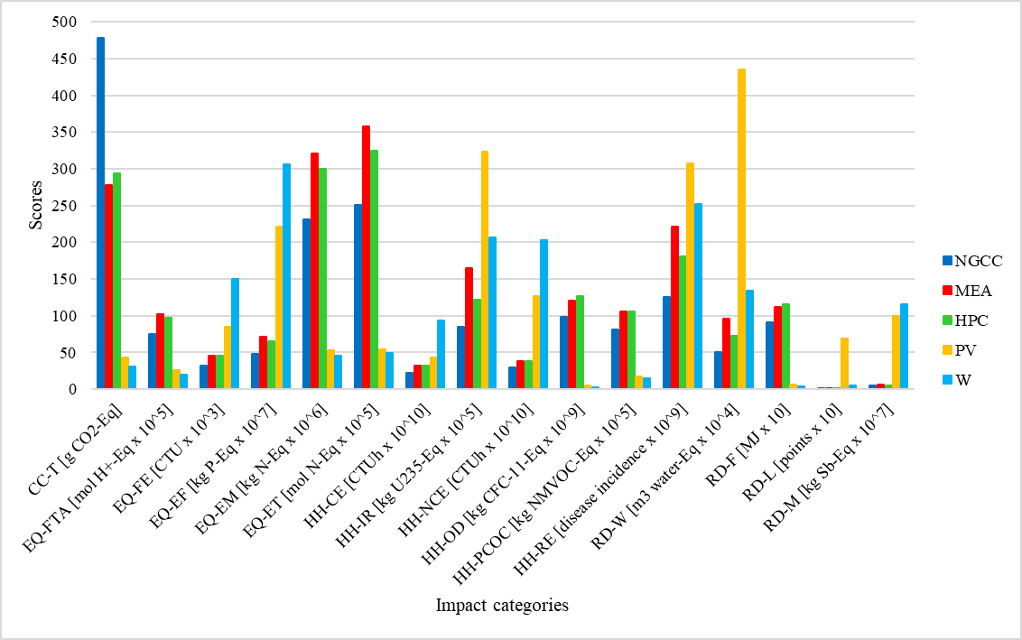
Figure 3: Impact categories scores for each power generation technology considered in this study. NGCC: Natural Gas Combined Cycle, MEA: MEA-based CCS, HPC: HPC-based CCS, PV: photovoltaics, W: wind.
It can be shown that natural gas use, in terms of extraction, refining, transportation, and burning, drives many impact category outcomes. Indeed, the largest impacts of HPC-based CCS on resource depletion of fossil fuels (RD-F) and human health (HH-OD and HH-PCOC) may be attributable to the configurations' maximum energy consumption. According to process modelling, this is due to the energy required for the compression of the high flow rate of flue gas, which exceeds the one required for MEA regeneration. Climate change (CC-T), like the previous impact categories, is linked to natural gas combustion. However, in this instance, owing to the carbon capture process, NGCC emerges as the worst option. Given that the development of CCS is motivated by the need to reduce greenhouse gas emissions as measured by CC-T, it is evident that renewable technologies, such as photovoltaic or wind installations, perform better than CCS in this regard. In fact, in terms of numerous impact categories (including climate change CC-T), it is worth noting how photovoltaic and wind installations have extremely low impacts when compared to fossil-fuel-based technologies. However, care must be taken to avoid burden shifting between the diverse natural compartments. The results of several sensitivity analyses were then used to examine various scenarios related to some assumptions adopted through the assessment. Sensitivity analyses dealt with natural gas power plant operating conditions, ranging over capacity factor, natural gas specific consumption and CO₂ specific emission. Despite the fact that impact categories values varied owing to parameter changes, the essential analysis previously stated on the benefits and downsides of each technology was confirmed, since sensitivity analyses had no effect on relative performance among the numerous options.
Hydrogen production process
The following processes have been simulated using Aspen plus™ 12.0: (i) water electrolysis (Figure 4), (ii) methane steam reforming (Figure 5) and carbon capture and storage (Figure 2).
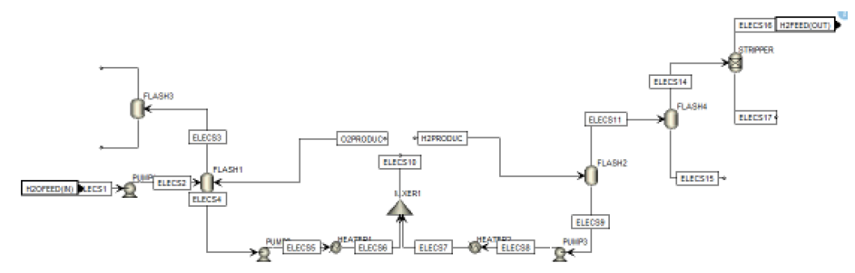
Figure 4. Water Electrolysis process flowsheet within Aspen Plus™.

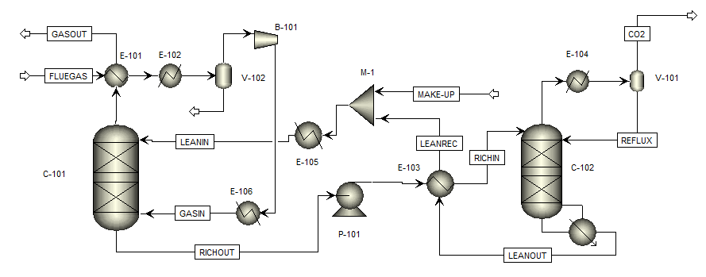
Figure 5: Methane steam reforming process flowsheet within Aspen Plus™.

Material and energy balance data coupled with cost estimation obtained by process simulation software are used to calculate the performance indicators: the detail of the data transferred from the process simulation are reported in Table 1. Values of the key performance indicators, namely EROEI, LCOH and LCA, indicates that the best route for producing hydrogen in terms of global impact is the green hydrogen. Table 3 shows as an example a comparison among EROEI values for the processes of interest.
 | MSR | MSR & CCS | Electrolysis
Eout [GWh] | 2,369.572 | 1,871.962 | 2,391.152
Ecap [GWh] | 5.746 | 7.783 | 4.466
Eo&m [GWh] | 6.895 | 9.340 | 5.359
Ef [GWh] | 296.197 | 267.423 | 95.646
EROEI | 7.8 | 6.58 | 22.67
Table 3: EROEI for methane steam reforming with and without CCS and water electrolysis hydrogen production processes.
4. Conclusions
The goal of this study is to demonstrate how in-silico techniques may be used to generate data to be used for the evaluation of different indicators: EROEI, LCOE, LCOH, LCA. The integration of indicators’ evaluation into a multiscale molecular modeling framework produces a double benefit: i) we extended the scope of multiscale molecular modelling by taking the most comprehensive approach feasible, and ii) future evaluation applications, may benefit of this cutting-edge approach. This study shows how process simulation plays a fundamental role in providing material and energy balances as well as energy and costs information for the evaluation of the required indicators already at design time.
References
- Fermeglia M, Mio A, Aulic S, Marson D, Laurini E, Pricl S.. Mol Syst Des Eng 2020; 5:1447–76.
- Laurini E, Marson D, Aulic S, Mio A, Fermeglia M, Pricl S., Chem. Eng Trans 2019; 74:619–24.
- Wernet G, Bauer C, Steubing B, Reinhard J, Moreno-Ruiz E, Weidema B., Int J Life Cycle Ass. 2016;21:1218–30.
- PE-International. Gabi Database 2012.
- Barbera E, Mio A, Massi A, Bertucco A, Fermeglia M. . Submitted 2021.
- Petrescu L, Burca S, Fermeglia M, Mio A, Cormos CC., J Water Process Eng 2021;41.
- Lodato C, Tonini D, Damgaard A, Fruergaard Astrup T., Int J Life Cycle Assess 2020;25:73–88.
- Gonzalez-Garay A, Guillen-Gosalbez G. SUSCAPE., Chem Eng Res Des 2018;137:246–64.
- Calvo-Serrano R, González-Miquel M, Papadokonstantakis S, Guillén-Gosálbez G., Comput Chem Eng 2018;108:179–93.

