A novel integrated technology to recover high-valuable minerals from seawater through a circular economy approach

Carmelo Morgante¹, Fabrizio Vassallo¹, Andrea Cipollina¹*, Alessandro Tamburini^{1,2}, Giorgio Micale¹
1 Dipartimento di Ingegneria, Università degli Studi di Palermo - viale delle Scienze Ed.6, 90128 Palermo, Italy;
2 ResourSEAs SrL, viale delle Scienze Ed.16, 90128 Palermo
*Corresponding author E-Mail: andrea.cipollina@unipa.it

1.Introduction
Within the last few decades, the European Union (EU) has had to witness a gradual increase of its economic dependence on other non-EU nations due to mineral land mining depletion. Such matter has led to define thirty “critical” raw materials (CRMs), on which the EU has recently been focusing much attention, attempting to solve the issue via several action plans [1]. The discovery of new sources of the CRMs seems to be a solution to the problem, yet nowadays it still remains to be very challenging. It is no ground-breaking news the fact that seawater can be considered as an “infinite” source of valuable minerals, containing magnesium, lithium, calcium etc. These minerals have been recovered from seawater for centuries. Nevertheless, such method has never dominated the mineral production field due to the employment of inefficient technologies. Within this framework, a novel integrated process was proposed and tested at semi-industrial/pilot scale to recover high valuable minerals from Mediterranean seawater. More precisely, the integrated process comprises three different technologies: (i) a Nanofiltration unit NF, (ii) a Multiple Feed – Plug Flow Reactor MF-PFR and (iii) an Electrodialysis unit with Bipolar Membranes EDBM.
2. Methods
One semi-industrial and two pilot-scaled plants were installed and integrated in the minor Sicilian island of Lampedusa. A conceptual scheme of the integrated process is illustrated in Figure 1. The first plant (semi-industrial scale) was an NF unit, developed by Lenntech BV, with a feed capacity of ⁓2 m³/h. Seawater from Lampedusa Island was fed to the NF unit, producing two streams: (i) a permeate stream rich in monovalent ions e.g. sodium and chloride and (ii) a retentate stream rich in bivalent ions e.g. magnesium and calcium. The NF retentate was then fed to a second unit (pilot scale), MF-PFR. Such unit was designed and constructed by the University of Palermo [2]. The reactor consisted of two co-axial cylindrical tubes in which the NF retentate (rich in magnesium and calcium) was injected into one of the tubes whereas a sodium hydroxide (NaOH) solution into the remaining one. At controlled reaction pH values, it was possible to selectively promote the precipitation of magnesium hydroxide Mg(OH)₂ particles and calcium hydroxide Ca(OH)₂ particles in two consecutive steps. The pilot-scaled reactor had a feed capacity of 150 L/h. Since the second precipitation step occurred at a reaction pH value ⁓ 13, the remaining effluent that exited the reactor was neutralized with a hydrochloric acid (HCl) solution and sent to the third and last plant: EDBM. The EDBM unit (pilot scale), with a feed capacity of 100 L/h, was also developed by the University of Palermo. By the effect of an electric field and the use of selective/bipolar membranes positioned in an alternative way, an alkaline solution (NaOH) and acidic solution (HCl) were produced other than a remaining salty effluent. The EDBM effluent was then mixed with the NF permeate and discharged back to the Mediterranean Sea. As far as the produced NaOH and HCl were concerned, a recycling strategy was adopted to re-use them within the process as the alkaline solution for the MF-PFR and for the neutralization of the MF-PFR effluent, respectively.

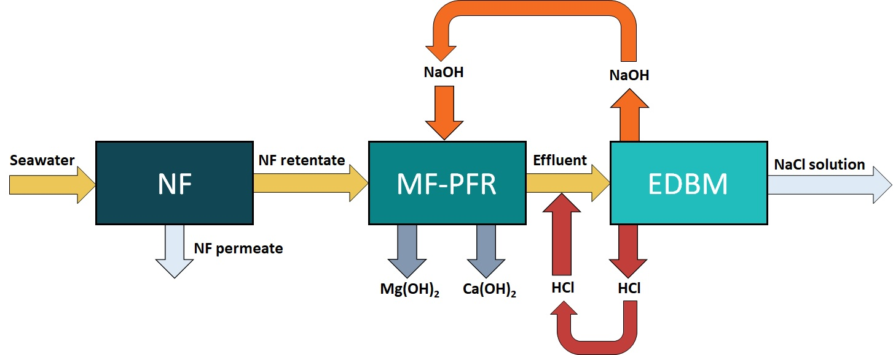 Figure 1. Conceptual scheme of the novel integrated technology for mineral recovery from seawater
3. Results and discussion
The entire plant was operated for 4 to 6 hours per day, testing its operational and performance stability. Given seawater (salinity ⁓ 35 g/L) as the feed of the process, the NF plant was able to produce a retentate with an average concentration of magnesium and calcium of ⁓ 5.5 and 1.5 g/L, respectively, with both ionic NF membrane rejections higher than 90%. This meant that it was possible to maximize the quantity of magnesium and calcium entering the MF-PFR. As for this unit, magnesium recovery equal to 100% was achieved whereas calcium recovery values were slightly lower (⁓90%). Finally, the EDBM unit was able to produce the desired/required concentrations of NaOH and HCl only when initial low concentrations of NaOH and HCl were fed to the EDBM unit along with the MF-PFR effluent.
4. Conclusions
A novel integrated technology was proposed and tested at the semi-industrial/pilot scale to recover high valuable products (Mg(OH)₂ and Ca(OH)₂) from Mediterranean seawater. Results obtained from its testing proved its performance stability, demonstrating its feasibility of being an alternative method to recover minerals with reduced environmental and economic impact (mainly due to its production of hydroxides and in-situ production of chemicals). Taking into account the process’s future prospects, an application of possible greater interest could be the treatment of waste brines from the desalination field. In such scenario, larger quantities of hydroxides produced and a lower environmental impact could be contemporarily achieved, approaching the circular economy concept.
Acknowledgements
This project has received funding from the European Union’s Horizon 2020 research and innovation program under Grant Agreement no. 869474 (WATER-MINING – Next generation water-smart management systems: large scale demonstrations for a circular economy and society). www.watermining.eu.
References
[1] European Commission, Study on the review of the list of Critical Raw Materials - Final Report, 2020. doi:10.2873/11619.
[2] F. Vassallo, D. La Corte, N. Cancilla, A. Tamburini, M. Bevacqua, A. Cipollina, G. Micale, A pilot-plant for the selective recovery of magnesium and calcium from waste brines, Desalination. 517 (2021) 115231. doi:10.1016/j.desal.2021.115231.

