Electrochemical detection of human immunoglobulin-G using immunosensor based on ZnO nanorods
Nadia Moukri¹*, Bernardo Patella¹, Gaia Regalbuto¹, Giuseppe Aiello¹, Chiara Cipollina², Elisabetta Pace³, Serena Di Vincenzo³, Alan O’Riordan⁴, Rosalinda Inguanta¹
1 Dipartimento di Ingegneria, Università degli Studi di Palermo, Palermo, Italy; bernardo.patella@unipa.it; gaia.regalbuto@community.unipa.it; giuseppe.aiello02@unipa.it; rosalinda.inguanta@unipa.it; 2 Fondazione Ri.MED, Palermo,Italy; ccipollina@fondazionerimed.com;3 Istituto per la Ricerca e l’Innovazione Biomedica (IRIB)-Consiglio Nazionale delle Ricerche, Palermo, Italy; elisabetta.pace@cnr.it; serena.divincenzo@irib.cnr; 4 Tyndall National Institute, University College Cork, Ireland, alan.oriordan@tyndall.ie.
Corresponding author E-Mail: nadia.moukri@unipa.it

1.Introduction
In recent years, the demand for new types of analytical devices has been growing in several medical applications, such as clinical diagnosis and home patient monitoring. For this reason, research is focused on obtaining new devices capable of performing fast, accurate and in situ real-time analyses. In this work, an electrochemical immunosensor based on ZnO nanorods (ZnO-NRs) was developed for the detection of human immunoglobulin G (H-IgG). This protein was selected as model analyte because of its physical, chemical, and biological features similar to many other biomarkers.
Commercial methods for production of ZnO thin films are gas phase-based techniques such as sputtering and metal organic vapor deposition. These methods are highly expensive for both instrumentations and operational conditions and they also require specialized personnel. The fabrication methods are based on electro-generation of base that leads to the deposition of ZnO starting from a solution containing Zn²⁺ and nitrate ions. In particular, the electro-reduction of nitrate to nitrite leads to the generation of OH– at electrode/electrolyte interface with a consequent increase of local pH [1]. This increase in pH allows the precipitation of ZnO on the electrode surface [2]. By tuning the electrodeposition parameters, it is possible to obtain ZnO with different morphologies such as thin film, self-assembled hexagonal nanorods (NRs), nanofibers, nanoparticles, nanorings and nanowires. The nanostructured morphology allows electrodes with higher surface area and thus high activity. For these reasons, in this work we explored the possibility of using electrochemically obtained ZnO nanorods (ZnO-NRs) as a basis for the fabrication of immunosensors.
In order to detect proteins, a sandwich configuration was assembled on the surface of the electrode. The sandwich layout is shown in Figure 1. This configuration consists of a) a primary antibody attached on the electrode surface, b) the antigen to be detected (analyte) that is selectively bound by the primary antibody, and c) a secondary labelled antibody. The immunosensor is electrochemically active thanks to the presence of gold nanoparticles tagging the secondary antibody. Therefore, it has been used to measure the current density of the hydrogen evolution reaction, which is indirectly related to the concentration of H-IgG antigens. In this way the calibration curve was constructed obtaining a linear range of 1-1000 ng mL⁻¹ with a detection limit of few ng mL⁻¹ and good sensitivity

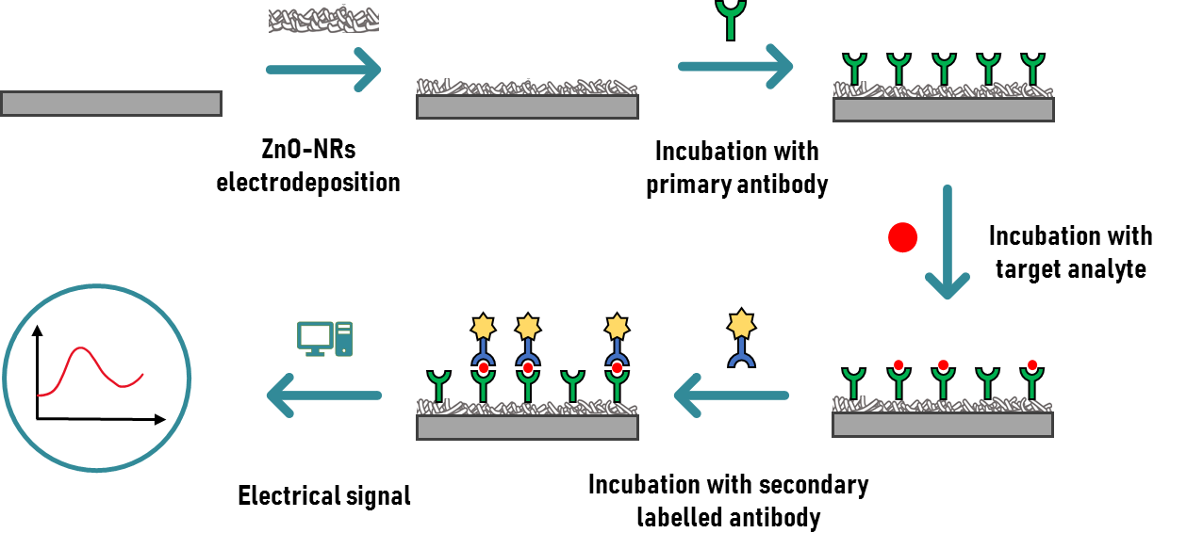
Figure 1. Scheme of immunosensor with a sandwich configuration based on ZnO nanorods.
2. Methods
ZnO nanorods were fabricated by means of an electrochemical deposition technique called electro-generation of base. This deposition was carried out over the flexible substrate ITO-PET (Indium Tin Oxide Polyethylene Terephthalate). The electrodeposition of ZnO-NRs was carried out applying a constant potential of -0.95 V vs Ag/AgCl for 60 min in an inert atmosphere under a continuous flow of nitrogen. A
3-electrodes cell was used, with a Pt mesh as a counter-electrode and a silver-silver chloride (Ag/AgCl) reference electrode. The deposition was carried out at 60 °C using an aqueous solution of ZnCl₂ 10 mM and NaNO₃ 10 mM as electrolyte.
To increase the covalent immobilization of the primary antibody, rGO (reduced graphene oxide) was deposited on top of the ZnO NRs electrodes using electrodeposition by applying a constant potential. This deposition was carried out in a homemade cell with small exposing area (0.07 cm²) of the NRs electrode that operates as working electrode; a rod of platinum and SCE were used as counter and reference electrodes, respectively. The electrolyte solution was an acetate buffer solution containing GO (graphene oxide)
5 mg mL⁻¹. A cathodic potential of -0.8 V (SCE) for 300 s was applied, to obtain the formation of rGO on electrode surface.
The method employed to obtain the immunosensor and to detect H-IgG consists of 5 different steps detailed in [3]. The first incubation step is a key step because it modifies the electrode surface with amino groups that can easily react with the primary antibodies, that were immobilized on electrode surface during the second step. In the subsequent step the modified electrode was treated with a solution of ETA to block all areas of the electrode not covered by the primary antibody. In this way, during the detection phase, the current signal will arise only from the sandwiches because they will be the only electrochemically active parts. Then, electrodes were incubated with different amounts of target H-IgG (ranging from 1 to 1000 ng mL⁻¹) diluted in PBS to define a calibration plot. Finally, the electrodes were incubated (1 h at room temperature) in a solution containing the secondary antibody, previously tagged with Au-NPs, to complete the sandwich. Au NPs were synthesized following the Turkevich method [4]. A chronoamperometry technique, performed by imposing a constant potential of -0.9 vs SCE, was employed for evaluate the immunosensor performance.

3. Results and discussion
Figure 2. SEM image of ZnO nanorods electrode.
For sensing applications, the nanorods is the preferred morphology, due to its high surface area. By SEM we found that ITO-PET substrate is covered by nanorods with hexagonal shape characteristic of ZnO with wurtzite-type structure. SEM image of the electrode is shown in Figure 2. The presence of rGO film, that do not change the nanostructured morphology of the electrode, was also observed. On this electrode, after the different incubation steps, the immunosensor with sandwich configuration composed of primary antibody, antigen (immunoglobulin G), and secondary antibody labelled with gold nanoparticles, was fabricated. The greater the number of electrochemically active sandwiches, the greater the hydrogen developing current. By measuring this current, (0.1 M HCl polarized at -0.9 V vs SCE) the sensor calibration line was determined. The linear operating range of the sensor was found in the range 10–1000 ng mL⁻¹ with a detection limit of 1.25 ng mL⁻¹ and a sensitivity of 6.77 µA cm⁻²/log (ng mL⁻¹).
4. Conclusions
In this work, an electrochemical immunosensor based on ZnO nanorods was developed for the quantification of human immunoglobulin G. This protein is selected as it has physical, chemical, and biological characteristics similar to many others and can be used as a model analyte. The immunosensor was developed using the “sandwich” configuration in which the target antigen binds with the primary antibody and the secondary antibody labelled with gold nanoparticles (Au-NPs). With this configuration, the sandwich is electrochemically detectable, as the Au-NPs catalyze the hydrogen development reaction. Thus, the current density related to the hydrogen development reaction is indirectly correlated with the concentration of
H-IgG. Through these measurements, the calibration curve of the sensor was obtained in the concentration range of the H-IgG from 1 ng mL⁻¹ to 1000 ng mL⁻¹. From the calibration curves it has been observed that the linear operating range of the sensor is included in the range 1-1000 ng mL⁻¹ with a detection limit of
1.21 ng mL⁻¹ and a sensitivity of 0.13824 µA cm⁻²/(ng mL⁻¹).

References
[1] M. Nobial, O. Devos, O. R. Mattos, e B. Tribollet, «The nitrate reduction process: A way for increasing interfacial pH», Journal of Electroanalytical Chemistry, pag. 8, 2007.
[2] M. Vaghayenegar, A. Kermanpur, e M. H. Abbasi, «Formation mechanism of ZnO nanorods produced by the electromagnetic levitational gas condensation method», Scientia Iranica, vol. 18, n. 6, pagg. 1647–1651, dic. 2011, doi: 10.1016/j.scient.2011.11.025.
[3] B. Patella et al., «Electrochemical Synthesis of Zinc Oxide Nanostructures on Flexible Substrate and Application as an Electrochemical Immunoglobulin-G Immunosensor», Materials, vol. 15, n. 3, pag. 713, gen. 2022, doi: 10.3390/ma15030713.
[4] J. Kimling, M. Maier, B. Okenve, V. Kotaidis, H. Ballot, e A. Plech, «Turkevich Method for Gold Nanoparticle Synthesis Revisited», J. Phys. Chem. B, vol. 110, n. 32, pagg. 15700–15707, ago. 2006, doi: 10.1021/jp061667w.

