GRICU 2022, Ischia, (Italy), July 3-6, 2022

Experimental Campaigns and In-silico Assessment for the Conceptual Design of a Catalytic Splitting Process of Hydrogen Sulfide into Hydrogen and Elemental Sulfur
Anna Nova1,2, Flavio Manenti1,2*

- Politecnico di Milano, Dipartimento di Chimica, Materiali ed Ingegneria Chimica “Giulio Natta”, Piazza Leonardo da Vinci 32, 20133 Milano, Italy;
- Consorzio Interuniversitario Nazionale per la Scienza e Tecnologia dei Materiali, Via Giusti 9, 50121 Firenze, Italy;
*Corresponding author E-Mail: flavio.manenti@polimi.it

Introduction

Hydrogen sulfide (H2S) is a synthetic and natural compound, the presence of which can affect both fossil (e.g., gas fields, oil processing) and renewable (e.g., biogas, geothermal wells) resources. H2S processing is quite cumbersome since this species is lethal, corrosive and flammable. Today, H2S is mainly disposed of through the Claus process [1], which performs an oxidative conversion able to transform it into elemental sulfur and water and, at the same time, to recover thermal energy. In this case hydrogen in H2S cannot be recovered and is finally wasted in the form of water [2]. The production of hydrogen results of great interest since this compound is a highly valuable product with a wide range of applications, especially in the energy and chemicals industry. Therefore, a variety of splitting techniques, aimed at producing hydrogen and sulfur from H2S, have been studied. These includes thermal [3] and catalytic [4 - 6] technologies. In this work, a MoS2 catalyst-based decomposition method is presented and integrated into a conceptual process design.

Methods

The technology performing the H2S catalytic splitting, called Sulfidric Acid Catalytic Splitting (SACSTM), has been tested by setting up an ex-novo experimental apparatus. This consists of an open circuit system fed by a gaseous H2S/N2 mixture with a H2S concentration up to 8 vol%. The reactor, designed according to the ideal Plug Flow Reactor (PFR) model, is made of quartz and is composed of three sections: the inlet section, the central body and the outlet section. To ensure the adequate thermal conditions required by the process, the reactor is placed inside a tubular oven. The catalyst is constituted by MoS2 powder supported on quartz wool. Upon exiting the reactor, the sulfur is condensed into a cold trap and subsequently the gases are analyzed with a Micro GC (Micro Gas Cromatograph). The experimental campaigns are currently in progress. Experimental observations are the backbone for the definition of a plant-scale conceptual process design for the conversion of an H2S stream into hydrogen and sulfur. The detailed process simulation has been developed using Aspen HYSYS V11 suite. As thermodynamic model, the SRK (Soave-Redlich-Kwong) equation of state has been chosen for the reactive section of the process, while the Aspen HYSYS amine package has been chosen for the separation section.

2. Results and discussion

The process design shows how the catalytic conversion of H2S can be exploited in a plant to convert a stream of H2S into hydrogen and sulfur. The gaseous H2S enters the SACSTM reactor and is converted at a pressure slightly higher than the atmospheric pressure and at a temperature between 500 and 1000 °C. Sulfur vapors are removed by condensation and the residues are hydrogenated at 260 °C in a dedicated reactor. The obtained gas stream (containing hydrogen, unreacted H2S and H2S produced by the hydrogenation of sulfur vapors) is treated in an amine scrubbing process. A first absorption column employs a water solution of MEA (20 wt%) to remove H2S from the gaseous stream. The residual concentration of H2S in the sweetened gases is around 1 ppm. This stream is then cooled to 5 °C in order to condense the water entrained during the washing step. The clean gases are compressed up to 16.5 bar and the last traces of water and H2S are separated by means of a filter. The stream, now containing only hydrogen, is finally sent to a compression train and reaches a pressure

GRICU 2022, Ischia, (Italy), July 3-6, 2022

of 200 bar. The contaminated amine is regenerated in a distillation column operating at 1.2 bar. The top product is an acid stream containing H2S and saturation water. After a water condensation step H2S is recirculated to the SACSTM reactor. The purified amine leaving the bottom is cooled to 60 °C and recirculated to the absorption column. In this stream a water make-up is required. For this purpose, it is possible to exploit the two H2S contaminated water streams obtained by the condensation steps of the process.

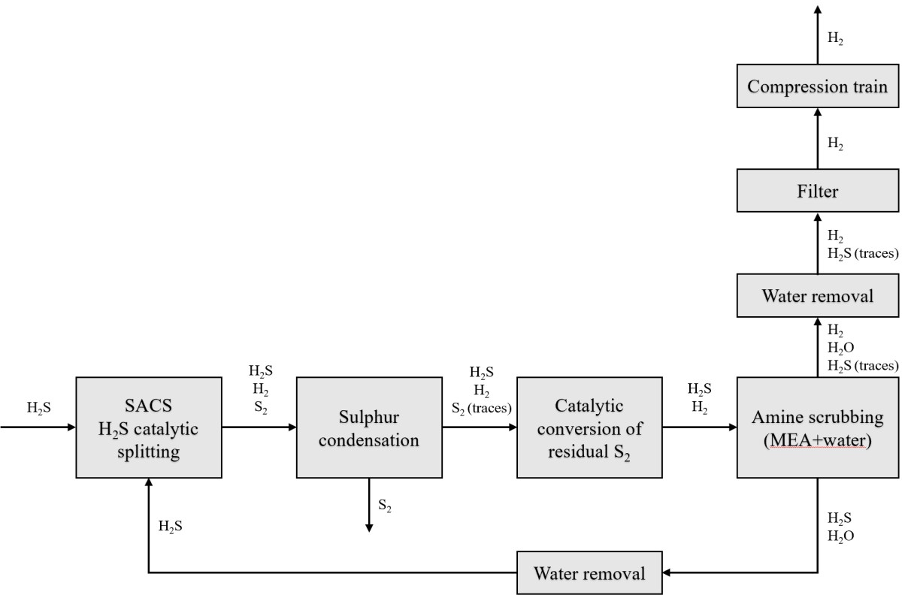
Figure 1. Block-flow diagram of the conceptual process for H2S conversion.

4. Conclusions

The SACSTM process exploits the catalytic splitting of H2S to allow the simultaneous production of H2 and elemental sulfur from the undesired molecule H2S. A process simulation that integrates experimental observations into a conceptual process design has been developed, proving how it is possible to achieve 100% conversion of H2S streams into H2 and elemental sulfur. This process could improve the performances of refineries or other industrial plants, since it changes the role of H2S from waste to commodity. Also, the emissions would be reduced, both in terms of CO2 and flue gases. The experimental campaign is still ongoing and aims at studying different possible catalysts, defining the kinetics of the reaction and optimizing the process.

References

[1] J.A. Lagas, J. Borsboom, P.H. Berben. Selective-oxidation catalyst improves Claus process. Oil Gas J, 86 (1988) 68–71.
[2] F. Manenti, D. Papasidero, G. Bozzano, E. Ranzi. Model-based optimization of sulfur recovery units. Computers and Chemical Engineering, 66 (2014) 244–251.
[3] F. Faraji, I. Safarik, O.P. Strausz, E. Yildirim, M.E. Torres. The direct conversion of hydrogen sulfide to hydrogen and sulfur. Int J Hydrogen Energy, 23(6) (1998) 451–456.
[4] K.R.G. Burra, G. Bassioni, A.K. Gupta. Catalytic transformation of H2S for H2 production. Int J Hydrogen Energy, 43(51) (2018) 22852–22860.
[5] L. Zhao, X. Liu, X. Mu, Y. Li, K. Fang. Highly selective conversion of H2S-CO2 to syngas by combination of non- thermal plasma and MoS2/Al2O3. Journal of CO2 Utilization, (2020) 45–54.
[6] V. Preethi, S. Kanmani. Photocatalytic hydrogen production. Materials Science in Semiconductor Processing, 16(3)
(2013) 561–575.

