Electrically driven SiC-based structured catalysts for hydrogen production
Vincenzo Palma*, Eugenio Meloni, Giuseppina Iervolino
Department of Industrial Engineering, University of Salerno (Italy
*Corresponding author E-Mail: vpalma@unisa.it

1.Introduction
The environmental issues raising from the chemical industry has reached the attention of people all over the world, and the reduction in greenhouse gas (GHG) emissions has been identified as a strategy for the mitigation of climate change. Nowadays, chemical industry is mostly powered by the combustion of fossil fuels, which is responsible for a significant portion of anthropogenic GHG emissions. In this context, many energy experts have agreed that the electrification is the most promising route for reaching the targets, even if electricity generation and transmission involve substantial energy losses and thus its application as a heat source in chemical industry is less efficient than onsite combustion from an energy efficiency point of view. However, the potential of electrification mainly lies in a future scenario where there is a pathway leading to zero-carbon electricity [1]. There are many types of electrification that can be implemented in current chemical industry: power-to-gas (PtG), power-to-chemicals (PtC), power-to-electricity (PtE), power-to-heat (PtH) and power-to-liquids. In the last years, an energy transition has been underway, and many leading energy, transport and industrial companies have taken initiatives to develop the energy transition with hydrogen [2], which is a versatile energy carrier, that can be integrated in different areas such as power grids, transport, heating, fuel-cell electric vehicles, and energy storage . Hydrogen can be produced through different processes, such as natural gas or biogas reforming, gasification of coal and biomass, water electrolysis, water splitting by high temperature heat, photoelectrolysis, and biological processes. Currently, among the above cited processes, the conventional large-scale production of hydrogen is mainly obtained by the reforming of fossil fuels, among which the main processes are methane steam reforming (MSR) and methane dry reforming (MDR). The two mentioned processes are highly endothermic; therefore, the constant supply of heat to the catalytic sites is one of the main constrain limiting their efficiency. In these reactors huge temperature gradients occur from the reactor external side to the catalyst bed, due to the heat transfer resistance mainly linked to the low thermal conductivity of the commercial catalysts actually used [3]. In this work the process intensification of both MSR and MDR is proposed by using an innovative structured catalyst which combines two fundamental features (i) a high thermal conductivity, that aim to flatten the thermal profile inside the reactor , and (ii) an integrated joule heating, that allow to perform a direct electricity-driven process. In this way, the energy is directly supplied to the catalyst, due to its intimate contact with the electric heat source, therefore the removal of thermal limitations and a better control of the reaction front may be obtained.
2. Methods
In this work a laboratory-scale reactor has been realized, using a commercial silicon carbide (SiC) electrical heating element that simultaneously acted as heating medium and support for the catalyst. In this way, the sense of the heat flux has been inverted (from the center to the external) with respect to the conventional reformer (from the external to the center). Commercial ceramic material was employed as support for the Ni-based catalysts preparation. A fixed amount of 5 wt% Ni was deposited on the support, previously dried and calcined at 850 °C in air. he catalysts were prepared via wet impregnation, with a solution of Ni(NO3)2·6H2O as Ni precursor; the resulting catalysts were dried at 120 °C for 2 h and calcined at 850 °C in air for 1 h. the catalysed SiC element has been enclosed in a properly shaped quartz reactor and a mixture consisting of 10 vol% of CH4, 30 vol% of Steam and diluted in argon has been fed from the top to the bottom of the reactor. As regards the preliminary electrified MDR tests carried out on Ni catalysed SiC element, the same reactor configuration described in the previous paragraph was used. In particular, a mixture consisting of 50 vol% of CH₄ and 50 vol% of CO₂ has been fed to the reactor.
3. Results and discussion
The results of the preliminary MDR test evidenced that the methane conversion and hydrogen yield (Figure 1) are particularly promising. In particular, it is possible to observe that the catalytic SiC element is able to reach the reaction temperatures by means of the Joule heating. It is possible to note that the MDR reaction proceeds following the equilibrium thermodynamic profile of the reaction (black curve) even at low temperatures.
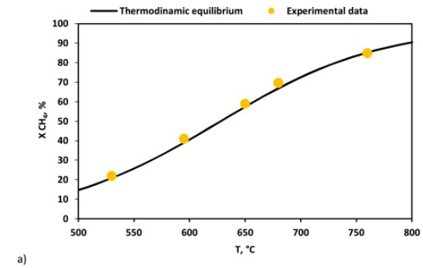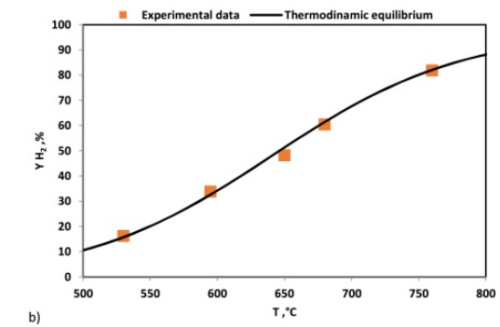
Figure 1. atalytic activity test results (MDR) a) CH₄ conversion; b) H₂ yield; CO₂/CH₄ ratio for MDR reaction = 1; WHSV =70 h^{−1.}
As expected, the energy consumption of the system is strictly linked to the H₂ productivity; in fact, the higher is this amount the lower is the energy consumption. Moreover, at lab scale, the effects of heat dissipation have a big role with respect to the low gas flow rate fed to the reactor and for this reason higher energy consumption was observed at the lower WHSV values. The direct comparison in terms of energy consumption for H₂ production with other electrified reforming processes is very difficult, since not a so high number of data is available in literature. However, from preliminary results, it is possible to confirm that energy consumption values close to that reported for other electrified processes, including the modern electrolysers,
4. Conclusions
The results reported in this work demonstrate that a commercial SiC based heating element, coated with a Ni-based catalyst, can be used in the context of the chemical processes electrification scenario, a topic that is acquiring more and more focus from the scientific and industrial world. The investigation concerning the adoption of the Ni catalysed SiC electrically heated element pointed out its effective capacity of heating up the reaction zone without any external source till temperature of 900 °C. It is possible to summarize that the results have shown values close to that reported for other electrified processes, including the modern electrolysers. These results can be considered even more promising if one takes in to account the laboratory scale of the reactor, where the effects of heat dissipation have a big role with respect to the low gas flow rate fed to the reactor.
References
- C. Chen, Y. Lu, R. Banares-Alcantara Direct and indirect electrification of chemical industry using methanol production as a case study Appl. Energy, 243 (2019), pp. 71-90, H.V. Patel, J.A.M. Kuipers, E.A.J.F. Peters, Chem. Eng. Sci. 193 (2019) 243–254 .
- F.J. Durán, F. Dorado, L. Sanchez-Silva Exergetic and economic improvement for a steam methane-reforming industrial plant: simulation tool Energies, 13 (2020), p. 3807, G.F.Froment, K.B.Bishoff, Chemical Reactor Analysis and Design, second ed., Wiley, New York, 1990.
- E. Meloni, M. Martino, V. Palma A short review on Ni based catalysts and related engineering issues for methane steam reforming Catalysts, 10 (2020), p. 352.

