Biological conversion of agricultural wastes into microbial proteins for aquaculture feed

Giovanna Pesante¹, Anna Zuliani¹, David Bolzonella¹ and Nicola Frison^{*,1}
1 Department of Biotechnology, University of Verona, Strada Le Grazie 15, 37134 Verona, Italy
*Corresponding author E-Mail: nicola.frison@univr.it

1.Introduction
Due to the ever-growing population, the demand of protein-rich food for human and animal nutrition is continually increasing (FAO, 2018). The current use of plant and animal-based proteins is not environmentally sustainable because of the high CO2 footprint of agriculture and livestock rearing (Vermeulen et al., 2012) and is also problematic because of the scarcity of land (Mekonnen & Hoekstra, 2014). The European Green Deal promotes the use of alternative sources of proteins, such as insects or single cell proteins (SCP) (Siddi, 2020). SCP or microbial proteins include dried microorganisms rich in proteins, vitamins and lipids (bacteria, algae, fungi and yeasts), which can be used as supplements in human food or as animal feed (Saeed et al., 2016), but also for the production of third-generation biofuels – bioethanol and biodiesel (Martínez et al., 2015) and the manufacture of bioplastics and adhesive materials (Yadav et al., 2020), as well as fertilisers replacing conventional nitrogen and phosphorous rich material. SCP have so far mainly been produced from raw materials with high commercial value, while they could be obtained by the fermentation of inexpensive feedstocks such waste, making them more economical, and helping with the environmental burden created by the disposal of wastes (Nasseri et al., 2011). In our study we set up the production of SCP of microbial origin from agricultural and zootechnical waste, using the VFA-rich fluid obtained from the fermentation of the waste as feed for a bioreactor, with the aim of using them microbial biomass in the aquaculture industry. The bacterial species used to produce the SCP were selected to be polyhydroxyalkanoates (PHAs) producers, because of the added value they provided in the fish feed. Indeed, these biological polymers have been shown to help protect aquatic animals from pathogenic bacteria acting both as prebiotics and probiotics (Laranja et al., 2014; Suguna et al., 2014). PHAs producing organisms can be used directly as SCP without the need of expensive extraction and purification PHAs procedures, which are at present hindering their use as bio-plastics (Chee et al., 2019).
2. Methods
2.1 Experimental set-up
The feedstock consisted in cattle’s manure or digestate obtained at the end of an anaerobic digestion process, together with leftovers from a pasta making factory. This mixture was homogenized with water (total solids content 5-10%) and loaded in a 4 m3 acidogenic fermentation unit (AFU) at the anaerobic digestion (AD) plant “La Torre” located near Verona, Italy, where the initial acidogenic fermentation (AF) took place, according to Righetti and colleagues (Righetti et al., 2020). The volatile fatty acids (VFAs) stream obtained from the AFU was used to feed a 1.6 liters continuous stirred tank reactor (CSTR) after a solid-liquid separation step and a mechanical filtration phase up to 0.22 μm with a Juice Clarification System pump. The reactor was inoculated either with the bacterial consortium of the AF, or with a pure culture of the PHA producer Thauera sp. Sel9 (Conca et al., 2020; Sabapathy et al., 2020). The culture was supplied with oxygen, kept at 30˚ C and stirred at 180 rpm. Different hydraulic retention times (HRT) were tested, with steady-state conditions reached when MLSSs (mixed liquor suspended solids) variations were less than 5% for 3 times the value of the HRT. The bacterial biomass obtained from the culture at the end of the 38 days of the experiment was centrifuged, resuspended in deionized water to remove any remaining culture medium and was analyzed for the determination of its centesimal composition, with particular focus on the amino acid composition. Part of the biomass obtained from the CSRT was also used, prior to the centrifugation step, for a PHAs accumulation test designed to produce the highest possible content of PHAs.
2.2 Fermentation fluid characterization
Total suspended solids (TSS), volatile suspended solids (VSS) and soluble COD (sCOD) were determined according to standard protocols (APHA et al., 1998; IRSA-CNR, 2003). Total nitrogen (TN) was determined using LCK338 LATON kit and ammonium (NH4-N) with LCK303 kit, both by Hack, following manufacturer’s protocol. VFAs concentration was verified by ion-chromatography using a Dionex ICS-1100 (Thermo Fisher Scientific, USA) equipped with IonPac ICE-AS1 column as described by Conca and colleagues (Conca et al., 2020). PHA contents were quantified by gas chromatography (GC) following Braunegg and colleagues (Braunegg et al., 1978) together with standards of pure poly(3-hydroxybutyric acid-co-3-hydroxyvaleric acid) (Sigma, 403105). PHA contents in experimental samples were calculated as percentage over the sample VSS with the following equation: (mgPHA/mgVSS)*100, whereas the PHA yields were calculated as mgPHA/mgCOD.
2.3 Bacterial biomass characterisation
The proximate composition and amino acid analyses were performed by Chelab Srl laboratories - Merieux NutriSciences (Resana, Treviso, Italy, www.merieuxnutrisciences.com/it/). Moisture and ash contents were determined gravimetrically according to standard methods (APHA et al., 1998; IRSA-CNR, 2003). Crude lipids, oils and cellulose were quantified using internal methods subject to copyright and therefore not disclosable. Nitrogen-free compounds were obtained by subgrating from 100 the other obtained values, which are presented as g/100g. Crude protein amounts were determined by quantifying the total nitrogen content with the Dumas method (Saint-Denis & Goupy, 2004) and then multiplying the result by the conversion factor of 6.25 (IRSA-CNR, 2003). The amino acid composition was determined in triplicates by oxidising and then hydrolysing the samples (or vice versa, depending on the amino acid under examination) and then determining each amino acid presence and quantity by ion chromatography with post-column derivatisation with ninhydrin. Cystine and cysteine were both determined as cysteic acid and then calculated as a sum expressed as cysteine; methionine was determined as methionine sulfone and then calculated as methionine. Tryptophan was determined according to the AOAC method 2017.03 (Draher & White, 2018). Total carbohydrate contents were calculated by a two-step acid hydrolysis with sulfuric acid (72% v/v) (Sluiter et al., 2008), followed by HPLC using a Jasco Extrema LC-4000 system equipped with a Rezex RoA H+ (Phenomenex) column.
2.4 PHAs accumulation test
500 ml of bacterial biomass extracted from the CSRT were placed at the concentration of 1g MLVSS/L in 1 litre flasks at the temperature of 27°C and 180 rpm. 5 hourly spikes of either fermentation fluid or VFAs mix (acetic, butyric, propionic, pentanoic, isobutyric, isopentanoic) were dosed to reach an sCOD concentration of 2 g/L and pH of 8.5 in the mixed liquor, and at the same time 100 ml samples were extracted for analysis of MLVSS, sCOD, PHAs, VFAs and pH.
3. Results and discussion
Table 1 and 2 present the results of the analysis of the fermentation fluid obtained from the AF of the zootechnical waste, and subsequently used to feed the CSRT. The sCOD had a value of 42.93 g/L, to which the VFAs contributed with 8.9 g/L. Among the VFAs, acetic acid was the most abundant (43.8%), followed by butyric (21.2%) and propionic acid (20.2%), while pentanoic, isobutyric and isopentanoic made up together to the remaining 14.8%. The pH of the fluid was quite acidic, and therefore it was increased to 8.5 before feeding it to the CSTR. The C/N ratio of the fluid was around 24, thus creating nitrogen deficiency conditions in the mixed liquor, which are favourable for cell PHAs accumulation.

Table 1. Characterisation of the fermentation liquid used to feed the CSTR bioreactor.

Parameter | Acronym | Unit | Value
Soluble COD | sCOD | gCOD/L | 42.5
Volatile Fatty Acids | VFAs | gCOD/L | 8.9
Total solids | TS | % | 13.3
Ammonium | NH₄-N | g/L | 1.6
pH | pH | - | 3.9
Carbon to Nitrogen ratio | C/N | - | 24
Table 2. Details of the VFAs composition of the fermentation fluid.

Volatile fatty acids
Acetic | 43.8% | Pentanoic | 8.1%
Butyric | 21.2% | Isobutyric | 3.7%
Propionic | 20.2% | Isopentanoic | 3.0%

Figure 1 shows the variations of the HRT (from 17 to 1 days) and of the OLR (from 2.5 to 42.5 g/L per day), with the consequent increase of the bacterial biomass and of the sCOD (after an acclimatisation period during day 1 to 5), followed by a steady state up to day 28 (Figure 2). The best performances of the CSTR were obtained with an HRT of 2 days, with a productivity of 1.6-2.0 gMLVSS/L per day (Figure 1), with progressive bacterial death and CSRT wash out happening with higher ORL and lower HRT after day 28.
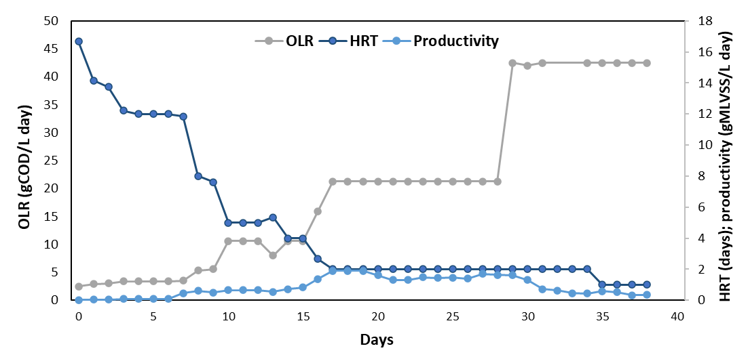
Figure 1. OLR, HRT and productivity during the 38 days of the CSTR operation.
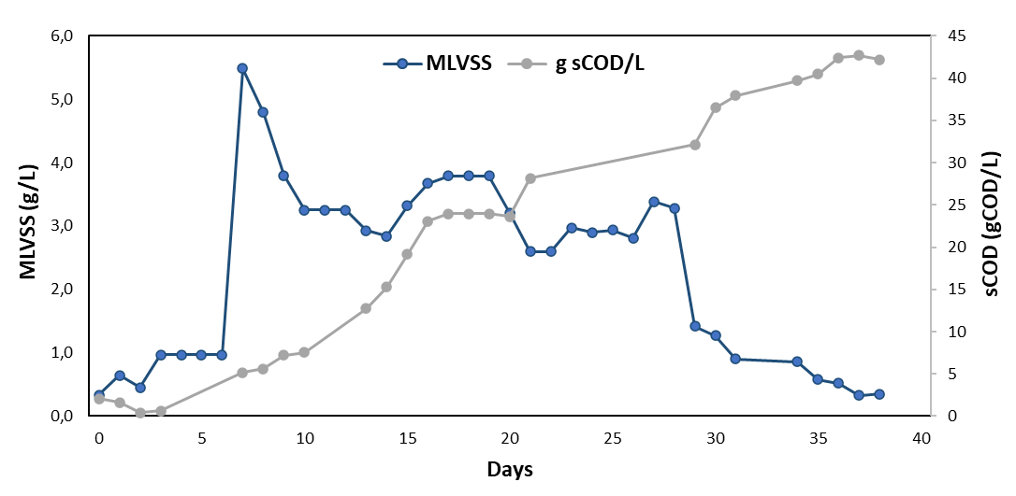
Figure 2. Biomass growth and sCOD of the mixed liquor during the 38 days of the CSTR operation.

The bacterial biomass presented a high protein content (70.4% of TSS, Table 3), with the amino acids glutamic and aspartic acid being the most abundant and histidine not possible to quantify (Figure 3). Most of the amino acids were found in quantities similar or higher to those necessary for the growth of commercial fish species. However, the absence of oils, carbohydrates and of the essential amino acid histidine, indicates that this biomass cannot be used on its own as fish feed, but it could however be part of a carefully formulated feed where SCP can make up to 50% of the diet and oils or PHAs are added to complement the formula.

Table 3. Centesimal composition of the bacterial biomass used as fish feed (% of dry sample).
Parameter | Value
Moisture | 98.4%
Ash | 8.9%
Crude proteins | 74.0%
Crude lipids and oils | <LoQ
Carbohydrates | <LoQ

Tryptophan, 0,3

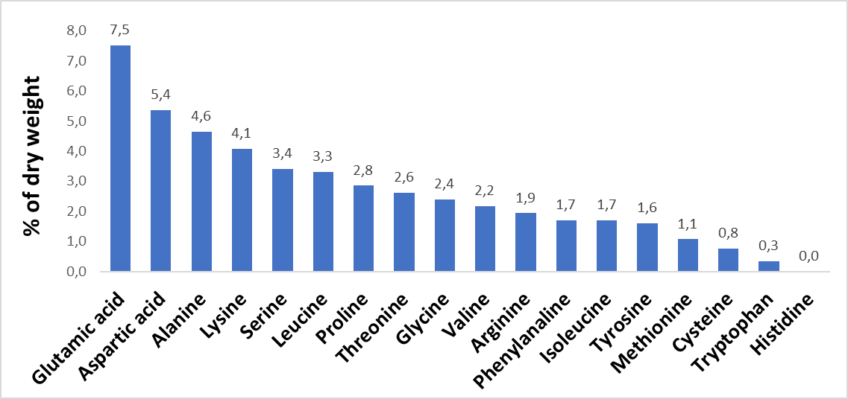
Figure 3. Amino acid profile (% of dry weight) of the bacterial biomass used as fish feed.

The accumulation of PHAs in the microbial cells was more evident with the fermentation fluid that with the VFAs mix, with percentages increasing from the initial 27.7% and reaching a maximum of 62.3% after the 4th spike (Figure 4), while the bacterial biomass remained constant. The PHAs composition indicated that methyl 3-hydroxypentanoate constituted 100% of the bioplastic at the beginning of the test, while methyl 3-hydroxybutanoate rose steadily during the experiment for both conditions, up to a final methyl 3-hydroxybutanoate/methyl 3-hydroxypentanoate ratio of around 4,21 (fermentate) and 3,77 (VFA mix) after the 5th spike%.
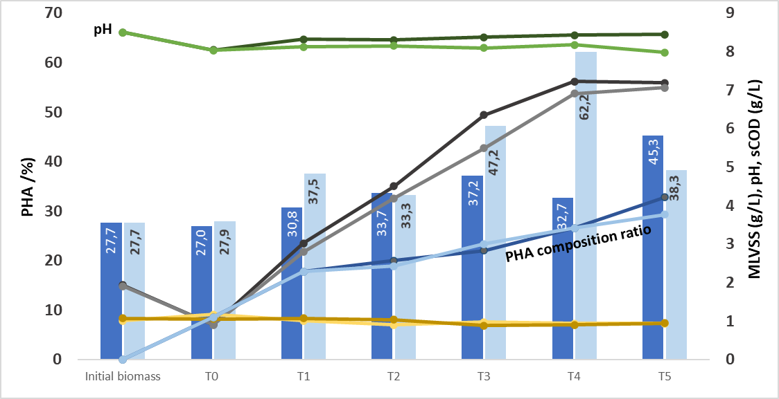
MLVSS
sCOD
PHAs
Figure 4. PHAs accumulation test performed with the biomass extracted from the CSTR. The data show the results for the flasks fed with either synthetic VFAs medium (dark shades) or with fermentation fluid (light shades).

4. Conclusions
Leftovers from food industries and from zootechnical and agricultural practices can be used to produce SCP and therefore fish feed, while at the same reducing the economic and environmental burden linked to waste disposal. The analysis of the microbial biomass produced from the bioreactor and from PHA accumulation test showed that high protein and PHA content can be achieved, therefore producing fish food of great nutritional value. Further work is needed to test the SCP feed on the survival and growth rates of commercial fish species, and to quantify the presence of unwanted compounds such as heavy metals and antibiotics in the feed.
References
APHA, AWWA, WEF, 1998, Standard Methods for the Examinations of Water and Wastewater. Washington, DC, USA: American Public Health Association.
Braunegg, G., Sonnleitner, B., Lafferty, R., 1978, A rapid gas chromatographic method for the determination of poly-β-hydroxybutyric acid in microbial biomass. European journal of applied microbiology and biotechnology, 6(1), 29-37.
Chee, Y.Y., Lakshmanan, M., Jeepery, I.F., Hairudin, N.H.M., Sudesh, K., 2019, The Potential Application of Cupriavidus necator as Polyhydroxy-alkanoates Producer and Single Cell Protein. Applied Food Biotechnology, 6(1), 19-34.
Conca, V., da Ros, C., Valentino, F., Eusebi, A.L., Frison, N., Fatone, F., 2020, Long-term validation of polyhydroxyalkanoates production potential from the sidestream of municipal wastewater treatment plant at pilot scale. Chemical Engineering Journal, 390, 124627.
Draher, J., White, N., 2018, HPLC determination of total tryptophan in infant formula and adult/pediatric nutritional formula following enzymatic hydrolysis: single-laboratory validation, first action 2017.03. Journal of AOAC International, 101(3), 824-830.
FAO, 2018. Future of food and agriculture 2018: Alternative Pathways to 2050.
IRSA-CNR, A., 2003, Analytical methods for waters (Vol. 3). Rome, Italy.
Laranja, J.L., Ludevese-Pascual, G.L., Amar, E.C., Sorgeloos, P., Bossier, P., De Schryver, P., 2014, Poly-beta-hydroxybutyrate (PHB) accumulating Bacillus spp. improve the survival, growth and robustness of Penaeus monodon (Fabricius, 1798) postlarvae. Veterinary Microbiology, 173(3-4), 310-317.
Martínez, E.J., Raghavan, V., González-Andrés, F., Gómez, X., 2015, New biofuel alternatives: integrating waste management and single cell oil production. International journal of molecular sciences, 16(5), 9385-9405.
Mekonnen, M.M., Hoekstra, A.Y., 2014, Water footprint benchmarks for crop production: A first global assessment. Ecological indicators, 46, 214-223.
Nasseri, A.T., Rasoul-Ami, S., Morowvat, M.H., Ghasemi, Y., 2011, Single Cell Protein: Production and Process. American Journal of Food Technology, 6(2), 103-116.
Righetti, E., Nortilli, S., Fatone, F., Frison, N., Bolzonella, D., 2020, A Multiproduct Biorefinery Approach for the Production of Hydrogen, Methane and Volatile Fatty Acids from Agricultural Waste. Waste and Biomass Valorization, 1-8.
Sabapathy, P.C., Devaraj, S., Meixner, K., Anburajan, P., Kathirvel, P., Ravikumar, Y., Zabed, H.M., Qi, X., 2020, Recent developments in Polyhydroxyalkanoates (PHAs) production–A review. Bioresource technology, 306, 123132.
Saeed, M., Yasmin, Y., Murtaza, M.A., Fatima, I., Saeed, S., 2016, Single cell proteins_ A novel value added food product.pdf. Pakistan Journal of Food Science, 26(4), 211-217.
Saint-Denis, T., Goupy, J., 2004, Optimization of a nitrogen analyser based on the Dumas method. Analytica Chimica Acta, 515(1), 191-198.
Siddi, M., 2020. The European Green Deal: Assessing its current state and future implementation. Finnish Institute of International Affair, Helsinki.
Sluiter, A., Hames, B., Ruiz, R., Scarlata, C., Sluiter, J., Templeton, D., Crocker, D., 2008, Determination of structural carbohydrates and lignin in biomass. Laboratory analytical procedure, 1617(1), 1-16.
Suguna, P., Binuramesh, C., Abirami, P., Saranya, V., Poornima, K., Rajeswari, V., Shenbagarathai, R., 2014, Immunostimulation by poly-beta hydroxybutyrate-hydroxyvalerate (PHB-HV) from Bacillus thuringiensis in Oreochromis mossambicus. Fish Shellfish Immunol, 36(1), 90-97.
Vermeulen, S.J., Campbell, B.M., Ingram, J.S., 2012, Climate change and food systems. Annual review of environment and resources, 37, 195-222.
Yadav, B., Chavan, S., Atmakuri, A., Tyagi, R.D., Drogui, P., 2020, A review on recovery of proteins from industrial wastewaters with special emphasis on PHA production process: Sustainable circular bioeconomy process development. Bioresource technology, 317, 124006.

