**Multiscale modeling approaches to describe complex chemical engineering systems**

Francesco Petrosino1*, Giorgio De2, Javier Luque Di Salvo3, Sudip Chakraborty1, Stefano Curcio1

*1 Department of Computer Engineering, Modeling, Electronics and Systems (D.I.M.E.S.), University of Calabria, Via- P. Bucci, Cubo-42A, 87036 Rende (CS), Italy;*

*2 Institute on Membrane Technology, ITM-CNR, Ponte P. Bucci, Arcavacata, 87036 Rende (CS), Cosenza, Italy;*

*3 INFIQC, Universidad Nacional de Córdoba, Facultad de Ciencias Químicas, Departamento de Química Teórica y Computacional, CONICET, Ciudad Universitaria, X5000HUA Córdoba, Argentina*

*\*Corresponding author E-Mail: f.petrosino@dimes.unical.it*

**1.Introduction**

Multiscale approaches are receiving more and more interest in different scientific and technological areas. “Multiscale simulation can be defined as the enabling technology of science and engineering that links phenomena, models, and information between various scales of complex systems [1]. Nowadays, one of the major challenges in chemical engineering resides in the description of complex phenomena, which are essentially multiscale in nature. Multiscale simulations allow properly modeling and analyzing the connections between different scales so to determine how a change or even a perturbation at one scale may influence the results at a different scale of detail [2]. Incorporating the transition from one to another scale within a multiscale approach is a real challenge in several chemical engineering applications. Localized properties at the microscale have to be incorporated directly in the macroscale description without any averaging due to their model key role. However, multiscale approaches are not restricted to chemical engineering problems: environmental, biological, medical, astrophysical situations would equally benefit from such approaches.

Given the importance of these modeling techniques and given the different studies carried out by our research group in this area [3]–[6], the present work is intended to propose two different applications to chemical engineering processes strictly related to multiscale approach.

The first application consisted on the study of concentration polarization phenomena during membrane processes. The macroscopic characterization of fouling structure formation occurring during the Ultra-Filtration (UF) of Bovine Serum Albumin (BSA) was analyzed from a theoretical point of view. A twisted Monte-Carlo (MC)/Computational-Fluid-Dynamic (CFD) approach was developed to calculate macroscopic fluid-dynamic proprieties. Different fluid-dynamic simulations were performed on the base of the knowledge acquired by an MC analysis that provided boxes of adsorbed molecules (i.e., 3D proteins meso configurations on the UF membranes surface). These represented the deposit layers, formed at different distances from the membrane. The 3D meso structure were imported into a bespoke simulation environment, and several meshes were created to perform micro-fluid dynamic calculations (m-FD). The resistance to flow of deposit layers accumulated on the membrane surface, $R_{add}$, usually estimated by experimental methods, was therefore, computed starting from the ab-initio knowledge acquired at sub-nanoscopic scale.

The second application consisted of the simulation the long-range interactions between SARS-CoV-2 spike protein and three synthetic polymeric materials (Polypropylene (PP), Polyethylene Terephthalate (PET), and Polylactic Acid (PLA)) experimented by the virion when it is dispersed in the droplet before its possible adsorption. Some descriptors, namely the interaction potentials per single protein and global potentials, were calculated in this work. These descriptors, evaluated for the closed and open states of the spike protein, were correlated to the long-range noncovalent interactions between the SARSCoV-2 spikes and the considered polymeric surfaces. They were associated to the surface’s affinity towards SARS-CoV-2 dispersed in respiratory droplets or water solutions. For closed and open structures, the long-range interactions with the surfaces decreased in the following order PP ~ PLA > PET and PLA > PP > PET, respectively [6].

It is important to underline that the above-described works, although different in their subjects, are linked by a fundamental unifying basic strand, which is represented by the multiscale approach for the analysis of protein-protein and protein-surface interactions. Moreover, as already discussed, this unifying strand has fallen into a very broad and promising multidisciplinary field.

**2. Methods**

The density functional theory, used as the first-brick of the entire work, allowed the fundamental atomic proprieties calculations without resorting to any empirical or experimental parameter. The Molecular Dynamics and Monte Carlo approaches permitted the determination of a minimal energy structure of both the polymeric membrane at nanoscale level and the aggregated colloidal particles during ultrafiltration or virus interaction at microscale level. Despite the two approaches are aimed at the same minimization goal, the first one is based on the solution of the classical equation of motion, while Monte Carlo is a stochastic-based approach. To get some fundamental macroscopic properties like the Osmotic pressure and the Diffusion coefficient in the membrane process, the colloidal soft matter theory was used. In this field, different statistical thermodynamics approaches resulted of vital importance for the complete closure of the multiscale framework and the achievement of the final transition at macroscopic level by a completely ab-initio methodology. Moreover, a micro-Computational-Fluid-Dynamic approach was exploited for the final process simulation based on the previously defined quantities. To have a macroscopic estimation of the virus-surface potential energy different Molecular Mechanics optimizations were also performed.

**3. Results and discussion**

3.1 Micro-CFD modelling of UF bio-fouling

The ab-initio approach allowed acquiring a fundamental knowledge about the characteristics of the membrane system, i.e., the quantum mechanics colloidal surface charge at sub-nanoscopic scale [3], [5]. A Monte Carlo based code was developed to simulate the fouling formation through a coarse-graining methodology. The schematic of such a methodology is shown in Fig.1.

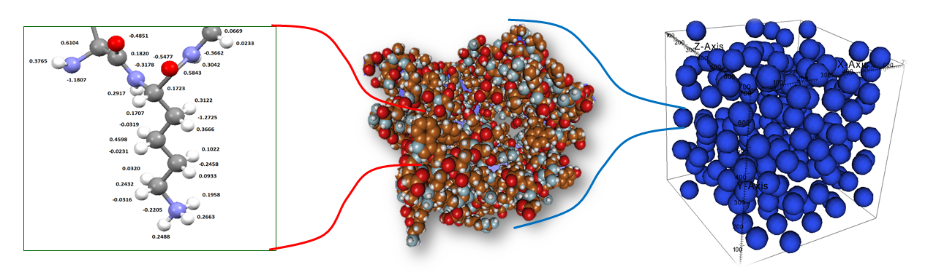

Figure 1: Developed multiscale framework from sub-nanoscale to nano/mesoscale level. Point charges on external amino acid atoms (on the left), a coarse-grained total colloid of overall macromolecule (in the middle) and a colloids box at nano/mesoscopic scale performed by MC simulations (on the right).

After defining both the boundary and the initial conditions, the 3D Navier-Stokes problem was computed through the defined mesh geometry based on the MC box. A schematic of MC/CFD procedure was reported in Fig.2.

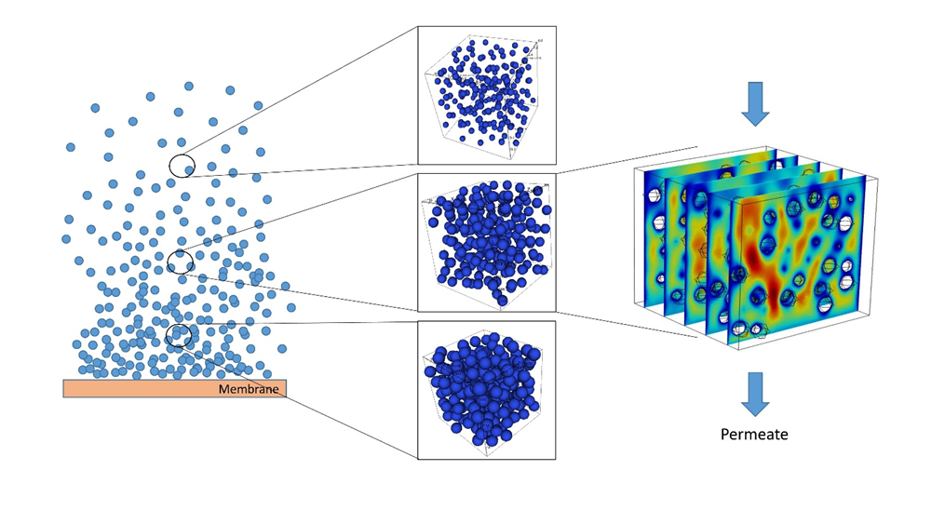

Figure 2: micro-CFD approach to develop a complete fluid dynamic study on the deposited cake layers during membrane filtration. The number of MC-CFD simulation boxes depends on the computational resources.

A set of fluid-dynamic simulations was performed, and a total pressure drop across the whole fouling layers was so calculated. If the average volume fraction for every fouling thickness range is known, the calculated pressure drop per unit length of the cake can be multiplied by the corresponding fouling thickness so to obtain a global fouling cake pressure drop summing all contributions: $∆P=\sum_{i=1}^{n}{∆P_{i}∙∆d_{i}}= 1.35 bar$. Moreover, the additional resistance $R_{add}$ at the specified filtration time t=5min, was estimated based on the well-known Darcy’s law and resulted equal to $R_{add}=1.91 ∙{10}^{13} m^{-1}$.

3.2 Noncovalent interactions between SARS-CoV-2 spikes and polymer surfaces

The noncovalent interactions between the single S-protein and the target surfaces, as well as the global interaction potentials, were calculated using a classic Molecular Mechanics approach. In particular, the single-protein potential describes the potential energy of a single spike interacting with the polymer surface; thus, the surrounding protein’s effects are not considered. The second potential is instead the interaction potential due to a protein ensemble formed by a reference spike, considered perpendicular to the polymer surface, and its surrounding proteins: i.e., the 1st and 2nd neighbors. Hence, both descriptors are correlated with the affinity of SARS-CoV-2 towards a target polymer surface.

In order to evaluate the contribution of various spikes around a reference protein, i.e., the effect of the 1st and 2nd neighbors, the global interaction potentials were evaluated and plotted in Fig. 3.



Figure 3: a) Global interaction potentials as a function of the protein-surface distance (d) for the closed structure of spike and target surfaces, b) global interaction potentials as a function of the protein-surface distance (d) for the open structure of spike.

PP and PLA surfaces interact with the S-proteins to a greater extent than the PET surface. Additionally, the global potentials highlight more clearly that the PP and PLA surfaces interact differently with the open state of the S-protein. Moreover, the global interaction potentials show that PP and PLA-based purification devices or membranes should retain the virus more effectively than PET-based devices.

**4. Conclusions**

A combined Monte Carlo/micro-CFD model was implemented in the present work. The overall aim was the calculation of the additional resistance, $R_{add}$, in the cake layers. This macroscopic quantity was calculated starting from the ab-initio surface charge obtained by Quantum Mechanics techniques. The pressure drop across the fouling layer was calculated and the fouling layer additional resistance resulted equal to $R_{add}=1.91 ∙{10}^{13} m^{-1}$. Long-range noncovalent interactions between the SARS-CoV-2 spikes and synthetic polymeric materials were investigated to suggest descriptors associated with the surface’s affinity towards coronavirus. Single-protein and global interaction potentials, evaluated through a combined computational approach based on molecular mechanics and dynamics simulations, were proposed as versatile descriptors. The evaluated descriptors highlight that the protein-surface long range interactions decrease in the following order PP ~ PLA > PET and PLA > PP > PET for the closed and open structures of the spike, respectively.

A completely multidisciplinary approach has been developed and applied in two areas substantially different but connected by a characterizing aspect such as the study of macromolecule-macromolecule and macromolecule-surface interactions at the nano/microscopic scale.

**References**

[1] M. Fermeglia and S. Pricl, “Multiscale modeling for polymer systems of industrial interest,” *Prog. Org. Coatings*, vol. 58, no. 2–3, pp. 187–199, 2007, doi: 10.1016/j.porgcoat.2006.08.028.

[2] R. E. Amaro and A. J. Mulholland, “Multiscale methods in drug design bridge chemical and biological complexity in the search for cures,” *Nat. Rev. Chem. 2018 24*, vol. 2, no. 4, pp. 1–12, Apr. 2018, doi: 10.1038/s41570-018-0148.

[3] S. Curcio, F. Petrosino, M. Morrone, and G. De Luca, “Interactions between Proteins and the Membrane Surface in Multiscale Modeling of Organic Fouling,” *J. Chem. Inf. Model.*, vol. 58, no. 9, pp. 1815–1827, Sep. 2018, doi: 10.1021/acs.jcim.8b00298.

[4] F. Petrosino, S. Curcio, S. Chakraborty, and G. De Luca, “Enzyme Immobilization on Polymer Membranes: A Quantum and Molecular Mechanics Study,” *Computation*, 2019, doi: 10.3390/computation7040056.

[5] F. Petrosino, Y. Hallez, G. De Luca, and S. Curcio, “Osmotic pressure and transport coefficient in ultrafiltration: A Monte Carlo study using quantum surface charges,” *Chem. Eng. Sci.*, vol. 224, p. 115762, Oct. 2020, doi: 10.1016/j.ces.2020.115762.

[6] G. De Luca, F. Petrosino, J. L. Di Salvo, S. Chakraborty, and S. Curcio, “Advanced descriptors for long-range noncovalent interactions between SARS-CoV-2 spikes and polymer surfaces,” *Sep. Purif. Technol.*, vol. 282, Feb. 2021, doi: 10.1016/J.SEPPUR.2021.120125.