Design and Development of a Microfluidic Platform for Extracellular Vesicles Engineering
Caterina Piunti^{1,2}, Sara Micheli^{1,2}, Elisa Cimetta^{1,2}*
¹Department of Industrial Engineering, University of Padua, Padua, Italy;
²Fondazione Istituto di Ricerca Pediatrica Città della Speranza, Padua, Italy
*Corresponding author E-Mail: elisa.cimetta@unipd.it

1.Introduction
Despite great progress achieved in the understanding of cancer biology, metastases are still synonymous of terminal illness. Therefore, developing targeted therapies in cancer is a clinical imperative.
In recent years, extracellular vesicles (EVs) have been found to be involved in cancer development. EVs are small-sized vesicles (30-10000 nm in diameter) of endocytic origin, released from different cell types under both normal and pathological conditions. These vesicles contain proteins, RNA, miRNA, double-stranded DNA, and lipids that are highly representative of their cell or tissue of origin. As mediators of near and long-distance intercellular communication in health and disease, EVs and their cargo affect various aspects of recipient cell biology [1]. Growing evidence ‎shows that cancer cell-derived EVs contribute to proliferation, angiogenesis, anti-tumor immune responses, and metastasis. For instance, EVs derived from Neuroblastoma (NB) - one of the most common solid tumors of childhood - are found to play a role in mediating its progression and metastasis [2]. Despite being the guilty part of cancer progression and metastasis, EVs could potentially also play a role in the treatment of cancers. Indeed, EVs can be used to our clinical advantage by transforming them into drug delivery systems in cancer therapy [3].
Although traditional methods for EVs studies and modifications will continue to play a significant role in the future, it is believed that microfluidic approaches will eventually replace benchtop methods for investigating EVs in speeding up precision therapeutics.
Considering such promises, the goal of the project is to evaluate the feasibility of designing and developing a microfluidic device for generating drug-loaded EVs. Currently, various strategies are being employed for EVs cargo loading; however, these approaches are faced with limitations of low loading efficiency, disruption of integrity, and aggregation. Taking advantage of lab-on-chip devices, passive cargo loading through microfluidic mixing and incubation may be an important strategy to produce functional engineered EVs. EVs can be loaded with various therapeutic agents, including Verteporfin (VP). VP is a small hydrophobic porphyrin recently identified as an inhibitor of YAP/TAZ complex. Notably, VP provided positive results for its anti-cancer activity in different tumors, including NB [4]. Although the utilization of EVs for therapeutic drug delivery is still in its infancy, a more advanced understanding and systemic evaluation of their use will boost the development of EVs as a superior and effective drug delivery system that can bring breakthroughs to the field of cancer nanomedicine.
2. Methods
The platform is designed so that both a perfect mixing between EVs and VP occurs within the mixing unit and the desired incubation time, set at 10 minutes, is achieved [5]. The platform is designed with AutoCAD® (Figure 1) and contains a “T” type inlet channel and is formed by two sections: the mixing and the incubation units. The mixing unit consists of a micromixer embedded with geometric features [6]; the 5-period mixing unit exists at the terminal of a 1.7 mm channel after the confluence of the two inlet channels and one mixing period is 500 μm wide by 500 μm long. The incubation section uses delay lines, allowing incubation for precise time periods as a function of the imposed flow rate. The delay lines consist of channels with a width of 700 μm and a total length of 30 cm. The entire device has a surface equal to 48 × 14.4 mm². The height of all elements is 100 μm.
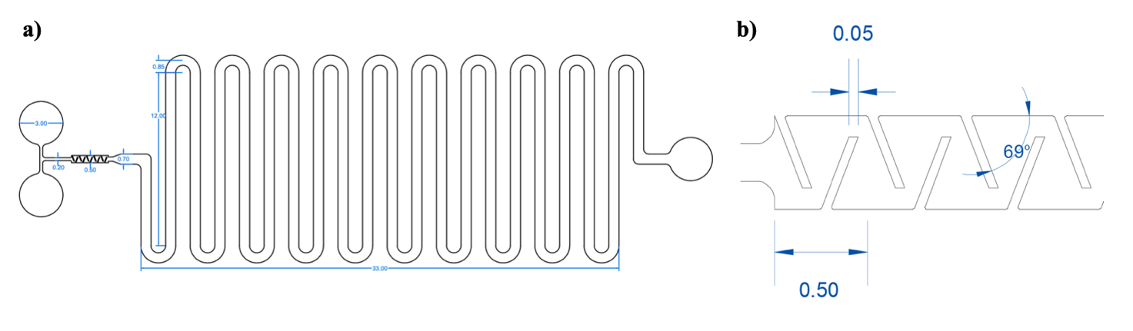Figure 1. Platform layout: a) AutoCAD® design of the platform; b) detail of the micromixer. All dimensions are in mm.
The platform is then modeled, performing computational fluid dynamics simulations through COMSOL Multiphysics®. The master mold for the optimized device is fabricated with photolithography, and polydimethylsiloxane (PDMS) replicas of the chips were obtained with replica molding processes. There are several advantages of the technologies related to the use of PDMS which make it the first choice for most biochemical and biological applications: its cytotoxicity is nullified by full curing, its preparation is rapid and inexpensive and its optical transparency allows for high resolution live imaging. Finally, plasma treatment is used to form an irreversible hydraulic seal of the microfluidic platform to a glass coverslip (60 × 30 mm).
The platform in this configuration is used to perform the fluid dynamic validations, using both food coloring and fluorescent tracers. The food coloring solution is simply prepared by mixing it with water, in a proportion suitable to obtain an intense color. The fluorescent tracers used are fluorescein isothiocyanate-dextrans (Sigma-Aldrich) with maximum excitation at a wavelength of 490 nm, and maximum emission at 520 nm. Specifically, the dextrans used have an average molecular weight (MW) of 500 kDa and are prepared by dilution in phosphate buffered saline (PBS) in a proportion 0.5mg/10mL. A syringe pump (Harvard Apparatus) is used to infuse the solutions through the platform. The volumetric flow rate is set to 1 μL/min. Finally, images of the platform are taken using Invitrogen EVOS™ FL Cell Imaging System microscope (Thermo Fischer Scientific).
3. Results and discussion
The COMSOL Multiphysics® simulation is performed in a 3D geometry. The physics that are added to the simulation are: a. the laminar flow of a single-phase incompressible fluid, to describe fluid motion inside the platform and, b. the transport of a diluted species, to simulate the convective/diffusive behavior of a generic species i inside the platform. The addition of the transport of diluted species interface does not require the properties of the species i, except for the diffusion coefficient and the initial concentration c at the inlets. The diffusion coefficient (D) of a spherical particle in a viscous fluid is calculated with the Stokes-Einstein equation (Equation 1), where k_{B} is the Boltzmann constant [J/K], T is the temperature [K], μ is the viscosity of the fluid [Pa·s] and r is the radius of the particle [m]:
$$D_{EVs}= \frac{k_{B}T}{6πμr} (1)$$
The diffusion coefficient of EVs in water is calculated using Equation 1 considering an average diameter of 70 nm and gives: $D_{EVs}≈6.14 {10}^{-12}m^{2}s^{-1}$.
The second information needed is the initial concentration c of the species at the inlets. At one inlet the concentration is set at an arbitrary value, while at the other one the concentration is set as equal to zero. The final graphs are created by normalizing the concentration, dividing it for the initial value, to obtain a dimensionless scale (from zero to one). Several simulations are performed in COMSOL, varying mainly two parameters: the inlet flow rates and the length of the mixing unit, with the aim of determining the optimal configuration for the perfect mixing of the species.

Once both variables are set, the length of the delay lines is calculated using Equation 2:
$$t=\frac{lwh}{Q} (2)$$
Where Q is the flow rate and l, w, and h are the length, width, and height of the channel, respectively. By setting the ideal delay time t to 10 minutes, the calculated length of the delay lines is $l=30 cm$.
A concentration plot from the COMSOL Multiphysics® simulations is presented in Figure 2. At the set inlet flow rate of 1 μL/min, the fluids completely mix after a 5-period mixing unit.
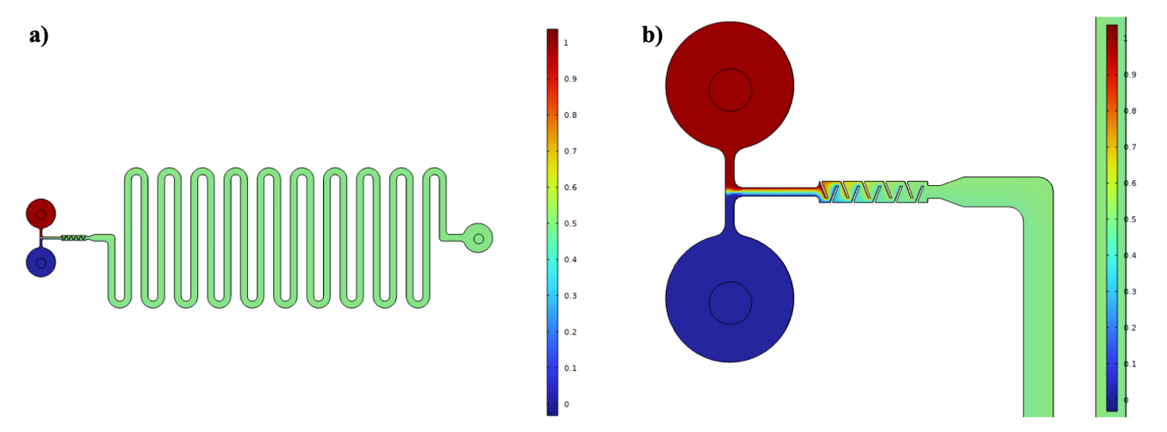
Figure 2. Concentration surface plots of the: a) entire platform; b) micromixer. The color indicates the mass fraction: the mass fraction of one is represented by red, while a mass fraction of zero is pictured in dark blue.
Based on the simulation result, the performance of the produced platform is then experimentally validated. First, both food coloring and dextran are used to obtain qualitative information about the fluid behavior inside the device (Figure 3). The validation confirms the correct production of the PDMS replica and the hydraulic seal of the platform.
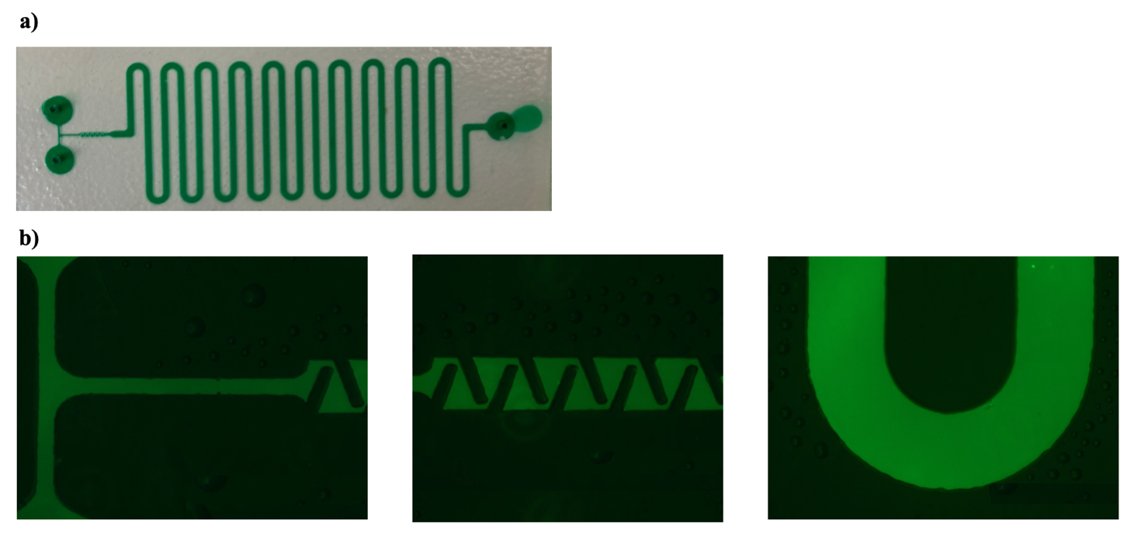
Figure 3. Result of the validation experiment on the irreversible configuration of the microfluidic platform. a) PDMS replica of the platform filled with green colorant; b) microscopy images of the platform filled with 500 kDa fluorescent isothiocyanate-dextran.
Then, different food coloring tracers are used to validate the mixing performance and achievement of the desired incubation time (Figure 4). The syringes with the blue and yellow colors are prepared and placed on the pump, which is then started setting the flow rate to 1 μL/min. After approximately 10 minutes, green fluid exit through the outlet, demonstrating that perfect mixing and incubation times is obtained using the platform, consistent with COMSOL simulations.
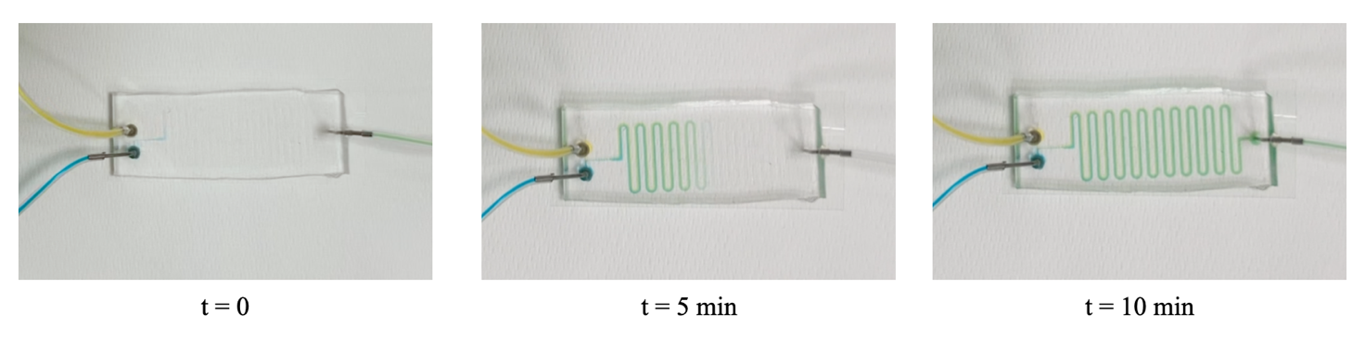
Figure 4. Result of the validation experiment on the irreversible configuration of the microfluidic platform at the beginning of the incubation time (t=0), after 5 and 10 minutes. Visually, the blue and the yellow colors become green, meaning that the microfluidic mixing is functioning.
4. Conclusions
The objective of this work is the design of an innovative microfluidic device that would allow drug-loading of EVs, using microfluidic mixing and incubation. The platform is produced using replica molding, employing PDMS as the production material. The performances of the device are simulated with COMSOL Multiphysics® software and used to perform a validation of the experimental data.
The biological experiments will be next carried out using EVs isolated from different cell types and VP as cargo. The loading methods employed in this study would be non-destructive and technically simple to allow application with a broad range of therapeutic molecules. Due to the relatively short history of EVs being utilized in therapeutics, there are only a few studies employing microfluidic platforms for engineering EVs for drug delivery, and the full potential and capability have not yet been well explored. Thus, as a versatile tool, microfluidic technology is expected to fully unlock the potential of EVs for speeding up precision medicine.
References
- Walker, S., Busatto, S., Pham, A., Tian, M., Suh, A., Carson, K., Quintero, A., Lafrence, M., Malik, H., Santana, M. X., & Wolfram, J. (2019). Extracellular vesicle-based drug delivery systems for cancer treatment. Theranostics, 9(26), 8001–8017. https://doi.org/10.7150/thno.37097
- Richard, H., Pokhrel, A., Chava, S., Pathania, A., Katta, S. S., & Challagundla, K. B. (2020). Exosomes: Novel Players of Therapy Resistance in Neuroblastoma. Advances in experimental medicine and biology, 1277, 75–85. https://doi.org/10.1007/978-3-030-50224-9_5
- Zhu, Q., Heon, M., Zhao, Z., & He, M. (2018). Microfluidic engineering of exosomes: editing cellular messages for precision therapeutics. Lab on a chip, 18(12), 1690–1703. https://doi.org/10.1039/c8lc00246k
- Fusco, P., Mattiuzzo, E., Frasson, C., Viola, G., Cimetta, E., Esposito, M. R., & Tonini, G. P. (2021). Verteporfin induces apoptosis and reduces the stem cell-like properties in Neuroblastoma tumour-initiating cells through inhibition of the YAP/TAZ pathway. European journal of pharmacology, 893, 173829. https://doi.org/10.1016/j.ejphar.2020.173829
- Fuhrmann, G., Serio, A., Mazo, M., Nair, R., & Stevens, M. M. (2015). Active loading into extracellular vesicles significantly improves the cellular uptake and photodynamic effect of porphyrins. Journal of controlled release : official journal of the Controlled Release Society, 205, 35–44. https://doi.org/10.1016/j.jconrel.2014.11.029
- Lee, Chia-Yen & Wang, Wen-Teng & Liu, Chan-Chiung & Fu, Lung-Ming. (2015). Passive Mixers in Microfluidic Systems: A Review. Chemical Engineering Journal, 288. http://dx.doi.org/10.1016/j.cej.2015.10.122

