Biphasic porous structures formed by monomer/water interface stabilization with colloidal nanoparticles
Fabio Pizzetti¹, Alessandro Marchetti¹, Giovanna Massobrio¹, Valeria Vanoli¹, Franca Castiglione¹, Filippo Rossi¹*
1 Politecnico di Milano. Department of Chemistry, Materials and Chemical Engineering “Giulio Natta”, Via Mancinelli 7, 20131; Milano
*Corresponding author E-Mail: filippo.rossi@polimi.it

1.Introduction
Bicontinuous jammed emulsion gels (known as bijels) are Pickering emulsion where the aqueous and organic phases are present as continuous phases [1]. These emulsions, stabilized by colloidal nanoparticles at the interface between the two phases, can be used in a variety of applications. The problem related to these systems is given by their low mechanical properties, thus limiting their use [2]. The goal of this study is that of using a hydrophobic monomer, able to polymerize in bulk, thus forming a bicontinuous structure with polymer and water present as immiscible phases. For this task, ε-caprolactone has been selected, thanks also to its biocompatibility. The system has been stabilized using hydroxyapatite as colloidal nanoparticles. The final product has been characterized with various techniques, among which DOSY experiments for ensuring the final structure bicontinuity. Furthermore, their ability to load and release both hydrophilic and hydrophobic drugs has been tested out. The strategy has been demonstrated to be highly versatile and can also be tuned changing the monomer used in the synthesis or the nanoparticles, in order to exploit also their functions and to satisfy specific industrial and medical needs [3]. Furthermore, current studies are also under development, shifting from inorganic NPs to organic ones, in particular nanogels.
2. Methods
ε-caprolactone, selected as monomer, has been inserted in the reacting cylinder, along with TBD as catalyst. The system was mounted on an orbital shaker, and a stirring velocity of 1000 rpm has been set. Once the polymerization has occurred, an aqueous solution of NPs (HAp or NGs) has been added, and the stirring speed has been increased up to 1700 rpm for 1 minute. Then, the stirring velocity has been decreased back to 1000 rpm until the bicontinuous structure formation occured. For the HR-MAS analysis, deuterium oxide has been used instead of distilled water. Release tests have been performed by soaking the bicontinuous structures in 2 mL of PBS at 37 °C for mimicking the physiological conditions. After certain timepoints, 1 mL has been withdrawn and replaced with 1 mL of fresh PBS.
3. Results and discussion
After some initial tests, different parameters of pivotal importance during the synthesis have been selected in order to obtain a successful bijel-like structure. Temperature was shown to be one of the most important parameters, since if it was higher than a threshold value the structure was not able to solidify or mix well (two separate phases were obtained). We were able to successfully load some drug mimetics (both hydrophilic and hydrophobic) inside the structure, and release them in PBS solution. As far as the characterizations are concerned, fluorescent confocal microscopy successfully shown the bicontinuous structure of our samples and the presence of NPs on the interface between the two phases. Furthermore, bicontinuity has been confirmed from DOSY mapping using HR-MAS technique, as it can be observed from Figure 1 for the HAp-based sample.
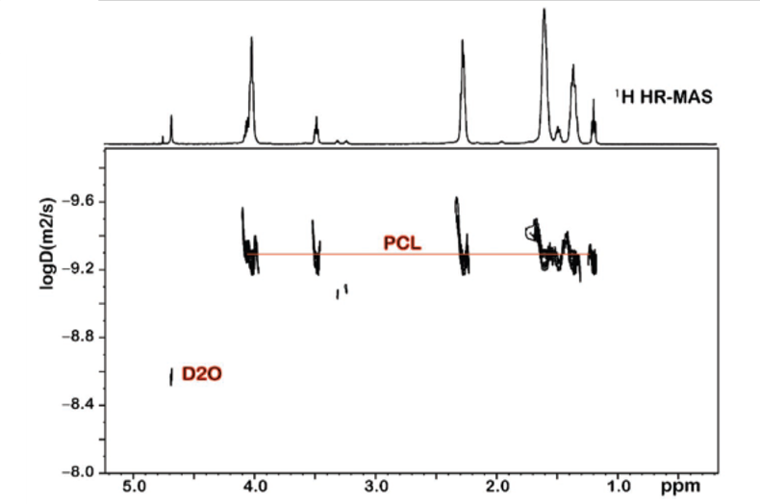
Figure 1. DOSY map of the HAP-based bicontinuous structure.
From Figure 1, it can be noticed how the water molecules (indicated as D2O) present only one value of the diffusion coefficient, thus confirming the presence of only one continuous phase. The same can also be deduced for the polycaprolactone (indicated as PCL). The preliminary results of the drug release experiments confirm that these bicontinuous structures can easily entrap and release in a controlled way both hydrophilic and hydrophobic drug mimetics. Furthermore, HR-MAS analyses on real drugs (ethosuximide and dimethyl fumarate) allowed the determination of the diffusion coefficients of such molecules, thus paving the way to a future modelling phase on the release dynamics for both single-loaded and co-loaded bicontinuous structures.
4. Conclusions
This study confirms that bicontinuous structures inspired from bijels can be successfully produced using monomers as organic phase. Both organic and inorganic NPs can be used for the structures formation, thus enhancing the versatility of these systems in biological applications. Finally, release tests were able to ensure the capability of loading both hydrophilic and hydrophobic drugs.
References
The reference format is provided below [1 – 3]. [Times New Roman 10].
- S. Cha, H. G. Lim, M. F. Haase, K. J. Stebe, G. Y. Jung, D. Lee, Scientific Reports 9 (2019) 1-6.
- P. S. Clegg, J. H. J. Thijssen, Introduction to Bijels, Soft Matter Series, 2020, 1-33.
- F. Pizzetti, A. Rossetti, A. Marchetti, F. Castiglione, V. Vanoli, E. Coste, V. Veneruso, P. Veglianese, A. Sacchetti, A. Cingolani, F. Rossi, Advanced Materials Interfaces 8 (2021), 1-7.

