GRICU 2022, Ischia, (Italy), July 3-6, 2022

Generalized Framework for the Simultaneous CapEx/OpEx Robust Optimization (CORO) of Production Processes Using Commercial Simulation Suites

Kristiano Prifti1,2, Andrea Galeazzi1,2, Flavio Manenti1,2*

- Politecnico di Milano, Dipartimento di Chimica, Materiali ed Ingegneria Chimica “Giulio Natta”, Piazza Leonardo da Vinci 32, 20133 Milano, Italy;
- Consorzio Interuniversitario Nazionale per la Scienza e Tecnologia dei Materiali , Via Giusti 9, 50121 Firenze, Italy;
*Corresponding author E-Mail: flavio.manenti@polimi.it

Introduction

During the design of a process, the most economically impactful choices are often taken with limited data and details available on the specifics of unit operations. Despite this fact, the effect that some of these choices have on the final economic performance of the plant can be dramatic and far more influential than later decisions[1]. The availability of fast and reliable preliminary cost estimations based on few key design parameters for the most common units can go a long way in improving flowsheet design. Due to the early design stage, these estimates do not need to be very accurate since errors in the range of 50% are admissible[2]. Automating the costs computation process and making the interface with the most common simulation packages standardized and easily accessible for users not accustomed to programming languages is very important in speeding up the cost evaluation of the plant and reducing the human resources tied to this task. Moreover, with such a tool it is possible to simultaneously optimize both CapEx and OpEx to reach the minimum payback time, contrarely to what is done in standard optimization routines where only the OpEx are optimized. These concepts stand at the core design of the CapEx OpEx Robust Optimizer (CORO) developed in this work. Aspen HYSYS serves as the commercial simulation package to estimate the input variable of the economic libraries. Excel is used both as a GUI (Graphic User Interface) and as a data extraction tool from Aspen HYSYS due to its widespread diffusion in industry and versatility provided by Visual Basic for Applications (VBA). The core of the computations is carried out by the proprietary process digitalization library BzzMath [3].

Methods

The automation process is based on three modules; the simulation package, the evaluation package, the optimization library. Each covers a standalone role and operates completely detached from the others except for a single file collecting the data in input and output of the module. The simulation package has the role of modeling the physical and chemical problem as well as the characteristic dimensions of the unit and process flowsheet with a consolidated structure. The evaluation package role is to provide a performance indicator for the optimization routine to use. The evaluation package used as a case study here is a financial key performance indicator: the payback time of the process. The optimization library role is the robust search of the minimum or maximum of the performance indicator in the system domain. The simulation package design is Aspen HYSYS V10 release. The ease of use and already included macro-enabled library for Microsoft Excel VBA allowed to develop the data extraction and writing add-on in a limited amount of time exploiting Excel spreadsheets for user data input and plotting of the results. All the data necessary for the evaluation library are organized in and eXtensible Markup Language file (.xml).

The data extracted from the simulation into the xml file are read by the CapEx/OpEx estimation BzzMath libraries. The economic libraries included in the software reach a study estimate precision on the final cost

GRICU 2022, Ischia, (Italy), July 3-6, 2022

estimation with an estimated error ranging from +30% to -25%. For the sake of direct comparison two different libraries are included: the Peter and Timmerhaus (2001) library based on percentage of delivered equipment cost and the Guthrie (1974) [1] and Turton (2012) [2] approach based on the bare module cost.

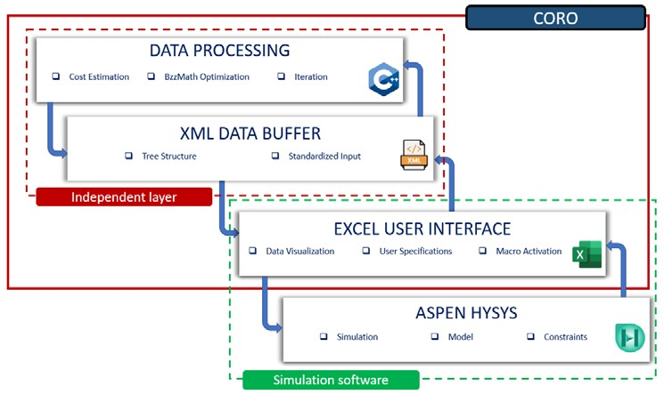

Figure 1. Data structure of the CapEx/OpEx robust optimizer

The detailed discussion on this costing approaches is not the topic of this paper and can be explored in detail in [1,2]. Both costing methods include in the Capital expenditure estimation:
  - ISBL: Inside Battery Limits cost include purchasing and shipping costs of equipment, piping, catalysts, and any other material needed for final plant operation, or construction of the plant.
  - OSBL: Off site battery limits are defined as utilities, common facilities, and other equipment and components not included in the ISBL definition
  - Engineering and Construction: indirect expenses associated with the actual building of the plant such as supervision, engineering and legal expenses.
  - Working Capital: is defined as the money required to start and run the already constructed plant until income can be obtained from the products
  - Contingency: allows for variation from the predicted cost estimate
When the conventional approach to cost estimation fails due to out of boundary values then each library falls back to less precise, but more versatile methods such as the sixth tenth’s rule.

4. Conclusions

A general automated framewok for the evaluation of economic performance of chemical plants is shown in its structure. The overarching algorithm structure is made in such manner as to allow for further expansion with new, non economic, performance indicators and proposed as a standard to interface data between commercial software solutions and external packages.

References

[1] G. Towler,, R. Sinnott, Chemical Engineering Design. Principles, practice and economics of plant and process design, 2008.
[2] W.W. R. Turton, J. Shaeiwitz, D. Bhattacharyya, Analysys, Synthesis, and design of chemical processes, 5th editio, Pearson, 2018.
[3] G. Buzzi-Ferraris,, F. Manenti, Comput. Aided Chem. Eng. 30 (2012) 1312–6. 10.1016/B978-0-444-
59520-1.50121-4.

