Biogas upgrading by adsorption: experimental performance of commercial zeolites and comparison with carbon-based sorbents

Fabrizio Rainone^{1*}, Sabrina Mauro¹, Marco Balsamo², Amedeo Lancia¹, Alessandro Erto¹
1 Dipartimento di Ingegneria Chimica, dei Materiali e della Produzione Industriale, Università degli Studi di Napoli Federico II, Piazzale Vincenzo Tecchio 80, 80125 Napoli, Italy; 2 Dipartimento di Scienze Chimiche, Università degli Studi di Napoli Federico II, Complesso Universitario di Monte Sant’Angelo, 80126 Napoli, Italy
*Corresponding author E-Mail: fabrizio.rainone@unina.it

1.Introduction
Biomethane, a renewable form of natural gas, can be produced by biogas upgrading, which consists in the removal of CO₂ to a maximum allowed concentration lower than 3% by volume. For its renewable origin, biomethane utilization is incentivized to mitigate CO₂ emissions but a cost-effective production, which mainly includes the CO₂ removal step, must be assured. Among the different options currently available for upgrading, adsorption has gained high attention, mainly due to the easy operation and, if coupled with a well-reasoned definition of the working condition, for the high efficiency assured. This work focuses on biogas upgrading to biomethane by adsorption of CO₂ onto commercial zeolites (13X BFK, 5A, 4A), whose CO₂/CH₄ separation performance is assessed by dynamic breakthrough tests in a fixed bed employing binary feed gas mixtures at environmental conditions (1 atm, 30 °C). Furthermore, an overall comparison between zeolites and carbon-based sorbents is presented, based on previously published results obtained with the same lab-scale plant [1].
2. Methods
Adsorption/regeneration tests were conducted in a lab-scale plant consisting of a 12 cm glass adsorption column encased in a heated shell and an ABB NDIR gas analyzer to monitor CO₂ and CH₄ concentration in the outlet flow rate.
The experimental campaign consisted in a full characterization of the performance of the three sorbents by performing adsorption and desorption runs with feed mixtures characterized by different CO₂/CH₄ compositions. Lastly, the best performing sample was subjected to cyclic adsorption and desorption runs with a model biogas mixture, to determine its regenerability in conditions closer to those of an actual industrial adsorption process.
Prior to the adsorption runs, the sorbent was loaded into the column and heated above 100 °C for an hour in a nitrogen flow to remove the adsorbed water; afterwards, the dehydrated sample was weighed and 4 g of dried sample were loaded in the column. All the adsorption tests were conducted with a gas temperature of 30 °C and atmospheric pressure, with a constant total flow rate of 0.7 L/min (calculated at 1 atm and 20 °C); different feed mixtures were employed (10, 20, 30, 40, 50, 60% vol. CO₂, balance CH₄). Desorption runs were carried out at atmospheric pressure and either 30 or 80 °C, with a constant N₂ flow of 0.7 L/min acting as the purge gas; these tests were useful to assess the rate and degree of regenerability of the sorbents.
3. Results and discussion
The CO₂ breakthrough curves obtained from the adsorption tests with model biogas mixture (40% CO₂ in CH_{4,} T = 30 °C, P = 1 atm) on 13X BFK, 5A and 4A zeolites are shown in Figure 1.
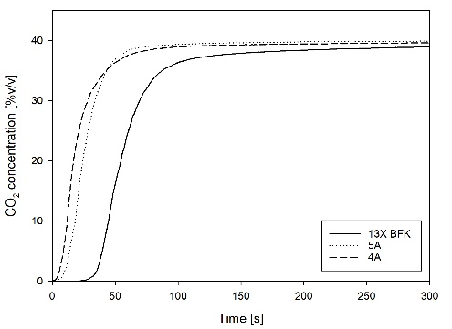
Figure 1. Comparison of CO₂ breakthrough curves for a model biogas mixture (40% CO₂ in CH₄, T = 30 °C, P = 1 atm) between the three zeolite samples (13X BFK, 5A and 4A)
Zeolites 5A and 4A show quite similar dynamic behaviors, as they belong to the same zeolite class and only differ for the average pore diameter. A slight difference can be retrieved in terms of adsorption rate, as the breakthrough curve of 5A sample is characterized by a steeper shape due to its wider mean pore diameter with respect to zeolite 4A. On the other hand, the 13X BFK sample exhibits a higher breakpoint time and, therefore, significantly greater adsorption capacity for CO₂. This result can be correlated to the higher BET surface area and micropore volume of this zeolite, thus confirming the better performance of this sample with respect to the other. Moreover, 13X BFK is characterized by the absence of the usual binder for pellets formation (substituted by a mechanical extrusion process). This result also testifies the positive effect of the removal of the binders for the separation performance of 13X zeolites, which is also in agreement with existing literature on this subject [2-3].
The desorption tests highlighted the main criticism of the 5A and 4A samples: the CO₂ desorption curves of these zeolites were characterized by extremely long tails, reaching a zero concentration level after more than three hours; even so, the curve integration showed that the amount of CO₂ desorbed was around the 70% of the amount previously adsorbed, indicating a critical lack of regenerability for these zeolites, at least by means of thermal swing processes. 13X BFK sample showed much faster desorption kinetics and displayed much better regeneration capabilities, which were also confirmed by the cyclic adsorption/desorption tests, showing a steady equilibrium CO₂ capture capacity ($ω_{{CO}_{2}}^{eq}$) of 4.05±0.05 mol/kg.
For these reasons, 13X BFK was deemed as the best sorbent for the biogas upgrade application among the investigated zeolites, and its $ω_{{CO}_{2}}^{eq}$, selectivity and regenerability were compared to those of the carbonaceous sorbents tested in our previous experimental campaign, i.e., two carbon molecular sieves (CMSs, Carbotech and Xintao) and an activated carbon (AC, Desotec) [1]. This analysis underlined that the CMSs exhibited an overall behavior comparable to that discussed for the zeolites (i.e. low CH₄ breakpoint time and adsorption capacity, leading to high selectivity), while the Desotec AC stood out and showed different performance indicators, specifically a much higher CH₄ breakpoint time indicative of a substantial CH₄ adsorption capacity, which is indeed almost an order of magnitude higher than the average of the other samples and is associated to the lower selectivity value among all sorbents. These results translate into poor applicability of this sorbent to the biogas upgrade process, although another positive aspect of this carbon is its regeneration time, as its CO₂ desorption times are the lowest at both temperatures investigated.
On the other hand, the comparison between zeolite 13X BFK and Xintao, the best performing CMS, highlighted some interesting results, and their CO₂ breakthrough curves for a model biogas mixture (40% CO₂ in CH₄, T = 30 °C, P = 1 atm) are reported in Figure 2. However, it is important to underline that the adsorption tests for carbon-based sorbents and zeolites were conducted with different sorbent mass values (equal to 12 and 4 g, respectively), therefore the comparison between the curves can only lead to qualitative considerations.
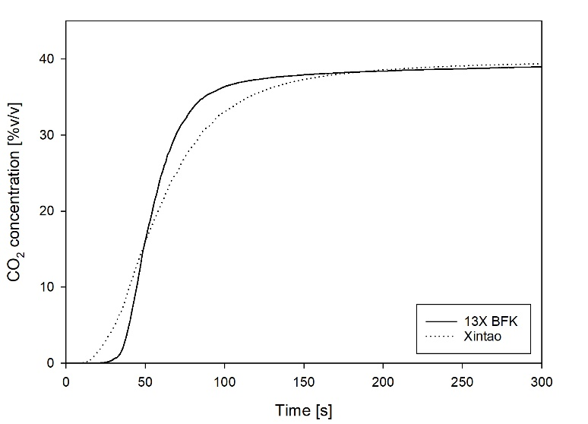
Figure 2. Comparison of CO₂ breakthrough curves for a model biogas mixture (40% CO₂ in CH₄, T = 30 °C, P = 1 atm) between zeolite 13X BFK (4 g) and Xintao CMS (12 g)
It can be noticed that, despite the significant difference in the mass employed, 13X BFK zeolite shows a higher CO₂ breakpoint time than the Xintao CMS. This is also reflected in a noticeably higher adsorption capacity at breakpoint (i.e., when CO₂ outlet concentration reaches 3% vol., $ω_{{CO}_{2}}^{b}$), which is a first indication of the higher CO₂ adsorption capacity of this sample. Furthermore, 13X BFK curve also exhibits a higher slope, which can be associated to a narrower mass transfer zone (MTZ), which is in agreement with the higher temperature increase recorded for this sample (peak temperature of 70 °C for 13X BFK versus less than 40 °C for Xintao) and the lower fractional length of unused bed (LUB, 61% for 13X BFK versus 68% for Xintao). Moving on to the comparison of the desorption tests (which were also performed employing the previously reported sorbent masses), we noticed that CO₂ desorption times are much lower for Xintao both at 30 and 80 °C, and this is once again a counterintuitive result considering the higher mass of sorbent employed in its tests. Therefore, it is possible to infer that the regeneration of this sorbent is much faster and equally effective, as confirmed by the results of the 9 adsorption/desorption cycles performed on this sorbent.
Moving on to the equilibrium results, zeolite 13X BFK showed higher $ω_{{CO}_{2}}^{eq}$ and $ω_{{CH}_{4}}^{eq}$ (4.02 and 1.24 mol/kg, respectively) with respect to Xintao (1.34 and 0.67 mol/kg), and also a higher selectivity (4.9 and 3); however, considering a real biogas upgrade application, it is generally better to minimize the methane losses rather than maximizing the CO₂ capture since the first is the product of interest while the latter is merely a by-product. Therefore, this is also a result favorable for Xintao, which can be considered the best sorbent among those investigated in our tests for the biogas upgrade application, mainly thanks to its kinetic sieving properties and smooth regenerability, at least in the case of a Temperature Swing Adsorption (TSA) process.
4. Conclusions
The breakthrough tests on 13X BFK, 5A and 4A zeolites highlighted their good kinetic separation capabilities for biogas-like mixtures (40% CO₂ in CH₄), as their CO₂ and CH₄ breakpoint times differ by at least 10-15 seconds. In comparison to the other tested zeolites, 13X BFK breakthrough curve was shifted toward longer times, resulting in higher CO₂ breakpoint time and greater adsorption capacity. However, the subsequent desorption tests underlined serious criticalities for the regeneration of the 5A and 4A zeolites.
Lastly, the zeolites were compared with two CMSs and an activated carbon which were investigated in a previous experimental campaign. While the AC performance stood out because of its poor selectivity, which heavily penalizes its applicability for the biogas upgrading process, the comparison with the CMSs was particularly interesting, as they exhibited comparable selectivities (since a lesser CO₂ capture capacity was balanced by much lower CH₄ adsorption values) and far better regenerability than the zeolites.
In conclusion, the good kinetic and equilibrium separation performance of zeolites is heavily downsized by their poor regenerability, at least by the means of temperature swings; therefore, other regeneration techniques (i.e., pressure or vacuum swings) should be evaluated to optimize their cyclic performance and assess their applicability for biogas upgrading at a commercial scale.

References
- F. Rainone, O. D’Agostino, A. Erto, M. Balsamo, A. Lancia, J. Environ. Chem. Eng. 9 (2021) 106256.
- M.C. Campo, A.M. Ribeiro, A.F.P. Ferreira, J.C. Santos, C. Lutz, J.M. Loureiro, A.E. Rodrigues, Fuel Process. Technol. 143 (2016) 185–194.
- P.A.S. Moura, D.P. Bezerra, E. Vilarrasa-Garcia, M. Bastos-Neto, D.C.S. Azevedo, Adsorpt.-J. Int. Adsorpt. Soc. 22 (2016) 71–80.

