Electrochemically-steered processes for polyhydroxyalkanoates production with mixed microbial cultures
Gaia Salvatori¹, Matteo Di Luzio¹, Angela Marchetti¹, Ottavia Giampaoli^{2,3}, Fabio Sciubba^{2,3}, Alfredo Miccheli^{2,3}, Marianna Villano¹*
¹ Department of Chemistry, Sapienza University of Rome, P.le Aldo Moro 5, 00185 Rome (Italy);
² NMR-Based Metabolomics Laboratory, Sapienza University of Rome, P.le Aldo Moro 5, 00185 Rome (Italy);
³ Department of Environmental Biology, Sapienza University of Rome, P.le Aldo Moro 5, 00185 Rome (Italy)
* E-Mail: marianna.villano@uniroma1.it
1.Introduction
Polyhydroxyalkanoates (PHAs) are a family of biologically synthesized polyesters that are attracting considerable attention due to their chemical and physical properties similar to those of conventional plastics. Furthermore, PHAs can be considered three times bio since they can be produced from renewable feedstocks and are completely biodegradable in the environment under both aerobic and anaerobic conditions [1].
Currently, PHA production at industrial scale is based on pure culture processes and this involves high management costs due to the use of well-defined substrates and the maintenance of sterile conditions [2]. In order to limit the production costs, processes based on the use of waste organic substrates and mixed microbial cultures (MMC) are under investigation and are being tested at pilot scale. These are multistage processes that include, among the others, a preliminary acidogenic fermentation (AF) step of the substrate, followed by aerobic steps for MMC selection and enrichment in PHA-storing microorganisms and polymer accumulation.
Here, an innovative electrochemically based approach to optimize each stage of the MMC-PHA production process, from feedstock AF to PHA production, has been investigated. As for AF, the introduction of a polarized electrode in the reaction medium represents an interesting and promising tool to control the spectrum of attainable products in terms of both composition and concentration. The process is referred to as electro-fermentation (EF) [3]. Here, EF has been investigated by supplying ¹³C-labelled glucose to anaerobic sludge in presence of a graphite electrode polarized at -0.70 V with respect to the Standard Hydrogen Electrode (SHE). Also, based on literature evidences reporting the enhancement of PHA production by pure cultures in bioelectrochemical systems [4-5], this study tested the PHA production capacity of an activated sludge in presence of a polarized electrode at +0.20 V and -0.20 V (vs. SHE).
2. Methods
2.1 Bioelectrochemical reactors configuration
Two chamber (H-type) cells have been used to perform all the tests herein described. The cells consisted of two gastight borosilicate glass bottles (each with a total volume of about 270 mL), functioning as the working- and counter- electrode chamber, respectively. A graphite rod electrode (10 cm length, 5 mm diameter, Sigma-Aldrich, Italy) equipped with a titanium wire (0.81 mm, Sigma-Aldrich, Milan, Italy) was placed in each chamber and a KCl saturated Ag/AgCl reference electrode (+199 mV vs. SHE) was also provided in the working- electrode chamber. The two chambers were separated by a Nafion® 117 proton exchange membrane (PEM) with a 3 cm² cross-sectional area. The working electrode was controlled by means of a potentiostat (BioLogic VSP-300) at -0.70 V, in the EF experiments with anaerobic sludge, and at +0.20 or -0.20 V when activated sludge was used as inoculum. All potential values are here reported with respect to SHE.
2.2 Analytical Methods
Volatile suspended solids (VSS) were measured according to Standard Methods (APHA, 2005). In the experiments with labelled glucose, acids production was monitored through nuclear magnetic resonance (NMR) spectroscopy, the elective technique for the C-labelled analysis [6].
3. Results and discussion
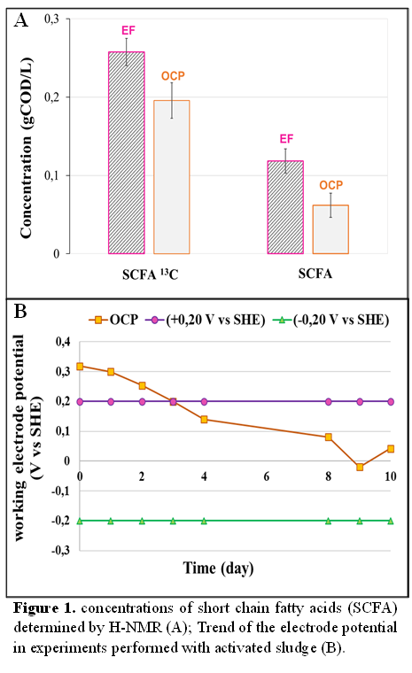
In this study, EF experiments have been performed inoculating the working chamber with anaerobic sludge at a final biomass concentration of 0.20 gL⁻¹ (measured as VSS). The electrode potential, functioning as cathode, was fixed at -0.70 V and a synthetic mixture of ¹³C-labelled glucose, acetate and ethanol was used as organic substrate. Tests were carried out in duplicate and compared to Open Circuit Potential (OCP) experiments, performed under identical conditions but in the absence of electrode polarization. Upon glucose depletion, preliminary analyses highlighted a different acids redistribution (with main reference to propionic and butyric acids) between EF and OCP experiments (Figure 1A). This finding is particularly relevant in the frame of the PHA production process, since a different ratio between acids with an odd and even number of C atoms affects the composition of the produced polymer and, in turn, its final application. As for the bioelectrochemical assisted MMC-PHA production, preliminary tests were conducted in the H-type cells wherein the working chamber was inoculated with activated sludge and operated under microaerophilic conditions. A synthetic mixture of acetic and propionic acids was used as substrate and the working electrode was polarized at +0.20 and -0.20V. The electrode potential in OCP experiments decreased over time up to about 0 V, that is an intermediated value between those controlled with the potentiostat (Figure 1B). A little production of PHA was detected in all investigated conditions, likely due to the fact that the activated sludge was not previously enriched in PHA-storing microorganisms. Therefore, further experiments with selected MMC are ongoing, in order to gain a deeper insight on the effect of the polarized electrode on PHA synthesis.
4. Conclusions
This study deals with the possibility to use the bioelectrochemical approach to control the performance of a multistage MMC-PHA production process. EF preliminary experiments revealed a change in the distribution of organic acids with respect to OCP tests. This finding is particularly interesting, since the acids mixture affects the PHA production and composition in the following stages of the process. The use of a polarized electrode to directly control the polymer yield and composition (independently from the acids composition) in the aerobic stages of the MMC-PHA production process requires further investigation.
References
[1] D. Jendrossek, R. Handrick, Annu. Rev. Microbiol. 56 (2002) 403–432.
[2] M.Villano, F.Valentino, L.Martino, M.Scandola, M.Majone, N. Biotechnol. 31 (2014) 289-296.
[3] M. Villano, P. Paiano, E. Palma, A. Miccheli, M. Majone, ChemSusChem 10 (2017) 3091–3097.
[4] K. Nishio, Y. Kimoto, J. Song, T. Konno, K. Ishihara, S. Kato, K. Hashimoto, S. Nakanishi, Environ. Sci. Technol. Lett. 1 (2013) 40–43.
[5] S. Srikanth, R. Venkateswar, M. Venkata, Bioresour. Technol. 125 (2012) 291–299.
[6] D. Goritetti, E. Zanni, C. Palleschi, M. Delfini, D. Uccelletti, M. Saliola, C. Puccetti, A.P. Sobolev, L. Mannina, A. Miccheli, Biochim. Biophys. Acta Gen. Subj. 1850 (2015) 2222-2227.

