Coupling machine learning and engineering judgment to reduce the cycle time of an industrial batch process
Francesco Sartori¹, Federico Zuecco², Pierantonio Facco¹, Fabrizio Bezzo¹, Massimiliano Barolo¹*
¹CAPE-Lab – Computer Aided Process Engineering Laboratory
Department of Industrial Engineering, University of Padova
35131 Padova, ITALY
²BASF Italia SpA
40037 Pontecchio Marconi (BO), ITALY
*Corresponding author E-Mail: max.barolo@unipd.it

1. Introduction
Batch processes are ubiquitous in many industries producing low volumes of high value-added goods. They consist of cyclic repetitions of a sequence of operations, or recipe, performed in specialized process equipment. Even if the recipe is fully automated, variability may arise from several factors, e.g. variability in raw materials, environmental conditions, initial status of the equipment. For a fixed recipe, this variability can affect both the time duration of a batch run and the product quality. A large variability in the time duration of a processing step can cause that step to become a bottleneck for the entire process, leading to a loss of productivity.
In this study, an industrial batch reactor that is a key step in the industrial manufacturing of a polymer additive is studied. The available data historian revealed that the batch length experienced a large variability, but no apparent cause was initially identified to explain this behavior.
2. Results and conclusions
Data historians for this process included the logs of 468 batches operated along a time window of 12 months. Over this period, the batches carried out in the reactor under investigation (~7.5 m³ in volume) showed a length ranging between 0.9 and 2.8 h, with an average value of 1.4 h. This variability resulted to be a limit to the performance of the manufacturing system. Principal component analysis [1] applied to the dataset revealed that over 40 % of the historical batches had been affected by the anomalous intervention of a safety interlock. This anomaly proved to strongly correlate to an increase of the batch length, which in turn determined an increase in energy consumption. Reconfiguration of the interlock system resulted in a reduction of both batch length variability and average batch length (Figure 1). A 6-month assessment following the intervention on the interlock system revealed a reduction both of the batch length variability (which ranged between 0.8 and 2.1 h) and of the average batch length (which settled to 1.0 h).
Application of advanced analytics therefore allowed for a 29 % reduction in the average batch length and an 8 % reduction of the overall process cycle duration, together with significant energy savings.
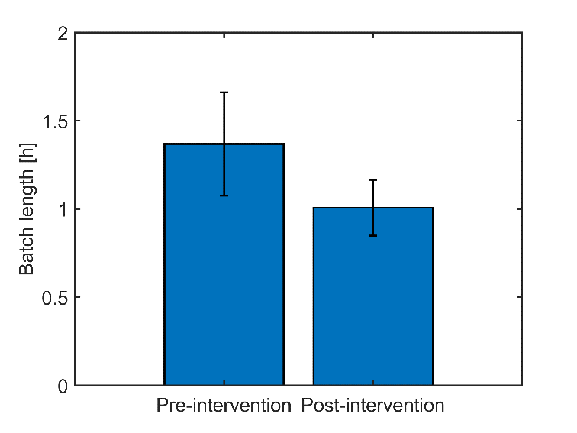
Figure 1. Comparison between the average batch length before and after the reconfiguration of the reactor safety interlock system
References
[1] I.T. Jollife, J. Cadima, Principal component analysis: A review and recent developments, Philos. Trans. R. Soc. A Math. Phys. Eng. Sci. 374 (2016). https://doi.org/10.1098/rsta.2015.0202.

