**Managing the operative conditions in photobioreactors to improve photoconversion efficiency: LED applied to microalgae cultivation**

Lisa Borella, Elena Barbera, Nicola Trivellin, Eleonora Sforza*

*Department of Industrial Engineering, University of Padova, via Marzolo 9, 35131 Padova, Italy*

*\*Corresponding author E-Mail: eleonora.sforza@unipd.it*

1. **Introduction**

Understanding the major bottlenecks in microalgal growth is of crucial importance for the development of economically feasible and energetically sustainable large-scale cultivation systems. Light is a key process parameter, associated with many difficulties in terms of its control, in particular the assurance of temporal stability and spatial uniformity [1]. In the last years, light emitting diodes (LEDs) have been investigated as a promising alternative to natural sunlight for microalgae growth, offering high durability and efficiency (less than 10% of energy is lost as heat in highly efficient LED [1]), together with a monochromatic emission, which is useful to tune the emitted spectrum, in order to optimize light supply [2], [3]. To decrease the costs associated with artificial illumination, however, improvements in both light sources and photosynthetic efficiency are required [4]. Photosynthesis is a low efficiency process [5] and to date different strategies have been proposed to achieve a high level of light utilization, including the spectral matching of the light source to the photosynthetically active spectrum [6]. However, it should be considered that the operating condition of the system also play a role in the increase of photoconversion efficiency. Current pilot-scale plants for microalgal production usually apply batch or semi-continuous cultivation methods, even though the continuous system should be preferred as it is the most productive. Batch is simple, the cheapest, and most widespread operation mode, but its productivity is inversely proportional to growth curves duration, so that the average value depends on harvesting day (during exponential or stationary phases) [7]. A compromise is a semi-continuous system, where a certain amount of culture volume is harvested periodically from the reactor to recover biomass, and replaced with fresh medium. Nevertheless, productivity depends on the harvesting frequency which, on average, can be approximated to a residence time. The light supply mode is also responsible of a potential increase of biomass production: flashing light can reduce the degree of mutual shading by penetrating deeper into the cultures, owing to the increased intensity of the instantaneous photosynthetic photon flux [8].

**2. Methods**

*Arthrospira maxima* was cultivated under continuous illumination with red-blue (R/B) light-emitting diodes. Experiments were carried out in a continuous operating photobioreactor. Kinetic parameters were retrieved from respirometric tests and implemented in a comprehensive growth model, which examines the spectral composition of the light source, and identifies optimal culturing conditions. The model was experimentally validated by data obtained at various light intensities, near the predicted optimal conditions. Moreover, *Arthrospira maxima* was cultivated under flashing regime in the range 10-1000 µs, and pulse intensities up to 70000 µmol m-2 s-1 on biomass growth wereinvestigated. The overall energy efficiency of the process was evaluated by calculating both the photosynthetic efficiency (i.e. the efficiency of conversion of light energy into chemical energy stored in the biomass) and the LED efficiency (i.e. the efficiency of conversion of electrical energy into light energy).

**3. Results and discussion**

Respirometric tests showed that an acclimation to a Red/Blue LED light source is necessary and that, after this period, kinetic parameters values were not significantly different from a white LED-grown culture. The kinetic parameters retrieved by respirometry were implemented in a mathematical model, able to reproduce the experimental data quite well. Based on simulations, it was shown and experimentally validated that adjusting the residence time it is possible to properly exploit the spectrum of light provided (Figure 1) and increase the biomass productivity by 15%. Nevertheless, energetic efficiency analysis indicated that integrating tailored illumination in the microalgae cultivation process may be a valuable approach to increase overall process efficiency.



Fig.1 Light attenuation profile at the optimal conditions. I0 = 300 μmol m-2 s-1, Cx = 315 g m-3

In addition, LED technology was used to overcome self-shading limitation, taking advantage of the possibility of generating high-intense pulsed light, that allows greater light penetration through the reactor depth. In a first set of experiments, light periods ranging from 10 to 1000 μs were applied, followed by longer dark periods and light intensities ranging from 8000 to 178000 μmol m-2 s-1. It has been found that flashing light effect (i.e. increased photosynthetic performance under pulsed light regime) occurs in both light-limited and light-saturated regime (120 and 300 μmol m-2s-1), and the optimal light period ranges between 100 and 200 μs, with a maximum observed biomass increase of 2.56 times with respect the control in continuous light. In the second set, different residence times (in the range between 0.8 and 5 days) and different pulse intensities (from 11605 to 37500 μmol m-2s-1) have been investigated, with a light period of 100 μs and average light intensity of 300 μmol m-2s-1. Results showed that for flash intensity up to 17850 μmol m-2 s-1 flashing light effect (FLE) can be observed, while beyond this value photoinhibition is so strong that FLE is not so evident (Figure 3). On the contrary, at the optimal pulse intensity, biomass productivity almost doubles the optimal one obtained in continuous light regime, at much higher residence times. In addition, results suggest that the higher the pulse intensity, the more the wash out shifts toward higher residence times, due to the increasing photo-inhibition.

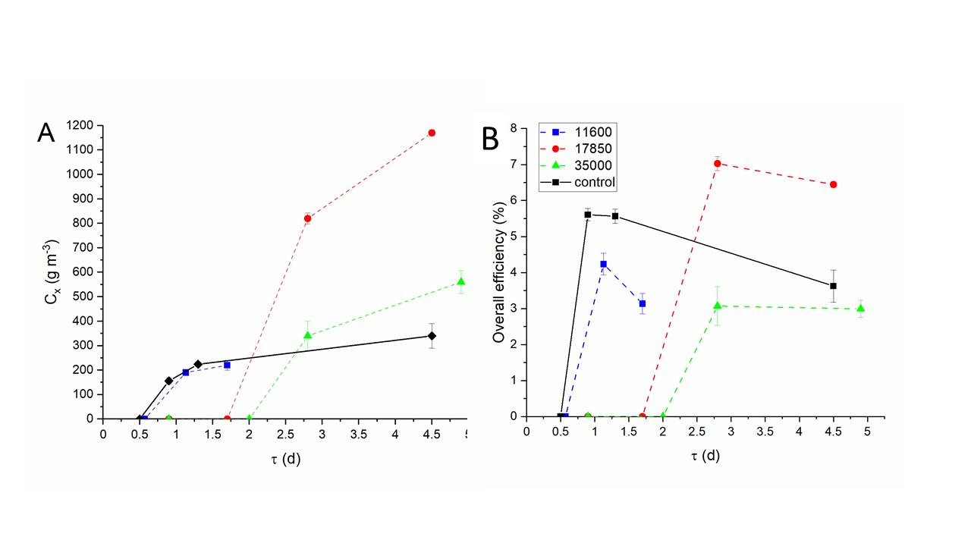

Figure 1: Overall efficiency at different residence time and different light periods for an incident light intensity of 300 µmol m-2 s-1 (A) and the corresponding energy conversion efficiency (B)

**4. Conclusions**

In this work, the possibility of increasing the production of microalgae by using tailored LED light was proved. A model approach demonstrated which should be the best operative condition of an artificially illuminated continuous system. The use of pulsed light at very high frequency showed an increased light penetration and biomass productivity, but only if the operating conditions (i.e the residence time) are properly set.

**References**

[1] A. P. Carvalho, S. O. Silva, J. M. Baptista, and F. X. Malcata, Appl. Microbiol. Biotechnol., (2011) 89, 5, 1275–88

[2] E. Bland and L. T. Angenent, Bioresour. Technol., (2016) 216, 579–586, , doi: 10.1016/j.biortech.2016.05.116.

[3] E. G. Nwoba, D. A. Parlevliet, D. W. Laird, K. Alameh, and N. R. Moheimani, Algal Res., (2019) 39, 101433, doi: 10.1016/j.algal.2019.101433.

[4] P. S. C. Schulze, R. Guerra, H. Pereira, L. M. Schüler, and J. C. S. Varela, Trends Biotechnol., (2017) 35, 11,. 1088–1101, doi: 10.1016/j.tibtech.2017.07.011.

[5] R. E. Blankenship et al., Science (80-. )., (2011) 332, 6031, 805–809, May, doi: 10.1126/science.1200165.

[6] P. S. C. Schulze, L. A. Barreira, H. G. C. Pereira, J. A. Perales, and J. C. S. Varela, Trends Biotechnol., (2014)32, 8, 422–430, doi: 10.1016/j.tibtech.2014.06.001.

[7] L. Borella et al., Adv. Sustain. Syst,( 2022) 2100346, doi: https://doi.org/10.1002/adsu.202100346.

[8] K. H. Park and C. G. Lee, Biotechnol. Bioprocess Eng, (2000) 5, 3, 186–190, , doi: 10.1007/BF02936592.