Optimization of the lifetime of CeO₂-carrier material over consecutive conversion cycles of methane for hydrogen and syngas production

Matteo Minelli¹, Mattia Boscherini¹, Francesco Miccio², Elena Landi², Ferruccio Doghieri¹, Alba Storione¹*,
1 DICAM, Alma Mater Studiorum Università di Bologna, via Terracini 28, 40136 Bologna, Italy;
2 CNR-ISTEC, National Research Council, via Granarolo 64, 48018 Faenza, Italy
* alba.storione2@unibo.it

1.Introduction
Despite all efforts to mitigate climate change, new energy sources cannot replace fossil fuels on a large scale at the short term and the supply of energy and fine chemicals must be addressed with the smart utilization of resources most largely available. The US energy information administration reports that there are abundant natural gas and shale gas reserves in the world and most of them are recoverable [1], as a consequence processes involving methane conversion are worthy to be investigated and optimized.
Traditional processes involving methane utilization suffer severe carbon deposition and sintering of the active phase, especially when CO₂ is present as co-reagent. Moreover, the majority of such processes relies on the use of expensive catalytic materials where the active phase is often a noble metal with high cost of raw material and also greater cost associated to the disposal of the exhausted catalyst. In the past years the utilization of CeO₂, a rare earth mineral, for reforming processes has constantly increased due to its remarkable redox properties and its resistance in harsh environments, including temperatures up to 2000 °C [2]. Furthermore, cerium, despite being a lanthanide, is rather abundant in the earth’s crust, comparable to copper [3]. However, its use poses kinetic limits of the reforming reaction that requires temperature around 900-950°C [4] to achieve appreciable yields of syngas.
The energy requirements represent a growing concern since they are strictly related to the CO₂ emissions and become more and more relevant to find alternative source of energy or a most successful approach to intensify the utilization of the energy available in the overall process [5,6].
Chemical looping technology could offer a route to optimize the energy utilization, splitting in two steps the overall process with the reforming in one unit and the carrier regeneration in a second unit. The energy needed by the endothermic reaction in the reforming could be partially supplied by the exothermic heat released during the oxidation step and CO₂ emissions could be limited employing CO₂ itself as oxidant agent in the prospective of a CO₂ net-zero emission process.
However, even in this case one of the main issues hindering large scale implementation of the process is given by the carbon deposition associated to methane decomposition that strongly affects the durability of the carrier. Thus, in this work large attention has been paid on the regeneration efficiency and its optimization to increase the performance and the lifetime of material. The process has been simulated with the thermodynamic tools of Aspen Plus software simulator to check the feasibility and restrict the number of experiments. Several conditions for the regeneration of CeO₂ carrier have been tested experimentally at different composition (air content 3%, 5%, 21%) and the lifetime of the material after repeated cycles has found to be satisfactory.

2. Methods
2.1 Simulations approach and description
Process analysis was performed by means of thermodynamic tools available in Aspen Plus simulator. All the simulations were carried out at the steady state using MIXCISLD model for the evaluation of vapors and conventional solids phases. A reactor of Gibbs type was selected to perform the simulations and the related results were obtained employing the Gibbs minimization energy method, in combination with the ideal gas law for the description of the equilibrium in the gaseous phase only. A sensitivity analysis was performed in the reforming unit in presence of cerium oxide and selecting the temperature as only variable to evaluate the effect of small variation in temperature on reagent conversion, carbon deposition, and syngas purity. The conditions required for carrier regeneration were investigated in a preliminary inspection at different temperature and oxidant composition (air, CO₂).

2.2 Material Preparation
Commercial cerium oxide powders (Pi-kem UK, purity 99.9 %) were pelletised in a hydraulic press (8-9 MTons which corresponds to an actual pressure on the sample of 250 MPa) and then sieved to the desired size fraction of 0,595-0,841 mm. The particles were calcinated with a heating rate of 3 °C/min, left in isothermal condition at 900 °C for 1 h, then cooled to room temperature.

2.3 Experimental apparatus and test procedure
The test rig consists of a stainless steel (AISI 316) fixed bed reactor with an inner diameter (ID) of 10 mm. The reactor is enclosed in a tubular furnace which allows to keep a constant temperature. A K-type thermocouple is located along the reactor to measure the bed (internal) temperature at mid-length. The system is entirely insulated with external layer of quartz wool.
The feed flow rate and composition are controlled by Bronkhorst mass flowmeters, while the outlet gases are analyzed continuously by means of an online analyzer (GEIT 3100 P+ Syngas) equipped with a thermal conductivity detector (TCD), an infrared detector (NDIR) and an electrochemical oxygen sensor.
The apparatus was used to conduct test at different temperature (900 °C and 950 °C) while keeping constant the feed flow rate, the reagent partial pressure and the loading of the carrier. It was set up to work in cyclic mode by switching gases atmosphere from reducing to oxidizing in order guarantee the material regeneration over consecutive cycles.
In a typical experiment, the reactor was loaded with 15 g of cerium oxide oxygen carrier prepared as previously described and employed without any further treatment. The sample was heated up to 900° at atmospheric pressure and the temperature of the material bed was monitored and recorded approximately every two minutes while the composition of the gases evolved during the reaction was analyzed continuously.
First experiments were conducted at 900°C and at 950 °C in CH₄ (10% in N₂, 1 NL/min) and last until no more gaseous products were detected while the reduced carrier was re-oxidized at different content of oxygen (3%,5%, 21%) in N₂ at the same reforming temperature. These tests were also repeated for both the conditions to check reproducibility and the maintenance of performance over 3 consecutive cycles. At a later time shorter experiments were performed increasing the cycle number up to five.

3. Results and discussion
The thermodynamic analysis (Table1) obtained by Aspen+ for the stoichiometric ratio of the reactants showed a large variability of the syngas ratio with the temperature and a significant contribution of coke to the scheme of reaction when temperature lower than 900°C is reached on CeO₂ carrier.
T[°C] | χCeO₂ | $$\frac{H2}{CO}$$ | nC/nCH₄in
860 | 0.33 | 6.19 | 0.65
870 | 0.45 | 4.59 | 0.55
875 | 0.52 | 3.94 | 0.48
880 | 0.60 | 3.37 | 0.40
890 | 0.83 | 2.43 | 0.17
900 | 1 | 2.02 | 0.01
910 | 1 | 2.02 | 0.01
920 | 1 | 2.01 | 0.01
930 | 1 | 2.01 | 0.01
Table 1: Simulation results for [O]/CH₄ ratio of 0.5 at different Temperature and 1 atm.
The results also pointed out an incomplete conversion of the carrier under the same temperature. In this light, all the experiments were conducted with a starting temperature at least equal to 900 °C and recording the temperature profile along the material bed for all the duration of the reforming reaction.
Preliminary results at 900 °C and at 950 °C showed a lower reproducibility of the experiments when the first is preferred as reforming temperature. Moreover the effect of an increase in temperature turned out to be more relevant on the CeO₂ average conversion than on the syngas ratio variability. Indeed, the CeO₂ conversion varied from 79.7 ± 9.5 to 86.8 ±1.7 % with the increase in temperature while modest variation interested the syngas ratio (max. variation of 0.7 for the case at 900 °C against the 0.5 for 950 °C). An explanation to this evidence was found in the analysis of the trend of the bed temperature profile with the extent of the involved reaction:
1_ CH₄ + 2CeO₂ $⇋$ CO + 2H₂ + Ce₂O₃ (reforming)
2_ CH₄ $⇋$ C + 2H₂ (decomposition)
Indeed, when the carrier is at 900°C, it strongly reacted with methane in the endothermic reaction (1) decreasing the bed temperature under 900°C and going below the minimum threshold suggested by simulation where the variables are more sensitive to changes of temperature. However, setting the temperature 50 °C higher permitted to avoid this effect leading to the obtainment of more stable values. The same analysis also allowed to determine an optimal time for the reduction reaction selecting the one for which the bed temperature’s profile was close to the isothermal condition. Next experiments were conducted at 950°C with 30 minutes for each reduction (10% CH₄ in N₂, 1 NL/min) and for a larger number of redox cycles. The regeneration of carrier was initially performed with a low partial pressure of oxygen to avoid to handle too much higher increase in temperature (up to 1000 °C) due to the occurrence of the exothermic reactions. Results are shown in the figure 1.
As one can see the minimum temperature reached during methane conversion corresponds to 920 °C and never goes below this value.
Furthermore, the plots show an evident correlation between the tendency of the minimum temperature of reduction and the values obtained for carrier conversion (figure 1a, 1b). The trend suggests that the fresh carrier undergoes under more severe reduction (superior contribution of the reaction 1) and this is also confirmed by the higher value of CeO₂ conversion at the beginning in comparison with the following cycles (figure 1b). However, the carrier reached appreciable conversions in all the cases with a degradation in performance over the cycles due to the presence of carbon accumulated on the carrier (figure 1c, 1d). Indeed, the carbon derived from the thermolysis side reaction was only partially consumed in the regeneration step.

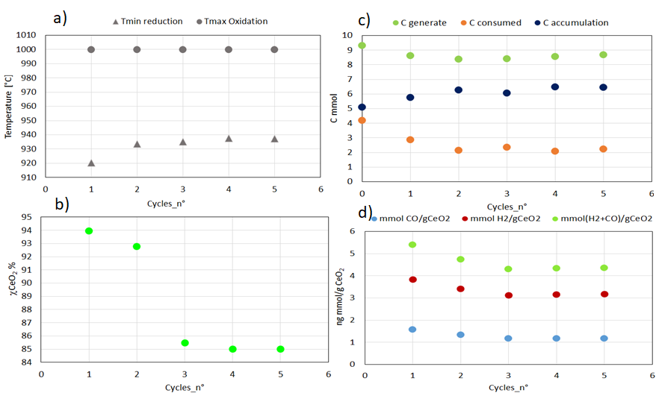
Figure 1: Main results obtained at 950°C and 1 atm with a CeO2 loading of 15,34g. The plot reported as a function of the number of redox cycles: a) operative temperature; b) carrier conversion; c) carbon deposition; d) syngas productions for g of carrier.
The same plot also reports as cycle 0 the data related to an experiment conducted in absence of carrier material. The related data showed that in absence of oxygen carrier only the thermolysis occurs and a content of 3% of oxygen in air is not enough to guarantee the consumption of all the carbon during oxidation. The same trend was confirmed even in presence of the oxygen carrier where a greater content of oxygen is available due to the nature itself of the carrier. Additionally, the data collected during regeneration were also analyzed to rule out the possibility of an incomplete regeneration of the carrier material and to estimate the time desired by oxidation (Figure 2a). The image reports the results of the mass balance on the oxygen where the oxygen released was quantified directly account the total fed and the molar fraction at the exit of the analyzer while the oxygen consumed was estimated as the sum of oxygenated compounds measured at the reactor exit and the oxygen needed back by the carrier accounting the quantity released for the methane oxidation.
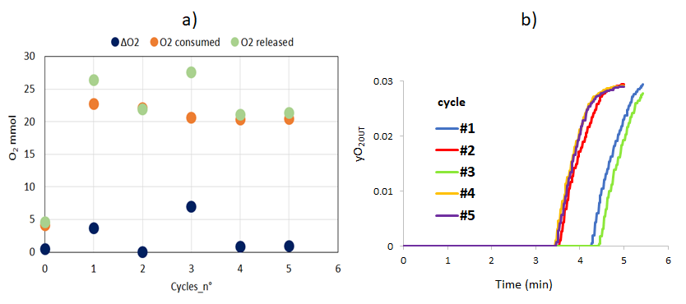
Figure 2: Results, over five consecutive cycles, of: a) regeneration efficiency and b) duration.

As evidence in the plot there is compliance in the oxygen mass balance proving the complete regeneration of the carrier over five consecutive cycle. It is also worth noticing that for all the cycles the oxidation lasts no more than five minutes (figure 2b) thus allowing a considerable decrease in the time of conduction of the overall process.

4. Conclusions
This work has showed that CeO₂ is promising as oxygen carrier material for looping methane conversion in fine chemicals. The carrier proved to be selective for syngas obtainment and to be easily and rapidly regenerated during several cycles without drastic changes in the performances. However, the presence of accumulated carbon on the CeO₂ material has been considered the cause of a decrease in the carrier conversion and of a drop of syngas production thus hindering the implementation of the process on a greater scale. Future works will aim to enhance the carbon removal, by studying the system with different oxygen partial pressure and testing the feasibility of the employment of other oxidant agent such as CO₂ even in consideration of a further optimization of the process that involved also energy balance assessment.

References

- Z. Sun, X. Wu, C. K. Russell, M. D. Dyar, E. C. Sklute, S. Toan, M. Fan, L. Duan, W. Xiang, J. Mater, Chem. A 7, (2019) 1216.
- R. Schmitt, Chem. Soc. Rev., 49 (2020), 554
- G. Haxel, J. Hedrick and G. Orris, US Geological Survey, US Geological Survey, 2002
- A. Storione, M. Minelli, F. Doghieri, E. Landi, F. Miccio, Chemical Engineering Transactions, 86(2021), 1267-1272.
- A. Ozbilen, I. Dincer, MA. Rosen, Environ Impact Assess Rev, 9 (2013), 1-42.
- B .Chen, Z. Liao, J. Wang, H. Yu, Y. Yang, Int J Hydrogen Energy, 200 (2012) 37-3191.

