Validation study of Windtrax backward Lagrangian model: critical discussion on model reliability and its optimisation

Francesca Tagliaferri^{1*}, Marzio Invernizzi², Selena Sironi³
1,2,3 Politecnico di Milano, Department of Chemistry, Materials and Chemical Engineering “Giulio Natta” - P.za Leonardo da Vinci 32, 20133 Milano, Italy;
*Corresponding author E-Mail: francesca.tagliaferri@polimi.it

1.Introduction
In last years, urbanization and industrialization have been major contributing factors to the poor air quality. As the air quality deteriorates, exposure to air pollution remains a fundamental concern to public health (Pope, 2000). Passive chemicals in the atmosphere, such as NO2, SO2, CO, PM10, PM2.5, C6H6, could severely damage the health of the population (Leelőssy et al., 2014).
Having information on atmospheric pollution and its environmental impact on citizens is the starting point for improving air quality (Wang et al., 2008). Therefore, the evaluation of the extent of exposure to chemicals becomes a key issue. In this regard, dispersion modelling represents a useful tool for reproducing spatio-temporal distribution of contaminants emitted by a specific source thereby quantifying the areas of population exposure as well as the ground level concentrations of contaminants (Mangia et al., 2014).
There are several types of atmospheric dispersion models, Gaussian (Gifford, 1959), Eulerian (Jacobson, 2005; Seinfeld and Pandis, 1998), Lagrangian (Rodean, 1996) and fluid dynamics models (Moon et al., 1997). Overall, they calculate the concentration of a species in space, given the meteorological and emissive conditions of the source (Barclay et al., 2021; Capelli et al., 2012; Tagliaferri et al., 2020).
In recent years, dispersion patterns have increasingly evolved (Herring and Huq, 2018; Yudego et al., 2018). However, although these models have been refined, there are still some criticalities related to the input dataset: in some situations, the characterization of the emission source is not trivial. (Invernizzi et al., 2020, 2018; Tagliaferri et al., 2020). In particular, it is necessary to define the emissive flux released by the source whose estimation, in case of complex sources (e.g. floating roof tanks, tanks topped by grates), may be critical (Invernizzi et al., 2018). For point sources, such as stacks, concentrations and emission rates can be measured rapidly. On the other hand, area sources may be tricky: if they have a measurable outward flow such as biofilters, they can be treated similarly to point sources, but in case of passive area sources without an outward flow it is difficult to estimate an emission rate, since there is no well-defined airflow, and hoods must be used (Capelli et al., 2009). However, in case of area sources such as floating roof tanks or tanks topped by grates, hoods cannot be adopted (Capelli et al., 2009).
To this end, it would be extremely useful to apply an inverse dispersion model: so, by knowing a concentration value in space, to quantify the emission rate of the source.
The Windtrax software (Crenna, 2006) is a backward Lagrangian stochastic model, based on the principles of Monin-Obukhov Similarity Theory (MOST) (Flesch and Wilson, 2005, 1995), that computes an ensemble of random paths backward in time from the detectors to the sources thus quantifying the unknown emission rates from measured downind concentrations.
Windtrax is widely used for the evaluation of emission rates in the agro-meteorology field, where emissions of greenhouse gases, methane or ammonia are tipically measured (Gao et al., 2009; McBain and Desjardins, 2005; Yang et al., 2016). The studies available in literature regarding the application of the Wintrax model are generally focused on the evaluation of how well it predicts the emission of pollutants from area sources, which is typically the way in which agricultural sources are treated.
On the contrary, the present study focuses on the application of Windrax for a different type of source. In fact, before tackling datasets with complex sources, it was decided to initially test the model by considering sources, such as stacks, never discussed in literature in similar studies. Also, when dealing with sources of this kind, being easy to characterize, the observed emission rate to compare with the model output is more reliable and consequently the model validation is more robust. In addition, in the agricultural field, point sources are of great interest, considering for instance flares in anaerobic digestion plants, vents of fixed roof tanks or conveyed emissions from livestock farming. Precisely, two experimental campaigns with a point source (i.e. stack) will be considered.
In this study, a validation of the model was carried out not limiting to this, but also trying to understand under which conditions (i.e. stability class, number and location of the sensors) it provides a greater accuracy. The aim of this work is to validate the Windtrax model by comparing the model results with observed values taken from datasets of real experimental fields available in literature.
The choice of the Windtrax model is manly because it is free downloadable, not complex to use thanks to a user-friendly interface, widespread mentioned in the literature in the agro-meteoroloy field and it belongs to Langrangian particle models which are advanced dispersion models.
2. Methods
2.1 Windtrax model
WindTrax 2.0.9.7 (Crenna, 2021) is a software that simulates the transport of gaseous substances in the atmosphere. It is based on the theory of the Lagrangian Particle Model (Crenna, 2006): the dispersion of pollutants is considered as a flow of dimensionless particles whose trajectory is described in a stochastic way.
It can be used either to calculate the concentration of a gaseous substance at a given point if the Emission Rate is known, or to calculate the Emission Rate if the concentration of the pollutant at a given point is known. The generic equations on which the model is based are:
$a_{11}Q_{1}+a_{12}Q_{2}+…+a_{1n}Q_{n}+C_{b}= C_{1}$
$a_{m1}Q_{1}+a_{m2}Q_{2}+…+a_{mn}Q_{n}+C_{b}= C_{m}$ [1]
Where C_b is the background concentration, Q_j are the emission rates, a_ij are the coefficients, computed by the model, relating the emission rate to the measured concentration C_i.
In order to solve the system of equations, there must be at least as many known concentration measurements as there are unknown emission rates. If the number of known concentrations C_i is greater than the number of unknown sources Q_j, the solution will be the best fit in the least squares sense (Crenna, 2006).
A full description of the Windtrax model is not presented here, since it has been widely discussed in literature (Crenna, 2006; Flesch and Wilson, 2005, 1995).
2.2 Uttenweiler and Round Hill campaigns
In this paragraph, a brief description of the field experiments used in the present study to validate the model is provided. Further details are described in the field test reports (Bachlin et al., 2002; Cramer et al., 1958).
The Uttenweiler campaign was conducted in a pre-existing pig farm in 12 and 13 December 2000 and 31 October 2001. The farm is situated outside the small village Uttenweiler, 20 km west of the city of Bielberach (5331621 N, 548508 E) in Germany. The surrounding area is mostly flat. This farm consists of the pig barn and the feed processing room. The gas tracer, sulphur hexafluoride (SF6) was continuously emitted by a single point source located on a building. It was at 8.5 m above the ground level, and it was connected to the internal ventilation system. 14 trials were performed, named in alphabetical order from B to O: the experiment A was an attempt.
The second campaign is the Round Hill experiment (Cramer et al., 1958). The site area, with a flat terrain, is close to the Round Hill Field Station of the Massachusetts Institute of Technology (338022 E, 4600793 N). The site roughness was around 7-30 cm and the vertical emission consisted of a stack at 30 cm from the ground releasing SO2. A large number of experiments were conducted, some of them have been considered in the present study. The data set was obtained by means of the website http://www.harmo.org/jsirwin.
2.3 Model Validation
The first objective of this work was to estimate the performance of the Windtrax model in predicting the experimental data thereby performing a model validation. For this purpose, some statistical indicators were used (Chang and Hanna, 2004; Gustafson and Yu, 2012; Hanna and Chang, 2015; Willmott, 1981): Mean Bias (MB), Normalized Mean Bias (NMB), Root Mean Squared Error (RMSE), Normalized Mean Squared Error (NMSE), Index of Agreement (IOA) and FAC2.
The equations of each indicator are reported below:
$MB=\frac{1}{N} \sum_{i=1}^{N}{E_{i}= \overline{M}-\overline{O}}$ [2]
$NMB= \frac{\sum_{i=1}^{N}{{( M}_{i}-O_{i})}}{\sum_{i=1}^{N}{O_{i}}}= \frac{\overline{M}}{\overline{O}}-1$ [3]
$RMSE=\sqrt{\frac{1}{N} \sum_{i=1}^{N}{{{(M}_{i}-O_{i})}^{2}}}$ [4]
$NMSE= \frac{\frac{1}{N} \sum_{i=1}^{N}{{{( M}_{i}-O_{i})}^{2}}}{\overline{MO}}$ [5]
$IOA=1- \frac{\sum_{i=1}^{N}{{{( M}_{i}-O_{i})}^{2}}}{\sum_{i=1}^{N}{{\left(\left|{(M}_{i}-\overline{O}\right|+\left|{(O}_{i}-\overline{O}\right|\right)}^{2}}}$ [6]
$FAC2:0.5≤\frac{M_{i}}{O_{i}}≤2$ [7]
Where M_i is the single modelled emission rate and O_i is the single observed value. The optimal values of these parameters indicating the best fit between the model results and the experimental data are: MB=0, NMB=0, RMSE=0, NMSE=0, IOA=1. Regarding the last index, FAC2, the percentage of values within the factor 2 range will be expressed.
The percentage (%) error of the modelled value with respect to the observed one has also been calculated. The latter is computed by means of the following formula:
$ER\%=\frac{M_{i}-O_{i}}{O_{i}}$ [8]
3. Results and discussion

Uttenweiler campaign
In this section, the validation of the model with the Uttenweiler experimental campaign will be discussed (Bachlin et al., 2002).
The Uttenweiler campaign was carried out in several experiments (14) lasting ten minutes each.
All these experiments had their own characteristics, such as weather data (wind velocity, wind direction, stability class) and instrument placements (sonic anemometer and concentration sensors). Therefore, each experiment was implemented separately in the software to obtain as many calculated Emission Rate values as the number of experiments. As an example, a picture of the spatial configuration of experiment B is given in Figure 1,a. In detail, the star with outgoing arrows having a question mark represents the point source having unknown emission rate; the columns having the symbol “C” are the concentration sensors (with known concentration values); finally, the remaining column represents the anemometer. In Figure 1b, an example of the Windtrax interface is shown while the simulation is running, with N particles emitted from the point source.

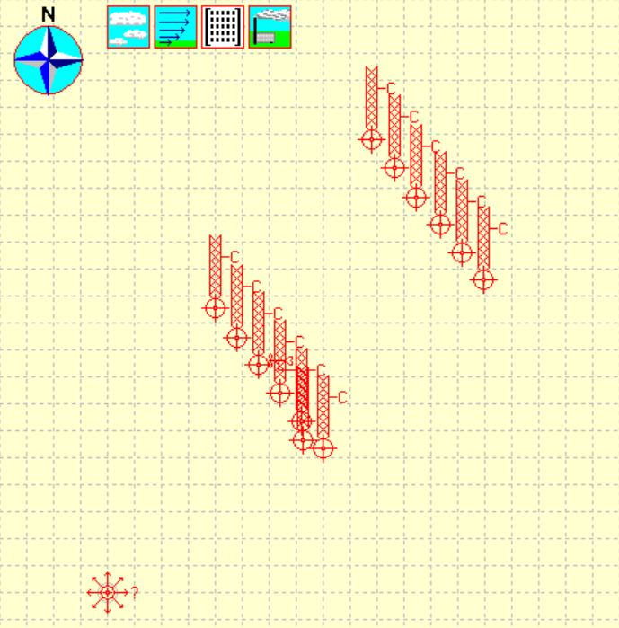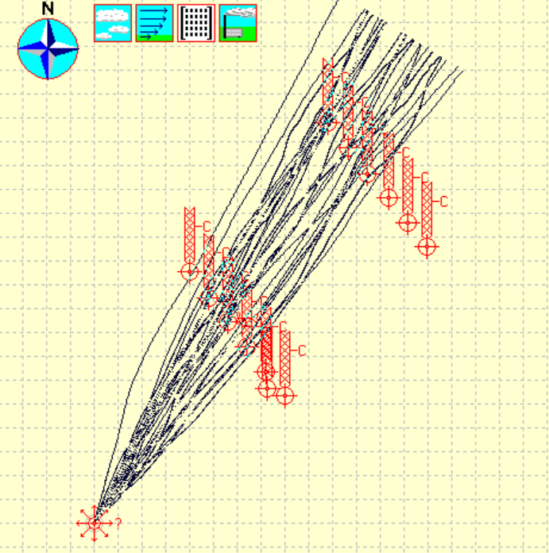
(a) (b)
Figure 1. Experiment B spatial configuration on Windtrax on the left (a); Windtrax simulation, in which the trajectories traced by the N particles emitted by the source are visible (Crenna, 2006).
As first test, all the possible concentration sensors (12 measurement points) of the Uttenweiler campaign were entered as input data. In Table 1 the statistical indicators computed by considering all the 14 experiments are reported.
Table 1. Statistical indicators computed by considering all the experiments; from the left: Mean Bias, Normalized Mean Bias, Root Mean Square Error, Normalized Mean Square Error and Index of Agreement.
MB | NMB | RMSE | NMSE | IOA
46.3 | 0.3 | 94.1 | 0.21 | 0.7

Focusing on the statistical indicators NMB, NMSE and IOA, the values predicted by the Windtrax model (Crenna, 2006) appear quite good. To confirm this, it is emphasized that the totality of the values obtained belong to the FAC 2 range.
From equation [1], it can be deduced that as many known concentration values are needed as there are unknown emission rates. Since in the investigated case-study there is just one unknown emission rate and given that such a large amount of concentration sensors (12) is rarely available, it was decided to evaluate the quality of the model progressively reducing the number of concentration sensors up to a single measurement point. The Uttenweiler campaign is characterized by a particular positioning of the concentration sensors: it develops in one or two transects (depending on the specific experiment) placed approximately perpendicular to the direction in which the wind was blowing. In experiments with two transects, these are placed parallel to each other and downwind of the emission source: so, one closer to the source and one further away, as visible in Figure 1. For the following test, i.e. validation of the model when reducing the number of measurement points, only the experiments having both transects were considered. Therefore trials (I, J, K, L) are neglected. This way it was also possible to test the influence of the distance of the receptor from the source on the accuracy of the results, i.e. to highlight if there is a significant difference when considering receptors closer of farther from the emission. To show the results of this test, a table with the percentage errors between the modelled and the observed value and the standard deviation of the modelled result for each experimental trial (B-O) is reported (Table 2). The different configurations implemented into the model are:
- The entire concentration sensors,
- The entire transect of concentration sensors closest to the source,
- The entire transect of concentration sensors farthest from the source,
- Two downwind sensors on the transect closest to the source,
- Two downwind sensors on the transect farthest from the source,
- One downwind sensor on the transect closest to the source,
- One downwind sensor on the transect farthest from the source,
- Two downwind receptors, one on the transect closest to the source and one farthest from the source.
It is worth underling that, for each experimental trial, the corresponding stability condition (N/S = neutral/stable; S = stable; VS = very stable) is indicated in the Table 2. In doing so, the way in which the stability class affects the performance of the model can be easily recognized in order to identify the optimal meteorological conditions to run the model.

Table 2. Percentage Error of the modelled value with respect to the observed value and standard deviation of the model result, for seven different spatial configurations of the concentration sensors (0-7), for the experiment considered (B-O).
 | 0 |  | 1 |  | 2 |  | 3 |  | 4 |  | 5 |  | 6 |  | 7
 | ER% | Standard Deviation | ER% | Standard Deviation | ER% | Standard Deviation | ER% | Standard Deviation | ER% | Standard Deviation | ER% | Standard Deviation | ER% | Standard Deviation | ER% | Standard Deviation
B | -13.6 | 14.1 | -3.4 | 30.9 | -2.9 | 18.5 | -10.3 | 21.6 | -2.3 | 19.6 | -40.8 | 17.0 | -9.9 | 26.0 | -31.6 | 15.5
(N/S)
C | -14.4 | 12.7 | -13.2 | 29.3 | -29.8 | 15.9 | -22.5 | 16.1 | -29.0 | 10.4 | -26.0 | 17.1 | -24.6 | 28.3 | -18.8 | 18.9
(N/S)
D | 6.8 | 32.5 | 10.3 | 47.4 | -30.0 | 35.0 | 1.9 | 28.0 | -6.2 | 102.8 | 0.6 | 28.9 | -31.7 | 39.6 | 4.8 | 28.8
(S)
E | 26.1 | 44.4 | 24.6 | 28.3 | 7.3 | 20.1 | -3.7 | 31.1 | 29.8 | 24.5 | -17.4 | 21.7 | 35.0 | 37.3 | 3.8 | 16.2
(N/S)
F | 54.7 | 15.2 | 72.8 | 56.8 | 8.8 | 18.4 | 43.3 | 53.1 | -17.0 | 19.3 | 46.4 | 48.7 | -5.9 | 45.3 | 13.3 | 27.3
(N/S)
G | 28.3 | 23.5 | 77.2 | 34.6 | -6.1 | 16.7 | 39.1 | 27.4 | -27.5 | 42.0 | 32.8 | 36.9 | -29.0 | 19.5 | 23.2 | 26.5
(N/S)
H | 25.4 | 28.9 | 100.3 | 29.8 | -27.3 | 13.8 | 151.3 | 95.8 | -25.4 | 14.0 | 130.8 | 101.2 | -30.6 | 22.1 | 35.6 | 41.8
(S)
M | 34.2 | 45.2 | 125.3 | 83.1 | -24.1 | 29.2 | 94.9 | 101.3 | -19.8 | 24.4 | 93.7 | 77.6 | 11.1 | 67.7 | 91.5 | 64.3
(S)
N | -5.6 | 27.0 | 27.0 | 88.0 | -22.3 | 46.6 | 27.1 | 56.5 | -33.3 | 35.2 | 192.4 | 219.0 | -40.4 | 20.6 | -30.1 | 26.9
(S)
O | -16.8 | 41.0 | 192.3 | 197.5 | -35.3 | 32.4 | 169.1 | 114.2 | -38.6 | 18.4 | 304.5 | 396.6 | -39.3 | 25.7 | -22.0 | 41.8
(VS)

For the sake of clarity, a conditional formatting is used to have an easy-to-use overview of the model response: the percentage errors are shaded in yellow with increasing intensity as further away from zero (ideal value), the standard deviations in blue.
From Table 2, it is possible to observe that the highest values of percent error and standard deviation occur when considering experiments with stable and very stable conditions, particularly in situations where the concentration sensor was positioned on the transect closest to the source. This may be related to the fact that the plume emitted from the source under stable conditions is poorly dispersed in both the vertical and horizontal directions, so it is less likely having the plume to pass through the concentration sensors and this effect is more pronounced in the vicinity of the emission source where the pollutant is less diluted and dispersed.
The average percentage error computed by considering the absolute values of the percentage errors of the single experiments is about 41%, while considering only experiments in neutral/stable condition the average error decreases up to 24%. However, for the experiment D, performed in stable conditions, low percentage errors are detected, even on receptors positioned close to the source. This may be attributed to the fact that the location of the concentration sensors in all the configurations developed for this experiment and the wind direction are such that the plume always crosses only one sensor. Therefore, since this sensor is the only one which contributes to the quantification of the emission rate and it has been maintained in all the configurations, the removal of the other receptors does not affect the results.
Another consideration concerns the influence of the number of receptors on the model accuracy. From Table 2, it turns out that the reduction of the number of sensors does not necessarily improve the model performance. Thus, it can be inferred that the correct downwind placement of the sensor is much more significant than the number of sensors. In other words, the model results show a good accuracy even when considering a single measurement point provided that the sensor is properly located.
To conclude, the implementation of the Uttenweiler dataset highlights the good performance of the model in predicting the emission rate under neutral condition. Under stable conditions great care must be taken with the location of the sensor due to the fact that the plume is poorly dispersed. In this sense, a possible solution might be to move the sensor away from the source.

Round Hill campaign
In this section the validation of the model with the Round Hill Campaign (Cramer et al., 1958) will be discussed.
The dataset from the Round Hill campaign provides several concentration values measured from sensors positioned along arcs at different distances from the source (i.e 50 m, 100 m and 200 m). In particular, eight experiments characterized by different stability classes, were chosen to be tested: three of them are conducted under Moderately Unstable (MU) conditions, two in Neutral (NN) conditions, two in Moderately Stable (MS) conditions and only one in Extremely Stable (ES) conditions.
In this way, it was possible to test the performance of the model under different stability conditions, as for the Uttenweiler campaign.
In addition, for each experiment, different configurations of receptors were considered:
1) One arc of six downwind receptors at 50 m from the source (blue in Figure 2);
2) One downwind receptor at 50 m from the source (brown in Figure 2);
3) One downwind receptor at 100 m from the source (green in Figure 2);
4) One downwind concentration at 200 m from the source (yellow in Figure 2);
5) Two downwind receptors, one at 50 m and one at 100 m from the source (red in Figure 2).

In Figure 2 the % errors obtained for the different configurations of receptors (1-5) for the eight experiments are reported. It should be noted that in configuration 4, the first and third columns are missing, due to the failure to obtain a model result for the specific experiments.
From Figure 2, a general tendency of the model to overestimate in stable atmospheric conditions and to underestimate in unstable conditions may be observed.
In addition, higher accuracy of the model in predicting the experimental data under neutral condition in shown. The percentage errors for neutral stability class are always good, in the range between a ±40% with an average value of 10 %.
Conversely, the mean % error for experiments in unstable conditions is about -60%; while the mean error for trial in stable conditions is about 50%. It should be noted that in stable conditions, the average percentage error seems to decrease as the distance of the sensors from the source increases: in particular, in configuration 2 (receptor at 50 m from the source) the resulting error is about 60%, in configuration 3 (receptor at 100 m from the source) it decreases up to 40% and in configuration 4 (receptor at 200 m from the source) the (%) error is 32%. This outcome confirms what previously discussed for the Uttenweiler campaign.
By reducing the number of concentration sensors, it turns out what previously verified with the Uttenweiler dataset: even considering a single concentration value, it seems that the model still responds well. Thus, it can be concluded that the number of sensors is not so limiting, but rather their correct placement.
In Table 3, the statistical indicators discussed are shown. In particular, the performance parameters are computed distinguishing between the experiments conducted in neutral, stable and unstable conditions. Overall, looking at the absolute values of this statistical indicators, it seems that the model predicts the experimental data with a quite high level of accuracy, with the best values obtained in neutral conditions. The totality of the values obtained in neutral conditions belong to the factor 2 range.
Therefore, from this study, it appears that the model is more reliable for neutral conditions, where a good agreement between the experimental data and the simulated values are observed. Although the absolute values of the percentage errors obtained under stable and unstable conditions are comparable (50% vs 60%), it seems that the unstable conditions have a much more fluctuating error pattern (i.e. very low errors in some experiments, very high in others and eventually no results provided by the model). This behaviour is probably attributable to the high level of turbulence in unstable condition. For this reason, it might be concluded that the model is more reliable in stable conditions, even because, as discussed for the Uttenweiler campaign, the positioning of the sensor not too close to the emission source might help in the improvement of the model predictions.

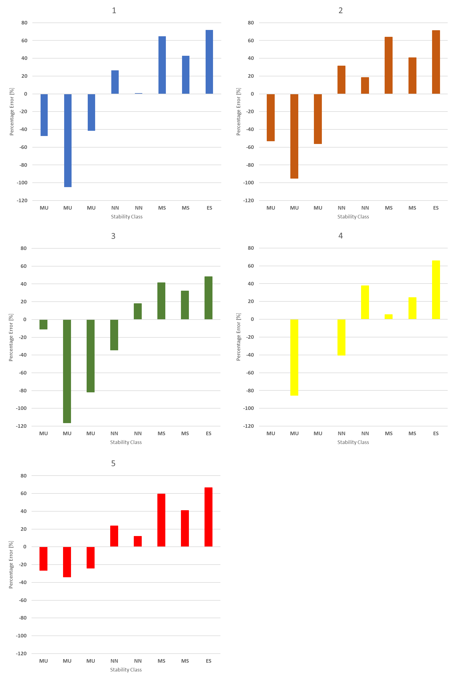
Figure 2. Percentage Error for the eight experiments with different stability class, in five different spatial configuration of concentration sensors (1-5). The absence of columns in configuration 4 means that there were no results provided by the model.
Table 3. Statistical indicators for all the considered experiments; from the left: Mean Bias, Normalized Mean Bias, Root Mean Square Error, Normalized Mean Square Error and Index of Agreement
MB |  |  | NMB |  |  | RMSE
Unstable | Neutral | Stable | Unstable | Neutral | Stable | Unstable | Neutral | Stable
6.3 | -0.6 | -3.1 | 0.5 | -0.1 | -0.5 | 7.3 | 1.7 | 3.3
NMSE |  |  | IOA |  |  | FAC2
Unstable | Neutral | Stable | Unstable | Neutral | Stable | Unstable | Neutral | Stable
0.3 | 0.1 | 0.5 | 0.005 | 0.1 | 0.4 | 81 % | 100 % | 50 %
4. Conclusions
Due to the high complexity associated, in some cases, to the characterization of emission sources, the availability of a reliable tool to estimate the source emission rate starting from a downwind measured concentration would be of great interest.
This work arises from this intent. It aims to test the performance of the backward Lagrangian model Windtrax, widespread mentioned in literature.
In particular, this validation study is not limited to investigate the reliability of the model in predicting the observed emission rate, but it also tries to understand under which conditions the performance of the model are expected to be higher.
From the results of this study, it turns out a general tendency of the model to predict the observed values with a good level of accuracy. In particular, for the Uttenweiler campaign, acceptable values of the performance indicators are obtained. For the Round Hill dataset, the model results are even better: in this case, an average percentage error of about 40% over all the experiments is estimated. In addition, this study highlights the importance of a correct positioning of the concentration sensor to make the model result reliable. In this regard, besides the downwind position of the sensor, in stable conditions, since the plume poorly dispersed, it is advisable to locate the measurement point not too close to the emission source. Another possible solution to adopt in stable conditions, might be the increase of the height of the sensor, so that it is more likely that the plume crosses the sensor box. Anyway, this possibility should be further investigated.
Also, from this evaluation, the performance of the model in different stability conditions were investigated. In this regard, it appears that the model is more reliable for neutral conditions, where a good agreement between the experimental data and the simulated values are observed.
In conclusion, Windtrax seems to be a very promising tool for the estimation of the emission rates. However, it is worth highlighting that it is not a trivial tool, and therefore, to obtain reliable results, it requires a deep preliminary study, regarding the position of the concentration sensor and the optimal meteorological conditions.
References
Bachlin, W., Rühling, A., Lohmeyer, A., 2002. Bereitstellung von validierungs-daten Für Geruchsausbreitungs-modelle – Naturmessungen, ingenieurbüro lohmeyer. Badenwürttemberg, Germany.
Barclay, J., Diaz, C., Galvin, G., Bellasio, R., Díaz-robles, L.A., Schauberger, G., Capelli, L., 2021. New International Handbook on the Assessment of Odour Exposure Using Dispersion Modelling 85, 175–180. https://doi.org/10.3303/CET2185030
Capelli, L., Sironi, S., Del Rosso, R., Centola, P., 2009. Design and validation of a wind tunnel system for odour sampling on liquid area sources 1611–1620. https://doi.org/10.2166/wst.2009.123
Capelli, L., Sironi, S., Delrosso, R., Bianchi, G., Davoli, E., 2012. Evaluating the dispersion of toxic odour emissions from complex sources. J. Environ. Sci. Heal. - Part A Toxic/Hazardous Subst. Environ. Eng. 47, 1113–1122. https://doi.org/10.1080/10934529.2012.668068
Chang, J.C., Hanna, S.R., 2004. Air quality model performance evaluation. Meteorol. Atmos. Phys. https://doi.org/10.1007/s00703-003-0070-7
Cramer, H.E., Record, F.A., Vaughan, H.C., 1958. The study of the diffusion of gases or aerosols in the lower atmosphere 19, 1–185.
Crenna, B., 2021. Thunderbeachscientific [WWW Document]. URL http://www.thunderbeachscientific.com/
Crenna, B., 2006. An introduction to WindTrax 19.
Flesch, T.K., Wilson, J.D., 2005. Estimating Tracer Emissions with a Backward Lagrangian Stochastic Technique 513–531. https://doi.org/10.2134/agronmonogr47.c22
Flesch, T.K., Wilson, J.D., 1995. Backward-Time Lagrangian Stochastic Dispersion Models and Their Application to Estimate Gaseous Emissions 1–27.
Gao, Z., Mauder, M., Desjardins, R.L., Flesch, T.K., van Haarlem, R.P., 2009. Assessment of the backward Lagrangian Stochastic dispersion technique for continuous measurements of CH4 emissions. Agric. For. Meteorol. 149, 1516–1523. https://doi.org/10.1016/j.agrformet.2009.04.004
Gifford, F., 1959. Statistical Properties of A Fluctuating Plume Dispersion Model. Adv. Geophys. https://doi.org/10.1016/S0065-2687(08)60099-0
Gustafson, W.I., Yu, S., 2012. Generalized approach for using unbiased symmetric metrics with negative values: Normalized mean bias factor and normalized mean absolute error factor. Atmos. Sci. Lett. 13, 262–267. https://doi.org/10.1002/asl.393
Hanna, S., Chang, J., 2015. Skyscraper rooftop tracer concentration observations in Manhattan and comparisons with urban dispersion models. Atmos. Environ. https://doi.org/10.1016/j.atmosenv.2015.01.051
Herring, S., Huq, P., 2018. A review of methodology for evaluating the performance of atmospheric transport and dispersion models and suggested protocol for providing more informative results. Fluids 3. https://doi.org/10.3390/fluids3010020
Invernizzi, M., Ilare, J., Capelli, L., Sironi, S., 2018. Proposal of a method for evaluating odour emissions from refinery storage tanks. Chem. Eng. Trans. 68, 49–54. https://doi.org/10.3303/CET1868009
Invernizzi, M., Teramo, E., Busini, V., Sironi, S., 2020. A model for the evaluation of organic compounds emission from aerated liquid surfaces. Chemosphere 240, 124923. https://doi.org/10.1016/j.chemosphere.2019.124923
Jacobson, M.Z., 2005. Fundamentals of atmospheric modeling., Second edi. ed. Cambridge university press.
Leelőssy, Á., Molnár, F., Izsák, F., Havasi, Á., Lagzi, I., Mészáros, R., 2014. Dispersion modeling of air pollutants in the atmosphere: a review. Cent. Eur. J. Geosci. 6, 257–278. https://doi.org/10.2478/s13533-012-0188-6
Mangia, C., Cervino, M., Gianicolo, E.A.L., 2014. Dispersion models and air quality data for population exposure assessment to air pollution. Int. J. Environ. Pollut. 54, 119–127. https://doi.org/10.1504/IJEP.2014.065112
McBain, M.C., Desjardins, R.L., 2005. The evaluation of a backward Lagrangian stochastic (bLS) model to estimate greenhouse gas emissions from agricultural sources using a synthetic tracer source. Agric. For. Meteorol. 135, 61–72. https://doi.org/10.1016/j.agrformet.2005.10.003
Moon, D., Albergel, A., Jasmin, F., Thibaut, G., 1997. The use of the MERCURE CFD code to deal with an air pollution problem due to building wake effects. J. Wind Eng. Ind. Aerodyn. 67–68, 781–791. https://doi.org/10.1016/S0167-6105(97)00118-9
Pope, C.A., 2000. Review: Epidemiological basis for particulate air pollution health standards. Aerosol Sci. Technol. 32, 4–14. https://doi.org/10.1080/027868200303885
Rodean, H.C., 1996. Stochastic Lagrangian models of turbulent diffusion. American Meteorological Society, Boston.
Seinfeld, J.H., Pandis, S.N., 1998. Atmospheric chemistry and physics: from air pollution to climate change. John Wiley & Sons.
Tagliaferri, F., Invernizzi, M., Sironi, S., Capelli, L., 2020. Influence of modelling choices on the results of landfill odour dispersion. Detritus 12, 92–99. https://doi.org/10.31025/2611-4135/2020.13998
Wang, G., Bosch, F.H.M. Van Den, Kuffer, M., 2008. Modelling urban traffic air pollution dispersion. Int. Arch. Photogramm. Remote Sens. Spat. Inf. Sci. 37, 153–158.
Willmott, C.J., 1981. On the validation of models. Phys. Geogr. 2, 184–194. https://doi.org/https://doi.org/10.1080/02723646.1981.10642213
Yang, W., Zhu, A., Zhang, J., Zhang, X., Che, W., 2016. Assessing the backward Lagrangian stochastic model for determining ammonia emissions using a synthetic source. Agric. For. Meteorol. 216, 13–19. https://doi.org/10.1016/j.agrformet.2015.09.019
Yudego, E.A., Candás, J.C., Álvarez, E.Á., López, M.S., García, L., Fernández-Pacheco, V., 2018. Computational Tools for Analysing Air Pollutants Dispersion: A Comparative Review. Proceedings 2, 1408. https://doi.org/10.3390/proceedings2231408

