Steady and unsteady reactive flows in an X-microreactor
Sara Tomasi Masoni*, Matteo Antognoli, Roberto Mauri, Chiara Galletti, Elisabetta Brunazzi.
Dipartimento di Ingegneria Civile e Industriale, Università di Pisa, Largo Lucio Lazzarino 2, Pisa 56122, Italy
*Corresponding author E-Mail: sara.tomasimasoni@phd.unipi.it

1.Introduction
Microreactors are very attractive for intensifying chemical and biochemical reactions, as they ensure a high surface-to-volume ratio, leading to an extremely efficient heat and mass transfer [1]. These features allow a significant improvement of reaction yield and selectivity. Microreactors also offer the possibility of implementing continuous operation with respect to batch stirred reactors, which are traditionally used for mixing and reaction operations in fine chemical and pharmaceutical industries.
Since the flow is laminar, mixing should be triggered either using active (based on external energy sources) or passive methods (based on special configurations of the inlet and mixing channels). As for the latter methods, the mixing process has been extensively studied in simple geometries, which are interesting for the easy fabrication, such as T- and Y-mixers. Recent studies have highlighted how the X-mixer guarantees better mixing performance than the previously mentioned geometries. Most of the investigations concerned the characterization of flow regimes using only water in an X-mixer, conceived as an impingement jet [2]. At low Reynolds number, the flow regime is completely segregated, and mixing is mainly promoted by diffusion. At Re=48 [2], the engulfment regime occurs exhibiting a single vortical structure in the mixing channel that enhances the mixing of the two streams. Above Re$≈$300, the unsteady regime was found, leading to higher mixing efficiency.
Although large attention has been paid to the characterization of the mixing process in these regimes, there is scarce knowledge about their effect on the yield of a chemical reaction. Indeed, only recently the effect of the flow regimes on the reaction yield in the T-microreactor was investigated experimentally and numerically [3, 4]. At low Re, with segregated flow regimes, the reaction yield decreases with increasing Re because of the lower residence time. Instead, increasing Re in the steady and unsteady engulfment regime leads to an increase of reaction because of the enhanced mixing.
Still, more investigations are needed to study the relationship between mixing and yield of chemical reactions in X-shaped devices. In this work, experimental flow visualizations and numerical simulations are carried out jointly to characterize the steady and unsteady flow regime in an X-microreactor using reacting fluids.
2. Methods
The X-microreactor is represented in Fig. 1 and consists of four identical channels, i.e., two inlets and two outlets, with a square cross-section 1$×$1 mm². The hydraulic diameter is d=1 mm, and the length of the channels is 60 mm. The experimental set-up consisted of KD Scientific syringe pump Gemini 88, equipped with two Becton Dickson plastic syringes of 60 mL, an upright microscope (model Nikon Eclipse 80i) with a magnifying lens of 4$×$, and a high-speed camera (Optomotive Velociraptor HS).
The considered reaction is the reduction of methylene blue (MB⁺) to the colorless leucomethylene blu (LMB⁺) using ascorbic acid (AsA) and hydrogen chloride (HCl) as a catalyst. The microreactor is fed with an aqueous solution of AsA in one of the inlet channels and an aqueous solution of MB⁺ and HCl into the other. The former solution is prepared by dissolving L-ascorbic acid (Ultrafine vitamin C powder by Cutetonic Ltd, London, SW17 9SH, UK) in deionized water, and the concentration of AsA is [AsA]=1.7 M. Instead, the aqueous solution of MB⁺ and HCl is obtained by dissolving methylene blue trihydrate powder (CAS No. 7220-79-3, Sigma Aldrich, St. Louis, USA) in aqueous solutions of HCl (CAS No. 7647-01-0) supplied by Merck KGaA (Darmstadt, Germany); the concentrations of MB⁺ and HCl are [MB⁺]=5.33$×$10⁻⁵ M and [HCl]=2.19 M.

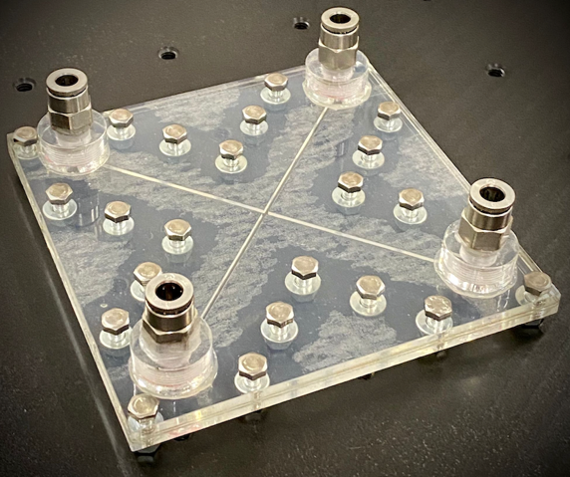
Figure 1. Picture of the fabricated PMMA device for the experiments.

The problem can be described by the Navier–Stokes with transport-reaction equations for the chemical species except water. The set of equations is discretized through the code ANSYS Fluent v. 19, using a steady solver with a second-order upwind scheme and a SIMPLE algorithm for pressure-velocity coupling. More details on the grid resolution and boundary conditions are provided in [6].
3. Results and discussion

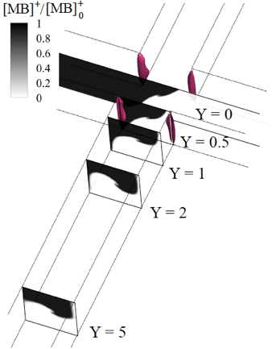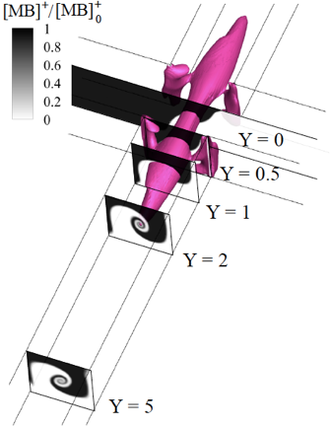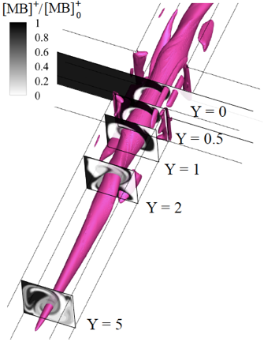
Figure 2. Isosurfaces of the vortex-indicator (λ₂) and contour of non-dimensional MB⁺ concentration along the outlet channel in numerical simulations. Considered case (from left to right): Re=40, Re=50, Re=200.

The different flow regimes are analyzed within the interval Re=10-600. The Reynolds number (Re) is evaluated by considering the physical properties of water. Figure 2 shows the isosurface of vortex-indicator (λ₂) and the contour of non-dimensional MB⁺ concentration along the outlet channel in numerical simulations for Re=40, 50, and 200. At Re=40, the flow stratifies over the mixing channels, and no vortical structures are observed in the confluence region. The impingement plane is slightly tilted as the higher density solution of ascorbic acid moves toward the lower part of the mixing channels. In this flow regime (i.e., stratified regime), mixing is promoted only by the diffusion of the two streams at the contact area. At Re=50, a single vortical structure forms at the channel intersection, extending the contact area and providing more efficient mixing. This central vortex is typical of the engulfment flow regime, which was observed at Re$≈$50 also in water-water and water-ethanol mixtures [5]. By further increasing the Reynolds number, the central vortical structure becomes stronger and elongated in the outlet channels. Furthermore, two additional vortices, counter-rotating with respect to the central vortex, are formed. This feature improves the mixing between the two inlet streams, and thus the reaction yield.
With the increase in Reynolds number, the flow becomes unsteady and time-periodic. Figure 3 shows the isosurface of vortex-indicator (λ₂) and the experimental flow visualization for two instants within a cycle at Re=450. A remarkable agreement between experimental results and simulations is found for the considered Reynolds number. The unsteady engulfment regime was found from Re=375. Here, as found for the steady engulfment regime, the initial flow pattern shows a single vortical structure with two lateral vortices. Subsequently, the central vortex splits into four main vortices, generating a blob of vorticity that is driven downstream along the mixing channels. At the end of the cycle, the four vortices merge into two, extending towards the mixing channels up to about 4 mm. Although the inlet streams are almost completely mixed during the unsteady engulfment regime, the reaction yield decreases with the Reynolds number owed to a reduction in residence time.

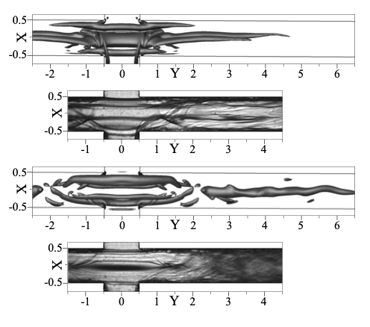
Figure 3. Isosurfaces of the λ₂ vortex-indicator (left) and experimental flow visualizations (right) at Re=450 at different times.

4. Conclusions
Steady and unsteady flow regimes in the X-microreactor were observed experimentally and numerically, finding a good match for the results. The CFD simulations provided an insightful analysis of the flow pattern and the vortical structures that characterized the regimes observed during the experiments. Compared to the stratified regime, the steady and unsteady engulfment regimes can ensure efficient mixing that enhances the microreactor performance, achieving a maximum value in reaction yield at Re=80. By increasing the Reynolds number, the reaction yield decreases as the time-to-react is reduced. When the unsteady engulfment regime occurs (Re=375), the reaction yield raises; then, it decreases again for higher Reynolds numbers. Future works may be addressed to produce nanoparticles through the flash precipitation determined by the rapid mixing of solvent and anti-solvent solutions.
References
- I. Rossetti, M. Compagnoni, Chemical Engineering Journal 296 (2016) 56-70.
- J.W. Zhang, W.F. Li, X.L. Xu, H.F. Liu, F.C. Wang, Physics of Fluids 31 (2019) 034105.
- A. Mariotti, M. Antognoli, C. Galletti, R. Mauri, M.V. Salvetti, E. Brunazzi, Chemical Engineering Journal 396 (2020) 125223.
- A. Mariotti, M. Antognoli, C. Galletti, R. Mauri, M.V. Salvetti, E. Brunazzi, Micromachines 12 (2021) 1–14.
- M. Antognoli, S. Tomasi Masoni, A. Mariotti, R. Mauri, E. Brunazzi, C. Galletti, Chemical Engineering Science 248 (2022) 117254.
- S. Tomasi Masoni, M. Antognoli, A. Mariotti, R. Mauri, M.V. Salvetti, C. Galletti, E. Brunazzi, Chemical Engineering Journal, 437 (2022) 135113.

