Boosting butyrate and hydrogen production in acidogenic fermentation of food waste and sewage sludge mixture

Francesco Valentino^{1*}, Hojjat Borhany¹, Michele Rasera², Alessio Dell’Olivo¹, Paolo Pavan¹, Marco Gottardo¹
¹Department of Environmental Sciences, Informatics and Statistics, Cà Foscari University of Venice, Via Torino 155, 30172 Mestre-Venice, Italy
²Contarina S.p.A., Via Vittorio Veneto 6, 31027 Lovadina di Spresiano (TV), Italy
*Corresponding author: francesco.valentino@unive.it

1.Introduction
The European Union (EU) 2030 strategy leads to ensure sustainable growth via a new and ambitious package of measures on “Circular Economy” (ec.europa.eu, 2020). These measures aim to increase products lifetime and their recyclability benefiting both the environment and the economy. Food waste (FW) management is part of this vision as it allows for conservative use of resources like carbon, nitrogen and phosphorous among the others. Separate collection, which allows to produce streams of recycled materials of good quality level, is a pre-requisite of this global approach. Once this material is collected it is the perfect substrate for the application of fermentative processes able to produce renewable biofuels in a sustainable way [1]. FW production in Europe accounts for about 87.6 million tons annually [2]; over past years, this waste was sent to landfill, without even any treatment, causing severe air, groundwater, and soil contamination due to its high biodegradability and leachate formation. The need different solutions led to food waste treatment with composting, allowing the production of high-quality compost for agricultural applications. However, this process is highly energy consuming and requires the occupation of large land quantities with possible GHG formation [3]. Similar disposal problems are encountered with other organic waste produced in urban areas, especially wastewater sludge (WWS) generated from municipal wastewater treatment processes.
Anaerobic digestion (AD) of one or more organic substrates is a process currently applied also in existing wastewater treatment plants (WWTPs), to stabilize organic matter along with the production of biogas; however, the application of a biorefinery technology chain in urban scenarios, where organic substrates are always available, can foster the combination and valorization of different substrates into added-value marketable products other than biogas alone. In this work, acidogenic fermentation (AF) process has been chosen as key step for the anaerobic treatment of FW and WWS. Volatile fatty acids and hydrogen production has been monitored in terms of yield and process stability as an alternative option to the already established AD technology. In a coupled AF-AD process, a possible gas composition could be 10% H₂, 30% CO₂ and 60% of CH₄ (v/v), for a second-generation biofuel that can be of great interest for combined heat and power (CHP), cogenerated motors or automotive industry (after upgrade for the CO₂ elimination). In addition, within a context of a biorefinery development, the production of a VFA-rich stream at constant concentration and stable chemical features is a key aspect for the market exploitation or the synthesis of added value products.

2. Methods
The substrates used in this study were thickened WWS and mechanically screw-pressed FW, both available in Treviso wastewater treatment plant (northeast Italy). The mixture utilized in this study consisted of 50% of thickened WWS and 50% FW as volumetric ratio. For a part of experiments, the feedstock mixture was thermally hydrolyzed (70°C) in 380 L hyper-thermophilic reactor for 24 h. Thickened WWS had the following characteristics: total solids (TS) 28.6 ± 0.4 g TS/kg, volatile solids (VS) 22.4 ± 0.2 g VS/kg, soluble COD (COD_{SOL}) 0.4 ± 0.1 g/L, total Kjeldahl nitrogen (TKN) 33 ± 2 g N/kg TS, phosphorus (P) 18 ± 1 g P/kg TS; screw-pressed FW had fluctuating characteristics: 44-54 g TS/kg, 37.5-46.0 g VS/kg, 13.2-30.0 g COD_{SOL}/L, 21-28 g N/kg TS as TKN and 4.0-6.0 g P/kg TS.
AF process was carried out in a 230 L Continuous Stirred Tank Reactor (CSTR) that was maintained at a fixed temperature (55°C) by an external thermostatic jacket and stirred with a mechanical impeller at 80 rpm. No inoculum was added. The reactor was fed once per day, in a semi-continuous manner. Three parallel CSTRs were operated for approximately 60 days, under three different hydraulic retention time (HRT): respectively 4.0, 5.0 and 6.0 days. In all the tested conditions, the hydrolyzed feedstock mixture was used the first 32 days; then, the hyper-thermophilic treatment was interrupted until the end of operation. Each condition was compared in terms of VFA yields and composition and hydrogen production. In each reactor, the effluent was collected before the feeding for pH measurements, COD_{SOL} and VFA analysis (roughly three times a week). Gas phase was analyzed twice a week.
The quantification of the VFA was conducted using AGILENT 6890N gas chromatograph equipped with a flame ionization detector (T 200°C), a fused silica capillary column, DB-FFAP (15 m x 0.53 mm × 0.5 μm thickness), and hydrogen was the gas carrier. Biogas production was quantified by a flow meter (Ritter CompanyTM), while CO₂ percentage in the biogas was quantified through a portable infrared gas analyzer GA2000TM (Geotechnical InstrumentsTM). H₂ and CH₄ percentage were determined by a gas chromatograph GC Agilent Technology 6890 NTM equipped with a column HP-PLOT MOLESIEVETM (30 m x 0.53 m ID x 25 μm thickness), using a thermal conductivity detector (TCD) at 250°C using Argon as gas carrier.
3. Results and discussion
The three CSTR runs were performed starting from hydrolyzed feedstock (first phase). The following figure 1 shows the trends of VFA, COD_{SOL} and specific hydrogen production (SHP) in the three runs performed at 4.0, 5.0 and 6.0 days as HRT (respectively A, B and C); the first and second phases are separated by the vertical axis. With reference to VFA and COD_{SOL} of figure 1A (HRT 4.0 days), the values ​​tend to be close on days 9, 15, 21, 23 and 27 while for the rest of the period the VFA/COD_{SOL} ratio was substantially lower. Given the similarity of both parameters in the first phase (after the first week from inoculum), the application of hyperthermophilic pretreatment favored the feedstock acidification. The feedstock shift caused an immediate drop of the acidification performance and only in the last five days it was noticed a realignment of VFA and COD_{SOL} values, suggesting a slow acclimatization of the biomass to the feedstock. The CSTR conducted at HRT 5.0 days (figure 1B) denotes greater congruity of VFA and COD_{SOL} values ​​over time and less variability. Both trends were stable after start-up in the presence of a pretreated feedstock. The growth of VFA and COD_{SOL} in the second period was due to the undesired increase in the organic load (because of the high solids content of the FW). Despite of this, such condition allowed to manage acclimation more efficiently than previously discussed condition. Finally, as regards the third investigated HRT (6.0 days; figure 1C), even reaching higher product concentrations during the second phase, the variability of the values ​​during the entire period of experimentation is such as to make it less preferable than the previous run (HRT 5).
Hydrogen production was quantified as yield, compared to the VS of the feedstock. In all the three runs, hydrogen production seemed to be favored by the utilization of a pre-treated feedstock (first part of the run), achieving values even higher than 0.05 Nm³ H₂/kg VS and up to 33% v/v in the second CSTR at 5.0 days as HRT (figure 1B). As discussed below, the higher H₂ production was linked to the higher level of acetic acid (often above 30% of the total VFA; COD basin), generally observed in the runs conducted with hydrolyzed feedstock compared to the use of not hydrolyzed mixture, independently from the applied CSTR. Also commonly observed, the stability in H₂ yield values was often weak, independently from the hydrolyzation of the feedstock. This is an intrinsic characteristic of the waste fermentation process, especially when a pH-control approach is not adopted. In all the CSTR, the pH was slightly above 5.0 without the need of any control strategy, given the sufficient alkalinity provided by the WWS.

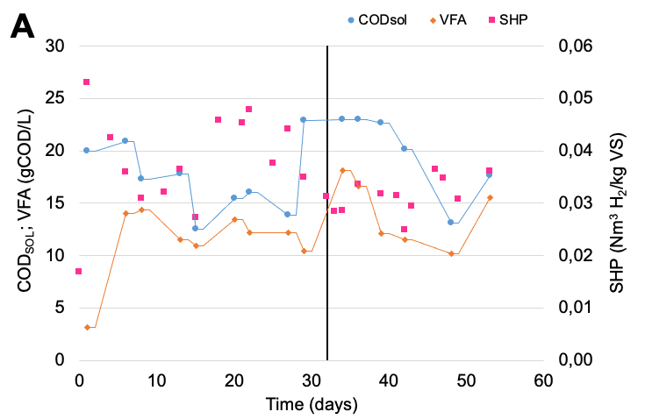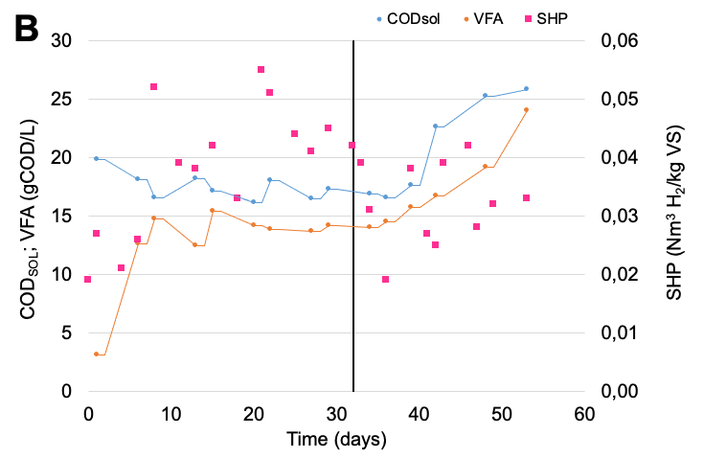
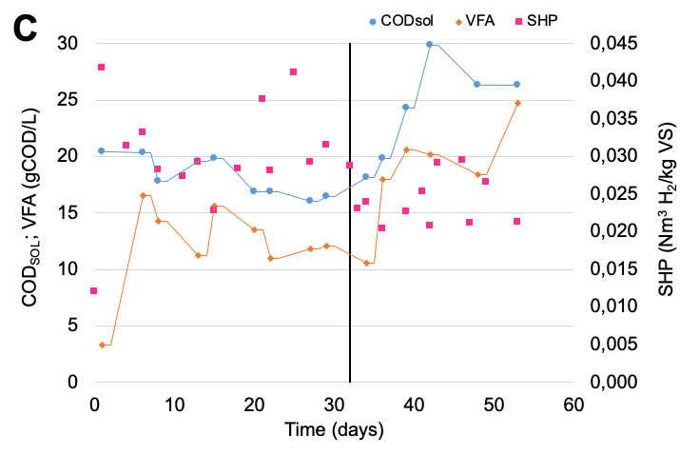
Figure 1. Trends of VFA, COD_{SOL} and SHP in the three runs performed at 4.0 days (A), 5.0 days (B) and 6.0 days (C) as HRT.
In terms of VFA spectrum, the three runs showed similar results, with a clear stability in the concentration of each single acid more noticeable when hydrolyzed feedstock was used. In general, all the conditions investigated, acids from C5 (valeric) to C7 (heptanoic) represented, individually, contributions ​​equal to or less than 5% (COD basin) of the total VFA; therefore, the operating conditions applied must be considered unsuitable to produce longer-chain acids. Butyric acid was the main product, representing values between 30-45% with hydrolyzed feedstock and 55-70% with not hydrolyzed feedstock (COD basin). The contribution of acetic acid in the first phase, where H₂ production was higher, was in the range 15-40%, greatly reduced in the second phase where it was often below 10% (COD basin).
4. Conclusions
Acidogenic fermentation of FW and WWS was investigated in a total of six different conditions, by changing the HRT and applying a short-term hyperthermophilic pretreatment as hydrolysis. In terms of process stability, H₂ production potential and acidification yield, the condition having 5.0 days as HRT conducted with hydrolyzed feedstock gave better results: 0.042 ± 0.03 Nm³ H₂/kg VS, 0.52 ± 0.02 g VFA/g VS and 0.81 COD_{VFA}/COD_{SOL} ratio. Despite of the higher fluctuations observed on the performances when the not hydrolyzed substrate was used, the selective production of butyric acid (up to 70% COD basin) is of a remarkable interest, since it is one of the higher market values compared to other VFA, with many possible application (flavoring, pharmaceuticals, food additive).

References
- F. Valentino, G. Munarin, M. Biasiolo, C. Cavinato, D. Bolzonella, P. Pavan, J. Env. Chem. Eng. 9 (2021) 106062.
- B. Colombo, F. Favini, B. Scaglia, T.P. Sciarria, G. D’Imporzano, M. Pognani, A. Alekseeva, G. Eisele, C. Cosentino, F. Adani, Biotechnol. Biofuels 10 (2017) 201.
- G. Moretto, I. Russo, D. Bolzonella, P. Pavan, M. Majone, F. Valentino, Wat. Res. 170 (2020) 115371.

