CFD-DEM simulations of shear-activated nanotherapeutic particles
Lorenzo Vasquez Giuliano^{1*}, Graziano Frungieri², Antonio Buffo¹, Marco Vanni¹
1 Department of Applied Science and Technology, Politecnico di Torino, Torino, Italy
2 Lehrstuhl für Systemverfahrenstechnik, TUM School of Life Sciences,
Technische Universität München, Gregor-Mendel-Straße 4, 85354 Freising, Germany
*Corresponding author E-Mail: lorenzo.vasquez@polito.it
1. Introduction
The obstruction of blood vessels due to clots is a worldwide leading cause of death. The treatment of ischemic pathologies caused by obstruction clots is a major issue in this field: a tissue plasminogen activator is administered to the patient to dissolve the clot and restore the normal blood flow [1,2]. This is the only FDA-approved treatment, but it presents some limitations: it requires a tempestive administration of the protein (within 3 hours from the onset of the ischemic symptoms) and the administered dose must be monitored to limit the amount of active agent that is free to circulate in the patient’s body.
A plethora of targeted drug delivery strategies have been considered to face this challenge. One of the most promising approaches is based on shear-activated nanotherapeutics and has been proposed by Korin and coworkers [3]. Polymeric nanometer-sized particles are coated with the active agent and constitute a micrometer-sized aggregate, or cluster. The strategy is inspired by the activation mechanism of natural platelets, and it is based on the effects of the flow field distortion caused by the obstruction itself. The cluster is designed to be stable, or de-activated, if subjected to a normal blood flow field, while it breaks when subjected to the local increase of the hydrodynamic forces caused by the clot. The breakup of the cluster generates smaller fragments that are more likely to adhere to the clot and perform the thrombolytic action. Among the other advantages, this approach does not require precise knowledge of the clot position or any external activation mechanism, thus offering a potential innovative approach for the treatment of life-threatening diseases that result from acute vascular occlusion.
An accurate tuning of the properties of the drug carrier is fundamental to achieve remarkable results in this field of application. At the early stage of drug carrier design, valuable insights can be obtained by coupling in-vitro experiments with numerical simulations. Breakup tests of plausible drug carrier morphologies can be performed in a microfluidic device that mimics an obstructed blood vessel, while computational fluid dynamics (CFD) simulations can be used to predict wall shear stress distribution inside the device. However, the mechanical response of clusters to the fluid dynamic stress is also crucial and needs to be investigated as well [4]. A discrete element method (DEM) can track the motion of every single primary particle in the cluster based on the forces acting on it, considering both the adhesive force binding a pair of particles together and the force exerted by the fluid on the discrete, dispersed phase [5,6]. Fluid dynamic forces are modelled by resorting to Stokesian dynamics [7], a method that has been widely employed to predict cluster restructuring and breakup in simple and complex flow field configurations [8-12].
The present work illustrates a numerical investigation of the flow field characteristics in obstructed blood vessels and in a microfluidic device realized for future in-vitro experimentations. The shear stress exerted by the fluid on the dispersed phase is converted by DEM simulations into the mechanical stress distribution acting in clusters, to predict the occurrence of breakup.

2. Methods
CFD simulations have been employed to compute the steady-state flow field of a fluid inside the vessel, whereas DEM simulations based on Stokesian dynamics have been used to investigate the mechanical response of three different drug carrier morphologies placed in the flow field. The simulated fluid is water. It is Newtonian and incompressible and its flow regime is assumed to be laminar. Clusters have been treated as tracer particles passively carried by the flow field, to evaluate the hydrodynamic forces exerted by the fluid on them. CFD simulations have been conducted using ANSYS Fluent 20 by solving the continuity and momentum transport equations and by coupling pressure and velocity with a SIMPLE algorithm.
Axisymmetric and asymmetric deformed cylindrical tubes have been chosen as a valuable approximation of an obstructed blood vessel [13,14], whereas the microfluidic device has a rectangular section. The three geometries present a pre-stenotic tract, a stenotic tract with 95% lumen obstruction, and a post-stenotic tract. The flow rate has been adjusted according to a trial-and-error procedure until the same pathological values of wall shear stress onto the obstruction were reached.
Three types of cluster morphologies have been considered: porous isostatic aggregates, spherical random close packing aggregates (RCP) and hollow aggregates (Figure 1). Porous aggregates result from a numerical reproduction of a diffusion-controlled aggregation process. These aggregates are isostatic, i.e., the failure of a single bond leads to the collapse of the entire structure. However, drug carriers are often produced via spray-drying. During a spray-drying process, the Péclet number plays a relevant role [15]. The Péclet number compares the diffusion velocity with the shrinkage velocity: if the diffusion of the particles inside an evaporating droplet is faster than the droplet shrinkage, the concentration of primary particles is kept homogeneous throughout the process and the resulting cluster is compact. On the other hand, particles accumulate at the periphery of the droplet if the shrinkage is faster than the diffusion, thus leading to shell-type aggregates with a pronounced void at their core. In this work the former output of a spray-drying process is generated by a Random Close Packing algorithm, i.e., minimizing the void fraction of the cluster, while the latter output is generated by removing internal particles from the RCP clusters. These classes of clusters are hyperstatic, and the failure of a single bond does not necessarily lead to the collapse of the entire structure.
Stokesian dynamics allows one to express the relationship between hydrodynamic force and torque and the relative velocity of primary particles compared to the velocity of the undisturbed flow at the particle position, through the definition of a mobility matrix. Therefore, hydrodynamic forces and torques acting on each primary particle of the aggregate can be evaluated. In our simulations, clusters are supposed to be rigid; hence deformation and breakup of clusters are not modelled, but tensile forces acting inside the clusters are known, thus giving valuable insights about the stability of the structure. The normal force acting at the contact region between each pair of primary particles is obtained by linearisation of the JKR theory [16], whereas the models by Dominik and Tielens and Marshall [17,18] are employed to calculate tangential force, bending moment and torsional moment.

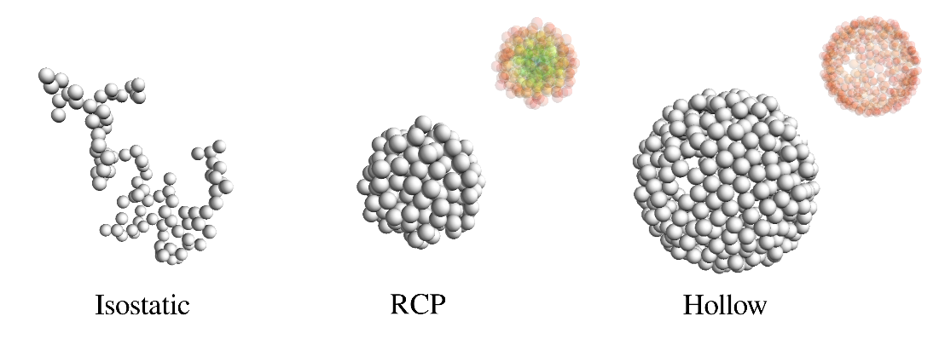
Figure 1. Isostatic, Random Close packing (RCP) and hollow aggregates. The difference between
the compact core of RCP and the empty core of hollow aggregates is highlighted by a colormap.

3. Results and discussion
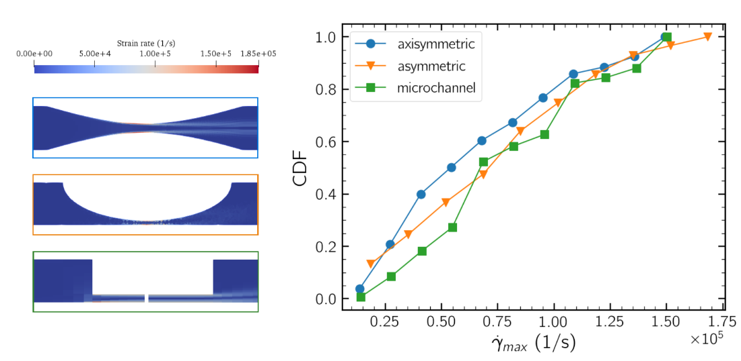
Figure 2. Left: strain rate contour on the longitudinal plane for axisymmetric and asymmetric obstruction and for the microchannel. Right: Cumulative Distribution Function of the maximum strain rate along trajectories in the three vessels.
The flow field in the three vessels has been fully characterized, and thus valuable insights about the hydrodynamic forces and the recirculation phenomena have been inferred. A peak of hydrodynamic forces has been found right onto the obstruction and the formation of vortices at the end of the stenotic tract has been observed. As mentioned above, the strain rate peak is a potential trigger for the activation of drug carriers flowing in blood vessels, i.e., for their breakup right onto the clot. Moreover, recirculation phenomena can keep the generated fragments in proximity to the stenotic tract. A large dataset of tracer trajectories has been extracted, and for every trajectory the maximum experienced strain rate has been calculated. A cumulative distribution function (CDF) of the maximum strain rate encountered by particles flowing in the three vessels can be extracted (Figure 2), thus proving that our microfluidic device well approximates the flow field in an obstructed blood vessel, and therefore it is suitable for experimental trials.
The breakup of clusters is a direct consequence of the internal tensile stress generated by the surrounding flow field, and the stresses acting on clusters depend on both the local strain rate and the geometry of the cluster itself. The strain rate signals obtained in the microchannel have been converted into tensile stress acting at contact regions between primary particles by using Stokesian dynamics simulations. The mechanical response of isostatic, RCP and hollow clusters to the hydrodynamic solicitation exerted by the flow-field in the microfluidic device has been studied. The CDFs in Figure 3 have been obtained from the maximum tensile stress experienced by a cluster along its path in the vessel. Internal stresses inside RCP clusters are low, therefore they are the most resistant class. Isostatic clusters show intermediate behaviour, while hollow clusters are the most fragile ones. As shown in Figure 3, the highest tensile stresses in isostatic clusters have been found at the core of the cluster and the fragments generated after a breakup event should be expected to have comparable dimensions. In RCP clusters the highest tensile stresses are in the outer region of the cluster because of their hyperstaticity, so breakup should lead to the detachment of small fragments from their outer surface. The distribution of mechanical forces inside the hollow clusters is similar, the shell-shape of the cluster limits the discharge of mechanical stress that characterizes a hyperstatic cluster. Therefore, the breakup of outer bonds should lead to the opening of the shell structure.
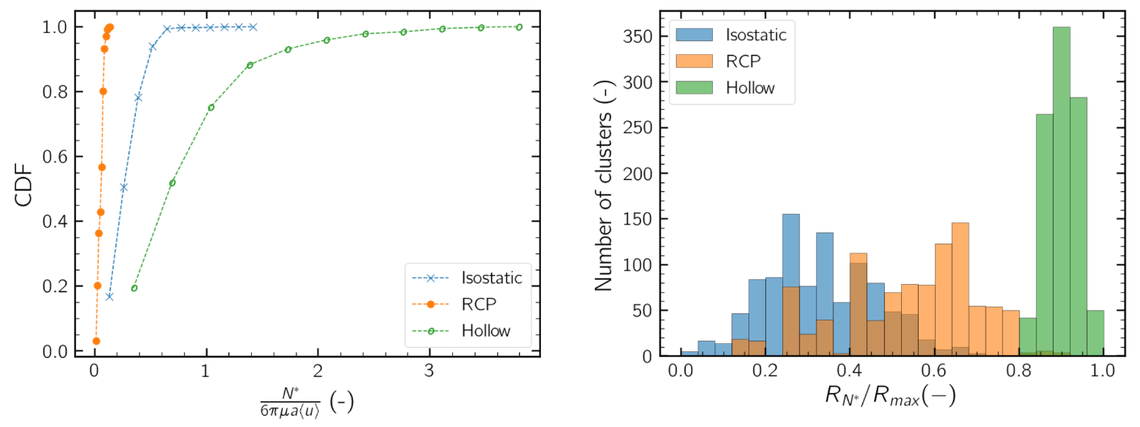
Figure 3. Left: Cumulative Distribution Function of the maximum tensile stress experienced by isostatic, RCP and hollow clusters flowing in the microchannel. Right: histogram showing the relative position of the most stressed bond in every aggregate.
4. Conclusions
CFD simulations of the flow field in obstructed vessels showed that fluid dynamic forces locally increase because of the lumen restriction. The microfluidic device represents a valid approximation of the flow field characteristics in clot-obstructed blood vessels and can therefore be employed for future in-vitro experimentations.
The local increase of fluid dynamic forces translates into a mechanical stress distribution inside clusters of particles flowing in the microchannel, and the magnitude of these mechanical stresses has been computed thanks to DEM simulations based on Stokesian dynamics. Compact aggregates are the most resistant ones, while hollow aggregates are the weakest class. The local increase of fluid dynamic stresses can effectively act as a trigger for the activation of drug carriers.
Such results will be used to effectively design drug carriers that are suitable for the proposed targeting strategy, thanks to an experimental campaign and the refinement of DEM breakup simulations.
References
[1] J. Grotta, J. Marler, Surg. Neurol. 2007, 68, S12.
[2] G. D. Graham, Stroke 2003, 34, 2847.
[3] N. Korin, M. Kanapathipillai, B. D. Matthews, M. Crescente, A. Brill, T. Mammoto, K. Ghosh, S. Jurek, S. A. Bencherif, D. Bhatta, et al., Science, 2012, 337, 738.
[4] M. Soos, L. Ehrl, M. U. Bäbler, M. Morbidelli, Langmuir 2010, 26, 10.
[5] G. Frungieri, M. Vanni, Powder Technol. 2021, 388, 357.
[6] G. Frungieri, M. U. Bäbler, M. Vanni, Langmuir 2020, 36, 10739.
[7] L. Durlofsky, J. F. Brady, G. Bossis, J. Fluid Mech. 1987, 180, 21
[8] M. Vanni, A. Gastaldi, Langmuir 2011, 27, 12822.
[9] M. Vanni, Comput. Phys. Commun. 2015, 192, 70.
[10] G. Frungieri, M. Vanni, Can. J. Chem. Eng, 2017, 95, 1768-1780.
[11] Y. M. Harshe, M. Lattuada, The Journal of Physical Chemistry B 2016, 120, 7244.
[12] G. Frungieri, G. Boccardo, A. Buffo, D. Marchisio, H. A. Karimi-Varzaneh, M. Vanni, Can. J. Chem. Eng. 2020, 98, 1880
[13] Y. Zhou, C. Lee, J. Wang, J. Healthc. Eng. 2018, 2018.
[14] G. Lorenzini, E. Casalena, J. Biomech. 2008, 41, 1862
[15] E. Lintingre, F. Lequeux, L. Talini, N. Tsapis, Soft Matter 2016, 12, 7435
[16] K. Johnson, K. Kendall, A. Roberts, Proceedings Royal Society London A 1971, 324, 301.
[17] C. Dominik, A. Tielens, Astrophysical Journal 1997, 480, 647.
[18] J. Marshall, J. Comput. Phys. 2009, 228, 1541.

