One-way vs two-way coupling approach for predicting Brownian-Sieving Hydrodynamic Chromatography separation performance

Claudia Venditti^{1*}, Stefano Cerbelli¹, Alessandra Adrover¹
¹ Sapienza University of Rome, Dept. Chemical Engineering, Materials, Environment, Via Eudossiana 18, 00184 Rome, Italy.
*Corresponding author E-Mail: claudia.venditti@uniroma1.it

1.Introduction
Recently, a one-way coupling approach was exploited to optimize the geometry and the operating conditions of a Brownian Sieving Microcapillary Hydrodynamic Chromatography device (BS-MHDC), an unconventional MHDC double-channel device, where a Brownian sieving mechanism acting alongside the MHDC separation drive is enforced to boost separation resolution [1-2].
The BS-MHDC consists of a two-channel coaxial annular structure, where the core and the annular channel communicate through slit openings of assigned cut-off length A. The geometry is designed so that the core and the annular channel are characterized by significantly different average velocities of the eluent. When a mixture of particles of two characteristic sizes, say d¹_{p} and d²_{p} with d¹_{p} > A > d²_{p}, is initially injected only within the core channel, both large and small particles flow downstream the channel under the action of the eluent pressure-driven laminar flow. Particles of diameter d²_{p}, smaller than A, can diffuse through the openings and eventually attain a uniform distribution onto the entire accessible cross-section, so their effective velocity will be affected by the average eluent velocity in both the core and annular channel. On the contrary, particles of diameter d¹_{p}, bigger than A, are confined to the core region so that their effective velocity is influenced only by the average eluent velocity within this region.
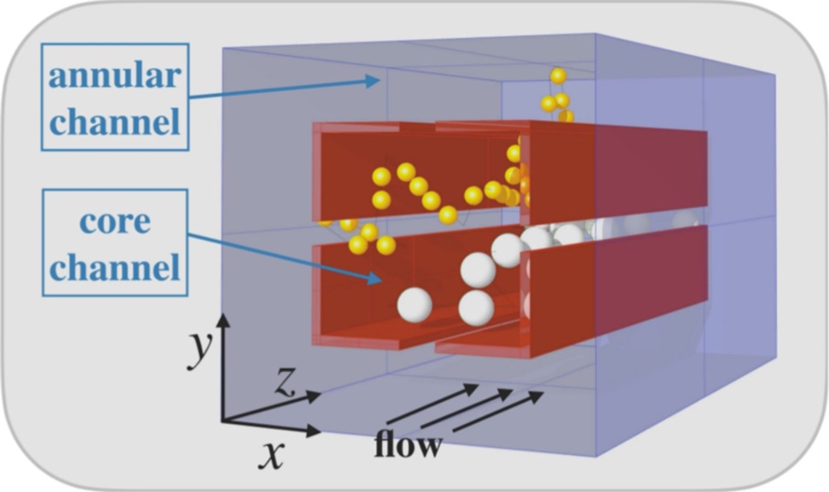
Figure 1. Schematic representation of the double-channel BS-MHDC device.
Previous approaches for quantifying the device performance hinged on the so-called one-way coupling excluded-volume approximation, in which the eluent flow is computed as a single-phase Stokes problem, and the particle-wall interactions are crudely simplified by only considering hindrance effects due to the finite size of the particle.
Bounds for the accuracy of the one-way coupling approach have been investigated in the literature only in single-channel geometries [3], where it is possible to single out a unique characteristic dimension of the cross-section which constitutes the reference length for scaling the particle size. On the contrary, the Brownian sieving device considered here possesses multiple reference lengths of the cross-section (the diameter of the core channel, the thickness of the annular channel and the slit opening A), which make the limits of validity of the one-phase approach uncertain.
The scope of this work is to explore these limits, comparing the predictions of the separation performance obtained with the one-way coupling approach with those obtained from a fully three-dimensional two-way coupling approach. Brenner's macro-transport theory [3-4] is used in both cases for obtaining the effective transport parameters, namely the effective particle velocity and the dispersion coefficient.
References
- V. Biagioni, A. L. Sow, A. Adrover, and S. Cerbelli, “Brownian sieving effect for boosting the performance of microcapillary hydrodynamic chromatography. proof of concept,” Analytical Chemistry 93, 6808–6816 (2021).
- V. Biagioni, A. L. Sow, A. G. Fagiolo, A. Adrover, and S. Cerbelli, “Brownian sieving enhancement of microcapillary hydrodynamic chromatography. analysis of the separation performance based on Brenner’s macro-transport theory,” Journal of Chromatography A , 462652 (2021).
- H. Brenner and L. J. Gaydos, “The constrained brownian movement of spherical particles in cylindrical pores of comparable radius: models of the diffusive and convective transport of solute molecules in membranes and porous media,” Journal of Colloid and Interface Science 58, 312–356 (1977).
- A. Adrover, C. Passaretti, C. Venditti, and M. Giona, “Exact moment analysis of transient dispersion properties in periodic media,” Physics of Fluids 31, 112002 (2019).

