A multi-objective optimization approach for preliminary design of economical and environmentally sustainable CO₂ transport pipelines

Francesco Zanobetti¹, Haroun Mahgerefteh², Sergey Martynov², Valerio Cozzani¹*
1 LISES - Laboratory of Industrial Safety and Environmental Sustainability,
Department of Civil, Chemical, Environmental and Materials Engineering, University of Bologna,
via Terracini 28, 40131 Bologna, Italy;
2 Department of Chemical Engineering, University College London, London, WC1E 7JE, UK
*Corresponding author e-mail: valerio.cozzani@unibo.it

1. Introduction
Carbon Capture and Storage (CCS) is widely recognized as a key CO₂ emissions abatement strategy in meeting the ambitious 2050 net zero emission target [1]. In this regard, pressurized pipelines represent the most economic and safest method of large-scale CO₂ transport for final geological storage [1 – 2]. The design of such transport infrastructures with the aim of significantly reducing costs and environmental impacts is therefore paramount for boosting the large-scale deployment of CCS. In this study, an approach for multi-objective optimization with respect to economic and environmental issues is presented as a decision tool supporting the preliminary design of CCS transport pipelines. This consists in a first analysis of the Pareto Front [3] for identifying a set of cost-effective and environment-friendly design trade-offs, followed by a quantitative assessment procedure based on the aggregation of Key Performance Indicators (KPIs) to identify the most effective alternative. The application of the methodology is exemplified for a point-to-point CO₂ pipeline and benchmarked against an alternative single-objective optimization route.
2. Methods
The optimal CCS pipeline design with respect to economic and environmental performance is formulated in terms of a multi-objective optimization problem. Levelized Cost of CO₂ transport (LC) and the amount of greenhouse gases emitted annually due to electricity consumption are accordingly set as the economic and environmental objective functions respectively, whereas the Nominal Pipe Size (NPS) is assumed as the decision variable. LC is obtained by dividing the annualized sum of CAPEX, OPEX and Operational & Maintenance (O&M) costs of the pipeline and upstream compression plant with the mass of CO₂ transported annually [4]. A European-wide Electricity Emission Factor (EEF) [5] is considered to model the CO₂ equivalents of annual GHG emissions per unit of electrical power demanded by compressors and pumps. Solving the multi-objective problem leads to identify the Pareto Front, where none of the design option is best for minimizing both objectives. In order to aid the selection of optimal solutions, a Level Diagrams visualization techniques is used [3]. This involves computing norm metrics quantifying the distance between a given design option and the ideal solution simultaneously optimizing both objectives. Three design options lying on the Pareto Front and presenting the lowest values of norm metrics are therefore selected as the optimal solutions to be further assessed by a quantitative methodology based on impact indicators [6]. The economic performance is assumed being quantified by the LC of CO₂ transport, whilst the Global Warming Potential Impact Factor (PIF_{GW}) is considered to account for the environmental impact due to global warming. Economic and environmental impact indicators are then normalized and aggregated to produce an overall performance index for each alternative. A single CO₂ point-to-point pipeline is considered as a case-study, for which both the proposed multicriteria optimization route and the single-objective optimization of the transport cost of avoided CO₂ emission (i.e., CO₂ transported diminished by the amount of CO₂ equivalents emitted annually) are solved for a comparative analysis. The uncertainty affecting the estimation of CO₂ transport cost values is assessed by a Monte Carlo probabilistic approach.
3. Results and discussion
Figure 1 shows a graphical representation of the solution of the multi-objective optimization problem.
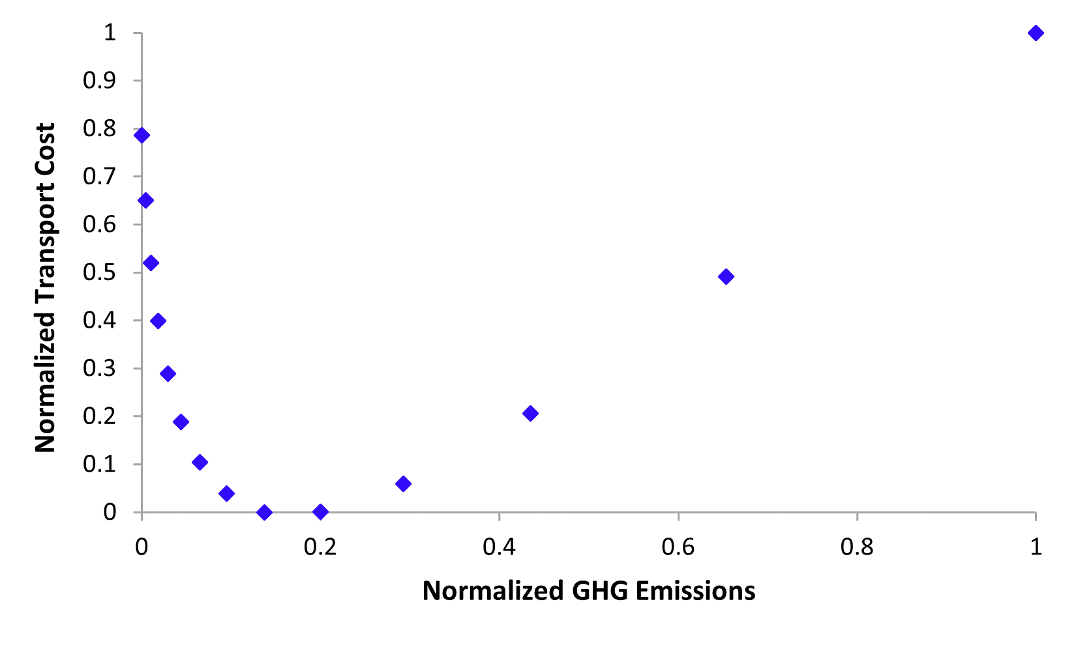
Figure 1. Representation of the multi-objective optimization problem and the corresponding Pareto Front.
As shown in Figure 1, a set of design trade-off points constituting the Pareto Front appears as the normalized value of GHG emissions spans the range from 0 to 0.2. The three optimal solutions minimizing the norm metrics are found to be NPS 28, 30 and 32. Therefore, these diameters were assessed by multi-criteria aggregation of economic and environmental KPIs. Equally weighing levelized cost of CO₂ transport and emitted GHG results in an overall optimal solution equal to NPS 30, whereas the design option given by the single-objective optimization of the transport cost of CO₂ avoided is NPS 28. Since compression power demand turns out to increase as NPS diminishes, it may be argued that lumping the minimization of economic and environmental issues in a single-objective problem rather than following the multicriteria route would lead to select a design option with a greater energy consumption and a higher global warming contribution, thus favoring lower transport costs over higher environmental impacts. The Monte Carlo sensitivity analysis of the transport cost considering the input variables giving the highest uncertainties in the cost assessment results in an unchanged economic ranking of alternatives, thus confirming the robustness of the CO₂ transport cost model used in the analysis.
4. Conclusions
A multicriteria optimization approach for the preliminary design of cost-optimal and environment-friendly CCS pipelines was developed and tested. The ranking of the overall economic and environmental performance of alternatives obtained by multicriteria weighted summation of KPIs turned out to provide an effective metric to guide the preliminary selection of one or more “best design” solutions. Comparing the proposed approach against a more conventional single-objective optimization pathway for a given case-study highlighted the possibility of underestimating environmental issues when not undergoing a multicriteria solution route. Overall, the optimization approach presented provides the decision makers with a flexible decision tool where each impact category may be appropriately weighed according to either local sustainability policies or case-specific expert judgment to arrive at the most economic and environmentally sustainable pipeline transport solution. A Monte Carlo probabilistic analysis is ultimately developed to assess the reliability of the applied CO₂ transport cost model when accounting for uncertainties in its input parameters.
References
- B. Metz, O. Davidson, H. de Coninck, M. Loos, L. Meyer (Eds.), IPCC Special Report on Carbon Dioxide Capture and Storage. Prepared by Working Group III of the Intergovernmental Panel on Climate Change, Cambridge University Press, Cambridge, 2005.
- World Resource Institute (WRI), CCS Guidelines: Guidelines for Carbon Dioxide Capture, Transport and Storage, WRI, Washington DC, 2008.
- E. Zio, R. Bazzo, Reliab. Eng. Syst. 96 (2011) 569–580
- M.M.J. Knoope, W. Guijt, A. Ramírez, A.P.C. Faaij, Int. J. Greenh. Gas Control 22 (2014) 25–46
- The Covenant of Mayors, Technical annex to the SEAP template instruction document: the emission factors.
- A. Tugnoli, F. Santarelli, V. Cozzani, Environ. Sci. Technol. 42 (2008) 4555–4562

