Electrification of methane steam reforming on Joule-heated SiSiC foams washcoated
with a Rh/Al₂O₃ catalyst
Matteo Ambrosetti, Lei Zheng, Francesca Zaio, Alessandra Beretta, Gianpiero Groppi and Enrico Tronconi *
1 Laboratory of Catalysis and Catalytic Processes, Dipartimento di Energia, Politecnico di Milano, Italy
*Corresponding author E-Mail: enrico.tronconi@polimi.it

1.Introduction
Methane steam reforming (MSR) is the process of choice for more than half of the global hydrogen production. Industrial scale MSR is typically carried out in multi-tubular reactors operated at high flow rates and externally heated by burning an additional amount of methane, which is responsible for roughly half of the CO2 emission of the process.[1] In view of largely accessible renewable electricity, the so-called power-to-X (P2X) represents a promising way to address the challenge of decarbonization and provide an option for chemical storage of the excess energy. Electricity can be converted into heat and transferred to thermally driven chemical reactors. Recently, Wismann et. al. [2] proposed an innovative reactor concept for direct Joule heating of a washcoated FeCrAl-alloy tube for methane steam reforming. CH4 conversion close to 87% was obtained with outlet temperature up to 900 °C. As an environmental benefit, a CO2 reduction of 20-50% was achieved when compared with industrial reformers.
Open cell foam-based substrates can be also conceived as heating resistances for the electrification of catalytic processes.[3] The porous structure of foams enables a higher catalyst inventory than washcoated tubes thanks to their high specific surface area and allows uniform heating inside the reactor tubes. Therefore, the application of foams has the potential to overcome heat and mass transfer limitations in electrified methane steam reforming (eMSR), being the external mass transfer one of the limiting factors in the configuration proposed by Wismann and coworkers.[2] In this work, a novel reactor configuration is proposed and experimentally demonstrated for the electrification of MSR using direct Joule heating of a washcoated foam. A cylindrical Si-infiltrated silicon carbide foam was washcoated with Rh/Al2O3 catalyst and electrically connected to power supply as shown in Figure 1a. We show that it provided optimal heat and mass transfer properties and efficient inner heating for the steam reforming reaction.
2. Methods
A commercial SiSiC foam (Erbicol, CH) with cylindrical geometry (dfoam = 3.2 cm, Lfoam = 9.9 cm) was adopted in the present work. A1%Rh/Al2O3 catalyst was prepared via an incipient-wet impregnation method by using Al2O3 powder (Sasol, PURALOX) and rhodium precursor (Rhodium (III) nitrate solution, Alfa Aesar). The washcoating of the SiSiC foam was obtained by dipping, spinning and flash drying processes. Foams with different loadings, from 2.2 up to 4 g of catalyst over ½ and ¾ of the foam length were prepared, corresponding to a catalyst inventory in the range of 40-85 g/lit.
Catalytic tests were performed at different GHSV up to 200.000 cm³/h/gcat (STP) with a non-diluted gas feed of CH4 and H2O (steam to carbon ratio of 4.1) at ambient pressure. Downstream from the reactor, water was removed from the products by a condenser and the dry gas mixture was analyzed using an online micro-GC (Agilent, 900 Micro GC).
3. Results and discussion
Figure 1shows the schematic representation of the electrified methane steam reforming reactor layout proposed in the present work. The washcoated SiSiC foam was placed in a tubular stainless-steel tube reactor (OD = 5 cm). A ceramic tube was inserted between the foam and the stainless-steel tube to avoid electric contact. To connect the foam with the power generator, home-made electric sockets were adopted. A thin layer of copper foam was placed between the foam and the electric plate to ensure a good electrical contact. The electric plates are connected to a DC power generator. K-type thermocouples, electrically insulated by ceramic thermocouple wells, are placed inside the electric contactors to measure the temperatures at the upper side and at the bottom of the foam.
Thanks to the interconnected geometry and the proper bulk resistivity of the SiSiC foam, the structured catalyst could be directly heated by the Joule effect (ohmic heating). Methane conversions approaching equilibrium were obtained across a range of conditions, with almost full methane conversion achieved above 700 °C, as shown in Figure 2(a). The foam-based eMSR system showed a high energy efficiency, which was found to be a strong function of the space velocity and reached a maximum of nearly 70% at lab-scale conditions.

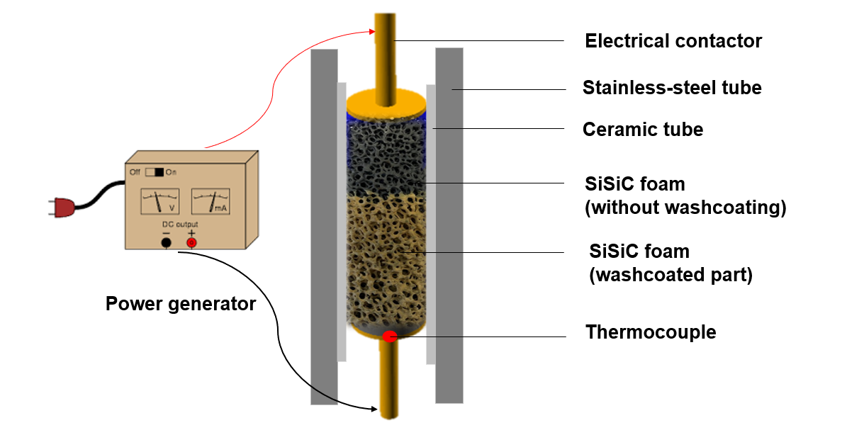
Figure 1 Schematic representation of the electrified methane steam reforming reactor layout
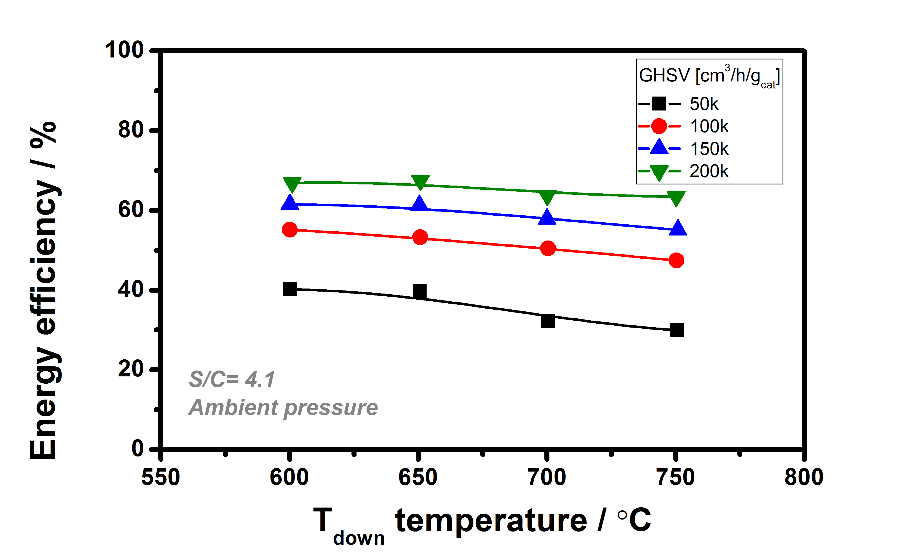
Figure 2. (a) CH₄ conversion and (b) thermal efficiencies as a function of GHSV for different space velocities
4. Conclusions
When driven by renewable electricity, such a reactor configuration promises a high potential to reduce CO₂ emissions in hydrogen production providing potential for process intensification with high H2 productivities per volume and per kg of catalyst. Such a concept can be exploited also for many other endothermic processes, granting CO2 savings.
References
- Holladay J.D., Hu J. et. al., Catalysis Today 139, 244 (2009).
- Wismann S.T., Engbæk J.S. et al, Science 364, 756 (2019).
- Badakhsh A., Kwak Y. et al, Chemical Engineering Journal, 426, 130802 (2021).

Acknowledgements
We acknowledge financial support from MIUR - Progetto PRIN 2020N38E75 “PLUG-IN”.

