Fractionation of three-particles mixture by Brownian Sieving mechanism

Valentina Biagioni*, Alessandra Adrover, Stefano Cerbelli

Dipartimento di Ingegneria Chimica, Materiali, Ambiente, Sapienza Università di Roma,
Via Eudossiana 18, 00184 Roma, Italy
*Corresponding author E-Mail: valentina.biagioni@uniroma1.it
1.Introduction
Measuring the size distribution of a population of nanometric particles is an important step in a variety of applications, ranging from biological essays to environmental sensors [1-3]. Due to its simplicity and high sample recovery, hydrodynamic chromatography remains a promising technique to sort nanoparticle mixtures. The separation mechanism of HDC is based on the combined effect between the drag action of a parabolic flow profile along the axial coordinate of the channel and transversal particle diffusion. Thanks to the latter, particles can experience different velocities depending on their size. Owing to reduced size, smaller particles can diffuse closer to the solid walls than the bigger ones and experience the low-velocity region of the eluent flow, whereas the largest particles are forced to travel in the central region, which is characterized by higher velocity values; consequently, they gain a higher average velocity than the smaller ones. The difference between the average velocity of particles of different sizes provides the driving force for the separation. This difference depends on the aspect ratio between the particle size and the width of cross-section. In standard HDC channels, this difference is typically weak, and it decreases as the particle size approaches the tens-of-nanometer range.[4] To avoid this problem and enhance the difference of the average velocities of the different types of particles, an alternative separation method, called Brownian sieving, has been theorized to separate a particle suspension [5-6]. The Brownian sieving HDC method exploits a two-channel annular geometry, where the internal (core) channel communicates with the external annular channel through openings of assigned length. The suspension is loaded inside the internal core. As they flow through the channel, particles smaller than the opening width are allowed to cross the openings and spread throughout the entire cross-section. Different average velocities of the eluent in the core and annular channel can be obtained by adequately designing the double channel geometry. Therefore, by tuning the width of the external section, it is possible to control the average velocity of particles of size below and above the opening width. Thus, in the Brownian sieving separation mechanism, the driving force is essentially governed by the width of the openings, and the ratio of the particle diameter to the characteristic dimension of the cross-section plays only a minor role. A proof of concept for BS-HDC has been demonstrated to separate a two-particle mixture. Here, we generalize the method and consider the simultaneous separation of suspensions of three nominal sizes in the same device. This is accomplished by changing the width of the openings along the channel (see. fig.1). Based on these preliminary results, the multi-stage Brownian sieving device could provide an efficient alternative to standard HDC methods.
2. Methods
The separation of three or more different sizes of particles can be obtained by enforcing different opening widths downstream the channel. The suspension is loaded inside the core channel, the first segment (Z1) of the device supports the smallest opening (λ1). Thus, within this segment, only the smallest particles can spread into the entire cross-section of the channel. Once the smallest particles are separated from the others, the width of the openings increases and the medium-sized particles can spread into the entire cross-section. In light of this, the separation of three or more particle sizes can be achieved by sequentially increasing the width of the openings along the channel. The length of each segment is designed so that a complete separation of the particles passing through the openings from the rest of the suspension has been realized (see fig.1).

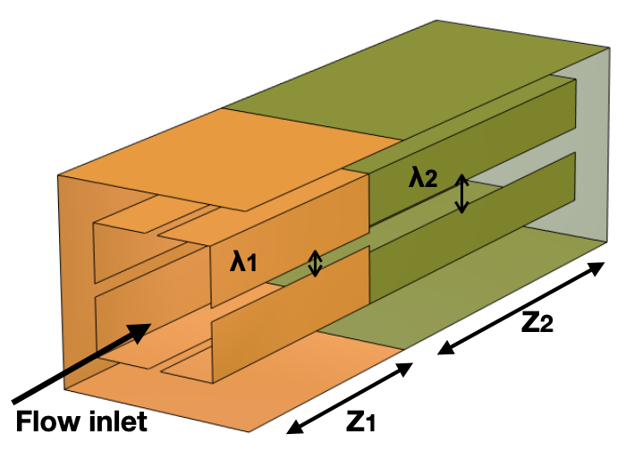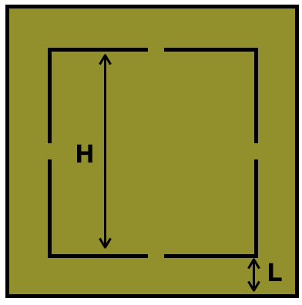
Figure 1. Device geometry
A Stochastic-Lagrangian approach has been used to simulate the trajectories of order fifty thousand particles for each size, and the separation efficiency of BS-HDC has been compared to the standard hydrodynamic chromatography. The model of particle dynamics considers the finite size of the particles, the fluid drag, and Brownian diffusion. The finite size of the particles is evaluated by simply excluding a volume equal to the radius of the particle from the solid walls. The convective term is quantified as equal to the velocity of the one-phase flow computed at the center of mass of the particle, thus assuming that the particles are in the overdamped regime. Finally, the Brownian diffusion is added as stochastic Wiener process.
3. Results and discussion
In figure 2 is shown the comparison between the swarms of particles characterized by a radius of 100 nm, 50 nm, and 25 nm, at an eluent velocity of 11 μm/s, for a width of 2 μm (H) and 0.6 μm (l) of the core and the annular channel, respectively. One can observe how the separation in the BS-HDC is reached by using a device long 1.5 mm while particles are all still overlapped in standard HDC. Note that to achieve the same BS-HDC resolution, standard hydrodynamic chromatography requires a device length of 40 mm. As regard the total analysis time, about 2 min and 60 min are needed for BS-HDC and HDC, respectively.
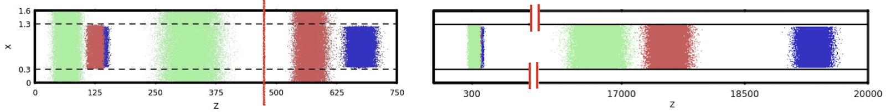
Figure 2: Particle dynamics for BS-HDC (right) and HDC (left) for particles of 100,50 and 25 nm.
4. Conclusions
The Brownian sieving mechanism can separate nanoparticles in a very short length and low operation time, making the multiple BS-HDC a potentially useful technique for nanoparticles characterization.
References
- L.Wang, W.Ma, L.Xu, W.Chen, Y.Zhu, C. Xu, N.A.Kotov . Mater. Sci. Eng. R 70 (2010) 265-274
- J.P.Lafleur, S.Senkbeil, T.G.Jensen, J.P.Kutter. Lab Chip ,2012, 12, 4651-4656
- M.Bouri, R.Saighi, M. Algarra, M.Zougagh, A.Rios. RSC Adv. 2015 ,5, 16672-16677
- Striegel, A. M. Anal. Chem. 2005, 77, 104A−113A.
- V Biagioni, AL Sow, A Adrover, S Cerbelli. Anal. Chem. 2021, 93, 17, 6808–6816
- V Biagioni, AL Sow, A.G. Fagiolo, A Adrover, S Cerbelli. J. Chromatogr. A Volume 1659, 2021, 462652

