Protein-rich biomass production exploiting biological nitrogen fixation: respirometry as a tool to investigate diazotrophic cyanobacteria cultivation

Veronica Lucato¹, Elena Barbera², Eleonora Sforza¹*
1 Department of Industrial Engineering DII, University of Padova, Via Marzolo 9, 35131 Padova, Italy
2 Interdepartment Centre Giorgio Levi Cases, University of Padova, Via Marzolo 9, 35131 Padova, Italy
*Corresponding author E-Mail: eleonora.sforza@unipd.it

1.Introduction
In a 7.9 billion people-world, expected to reach almost 10 billion by 2050, the need to get alternative solutions to meet increasing food demand turns pressing. Conventional food and feed production is not in itself capable to meet such a raised demand [1]. Moreover, food security and production are strongly threatened by global climate change, shortage and worsened quality of soil and water resources and biotic/abiotic stresses [2]. Hence, the time has come to dig up new food sources and to adopt sustainable production processes, which are not only eco-friendly but also cost-effective. In this sense, microalgae are attracting lots of interest as a promising forerunner high-nutrient food resource [3]. Microalgae is a broad term that refers to photosynthetic microorganisms, which can be both eukaryotes (microalgae) and prokaryotes (cyanobacteria). Their applications have historically been heavily carbon-centric [4], exploiting photosynthetic CO₂-fixation activity to get environmental benefits, including the possibility to grow in hostile and non-arable land, not competing with human activities [2]. However, now, microalgae attractive potential addresses also their ability to synthesize a vast plethora of bioactive compounds, such as proteins, lipids and carbohydrates [5]. Several among these macromolecules have already been highlighted for their healthy, antitumoral and antioxidant properties [2]. Great attention is posed on proteins because protein demand is expected to reach 175-361 Mt annually by 2050 [4]. Microalgal biomass stands out for equal or even better nutritional values when compared with vegetal biomass, taking into account amino acidic profile, protein quality and essential amino acid content, not synthesized by humans and necessarily supplied through nutrition [5].
Second only to carbon (about 50% of biomass), the most abundant element in microalgae is nitrogen (up to 14%). Since nitrogen composes approximately 16% of proteins [6], it is the most important parameter for high-protein production in microalgae farms [5]. Thus, commercial-grade and low-cost nitrogen sources are crucial for feasible microalgae farming. The use of wastewater as an economical nitrogen-rich source is not allowed in food production; however, noteworthy dinitrogen (N₂ gas) as a resource is nearly 2000-fold more abundant (78%) than CO₂ (0.04%) in the atmosphere. As a matter of fact, N₂ can be converted into a plethora of high-demand and high-value chemicals by N₂-fixing cyanobacteria, including proteins. Although microalgae applications are already ongoing, solar-powered nitrogen-fixing cyanobacteria capabilities have been largely ignored [4].
The biological nitrogen fixation (BNF) capability of many cyanobacteria has been traditionally investigated for biological fertilizers production replacing chemical ones to increase crop production [4]. Nevertheless, the direct use of biomass as a protein source could be more beneficial, avoiding inefficiency absorption by livestock or crop. In fact, only 30-50% of nitrogen fertilizer is absorbed by cereal crops and livestock converts this nitrogen into protein for human consumption at low efficiency (10%), resulting in nitrogen loss with respect to fertilizer [4]. Besides the reduction of upstream cultivation costs mainly due to nutrients (currently equal to 79 €/kg of produced biomass [5]), enhanced application of diazotrophic cyanobacteria will reduce the extent of Haber-Bosch process employment in the global nitrogen economy, which currently depends almost completely on such chemical process. Since it is highly energy-consuming and GHG-producing, the environmental impacts would be clearly positive. It is estimated that if cyanobacteria were cultivated on agricultural scales, cultures could fix nitrogen on a level equivalent to global ammonia demands [4].
Large-scale application of diazotrophic cyanobacteria could become competitive if we can maximize the efficiency of the nitrogen-fixation process and achieve improved biomass productivity. Thus, proper values of operative variables must be investigated in order to quantify kinetic parameters as well as to develop reliable growth models. However, modelling of BNF is challenging, since cyanobacteria metabolism relies on several environmental factors.
Respirometry is a technique typically used to study microbial metabolism. However, it also emerges as a successful tool to investigate microalgae phototrophic metabolism, based on the measurement of O₂ evolution in solution due to photosynthetic activity when light is supplied [7].
In this work, we propose respirometry as a promising tool to investigate the kinetic aspects of BNF.
2. Methods
The cyanobacterial strains Anabaena cylindrica and Nostoc PCC 7122 (Pasteur Culture collection of Cyanobacteria, France) were used in this work. They were maintained and propagated in sterilized BG11₀ medium [8], modified by removing nitrogen and substituting HEPES with 1.5 g L⁻¹ of sodium hydrogen carbonate, to maintain the pH within the optimal interval of 6.5–7.5. Batch experiments were carried out to study and compare the growth of the two strains, in a thermostated incubator at a constant temperature of 24°C, both under control and phosphate-limited conditions. In phosphate-limited conditions, phosphate was reduced from 16.63 to 4.16 mg/L. 200 mL-volume Quickfit® Drechsel Bottles (5 cm diameter) were used and illuminated by a continuous light of 100 μmol photons m⁻² s⁻¹. Good mixing within the reactor was ensured by a magnetic stirrer and CO₂-air (5% v/v) mixture continuously bubbling at the bottom of the bottle (total gas flow rate of 1 L h⁻¹) for non-limiting CO₂ supply.
Continuous cultivation of Nostoc PCC 7122 at 24°C in a vertical flat-panel polycarbonate photobioreactor with a working volume equal to 200 mL, an irradiated surface of 0.005 m and a thickness of 0.035 m was used to maintain the inoculum for respirometric tests. Light was provided by a white LED lamp with the incident light intensity equal to 150 μmol photons m⁻² s⁻¹. BG11₀ medium was modified by doubling nutrient concentration, reducing sodium hydrogen carbonate to 250 mg L⁻¹ and removing sodium carbonate. Steady-state was assessed by monitoring biomass optical density at 750 nm. Biomass concentration was also quantified by measuring dry cell weight concentration.
The respirometric protocol was adapted from E. Barbera et al. [9]
3. Results and discussion
Growth of Anabaena cylindrica and Nostoc PCC 7122 was compared both in control and limited conditions. Growth curves are shown in Figure 1. Under control conditions, A. cylindrica growth rate was equal to 0.38±0.10 d⁻¹, while it was 0.42±0.14 d⁻¹ for Nostoc PCC 7122. The difference between growth rate values was not statistically significant. On the contrary, Nostoc PCC 7122 was the most performing under limited conditions, achieving a growth rate equal to 0.33±0.01 d⁻¹ against 0.23±0.02 d⁻¹ of A. cylindrica. Thus, Nostoc PCC 7122 was chosen for respirometric tests. Through respirometry, we evaluate the growth rate of Nostoc PCC 7122 by varying one parameter at a time. Temperature, light intensity and nutrient concentration in the medium are taken into consideration. An example of a result that can be obtained from respirometry to describe the kinetic behaviour as a function of light intensity and temperature is shown in Figure 2.
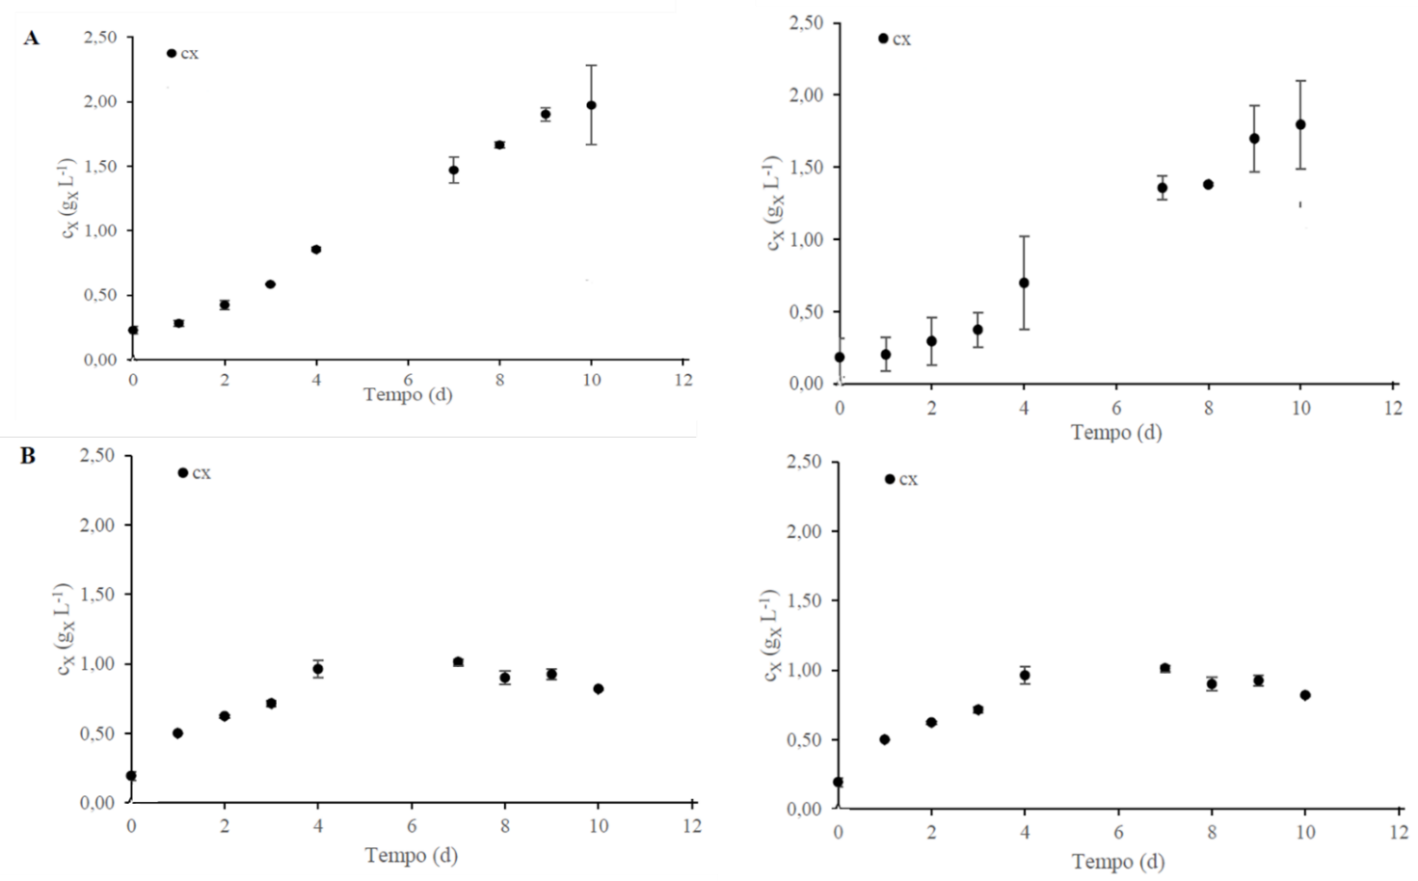
Figure 1. Biomass concentration C_{X} (g_{X} L⁻¹) over time (d) of Anabaena cylindrica (left) and Nostoc PCC 7122 (right) under control (A) and limited conditions (B).

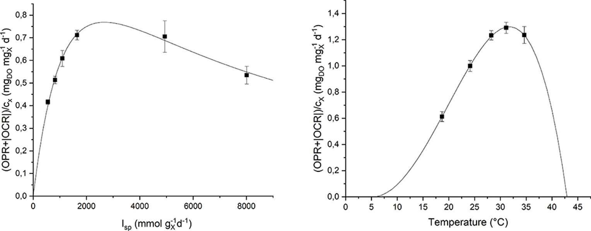
Figure 2. Specific oxygen production rate as a function of specific light supply rate (left) and temperature (right): experimental data (dots) and fitted model (continuous line).
4. Conclusions
Among the two nitrogen-fixing cyanobacteria species tested, Nostoc PCC 7122 was the best performing and thus it was chosen for respirometric tests. Respirometry, which has already turned out as a useful method to study optimal growth conditions of photosynthetic organisms, was applied to identify growth kinetic parameters and determine growth conditions to achieve high diazotrophic species productivity.

References
[1] M. Henchion, M. Hayes, A. M. Mullen, M. Fenelon, and B. Tiwari, “Future protein supply and demand: Strategies and factors influencing a sustainable equilibrium,” Foods, vol. 6, no. 7, pp. 1–21, 2017.
[2] C. M. Joan, L. Sbabou, and E. Arroussi, “Microalgae and Cyanobacteria: How Exploiting These Microbial Resources Can Address the Underlying Challenges Related to Food Sources and Sustainable Agriculture : A Review,” J. Plant Growth Regul., 2022.
[3] L. Garcia, “Microalgae, old sustainable food and fashion nutraceuticals,” vol. 2783, 2017.
[4] P. Hudson, “Harnessing Solar-Powered Oxic N2 -fixing Cyanobacteria for,” Front. Cyanobacteria Biotechnol., 2021.
[5] M. L. Amorim, J. Soares, J. S. dos R. Coimbra, M. de O. Leite, L. F. T. Albino, and M. A. Martins, “Microalgae proteins: production, separation, isolation, quantification, and application in food and feed,” Crit. Rev. Food Sci. Nutr., vol. 61, no. 12, pp. 1976–2002, 2021.
[6] S. O. Lourenço et al., “Distribution of intracellular nitrogen in marine microalgae : Calculation of new nitrogen-to-protein conversion factors Distribution of intracellular nitrogen in marine microalgae : Calculation of new nitrogen-to-protein conversion factors,” vol. 0262, 2007.
[7] E. Sforza, M. Pastore, E. Barbera, and A. Bertucco, “Respirometry as a tool to quantify kinetic parameters of microalgal mixotrophic growth,” Bioprocess Biosyst. Eng., vol. 42, no. 5, pp. 839–851, 2019.
[8] R. Rippka, J. Deruelles, J. B. Waterbury, and X, “Generic assignments, strain histories and properties of pure cultures of cyanobacteria,” J. Gen. Microbiol., vol. 111, no. 1, pp. 1–61, 1979.
[9] E. Barbera, A. Grandi, L. Borella, A. Bertucco, and E. Sforza, “Continuous Cultivation as a Method to Assess the Maximum Specific Growth Rate of Photosynthetic Organisms,” vol. 7, no. October, pp. 1–12, 2019.

