Crystal Engineering as a tool for rational design of novel sustainable food, agrochemical and pharmaceutical formulations
Panayiotis Klitou¹, Lorenzo Metilli², Elena Simone³*
1 School of Food Science and Nutrition, University of Leeds, Leeds, United Kingdom; 2 Laboratoire Rheologie et Procédés, Université Grenoble Alpes, Grenoble, France ,3 Department of Applied Science and Technology, Politecnico di Torino, Torino, Italy
*Corresponding author E-Mail: elena.simone@polito.it

1.Introduction
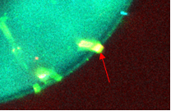
Recent progress in pharmacology, plant biology and biotechnology has led to a dramatic increase in potency and specificity of new generation drugs, active agrochemical ingredients and food nutraceuticals. Unfortunately, this has been accompanied by poor bioavailability and water solubility: it is estimated that around 40% of the active pharmaceutical ingredients currently on the market and 60% of the ones still in development are poorly soluble due to their high molecular weight and structural complexity. These issues have pushed scientific research towards the design of complex formulations, with enhanced dissolution rate and bioavailability, which allow more efficient and targeted delivery of active ingredients (AIs). Multiphase systems (e.g., emulsions, foams, creams) are a convenient and effective encapsulation and delivery strategy, particularly for oral and topical formulations. Currently, synthetic excipients, surfactants and specialty polymers are used to create formulations with enhanced properties. However, these compounds are derived from non-renewable resources through some of the most greenhouse gas-intensive manufacturing processes. For this reason it is necessary to replace the common synthetic stabilizers used for these products with natural, biocompatible and biodegradable materials. These include natural micro and nano-particles (Pickering stabilizers) such as proteins, polysaccharides and various crystalline materials including cellulose, chitin, fat crystals and polyphenol crystals. Pickering systems are particularly promising since particles adsorb at interfaces more strongly than surfactants, providing significantly more stable formulations (Figure 1). The stability of Pickering systems is strongly affected by particle size and shape, but surface wettability is the most important property of Pickering particles. For faceted, anisotropic crystals surface wettability is not easy to determine. In fact, crystals present multiple crystallographic facets, whose surface properties (e.g., polarity, wettability) depend on the type and directionality of the intermolecular interactions that characterize each facet. The purpose of the presented work is to understand how crystal properties (size, shape and polymorphism) of Pickering particles affect their surface properties, hence their orientation and adsorption behavior at interfaces.
Figure 1. Confocal microscopy image of quercetin crystals stabilizing a water/oil emulsion.

2. Methods
Molecular modelling (synthons analysis from crystallographic data) and experimental work (e.g., crystal properties characterization, stability studies) were conducted on two model systems: quercetin and cocoa butter. Two solid forms of quercetin, a solvate and a hydrate, were studied using Habit 98, a synthonic molecular modelling tool. The bulk intermolecular interactions and surface chemistry of the mentioned crystals of quercetin were estimated. An empirical force field was used to calculates the strength, directionality and dispersive nature of the intermolecular interactions. The strongest bulk intrinsic synthons molecular interactions in the crystalline lattice have been identified and characterized, and conformational analysis was performed, evaluating how the presence of the solvent molecule(s) affect the crystal structure, packing and the stability of the different forms. The experimental study consisted in the production (crystallization and aeration) and characterization of oil-based foams stabilized by cocoa butter crystals (oleofoams). The crystals and the air bubbles incorporated in the foams were characterized with polarized and electron microscopy, small and wide angle X-ray scattering, X-ray tomography and differential scanning calorimetry. The effect of processing conditions and the concentration of cocoa butter crystals on the microstructure and the stability of the produced foams were tested.
3. Results and discussion
Two solid forms of quercetin were modeled, a 2:1 hydrate crystal and a 1:1 DMSO solvate. Figure 2 shows schematically the main results of the synthon analysis and the attachment energy study.

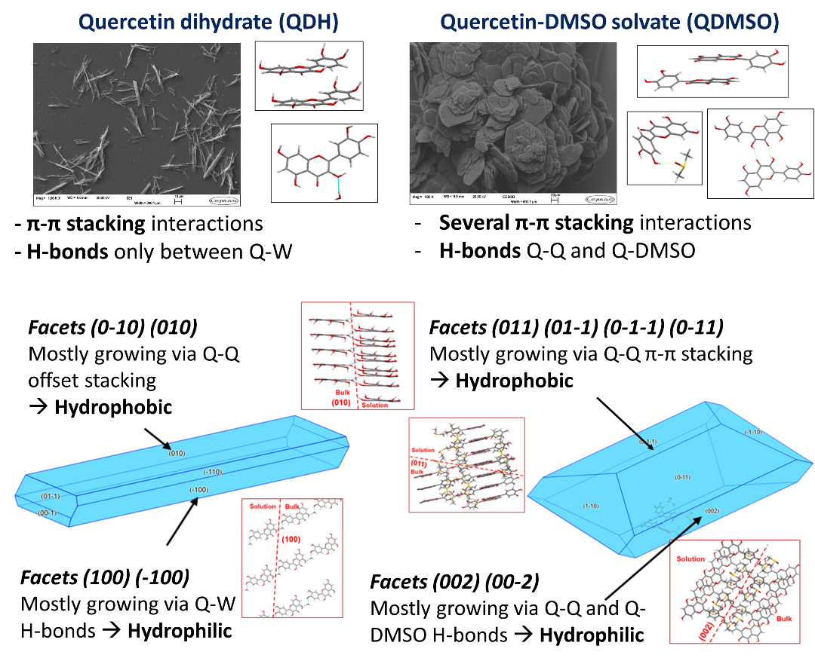
Figure 2. Main synthons of quercetin dihydrate and DMSO solvate. Chemical nature of the different facets of both forms from the attachment energy model.
Both structures shows H-bonds and π-π stacking interaction; however, in the DMSO solvent H-bonds and dipole-dipole interactions contributes more to total lattice energy (around 39%) compared to the dihydrate structure (<10%). The attachment energy model showed that both structures are hydrophobic, with a more hydrophilic and a more hydrophobic facet. This indicates the possibility of modifying the overall surface nature of both crystal forms of quercetin by modifying the morphology of the particles. Hence, both solid forms could be engineered to be either hydrophilic or hydrophobic, suitable for Pickering stabilization of a wide range of multiphase structures.
Experimental work was instead conducted on oil based foams stabilized by cocoa butter crystals. Crystals were produced by cooling from a liquid mixture of cocoa butter and high oleic sunflower oil. The effect of cooling rate and initial composition (percentage of cocoa butter in oil) on the foamability and storage stability of the produced oleofoam were tested. Figure 3 shows the microstructure of oleofoams characterized with polarized optical microscopy, electron microscopy and X-ray tomography. Evidence of Pickering stabilization is noticeable in the polarized and electron microscopy images.
Figure 3. Oleofoams stabilized by cocoa butter crystals. Microstructure highlighted via polarized microscopy, electron microscopy and X-ray tomography.
The amount of cocoa butter crystals dispersed in oil was found to have a strong effect on both foamability and stability of oleofoams; whereas the cooling rate did not affect much the microstructure of these materials. At the concentrations and cooling rates used only one polymorphic form (βV) was observed after crystallization. Higher amount of cocoa butter in the oil determined a slightly lower volume of incorporated air but higher bubble stability during long term storage, with less Ostwald ripening and phase separation. Instead, the cooling rate affected the size and morphology of cocoa butter crystals agglomerates dispersed in the oil after crystallization; however, the size, shape and chemical nature of cocoa butter crystals nanoplatelets was independent of the cooling rate. During aeration crystals aggregates were destroyed due to the effect of shear and temperature increase, leaving only the nanoplatelets at the air bubble interfaces and, hence cancelling the effect of different cooling rates during crystallization.
4. Conclusions
Crystal engineering can help in the design of tailored crystalline particles that can stabilize multiphase formulations for a wide range of applications including pharma, food and agriculture. Molecular modelling is a powerful tool to study facet specific surface chemistry of crystalline materials. It can help in the design of the optimal solid form and morphology of Pickering particles for specific applications.
Furthermore, the mechanism of stabilization of cocoa butter crystals in oil based foams was studied with a multi-technique approach. In particular, the relationship between processing and microstructure was studied, with a focus on the role of crystals in the efficiency of incorporation of air bubbles and in their stability. Such information can help in determining the optimal cocoa butter crystals population for the design of ultra-stable oleofoams.
References
[1] Klitou, P., Pask, C.M., Onoufriadi, L., Rosbottom, I., Simone, E. (2020) Crystal Growth and Design, 20 (10), pp. 6573-6584.
[2] Klitou, P., Rosbottom, I., Simone, E. (2019) Crystal Growth and Design, 19 (8), pp. 4774-4783.
[3] Metilli, L., Lazidis, A., Francis, M., Marty-Terrade, S., Ray, J., Simone, E. (2021) Crystal Growth and Design, 21 (3), pp. 1562-1575.
[4] Metilli, L., Storm, M., Marathe, S., Lazidis, A., Marty-Terrade, S., Simone, E. (2022) Langmuir, 38 (4), pp. 1638-1650.
[5] Metilli, L., Storm, M., Bodey, A.J., Wanelik, K., Tyler, A.I.I., Lazidis, A., Marty-Terrade, S., Simone, E. (2021) Materials Characterization, 180, art. no. 111408.

