Automation and Machine Learning in Chemical Engineering
D. Russo*

*Dipartimento di Ingegneria Chimica, dei Materiali e della Produzione Industriale, Università degli Studi di Napoli, Federico II.

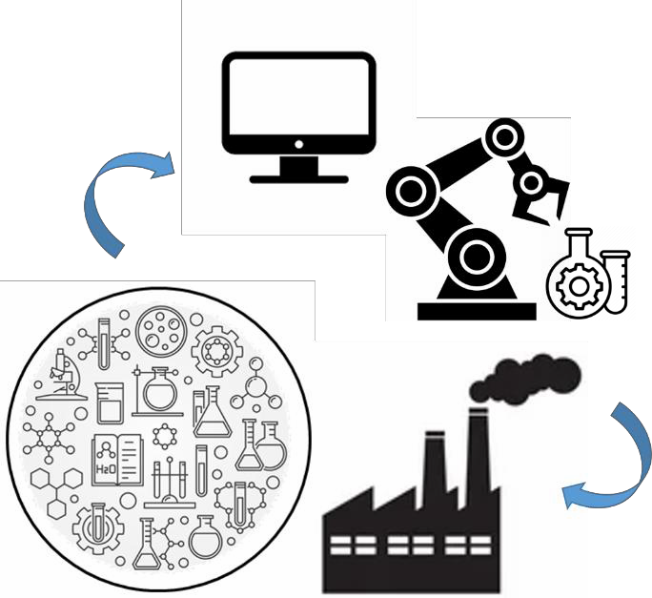

Chemical Engineering has a central role in our ever-changing world, offering promising pathways to an energetic paradigm change and new sustainable processes and products. In such a scenario, it is clear that traditional teaching, research, and applicative paradigms of chemical engineering need to be integrated in a wider framework, including a large number of disciplines and professional skills. Automation and Machine Learning are not new to fundamental research and technological development. However, in the last decade we have assisted to an exceptionally growing number of applications of such techniques to science and engineering both in the academia and industry. This shift from the traditional fields of social media, search indexing, and information management from webpages, to applied sciences, and in particular to chemical engineering, poses a large number of new challenges.
In this talk, I will provide an overview of the state-of-art of automation and machine learning techniques in the chemical engineering fields of product design and process optimization, also discussing the open problems of computer-aided product discovery, scale-up, and multistage design. The topics will be discussed from an academic research point of view, giving an insight into the possibility of integrating and/or deriving fundamental physical knowledge from automated experiments, and highlighting the fundamental differences between the traditional applications of machine-learning-aided robotics and the new challenges in the field of chemical engineering.

