CHEMICAL ENGINEERING TRANSACTIONS  VOL. 93, 2022 | A publication of
The Italian Association
of Chemical Engineering
Online at www.cetjournal.it

Guest Editors: Marco Bravi, Alberto Brucato, Antonio Marzocchella
Copyright © 2022, AIDIC Servizi S.r.l.
ISBN 978-88-95608-91-4; ISSN 2283-9216

Development of Calibration and Validation Models for the Determination of Acrylamide Levels in Pizza Samples through FT-NIR Spectroscopy
Clelia Covino^{a,b}, Angela Sorrentino^{b,*}, Prospero Di Pierro^{a,b}, Raffaele Romanoª, Paolo Masi^{a,b}
ªDepartment of Agricultural Sciences, University of Naples Federico II
^{b}Centre for Food Innovation and Development in the Food Industry, University of Naples Federico II
*angela.sorrentino@unina.it
Analytical methods to quantitatively detect acrylamide (AA) in food are expensive, laborious, time consuming and require costly scientific instruments, as LC-MS/MS and GC-MS. Near-Infrared (NIR) spectroscopy is a reliable technique, easy to use and able to quantify chemical components, and therefore could represent a fast tool for acrylamide screening in cooked foods.
The aim of this study was to develop a new and innovative method to predict AA content in pizza, using a non-destructive NIR spectroscopy. Specifically, NIR reflectance spectra (1000-2500 nm) of freeze-dried pizza samples, with a known acrylamide level, previously measured by UHPLC, were accurately captured. The recorded spectra were processed to design calibration, by chemometric methods for quantitative analysis as Partial Least Squares (PLS) regression, and validation models for the prediction of acrylamide in cooked pizza samples. Spectral range and the number of PLS factors were examined and the lowest Standard Error of Calibration (SEC) and highest Correlation Coefficient of Determination (R²) were selected. The optimized calibration was applied in scanning the NIR spectra of a new set of pizza samples to validate the created method. Results showed that NIR spectroscopy technique is a screening tool capable of rapidly predicting, with reasonable accuracy, the AA content in pizza. Overall, good linear correlation was found between the predicted acrylamide levels in solid matrix by NIR method, and the actual acrylamide values measured by UHPLC in extracted pizza samples.

KEYWORDS: acrylamide, FT-NIR spectroscopy, PLS regression, pizza, UHPLC
  - Introduction
Pizza is one of the most consumed foods in all over the world. Pizza has been produced and consumed in Italy since the 16th century and after World War II, due to the large scale emigration of Italians in the world, it was produced and distributed in all other countries (Caputo and Pugno, 2016). However, being a product derived from flour-based dough, pizza can also be a source of acrylamide (AA), a substance that even taken in modest quantities has harmful effects on health. In fact, acrylamide (H2C=CH-CO-NH2) is a toxic substance formed during cooking at high temperatures by reaction between free sugars, like glucose, and specific amino acids, such as asparagine, which are naturally present in the flour (Linke, 2015). It is well known that AA is present in commonly consumed carbohydrate-rich foods such as bread, pizza, and biscuits and produced at high temperatures during frying, baking, and roasting via the Maillard reaction (Zhang and Zhang, 2007). Acrylamide concentration in processed food products has become a very serious health issue, and thus EFSA recommends do not exceed the dose of 0.17 mg/kg b.w. per day (EFSA 2015:EN-817). Benchmark levels of acrylamide in bakery products are of 50-800 µg/kg while for fried potatoes and coffee 750-4000 µg/kg are accepted. Even if AA levels do not reach daily human reference limits, EFSA suggests adopting mitigation strategies for acrylamide formation and allowing monitoring of acrylamide content in finished food products (EU Reg. 2017/2158). However, there is a lack of literature about the level of acrylamide in cooked pizza nowadays, and therefore studies on the determination of this substance are always welcome. Current methods for detecting and quantifying acrylamide in food are LC-MS or GC-MS chromatography. However, their use involves long sample preparation, time consuming, dependent on expensive scientific instrumentation and trained operators, which limits their use for monitoring acrylamide content during processing or on finished products (Wenzl et al., 2006), thus they are not suitable for quality control during the manufacturing process or for screening large numbers of samples (Ayvaz and Rodriguez-Saona, 2015). Therefore, a quick and simple method for routine acrylamide analysis is required. Near Infrared (NIR) spectroscopy is inexpensive, fast, easy to use, and applicable to acrylamide detection. As a method, NIR utilizes electromagnetic radiation at wavelengths in the range 780–2500 nm that contain information about the primary structural components of organic molecules, such as C–H, N–H and O–H bonds (Cozzolino et al., 2001), obtaining spectra derived from fundamental absorptions. It allows to quickly (15-90 s) predict with a quantitative method the content of substances such as proteins, amino acids, moisture, fat, starch, sugars and fibers or, in the case of an identification method, if there is the presence or absence of a substance, using a small amount of sample non-destructively and with minimal sample preparation. The main advantages of the NIR technique are the high time savings over the number of samples analyzed, low cost, and simultaneous quantification of several traits in an individual sample measurement. Quantitative values can be calculated using mathematical models capable of correlating the NIR spectra, obtained from the scanned sample, with data derived from chemical analysis, and thus the goodness of the created method also depends on the use of appropriate analytical methods. The disadvantage is that it cannot determine low amounts of substances in samples and there is some question about the sensitivity of NIR for measuring acrylamide in food (Adedipe et al. 2016). Anyway, this technique has been used for numerous food applications related to quality control and safety, providing information in the fingerprint region. In fact, it has been utilized to estimate quality parameters such as starch, amylose, protein, moisture, and fat content in grains, seeds, fruits, tubers, wood, meat, fish, and other products (Diaz et al., 2014). Several studies employing these devices have been published, including the quantitation of carotenoids in intact watermelon (Tamburini et al., 2015a), sucrose levels in infant cereals (Lin et al., 2014), fatty acid value during storage of wheat flour (Jiang et al., 2020). For the food quality control, Delwiche and Weaver (1994) studied the quality of wheat flour via NIR technique, following several parameters such as water adsorption, dough mixing time, dough mixing tolerance, loaf height, internal grain appearance, and protein level, and/ or starch damage. Other recent studies have demonstrated the use of NIR in quantification of acrylamide in potato chips (Pedreschi et al. 2010). The purpose of this study is to establish a standard method for quantitative detection of acrylamide in pizza using NIR spectroscopy. Acrylamide content will be measured from pizza samples using NIR coupled with Partial Least Squares computational software and a standard curve. A standard acrylamide curve in solid matrix will be made. Acrylamide from pizza will be monitored by NIR and the results validated using UHPLC. Finally, the best way to predict the levels of acrylamide in pizza using NIR spectroscopy will be evaluated in order to ensure the safety of consumers.
  - Materials and Methods
2.1 Pizza preparation
Pizza doughs were prepared and kneaded with the traditional ingredients (flour, water, yeast and salt). The doughs were leavened at 22°C and 80 % relative humidity (RH) for 2h (37 samples) or 8 h (32 samples) and then cooked by frying in sunflower oil (37 samples) or in a wood oven (32 samples). The obtained pizza samples were cut into pieces and subjected to freeze-drying and grinding to obtain a powder with a particle size ≤0.5 mm, which was used both for the following AA extraction and NIR spectra analyses.
2.2 Quantification of acrylamide through UHPLC-UV
AA from powder samples was extracted as described by Kumar et al. (2014) with minor modifications and estimated through UHPLC-UV (LC-4000, Jasco, Japan) detection. Chromatographic separation of AA was performed at 30°C on a reverse phase C-18 column (Nucleodur C18 Gravity 150 x 3 mm, 3 µm), using water and methanol as mobile phases, both containing 0.1% formic acid, at a constant flow rate of 0.25 mL/min. Applying a 3 min elution program at 100% water followed by a 5 min methanol gradient from 0 to 7% (Capuano et al. 2009), the AA retention time was estimated to be 5 min. The AA sample peak areas were used to estimate the AA content in pizza samples by extrapolation from a calibration curve (y = 43759x – 494; R2=0.9999) obtained with AA standard in the range of 0.05-10 mg/L. The calculated limits of detection and quantification were respectively LOD= 0.034 mg/L and LOQ= 0.113 mg/L.
2.3 NIR spectra measurement
Spectra of pizza samples were collected using a NIRFlex® N-500 (Büchi, Switzerland) equipped with the solids cell (Büchi, Switzerland) used for Steriplan Petri dishes (Duran Group, Czech Republic) with a volume of 31.4 cm3. Freeze-dried powder samples were placed on the glass surface of the 100x20 mm diameter by height plate using a spatula. FT-NIR (Fourier Transform Near Infrared) diffuse reflectance spectra were recorded using NIRWare 1.4 (Büchi, Switzerland) and capturing the full range, from 10000 to 4000 cm⁻¹, at 4 cm⁻¹ intervals. The spectrometer is suitable for rapid non-destructive analysis of powder samples. 5 measurements were taken to get a complete analysis on the whole sample. Each measurement of freeze-dried pizza sample was achieved by scanning 32 times to have an average spectrum and a good signal-to-noise ratio; therefore, the total measurement time for each sample was 2 min and 30 s. Acquisition of the internal reference was obtained with each spectrum acquisition to optimize the baseline of the spectrum.
2.4 NIR analyses: calibration, internal and external validation
NIRCal 5.6 (Büchi, Switzerland) was used to perform the chemometric analyses including math pretreatments, calibration and validation. Raw spectra and spectra preprocessed, first-derivative, standard normal variate (SNV), and multiplicative scatter correction (MSC) transformations were applied to develop the calibration models, in order to minimize the multiplicative interferences of scatter and surface roughness (Porep et al., 2015). 29 fried pizza and 25 wood oven cooked pizza samples were used to calibrate and cross-validate the FT-NIR technique for acrylamide content. 7 and 9 outliers were found to reach the best calibration, for fried pizza and wood oven pizza samples, respectively. Finally, 22 fried pizza (110 spectra) and 16 wood oven pizza (80 spectra) samples were considered for the calibration and internal validation.
Calibration models for AA content were determined using the blockwise cross-validation approach, which is a default software procedure, by randomly choosing 36 out of 110 fried pizza spectral samples as the validation while the remaining 74 were used as the calibration. In the same way, 26 out of 80 wood oven cooked pizza spectral samples were randomly selected by NIRCal software for the validation curve while the remaining 54 spectra were used as the calibration.
Calibrations were developed using all data points of the calibration in the full spectrum of NIR. Partial Least Squares (PLS) Regression was used to correlate the spectral information of the samples and AA contents determined by reference method. The number of factors used in the equation to calculate the analyte concentration was also considered by the software before selecting the equation for use.
Squared Pearson correlation coefficient (R²), standard error of calibration (SEC), and standard error of prediction (SEP), Bias (tendency to deviate from the mean value), and the ratio of performance to deviation (RPD=SD/SEP) of the prediction sets were considered in selecting the best quantitative model. The quality of calibration was described by the Q-value calculated by the NIRCal 5.6. Q-statistic was calculated, considering various combinations of wavelength ranges and data pretreatments. The Q-value qualifies all calibrations with a number between 0 (useless) and 1 (ideal) based on the statistic results. A calibration is defined as good when it shows a Q-value between 0.45 and 0.75. When a Q-value greater than 0.75 is obtained, the calibration gives excellent reliable results. LOD was calculated as 3 times the standard deviation of the intercept/slope, and LOQ was calculated as 3 times the LOD (Adedipe et al. 2016).
A second validation (external validation) of the calibrated FT-NIR technique was also carried out as confirm of a good calibration models built. For this purpose, 8 random fried pizza (40 spectra) and 7 wood oven cooked pizza (35 spectra) samples were taken for spectra acquisition using the same instrumentation of the calibration set. External validation was performed comparing NIR predicted data and reference data with Microsoft® Excel (office 365) and the prediction accuracy was calculating in terms of squared Pearson correlation coefficient (R²).
  - Results and Discussion
    - AA content and NIR spectra
AA content in pizza samples was chromatographically determined by UHPLC-UV instrument and the obtained values were used for the calibration and cross validation dataset on NIR instrument. In fried pizza samples the AA concentration varied from 0.99 and 3.775 mg/kg, while for the wood oven pizza samples the AA levels were in the range of 0.66÷2.46 mg/kg. The powder pizza model system was used to determine whether NIR tecnique is able to detect acrylamide in the above described pizza samples and evaluate the limit of detection in such a matrix. A total number of 145 and 125 original raw spectra were recorded for fried and wood oven cooked pizza’s powder samples respectively. The analysis of the NIR spectrum is aimed at identifying characteristic peaks for which it is possible to hypothesize a direct correlation with the presence and concentration of a specific analyte. The typical trend of a raw spectrum is the wide increase in the reflectance signal generated by the diffusion of light that hits the sample made up of complex and non-homogeneous structures, and therefore has characteristics of surface roughness. Thus, raw spectra could be affected by interferences generated by light scattering and background absorptions caused by other O-H containing molecules, as well as other systematic errors associated with intrinsic factors in the acquisition of spectra. In order to minimize these noises, stabilize the baseline shifts and improve the quality of the minor spectral variations, specific pretreatments were applied by the software, consisting of MSC full and first derivative for fried pizza spectral samples and SNV (Standard Normal Variate) for the wood oven cooked pizza spectra. Pretreated spectra from respective samples, were automatically divided in calibration and validation spectra by NIRCal software (Figure 1). The intensity of the NIR region is low so that the peaks in the spectrum are not clearly visible and are very broad. Using NIR spectroscopy, it is impossible for these peaks to correspond to a single vibration. The NIR spectrum (750-2500 nm) reads overtones and low energy vibrations of C-H, O-H and N-H bonds. The absorbances read at 5000-5500 cm⁻¹ corresponded to N-H bond and 6000-6500 cm⁻¹ were associated with carbonyl (C=O) for the amide functional group of acrylamide (Skinner et al., 2021).
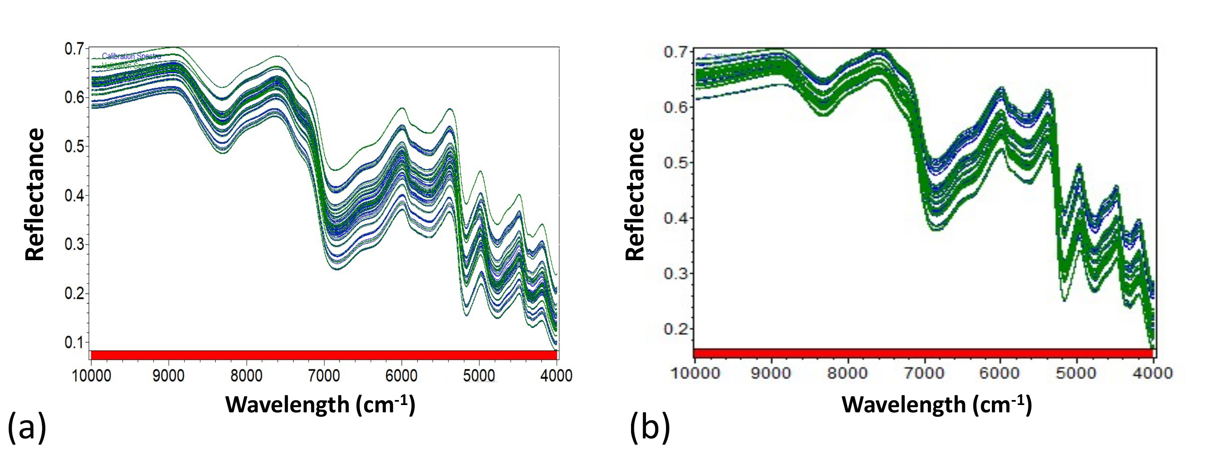
Figure 1: NIR pretreated spectra of fried (a) and wood oven cooked pizza samples (b). NIRCal® software automatically divided original spectra in calibration (blue) and validation (green) set.
    - Calibration and internal validation of AA models
It is well known that the reliability of a NIR calibration is restricted to the range of values considered. Pretreated spectra have been elaborated with the NIRCal program to build a calibration and internal-validation model for AA prediction in pizza samples.
For the case of fried pizza, 35 outliers out of the 145 spectral samples were observed during the calibration procedure. On the other side, 45 outliers were found out of the 125 wood oven cooked pizza spectral samples. After eliminating the spectra of the outlier samples, the calibration procedure was repeated with the remaining spectra taking into account 4 and 6 PLS factors for fried and wood oven cooked samples respectively. No outliers were observed during calibration using the data set of 110 samples for fried pizza and 80 samples for wood oven cooked pizza. The calibration curves and the internal validation results are given in Figure 2.
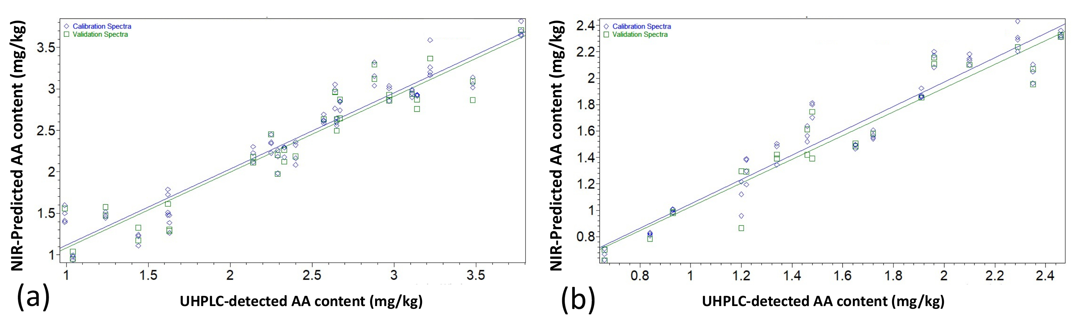
Figure 2: NIR predicted versus measured values of AA content, in fried (a) and wood oven pizza samples (b).
The robustness of calibration model can be evaluated by the statistical parameter of the Q-value which refers to a “good” calibration when it is in the range of 0.45÷0.75 and to an “excellent” calibration if it is > 0.75 (Tamburini et al., 2015a). For fried pizza the Q-value was 0.71, while for the wood oven cooked pizza Q-value was equal to 0.76 thus supporting the robustness of the models built. Moreover, for the calibration set, SEC and the R² were 0.2244 and 0.9176, respectively for fried pizza samples and 0.1503 and 0.9219 respectively for wood oven cooked pizza samples. However, since it is a multivariate calibration model, the consideration of the SEC alone is not a reliable test for assessing the accuracy of the model. Therefore, it is necessary to introduce a set of validation samples for which it is possible estimate the SEP parameter, that is, a calculation of the variability of the differences between the predicted and reference values. For the internal validation set of the 36 fried pizza spectral samples, SD, SEP and R² were 0.7373, 0.2584 and 0.8851, respectively, while the same parameters were equal to 0.5179, 0.1598 and 0.9173 for the 26 wood oven cooked pizza spectral samples. It is interesting to note that for both calibration models built, a very low Bias value (0.03428 and 0.03428 for fried and wood oven cooked samples) was observed between the measured and NIR predicted AA values during internal validation, indicating a good adherence of the samples used for validation compared to those on which the calibration was built. Another statistical parameter useful for evaluating the accuracy of the prediction, taking into account the standard deviation of the reference data, is the RPD or ratio of performance to deviation, which represents a standardization of the SEP (Herold et al., 2009). In the AA's internal calibration-validation model in fried pizza samples, the RPD was 2.85, while for pizzas cooked in a wood oven RPD = 3.26. These values indicate that the built models have a good but not excellent degree of accuracy. In fact, in a good calibration model, the internal validation should be characterized by values of SEP much lower than SD in order to obtain an RPD = 5. However, RPD values around 3 can also be considered acceptable, while suggesting an implementation of the model’s prediction capability to make predictions more reliable (Tamburini et al., 2015b).
LOD and LOQ parameters were calculated from calibration curves and resulted 0.64 and 1.94 mg/kg for fried pizza, and 0.42 and 1.27 mg/kg for wood oven cooked pizza samples, respectively. These results are encouraging for the determination of AA in pizza using NIR spectra, although they are considered insensitive for the detection of analytes in food present at levels below 0.100 mg/kg.
    - External validation of AA models
The predictive ability of the calibration model must be verified through an external validation, i.e. using a set of samples that were not used in the construction of the calibration model nor for internal validation (Fujiwara & Murakami, 2007). The latter, in fact, is carried out using spectra randomly selected from the calibration set and for this reason, it is not considered a sufficient test in complex and inhomogeneous matrices such as pizza samples. Therefore, after obtaining satisfactory internal validations, the performance (robustness and stability) of the calibrations for the prediction of AA levels have been tested with other samples showing an AA concentration between 1.41÷3.77 mg/kg, and 0.78÷2.42 mg/kg for fried or wood oven cooked pizza respectively. In particular, further 40 (fried) and 35 (wood oven) spectral samples were recorded by scanning 8 and 7 pizza powder samples and AA content data predicted by NIR calibration were compared to reference chemical results obtained by UHPLC-UV chromatography. The performance of the effective predictive capacity of NIR calibration models was evaluated by plotting the AA data predicted by NIR as function of the corresponding reference analyses. As shown in Figure 3, the predicted results by NIR were positively correlated with chemical results for both calibration models related to fried and wood oven cooked samples. The Correlation Coefficient R² was higher than 0.9 for both models (0.9086 and 0.947), thus suggesting a fairly accuracy of predicted values.
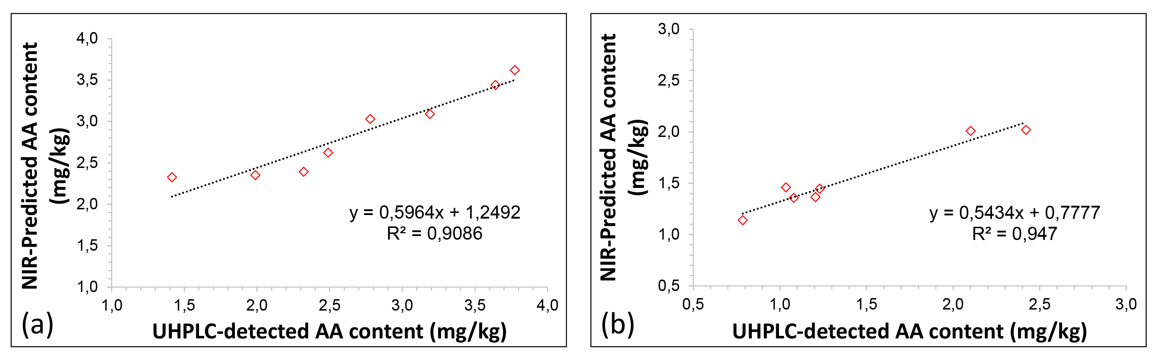
Figure 3: Correlation between NIR predicted and reference measured values for fried (a) and wood oven cooked pizza samples (b) during the external validation.
  - Conclusions
For the first time, a non-destructive NIR spectroscopy model has been developed for the prediction of acrylamide levels in pizza samples, certainly a structured and complex matrix associated with a fairly high intrinsic variability. However, for both fried pizza and wood-fired pizza samples, the processing of NIR spectra allowed to build calibration models with internal validation that present an acceptable degree of reliability, supported by RPD values close to 3 (2.85 and 3.26 for fried and wood-fired samples respectively). The robustness of the calibrations was confirmed by the high correlation found between the levels of AA predicted by NIR spectroscopy and those measured at UHPLC for the samples used in the external validation of the models built, with R² values equal to 0.9086 and 0.947 for the two developed models. Surely both models can be further improved by increasing the number of samples scanned to obtain spectra, to strengthen the validity of the calibration and minimize prediction errors. In conclusion, this method could lay the groundwork for faster screening of acrylamide levels in order to contribute to food safety, security, and competitiveness within European and U.S. markets.
Acknowledgments
This research was funded by the MIUR PRIN 2017 –2017SFTX3Y- The Neapolitan pizza: processing, distribution, innovation and environmental aspects.
References
Adedipe O.E., Johanningsmeier S.D., Truong V.D., Yencho G.C., 2016, Development and Validation of a Near-Infrared Spectroscopy Method for the Prediction of Acrylamide Content in French-Fried Potato, Journal of Agricultural and Food Chemistry, 64, 1850−1860.
Ayvaz H. and Rodriguez-Saona L.E., 2015, Application of handheld and portable spectrometers for screening acrylamide content in commercial potato chips. Food Chemistry, 174, 154–162.
Capuano E., Ferrigno A., Acampa I., Serpen A., Açar Ö.Ç., Gökmen V., Fogliano V., 2009, Effect of flour type on Maillard reaction and acrylamide formation during toasting of bread crisp model systems and mitigation strategies, Food Research International, 42, 1295–1302.
Caputo W. and Pugno L., 2016. La pizza al microscopio. In: Storia, fisica e chimica di uno dei piatti più amati e diffusi al mondo. San Giovanni Lupatoto, Gribaudo.
Cozzolino D., Fassio A., Gimenez A., 2001, The use of near-infrared reflectance spectroscopy (NIRS) to predict the composition of whole maize plants, Journal of Science of Food and Agriculture, 81, 142-146.
Delwiche S.R. and Weaver G., 1994, Bread Quality of Wheat Flour by Near-Infrared Spectrophotometry: Feasibility of Modeling, Journal of Food Science, 59, 2, 410-415.
Diaz J.T., Veal M.W., Chinn M.S., 2014, Development of NIRS models to predict composition of enzymaticallyprocessed sweetpotato, Industrial Crops and Products, 59, 119–124.
EFSA 2015:EN-817, Outcome of the public consultation on the draft Scientific Opinion of the EFSA Panel on Contaminants in the Food Chain (CONTAM) on acrylamide in food.
EU Regulation 2017/2158, Establishing mitigation measures and benchmark levels for the reduction of the presence as acrylamide in food, Official Journal of the European Union, 60, 24–44.
Fujiwara T. and Murakami K., 2007, Application of near infrared spectroscopy for estimating available nitrogen in poultry manure compost, Journal of Soil Science and Plant Nutrition, 53, 102–107.
Herold, B., Kawano, S., Sumpf, B., Tillmann, P., Walsh K.B., 2009, VIS/NIR spectroscopy. In M. Zude (Ed.), Optical monitoring of fresh and processed agricultural crops, 141–249.
Jiang H., Tong L., Quansheng C., 2020, Quantitative detection of fatty acid value during storage of wheat flour based on a portable near-infrared (NIR) spectroscopy system, Infrared Physics and Technology, 109, 103423.
Kumar N.S.M., Shimray C.A., Indrani D., Indrani D., Manonmani H.K., 2014, Reduction of Acrylamide Formation in Sweet Bread with L-Asparaginase Treatment, Food Bioprocess Technology, 7, 741-748.
Lin C., Ayvaz H., Rodriguez-Saona L.E., 2014, Application of portable and handheld infrared spectrometers for determination of sucrose levels in infant cereals, Food Analytical Methods, 7, 1407–1414.
Linke D., 2015, Enzymatic prevention of health risks in food, Current Opinion in Food Science, 1, 21–27.
Pedreschi F., Segtnan V.H., Knutsen S.H., 2010, On-line monitoring of fat, dry matter and acrylamide contents in potato chips using near infrared interactance and visual reflectance imaging, Food Chemistry, 121, 616.
Porep J.U., Kammerer D.R., Carle R., 2015, On-line application of near infrared (NIR) spectroscopy in food production, Trends in Food Science & Technology, 46, 211–230.
Skinner M.M., Seale J.T., Cantrell M.S., Collins J.M., Turner M.W., McDougal O.M., 2021, Instrumentation for Routine Analysis of Acrylamide in French Fries: Assessing Limitations for Adoption, Foods, 10, 2038.
Tamburini E., Castaldelli G., Ferrari G., Marchetti M.G., Pedrini P., Aschonitis V.G., 2015b, Onsite and online FT-NIR spectroscopy for the estimation of total nitrogen and moisture content in poultry manure, Environmental Technology, 36,18, 2285–2294.
Tamburini E., Ferrari G., Pedrini P., Donegà V., Malavasi M., Marchetti M.G., 2015a, Non-destructive quantification of carotenoids in intact watermelon (citrullus lanatus) using on-line near infrared spectroscopy, Proceedings of the ICNIRS, <10.17648/nir-2015-34177>
Wenzl T., Karasek L., Rosen J., Hellenaes K., Crews C., Castle L., Anklam E., (2006), Collaborative trial validation study of two methods, one based on high performance liquid chromatography–tandem mass spectrometry and on gas chromatography–mass spectrometry for the determination of acrylamide in bakery and potato products, Journal of Chromatography A, 1132, 211–218.
Zhang Y. and Zhang Y., 2007, Formation and reduction of acrylamide in Maillard reaction: A review based on the current state of knowledge, Critical Reviews in Food Science and Nutrition, 47, 521−542.

