CHEMICAL ENGINEERING TRANSACTIONS  VOL. 93, 2022 | A publication of
The Italian Association
of Chemical Engineering
Online at www.cetjournal.it

Guest Editors: Marco Bravi, Alberto Brucato, Antonio Marzocchella
Copyright © 2022, AIDIC Servizi S.r.l.
ISBN 978-88-95608-91-4; ISSN 2283-9216

Chitin and its derivatives: nanostructured materials from different marine and terrestrial sources
Maria-Beatrice Coltelli^{a,b,}*, Luca Panariello^{a,b}, Alessandro Vannozzi^{b}, Vito Gigante^{a,b}, Alessandro Gagliardini^{c}, Pierfrancesco Morganti^{d}, Patrizia Cinelli^{a,b}, Andrea Lazzeri^{a,b}, Angela De Bonis^{e}, Patrizia Falabella^{e,f}
ªDepartment of Civil and Industrial Engineering, University of Pisa, Italy
^{b}Interuniversity National Consortium of Materials Science and Technology (INSTM), Florence, Italy
^{c}Texol, Pescara, Italy
^{d}Academy of History of Healthcare Art, Rome, Italy
^{e}Department of Science, University of Basilicata, Italy
^{f}Spinoff XFlies s.r.l, University of Basilicata, Via dell'Ateneo Lucano 10, 85100, Potenza, Italy
maria.beatrice.coltelli@unipi.it
Chitin is a very abundant polysaccharide that can be obtained from well-known marine sources (crustaceans), but also from terrestrial sources (mushrooms and insects). In the case where animal sources are considered, the material can be obtained by much abundant food or feeding waste. The extraction methodologies were not developed with similar technical readiness levels considering the different sources and the further conversion to chitin nanofibrils and chitosan is also under study, enabling the production of products differentiated for their macromolecular structures and morphology.
Chitin nanofibrils from sea food sources were used in sanitary, cosmetic and packaging applications, where their anti-microbial properties and good biocompatibility were very useful. Chitin from mushrooms and sea food was used as starting material in possible coatings for cellulosic and bioplastic substrates. Currently chitin from insects (Hermetia Illucens) is also under study as well as the methodologies for extracting derivatives from it. Infrared analysis is an interesting technique to compare chitins, chitin nanofibrils and chitosan from different sources as well as electron microscopy for studying their morphology.
The derivatives of chitin, such as chitosan and chitin nanofibrils, show anti-microbial properties. Hence, their use in several applications, ranging from packaging to sanitary and cosmetics, can conjugate high performance novel products with a reduced environmental concern. The comparison between chitin derivatives from different sources is very useful to address the biopolymers to specific applications, including the agricultural sector.
While more and more applications for chitin derivatives will be developed, differences between them should be clarified and correlated to the sources, the methodologies of their production and their physical-chemical properties.

  - Introduction
Chitin, composed of repeating β(1,4)-N-acetylglucosamine units, is a very abundant biopolymer that can be obtained from both marine (crustaceans) and terrestrial (mushrooms and insects) sources.
Interesting products can be obtained by chitin deacetylation: chitin nanofibrils, that represent the crystalline whisker-like part of the material, and chitosan. In the case of chitosan, a full deacetylation of the polymer is achieved, whereas in the case of chitin nanofibrils the acetyl groups are only partially removed (Morganti 2019). Chitosan is soluble in acidic water, on the contrary, the solid chitin nanofibrils can form nanostructured suspension in water (Panariello et al. 2019).
Chitosan (Pakizeh, Moradi, and Ghassemi 2021) and chitin nanofibrils (Muzzarelli and Morganti 2006) were largely obtained from waste coming from sea food, in particular shrimps, with different methodologies and applied in sanitary, cosmetic and packaging applications, where their anti-microbial properties and good biocompatibility were very useful (Coltelli et al. 2019). Chitin from mushrooms and sea food was investigated as starting material in possible coatings for cellulosic and bioplastic substrates (Gigante et al. 2021). Currently chitin from insects (Hermetia Illucens) is also under study as well as the methodologies for extracting derivatives from it (Hahn et al. 2020). The effect of the different life stages of the insect as well as the necessary pre-purification steps to obtain a chitin product having a purity similar to largely available ones have been recently studied.
Interestingly Hermetia Illucens is a bioconverter insect, thus it can valorise organic waste from the agri-food industry through the bioconversion process. This process allows numerous products to be obtained of high biological and economic value: proteins and lipids of animal origin, chitin and residue from the bioconversion process (frass of insect and partially digested organic material comparable to soil conditioners for agriculture and therefore useful for crop fertilization) (Triunfo et al. 2021).
Chitosan and chitin nanofibrils, showed anti-microbial properties and their use in several application, ranging from packaging to sanitary and cosmetics, can conjugate high performance novel products with a reduced environmental concern (Panariello et al. 2019). The comparison between chitin derivatives from different sources is very useful to address the biopolymers to specific applications, including the agricultural sector (Pagno et al. 2018).
Infrared analysis is an interesting technique to compare chitins, chitin nanofibrils and chitosan from different sources. Many articles reported a reduction of amide I band of acetamide groups, that showed a well-defined peak at 1650 cm⁻¹ with a minor shoulder at 1625 cm⁻¹, in more deacetylated products, thus revealing a converstion of chitin to chitosan (Brugnerotto et al. 2001). This technique was used by several researchers to determine the deacetylation degree of chitin based on transmission spectra (Kasaai 2008).
A faster methodology for characterizing chitin, chitosan and chitin nanofibrils is Attenuated Total Reflectance (ATR) infrared spectroscopy, a non-destructive technique based on recording the spectrum of a sample in contact with a crystal having a high refractive index. ATR-IR technique allows spectra to be obtained also from solid samples, without any preliminary preparation, saving time and allowing to analyse non-soluble systems such as chitin. Spectra were strongly dependent on the adhesion between sample and crystal but, if the samples to be characterized are powdery, generally it is possible to obtain good quality spectra and a sufficient representativity for composition of the powder-based sample.
In the present paper, chitin powder, obtained from insects (adult of Hermetia Illucens) with very recent techniques, was studied and compared with other samples coming from different sources such as shrimps and mushrooms on the basis of their ATR infrared spectra. Then the acetylation degree was evaluated for chitosans obtained from adult insect samples and compared with commercial shrimps chitosans. Moreover, the morphology of chitin and chitosan were compared by Scanning Electron Microscopy (SEM). It was found that Hermetia Illucens microstructured and nanofibrillated chitin was successfully converted to chitosan, resulting more homogeneous.
  - Experimental
    - Material
The extraction of chitin from insect samples was carried out based on the multi-step process reported by Hanh et al. (2020) including a demineralization and deproteinization steps. A bleaching step was also considered.
The chitosan was produced by heterogeneous deacetylation of adult Hermetia Illucens chitins by using 12 M NaOH. After the end of the reaction, the suspension was filtered using filter paper. Successively the solid residue was washed on the filter to neutral pH with distillated water. Then, the deacetylated sample was suspended in 1% (v/v) acetic acid and, under continuous stirring, it was maintained at room temperature for 48 h. After centrifugation, the supernatant was collected. By using NaOH the solution was converted to a pH 8. Then, it was incubated overnight in order to precipitate the chitosan. A second centrifugation was carried out, so the recovered chitosan was washed with distilled water, to remove the residual acetate adsorbed by chitosan (Hahn et al., 2020). At the end, the product was freeze-dried and stored at ambient temperature.
Chitin showed a brown color because of residual pigments. With the aim of removing them, a bleaching treatment was applied to a portion of the chitin obtained from Hermetia Illucens, by using a solution of 5% hydrogen peroxide (H₂O₂) (Hahn T. et al., 2021). Bleached samples were then filtered using filter paper and washed with deionized water until neutral pH was reached.
Commercial chitin from shrimp shells was purchased by Aldrich, commercial chitin from mushrooms was purchased by Glentham Life Sciences.
Commercial chitosan from shrimp shells low viscosity was purchased by Aldrich, commercial chitosan from shrimp shells low molecular weight was purchased by Aldrich and commercial chitosan GP8523 was purchased by Glentham Life Sciences.

    - Infrared Characterization
The powder of chitin or chitosan was homogenized and reduced in dimension in a mortar using a pestle. Then the powder is transferred from the mortar to the ATR crystal by using a spatula. Infrared spectra were recorded in the 550–4000 cm⁻¹ range with a Nicolet 380 Thermo Corporation Fourier Transform Infrared (FTIR) Spectrometer (Thermo Fisher Scientific, Waltham, MA, USA) equipped with smart Itx ATR (Attenuated Total Reflection) accessory with a diamond plate, collecting 256 scans at 2 cm⁻¹ resolutions. ONMIC software was used to elaborate the spectra and to compare different spectra profiles.
The R_{AC} ratio, that can be correlated to the acetylation degree of the sample, was determined by Eq(1)
$${\text{R}}_{\text{AC}}\text{=}\frac{{\text{A}}_{\text{1620}}}{{\text{A}}_{\text{1020}}}$$ | (1)
where A₁₆₂₀ is the area of the band obtained by integrating the peak at 1620 cm⁻¹ in the range 1695-1618 cm⁻¹ and A₁₀₂₀ is the area of the reference band in the range 1184-1024 cm⁻¹.
The integrations were carried out after tracing a baseline passing through the minima present in all the spectra at about 1735 cm⁻¹ and 1185 cm⁻¹.
    - Scanning Electron Microscopy characterization
SEM investigations were carried out on the powder samples. The instrument was a FEI Quanta 450 ESEM FEG scanning electron microscope (SEM) (Thermo Fisher Scientific, Waltham, MA, USA), which has a resolution power of 3.5 nm and possibility of magnification until 300,000×. Samples were preliminary coated with a thin metallic layer to avoid charge build up.

2.4 Deacetylation degree of chitosan

The acetylation degree (AD) of all chitosan samples was determined by potentiometric titration (Jiang, Chen, and Zhong 2003). Chitosan solutions were prepared dissolving 0.25 g of chitosan in 10 ml of deionized water and 20 ml of 0.1 M HCl. After stirring for 2 h at room temperature until complete dissolution of the chitosan sample, the chitosan-HCl solution was titrated with 0.1 M NaOH. 3 ml of NaOH were firstly added and the resultant pH of the solution was measured. Then 1 ml of NaOH at a time was added several times, measuring the pH of the solution after each addition. The titration was ended after the addition of 7 ml NaOH. Acetylation degree of chitosan was calculated considering the protonation of glucosamine group in the chitosan chains according to the Eq(2).
$\text{A}\text{D \% =}\text{(1-}\frac{\text{[}\text{HCl}\text{]}\text{ ∙ }V_{A}\text{ - }\text{[}\text{NaOH}\text{]}\text{ ∙ Ve}}{\text{W}}\text{ ∙161}\frac{\text{g}}{\text{mol}} \text{)}\text{∙100}$ | (2)

where [HCl] is the concentration of HCl (0.1 M), V_{A} is the volume of 0.1 M HCl (20 mL), [NaOH] is the concentration of NaOH (0.1 M), V_{e} is the consumed volume of NaOH at the equivalence point, W is the weight of dissolved chitosan and 161 g/mol correspond to the molecular weight of glucosamine in the chitosan chain
  - Results and discussion
The chitin obtained from adult Hermetia Illucens was compared with commercial chitins from other sources (shrimps and mushrooms) with ATR-IR spectroscopy to compare eventual differences in their molecular structure (Figure 1).
Characteristic peaks of chitin can be identified in all the spectra. In particular peaks typical of amine and amide group of chitin can be observed. The stretching CO (amide I) can be identified at 1620-1650 cm⁻¹, the bending NH (amide II) at 1550-1560 cm⁻¹. At higher wavenumbers, -OH stretching broad band in the range 3000-3400 cm⁻¹, NH symmetric stretching at 3100-3110 cm⁻¹ and NH asymmetric stretching at 3255-3270 cm⁻¹ are present.
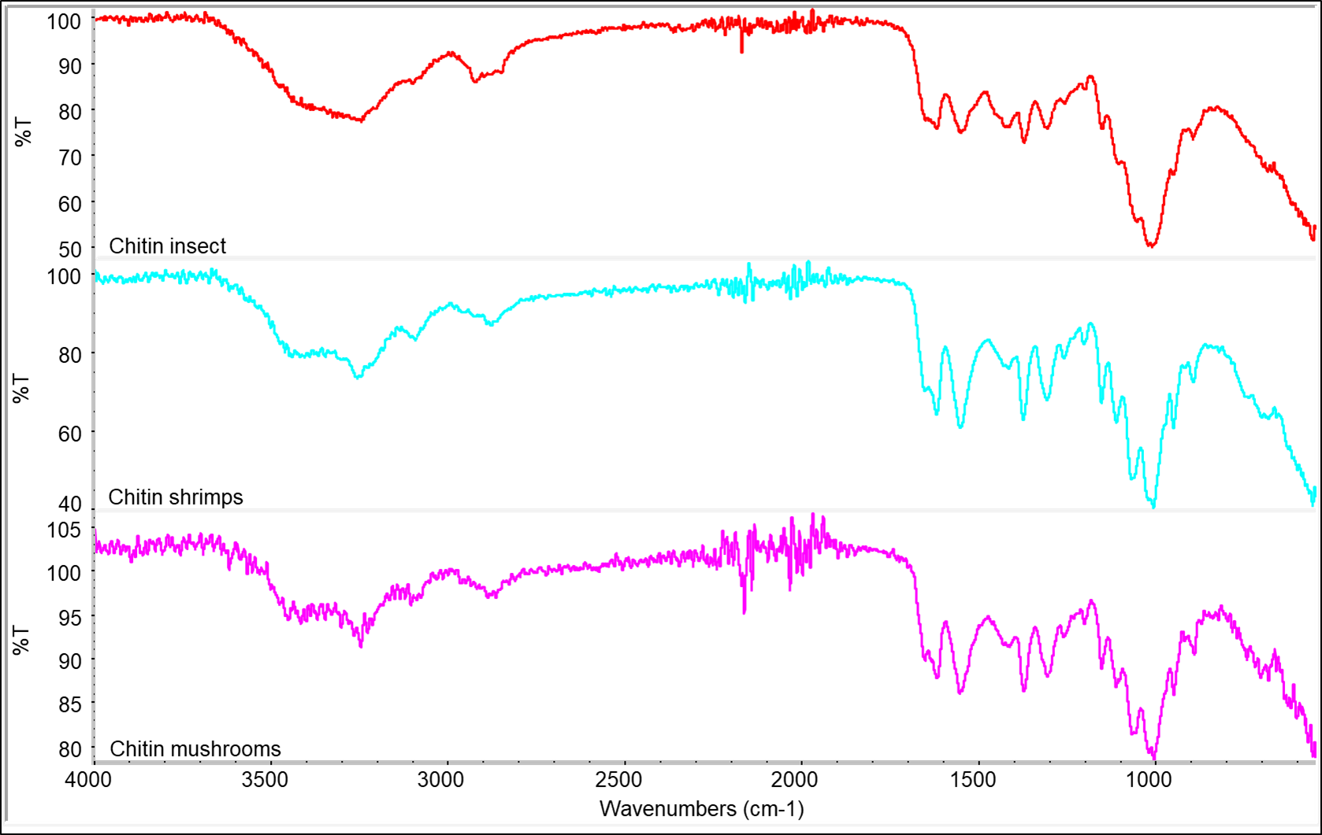
Figure 1. comparison between ATR spectra of chitin extracted from different sources
All the spectra showed a similar structure, although the chitin from insect showed a different shape of the characteristic peaks. Those differences can be attributed to a different structure of the chitin fibrils but also to the different extraction and purification methods and to the different acetylation degree.
Chitin from adult (CHITI-A) was bleached to obtain an alternative purified version with a less intense coloration (CHITI-AB). Then, chitosan was obtained from deacetylation of chitin from adult insects. Bleached (CHITO-AB) and unbleached (CHITO-A) versions were analyzed by ATR-IR to evaluate their acetylation degree through the comparison of R_{AC} values. A higher value or R_{AC} represents a higher acetylation degree of chitosan, so it indicates that the deacetylation was less effective.
Table 1: Areas calculated by ATR spectra and corresponding R_{AC} values
samples | A₁₆₂₀ | A₁₀₂₀ | R_{AC}
CHITI-A | 7.256 | 13.643 | 0.53
CHITI-AB | 8.768 | 19.184 | 0.45
CHITO-A | 3.314 | 16.883 | 0.20
CHITO-AB | 2.853 | 14.748 | 0.19

The R_{AC} values obtained for chitin samples were more than two times the values calculated for corresponding chitosans, indicating the occurrence of extensive deacetylation passing from chitin to chitosan. Comparison between bleached and unbleached samples evidenced that the bleaching treatment induced also a slight deacetylation, but this effect was more evident for chitin than for chitosan samples.
The correlation between R_{AC} and acetylation degree of chitosans was investigated measuring the R_{AC} values and acetylation degree of three commercial chitosans respectively with the ATR-IR spectroscopy and the potentiometric titration. The R_{AC} data for commercial chitosan samples are similar but slightly lower than those of chitosan from adult insects.
Table 2: R_{AC} values from commercial chitosans and acetylation degree from potentiometric tests
samples | R_{AC} | Acetylation degree
CHITO ALD 1 | 0.1543 | 17
CHITO ALD 2 | 0.1440 | 15
CHITO GLENT | 0.1215 | 9

The data, elaborated by linear fitting, were used to evaluate the equation of a line (Figure 2). Considering the equation of the line it is possible to predict that the acetylation degree of CHITO-A and CHITO-AB samples is 28.5 % and 26.06 %, respectively. This methodology can be applied for a fast prediction of acetylation degree of chitosan samples, for optimizing the deacetylation reaction converting chitin into chitosan. Nevertheless, this methodology, should be improved and better validated after successive purification of insect samples, to verify that the higher values is affectively attributable to a different polymeric structure (acetylation degree) and not to the presence of impurities. In particular, the presence of unreacted chitin, could significantly affect the acetylation degree values. Moreover, the linear dependence of Acetylation Degree and R_{AC} should be also verified and validated in a wide range of values, especially for ATR-IR analysis, where the change in functional groups can affect the molecular structure and consequently the shape and intensity of bands.

Figure 2: correlation line between R_{AC} and acetylation degree from commercial chitosan analysis
The morphology of chitin and chitosan was investigated by SEM analysis. In Table 3 the micrograph at low magnification evidenced for chitin (CHITI-A) a peculiar geometrical structure correlated to the specific surface morphology of the insect body. On the contrary the chitosan, obtained after the deacetylation, present as fragments in the micrograph of CHITO-A, showed a homogeneous morphology. Nanofibrils are present both in chitin and chitosan micrographs at high magnification.

Table 3 micrographs of chitin and chitosan from insects at different developmental stages that evidence their microstructure
 | Low magnification | High magnification
CHITI-A | 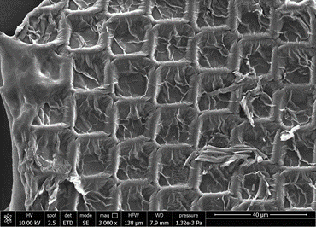 | 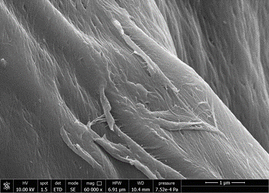
CHITO-A | 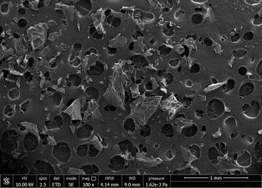 | 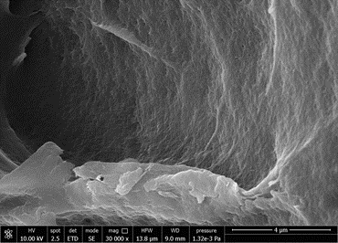

  - Conclusions
Investigation of extract from different sources such as shrimps, mushrooms and insects evidenced the feasibility of chitin supplying from many sources, obtaining similar products (as reported in the ATR-IR analysis) and comparable with spectra obtained with FT-IR in transmittance (Van de Velde and Kiekens 2004). Correlation between acetylation degree of chitin and chitosan and the R_{AC} parameter was experimentally verified, allowing an evaluation of acetylation degree with ATR-IR technique. Chitosan can be successfully obtained through the deacetylation of chitin from Hermetia Illucens insects and its deacetylation degree resulted slightly lower respect to the commercial ones from other sources, in agreement with literature (Luo et Al. 2019). Morphology analysis of chitosan and chitin mainly evidenced differences in the microstructure. Chitin structure preserved microstructures typical of different insect body surface (Waśko et Al. 2016), whereas chitosan resulted homogeneous.
While more and more applications for chitin derivatives will be developed, differences between them should be clarified and correlated to the sources, the methodologies of their production and their physical-chemical properties.
Nomenclature
R_{AC} = acetylation ratio, -

AD % = acetylation degree, %
% T = Transmittance, %
Acknowledgments
This work has received partial funding from the Bio-based Industries Joint Undertaking under the European Union’s Horizon 2020 research and innovation programme under grant agreement No 837863 (ECOFUNCO project). The CISUP—Centre for Instrumentation Sharing—University of Pisa, is thanked for its support.
References

Brugnerotto, J., J. Lizardi, F. M. Goycoolea, W. Argüelles-Monal, J. Desbrières, and M. Rinaudo. 2001. “An Infrared Investigation in Relation with Chitin and Chitosan Characterization.” Polymer 42 (8): 3569–80. https://doi.org/10.1016/S0032-3861(00)00713-8.
Coltelli, Maria-Beatrice, Vito Gigante, Luca Panariello, Laura Aliotta, Pierfrancesco Morganti, Serena Danti, Patrizia Cinelli, and Andrea Lazzeri. 2019. “Chitin Nanofibrils in Renewable Materials for Packaging and Personal Care Applications.” Advanced Materials Letters 10 (6): 425–30. https://doi.org/10.5185/amlett.2019.2250.

Gigante, Vito, Luca Panariello, Maria Beatrice Coltelli, Serena Danti, Kudirat Abidemi Obisesan, Ahdi Hadrich, Andreas Staebler, et al. 2021. “Liquid and Solid Functional Bio-Based Coatings.” Polymers 13 (21): 1–22. https://doi.org/10.3390/polym13213640.
Hahn, Thomas, Elena Tafi, Aman Paul, Rosanna Salvia, Patrizia Falabella, and Susanne Zibek. 2020. “Current State of Chitin Purification and Chitosan Production from Insects.” Journal of Chemical Technology \& Biotechnology 95 (11): 2775–95. https://doi.org/https://doi.org/10.1002/jctb.6533.
Jiang, Xuan, Lirong Chen, and Wei Zhong. 2003. “A New Linear Potentiometric Titration Method for the Determination of Deacetylation Degree of Chitosan.” Carbohydrate Polymers 54 (4): 457–63. https://doi.org/https://doi.org/10.1016/j.carbpol.2003.05.004.
Kasaai, Mohammad R. 2008. “A Review of Several Reported Procedures to Determine the Degree of N-Acetylation for Chitin and Chitosan Using Infrared Spectroscopy.” Carbohydrate Polymers 71 (4): 497–508. https://doi.org/https://doi.org/10.1016/j.carbpol.2007.07.009.
Luo, Qiang, Ying Wang, Qianqian Han, Lisu Ji, Hongmei Zhang, Zhenghao Fei, Yanqing Wang, 2019 "Comparison of the physicochemical, rheological, and morphologic properties of chitosan from four insects." Carbohydrate Polymers 209: 266-275. https://doi.org/10.1016/j.carbpol.2019.01.030.
Morganti, Pierfrancesco. 2019. Bionanotechnology to Save the Enviroment. Bionanotechnology to Save the Environment. https://doi.org/10.3390/books978-3-03842-693-6.
Muzzarelli, Corrado, and Pierfrancesco Morganti. 2006. Preparation of chitin and derivatives thereof for cosmetic and therapeutic use, issued 2006.
Pagno, Carlos Henrique, Antonella Castagna, Alice Trivellini, Anna Mensuali-Sodi, Annamaria Ranieri, Ester Alice Ferreira, Alessandro de Oliveira Rios, and Simone Hickmann Flôres. 2018. “The Nutraceutical Quality of Tomato Fruit during Domestic Storage Is Affected by Chitosan Coating.” Journal of Food Processing and Preservation 42 (1): 1–9. https://doi.org/10.1111/jfpp.13326.
Pakizeh, Majid, Ali Moradi, and Toktam Ghassemi. 2021. “Chemical Extraction and Modification of Chitin and Chitosan from Shrimp Shells.” European Polymer Journal 159 (May): 110709. https://doi.org/10.1016/j.eurpolymj.2021.110709.
Panariello, Luca, Maria Beatrice Coltelli, Marco Buchignani, and Andrea Lazzeri. 2019. “Chitosan and Nano-Structured Chitin for Biobased Anti-Microbial Treatments onto Cellulose Based Materials.” European Polymer Journal 113 (February): 328–39. https://doi.org/10.1016/j.eurpolymj.2019.02.004.
Triunfo, Micaela, Elena Tafi, Anna Guarnieri, Carmen Scieuzo, Thomas Hahn, Susanne Zibek, Rosanna Salvia, and Patrizia Falabella. 2021. “Insect Chitin-Based Nanomaterials for Innovative Cosmetics and Cosmeceuticals.” Cosmetics 8 (2): 1–20. https://doi.org/10.3390/cosmetics8020040.
Van de Velde, Kathleen, Paul Kiekens. 2004. "Structure analysis and degree of substitution of chitin, chitosan and dibutyrylchitin by FT-IR spectroscopy and solid state 13C NMR". Carbohydrate Polymers 58 (4): 409-416. https://doi.org/10.1016/j.carbpol.2004.08.004.
Waśko, Adam, Piotr Bulak, Magdalena Polak-Berecka, Katarzyna Nowak, Cezary Polakowski, Andrzej Bieganowski, 2016. "The first report of the physicochemical structure of chitin isolated from Hermetia illucens". International Journal of Biological Macromolecules 92: https://doi.org/10.1016/j.ijbiomac.2016.07.038.

