|  |  |
| --- | --- |
| cetlogo ***CHEMICAL ENGINEERING TRANSACTIONS***  ***VOL. 93, 2022*** | A publication of  aidiclogo_grande |
| The Italian Association  of Chemical Engineering  Online at www.cetjournal.it |
| Guest Editors: Marco Bravi, Alberto Brucato, Antonio Marzocchella  Copyright © 2022, AIDIC Servizi S.r.l. **ISBN** 978-88-95608-91-4; **ISSN** 2283-9216 | |

CIVIL WASTEWATER REMEDIATION THROUGH EMPLOYMENT OF INDIGENOUS MICROALGAE AND SEWAGE SLUDGE

Lima S., D'Agostino N., Brucato A., Caputo G., Grisafi F., Scargiali F.

Università degli studi di Palermo, viale delle Scienze Ed. 6, 90128, Palermo

serena.lima@unipa.it

Microalgae are photosynthetic microorganisms that can employ some inorganic pollutant compounds as nutrients, for example nitrates and phosphates. Traditional wastewater treatment comprises oxidation ponds in which the Activated Sludge performs the oxidation of the organic matter. Microalgae may be well applied in these processes. In this work, we tested the potential of remediation of a mixture of a local microalga, *Chlorella sp. Pozzillo*, and activated sludge and compared it to controls of only microalga and only activated sludge. We found that the mixture of bacteria and microalgae leads to an improvement in nitrogen removal up to the 83,68%, while phosphorous removal is improved when the autochthonous microalgae are used alone. The abatement of the Chemical Oxygen Demand was of 59,17% when using the microalgae and activated sludge consortium, while it was higher (-76,67%±0) when using the only activated sludge. The biomass was also analysed for its content in lipids and carbohydrates. This information may be useful to assess the best industrial application for the biomass obtained from civil wastewaters remediation process, in accordance with principles of circular economy and waste-to-resources view.

* 1. Introduction

Wastewater treatment has a great importance for avoiding phenomena of eutrophication and consequently the pollution of seawater. Conventional civil wastewater treatment occurs inside wastewater treatment plants. The core of the remediation process consists of oxidation ponds in which a pull of indigenous microorganisms performs oxidation of the organic compounds. All these microorganisms constitute the Activated Sludge (AS). In order to promote the reactions, the ponds are insufflated with air; this operation affects approximately 45–75% of a wastewater treatment plant's total energy costs (Liu et al., 2011). In this context, a possible application for microalgal biomass has been found. Microalgae, in fact, are microorganisms able to perform photosynthesis and consume inorganic substances such as nitrates and phosphates, normally present in high concentrations in civil wastewaters. They are also useful for decreasing the concentration of pollutants such as heavy metals. Microalgae have been employed in wastewater treatment for several reasons: i) the decrease of the concentration of nitrates and phosphates; ii) the reduction of aeration costs, thanks to the photosynthetic aeration provided; iii) the production of a biomass that may be employed in several fields and that contains high-value biomolecules. For these reasons, they have been already employed in wastewater treatment (Lima et al., 2020). Beyond this application, microalgal biomass is employed in several other fields: for example, the production of biodiesel (Plata et al., 2010), that is probably one of the most ambitious applications, and the production of carbohydrates and lipids (Pierucci et al., 2017). Furthermore, they are exploited for their content in high-value biomolecules (such as carotenoids and omega-3) and strategies for the optimization of the production of these biomolecules have been proposed (Lima et al., 2021).

Together with the microalgal biomass specifically produced for these applications, also the microalgal biomass obtained in wastewater remediation applications can be employed in several ways, for example with energetic purposes (Casazza et al., 2016). In this case, it is to remark that the cost of the production of biodiesel may be significantly lower compared to that of biodiesel obtained from microalgae cultivated only with this goal. In addition, also other biomass fractions may be recovered from the same process (e.g. the carbohydrate fraction, that may be employed for fermentation purposes), according to the principles of algal bio-industry and circular economy. With this background, the aim of this research was that of exploiting an autochthonous microalgal strain for the remediation of a civil wastewater, starting from a previous similar work (Lima et al., 2020). In this work, the algal strain of *Chlorella sp. Pozzillo* together with the microorganisms from an AS were inoculated in civil sewage. The aim was to test the potential of removal of Chemical Oxygen Demand (COD), Total Nitrogen and Total phosphorous of the microorganisms taken together. The obtained biomass was also analysed to assess the content of lipid, useful to produce biodiesel, and carbohydrates, which may be employed in several industrial applications.

* 1. Material and methods
     1. Microalgal growth

Microalgae *Chlorella sp. Pozzillo*, previously isolated, was grown in municipal sewage coming from AMAP plant of Balestrate, 90041, PA, Italy. Microalgae were grown alone or together with Activated Sludge (AS) in the ratio 1:5 (w/w).

A pre-culture for each sample was set up by inoculating 10 mL of sample from a stock culture in 100 mL of sewage. When cells were in late exponential phase (after about 8 cultivation days), 10 mL of the cell suspension were used to inoculate the sewage. 150 mL of culture were grown in 500 mL Erlenmeyer flasks placed in an oscillating incubator (Corning Lse) under a 130 μE m-2 s-1 photon flux with a photoperiod light/dark of 12 h at 27°C. Light intensity was measured with a Delta Ohm-HD 9021 quantometer equipped with a Photosynthetic Active Radiation (PAR) probe (Delta Ohm LP 9021 PAR). The algae were cultivated for 10 days. The concentration of the microalgal suspension was checked by measuring daily the absorbance at 750 nm in a spectrophotometer (Cary 60 Uv-vis, Agilent technologies) and in a fluorometer (Cary Eclipse Fluorescence Spectrophotometer, Agilent Technologies, Ex. 430 nm – Em. 670 nm) in order to distinguish the contribute of photosynthetic microorganisms. For each condition, a biological duplicate (*n* = 2) was performed.

* + 1. Harvesting of microalgal biomass

After the growth the cell suspension was centrifuged (3600 rpm, 10 min, NEYA 10R) and the biomass frozen in liquid nitrogen and freeze-dried for 48 h in a bench lyophilizator (FreeZone 2.5 L, LABCONCO, US). The biomass was then stored at -20°C for further analysis.

* + 1. Extraction and analysis of fatty acids

About 20 mg of lyophilized microalgae biomass was weighted in a glass tube and about 7 mg of glass beads were added. Then 5 mL of chloroform/methanol (2:1, v/v) and 1 mL of NaCl 1% were added and the mixture was vigorously mixed with a vortex and subsequently centrifuged until the formation of two phases. The lower phase (chloroform phase) was transferred in a pre-weighted tube and the solvent was evaporated under nitrogen stream. After complete solvent evaporation, total lipids were determined gravimetrically.

* + 1. Total carbohydrates

Total carbohydrate content was determined according to Trevelyan et al. (Trevelyan et al., 1952). Briefly, 10 mg of freeze-dried biomass were suspended in 3 mL HCl 2 N and hydrolysed in a water bath for 1 h at 100°C. Subsequently, 4 mL of a fresh anthrone solution (Sigma-Aldrich, 2 mg mL-1 in 95-97% H2SO4) were added to 1 mL of sample extract. The absorbance of each sample was read at 620 nm (Cary 60 Uv-vis, Agilent technologies). Aliquots of different glucose concentrations (0.02-0.1 mg L-1) were prepared and processed in the same way as microalgal extracts, to obtain a calibration curve.

* + 1. Sewage analysis

A pre-treated sewage coming from the municipal treatment plant AMAP located in Balestrate, 90041, PA, Italy, was used. This batch was analysed for COD, total phosphorous (TP) and total nitrogen (TN) and then stored at -20°C until it was used for microalgae inoculation. After microalgal growth, the sewage was filtered (11 mm, Whatman filter paper) and the above analyses were repeated. The COD analysis was performed following the ISPRA Method 5135 by employing cuvette test LCK 514, Hach Company. TN and TP analysis were performed by a breakdown procedure following UNI EN ISO 11905-1 followed by a colorimetric reaction according to DIN 38405-9 for TN and UNI EN ISO 6878 for TP. For the colorimetric analysis a spectrophotometer UV-VIS DR6000, Hach Company, was employed.

* 1. Results and discussion
     1. Growth curves

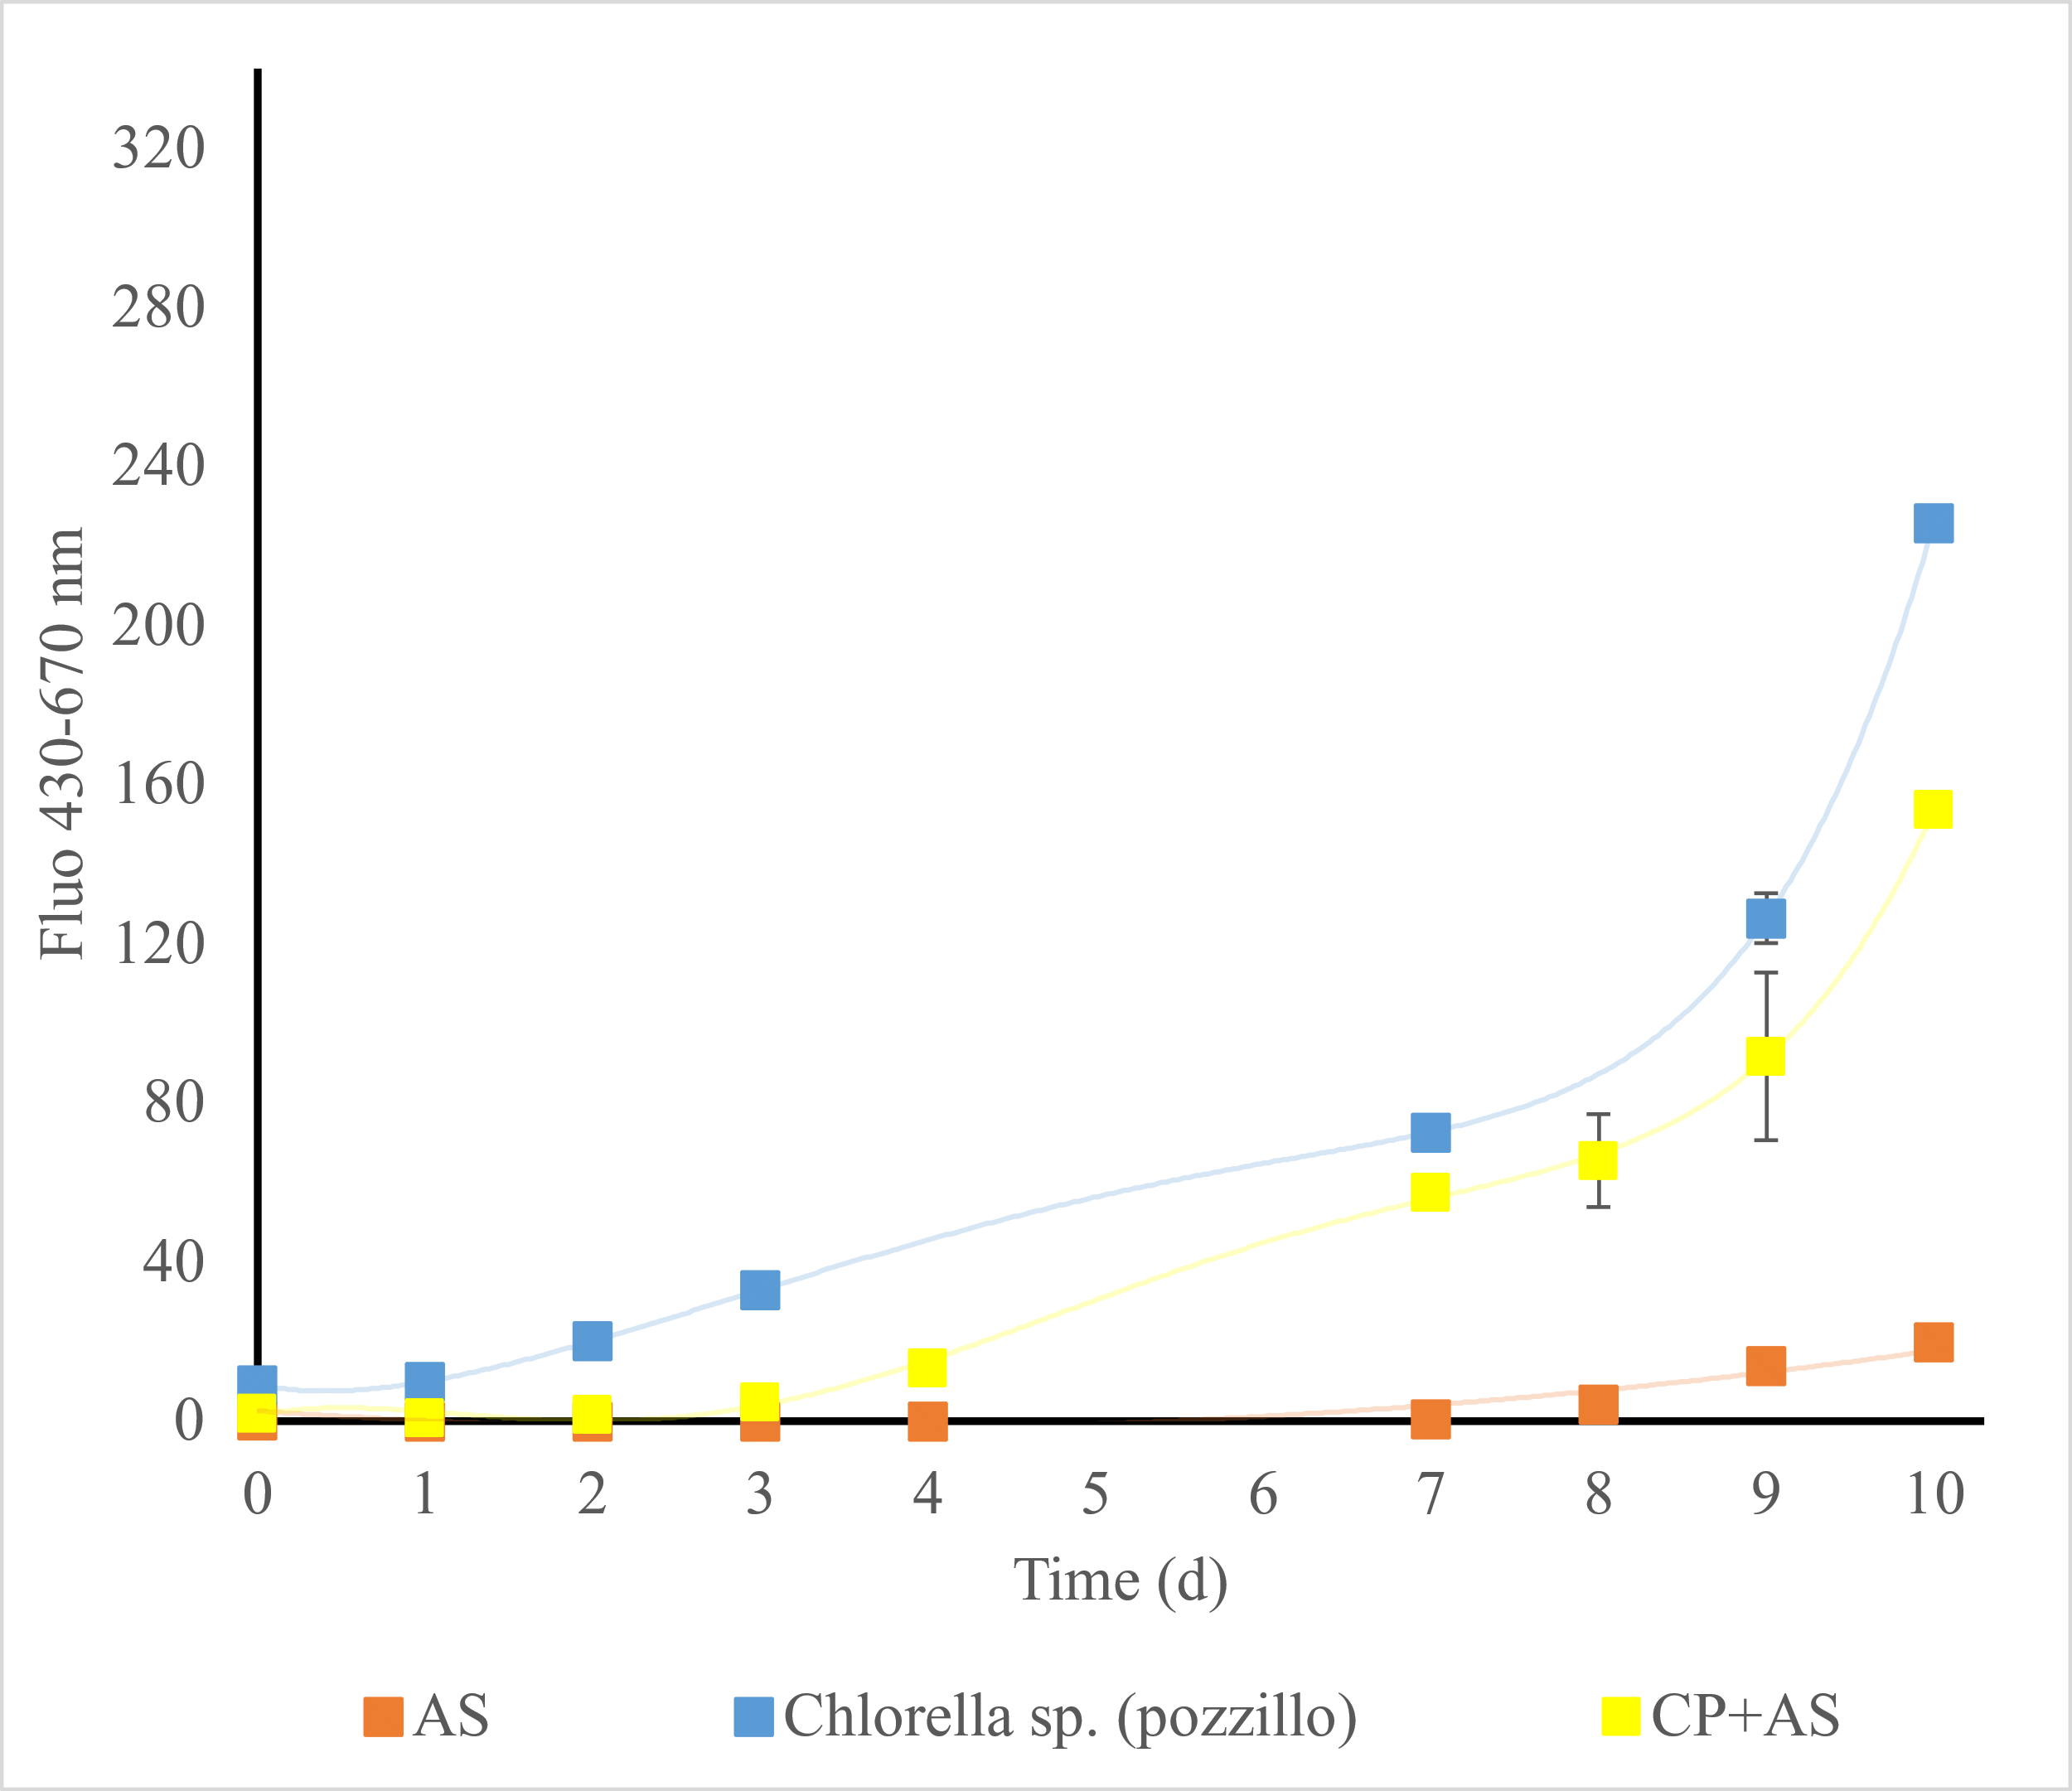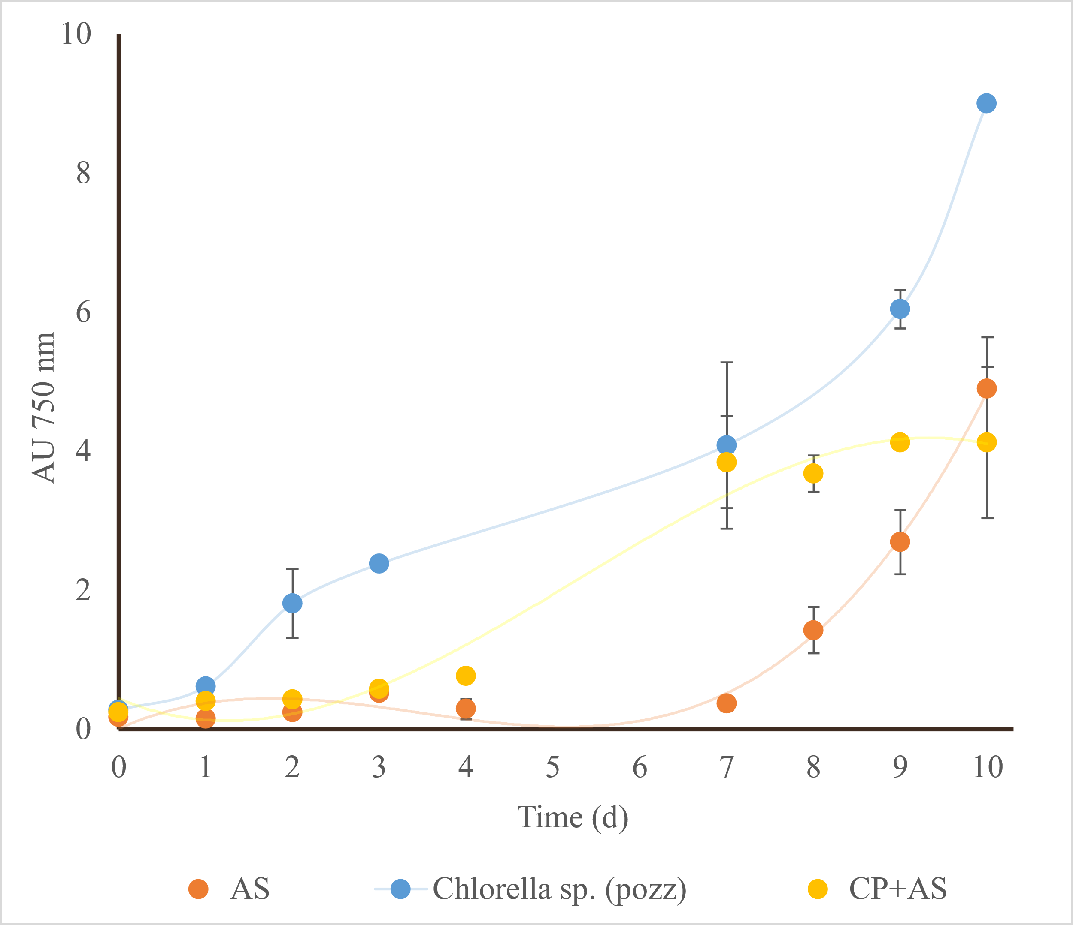

a

b

Figure 1: Growth curves of the microalgal strains Chlorella sp. Pozzillo inoculated with activated sludge in civil sewage. a) and b) show the values of absorbance (750 nm) and the fluorescence (430-670 nm), respectively, of the cultures). Values are reported as means (n = 2) and error bars report the standard deviations. CP: Chlorella sp Pozzillo; AS: Activated Sludge.

Figure 1 shows the growth curves of pure microalgae, Activated Sludge (AS) and the mixture of microalgae and activated sludge grown in not-treated civil sewage. Both the civil sewage employed in these cultivations and the AS were coming from a municipal treatment plant AMAP located in Balestrate, 90041, PA, Italy. The growth has been measured through the value of absorbance at 750 nm and fluorescence (excitation 430 and emission 670 nm). This method was adopted because the absorbance measurement alone was not able to distinguish between the microalgae and other microorganisms. The fluorescence, instead, allows to read the signal of the chlorophyll molecule, that is only present in photosynthetic microorganisms. From Figure 1 it is possible to observe that *Chlorella sp Pozzillo* was able to growth in sewage and has a strong signal both through absorbance and fluorescence signals. The AS growth well in sewage as well, as expected, but its signal is stronger by measuring it through absorbance than through fluorescence. Also, this last measurement, anyway, gives a signal, meaning that there is a certain photosynthetic community in the AS. The sample inoculated with both microalgae and AS has an intermediate growth between AS and *Chlorella sp. Pozzillo* by the measurement through both absorbance and fluorescence.

* + 1. Bioremediation of the civil sewage

In order to investigate the role of microalgal communities in the remediation of civil wastewater, chemical analysis of the untreated sewage compared to the treated ones were performed. The biomass was separated from the sewage by filtering the suspension before the analysis; this was necessary to avoid that the biomass itself lead to an increase of the COD. Chemical oxygen demand (COD), Total nitrogen and Total phosphorous were analysed. Figure 2 and Table 1 report the results of the analysis. The treatment with *Chlorella sp. Pozzillo* alone leads to an increase of the COD (+1,94±0). This increase was already observed before (Lima et al., 2020) and is probably due to a release of organic compounds from the microalgae. COD is instead well abated by the AS (-76,67±0), while the treatment with microalgae and AS together leads to an intermediate decrease (-59,17±2,75). In Figure 2 the loyal requirement for civil wastewaters delivering in Italy is reported (dotted lines) (D.Lgs 152/06). In Figure 2 a it is shown that the treatment with *Chlorella sp*. *Pozzillo* both alone and together with the activated sludge is not sufficient to abate the COD under the admissible limit. Instead, the treatment with the only activated sludge is sufficient to lower the COD. This is probably caused by the fact that microalgae of the genus *Chlorella* release into the medium some organic compounds that are included into the COD measurement. They are probably cellulose, as explained before (Lima et al., 2020). On the contrary, by inoculating together *Chlorella sp. Pozzillo* and AS, a good removal of total nitrogen is obtained, as observed in Figure 2 b. In this case the abatement is of the 83,68%±0,78, while in the sewage treated with the only AS is of the 44, 04%±0,94 and in the sewage treated with the only *Chlorella sp. Pozzillo* of the -48,79%±2,55. The obtained percentage of removal by inoculating both microalgae and bacteria are in line with other studies; for example, Leong et al., 2018, found a removal of the 97% of the nitrogen obtained by a consortium of *Chlorella sp*. and AS. In a previous work, it was found a maximum removal of 76,4% of the total nitrogen, in a similar way that in this work (Lima et al., 2020).



Figure 2: Chemical analysis for the characterization of the sewage before and after the growth of microorganisms: a) Chemical Oxygen Demand (COD); b) Total Nitrogen; c) Total Phosphorous. All the results are reported for the untreated sewage, Activated sludge (AS), Chlorella sp Pozzillo alone and together microorganisms from activated sludge. Values are reported as means (n = 2) and error bars report the standard deviations. Samples with the same letter are statistically identical. Dotted lines indicate the loyal requirements for depuration in sensitive locations of the Sicilian littoral.

For what concerns Total phosphorous, also in this case a good percentage of removal is obtained. In this case, *Chlorella sp. Pozzillo* reaches an abatement of the 82,23%±0, while the AS of the 70,81%±19,74 and the consortium of *Chlorella sp*. and AS of the 59,64%±8,26. Therefore, in this case, the addition of activated sludge is not effective in further decreasing the content of total phosphorous. Furthermore, the only sample able to decrease the concentration under the loyal requirement is *Chlorella sp. Pozzillo*. Also in this case, the removal is in line with a previous work (Lima et al., 2020).

Table 1: Percentages of removal of COD, Total Nitrogen and Total Phosphorous of the sewage treated by Activated sludge (AS), Chlorella sp Pozzillo (CP) alone and together microorganisms from activated sludge. Values are reported as means (n = 2) and standard deviations is reported.

|  |  |  |  |
| --- | --- | --- | --- |
|  | % of removal of COD | % of removal of Total Nitrogen | % of removal of Total Phosphorus |
| Activated Sludge | -76,67±0 | -44,04±0,94 | -70,81±19,74 |
| *Chlorella sp pozz* | +1,94±0 | -48,79±2,55 | -82,23±0 |
| CP+AS | -59,17±2,75 | -83,68±0,78 | -59,64±8,26 |

* + 1. Biochemical analysis

The biomass obtained from the treatment of sewage was analyzed to assess which kind of applications may be advantageous for its valorization. For this reason, the total carbohydrate and total lipid content was assessed. Results are shown in Figure 6. The content of lipids is highest in the sample constituted by the only microalga *Chlorella sp Pozzillo* grown in sewage (31,66%±3,37), followed by the 19,41%±0,40 of the consortium of *Chlorella sp*. and AS and the 18,50%±2,72 of AS. The content in carbohydrate is higher as well in *Chlorella sp Pozzillo (18,35*%±1,25) followed by the consortium (9,48%±1,81) and the activated sludge (8,90%±1,85).

The content of lipids in *Chlorella sp.* cultured in wastewater is coherent with what found by Gao et al. (Gao et al., 2019), while Peng et al. showed that the concentration of carbohydrates in *C. vulgaris* grown in wastewaters with different organic carbon sources is around 30%, confirming what found in this work (Peng et al., 2019). Interestingly, the lipid content of the same *Chlorella sp Pozzillo* grown in a growth medium resulted almost the half of what found in this work (Arena et al., 2021). In general, the content in lipids and carbohydrates of the analyzed samples is good enough to evaluate them for application in bioenergy, to produce biodiesel from the lipid fraction, and for the fermentation of the sugars from the carbohydrate fraction.



Figure 3: Composition in percentage of total lipids and carbohydrates on dry weight (DW) of Chlorella sp. Pozzillo (CP) grown in urban wastewaters with and without the addition of Activated Sludge (AS).

* 1. Conclusions

This work analysed the effect of inoculating a microalgal strain together with activated sludge in civil wastewaters. The abatement of COD, total phosphorous and total nitrogen for each sample was assessed at the end of the cultivation. Results showed that total nitrogen is efficiently abated by the consortium (-83,68%±0,78) and total phosphorous by *Chlorella sp Pozzillo* (-82,23%±0). Regarding COD abatement, the treatment with *Chlorella sp. Pozzillo* alone leads to a slight increase of the COD (+1,94±0), while AS leads to a good abatement (-76,67±0), and the consortium of microalgae and AS leads to an intermediate decrease (-59,17±2,75). The residual biomass was analysed for the content in carbohydrate, lipids and fatty acid and considering the amount of these compounds in the residual biomass, it may be exploited in bioenergetic applications.

Acknowledgments

The authors wish to thank AMAP s.p.a. and, in particular, Ing. A. Siragusa and R. Arcuri, for kindly providing the sewage, the activated sludge and for making some of the analysis of this work.

References

Arena, R., Lima, S., Villanova, V., Moukri, N., Curcuraci, E., Messina, C., Santulli, A., & Scargiali, F. (2021). Cultivation and biochemical characterization of isolated Sicilian microalgal species in salt and temperature stress conditions. *Algal Research*, *59*(March), 102430. https://doi.org/10.1016/j.algal.2021.102430

Casazza, A. A., Ferrari, P. F., Aliakbarian, B., Comotto, M., & Perego, P. (2016). Microalgae growth using winery wastewater for energetic and environmental purposes. *Chemical Engineering Transactions*, *49*, 565–570. https://doi.org/10.3303/CET1649095

Gao, F., Yang, H.-L., Li, C., Peng, Y.-Y., Lu, M.-M., Jin, W.-H., Bao, J.-J., & Guo, Y.-M. (2019). Effect of organic carbon to nitrogen ratio in wastewater on growth, nutrient uptake and lipid accumulation of a mixotrophic microalgae Chlorella sp. *Bioresource Technology*, *282*, 118–124. https://doi.org/10.1016/j.biortech.2019.03.011

Leong, W. H., Lim, J. W., Lam, M. K., Uemura, Y., Ho, C. D., & Ho, Y. C. (2018). Co-cultivation of activated sludge and microalgae for the simultaneous enhancements of nitrogen-rich wastewater bioremediation and lipid production. *Journal of the Taiwan Institute of Chemical Engineers*, *87*, 216–224. https://doi.org/10.1016/j.jtice.2018.03.038

Lima, S., Schulze, P. S. C., Schüler, L. M., Rautenberger, R., Morales-Sánchez, D., Santos, T. F., Pereira, H., Varela, J. C. S., Scargiali, F., Wijffels, R. H., & Kiron, V. (2021). Flashing light emitting diodes (LEDs) induce proteins, polyunsaturated fatty acids and pigments in three microalgae. *Journal of Biotechnology*, *325*(November 2020), 15–24. https://doi.org/10.1016/j.jbiotec.2020.11.019

Lima, S., Villanova, V., Grisafi, F., Caputo, G., Brucato, A., & Scargiali, F. (2020). Autochthonous microalgae grown in municipal wastewaters as a tool for effectively removing nitrogen and phosphorous. *Journal of Water Process Engineering*, *38*(August), 101647. https://doi.org/10.1016/j.jwpe.2020.101647

Liu, C., Li, S., & Zhang, F. (2011). The oxygen transfer efficiency and economic cost analysis of aeration system in municipal wastewater treatment plant. *Energy Procedia*, *5*, 2437–2443. https://doi.org/10.1016/j.egypro.2011.03.419

Peng, Y., Gao, F., Hang, W. W., Yang, H., Jin, W., & Li, C. (2019). Effects of organic matters in domestic wastewater on lipid/carbohydrate production and nutrient removal of Chlorella vulgaris cultivated under mixotrophic growth conditions. *Journal of Chemical Technology & Biotechnology*, *94*(11), 3578–3584. https://doi.org/10.1002/jctb.6161

Pierucci, S., Klemeš, J. J., Piazza, L., Bakalis, S., Visca, A., Di Caprio, F., Spinelli, R., Altimari, P., Cicci, A., Iaquaniello, G., Toro, L., & Pagnanelli, F. (2017). Microalgae Cultivation for Lipids and Carbohydrates Production. *Chemical Engineering Transaction*, *57*, 127–132. https://doi.org/https://doi.org/10.3303/CET1757022

Plata, V., Kafarov, V., & Moreno, N. (2010). Optimization of third generation biofuels production: Biodiesel from microalgae oil by homogeneous transesterification. *Chemical Engineering Transactions*, *21*, 1201–1206. https://doi.org/10.3303/CET1021201

Trevelyan, W. E., Forrest, R. S., & Harrison, J. S. (1952). Determination of Yeast Carbohydrates with the Anthrone Reagent. *Nature*, *170*(4328), 626–627. https://doi.org/10.1038/170626a0