CHEMICAL ENGINEERING TRANSACTIONS  VOL. 92, 2022 | A publication of
The Italian Association
of Chemical Engineering
Online at www.cetjournal.it

Guest Editors: Rubens Maciel Filho, Eliseo Ranzi, Leonardo Tognotti
Copyright © 2022, AIDIC Servizi S.r.l.
ISBN 978-88-95608-90-7; ISSN 2283-9216

Optimization of Liquid Polyphenol Extraction from Coffee Pulp
¹*Correa-Mahecha, F., ^{2,3}Murillo, W., ¹Arturo-Calvache, J. E., ⁴ Cuesta-Parra, D. ⁵ Mayorga, M., ¹Sandoval, J
¹Grupo de Procesos de Separación no Convencionales-GPS, Departamento de Ingeniería Química y Ambiental, Fundación Universidad de América, Avda Circunvalar No. 20-53, Bogotá D.C, Colombia.
²CIMAD, Universidad de Manizales, Cra 9 a # 19-03 Campo Hermoso, Manizales, Colombia
³Grupo de Investigación en Productos Naturales- GIPRONUT, Universidad del Tolima, Cl 42 1-02, Ibagué, Colombia.
⁴Grupo de Investigación en Ingenierías y Gestión Ambiental- GIGA. Departamento de Ingeniería Química y Ambiental, Fundación Universidad de América, Avda Circunvalar No. 20-53, Bogotá D.C, Colombia.
⁵Grupo de Investigación de Aprovechamiento Tecnológico de Materiales y Energía GIATME, Universidad ECCI, Carrera 19 # 49 – 20, Bogotá, Colombia.

Summary

Coffee pulp is one of the most abundant residues in the coffee agroindustry. Its inadequate handling and disposition produce contamination of water and soil. However, this waste contains high levels of tannins and other phenolic compounds, which could be extracted, getting added value. A vertical rotational composite design was used to optimize procedures for obtaining total polyphenols and tannins, based on temperature and concentration of sodium hydroxide in the extraction solution, at a fixed time of 30 minutes of contact. The optimal values for the extraction of total polyphenols were obtained at a temperature of 55.8°C, using sodium hydroxide solutions of 2.55 M, achieving the extraction of 116.59 mg GAE/g (mg of gallic acid equivalent per gram of pulp). These values are significantly higher than those reported in other studies. The optimum conditions for the extraction of tannins were a maximum temperature of 64.14°C for the test and concentrations of sodium hydroxide of 2.58 M, which obtained the extraction of 66.07 g GAE per gram of pulp in tannins. Most favorable values for antioxidant capacity were close to those obtained for both polyphenols and tannins. The increase in the concentration of sodium hydroxide of the extraction solution above 2.7 M caused the reduction of the contents of total polyphenols, and tannins. Results show the possibility of valorizing coffee pulp by extracting tannins and other polyphenols and reveal possible uses of process streams. These would allow the formulation of strategies framed within the concepts of green chemistry, circular economy and biorefineries.

Keywords: tannins, antioxidant capacity, alkaline extraction, DPPH assay,
___________________________________
*Corresponding author. Email: felipe.correa@profesores.uamerica.edu.co

- Introduction
After oil, coffee is the second most commercialized product in the world. Arabica coffee is the best-selling variety, with 82.75 million bags of 60 kg during 2019, followed by the robust variety, with 46.65 million sacks (ICO, 2020). Colombia is the third world producer of coffee. La Federación Nacional de Cafeteros (2021) reported during the period from April 2020 to March 2021 there were harvest equivalent to 14.6 million bags of 60 kg, demonstrating how coffee economy is a key for the sustainability of rural communities in a wide area of the national territory. However, during the production process, pulp, mucilage and shell are generated, achieving around 784.000 tons of waste each year (Serna-Jiménez et al., 2018). Coffee pulp comprises 30% of the dried fruit and between 40% and 50% of the wet fruit, thus it becomes the main residue of this industry. It is a material rich in fats (2.0-7.0%), carbohydrates (20-32%), reducing sugars (14%), tannins (5%), caffeine (1%), and protein (7.5-15.0%) (Aristizábal-Marulanda et al., 2017). For this reason, the coffee pulp can be a useful source of both bioactive substances and nutrients for animal feed and the production of organic fertilizers, methane (Widjaja et al., 2017) and Bio-Hydrogen production (Rangel et al., 2020); strategies for recovering residues with methodologies of bioeconomy and circular economy are promising alternatives for the satisfactory use of this resource (Rajesh Banu et al., 2020a; Solarte-Toro & Cardona Alzate, 2021).

In the compounds present in the coffee pulp, polyphenols have received special attention, due to their antioxidant, antibacterial, and antifungal features in the onset or development of diseases (Bagheri et al., 2021; Chaves-ulate & Esquivel-rodríguez, 2019), and to the pharmaceutical and cosmetic industrial use (Torres-Valenzuela et al., 2020). Proanthocyanidins have industrial applications, including leather tanning (Neto et al., 2020), adsorbents (Bacelo et al., 2016), and sustainable materials for the manufacture of adhesives, coatings, brake pads, corrosion inhibitors, packages, metal recovery, food additives, polymers, and wood coatings (Barbero-López et al., 2020). Additionally, inadequate handling and disposal could negatively affect the life of different aquatic organisms (Janissen & Huynh, 2018). Most of the studies about polyphenols extraction focus on the fraction derived from aqueous or organic solutions (Correa-Mahecha et al., 2021). However, a fraction of polyphenols remains retained in the solid matrix. These non-removable polyphenols are high molecular weight polymers, as in the case of condensed tannins (Domínguez-Rodríguez et al., 2017).
This work aims to study the effect of temperature and sodium hydroxide concentration in the extraction of polyphenols and tannins, and their antioxidant power. It will help to find optimal conditions for their extraction and to open pathways for future applications of coffee pulp as a valuable resource within the schemes of circular economy.

- Materials and methods
  - Coffee pulp and reagents
The arabica coffee pulp was supplied by the Innovation Technology Coffee Park - Tecnicafé, from grains grown in Cajibío, Cauca, (Colombia), during June and July 2019. The material was sun dried for two days and milled for extractions. The sample remained refrigerated (7°C) until use. For quantification, Folin-Ciocalteu reagent (Sigma Aldrich®) was used with 2.2-diphenyl-1-picrilhydrarail DPPH (Sigma Aldrich®), sodium carbonate (Rodaquímicos®), and gallic acid (Merck®) for pattern curve calibration.
  - Experimental
The solid to liquid ratio was maintained at 1:20, and the extraction time was set in 30 minutes, id est the time to achieve the steady state for extraction under experimental conditions. Temperature levels (X_{T}) and NaOH concentration (X_{C}) were also determined for the central composite design (CCD) of the response surface, to establish the effect of these two variables on the extraction of polyphenols and tannins as well as on the antioxidant capacity of the extract. The design was considered in duplicate: a complete factorial design 2² (eight runs), six replicas of the center point (six runs), and the axial points at a distance of ±α from the central points (eight runs) to ensure the rotationality of the design, with a value of α=nf^{1/4}, where n_{f} corresponds to the number of factorial points α=n_{f} (Dean et al., 2017), providing:

$α=4^{\frac{1}{4}}=1.4142$ (1)
For a total of 22 experiments, table 1 presents the natural and coded levels of the experiment design factors. The concentration of sodium hydroxide used for extraction is given in molar concentration (NaOH/L mol).

Table 1: Natural and coded levels of experiment design factors.

Factor | Factor level  -α -1 0 1 +α | Unit
Temperature, x_{T} | 35.86 40.00 50.00 60.00 64.14 | °C
NaOH concentration, x_{C} | 0.000 0.515 1.757 3.000 3.515 | M

Extractions were carried out using 0.5000 g of pulverized pulp and 10.0 mL of NaOH solution in covered test tubes, under agitation of 80 revolutions per minute (rpm), in a thermostat bath at the temperature set, for 30 minutes. Then, the sample was centrifuged at 3000 rpm for 10 minutes, 7.0 mL of the supernatant was neutralized with sodium hydroxide or hydrochloric acid 0.1M, until reaching a pH of 7.0. The neutralized extract was transferred to a 50 mL balloon. In some cases, additional dilutions were necessary to ensure linearity range. Statgraphics Centurion XVI version 16.1.03 was used for both experimental design and statistical analysis of the results. The differences were considered statistically significant with p-values below 0.05, representing a confidence level of 95%.
  - Determination of total phenols in the extract
Polyphenols were quantified using the Folin-Ciocalteu colorimetric method described by Chen et al. (2015). The calibration curve was adjusted using standard gallic acid solutions in concentration ranges of 0, 10, 20, 30, 40, 50 and 60 mg GAE/L. The target was prepared using distilled water. Absorbances were measured using a Jenway spectrophotometer® 6320D (United Kingdom) at a wavelength of 765 nm. Total polyphenol concentration was expressed in equivalent milligrams of gallic acid per liter (mg GAE/L).
  - Determination of tannins
The tannins were indirectly estimated after being adsorbed in insoluble polyvinylpolipyrrolidone (PVPP). 100 mg of PVPP were weighed in 2 mL Eppendorf tubes, then, 500 μL of the extract and 500 μL of distilled water were added and incubated for 4 hours at 4°C. Then, the tubes were centrifuged at 3000 rpm for 10 minutes at 4°C, and the content of non-tannic phenols of the supernatant was determined using the method described by Chen et al. (2015). Finally, tannins were calculated as the difference between total phenols minus non tannic phenols using the following equation:

$Tannins \left(mg GAE/L\right)=total phenols \left(mg GAE/L\right)-nontannic phenols (mg GAE/L).$ (2)

- Result and discussion
  - Optimizing extraction
Figure 1 presents the results of the central rotational composite design for total polyphenols. The R² value for a quadratic model was found to be 96.068%. R₂ values greater than 75% are considered acceptable for most optimization experiments (Ravindran et al., 2018). The adjusted R2 value was 94.49%, therefore the model is considered valid.

Optimal conditions were 55.8°C and NaOH 2.55 M (center in figure 1) giving 2914.73 mgGAE/L, equivalent to 116.5892 mgGAE/g of pulp, higher than those reported by other authors. Heeger et al. (2017) reported 283 mg GAE/L, taking up to 9.2 mg GAE/g of pulp, and using water at 85°C for 15 minutes. Serna-Jiménez et al. (2018) performed aqueous extractions of arabica coffee pulp at 90°C and a time of 8 minutes, finding 356.78 mg GAE/L, equivalent to 27.028 mg GAE/g of pulp.

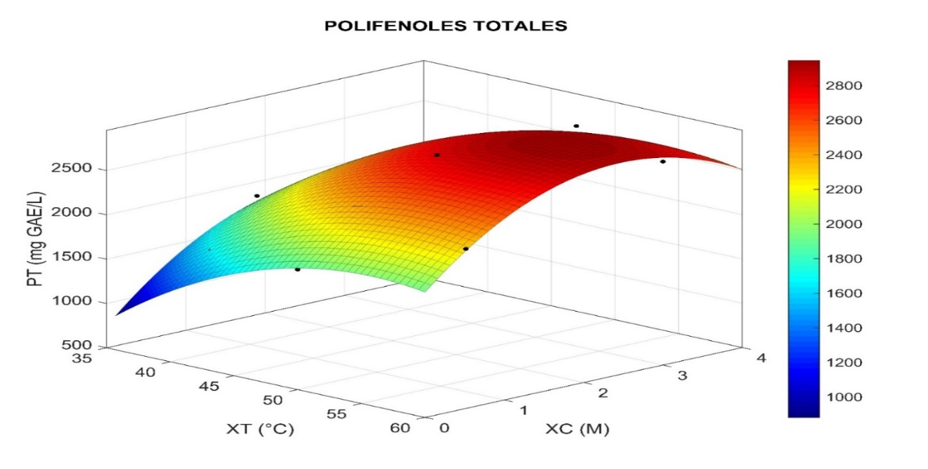
Figure 1. Response surface curve for the concentration of total polyphenols of extracts in mg GAE/L.

Other authors have found that improvements in pulp extraction are achieved through alkaline hydrolysis. Da Silveira et al. (2020) completed more satisfactory extractions of hydroxycinnamic acids, which are linked to the cell wall by covalent bonds, using solutions of 2.0 M sodium hydroxide. Jo et al. (2017) found direct interaction between the concentration of hydroxide and the extraction of polyphenols from coffee grounds, as well as direct interaction with the extraction temperature. They obtained the highest concentrations (36.5 mg GAE/g) at temperatures of 120°C and with solutions of 2.0 M sodium hydroxide. Higher concentrations of sodium hydroxide did not improve the extraction of polyphenols. The coefficient values for the obtained quadratic model are presented in the following equation:

PT = -5762.67+274.29*X_{T}+800.71*X_{C}- 2.43278*X_{T}² - 1.0365*X_{T}*X_{C} - 145.717*X_{C}² (1)

The quadratic effects of the two factors were also statistically significant in extraction, but with negative coefficient values. When the temperature exceeds the optimal value, a reduction of the extraction appears. Ravindran et al. (2018) found that this behavior gives an optimal value at 51.4°C in coffee grounds, while Zuorro et al. (2015) found the optimal at 47.1°C near to the value found in this study (55.8°C). Quadratic coefficient of the NaOH concentration (-145.717) is, in several orders of magnitude, greater than the quadratic coefficient of temperature (- 2.43278). This suggests a dramatic effect of this variable that causes a rapid drop in the concentration of polyphenols, once the optimal value is reached. The interaction between both factors was not found significant enough (p=0.723 >0.05) to affect extraction performance.

Figure 2 shows the results of the central rotational composite design for tannins. Optimal conditions were 64.14°C and NaOH 2.58 M, giving the extraction of 1651.92 mg GAE/L, equivalent to 66.07 mg GAE/g of pulp
Since optimal temperature corresponds to the maximum temperature of the study, it is predicted that an increase in this variable will allow higher extraction yields. These results coincide with (Low et al., 2015). R² value for tannin extraction was 75.71%. The coefficient values for the extraction of tannins based on concentration (X_{C}) and temperature (X_{T}) are presented in equation (2):

Tan=275.206–25.1279*X_{T}+630.987*X_{C}+0.498927*X_{T}²+1.45129*X_{T}*X_{C}-140.067*X_{C}² (2)

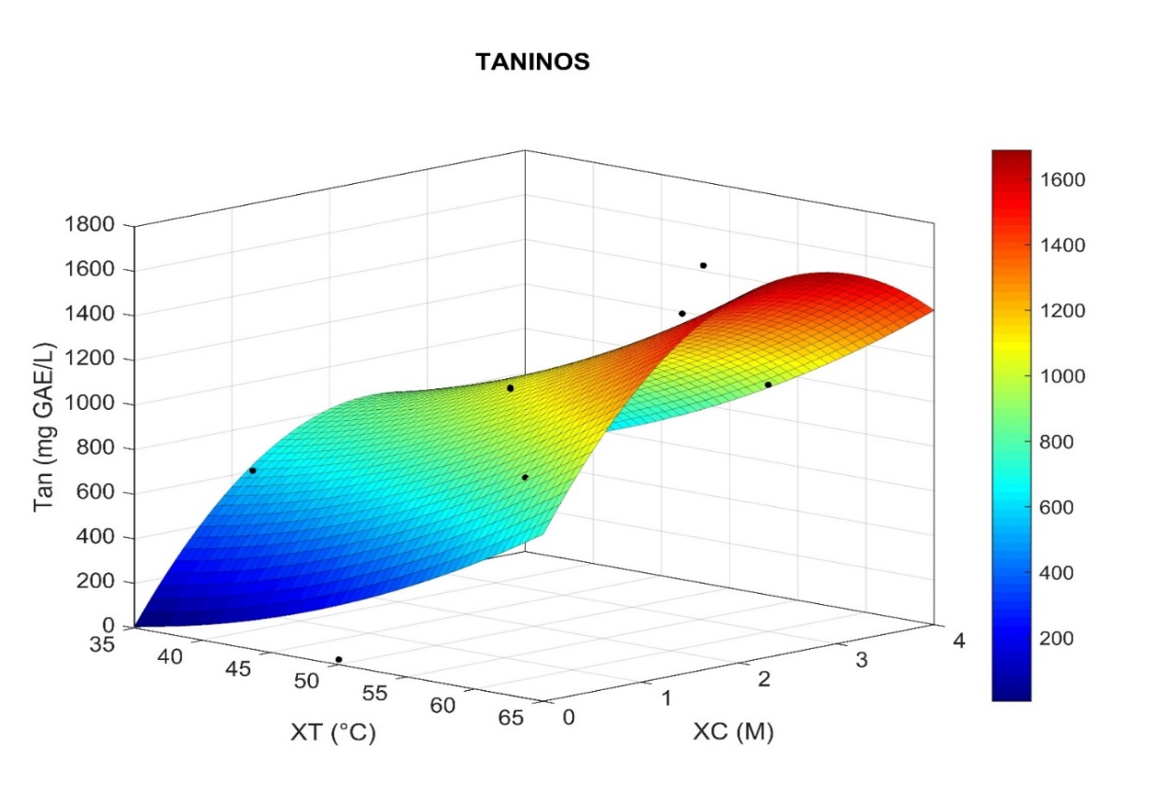
Figure 2. Response surface curve for experimental design. Tannin concentration is reported in mg GAE/L.

Results of the NaOH concentration coefficient (630.987) suggest that bigger tannin extractions may be achieved by increasing this coefficient. However, at very high pH values, tannins suffer a decrease of the available reactive sites (Low et al., 2015). Research about tannin extraction for its formulation in adhesives recommend self-condensation processes at highly alkaline values (Pizzi, 2008). This could be explained by the coefficient that accompanies the quadratic value of the concentration variable (- 140.067) and represents the tannins reduction due to this self-condensation.
Ulloa Rojas et al. (2002) proved that sodium hydroxide extraction counts as the most effective treatment for improving the nutritious characteristics of coffee pulp. The currents of tannins and polyphenols can be used as raw material for the manufacture of multiple products, such as nutraceutical supplements, adhesives, tanning agents (Shirmohammadli et al., 2018), coagulants and natural adsorbents (Bacelo et al., 2016, Lopes et al., 2019).

- Conclusions and recommendations
The temperature and concentration of sodium hydroxide proved to have a significant effect on the extraction of polyphenols and tannins. The second-order mathematical models have an acceptable degree of correlation with the experimental data, with optimal points for obtaining polyphenols and tannins. Increases in temperature or concentration of sodium hydroxide over the optimal points obtained caused a reduction in the extraction. These results open the way to valorize coffee pulp as a source of high added value extracts and to produce solid refining that can be evaluated for other applications, in accordance with the precepts of the circular economy, and can be used as reference information for bench, pilot and industrial-scale tests. For future work, it is still pending the recovery and reuse of sodium hydroxide from the extract, to diminish the use of mineral materials in the process.
The drying method executed corresponds to the postharvest practices in the region of origin of the material, drying in the sun can reduce the content of polyphenols and their antioxidant capacity, so it is recommended to modify the process in the future using processes of drying to shade in order to preserve the active substances.
It is also recommended to carry out material balances and the evaluation of the use of the solid raffinate that remains after extraction for use as animal feed, cellulose extraction and composting processes.

Acknowledgements
The authors express sincere gratitude to the Universidad de América, for the financial support to this research granted through its internal call process, as well as to the Coffee Innovation Technology Park - Tecnicafé in Cauca for the supply of the plant material used in this research.

References

Aristizábal-Marulanda, V., Chacón-Perez, Y. & Cardona Alzate, C. A. (2017). The biorefinery concept for the industrial valorization of coffee processing by-products. In Handbook of Coffee Processing By-Products (pp. 63–92). Academic Press. doi.org/10.1016/B978-0-12-811290-8.00003-7
Bacelo, H. A. M., Santos, S. C. R. & Botelho, C. M. S. (2016). Tannin-based biosorbents for environmental applications: A review. Chemical Engineering Journal, 303, pp. 575–587. doi.org/10.1016/j.cej.2016.06.044
Bagheri, S., Alinejad, M., Nejad, M., & Aliakbarian, B. (2021). Creating incremental revenue from industrial cherry wastes. Chemical Engineering Transactions, 87. doi.org/10.3303/CET2187093
Barbero-López, A., Monzó-Beltrán, J., Virjamo, V., Akkanen, J. & Haapala, A. (2020). Revalorization of coffee silverskin as a potential feedstock for antifungal chemicals in wood preservation. International Biodeterioration & Biodegradation, 152, 105011. doi.org/10.1016/j.ibiod.2020.105011
Chaves-Ulate, E. C. & Esquivel-Rodríguez, P. (2019). Chlorogenic acids present in coffee: antimicrobial and antioxidantcapacity. 30(1), pp. 299–311. doi.org/10.15517/am.v30i1.32974
Chen, L. Y., Cheng, C. W. & Liang, J. Y. (2015). Effect of esterification condensation on the Folin-Ciocalteu method for the quantitative measurement of total phenols. Food Chemistry, 170, pp. 10–15. doi.org/10.1016/j.foodchem.2014.08.038
Correa Mahecha, F., Cuesta Parra, D., Sandoval, J. A., Mayorga, M. A., & Ortiz, S. A. (2021). Removal of Cationic Dyes Utilizing Natural Coffee Pulp Coagulant. Chemical Engineering Transactions, 87, 487-492. doi.org/10.3303/CET2187082
da Silveira, J.S.; Mertz, C.; Morel, G.; Lacour, S.; Belleville, M.-P.; Durand, N.; Dornier, M. Alcoholic fermentation as a potential tool for coffee pulp detoxification and reuse: Analysis of phenolic composition and caffeine content by HPLC-DAD-MS/MS. Food Chem. 2020, 319, 126600, doi:10.1016/J.FOODCHEM.2020.126600.
Dean, A., Voss, D. & Draguljio, D. (2017). Design and Analysis of Experiments (second edition). Springer Nature. doi.org/10.1007/978-3-319-52250-
Domínguez-Rodríguez, G., Marina, M. L. & Plaza, M. (2017). Strategies for the extraction and analysis of non-extractable polyphenols from plants. Journal of Chromatography A, 1514, pp. 1–15. doi.org/10.1016/j.chroma.2017.07.066
Duangjai, A., Suphrom, N., Wungrath, J., Ontawong, A., Nuengchamnong, N. & Yosboonruang, A. (2016). Comparison of antioxidant, antimicrobial activities and chemical profiles of three coffee (Coffea arabica L.) pulp aqueous extracts. Integrative Medicine Research, 5(4), pp. 324–331. doi.org/10.1016/J.IMR.2016.09.001
Esquivel, P. & Jiménez, V. M. (2012). Functional properties of coffee and coffee by-products. Food Research International, 46(2), pp. 488–495. doi.org/10.1016/j.foodres.2011.05.028
Federación Nacional de Cafeteros. (2021). Producción de café de Colombia aumenta 30% en marzo - Federación Nacional de Cafeteros. https://federaciondecafeteros.org/wp/listado-noticias/produccion-de-cafe-de-colombia-aumenta-30-en-marzo/
Guo, X., Zhang, T., Meng, H. & Yu, S. (2017). Ethanol precipitation of sugar beet pectins as affected by electrostatic interactions between counter ions and pectin chains. Food Hydrocolloids, 65, pp. 187-197. doi.org/10.1016/j.foodhyd.2016.11.010
Heeger, A., Kosisska-Cagnazzo, A., Cantergiani, E. & Andlauer, W. (2017). Bioactives of coffee cherry pulp and its utilisation for production of cascara beverage. Food Chemistry, 221, pp. 969–975. doi.org/10.1016/j.foodchem.2016.11.067
ICO. (2020). What's New. International Coffee Organization. http://www.ico.org/
Jo, J., Kim, S., Min, B., Jung, H., Han, Y. & Kim, J. (2017). Optimization of Hot-Water Extraction Conditions of Bioactive Compounds From Coffee Residue Extracts. 55(3), pp. 358–362. http://www.koreascience.or.kr/article/JAKO201718836710204.page
Janissen, B. & Huynh, T. (2018). Chemical composition and value-adding applications of coffee industry by-products: A review. Resources, Conservation and Recycling, 128, pp. 110–117. doi.org/10.1016/j.resconrec.2017.10.001
Lopes, E. C., Santos, S. C. R., Painter, A. M. A., Boaventura, R. A. R. & Botelho, C. M. S. (2019). Evaluation of a tannin-based coagulant on the decolorization of synthetic effluents. Journal of Environmental Chemical Engineering, 7(3), 103125. doi.org/10.1016/j.jece.2019.103125
Low, J. H., Rahman, W. A. W. A. & Jamaluddin, J. (2015). The influence of extraction parameters on spent coffee grounds as a renewable tannin resource. Journal of Cleaner Production, 101, pp. 222–228. doi.org/10.1016/J.JCLEPRO.2015.03.094
Neto, R. T., Santos, S. A. O., Oliveira, J. & Silvestre, A. J. D. (2020). Biorefinery of high polymerization degree proanthocyanidins in the context of circular economy. Industrial Crops and Products, 151, 112450. doi.org/https://doi.org/10.1016/j.indcrop.2020.112450
Pérez-Jiménez, J. & Saura-Calixto, F. (2018). Fruit peels as sources of non-extractable polyphenols or macromolecular antioxidants: Analysis and nutritional implications. Food Research International, 111, pp. 148–152. doi.org/https://doi.org/10.1016/j.foodres.2018.05.023
Rajesh Banu, J., Kavitha, S., Yukesh Kannah, R., Dinesh Kumar, M., Preethi, Atabani, A. E. & Kumar, G. (2020). Biorefinery of spent coffee grounds waste: Viable pathway towards circular bioeconomy. Bioresource Technology, 302, 122821. doi.org/10.1016/J.BIORTECH.2020.122821
Ramón-Gonçalves, M., Gómez-Mejía, E., Rosales-Conrado, N., León-González, M. E. & Madrid, Y. (2019). Extraction, identification and quantification of polyphenols from spent coffee grounds by chromatographic methods and chemometric analyses. Waste Management, 96, pp. 15–24. doi.org/10.1016/J.WASMAN.2019.07.009
Rangel, C., Sastoque, J., Calderon, J., Mosquera, J., Velasquez, P., Cabezab, I., & Acevedo, P. (2020). Hydrogen production by dark fermentation process: Effect of initial organic load. Chemical Engineering Transactions, 79. doi.org/10.3303/CET2079023
Ravindran, R., Desmond, C., Jaiswal, S. & Jaiswal, A. K. (2018). Optimisation of organosolv pretreatment for the extraction of polyphenols from spent coffee waste and subsequent recovery of fermentable sugars. Bioresource Technology Reports, 3, pp. 7–14. doi.org/10.1016/j.biteb.2018.05.009
Serna-Jiménez, J. A., Torres-Valenzuela, L. S., Martínez Cortínez, K. & Hernández Sandoval, M.C. (2018). Use of coffee pulp as a by-product recovery alternative. Ion Magazine, Research, Optimization and New Engineering Processes, 31(1), pp. 37–42. doi.org/10.18273/revion.v31n1-2018006
Solarte-Toro, J. C., & Cardona Alzate, C. A. (2021). Perspectives of the sustainability assessment of biorefineries. Chemical Engineering Transactions, 83, 307–312. doi.org/10.3303/CET2183052
Torres-Valenzuela, L. S., Ballesteros-Gómez, A. & Rubio, S. (2020). Supramolecular solvent extraction of bioactives from coffee cherry pulp. Journal of Food Engineering, 278, 109933. doi.org/10.1016/J.JFOODENG.2020.109933
Vega, A., León, J. A., de & Reyes, S. M. (2017). Determination of the content of total polyphenols, flavonoids and antioxidant activity in 34 commercial coffee brands of Panama. Technology Information, 28(20), pp. 29–38. doi.org/10.4067/S0718-07642017000400005
Widjaja, T., Iswanto, T., Altway, A., Shovitri, M., & Juliastuti, S. (2017). Methane Production from Coffee Pulp by Microorganism of Rumen Fluid and Cow Dung in Co-digestion. Chemical Engineering Transactions, 56, 1465-1470. doi.org/10.3303/CET1756245
Zuorro, A. (2015). Optimization of polyphenol recovery from espresso coffee residues using factorial design and response surface methodology. Separation and Purification Technology, 152, pp. 64–69. doi.org/10.1016/j.seppur.2015.08.016

