CHEMICAL ENGINEERING TRANSACTIONS  VOL. 93, 2022 | A publication of
The Italian Association
of Chemical Engineering
Online at www.cetjournal.it

Guest Editors: Marco Bravi, Alberto Brucato, Antonio Marzocchella
Copyright © 2022, AIDIC Servizi S.r.l.
ISBN 978-88-95608-91-4; ISSN 2283-9216

Synthesis And Evaluation Of Vitreous Carbon Foams From Sucrose For The Absorption Of Crude In Water Sources
Natalia Teran-Acuña, Nixon Magallanes, Miguel A. Muñoz, Carlos A. Hernandez, Juliana Puello-Mendez*, Carmine Fusaro
GICI Research Group, Chemical Engineering Department, Universidad de San Buenaventura Cartagena, Diag. 32 # 30-966, Cartagena, Colombia
jpuello@usbctg.edu.co

The purpose of this research was the synthesis and evaluation of reticulated vitreous carbon (RVC) foams from sucrose, as an environmentally friendly alternative material for the absorption of oil in water. For this, the RVC foams were prepared by polymeric sponge replication method, using as sacrificial template commercial cellulose and polyurethane polymeric sponges with different pore sizes. In this process, the precursor resin was synthesized by polymerization of a sucrose solution (0.4 g/ml) at 120 °C for 6 h in the presence of nitric acid (2x10⁻³ N). Subsequently, the templates were impregnated with the resin and cured at 210 °C for 2 h and then carbonized at 900 °C for 1 h in an inert atmosphere. The RVC foams obtained were analyzed by infrared spectroscopy and confocal optical microscopy. The oil absorption capacity was determined by flotation and immersion tests according to the ASTM F726-18 standard. The experimental results revealed that the RVC foams showed porosities between 65% and 90%, an absorption capacity between 4.0 and 8.4 g of crude oil/g of foam, which is superior to other materials traditionally employed.
  - Introduction
Oil spills in aquatic ecosystems are among the most serious accidental events which damage significantly aquatic flora and fauna (Othumpangat and Castranova 2014). Generally, leaks and accidental releases of petroleum occur during exploration activities or throughout the phases production, refining, transport, and storage (Bhardwaj and Bhaskarwar 2018). Chemical, physical and biological treatments, including 1) dispersing, herding, and gelling a floating oil slicks, 2) physical sorption, 3) sinking the oil, 4) burning the oil mass and 5) applying film-forming chemical agents (Hammouda et al. 2021) are commonly used, with varying degrees of success, in order to mitigate the effects resulting from oil spills and restore aquatic ecosystems (Chen et al. 2019); the efficiency of the on-site decontamination technique depends on the environmental factors such as winds, low visibility, temperature, rough and turbulent seas (Etkin and Nedwed 2021). In particular, physical sorption through porous materials, is widely used technique to completely remove crude oil from water and recover aquatic ecosystems (Makoś-Chełstowska, Słupek, and Małachowska 2022).
Several types of porous materials, of different origin and structure, such as synthetic organic sorbents, inorganic mineral sorbents and natural organic sorbents have been frequently used for the removal of petroleum substances in aquatic areas (Bhardwaj and Bhaskarwar, 2018). The main characteristics for selecting porous materials are high oil sorption capacity, low water pickup, and good recyclability (Bhardwaj and Bhaskarwar 2018). Synthetic organic sorbents, including sponges and polymeric fibers, are manufactured to provide great sorption capacity and low density; however, these synthetic materials are amphiphiles, therefore, it is necessary to carry out preliminary treatments to reduce their water absorption (Mokoba et al. 2021). Inorganic mineral sorbents such as perlite, vermiculite, diatomite and sepiolite are abundant in nature, low – cost and environmentally friendly (Rotaru et al. 2014; Bhardwaj and Bhaskarwar 2018); specific treatments are required to improve their hydrophobicity and lipophilicity, since the low absorption capacity, low selectivity and limited recycling of these materials limit their use on a large scale (Abdullah et al. 2021). Finally, natural organic products such as straw, sawdust, cotton, cane bagasse, wheat husks, coconut fiber stand out for being relatively low – cost, abundant in nature and for their ease in final disposal (Bhardwaj and Bhaskarwar 2018); in many cases, their efficiency in the removal of petroleum substances is limited due to their low buoyancy and poor selectivity (Hammouda et al. 2021).
Recently, new promising materials such as supramolecular gels (Wang et al. 2017), carbon aerogels and graphene aerogels (Gupta and Tai 2016), with high absorption capacity for different types of crude oil, elevate hydrophobicity, excellent retention capacity and mechanical resistance to compression, have been developed and implemented to remove oil or petroleum derivatives from water ecosystems. However, their manufacture generally involves complex processes and techniques which makes them less accessible (Asgar et al. 2021).
In contrast, reticulated vitreous carbon (RVC), can be obtained by carbonization of thermostable resins in an inert atmosphere, which is a relatively low cost process (Czarnecki et al. 2014) and the resulting material is considered a good absorber due to its characteristics of high porosity, buoyancy, low density, hydrophobic surface, chemical, thermal and biological stability (Bhardwaj and Bhaskarwar 2018); moreover, it is biocompatible and when it is properly treatment can be reused for more than 16 times (Qiu et al. 2015).
Several studies report the fabrication of vitreous carbon foams using sucrose as carbon precursor for several applications such bone tissue regeneration (Acuña, Güiza-Argüello, and Córdoba-Tuta 2020), energy and thermal storage (Jana, Fierro, and Celzard 2016; Narasimman et al. 2016). Therefore, the objective of this work was to evaluate the efficiency of sucrose based RVC for the absorption of crude oil in aqueous effluents under a low-cost and environmentally friendly approach. More important, the proposed manufacturing method is simple and easy to be scaled up.
  - Experimental
    - Foam Fabrication
The template replica method was applied to obtain the preferred porous RVC sponges. Initially, a precursor resin from a solution 2*10⁻³ N of nitric acid (HNO₃) with 0.4 g/ml of commercial sucrose was heated to 120 °C to six hours to achieve its polymerization. Cellulose and polyurethane (PU) polymeric sponges, cut into cubes of 1 cm³, were impregnated with the resin; the excess of the resin was removed with a roller. The impregnated sponges were cured at 210 °C (heating rate of 1 °C/min) for 1 h in a muffle Vulcan ® A-550 and, subsequently, carbonized at 900 °C (heating rate of 3 °C/min) for 1 h under inert nitrogen atmosphere (N₂, 20 mL/min) in a tubular oven of 1 – inch diameter (alumina, 99.9%). A schematic overview of the procedure is shown in Figure 1.
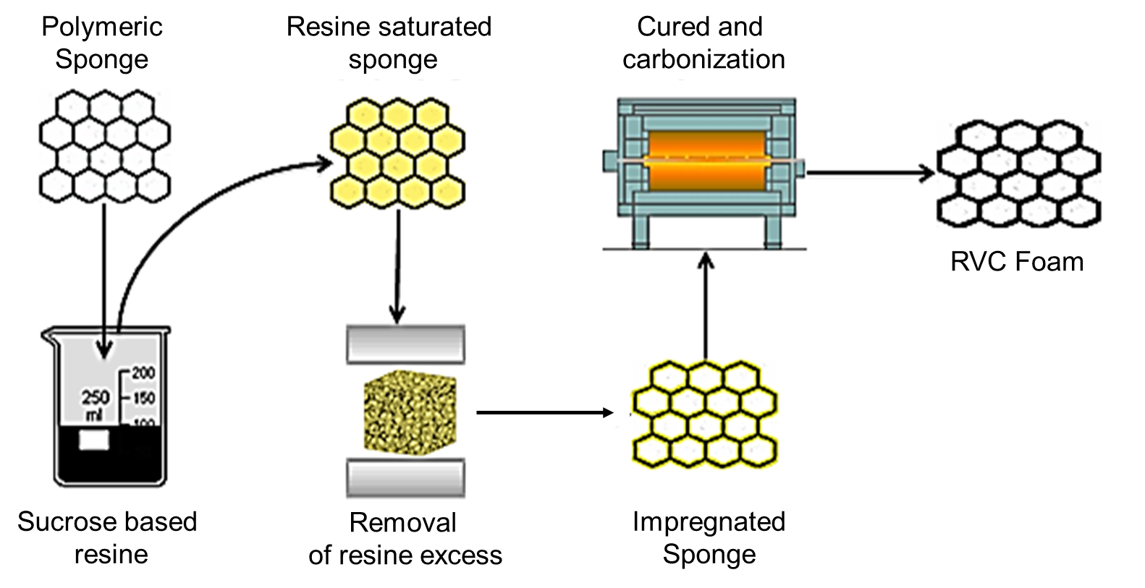

Figure 1. Fabrication process of reticulated vitreous carbon foams by template method.

    - Characterization
The RVC sponges were physic – chemically characterized through two methos i.e., Fourier Transform Infrared Spectroscopy (FTIR) and Confocal Optical Microscopy (MOC). The FTIR tests were performed using the spectrophotometer IRTracer-100 (Shimadzu), while the microscopy tests with a microscopy KH-7700 (HIROX). Finally, the absorption capacity (AC) of the manufactured sponges was evaluated trough the immersion and buoyancy in oil-water solutions test and based on the ASTM F726-18 standard for absorbent/adsorbent performances. Medium crude (300 cP; API 24°) oil samples were provided by the local refinery. The FTIR and MOC tests were also applied to polymeric sponges in order to compare their performance against RVC sponges. Each test was performed three times.
  - Results and Discussion
    - FTIR analysis
Figure 2 shows the FTIR spectra obtained for sucrose, resin and the synthesized RVC foams. Regarding sucrose and resin, localized bands between 3700-3000 cm⁻¹ associated with the tension vibration of the OH bonds present in the sucrose molecule and in the remaining water are observed. These bands show a lower intensity in the spectrum of the resin, corresponding to the condensation and evaporation of water during heating (Balan et al. 2020). Likewise, bands around 2900 cm⁻¹ are also present, corresponding to the tension of the C–H bonds typically found in organic compounds (Balan et al. 2020). Additionally, in the case of the resin, a signal appears around 1655 cm⁻¹, which is characteristic of the C=O stretching of functional groups esters, aldehydes, ketones, as well as substituted furan rings, indicating the presence of different reaction products such as humins (Abdilla-Santes et al. 2020). This is confirmed by the difference between the spectra of sucrose and resin in the region located between 1426 and 1236 cm⁻¹, in which characteristic behaviors of saccharides and humins are identified (Balan et al. 2020). For the spectrum of sucrose, absorption signals are observed at 1426 and 1334 cm⁻¹ corresponding to the bending vibrations of C–H, and the absorption signal located at 1236 cm⁻¹ is due to the stretching vibrations of C–OH (Yoo et al. 2021). In the case of the resin, this section of the spectrum is characterized by a decrease in the intensity of the signals corresponding to the C=C bonds of the furan rings present in humins (1426 cm⁻¹) and C-OH still present in its structure (Cantarutti, Dinu, and Mija 2020).

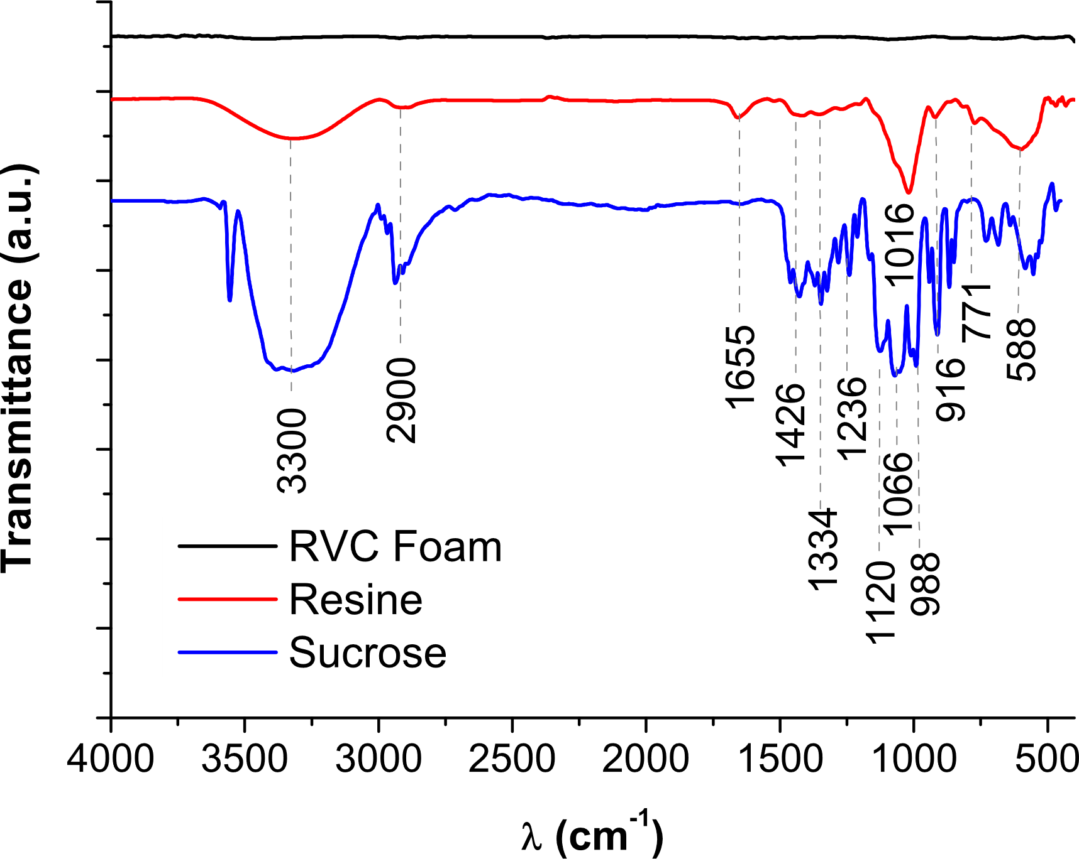

Figure 2: FTIR spectrum for sucrose, resin and RVC foam
Three bands located at 1120, 1066 and 988 cm⁻¹ appear in the sucrose spectrum, which are characteristic of the exocyclic and endocyclic C-O-H and C-O bonds in saccharides (Wibowo et al. 2021); in the resin spectrum, there is a band around 1066 cm⁻¹, which indicates a decrease in the amount of sugar-based molecules caused by the polymerization process (Cantarutti, Dinu, and Mija 2020). In the right-side portion of the spectrum, the most representative peaks are observed around 771 and 588 cm⁻¹ for the resin, and around 729, 682 and 562 cm⁻¹ for sucrose. These peaks appear due to the CH vibrations of sucrose and other compounds present in the reactions (Cantarutti, Dinu, and Mija 2020; Wibowo et al. 2021). Finally, regarding the FTIR spectrum of the RVC foam, it is evident that the bands related to the chemical bonds present in the resin and sucrose disappear, indicating that the carbonization process was effective, giving rise to the formation of the characteristic C-C structure of vitreous carbon, which is mainly constituted by fragments of three-dimensionally flexed carbon sheets (Jurkiewicz et al. 2017).
    - Morphology of foams and templates
Figure 3 shows the confocal micrographs of the polymeric sponges and RVC foams synthesized in this study. PU and Cellulose sponges used as sacrificial templates are thermosetting polymeric materials which are commercially available, inexpensive, with a highly porous and interconnected structure that favors the impregnation process. This allowed, with the addition of the resin, a weight gain of 2.5 times the weight of the original sponge. In general, it is observed that the manufacturing method used allows to reproduce the morphology of the polymeric foams used as sacrificial templates with a high degree of accuracy. However, as a result of carbonization, the volume of the samples is reduced by approximately 50 %. This contraction of the material is due to the loss of volatile components during carbonization, in addition to the thermal degradation processes of the polyurethane and cellulose templates, which show a weight loss higher than 90% at temperatures under 400 °C (Reinerte et al. 2020; Postawa et al. 2022). Figure 3a and 3b show the macropores with a size between 850-400 and 1600-300 μm, that comprise the polyurethane and cellulose templates, respectively. In the case of the RVC foam manufactured on the PU template (Figure 3c), the micrograph reveals a reticular structure of open and highly interconnected pores with a diameter of up to 700 μm, while the RVC foam obtained on the cellulose sponge has a less homogeneous and interconnected structure, despite having a larger pore size (~1000 μm) (Figure 3d). No cracks or defects were observed in any of the in the foam structures obtained, which suggests a good mechanical stability of the foams.

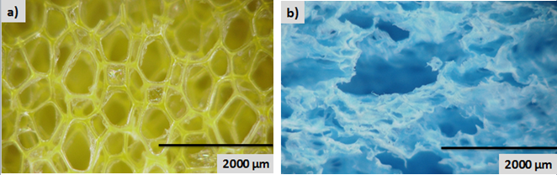
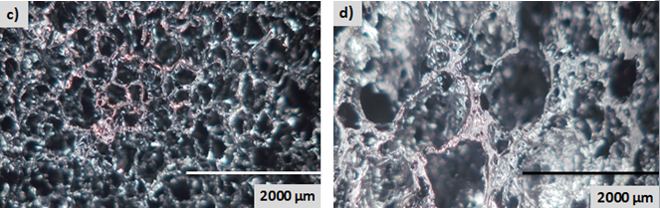

Figure 3: Confocal micrographics of a) polyurethane, b) cellulose sponges and RVC foams elaborated with c) polyurethane and d) cellulose as sacrificial templates.
  - Absorption tests
Regarding the absorption capacity of the materials, buoyancy and immersion tests were carried out; buoyancy test consists of placing the samples on the surface of the fluid in order to observe the floating/sinking behavior and then determining the mass absorbed by the material. The result is expressed as a percentage of absorption, according to Eq(1).
$$\%q=\frac{m_{f}-m_{i}}{m_{i}}*100$$ | (1)
In the immersion test, the same parameters are determined, but it is necessary to immerse the sample in the fluid for one minute. The results of these tests are reported in Table 1.
Table 1: Comparison between results of buoyancy and immersion tests
 | Absorption percentage |  |  |  | Float characteristics
Test | Celulose RVC¹ | PU RVC ² | Cellulose sponge³ | PU Sponge⁴
Buoyancy in water | 21% | 29% | 51% | 640% | ¹ and ² show minimum sinking  ³ and ⁴ get submerged by 60%
Immersion in water | 35% | 123% | 857% | 2340% | ¹ and ² show buoyancy when strength is eliminated  ³ and ⁴ stay submerged
Buoyancy in water/crude oil | 348% | 781% | 52% | 1457% | All samples get partially submerged
Immersion in crude oil | 402% | 837% | 348% | 2019% | All samples stay submerged

When comparing the behavior of the tested materials, it can be seen that the RVC foams synthesized in this study have high buoyancy and low water absorption compared to the polymeric sponges. The results also suggest that the foams synthetized in this study have a higher affinity for crude oil than for water, since their absorption parameter increases significantly in the water-oil flotation tests and those of immersion in crude oil, unlike cellulose and PU sponges, whose absorption capacity decreases in these tests. These results are consistent with those reported by Asgar et al. (2021), who reports great efficiency in the selectivity of vitreous carbon for organic oils similar in nature to petroleum. Despite the fact that the PU sponges presented higher absorption values, the comparative results indicate that the RVC foams have promising characteristics for the absorption of crude oil in water sources. The low oil absorption capacity with respect to the polyurethane templates may be due to the decrease in the porosity of the RVC with respect to the original templates, caused by the obstructions generated during the impregnation process. These obstructions could be cause by pore clogging due to excess resin. Even so, the oil absorption percentages obtained in study for the RVC were higher than those reported for the absorption of other oils and organic solvents, whose absorption ranges between 186 and 290% (Asgar et al. 2021).
In comparison to other materials commonly used for the removal of crude oil in water sources, it is observed that RVC foams have a higher absorption capacity than clay-type granular materials (AC up to 360%) which, in addition, do not have the possibility of being recycled, causing problems in their final disposal. Also, the granular form of clay-type materials causes difficulties in their collection after being used (Bhardwaj and Bhaskarwar 2018). On the other hand, natural absorbents such as rice hulls, feathers, cotton fiber, barley straw, among others, have absorption capacities in oil-water matrices of up to 4000% and can be reused up to a maximum of 5 times; however, these are prone to absorb large amounts of water, which affects their buoyancy, causing the materials to sink and, therefore, their effectiveness in oil removal processes is considerably reduced (Al-Majed, Adebayo, and Hossain 2012). In contrast, RVC foams have a high degree of hydrophobicity and affinity for crude oil and also, they can be reused for more than 16 times (Qiu et al. 2015). In addition, as mentioned above, the absorption capacity of the material can be influenced by its porosity; in this sense, the method used in this study allows exploring a large number of morphologies and porosities, in order to improve the efficiency in the removal of crude oil from water bodies. Adicionalmente, el método a partir del método utilizado, por lo que se infiere que a partir de la resina de sacarosa sintetizada se podrían modificar de manera controlada las variables morfológicas de las espumas
  - Conclusions
This work presents a methodology for the manufacture of vitreous carbon foams from a renewable and low-cost precursor. The prepared carbon monoliths show characteristics of buoyancy, hydrophobicity and affinity for crude oil that are suitable for the removal of oil and/or its derivatives in water sources. The main advantage of these foams, compared to other commonly used adsorbent materials, is that their water uptake is lower, which suggests that RVC foams are an efficient and selective material for water-oil separation processes. In addition, RVC foams have the possibility of being used during several absorption cycles. This, added to the typical chemical stability of vitreous carbon, makes RVC foams a convenient and safe absorbent in the field of oil spill cleanup.
Nomenclature
%q – absorption percentage, %

m_{i} – RVC initial foam weigh, g
m_{f} – RVC foam weigh after absorption process, g
Acknowledgments
Authors would like to thank to group GIMAT at Universidad Industrial de Santander for support on the infrared and the microscopy studies.
References
Abdilla-Santes, R. M., S. Agarwal, X. Xi, H. Heeres, P. J. Deuss, and H. J. Heeres, 2020, Valorization of Humin Type Byproducts from Pyrolytic Sugar Conversions to Biobased Chemicals, Journal of Analytical and Applied Pyrolysis, 152.
Abdullah, Thamer Adnan, Tatjana Juzsakova, Sanaa A. Hafad, Rashed Taleb Rasheed, Noor Al-Jammal, Muhammad Ali Mallah, Ali Dawood Salman, P. C. Le, Endre Domokos, and Mustafa Aldulaimi, 2021, Functionalized Multi-Walled Carbon Nanotubes for Oil Spill Cleanup from Water, Clean Technologies and Environmental Policy.
Acuña, Natalia Terán, Viviana Güiza-Argüello, and Elcy Córdoba-Tuta, 2020, Reticulated Vitreous Carbon Foams from Sucrose: Promising Materials for Bone Tissue Engineering Applications, Macromolecular Research, 28 (10), 888–95.
Al-Majed, Abdul Aziz, Abdulrauf Rasheed Adebayo, and M. Enamul Hossain, 2012, A Sustainable Approach to Controlling Oil Spills, Journal of Environmental Management, 113, 213–27.
Asgar, Md. Ali, Jun Kim, Jeong Woo Yeom, Seongmin Lee, Muhammad Refatul Haq, and Seok-min Kim, 2021, Facile Fabrication of Microporous Vitreous Carbon for Oil/Organic Solvent Absorption, Environmental Technology & Innovation, 24,101946.
Balan, Biji, Amit S. Dhaulaniya, Rahul Jamwal, Amit Yadav, Simon Kelly, Andrew Cannavan, and Dileep K. Singh, 2020, Rapid Detection and Quantification of Sucrose Adulteration in Cow Milk Using Attenuated Total Reflectance-Fourier Transform Infrared Spectroscopy Coupled with Multivariate Analysis, Spectrochimica Acta - Part A: Molecular and Biomolecular Spectroscopy, 240.
Bhardwaj, Neha, and Ashok N. Bhaskarwar, 2018, A Review on Sorbent Devices for Oil-Spill Control, Environmental Pollution, 243, 1758–71.
Cantarutti, Cristina, Roxana Dinu, and Alice Mija, 2020, Biorefinery Byproducts and Epoxy Biorenewable Monomers: A Structural Elucidation of Humins and Triglycidyl Ether of Phloroglucinol Cross-Linking, Biomacromolecules, 21 (2), 517–33.
Chen, Jihong, Weipan Zhang, Zheng Wan, Sifan Li, Tiancun Huang, and Yijie Fei, 2019, Oil Spills from Global Tankers: Status Review and Future Governance, Journal of Cleaner Production, 227, 20–32.
Czarnecki, J. S., M. Blackmore, S. Jolivet, K. Lafdi, and P. A. Tsonis, 2014, Bone Growth on Reticulated Vitreous Carbon Foam Scaffolds and Implementation of Cellular Automata Modeling as a Predictive Tool, Carbon, 79 (1), 135–48.
Etkin, Dagmar Schmidt, and Tim J. Nedwed, 2021, Effectiveness of Mechanical Recovery for Large Offshore Oil Spills, Marine Pollution Bulletin, 163.
Gupta, Shivam, and Nyan Hwa Tai, 2016, Carbon Materials as Oil Sorbents: A Review on the Synthesis and Performance, Journal of Materials Chemistry A, 4 (5), 1550–65.
Hammouda, Samia ben, Zhi Chen, Chunjiang An, and Kenneth Lee, 2021, Recent Advances in Developing Cellulosic Sorbent Materials for Oil Spill Cleanup: A State-of-the-Art Review, Journal of Cleaner Production, 311.
Jana, P., V. Fierro, and A. Celzard, 2016, Sucrose-Based Carbon Foams with Enhanced Thermal Conductivity, Industrial Crops and Products, 89, 498–506.
Jurkiewicz, K, S Duber, H E Fischer, and A Burian, 2017, Modelling of Glass-like Carbon Structure and Its Experimental Verification by Neutron and X-Ray Diffraction Research Papers, 36–48.
Makoś-Chełstowska, Patrycja, Edyta Słupek, and Aleksandra Małachowska, 2022, Superhydrophobic Sponges Based on Green Deep Eutectic Solvents for Spill Oil Removal from Water, Journal of Hazardous Materials, 425.
Mokoba, Thabang, Junfeng Lu, Tian C. Zhang, Like Ouyang, and Shaojun Yuan, 2021, Superhydrophobic ODT-TiO2 NW-PDA Nanocomposite-Coated Polyurethane Sponge for Spilled Oil Recovery and Oil/Water Separation, Colloids and Surfaces A: Physicochemical and Engineering Aspects, 630.
Narasimman, R, Sujith Vijayan, K S Dijith, K P Surendran, and K Prabhakaran, 2016, Carbon Composite Foams with Improved Strength and Electromagnetic Absorption from Sucrose and Multi-Walled Carbon Nanotube, Materials Chemistry and Physics, 181, 538–48.
Othumpangat, S., and V. Castranova, 2014, Oil Spills, In Encyclopedia of Toxicology: Third Edition, 677–81. Academic Press, Bethesda, MD, USA.
Postawa, Karol, Hanna Fałtynowicz, Jerzy Sczygieł, Elżbieta Beran, and Marek Kułażski, 2022, Analyzing the Kinetics of Waste Plant Biomass Pyrolysis via Thermogravimetry Modeling and Semi-Statistical Methods, Bioresource Technology, 344.
Qiu, Shi, Bo Jiang, Xing Zheng, Jingtang Zheng, Chaosheng Zhu, and Mingbo Wu, 2015, Hydrophobic and Fire-Resistant Carbon Monolith from Melamine Sponge: A Recyclable Sorbent for Oil-Water Separation, Carbon, 84 (1), 551–59.
Reinerte, Sanita, Liga Avotina, Arturs Zarins, Ugis Cabulis, and Arturs Viksna, 2020, TG/DTA-FTIR as a Method for Analysis of Tall Oil Based Rigid Polyurethane Foam Decomposition Gaseous Products in a Low Oxygen Environment, Polymer Degradation and Stability, 180, 109313.
Rotaru, Alexandru, Corneliu Cojocaru, Igor Cretescu, Mariana Pinteala, Daniel Timpu, Liviu Sacarescu, and Valeria Harabagiu, 2014, Performances of Clay Aerogel Polymer Composites for Oil Spill Sorption: Experimental Design and Modeling, Separation and Purification Technology, 133, 260–75.
Wang, Yongzhen, Songquan Wu, Xingru Yan, Tao Ma, Lu Shao, Yuyan Liu, and Zhanhu Guo, 2017, Alkyl Bicarbamates Supramolecular Organogelators with Effective Selective Gelation and High Oil Recovery from Oil/Water Mixtures, Chemosphere, 167, 178–87.
Wibowo, Eko Setio, Sukma Surya Kusumah, Subyakto, and Kenji Umemura, 2021, Modification of Novel Bio-Based Adhesive Made from Citric Acid and Sucrose by ZnCl₂, International Journal of Adhesion and Adhesives, 108.
Yoo, Suk Hyun, Jin Kyu Kang, Seung Chan Lee, Ho Young Jang, and Song Bae Kim, 2021, Analysis of Adsorption Characteristics of Diclofenac to Sucrose-Derived Carbon Spheres from Aqueous Solutions, Journal of Environmental Chemical Engineering, 9 (6), 106573.

