CHEMICAL ENGINEERING TRANSACTIONS  VOL. 93, 2022 | A publication of
The Italian Association
of Chemical Engineering
Online at www.cetjournal.it

Guest Editors: Marco Bravi, Alberto Brucato, Antonio Marzocchella
Copyright © 2022, AIDIC Servizi S.r.l.
ISBN 978-88-95608-91-4; ISSN 2283-9216

Release Profile of Olive Oil Nanocapsules Manufactured by Coaxial Electrospray
Dianney Clavijo-Grimaldo^{a,b*} , MagrethTorres-Paradaª, Ciro Casadiego-Torrado^{b}
ª Univerisidad Nacional de Colombia, Carrera 45 # 26 – 85, Bogotá Colombia
^{b} Fundación Universitaria Sanitas, Calle 170 # 8-41, Bogotá Colombia
dclavijog@gmail.com

In the area of food production, macro, micro and nanocapsules with polymer walls have been developed. Nanocapsules offer huge advantages, extends the time in the gastrointestinal tract and thus the bioavailability of the encapsulated compound. Electrospray is a low-cost and easily reproducible electrohydrodynamic technique in which a conductor liquid, subjected to the controlled action of an electric field, generates complex structures at a nanometric scale. Coaxial electrospray has been used for the encapsulation of different products: the exterior liquid will form the wall of the capsule and the active compound (in the internal liquid) will be released due to the degradation of the wall. In this study, the coaxial electrospray parameters were standardized (voltage, concentration, flow and distance) in order to encapsulate the extra-virgin olive oil. A biodegradable polymer was used for the capsule wall. The characterization was carried out by means of scanning electron microscopy and atomic force microscopy in which nanocapsules with an average diameter below 100 nm were observed. The nanocapsules were submerged in a solution similar to body fluids and in a saliva-like solution in order to quantitatively verify the oil release and the profile thereof by means of UV-Vis spectrophotometry. This technique opens possibilities in the food industry with regards to generating nanocapsules that can be used to improve the stability and the texture of food or to enable the controlled released of food ingredients or nutraceuticals.
  - Introduction
Olive oil (OO) is known for its benefits on the cardiovascular system (increased coronary blood flow and decreased blood pressure and the prevention of atherosclerotic plaques formation), its role in the prevention and development of type 2 diabetes mellitus and its immunomodulatory, antineoplastic and neuroprotective effects (Gorzynik-Debicka et al., 2018). Due to its antiviral properties and the ability to suppress the main protease of SARS CoV-2, several of its components have been studied as potential therapeutic candidates (Alhadrami et al.,2021). For these reasons, interest in OO encapsulation has grown in recent years. The encapsulation, a process in which an active ingredient is confined inside a material that forms the wall, (Bhushani, 2014) is a topic of interest in research given its potential applications, such as the delivery of an active compound, the isolation of a component in an aggressive environment, the reduction of decomposition or degradation in a given environment, the delivery of a given substance to a particular receptor, the improvement of stability and distribution of the encapsulated substance and the disguising of undesired odors or tastes, (Loscertales, 2002). Since the content release of macrocapsules is slower, and the absorption, delivery and distribution of a compound are directly related to the size, nanocapsules offer huge advantages, including the increase in the adhesion force, which extend the time in the gastrointestinal tract and thus the bioavailability of the encapsulated compound (Ghorani & Tucker, 2015).
Electrohydrodynamic techniques (such as electrospray and electrospinning) are one of the alternatives to produce nanocapsules and other types of products on a nanoscale with medical, biotechnical, industrial, and pharmaceutical applications, among others (Clavijo-Grimaldo et al., 2018). These techniques are appealing because the experimental processes are easy, versatile, replicable, and efficient, and they can be carried out in environmental conditions without compromising the biofunctionality of the materials. Coaxial electrospray uses a nozzle with two needles to dispense different solutions simultaneously. The exterior solution is subjected to high voltage and will form the wall of the capsule, and the interior solution contains the substance to be encapsulated. Obtaining products by this technique, allows you to build the core and wall from miscible or immiscible materials, decreasing denaturalization and allowing the use of aqueous solvents (Zamani et al. 2014). In consequence, coaxial electrospray was the technique used in this study. We describe the methodology used for the manufacture of nanocapsules with a polymeric wall, the encapsulation of extra-virgin olive oil and its release. This was qualitatively studied in two solutions (a saliva-like solution and a solution similar to body fluids).
  - Materials and methods
    - Manufacturing and characterization of nanocapsules
To build the wall of the nanocapsules a solution of polyethylene glycol (PEG) (Sigma-Aldrich, CAS Number: 25322-68-3, molecular weight Mn=35,000) was prepared at 6% w/v in water. The solution was subjected to ultrasound at a frequency of 50 Hz for 30 min and a temperature of 25 °C. It was subsequently stored at room temperature. The compound to be encapsulated was extra-virgin olive oil (Sigma-Aldrich, CAS Number: 8001-25-0, SKU 75343, tested according of European Pharmacopoeia). Manufacturing was carried out by a coaxial electrospray equipment as shown in Figure 1. The PEG solution was placed on the outer needle and the OO inside. A copper collector was used, and the capsules were collected in 2 x 2 mm glass slides. The deposition time was 10 min. Tests were carried out to adjust the following variables: voltage, flow of the PEG solution, flow of the OO solution and needle-collector distance. The process was performed at 21,9 °C room temperature and 54% RH.
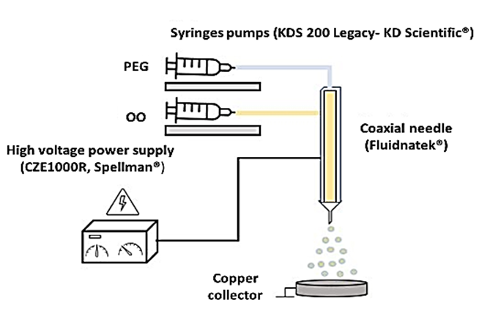
Figure 1: Coaxial electrospray assembly

For the morphological characterization of the capsules, according to their size, we used atomic force microscopy (AFM) (Asylum Research – MFP-3D-BIO) and scanning electron microscopy (SEM) (Tescan Vega 3) with an acceleration voltage of 15 kV and working distance of 9-10 mm. The capsules diameter was analyzed using image analysis software (Image J, National Institutes of Health).
    - Qualitative determination and release profile of OO
The OO release of 1 mg of the nanocapsules was evaluated in artificial saliva for pharmaceutical research (Sigma-Aldrich, SKU SAE149, pH 7) for incubation times of 1, 2 and 4 min and solution like body fluids (Ringer's lactate solution, pH =7.4) for incubation times of 1, 2, 5, 15, 30, 60, 120 and 240 min.
6-well culture plates were used. In each well, glass slides were placed with 1 mg of the capsules obtained and 3 ml of each medium were added (artificial saliva or Ringer´s lactate). Incubation was carried out at 37 °C under horizontal stirring at 210 rpm. At the end of each incubation period, the total solution of each well was taken and centrifuged at 9000 rpm for 15 min at room temperature. 3 ml of cyclohexane (Sigma-Aldrich, CAS Number: 110-82-7, molecular weight 84.16) were added to the obtained supernatant and it was centrifuged again at 5000 rpm for 5 min. The aqueous phase was discarded, and the organic phase (cyclohexane with extracted OO) was used for two tests:
- 50 μl of the organic phase was mixed with 0.5 ml of the Sudam III reagent. It was left for 5 min and 2 washings were carried out in distilled water and 2 in ethanol. The samples were dried at 70 °C for 10 min and observed under an optical microscope. The Sudam III reagent has red triglycerides and other lipids.
- 50 μl of the organic phase was used to detect the presence of the OO released by means of UV-VIS spectrophotometry at wavelengths of 233 and 268 nm.
  - Results and discussion
    - Coaxial electrospray parameters for nanocapsules manufacture
Several tests were performed. The parameters of the electrospray process (voltage, flow of the PEG solution, flow of the OO solution and needle-collector distance) were adjusted to reduce the diameter from micrometre scale to nanometre scale. Table 1 shows the final parameters of the tests performed that generated micro and nanocapsules.
Table 1: Definitive parameters in the manufacture of micro and nanocapsules
Capsule | Voltage  (kV) | External flow (PEG) (ml/h) |  | Internal flow Distance  (OO) (ml/h) Needle-collector (cm)
Micro  Nano | 22  23 | 0.5  0.3 |  | 0.3 20  0.3 22

Figure 2 shows the appearance under the optical microscope (400 x) of the microcapsules obtained with the parameters described in table 1. These are observed in various sizes. The contrast allows to differentiate the wall from the content in most of them.

Figure 2: Optical micrograph (400 x) of microcapsules obtained with the parameters described in Table 1

Figure 3 shows the appearance, under SEM, of the nanocapsules obtained with the parameters described in Table 1, at 25,000 x. The morphology of the capsules was spherical, and the average diameter was (97.5 ± 15.6) nm.
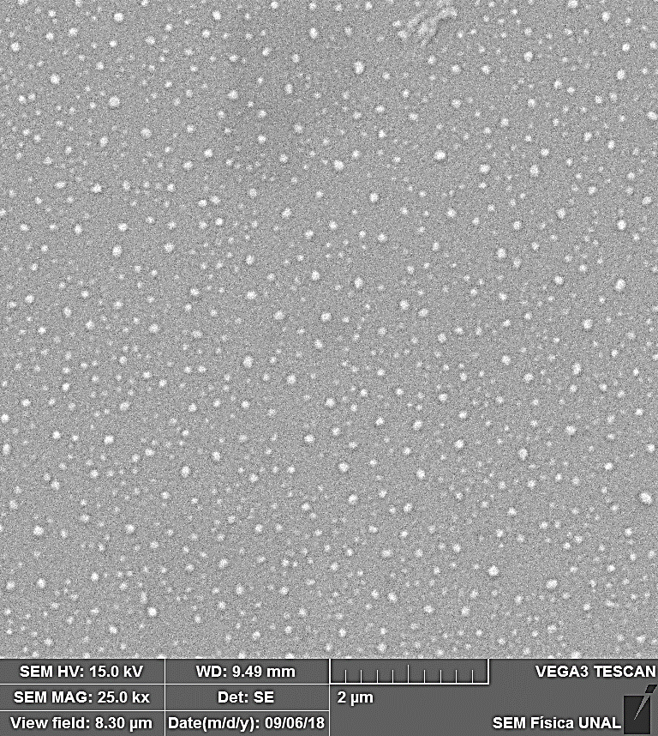
Figure 3: Scanning electron micrograph (25,000 x) of nanocapsules obtained with the parameters described in table 1
Figure 4 shows the appearance of the nanocapsules obtained by AFM. Although the capsules are not uniform in size, their nanometric dimensions are confirmed. Morphology is spherical, and the surface is regular.

Figure 4: AFM micrograph of nanocapsules obtained with the parameters described in Table 1

In contrast to other techniques, the coaxial electrospray is a technique simple, replicable, inexpensive, and carried out under environmental conditions (Tirado, 2021). Additionally, the only solvent used was water. In other works, organic solvents are used in the manufacture of OO nanocapsules, such as acetone and ethyl acetate, which can have harmful effects on health (Esmail & Gholami, 2015).

3.2 Qualitative determination of OO release by staining with Sudam III

Figure 5 shows the results of the Sudam III stain to qualitatively evaluate the OO release of the capsules in a saliva solution using a 50:50 solution of cyclohexane and artificial saliva as control. The presence of triglycerides and other lipids corresponds to the reddish coloration, which is evident at all incubation times, confirming that the OO was released in the artificial saliva during the incubation. Minutes 1 and 2 has the greatest intensity, whereas around the 4th minute it decreased slightly.

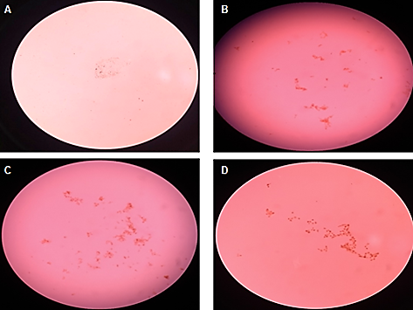
Figure 5: Sudam III staining to qualitatively assess the release of OO similar to saliva (A solution control, B: 1 min, C: 2 min and D: 4 min)

Figure 6 shows the results of the Sudam III staining to qualitatively assess the OO release of the capsules in a solution similar to body fluids, using a cyclohexane and Ringer’s lactate 50:50 solution as control. The reddish coloration is observed at all incubation times, with less intensity at 2, 5 and 15 minutes. It increases after 30 minutes, remaining constant until 240 minutes of incubation. This analysis confirms that the OO was released in the Ringer’s lactate solution during the incubation. These results show that the wall of the nanocapsules degrades early, which results in an adequate OO release. This is explained by the high solubility of PEG in water.

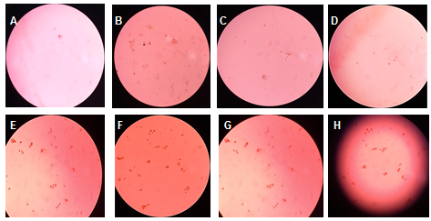
Figure 6: Sudam III staining to qualitatively assess the release of OO in a solution similar to body fluids (A: 1 min, B: 2 min, C: 5 min, D: 15 min, E: 30 min, F: 60 min, G: 120 min and H: 240 min)

3.3 Determination of the OO release profile by UV-VIS spectroscopy

Figure 7 shows the UV-Visible spectroscopy for the different incubation times in artificial saliva (A) and in a solution similar to body fluids (B). Absorbance in the region of 268 nm (characteristic of α-diketones and α-unsaturated ketones) and in the region of 233 nm (characteristic of linoleic acid) is observed in each one. In the case of saliva, a peak is observed around the first minute, with a lower release profile but stable until minute 4th. In the solution similar to the body fluids two peaks are observed, the first in the 30th minute and the second in the 60th minute; after this time point there is a decrease in absorbance, with a stable release profile until minute 240th.

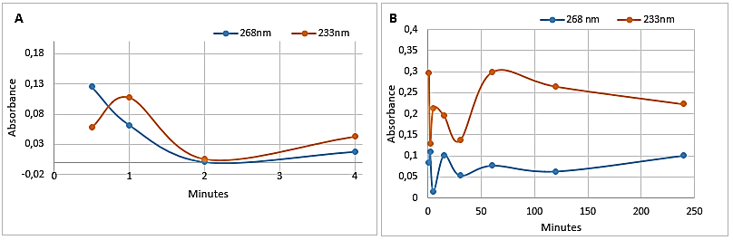
Figure 7: UV-VIS spectroscopy showing the release profile of the nanocapsules (A) in artificial saliva and (B) in a solution similar to body fluids

The contact of the food with the saliva is short: in the oral cavity the chewing process has a variable duration. The propulsion of the alimentary bolus towards the back of the mouth lasts few seconds, the pharyngeal phase lasts around a second and the esophageal phase, which ends with the passage of the bolus to the stomach, lasts about 6 to 8 s. Gastric pH inactivates salivary amylase, but the function of the lipase (enzyme that breaks down triglycerides into glycerides and fatty acid components, thereby catalyzing the digestion of lipids) continues in the stomach. The OO released in the artificial saliva during the incubation at minute 1th has the greatest intensity, whereas around the 4th minute it decreased slightly.The food remains in the stomach on average 4 h before moving to the small intestine where the enzymatic action allows for the absorption of fat. Therefore, it is important that the degradation of the nanocapsule wall allows for its maximum release at this time. In the solution similar to the body fluids, the two release peaks observed (30th and 60th minutes) and sustained release for 4 h are adequate, since they mimic the physiological conditions necessary for optimal intestinal absorption. Given that this is a preliminary study, the quantitative determination of the OO release profile was not performed. Future studies are necessary to perform this quantification as well as the determination of the extinction measurement in the wavelengths used, which will provide important information on the state of conservation of the oil and the modifications that may occur during the coaxial electrospray encapsulation process.
  - Conclusions
Coaxial electrospray allowed the encapsulation of olive oil inside a biodegradable polymeric material obtaining nanoscale structures. The morphology of the capsules was spherical, and the average diameter was (97.5 ± 15.6) nm. The size was controlled by modifying the applied voltage and the feed flow of the solutions. The release of OO in the artificial saliva was greater in the first minutes of incubation, compared to the release in the solution similar to the body fluids that showed higher peaks at 30th and 60th minutes, after that, there is a decrease in absorbance, with a stable release profile until minute 240th.These results show that the wall of the nanocapsules degrades early, which results in an adequate OO release. The times are adequate because the contact of the food with the saliva is short compared to the permanence in to the gastrointestinal tract (hours).
Further analysis is necessary to quantify the release profile of the active ingredient and the efficiency of the encapsulation. This study serves as a basis for future research in which nanocapsules are manufactured with this technique, so they can then be used to improve the stability and texture of foods through the controlled release of other food ingredients and/or nutraceuticals to optimize the benefits that the consumption of OO has on human health. Supplementation with nanocapsules of OO, incorporated into low-cost foods, may be alternatives, to be evaluated in future, for the management of malnutrition and specific pathologies. The procedure described in this work is simple, replicable, economical and biosafe, since organic solvents were not used in the manufacture of the OO nanocapsules.
Acknowledgments
This research was funded by the Universidad Nacional de Colombia and the Fundación Universidad Sanitas. The authors express their acknowledgments to the staff of the Electrospray and Electrospinning Laboratory and to Mrs. Jaidy Acosta of the Histotechnology Laboratory, Faculty of Medicine, Universidad Nacional de Colombia.
References
Alhadrami, H. A., Sayed, A. M., Sharif, A. M., Azhar, E. I., Rateb, M. E., 2021, Olive-Derived Triterpenes Suppress SARS COV-2 Main Protease: A Promising Scaffold for Future Therapeutics. Molecules (Basel, Switzerland), 26(9), 2654.
Bhushani, J.A., 2014, Electrospinning and electrospraying techniques : Potential food based application. Trends in Food Science & Technology, 38(1), 21–33.
Clavijo, D., Casadiego-Torrado, C.,Perea-Covarrubias, A., Galindo-Zamora, V., 2018, Biofunctionalization of Titanium to Improve the Response in Patients with Osteoporosis Requiring Implants. Chemical Engineering Transactions, 64, 643-648.
Ghorani, B., Tucker, N., 2015, Food Hydrocolloids Fundamentals of electrospinning as a novel delivery vehicle for bioactive compounds in food nanotechnology, Food hydrocolloids, 51, 227–240.
Gorzynik-Debicka, M., Przychodzen, P., Cappello, F., Kuban-Jankowska, A., Marino Gammazza, A., knap, Narcyz, Wozniak, M., Gorska-Ponikowska, M., 2018, Potential Health Benefits of Olive Oil and Plant Polyphenols. Int J Mol Sci, 19(3):686.
Esmaeili, A., Gholami, M., 2015,Optimization and preparation of nanocapsules for food applications using two methodologies. Food Chemistry,179, 26-34.
Loscertales, I.G., 2002, Micro / Nano Encapsulation Via Electrified Coaxial Liquid Jets Micro / Nano Encapsulation via Electrified Coaxial Liquid Jets., Science, 295, 1695-1698.
Tirado, D., Latini, A., Calvo, L.,2021, The encapsulation of hydroxytyrosol-rich olive oil in Eudraguard protect via supercritical fluid extraction of emulsion.Journal of Food Engineering, 290,110215.
Zamani, M., Prabhakaran, M.P., San, E., 2014, Protein encapsulated core – shell structured particles prepared by coaxial electrospraying : Investigation on material and processing variables, International Journal of Pharmaceutics, 473, 134–143.

