|  |  |
| --- | --- |
| cetlogo ***CHEMICAL ENGINEERING TRANSACTIONS***  ***VOL. 93, 2022*** | A publication of  aidiclogo_grande |
| The Italian Association  of Chemical Engineering  Online at www.cetjournal.it |
| Guest Editors: Marco Bravi, Alberto Brucato, Antonio Marzocchella  Copyright © 2022, AIDIC Servizi S.r.l. **ISBN** 978-88-95608-91-4; **ISSN** 2283-9216 | |

Bacterial motility in Biofilm under Shear Flow

Daniele Marra, Federica Recupido, Giuseppe Toscano, Sergio Caserta\*

Dipartimento di Ingegneria Chimica, dei Materiali e della Produzione Industriale DICMaPI, Università di Napoli Federico II, P.le V.Tecchio 80, 80125 Napoli, Italy

sergio.caserta@unina.it

A key role in bacteria surfaces contamination and biofilm development is played by cell motility and adhesion, that can be heavily dependent on flow conditions. The aim of this work is to study the influence of flow induced -shear stresses on *P. fluorescens* AR11 cell motility at solid-liquid interface. We quantitatively characterized cell motility during biofilm formation, using a commercial microfluidic flow cell. Flow conditions were defined by changing the imposed flow rate to mimic in our lab scale microfluidic setup stresses at the chamber walls typical of real conditions. Biofilm development in time was monitored by Time-Lapse microscopy coupled with image analysis to quantify cell motility. Persistent Random Walk models were used to analyse cells trajectories and describe bacteria motility according to Fickian (not Brownian) diffusion models. Specific attention was paid to assess statistical significance of measurements. Preliminary results suggest that mechanical stresses have a measurable effect on cell attachment and motility in biofilm, affecting system morphology.

* 1. Introduction

Biofilms are surface-associated microbial communities usually enclosed in self-produced matrix of Extra Cellular Polymeric Substances (EPS) (Flemming and Wingender, 2010a; Hall-Stoodley et al., 2004), whose formation is typical of bacteria, needed to guarantee microbial growth in different environmental conditions. More specifically, surface association, and EPS production provide a scaffold for cells and a protection from external cues such as mechanical stimuli (e.g. flow stress), chemical stresses (e.g. cleaning solutions), biological agents (e.g. antibiotics or other antimicrobials), and nutrient depletion (Mattila‐Sandholm and Wirtanen, 1992). Moreover, microbial communities enclosed in EPS exhibit an extracellular signalling called *quorum sensing* subjected by diffusion phenomena (Fanesi et al., 2021; Feng et al., 2013). *Quorum sensing* is a gene regulated mechanism that microorganism uses in response to fluctuations in cell-population density. In general, microorganism produces and releases chemical signal molecules called autoinducers that increase in concentration as a function of cell density (Miller and Bassler, 2001).

Biofilm formation begins when free floating bacteria adhere to a surface. This transition starts with a reversable and non-covalent adhesion among the bacterial cell and the surface of interest. The proximity between cell and surface is a prior condition for the attachment, and all the environmental (flow-driven forces) and endogenous (bacteria self-motility) factors related to this condition can influence the early stage of biofilm formation (Salek et al., 2009). The reversible adhesion can evolve in irreversible and covalent adhesion followed by a phase of proliferation and maturation, where the EPS matrix is formed. Biofilm’s life cycle culminates in the dispersal of detached bacterial cells into the bulk fluid, that can further colonize other environments (Hall-Stoodley and Stoodley, 2002).

Due to the enhanced resilience of this microbial system, biofilm is an issue in several industrial and health-related environments, such as contamination of medical equipment, bio-corrosion of industrial equipment, biofouling (Cirillo et al., 2021), and microbial contamination of industrial products (Mattila‐Sandholm and Wirtanen, 1992). A part for biosafety, the most problematic issue of biofilm contaminations is that it can proliferate in a wide range of surfaces and its removal is demanding and economic cost (Persat et al., 2015). On the other hand, there are also several important positive implications of biofilms mainly related to their implementation in many biotechnological processes such as bioremediation (Rajbir et al., 2006), wastewater treatment (Feng et al., 2013), synthesis of fine chemicals (Halan et al., 2012) and biofuels production (Wang and Chen, 2009).

From a morphological, and biochemical point of view, biofilms are complex systems whose formation and evolution are heavily influenced by different properties like biological, chemical, and physical factors such as cell features, nutrient availability, flow velocity and incubation times. For example, the same bacteria strain at different growth conditions can produce different types of architectures (Flemming and Wingender, 2010).

Flow velocity plays a role in biofilm formation, in fact cells in flowing fluids may be subjected to shear stresses that vary widely both in magnitude and frequency according to the imposed flow conditions (Stoodley et al., 1999), heavily affecting its morphology. Increased fluid flow towards or parallel to a substratum surface results in a faster adhesion of microorganisms due to higher mass transport. On the contrary, when flow exceeds a critical limit, the resulting wall shear stresses may prevent adhesion (Bakker et al., 2003), or wash out preexisting structures.

Microorganism exhibit the capability of self-generated movement due to different appendages on their surfaces (e.g. flagella, pili) (Kearns, 2010). In absence of external stresses, bacterial motility can be described by Persistent Random Walk model (PRW) (Dickinson and Tranquillo, 1993), where cell trajectories are considered as a succession of uncorrelated movements of duration equal to a characteristic time called persistence time. From fits of the mean-squared displacements (MSDs) of the cells with the PRW model, motility can be fully characterized by means of two parameters: cell motility coefficient (μ, μm2/s), and persistence time (P, s).

Recent studies, were focused on flow influence on biofilm formation, investigating its morphology by 3D reconstructure of Confocal images, and surface properties by forced wetting (Recupido et al., 2020; Castigliano et al., 2021 ; Recupido et al., 2021).

In this work, *Pseudomonas fluorescens* AR 11, a Gram-negative, rod-shaped aerobic bacterium, was used as model organism (Oliveira et al., 1994). Single strain-biofilms were cultivated using commercial microfluidic flow cells (Ibidi) under controlled shear rate. Cell motility under was investigated by direct visualization Time – Lapse microscopy and image analysis. Quantitative parameters were obtained by analyzing trajectory according to PRW models. The minimal number of trajectories required to guarantee statistically significant results was investigated.

* 1. Materials and Methods
     1. **Microorganism and Culture Conditions.**

Lyophilized *P.g fluorescens* AR 11 bacteria were provided by DSMZ - German Collection of Microorganisms and Cell Cultures (Braunschweig, Germany) and reactivated according to the provider recommendations (www.dsmz.de).

Cultures were prepared by inoculating 3 mL of complex medium (consisting in 5 g/L of peptone from animal tissue, and 3 g/L of meat extract in double-distilled water) from a frozen stock and incubating overnight at 30 °C, while shaking at 90 rpm. Approximately 1 mL of solution was then resuspended in 10 mL of sterile M9-minimal medium (6.8 g/L of Na2HPO4, 3 g/L of KH2PO4, 0.5 g/L of NaCl, and 1 g/L NH4Cl, 0.24 g/L MgSO4·7H2O, 0.04 g/L CaCl2·2H2O, 0.05 g/L EDTA, 8.3 mg/L FeCl3, 0.84 mg/L ZnCl2, 0.1 mg/L CuCl2·2 H2O, 0.1 mg/L CoCl2·2H2O, 0.1 mg/L H3BO3, and 0.016 mg/L MnCl2·4 H2O supplemented with 0.4% succinic acid, at pH 7). The obtained suspension was then incubated under the same conditions indicated above, to achieve an optical density (OD600nm) ≈ 0.5 which corresponds to 107 cells/mL, approximately.

* + 1. **Experimental setup and flow condition.**

To analyze bacterial cell motility in flow, a custom-made apparatus based on a commercial microfluidic rectangular flow cell (Ibidi Cell in Focus, µ-Slide VI 0.1, 100 μm x 17 mm x1 mm) was used. A syringe pump (Harvard Apparatus, Pump 11, Pico Plus Elite, USA) equipped with two 10 mL syringes was connected to the flow cell by silicone tubes and connectors, a downstream tank was finally used to collect the fluid (Figure 1). Such in-flow apparatus enables to impose controlled shear stress conditions by monitoring the inlet flow rate to the microfluidic flow cell. The wall shear rate is a function of the imposed volumetric flow rate and the flow cell geometrical characteristics through the following equation: ${\dot{γ}}_{w}=\frac{3 Q}{({2 δ}^{2}∙W)}$. Where δ and $W$ are the half thickness and the width, respectively, of the rectangular section of the microfluidic chamber, in our case δ = 50 μm and W = 1 mm.

Experiments were run for 72 h at room temperature, which corresponds to the biofilm maturation phase. Approximately 200 µL of inoculum were injected into the microfluidic channel and left in quiescent conditions (no flow) for 2 hours to induce bacterial adhesion on surfaces. In experiments here reported a constant volumetric flow rate, *Q*, of 0.04 μL/min was imposed, corresponding to a wall shear rate () of 0.4 s−1. Reynolds number ($Re=\frac{ρ∙v∙D_{h}}{}$), calculated considering the hydraulic diameter ( $D_{h}=\frac{4A}{P}=\frac{4 (W·δ)}{W+2δ}$) was about 1.2 \* 10-3.

* + 1. Cell imaging and tracking.

Time-lapse microscopy experiments were performed using an automated workstation equipped with an inverted microscope (Zeiss Axiovert 200; Carl Zeiss, Jena, Germany) and a 32× objective in bright field. The microscope was equipped with a motorized stage and focus system (Microscope Stages; Märzhäuser Wetzlar) for automated sample positioning. Live-cell imaging was performed by using a CCD video camera (Orca AG; Hamamatsu, Japan) at frame rate of 9 frame/s. The whole workstation was driven by homemade control software in LabView (National Instruments).

After the inoculum, images were taken before staring flow 0h, and 24h, 48h, 72h. All images were taken under flow, except for the 0h, where images referred to static conditions.

At each time point, individual cells were identified by means of a semi-automated image analysis macro based on standard software libraries (Image Pro Plus), and their coordinates determined. The coordinates were used to reconstruct the trajectory described by each cell for a period of some seconds. Cell tracking was repeated at least for 3 independent experiments. About 70 different bacterial cells for each sample were tracked for about 50 subsequent frames.

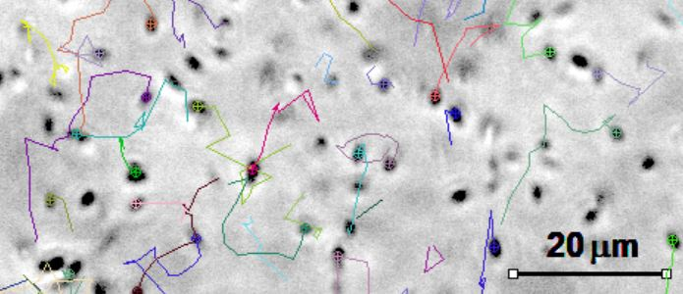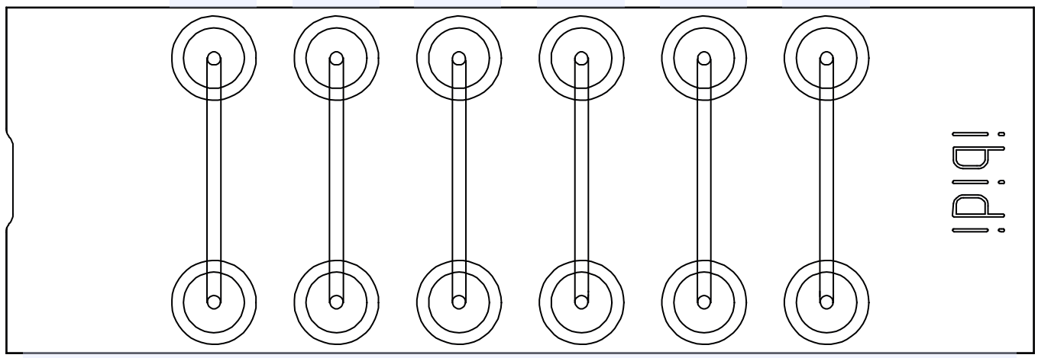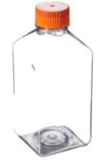

**Flow**

**Syringe pump**

**Tank of collection**

Figure 1: Schematic representation of time-lapse workstation along with an example of bacterial tracking at inoculum condition. Bacterial were identified as a dark object of appropriate dimension (2mm length) on a bright field after image processing.

* + 1. **Cell motility analysis.**

Cell motility parameters were estimated processing trajectories by means of a custom-made Matlab script. For each trajectory, several non-overlapping intervals of size, *t* were identified, and the mean squared displacement (MSD) described by cells in t was measured, for every different value of t (Ascionea et al., 2014). Persistent random walk (PRW) model (Dickinson and Tranquillo, 1993) (Eq. 1), was used to describe cell motility in analogy to a Fickian diffusion, as dependent to a random motility coefficient μ (μm2/s), analogous of a diffusivity, and a persistence time P (s), corresponding to the time required to observe changes in cell direction.

|  |  |
| --- | --- |
| $$〈d^{2}(t)〉=4μ\left[t-P\left(1-e^{-\frac{t}{P}}\right)\right]$$ | (1) |

The trend predicted by Eq. (1) is linear for t ≫ P, with a slope proportional to the random motility coefficient and an intercept with the horizontal axis depending also on persistent time P.

* 1. Results and Discussion

We quantitatively investigated the dynamic behavior of *P. fluorescens* AR 11 cells at different stages of biofilm formation by means of validated image analysis approach (Ascione et al, 2014). A detailed analysis of bacterial motility evaluated at the bottom surface of the microfluidic channel is reported in the following section. Trajectories described by 25 cells soon after inoculation and after 24 hours, are reported In Figure 2A and B, respectively. In each chart bacterial trajectories are plotted starting from the same initial position. After inoculum (Figure 2A), trajectories show a random orientation being uniformly distributed on the XY plane (i.e., no preferential direction in cell motion is visible). After 24 hours from inoculation (Figure 2B) a preferential direction along flow direction (i.e. positive Y axis) is clearly visible. In Figure 2C MSD vs t data are fit according to PRM model (Eq. 1) for both data series, obtaining estimates of μ and P parameters (Figure 2D).

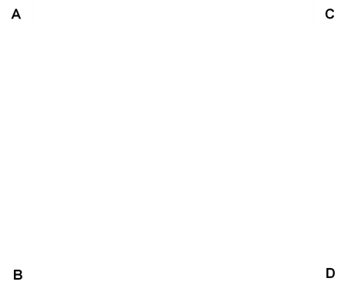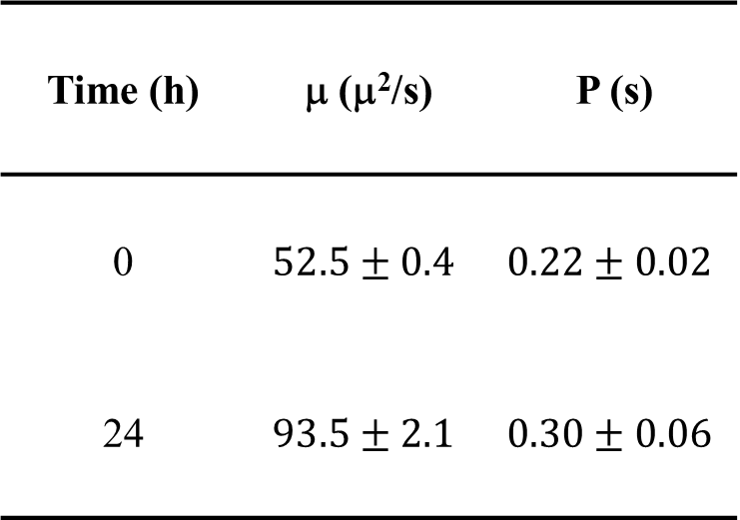

Figure 2: Bacterial trajectory analysis and mean squared displacements. A comparison between inoculum cell trajectories in static condition (A) and 24 hours flux condition (B). To quantitatively assess cell movement, the mean squared displacements vs t data are fit (C) according to eq. 3 obtaining motility parameters reported in the table (D) at inoculum condition and 24h of flow.

To verify statistical significance of the methodology here propose, we repeated the same analysis on independent groups of 20, 30, 70, 140 cells from the same sample in inoculum conditions, calculating for each sample size, motility coefficient and persistence time. Measurements were repeated 3 times, and reported in Figure 3 as average, standard deviation is reported as error bar, while numbers in the chart report the % error of the average value of each data series respect to the sample of 140 cells, we considered as true value.



**A**

**B**

Figure 3: Analysis of motility coefficient (A) and Persistence time (B) vs number of trajectories for the case of cells soon after inoculation. The statistical significance of the results was verified by repeating the analysis on independent samples at the same growth condition.

By comparing % error and error bar, we considered as reliable results obtained using a minimum number of 70 tracked trajectories.

In Table reported in Figure 2D motility parameter and persistence time for inoculum and 24h conditions, obtained from the fit of 70 cells each (Figure 2C) are reported. As further results, by comparing data in the 2 conditions, we found that flow affects not only the value of motility parameters, but also bacterial trajectories isotropy, as visible from Figure 2A and 2B. It is worth mentioning this is not a trivial result of flow drag, since bacteria are at least partially embedded in biofilm. Furthermore, some cells tend to swim in direction opposite respect to flow velocity. For these reasons, isotropic models must be further improved considering flow induced anisotropies. Some possibilities are already available in the literature, such as Anisotropic Persistent Random Walk (APRW) model (Wu et al., 2015), and will be considered for future investigation of the problem, using the methodology here proposed and validated.An experimental protocol was defined to quantitatively characterize random cell movement according to PRW model.Results shown that two different directions can be identified: the non-primary direction, orthogonal to flow, and a primary direction parallel to flow velocity. Further investigation with APRW is needed to quantify cell motility according to these findings.

* 1. Conclusion

In this work a novel methodology is proposed to investigate influence of flow on bacteria motility in biofilm. *Pseudomonas fluorescens* biofilms have been grown with the aim to investigate the influence of shear flow on cell motility at liquid/EPS interfaces. Data fitting provided quantitative estimates of cell motility parameters: directional persistence time, and random motility coefficient. Results shown that the number of tracked bacteria can heavily affect the reliability of the measurement done. A minimum of 70 independent trajectories is needed to obtain statistically significant results. Shear flow affects cell trajectories, inducing anisotropies in biofilm structure and in cell behavior.

The development of a methodology for cell motility analysis as a function of the different stages of biofilm formation can be an innovative method to evaluate the influence of cell motility on biofilm morphology. Moreover, the same method can be used to obtain a quantitative characterization of the role environmental conditions on cell motility and biofilm morphology.

Acknowledgments

This study was conducted under the umbrella of the European Space Agency Topical Team: “Biofilms from an interdisciplinary perspective”. Martina Rotella and Francesco Guerriero contributed to the experiments and data analysis during their master thesis. Financial support was provided from University of Naples Federico II, Project ROTOR, Finanziamento Ricerca di Ateneo 2021.

Reference

Ascione F., Caserta S., Perrisd R., Guidoa S., 2014, Investigation of cell dynamics in vitro by time lapse microscopy and image analysis, Chemical Engineering, 38.

Bakker D. P., Van Der Plaats A., Verkerke G. J., Busscher H. J., Van Der Mei H. C., 2003, Comparison of velocity profiles for different flow chamber designs used in studies of microbial adhesion to surfaces, Applied and environmental microbiology, 69**,** 6280-6287.

Castigliano M., Recupido F., Petala M., Kostoglou M., Caserta S., Karapantsios T. D, 2021, Wetting of Dehydrated Hydrophilic Pseudomonas fluorescens Biofilms under the Action of External Body Forces, Langmuir, 37,10890-10901.

Cirillo A. I., Tomaiuolo G., Guido S., 2021, Membrane Fouling Phenomena in Microfluidic Systems: From Technical Challenges to Scientific Opportunities, Micromachines, 12**,** 820.

Dickinson R. B., Tranquillo R. T., 1993, Optimal estimation of cell movement indices from the statistical analysis of cell tracking data, AIChE Journal, 39**,** 1995-2010.

Fanesi A., Lavayssière M., Breton C., Bernard O., Briandet R., Lopes F, 2021, Shear stress affects the architecture and cohesion of Chlorella vulgaris biofilms, Scientific reports, 11**,** 1-11.

Feng L., Wu Z., Yu X, 2013, Quorum sensing in water and wastewater treatment biofilms, Journal of Environmental Biology, 34**,** 437-444.

Flemming H.-C., Wingender J., 2010, The biofilm matrix, Nature reviews microbiology, 8**,** 623-633.

Halan B., Buehler K., Schmid A., 2012, Biofilms as living catalysts in continuous chemical syntheses, Trends in Biotechnology, 30**,** 453-465.

Hall-Stoodley L., Costerton J. W., Stoodley P., 2004, Bacterial biofilms: from the natural environment to infectious diseases, Nature reviews microbiology, 2**,** 95-108.

Hall-Stoodley L., Stoodley P., 2002, Developmental regulation of microbial biofilms, Current opinion in biotechnology, 13**,** 228-233.

Kearns D. B., 2010, A field guide to bacterial swarming motility, Nat Rev Microbiol, 8**,** 634-44.

Mattila‐Sandholm T., Wirtanen G., 1992, Biofilm formation in the industry: a review, Food reviews international, 8**,** 573-603.

Miller M. B., Bassler B. L., 2001, Quorum sensing in bacteria, Annual Reviews in Microbiology, 55**,** 165-199.

Oliveira R., Melo L. F., Oliveira A., Salgueiro R., 1994, Polysaccharide production and biofilm formation by Pseudomonas fluorescens: effects of pH and surface material, 2, 41-46.

Persat A., Nadell C. D., Kim M. K., Ingremeau F., Siryaporn A., Drescher K., Wingreen N. S., Bassler B. L., Gitai Z., Stone H. A., 2015, The mechanical world of bacteria, Cell, 161**,** 988-997.

Rajbir S., Debarati P., Rakesh K. J., 2006, Biofilms: implications in bioremediation, Trends Microbiol., 9**,** 389-397.

Recupido F., Petala M., Caserta S., Kostoglou M., Guido S., Karapantsios T. D., 2021, Wetting properties of dehydrated biofilms under different growth conditions, Colloids and Surfaces B: Biointerfaces**,** 112245.

Recupido F., Toscano G., Tatè R., Petala M., Caserta S., Karapantsios T. D., Guido S., 2020, The role of flow in bacterial biofilm morphology and wetting properties, Colloids Surf B Biointerfaces, 192**,** 111047.

Salek M. M., Jones S. M., Martinuzzi R. J., 2009, The influence of flow cell geometry related shear stresses on the distribution, structure and susceptibility of Pseudomonas aeruginosa 01 biofilms, Biofouling, 25**,** 711-725.

Stoodley P., Lewandowski Z., Boyle J. D., Lappin‐Scott H. M., 1999, Structural deformation of bacterial biofilms caused by short‐term fluctuations in fluid shear: An in situ investigation of biofilm rheology, Biotechnology and bioengineering, 65**,** 83-92.

Wang Z.-W., Chen S., 2009, Potential of biofilm-based biofuel production, Applied microbiology and biotechnology, 83**,** 1-18.

Wu P.-H., Giri A., Wirtz D, 2015, Statistical analysis of cell migration in 3D using the anisotropic persistent random walk model, Nature protocols, 10**,** 517-527.