CHEMICAL ENGINEERING TRANSACTIONS  VOL. 93, 2022 | A publication of
The Italian Association
of Chemical Engineering
Online at www.cetjournal.it

Guest Editors: Marco Bravi, Alberto Brucato, Antonio Marzocchella
Copyright © 2022, AIDIC Servizi S.r.l.
ISBN 978-88-95608-91-4; ISSN 2283-9216

Black Garlic: An Innovative Additive for Food Formulations.
Carlo Oreficeª, Nicolina Morganellaª, Marianna Gallo^{a,b,*}, Isidoro Garella^{c} and Antonio Marzocchellaª, Roberto Nigroª
aDepartimento di Ingegneria Chimica, dei Materiali e della Produzione Industriale. Università degli studi di Napoli Federico II, Piazzale Tecchio 80, 80125, Napoli, Italia.
bUniversità degli studi di Roma Niccolò Cusano, Dipartimento di Ingegneria Industriale, Via Don Carlo Gnocchi, 3, 00166, Roma, Italia.
c Innovation & Technology Provider (ITP S.r.l.), Via Bisignano a Chiaia 68, 80121 Napoli, Italia.
*Corresponding Author: marianna.gallo@unicusano.it

Black garlic (BG) can be found on menus everywhere, but this unique ingredient isn’t anything new.
Traditional and natural BG is, simply put, the product of aging regular garlic bulbs leaving them for weeks and months at typical ambient temperatures and high humidity (about 40°C and 90-100% RH) without addition of any preservatives achieving its typical colour and sticky texture.
In this work, in order to speed up the complex Maillard reactions at the base of the organoleptic, textural and nutritional characteristics of the BG. The optimal process conditions and time were determined and the time of the browning of the cloves have been reduced considerably; the tests to produce black garlic are carried out with different temperature values (70-80-90°C) and different relative humidity values (70-80-90% RH). The process time can be consistently reduced ranging between 2-4 days. Samples produced at higher temperature (90°C) and low humidity (70%RH) were dry, friable and with low content of water while samples produced at high humidity (80-90%RH) and low temperature presented a gum-like consistency. The allicin has been totally transformed by the treatment losing the typical smell of the garlic. Moreover, there is also an increasing of the polyphenols and flavonoids contents if compared to the raw fresh garlic (respectively ranging between 32 -26 and 18 -13 mgGAE/g_{dr}). Higher fructose content (250÷ 500 mg / g dry) - that confers sweetness - was measured at the end of the thermal processing as a possible consequence of the hydrolysis of long chain of the fructans.

  - Introduction
Garlic (Allium sativum) is one of the oldest medicinal plants, used since ancient times to cure different diseases. Reports sustain it was used in the daily diet of Ancient Egypt (E.Block, 1985). Several scientific research and clinical trials have been conducted during the last decade to determine the effects on human health. Garlic main use in medicine was the treatment of cardiovascular diseases thanks to its anti-hypertensive activity and anti-cholesterol activity, whereas recently the focus shifted on its antimicrobial properties (R. S. Rivlin, 2006; E. Tattelman, 2005). The physiological effects of garlic come from volatile sulphur compounds like thiosulfates (as allicin), which give it its pungent aroma. Several recent studies have shown that these organosulfur compounds have an anti-cancer, anti-cardiovascular, anti-neurological, and anti-liver disease effects, as well as effects on the prevention of allergies and arthritis (R. S. Rivlin et al., 2006; C. Cerella et l., 2011; M. Corzo-Martínez, et al., 2007; R. Chowdhury et al., 2008). However, some people are reluctant to use raw garlic because of the strong pungent odour and the gastrointestinal problems caused by excessive consumption (F. Borrelli et al., 2007). Many favourable experimental and clinical studies on the consumption of garlic preparations, especially treated samples as Aged Garlic Extract(AGE) and Black Garlic (BG), demonstrate a wide variety of biological activities attributed to them. AGE and BG also has hepatoprotective, neuroprotective, and antioxidative activities. These biological effects may be due to those compounds that are formed during AGE/BG’s long-term process, called the Aging Process. It has long been known that the aging process increases the potency and bioavailability of many compounds in various crude herbs and eliminates undesirable harsh and toxic characteristics. Many adverse reactions to garlic can be attributed to allicin and its degraded compounds (L. Bayan et al., 2014) and an appropriate extraction process can eliminate these undesirable compounds while retaining other, active ones (R.S. Rivlin et al, 2006).
BG is traditionally obtained from fresh garlic through a long seasoning process (often lasting several months) which is obtained in environmental conditions of high temperature and humidity (generally higher than 30 ° C and 90%), as there are in the Far Eastern countries where both BG and AGE are traditionally included in the daily diet. Lately the use of these functional foods is spreading in Western countries (E. Capuano and V. Fogliano, 2011), both for the full scientific validation of health characteristics, but above all, for the wide acceptance by consumers linked to new culinary trends.
The long seasoning process, performed at relatively high temperature and at high humidity level on garlic makes it brown, changes its taste and texture, and gives it new functionality. Black garlic releases a pleasant liquorice flavour and has a gum-like texture which is more acceptable by consumers losing completely the strong allicin flavour. The latter effect is the reason behind the easier digestibility of black garlic compared to fresh one. Furthermore, the antioxidant activity of black garlic is higher than that of fresh garlic. The improvement in antioxidant activity of black garlic was correlated with the increase in polyphenols as well as 5-hydroxymethyl furfuraldehyde (5-HMF), which is an important intermediate of Maillard reaction during the aging process (Q. Liu et al, 2014). Moreover, BG have anti-allergic, anti-diabetic, anti-inflammatory, and anti-carcinogenic effects.
The healthy and taste characteristics of BG are viewed very favourably by industrial players in the formulation of food, also considering it an excellent preservative due to the high concentration of antioxidants contained and formed by the Maillard reactions. The use of BG as a "natural" preservative in the formulation of condiments and sauces is viewed very favourably by the players in the sector, but the high production costs, mainly linked to the slow Maillard reaction rate, strongly dependent on temperature, are the limits main to its use in large consumer foods.
Black garlic is produced through the natural aging of whole ordinary garlic under controlled conditions of high temperature and humidity for several days, without any artificial treatments or additives. Thermal processes are commonly used in food manufacturing to enhance the sensorial quality of foods, their palatability, to extend the range of colours, tastes, aromas, and textures in food (I. S. Choi, 2014). In addition, heating processes have led to the formation of biological compounds that are not originally present in food (M. A. Toledano Medina et al., 2015).
In the present work, the effect of temperature and humidity on the main quality characteristics of BG was studied. such as water content, pH, colour, allicin concentration, sugar content, polyphenol and flavonoid content, in order to identify process conditions that allow to minimize process times.

2. Materials and methods
2.1 Samples
The fresh garlic (Allium Sativum cv Voghiera) used in the experiment was purchased in a local market. It has a typical brilliant white peel with some pink stripes and its bulbils are big and round-like. Garlic flavour is strong for its high content in allicin The weight of each bulb ranges between 45 and 50 g with about 10-15 cloves.
2.2 Equipment: Climatic chamber
The instrument used was a REF-CON Climatic Chamber Type 1.0 (Figure 1) with a volume of 210 L, a temperature ranges between 15-100°C with an accuracy of ±3°C and a regulable RH% with a range between 50%-95% and an accuracy of ±5°%. During treatment processes between 21 to 25 bulbs were placed, regularly, on a perforated shelf.
Figure 1. REF-CON Climatic Chamber Type 1.0

2.3 Experimental Plan: Black Garlic production
The bulbs were treated at three different levels of temperature and humidity: 70 °C, 80 °C, 90 °C and 70%, 80% and 90% RH. Three samples (bulbs) were sampled each day and after weighing pH, colour (DE), allicin content, sugar content, polyphenol content and flavonoid content were measured.
2.4 Analysis
2.4.1 Water Losses
To calculate water losses, 10 g of garlic was weighted every hour. The weight reduction is attributed to water lost for evaporation.

2.4.2 pH
pH was measured as pH of black garlic and water solution (10 g of the Black Garlic was diluted in 90 ml of distilled water). It was measured with desk pHmeter Orion Star A111 during all treatment time process.
2.4.3 Browning Intensity (colour)
The browning intensity were evaluated with colorimeter Konica Minolta that measures colours using CIELab system.
2.4.4 Allicin content
The synthesis of allicin was performed following the method proposed by Bocchini et al. (Bocchini et al., 2001). According to this, for each sample 30 g of lyophilizate garlic cloves in 300 ml of distilled water were crushed for 1 min in a blender mixer to extract allicine content. The dichloromethane solution was rinsed with distilled water, dried over anhydrous sodium sulphate and the solvent was removed by rotary-evaporation. Each aqueous extract was filtered and diluted to 500 ml with water. Standard solution was made by dissolving the pure allicin in methanol. The diluted extract (10 ml) was filtered by 0,22 µm filter before injection. Allicin content was evaluated by HPLC using a column Phenomenex Kinetex C18 EVO. Flow rate imposed is 1,2 ml/min, the column was operated in isocratic mode (50:50 MeOH: H2O), the UV detector was set at 230 nm for all operations.
2.4.5 Sugar content
The free sugars were determined by HPLC analysis. Briefly, 1g of garlic powder was dissolved in 30 ml of distilled water and centrifuged at 4000 rpm for 30 minutes. The supernatant was bringed to volume at 50 ml of distilled water and filtered through membrane filter 0,45 μm. The filtrate was then injected into the HPLC (Agilent Technologies 1100) with a Refractive Index (RI) detector using a column Rezex RHM-Monosaccharide (300 mm x 7.8 mm and a pore size of 8 μm). The eluent was 3.5 mM H₂SO₄ aqueous solution with a flow rate of 0.6 mL/min. The temperature for the analysis was room temperature. The mobile phase was composed of distilled water and the flowrate was set at 0,6 ml/min.
2.4.6 Polyphenol Content
Polyphenol content was determined with colorimetric analysis. Briefly, 0,2 g of garlic powder was dissolved in 5ml of 70% methanol at 70°C. The extract obtained was heated at 70°C for 10 minutes. The extract was cooled down at room temperature and then centrifuged at 4000 rpm for 20 minutes. 1 ml of the extract was diluted in 5 ml of distilled water then 1 ml of this solution was diluted in 10 ml volume with 0,300 μL of Folin-Ciocalteu reagent according to the method of Singleton and Orthofer (Singleton and Orthofer ,1999), 1 ml of Na2CO3 (7,5% p/v) and distilled water. The solution rested for 60 minutes in the dark and then solution’s absorbance was read with a spectrophotometer Cary 50 Scan UV-visible (Varian) at 765 nm. The values were based on a curve made using gallic acid as a standard with concentrations between 4,00-25,00 μg/ml.
2.4.7 Flavonoid Content
Flavonoids content was determined with colorimetric analysis with a modified of polyphenols analysis protocol. Briefly 0,2 g of garlic powder was dissolved in 5 ml of 70% methanol at 70°C. The extract obtained were warming at 70°C for 10 minutes. The extract was cooled down at room temperature and then centrifuged at 4000 rpm for 20 minutes. The supernatant was withdrawn and methanol was added until 10 ml in volume. 1 ml of the extract was diluted in 5 ml of distilled water. In this phase formaldehyde was added until there wasn’t precipitation then 1 ml of this solution was diluted in 10 ml volume with 0,300 μL of Folin-Ciocalteu reagent, according to the method of Singleton and Orthofer (Singleton and Orthofer ,1999), 1 ml of Na2CO3 (7,5% p/v) and distilled water then after 60 minutes the solution abs was read with a spectrophotometer Cary 50 Scan UV-visible (Varian) at 765 nm.

  - Results
3.1 Water Losses
The weight of the processed garlic decreased with the time until steady state conditions approached. The weight reduction is attributed to water lost for evaporation. The analysis of data reported in Figure 2 points out that the weight decreases for garlic processed at high temperature and low humidity is faster than the weight decreases for garlic processed at higher humidity and low temperature. The plateau was reached after 3 days for treatment characterized by 90°C and 70% RH.
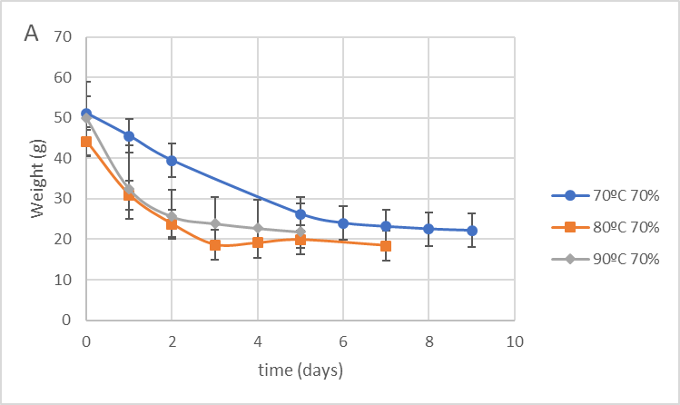 | 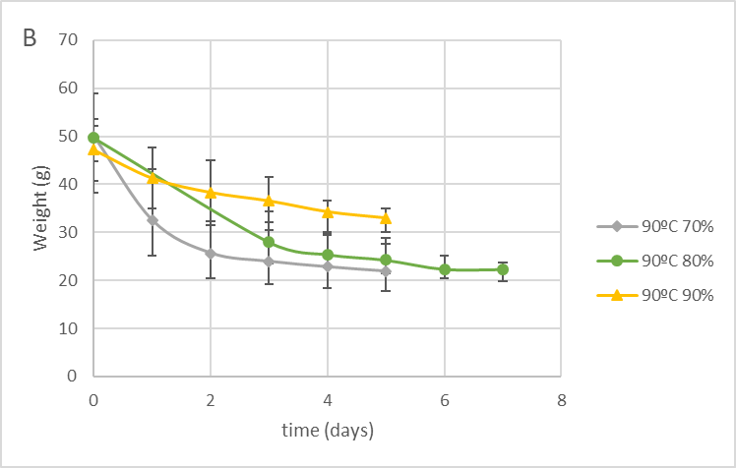
Figure 2. Weight of processed garlic vs. thermal processing time: A) At different Temperature and Constant Humidity; B) At different Humidity and Constant Temperature.
3.2 pH
According to results reported in the literature and as expected form the analysis of Figure 3 (I. S. Choi et al., 2014; H. Yuan et al., 2016) we can observe that higher is the temperature in the process and more quickly pH’s value decrease.
The pH reaches the plateau after 3 days for a treatment at the highest temperature for all humidity values.

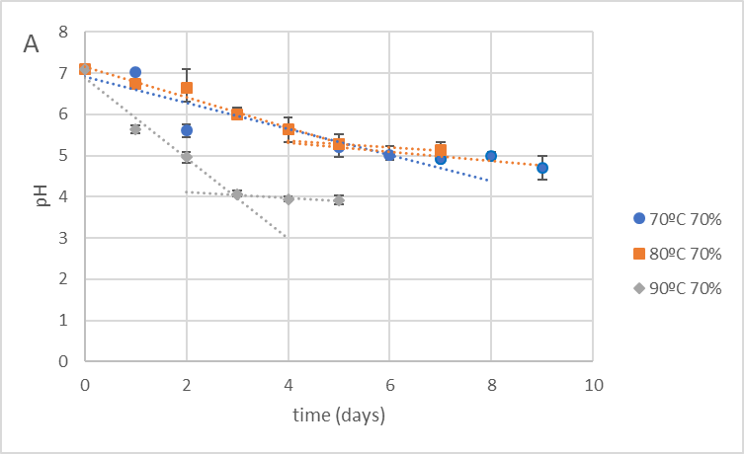 | 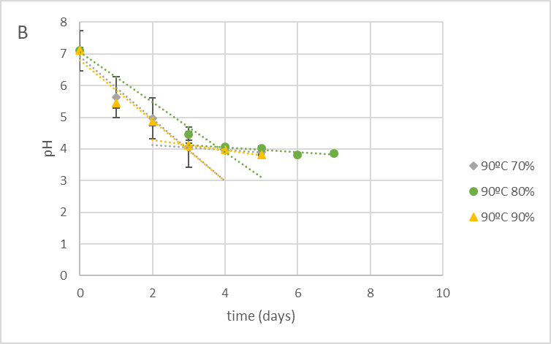
Figure 3. pH variation in processed garlic vs. thermal processing time: A) At different Temperature and Constant Humidity; B) At different Humidity and Constant Temperature.
3.3 Browning Intensity (Colour)
The colour of the garlic is expressed as “browning intensity” or ∆E on a scale that goes from 1 to 100 (where 1 is perceived as white and 100 as absolute black) (X. Zhang et al., 2016). The figure 4, reports the browning intensity measured during the thermal processing carried out under the operating conditions investigated.
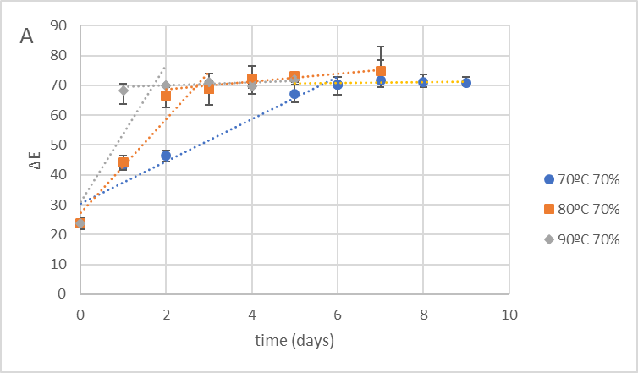 | 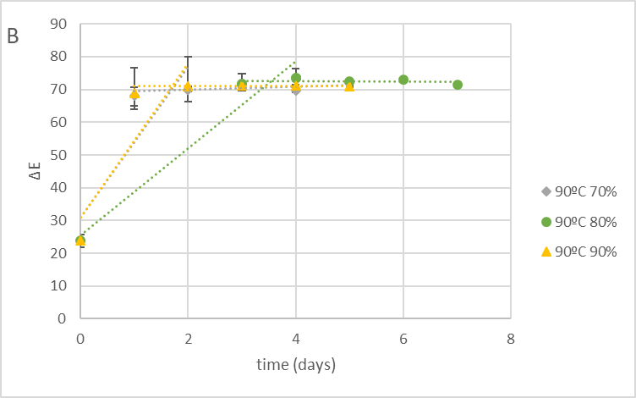
Figure 4. Garlic ∆E vs. time for garlic thermal processes. Operating conditions: A) At different Temperature and Constant Humidity; B) At different Humidity and Constant Temperature.
It is possible to observe the gradual colour change of samples during the thermal process and became black garlic characterized by a ∆E of 70 after also 1 day.
The ∆E parameter increments more quickly when the temperature is higher and this values are in accord to literature.
3.4 Allicin Content
The analysis of the results points out that the allicin content is high only in fresh garlic (3,32 mg/g) but by analysis on the processed garlic it was possible concluded that concentration is about zero as according to literature (X. Zhang et al., 2016).
3.5 Sugar Content
By the analysis results It is possible to assume that the concentration of glucose and sucrose are constant, while it is present an increment in fructose content that is probably responsible of the black garlic’s sweetness (H. Yuan et al., 2018). The fructose concentration is reported in figure 5. As can be seen from the figure, the maximum concentration of fructose and, therefore, the maximum hydrolysis of long chain of the fructans, is found at the maximum temperature and is dependent on relative humidity. The maximum concentration is about 500 mg/g dry sample for 80%RH, about 400 mg/g dry sample to 90%RH and about 270 mg/g dry sample to 70%RH.
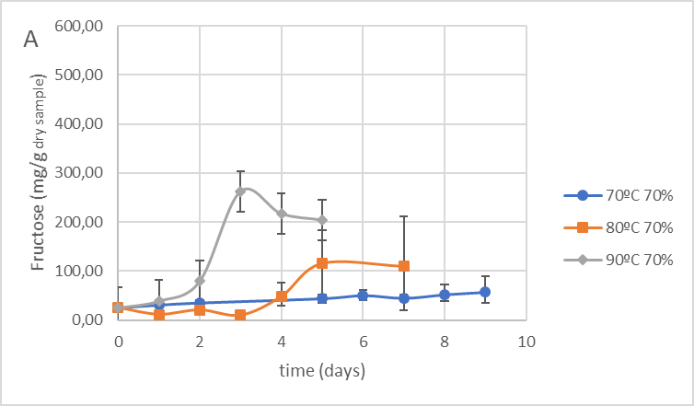 | 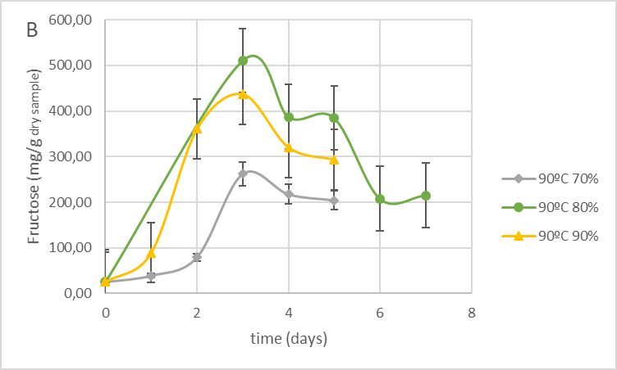
Figure 5. Fructose concentration in the processed garlic vs. thermal processing time. Operating conditions: A) At different Temperature and Constant Humidity; B) At different Humidity and Constant Temperature.
3.6 Polyphenol Content
The polyphenols content of the processed garlic vs. time is reported in the Figure 6. Data agree with investigation reported in the literature (S. Kimura et al., 2017). In particular, it is possible to see that maximum Polyphenol content it is reached for process characterized by higher temperature (90°C) and by 70%RH and this value is presented just after 3 days.
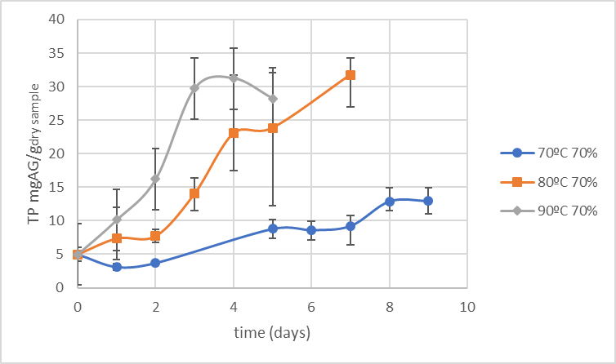 | 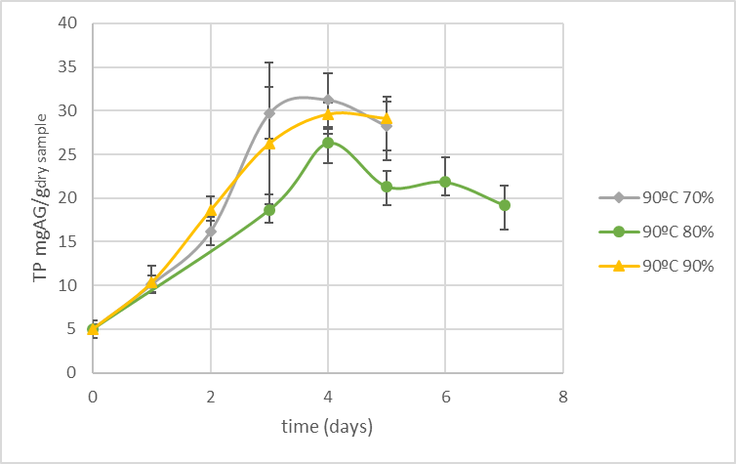
Figure 6. Polyphenols concentration in the processed garlic vs. thermal processing time. Operating conditions: A) At different Temperature and Constant Humidity; B) At different Humidity and Constant Temperature.
3.7 Flavonoid Content
The Figure 7 reports the concentration of flavonoid vs. time measured during the garlic thermal processing. According to results reported in the literature and as expected form the analysis of Figure 7, flavonoids increased as polyphenols increased (S. Kimura et al., 2017). The maximum value is reached, also in this case, after 3 days for the process characterized by higher temperature (90°C) and 70%RH.

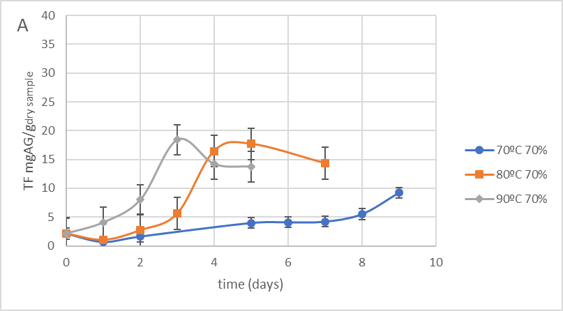 | 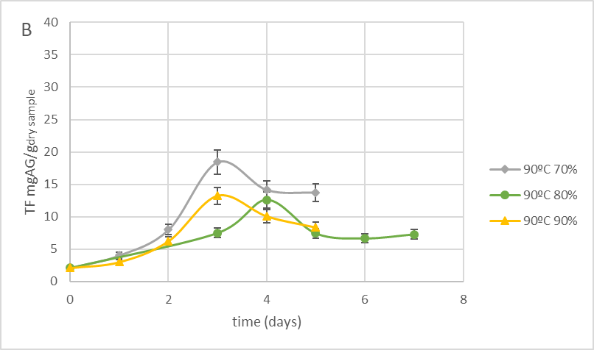
Figure 7. Flavonoids concentration in the processed garlic vs. thermal processing time. Operating conditions: A) At different Temperature and Constant Humidity; B) At different Humidity and Constant Temperature.

  - Discussion and Conclusions
Black garlic is used as food ingredient in Asian cuisine and more recently in modern cuisine as wanted functional food as well. Traditional and natural BG is produced leaving garlic bulbs for weeks and months at typical ambient temperatures and high relative humidity (about 40°C and 90-100% RH). To reduce process time, it is possible to process fresh garlic at higher temperatures and RH having the same healthy, functional and taste characteristics of the traditional and “natural” BG product.
Tests of BG production performed at increasing levels of temperatures (70 °C, 80 °C and 90°C) and RH (70%, 80% and 90%) showed that the process time ranging between 2-4 days it is consistently reduced than literature results (Pires at al, 2019, Zhang et al., 2015, Kimura et al., 2017). The typical black colour can be obtained already after 2 days of treatment at higher temperature and lower RH. The increase of RH increase the time of browning of the garlic denoting an increase of the rate of the production of melanoidins linked to the Maillard’s reactions. The typical pungent odour and flavour of fresh garlic linked to the presence of allicin are absent in BG in all process conditions already from 1 day of treatment, more rapidly than literature results (Zhang et al, 2015). Data showed that the optimal process temperature is 90 °C at which the Maillard reaction rate is very fast obtaining, after 3-4 days of treatment: the equilibrium WC (ranging between 62-75 %), the lower pH (4), the higher concentration of Total Polyphenols and Flavonoids espectively ranging between 32 -26 and 18 -13 mgGAE/g_{dry}). The highest value of the fructose content, which gives the typical and intense sweet taste of BG, is obtained after 3 days of treatment at 90°C, varying from 250 to about 500 mg / g dry with increasing relative humidity and as a consequence hydrolysis of the fructans contained in the samples.
In conclusion, the experimental activities have shown that increasing the process temperature in a range between 70 and 90°C allows to considerably reduce the production time of Black Garlic down to 2-4 days. These results are congruent with the effect that the temperature has with the Maillard reaction responsible for the main nutritional, organoleptic and functional characteristics of BG. The effect of relative humidity is much less noticeable than temperature on the main characteristics of BG, except on colour. The increase in the process RH tends to reduce the black degree of the final product.

References
Bayan L., Koulivand P. H., and Gorji A., “Garlic: a review of potential therapeutic effects.,” Avicenna J. phytomedicine, vol. 4, no. 1, pp. 1–14, Jan. 2014.
Block E., “The Chemistry of Garlic and Onions,” Sci. Am., vol. 252, no. 3, pp. 114–118, Mar. 1985.
Bocchini P., Andalò C., Pozzi R., Galletti GC, Antonelli A.. Determination of diallyl thiosulfinate (allicin) in garlic (Allium sativum L.). by high-performance liquid chromatography with a post-column photochemical reactor. Anal Chim Acta. 2001;441:37–43.
Borrelli F., Capasso R., and Izzo A., “Garlic (Allium sativum L.): Adverse effects and drug interactions in humans,” Mol. Nutr. Food Res., vol. 51, no. 11, pp. 1386–1397, 2007.
Capuano E. and Fogliano V., “Acrylamide and 5-hydroxymethylfurfural (HMF): A review on metabolism, toxicity, occurrence in food and mitigation strategies,” LWT - Food Sci. Technol., vol. 44, no. 4, pp. 793–810, 2011.
Cerella C., Dicato M., Jacob C., and Diederich M., “Chemical Properties and Mechanisms Determining the Anti-Cancer Action of Garlic-Derived Organic Sulfur Compounds,” Anticancer. Agents Med. Chem., vol. 11, no. 3, pp. 267–271, Mar. 2011.
Choi I. S., Cha H.S., and Lee Y.S., “Physicochemical and antioxidant properties of black garlic,” Molecules, vol. 19, no. 10, pp. 16811–16823, 2014.
Chowdhury R., Dutta A., Chaudhuri S.R., Sharma N., Giri A.K., and Chaudhuri K., “In vitro and in vivo reduction of sodium arsenite induced toxicity by aqueous garlic extract,” Food Chem. Toxicol., vol. 46, no. 2, pp. 740–751, 2008.
Corzo-Martínez M., Corzo N., and Villamiel M., “Biological properties of onions and garlic,” Trends Food Sci. Technol., vol. 18, no. 12, pp. 609–625, 2007.
Kasuga S., Uda N., Kyo E., Ushijima M., Morihara N., and Itakura Y., “Pharmacologic Activities of Aged Garlic Extract in Comparison with Other Garlic Preparations,” J. Nutr., vol. 131, no. 3, pp. 1080S-1084S, Apr. 2001.
Kimura S., Tung Y.C., Pan M.H., Su N.W., La Y.J. and Cheng K.C., “Black garlic: A critical review of its production, bioactivity, and application,” J. Food Drug Anal., vol. 25, no. 1, pp. 62–70, 2017.
Liu Q., Li J., Kong B., Li P., and Xia X., “Physicochemical and antioxidant properties of Maillard reaction products formed by heating whey protein isolate and reducing sugars,” Int. J. Dairy Technol., vol. 67, no. 2, pp. 220–228, 2014.
Pires L. de S., Todisco K.M., Janzantti N.S., Mauro M. A., “Black Garlic: Effects of the processing on the kinetics of browning and moisture transfer and on antioxidant properties”, J Food Process Preserv 2019; 43:e14133
Rivlin R.S., “Is Garlic Alternative Medicine?,” J. Nutr., vol. 136, no. 3, pp. 713S-715S, Mar. 2006.
Rivlin R.S., Budoff M., and Amagase H., “Significance of Garlic and Its Constituents in Cancer and Cardiovascular Disease,” J. Nutr., vol. 136, no. 3, pp. v–v, Mar. 2006.
Singleton VL, Orthofer R., “Analysis of total phenols and other oxidation substrates and antioxidants by means of Folin- -Ciocalteu reagent”. In: Abelson JN, Simon MI, Sies H, editors. Methods in enzimology, vol. 299. Burlington, MA, USA: Academic Press; 1999. pp.152–78. http://dx.doi.org/10.1016/s0076-6879(99)99017-1
Tattelman E., “Health effects of garlic.,” Am. Fam. Physician, vol. 72, no. 1, pp. 103–6, Jul. 2005.
Toledano Medina M. A., Pérez-Aparicio J., Moreno-Rojas R., and Merinas-Amo T., “Evolution of some physicochemical and antioxidant properties of black garlic whole bulbs and peeled cloves,” Food Chem., vol. 199, pp. 135–139, 2016.
Yuan H., Sun L., Chen M., and Wang J., “The Comparison of the Contents of Sugar, Amadori, and Heyns Compounds in Fresh and Black Garlic,” J. Food Sci., vol. 81, no. 7, pp. C1662–C1668, 2016.
Yuan H., Sun L., Chen M., and Wang J., “An analysis of the changes on intermediate products during the thermal processing of black garlic,” Food Chem., vol. 239, pp. 56–61, 2018.
Zhang Z., Lei M., Liu R., Gao Y., Xu M. and Zhang M., “Evaluation Of Alliin, Saccharide Contents And Antioxidant Activities Of Black Garlic During Thermal Processing”, Journal of Food Biochemistry 39 (2015) 39–47
Zhang X., Li N., Lu X., Liu P., and Qiao X., “Effects of temperature on the quality of black garlic,” J. Sci. Food Agric., vol. 96, no. 7, pp. 2366–2372, 2016.

