CHEMICAL ENGINEERING TRANSACTIONS  VOL. | A publication of
The Italian Association
of Chemical Engineering
Online at www.cetjournal.it
Guest Editors:
Copyright © AIDIC Servizi S.r.l.
ISBN 978-88-95608-xx-x ISSN 2283-9216

Techno-economic Evaluation of Heterotrophic Microalgal Cultivation Approaches
Marco Valentini ª *, Alessio Mazzelli ^{b}, Annalaura Iannone ª, Eryka Mrotek ª,
Vittoria Sapone ª, Marco Bravi ª
ª Dept. Chemical Engineering Materials Environment, University of Rome La Sapienza; via Eudossiana 18, 00184 Rome (IT)
^{b} NextChem S.p.A. via di Vannina 88/94, 00156 Rome (IT)
* ma.valentini@uniroma1.it
This work focuses the attention on the evaluation of different heterotrophic microalgal cultivation approaches, finding the best process solution to achieve the accumulation of high value-added metabolites, such as astaxanthin and polyunsaturated fatty acids (PUFA), trying also to use a wastewater as carbon source.
Three different approaches are evaluated: 1) Classical batch cultivation in sterilized fermenter; 2) Impulse nutrient feeding without sterilizing the reactor; 3) Impulse nutrient approach coupled with wastewaters’ usage in two different parallel reactors. This latter strategy is the one adopted in the European Project MEWLIFE (MicroalgaE biomass from phototrophic-heterotrophic cultivation using olive oil Wastewaters) that aims to produce microalgal biomass in an integrated photo-heterotrophic cultivation system using preconcentrated (in a membrane filtration plant) olive oil mill wastewater (OOMWW) as carbon source for growing algae, thus contributing to waste reuse and valorisation. Thanks to the Aspen Custom Modeler software, it is possible to write codes to represent the fermentation units, which are normally not present in the databases of most common simulators. Finally, a technical-economic analysis is conducted to evaluate the most advantageous process. At present, the pulse technique represents an extremely promising strategy with margins of improvement, deserving thus further investigation.
  - Introduction
Various microalgae species can be used in raw or semi-decomposed form as organic biofertilizers, for remediation or biosorption of environmental problems and for the production of biofuels and carbon dioxide sequestration (Aishvarya et al. 2015).
In addition to proteins, pigments, biopolymers and fatty acids, microalgae can produce antioxidant substances for commercial and pharmaceutical purposes (Mazzelli et al. 2019a, Mazzelli et al 2019b, Mazzelli et al. 2022). Microalgae must be cultivated in a way that meets all their requirements for growth and maintenance. In addition, it is necessary to consider several factors and the most important variables that regulate algal growth, such as nutrient quantity and quality, light, temperature, and pH. (Mazzelli et al. 2018, Acièn 2013). Cell biomass productivity is not only affected by all these parameters, but they also affect the pattern, pathway, and activity of cellular metabolism and the resulting change in cellular composition. The cultivation methods are classified based on their exposure to light (phototrophy) or absence of light (heterotrophy). It is possible to reach higher cell densities and to use traditional fermenters for microalgae cultivation by using heterotrophic cultivation, which does not require CO₂ (unlike photoautotrophic cultivation). (Hua et al. 2017).
The purpose of this study is to examine three different microalgal heterotrophic cultivation techniques in terms of productivity and economics. The first one involves classical batch fermentation followed by sterilization, in which the nutrients are supplied at the beginning, and the microalgae are added after having been sterilized. To grow the microorganism, the fermenter is closed, and the temperature and pH are kept constant. Using this technique without sterilization causes problems with bacterial contamination since bacteria and fungi compete for growth with microalgae (Sandani et al. 2020). This study analyzes the impulse nutrient feeding without sterilizing the reactor; an innovative solution patented by NextChem (EP3498855) as a second cultivation technique. By using this approach, it is possible to avoid the use of sterilization and aseptic conditions, since the carbon and nitrogen sources are injected respectively into the growth medium in alternate pulses. The principle behind the implemented cultivation strategy is that microalgae can grow in the absence of nitrogen by consuming nitrogen stored in the cells, while most bacteria can grow only if all nutrients are simultaneously present in the culture medium. Using the pulse technique with the OOMWW-based feeding (as organic carbon source), the third and last technique studied aims to both accumulate metabolites and treat wastewater. This method was used in the MEWLIFE (https://www.mewlife.eu) project. MEWLIFE was a LIFE project aiming to demonstrate the environmental benefit and economic feasibility of an innovative approach to produce microalgal biomass in an integrated phototrophic – heterotrophic cultivation system using preconcentrated (in a membrane filtration plant) olive oil wastewaters as carbon source for growing algae, thus contributing to waste reuse and valorization.
According to estimates, the annual world production of OOMWW is between 7 and over 30 million m³. In this context, there is an urgent need to find ways to treat this liquid residue and other by-products of the olive oil industry. Considering these difficulties in the disposal of vegetation water, its use as a growth medium for microalgae can be a very promising alternative.
Lastly, this work discusses a techno-economic evaluation comparing a classical cultivation technique, the pulse technique and OOWMM + pulses. A techno-economic evaluation of the innovative pulse cultivation technique and OOWMM + pulses has not been done so far.
  - Materials and methods

  - Experimental conditions and modeling
In the present work the experimental data, for the pulsed technique, are taken from NextChem database related to MEWLIFE project. In this project indeed two fermenters working in parallel, with an operative volume of 3 m³ each, have been used. One is F-101, always operating according to the pulse technique to accumulate nitrogen inside the microalgal cells, using pure glucose as carbon source. Once the biomass in F-101 reaches the desired concentration, ending its cultivation cycle only when the nitrogen in the broth is consumed, a part of it is transferred to F-102. This biomass will then have the maximum possible intracellular nitrogen content that will be exploited in the second fermenter, since only organic carbon will be present in the reactor as a nutrient in form of OOMWW, to induce the accumulation of starch and lipids in the microalgae.
To create a tool for the simulation of these coltivation approaches, the following model is used, relating this model to the existing fermenters with an operating volume of 3 m³. The specific growth rate is defined as a function of the maximum specific growth rate ($μ_{m}$) and several growth-limiting factors according to Eq. 1 (Murwanashyaka et al. 2020).

$μ= μ_{m}*\prod_{i=1}^{n}{f(S_{i})}$ (1)

n is the total number of limiting factors and f(S_{i}) is the function that defines the extent to which the S_{i} factor limits growth. The function describing how much a limiting factor affects the growth rate can take many different forms including the Monod function which is widely used.

$f\left(S_{i}\right)= \frac{S_{i}}{K_{S}+S_{i}}$ (2)

K_{s} is the semi-saturation constant.
Consequently, the specific growth rate of algal biomass, assuming glucose G, nitrate N, and phosphate P as the limiting substrates, can be expressed as follows.

$μ=\frac{μ_{m}* G*N*P}{(K_{n}+G )+(K_{n}+N)+(K_{p}+P) }$ (3)

K_{g}, K_{n}, and K_{p} are the semi-saturation constants for glucose, nitrate, and phosphate consumption, essential substrates for cell growth. Expressions of their consumption rates are the critical elements of the model since their uptake regulates cell growth and metabolite accumulation. Typically, in a simplified manner, these rates are linearly related to the biomass growth rate according to the Luedeking-Piret expression as follows.
$ρ_{g}=-\left(\frac{1}{Y_{g}}\right)*μ -m_{g}$ (4)
$ρ_{n}=-\left(\frac{1}{Y_{n}}\right)*μ -m_{n}$ (5)
$ρ_{p}=-\left(\frac{1}{Y_{p}}\right)*μ -m_{p}$ (6)

Y_{g}, Y_{n}, and Y_{p} are the biomass yield coefficients, and m_{g}, m_{n}, and m_{p} are the maintenance coefficients on carbon, nitrogen, and phosphorus consumption, respectively. In microalgae culture, once growth has been limited due to nutrient depletion, assimilated carbon can be accumulated as storage products in the form of starch and/or lipids (Breuer et al. 2015). Based on the above formulations, the dynamics of the algal culture in this batch work are therefore described by a system (Eq. 7) set of six differential equations.

$\left\{\begin{aligned}\frac{dX}{dt}=μ*X \\ \frac{dG}{dt}=ρ_{g}*X \\ \frac{dN}{dt}=ρ_{n}*X \\ \frac{dP}{dt}=ρ_{p}*X \\ \frac{dS}{dt}=π_{s}*X \\ \frac{dL}{dt}=π_{l}*X\end{aligned}\right.$ (7)
The mathematical model describing the dynamic behavior of the system is a system of ordinary differential equations of the following general form: 𝑑𝑥(𝑡) 𝑑𝑡 = 𝑓(𝑥(𝑡), 𝜃) where 𝑥 is the vector of differential variables (X,G,N,P,S,L) and θ is the vector of model parameters to be determined. Solved by using the Simulated Annealing Constrained method to find the best set of parameters. Table 1 shows the parameters used in "run 9" found in the Murwanashyaka et al. 2020 model.
Table 1: Reported by Murwanashyaka et al. 2020
K_{g} [g_{C} L⁻¹] | K_{n} [g_{C} L⁻¹] | K_{p} [g_{P} L⁻¹] | μ_{m} [h⁻¹] | α_{s} [g g_{DW}⁻¹] | β_{s} [g g_{DW}⁻¹ h⁻¹] | α_{l} [g g_{DW}⁻¹] | β_{l} [g g_{DW}⁻¹ h⁻¹]
1 | 1.5*10⁻² | 2*10⁻³ | 1.1*10⁻¹ | 3.1*10⁻¹ | 4.4*10⁻⁴ | 3.6*10⁻² | 3.4*10⁻⁴

Y_{g} [g_{DW} g_{C}⁻¹] | m_{g} [g_{C} g_{DW}⁻¹h⁻¹] | Y_{n} [g_{DW} g_{N}⁻¹] | m_{n} [g_{N} g_{DW}⁻¹h⁻¹] | Y_{p} [g_{DW} g_{P}⁻¹] | m_{p} [g_{P} g_{DW}⁻¹h⁻¹] | R²
1.2 | 4.3*10⁻⁴ | 16 | 1*10⁻⁷ | 68 | 3.7*10⁻⁵ | 0.97

  - Batch and Pulsed technique simulation
For the batch simulation performed in this work, the parameters of Murwanashyaka et al. 2020 are used, since the concentration of substrates fed to the fermenter reflected the relative ratio of nutrients used in this experimental trial. ASPEN CUSTOM MODELER® (ACM), integrated into Aspen Plus® is used for fermentation modeling (Atikah et al. 2019).
The heterotrophic cultivation of microalgae poses a severe problem of managing the contamination of bacteria that have growth rates an order of magnitude higher than those of microalgae (Sandani et al. 2020). To solve this problem the High-Pressure, High-Temperature (HTHP) treatment is considered in this work and applied in the process simulation to the inoculum before it enters the fermenter, using for sterilization phase T=121°C, P=0.2 MPa with a treatment time of 15 min (Ashidate et al. 2018).
Similar approach is used for the pulsed feeding (both for OOMWW and glucose usage), modeling it in an ACM script to obtain a simulation of heterotrophic growth. Indeed, the same formula described above for the metabolic and growth modeling are used but the typical sawtooth trend is obtained considering the correct timing, between the start/end of glucose/nitrate phase, taken from the experimental results database of NextChem. The pulse technique allows to have a reactor management less critical from the point of view of bacterial contamination. This is reflected in lower investment and management costs.
  - Results
3.1 Process simulation
The results of the simulation of the batch culture technique on ACM are shown in Fig. 1a. Using a 3 m³ fermenter, a final biomass concentration of approximately 15.5 g/l is achieved, with initial glucose and nitrate amounts of 10 and 0.6 g/l, respectively. Interestingly, despite the depletion of the nitrogen source from the growth medium, the accumulation of carbohydrates and lipids by the biomass continues. Indeed, under nitrogen deficiency conditions, the biomass undergoes to a stress condition that leads it to accumulate starch and lipids as storage products necessary for its survival. Considering a process time of about 5.5 days, including the phases of filling, cleaning and sterilization, the following results are obtained: Biomass productivity 5.9 (kg/day), Glucose consumption 5.4 (kg/day) and Nitrate consumption 0.32 (kg/day).
Regarding the simulation of the pulse technique the results are shown in Fig 1b. The profile obtained shows the trend of saw-tooth from the biomass (red line), with growing trends during the glucose phases (blue line) and consumption trends during nitrate phases (green line). The plot also shows the profile of the internal nitrogen quota (light-blue line), which shows an oscillating trend between the maximum and minimum values that were determined previously. Considering a process time of about 8 days, also considering filling and cleaning of the fermenter, the following values of productivity and consumption are obtained: Biomass productivity 5.91 (kg/day), Glucose consumption 16.03 (kg/day) and Nitrate consumption 1.7 (kg/day).

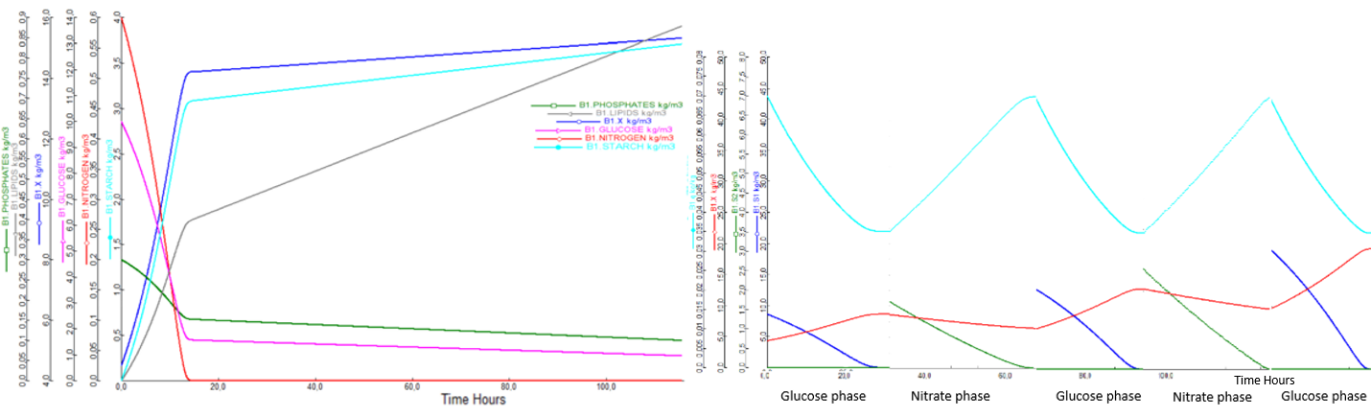
Figure 1: Profile concentration of a) Batch simulation, b) Pulsed technique simulation
With respect to the third option applied in the MEWLIFE project, the operating phase is divided in two fermenters working in parallel as described in previous paragraph. The cycle in F-101 is interrupted at the end of the second nitrate phase (after 6.5 days), when a biomass concentration of about 10 g/l is reached and a part of this suspension is sent to F-102 cultivation with only OOMWW.
Specifically, the microalgae suspension of 3 m³ of the first fermenter is in part (1.33 m³) recirculated to the F-101 to obtain, through dilution, the initial concentration of 4.5 g/l of biomass with which to start the cycle again, while the remaining part (1.67 m³), will be inoculated into the second fermenter F-102, on which only the first glucose phase (substituting glucose with OOMWW) of the pulsed strategy is carried out, thus starting from 5.63 g/l and arriving at 11.3 g/l of microalgal biomass. The two fermenters run in parallel; the F-102 can run two consecutive cycles of about 3 days each before the F-101 ends.
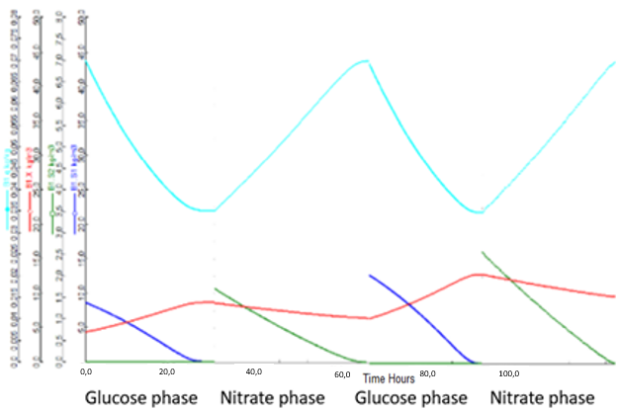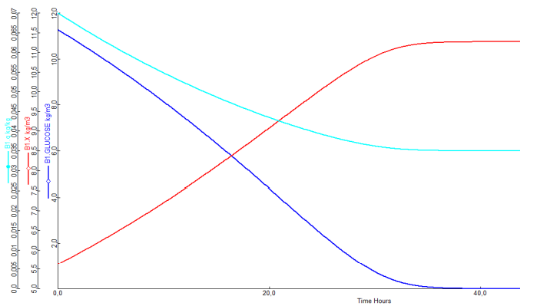
Figure 2: a) Biomass and Nutrient Profile in F-101 b) Biomass and Nutrient in F-102
The second cycle of F-102 is inoculated with the microalgal suspension derived from the previous phototrophic section since it has not yet completed its cycle and therefore cannot be sent to F-102. After reaching 4.5 g/l of biomass concentration in the second cycle, F-102 will reach 9 g/l of biomass concentration. To obtain a saving on the glucose to be supplied, a concentrate of vegetation waters is also sent to the second fermenter. Fig. 2 shows the biomass and nutrient profiles of the two fermenters. Overall, the following data are obtained: Biomass productivity 7.27 (kg/day), Glucose consumption 15.0 (kg/day) and Nitrate consumption 2.07 (kg/day).

3.2 Techno-economic analysis
Economic analyses of the studied fermenters are performed to evaluate the most cost-effective solution starting with the AACE Association for the Advancement of Cost Engineering guidelines for making cost estimates of an engineering project. The present work can be classified as an estimation class number 3, with a cost estimation error ranging from 20% under to 30% over. Once both the CAPEX (Fig. 3) and OPEX needed to build and operate the plant are estimated, the Cost Of Production (COP) must be calculated, which is the cost that must be incurred per unit of product.

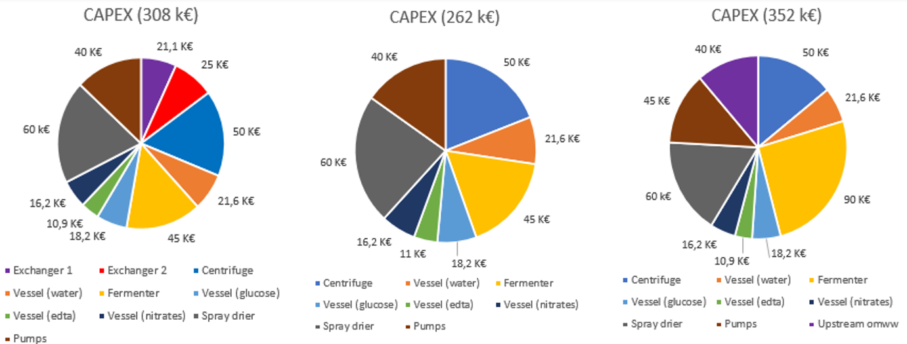
Figure 3: Economic results of each cultivation approach - a) Batch with sterilization b) Pulsed without sterilization c) Pulsed + OOMWW usage in parallel reactors
Although the amount of biomass produced is the same, with the pulsed strategy it is possible to store inside the microalgal cells a higher amount of starch and lipids. This happens because with pulsed fermenter feeding, the biomass is repeatedly subjected to a stress condition, due to the absence of the nitrogen source in the growth medium. As a result, the biomass responds to this stress by accumulating more products such as starch and lipids, resulting in a productivity of these metabolites that is almost double that of the batch strategy, where nitrogen and glucose are fed simultaneously. Fig. 3 shows the economic results in terms of CAPEX of each cultivation technique. Overall, for the same biomass produced, the operating costs are similar for the first two cultivation techniques (batch 130 €/kg, pulsed 128 €/kg), while for pulsed + OOMWW, it is 187 €/kg. Obviously, since the goal of the process is the extraction of these metabolites, the pulse strategy proved to be more promising and convenient than the batch case with sterilization of the incoming current. Despite the use of two fermenters and a whole section of wastewater pre-treatment, the pulse with vegetation water system, with the related investments, can reach production cost values very close to the single fermenter pulse strategy, by reason of a significant saving on exogenous glucose, with still wide possibilities of development.
Consequently, the goal is to aim at optimizing growth in the presence of vegetation water, to be able to mitigate as much as possible the consumption of glucose, which is one of the main cost items that characterizes this cultivation strategy. Furthermore, the usage of OOMWW could further reduce the investment cost because an income due to the wastewaters’ treatment, paid from mill sites, should be considered for a more complete business plan of this technology.
  - Conclusions
This work shows how heterotrophic microalgae cultivation can be effectively conducted even without sterilization and aseptic procedures due to decoupled nutrient feeding. This also allows the production of secondary metabolites to be optimized based on the nitrogen starvation condition, to which the microalgae are alternately subjected. The problem with this cultivation technique is related to the low productivity and high glucose consumption. This is solved by running two fermenters in parallel, with one fed by wastewater from the olive mills, which reduces the extra supply of carbonaceous substrate.
The final aim is to achieve complete remediation of the wastewater, which at present still cannot be discharged to the sewer after being used in the fermenter. Further upgrades of the work could be the possibility to include other wastes, such as those from the dairy industry, to further limit the demand for glucose.
From an economic point of view, the pulse strategy conducted in parallel with a cultivation phase in the presence of vegetation water has shown extremely encouraging results. However, further evaluations should be done in case it is decided to increase productivity. Batch production, in fact, can be increased simply by providing more nutrients to the microalgae. The pulse technique, on the other hand, is more rigid from this point of view, as the concentration of substrates to be loaded in each phase must not exceed the value predicted by the internal nitrogen quota trend. Therefore, for this technique it would be necessary to intervene with additional investments related to the use of a larger fermenter or several bioreactors placed in parallel. Currently, the pulse technique represents an extremely promising strategy with ample room for improvement and therefore deserves further investigation to also optimize the usage of wastewaters as organic source, coupling thus biomass production and wastewater treatment.
Acknowledgements
This work was supported by the European Union in the framework of the LIFE program (MEWLIFE project - LIFE17 ENV IT 000180). The authors wish to tank Dr. Vittorio Galanti for efforts made on the Aspen Model.
Reference
Acièn F.G, Molina E., Reis A., Torzillo G., Zittelli G.C., lveda C. Sepu´, Masojı´dek J., 2013, Photobioreactors for the production of microalgae. Microalgae-Based Biofuels and Bioproducts, 12, 131-151.
Aishvarya V., Jena J., Pradhan N., Panda P.K., L.B. Sukla L.B., 2015, Microalgae: Cultivation and Application. Springer International Publishing Switzerland, 291-307.
Ashidate M., Yamashita T., Hamasaki K., 2018, Effects of thermal disinfection and autoclave sterilisation on the quality of microalgae concentrates. Aquaculture research.
Atikah M. S. N., Harun Razif, 2019, Simulation and Optimization of Chlorella vulgaris Gasification Using Aspen Plus. Process Integration and Optimization for Sustainability, 3, 349–357.
Breuer G., Lamers P., Martens D. E., Draaism R. B., Wijffels R. H., 2012, The impact of nitrogen starvation on the dynamics of triacylglycerol accumulation in nine microalgae strains. Bioresource Technology, 124, 217-226.
Hua J., Nagarajan D., Zhanga Q., Chang J., Lee D., 2017, Heterotrophic cultivation of microalgae for pigment production: A review. Biotechnology Advances.
Mazzelli A., Cicci A., Sed G., Bravi M., 2018, Development of a Semi-Theoretical Light Radiation and Photosynthetic Growth Model for the Optimal Exploitation of Wastewaters by Microalgae, Chemical Engineering Transactions, 64, 685-690
Mazzelli A., Luzzi D. M., Buonanno G., Cicci A., Piemonte V., Iaquaniello G., 2019a, An optimized separation process of microalgal lipidic products by molecular distillation: Techno-economic analysis. Chemical Engineering Science Volume 207, Pages 1187 - 119
Mazzelli A., Buonanno G., Luzzi D. M., Cicci A., Piemonte V., Iaquaniello G., 2019b, Multi-component extraction process of high added value compounds from microalgae with supercritical CO2: A technical and economic study. Chemical Engineering Research and Design. Volume 150, Pages 65 – 73 October 2019
Mazzelli A., Valentini M., Cicci A., Iaquaniello G., Bravi M., 2022, Industrial bio-fractionation process of microalgae valuable products using supercritical CO2. A techno-economical evaluation. Chemical Engineering Research and DesignVolume 178, Pages 50 - 60
Murwanashyaka T., Shen L., Yang Z., Chang J., Manirafasha E., Ndikubwimana T., Chen C., Lu Y., 2020, Kinetic modelling of heterotrophic microalgae culture in wastewater: Storage molecule generation and pollutants mitigation. Biochemical Engineering Journal, 157, 107523.
Sandani W. P., Gannoru, Sanuji K., Nishshanka H., Premaratne G. M. M., Chamode S., Wijayasekera N., Ariyadasa T. U., Premachandra J. K., 2020, Comparative assessment of pretreatment strategies for production of microalgae-based biodiesel from locally isolated Chlorella homosphaera. Journal of Bioscience and Bioengineering, 130 (3), 295-305.

