|  |  |
| --- | --- |
| cetlogo ***CHEMICAL ENGINEERING TRANSACTIONS***  ***VOL. 93, 2022*** | A publication of  aidiclogo_grande |
| The Italian Association  of Chemical Engineering  Online at www.cetjournal.it |
| Guest Editors: Marco Bravi, Alberto Brucato, Antonio Marzocchella  Copyright © 2022, AIDIC Servizi S.r.l. **ISBN** 978-88-95608-91-4; **ISSN** 2283-9216 | |

Microalgae Cells Tracking in Hybrid Tubular Photobioreactor

Vojtech Belohlav\*, Tomas Jirout, Lukas Kratky

Czech Technical University in Prague, Faculty of Mechanical Engineering, Department of Process Engineering, Technicka 4, 16000, Prague, Czech Republic

vojtech.belohlav@fs.cvut.cz

The mixing of the culture medium in a photobioreactor (PBR) is very important to enhance the cultivation of microalgae since it ensures that microalgae cells can access nutrients and light radiation. In this study, a numerical model of hydrodynamic conditions was developed to investigate the mixing of the culture medium in a hybrid tubular photobioreactor under various operating conditions. The movements of microalgae cells in transparent tubes was simulated. The motion of the cells was integrated into a mechanistic model, to simulate the influence of operating parameters on the distribution of light in the culture medium and, consequently, on the production of microalgae. According to the developed multi-physical model, when the flow rate of the culture medium increases, more intensive mixing takes place in the transparent area of hybrid tubular PBR, and microalgal cells are more often exposed to light radiation. Intensification of mixing showed an increase in microalgal biomass production. However, the increase in production was very low because the concentration of microalgal biomass in the culture medium was generally low and therefore the penetration of incident light into the culture medium was not limited.

* 1. Introduction

Mixing the culture medium with microalgae biomass has a significant influence on the cultivation process (Cui et al., 2020). It is important to avoid sedimentation of microalgae cells and thus ensure homogeneous access of cells to nutrients and light. Light gradients in the culture medium can occur due to absorption and scattering (Perner-Nochta and Posten, 2007). Inadequate mixing can cause microalgal cells to pass from the irradiated zone to the dark zone of the culture medium (Yan et al., 2018). Mixing of the culture medium can be achieved in various ways, such as aeration, pumping, mechanical agitation, modification of the cultivation system design, or a combination of these methods (Wang et al., 2012).

Computational fluid dynamics (CFD) technology is often used to design, optimize or scale-up of equipment. In the case of mixing, CFD can not only provide a quantitative description of the flow characteristics, but it can also simulate the motion of particles in multiphase flow (Fernández del Olmo et al., 2021). Thus, with CFD it is possible to monitor the movement of microalgal cells in the culture medium. Numerical modelling can also be used for the simulation of the cultivation process. Huesemann et al. (2016) validated a model that can predict the growth of microalgae based on light intensity. Solimeno et al. (2017) created a mechanistic BIO\_ALGAE model simulating the function of a system processing a culture medium containing microalgae and bacteria. Based on the input parameters (incident light intensity, culture medium temperature, nutrient content in inflow culture medium), this model can simulate the production of microalgal biomass and it is thus possible to study the consumption of nutrients in the system as well. However, the model does not include the effect of hydrodynamics on operating conditions and microalgae production (Solimeno and García, 2019). Hydrodynamic conditions can have a significant effect on biomass production, especially in systems operating with high concentrations of biomass in the culture medium or in systems that have a large thickness of the culture medium. These factors significantly reduce the intensity of incident light radiation penetrating the culture medium.

The aim of this study was to integrate the influence of hydrodynamic conditions into a mechanistic model simulating the process of microalgae cultivation. In order to describe the hydrodynamic conditions in the culture medium of hybrid tubular photobioreactor, a CFD model was developed. CFD simulations allow the investigation of the culture medium mixing and its effect on the movement of microalgae cells. The integration of hydrodynamic conditions into a mechanistic BIO\_ALGAE model allows investigating the influence of operating conditions on culture medium mixing, light distribution within the culture medium, and microalgae production.

* 1. Materials and methods
     1. Novel hybrid tubular photobioreactor

The hybrid tubular photobioreactor used for this study (HT PBR) consisted of 16 transparent tubes with an inner diameter of *d* = 0.125 m that connect two retention open tanks. The tubes length (*L* = 47 m) determined the distance between the open retention tanks. The tubes were divided into two rows of eight tubes, which allow the culture medium to circulate between the retention tanks. Two paddle wheels installed in the retention tanks ensured the circulation of the culture medium on both sides of the HT PBR. Under the paddle wheels, an overflow dam was installed, which determines the difference of culture medium levels in two parts of the retention tank. This water level difference causes the culture medium to flow through the transparent tubes. A section of the retention tank is shown in Figure 1. A detailed description of the HT PBR design can be found in Belohlav et al. (2021) and a description of the PBR function can be found in Díez-Montero et al. (2020).

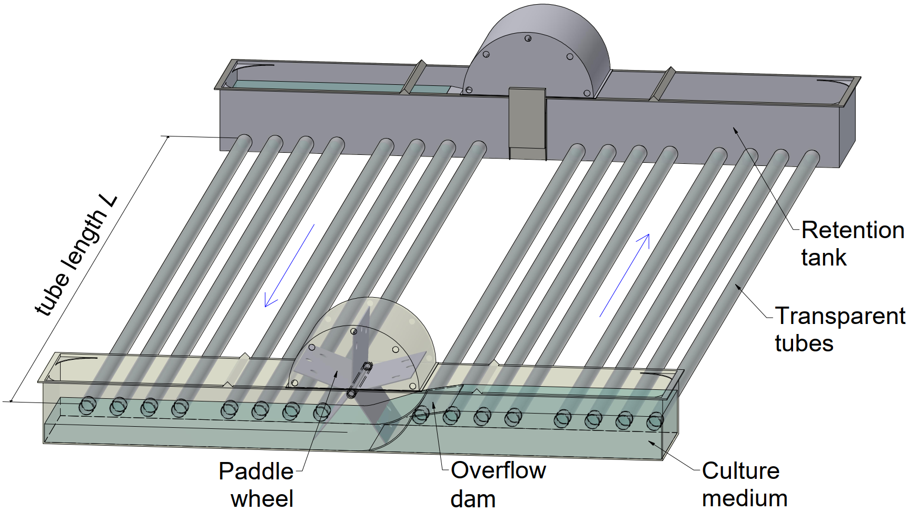

Figure 1: 3D isometric view of HT PBR, L represents the tube length

* + 1. Model of hydrodynamics

A detailed numerical model for the hybrid tubular photobioreactor was developed and validated by experimental measurements. The function of the model and its validation were described in detail in the study Belohlav et al. (2021). The Large eddy simulation (LES) method was used to simulate hydrodynamic conditions. Small turbulent eddies, which are generally isotropic, are modelled using submodels and are removed by filtering. For the LES method, the mesh of the created model must be significantly finer, which results in more complex calculation requirements (ANSYS Inc. (US), 2018). According to the demanding calculation requirements of the model, the length of the tube geometry was reduced to one meter and a fully developed flow was defined at the inlet to the tube. The mesh of the tube consists of 1,375,358 elements with a 1 mm maximum size. The mesh structure was modified to be significantly finer at the tube wall since the large-scale eddies are geometrically very small in the turbulent regime. Computations were performed until the calculation converged at a residue of 10-5 between iterations and the skewness of developed mesh reached the value of 0.21. The mesh quality was checked using skewness reaching the value of 0.21. To simulate the hydrodynamic conditions in a 3D tube model, the inlet was defined by the inlet velocity according to the selected operating conditions in the HT PBR. The used mean flow velocities for simulation were 0.19, 0.25, and 0.37 m s‑1, corresponding to Reynolds numbers *Re* of 23,700, 31,200, and 46,200, respectively.

The movement of microalgal cells during its flow in the tube was simulated with particle tracking injection function. The physical properties of particles (density, diameter) were adjusted according the parameters of microalgal cells (Belohlav and Jirout, 2019). The injection point (62 mm below the tube axis) was chosen to simulate the trajectory of microalgae cell in the area of the tube which is least irradiated by the light source and thus affected by unfavourable condition of light limitation. Since the light source is assumed to be located directly above the HT PBR tubes, the microalgae cell position is defined as the vertical distance from the transparent wall of the irradiated tube wall H (m). The intensity of the light received by the cells from the incident light source can be simulated according to the actual distance of the cells from the irradiated wall of the tube. The position of injection point in the tube and the scheme of the developed system is shown in Figure 2.

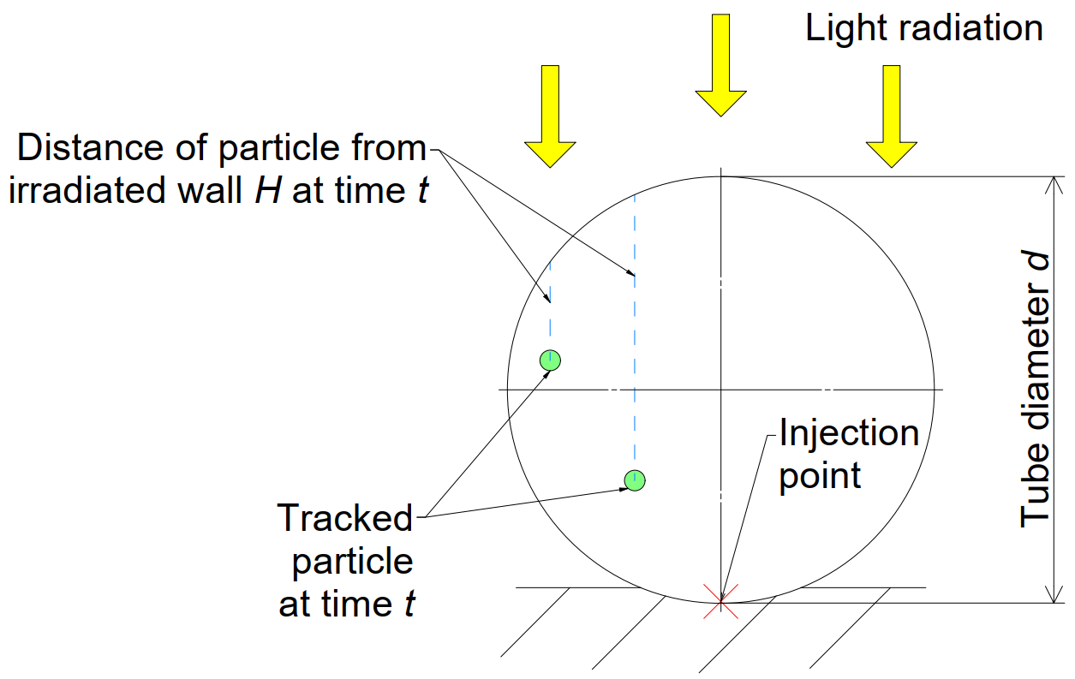

Figure 2: Scheme of particle tracking model principle in the cross-sectional view of HT PBR transparent tube, H represents the distance of the particle from the irradiated wall, d indicates the tube diameter

* + 1. Model of light attenuation

In cultivation systems that work with a wide layer of culture medium, the intensity of mixing can affect the efficiency of microalgae production. In systems where no mixing of culture medium occurs, the microalgae can grow only in a part of the entire volume of the culture medium that is irradiated. Systems with intensive mixing and a large layer of culture medium can thus achieve higher productions than systems that work with a smaller layer of unmixed culture medium.

If the culture medium is not mixed sufficiently in the transparent tubes, the individual parallel streamlines of flowing medium do not mix. This results in the formation of a light gradient in the culture medium, which is caused by the mutual scattering of incident light as it penetrates the culture medium layer. The microalgae at the bottom of the tube are thus in the dark zone at all times, which reduces the overall efficiency of the entire culturing process. Dark zones can be defined as regions where the average light intensity value does not reach critical saturation intensity values. To quantify the quality of the light conditions, the cross section of the tube can be divided into light and dark zones based on the critical saturation intensity value for the cultivated *Chlorella*. Tilzer (1987) defined the critical saturation intensity for *Chlorella* to be 70 μmol m‑2 s‑1. To evaluate the light regime under different operating conditions of HT PBR, it is possible to use the light fraction *ε* (-) indicating the ratio of the retention time in the light and dark zones (light/dark or L/D cycle). The light fraction is defined by Eq. (1)

|  |  |
| --- | --- |
| $$ε_{L}=\frac{t_{L}}{t_{L}+t_{D}}$$ | (1) |

where *tL* (s) is the retention time of microalgae cells in the light zone, and *tD* (s) is the time when the cells are in the dark zone.

The direct effect of the reduction of light radiation during penetration of the culture medium layer can be described by Lambert-Beer’s law. This law can be used to describe the average intensity of light radiation *Iav* (W m‑2) in mixed cultivation systems. Considering the mixing of culture medium, the thickness of the irradiated layer can be replaced in Lambert-Beer’s law by the actual distance of the microalgae cell from the transparent irradiated PBR wall *H* (Figure 2). The average intensity of light radiation *Iav* acting on microalgal cells in the tube can be expressed using Eq. (2)

|  |  |
| --- | --- |
| $$I_{av}=\frac{I_{o}∙\left[1-e^{\left(-K_{I}∙X_{alg}∙H\right)}\right]}{K_{I}{∙X}_{alg}∙H}$$ | (2) |

where *Io* (W m‑2) is the incident light intensity, *KI* (m2 g‑1) is the extinction coefficient, *Xalg* (g m‑3) is the concentration of microalgae biomass in the culture medium.

* + 1. Multi-physical model

To observe the effect of hydrodynamic conditions on the cultivation process, a multi-physical model was developed. The multi-physical model is based on the BIO\_ALGAE model, which can be used to predict the production of microalgae depending on different operating conditions. A detailed description of the BIO\_ALGAE model was reported in Solimeno et al. (2017) and Solimeno et al. (2017). The BIO\_ALGAE model does not consider the intensity of culture medium mixing as it flows through the transparent tubes. A 3D model and a hydrodynamic CFD model mesh were created for the selected geometry of photobioreactor (section 2.2). With the created model it is possible to simulate the movement of individual microalgae cells contained in the culture medium. The trajectories of the flowing cells can then be used in the light attenuation model. The light model allows to simulate the average intensity of light radiation received by cells depending on their trajectory or distance from the irradiated transparent surface of the photobioreactor, respectively. The BIO\_ALGAE model can use the average light intensity value to predict biomass production from microalgae, which further add data about the transparency of the culture medium to the light attenuation model (Eq. 2). By integrating each submodel into a comprehensive multi-physical model, it allows the production of biomass in a real cultivation system to be predicted over time.

* 1. Results
     1. Microalgae cells tracking

Cell trajectories were generated from the hydrodynamic CFD model and the distance of the cells from the transparent surface of the tube *H* (m) was subsequently monitored. To compare the effect of flow on cell movement in geometrically similar cultivation systems, the distance *H* was related to the diameter of the transparent tube *d* (m). The dimensionless distance of cells from the transparent surface *H/d* for different operating conditions in HT PBR is shown in Figure 3. The figure shows the mean values of the distance, which are indicated by the dashed line. From the shown trajectories, it is clear that as the flow rate of the culture medium increases, the mixing becomes more intense and the microalgae cells are thus distributed in the cross-section of the transparent tube.



Figure 3: Dimensionless distance of microalgae cell from the irradiated wall of HT PBR

The dimensionless distance *H/d* of the transition boundary between the light and dark zones corresponds to the value of 0.72. As the flow rate of culture medium increases, the microalgae cells more often enter the light zone of the tube, as is shown if Figure 4. Conversely, in the case of the lowest flow velocity (*Re* = 23,700), the cells are it the dark zone during their entire flow. For the flow regime *Re* = 31,200, the light fraction *ε* was reaching value of 0.128. For the highest flow rate and a corresponding highest velocity (*Re* = 46,200), the light fraction increased to *ε*= 0.678. The results clearly confirm that the irradiation of microalgae cells becomes more intense with the increasing flow rate.

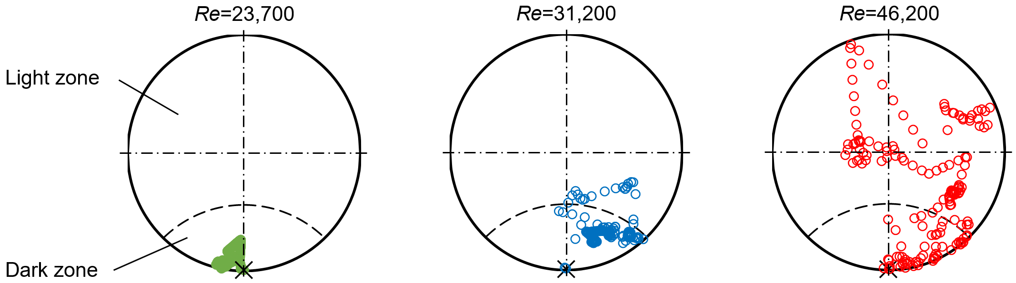

Figure 4: Particle tracking in light and dark zones in the cross-sectional view of HT PBR transparent tube

* + 1. Influence of hydrodynamics on the biomass production

The influence of hydrodynamic conditions on microalgae production was simulated using an integrated multi-physical model. A comparison of microalgae concentration in culture medium *Xalg* for three operating configurations is shown in Figure 5. According to the change of operating configuration from *Re* = 23,700 to 31,200, the microalgae production can increase by 0.7 %. In terms of HT PBR capacity, it means an increase in biomass production of 16 g day-1. For the configuration of *Re* = 46,200, the production increased by 2.0 % in comparison to *Re* = 23,700, which means an increase in biomass production of 43 g day-1 from base 2,145 g day-1.



Figure 5: Microalgae production in HT PBR according to increasing flowrate in transparent tubes

The increase in production is not significant for selected operating conditions in HT PBR. However, hydrodynamic conditions will have a greater effect in systems where the layer of culture medium is larger so the influence of the dark zone would be more significant as well. Also, in systems where higher concentrations of microalgae in the culture medium are achieved, the effect of hydrodynamics could be significant. An important factor here will also be the energy demand for operation, which is associated with an increase in the flow rate in the tubes. As the flow rate in HT PBR tubes increases, electricity consumption will also increase and the engines driving the paddle wheel will be more loaded. Therefore, the maintenance costs will be affected as well. For an overall assessment, a detailed balance would be needed to take into account the increase in biomass production from microalgae and the associated increases in operating costs. Generally, the process of scale-up is complex and it is necessary to consider not only the microalgae production but also operational requirements. As the diameter of the tubes increase, it is necessary to ensure the pumping of a larger amount of culture medium to achieve a comparable flow regime.

* 1. Conclusions

A computational fluid dynamics (CFD) model was created to simulate hydrodynamic conditions in a hybrid tubular photobioreactor (HT PBR). The model was integrated into an already existing mechanistic model (BIO\_ALGAE) simulating the cultivation process. Using a developed multi-physical model, it was possible to monitor the influence of hydrodynamic conditions on the irradiation of the culture medium in HT PBR and microalgal biomass production. By increasing the flow rate of the culture medium, more intensive mixing takes place in the transparent area of HT PBR and microalgal cells were thus more often exposed to light radiation. However, in this specific case, more intensive mixing in HT PBR did not show a significant increase in microalgae production. The increase in biomass production would probably be negligible compared to the increase in energy requirements associated with the increasing flow rate of the culture medium. This can be attributed to the fact that generally low microalgae concentrations were reached in the PBR (reaching 1 g L‑1). At these concentrations, the majority of the culture medium was irradiated, so the intensity of mixing does not significantly affect the production of microalgae. The intensity of mixing would be more pronounced in systems working with deeper culture medium or in systems that achieve higher concentrations of microalgae.

Nomenclature

*d* – tube inner diameter, m

*H* – distance from the tube wall, m

*Iav* – average intensity of light radiation, W m‑2

*Io* – incident light intensity, W m‑2

*KI* – extinction coefficient, m2 g‑1

*L* – tube length, m

*t* – time, s

*tD* – retention time in the dark zone, s

*tL* – retention time in the light zone, s

*Xalg* – concentration of microalgae biomass, g m‑3

*ε* – light fraction, -

Acknowledgments

This work was supported by the Ministry of Education, Youth and Sports of the Czech Republic under OP RDE grant number CZ.02.1.01/0.0/0.0/16\_019/0000753 “Research centre for low-carbon energy technologies”.

References

ANSYS Inc. (US), 2018, Ansys Users’ Guide, Release 19.0 (Vol. 7, Issue 11).

Belohlav V., Jirout, T., 2019, Design methodology of industrial equipment for microalgae biomass primary harvesting and dewatering, Chemical Engineering Transactions, 76, 919–924.

Belohlav, V., Uggetti, E., García, J., Jirout, T., Kratky, L., 2021, Assessment of hydrodynamics based on Computational Fluid Dynamics to optimize the operation of hybrid tubular photobioreactors, Journal of Environmental Chemical Engineering, 9(5).

Cui, X., Yang, J., Feng, Y., Zhang, W., 2020, Simulation of a Novel Tubular Microalgae Photobioreactor with Aerated Tangent Inner Tubes: Improvements in Mixing Performance and Flashing-Light Effects, Archaea, 2020.

Díez-Montero, R., Belohlav, V., Ortiz, A., Uggetti, E., García-Galán, M. J., García, J., 2020, Evaluation of daily and seasonal variations in a semi-closed photobioreactor for microalgae-based bioremediation of agricultural runoff at full-scale, Algal Research, 47(February), 101859.

Fernández del Olmo, P., Acién, F. G., Fernández-Sevilla, J. M., 2021, Productivity analysis in tubular photobioreactors using a dynamic photosynthesis model coupled to computational fluid dynamics particle tracking, Bioresource Technology, 344.

Huesemann, M., Crowe, B., Waller, P., Chavis, A., Hobbs, S., Edmundson, S., Wigmosta, M., 2016, A validated model to predict microalgae growth in outdoor pond cultures subjected to fluctuating light intensities and water temperatures, Algal Research, 13, 195–206.

Perner-Nochta, I., Posten, C., 2007, Simulations of light intensity variation in photobioreactors, Journal of Biotechnology, 131(3), 276–285.

Solimeno, A., Acíen, F. G., García, J., 2017, Mechanistic model for design, analysis, operation and control of microalgae cultures: Calibration and application to tubular photobioreactors, Algal Research, 21, 236–246.

Solimeno, A., García, J., 2019, Microalgae and bacteria dynamics in high rate algal ponds based on modelling results: Long-term application of BIO\_ALGAE model, Science of the Total Environment, 650, 1818–1831.

Solimeno, A., Parker, L., Lundquist, T., García, J., 2017, Integral microalgae-bacteria model (BIO\_ALGAE): Application to wastewater high rate algal ponds, Science of the Total Environment, 601–602, 646–657.

Tilzer, M. M., 1987, Light‐dependence of photosynthesis and growth in cyanobacteria: Implications for their dominance in eutrophic lakes, New Zealand Journal of Marine and Freshwater Research, 21(3), 401–412.

Wang, B., Lan, C. Q., Horsman, M., 2012, Closed photobioreactors for production of microalgal biomasses, Biotechnology Advances, 30(4), 904–912.

Yan, H., Guan, C., Jia, Y., Huang, X., Yang, W., 2018, Mixing characteristics, cell trajectories, pressure loss and shear stress of tubular photobioreactor with inserted self-rotating helical rotors, Journal of Chemical Technology and Biotechnology, 93(5), 1261–1269.