CHEMICAL ENGINEERING TRANSACTIONS  VOL. 93, 2022 | A publication of
The Italian Association
of Chemical Engineering
Online at www.cetjournal.it

Guest Editors: Marco Bravi, Alberto Brucato, Antonio Marzocchella
Copyright © 2022, AIDIC Servizi S.r.l.
ISBN 978-88-95608-91-4; ISSN 2283-9216

Life Cycle Assessment of functional animal feeds enriched with natural bioactive compounds derived from medicinal plants and herbs
Konstantina M. Laina*, Panagiota N. Eleni, Dioni Talfanidi, Christos Boukouvalas, Nickolaos Panagiotou, Magdalini Krokida
National Technical University of Athens, School of Chemical Engineering, Iroon Polytechneiou 9, Zografou Campus, 15780, Athens, Greece
lainanandia@gmail.com
Animal breeding that includes antibiotics and vitamin consumption is considered as a major contributor to the multifaceted environmental impact of livestock farming. The production of innovative, functional animal feed premixes with antimicrobial and/or growth promoting activity from plants and herbal extracts could minimize the use of antibiotics and vitamins in livestock and enhance animal growth. However, the production of this new feed has to be followed by a low environmental footprint, and particularly lower when compared to conventional animal feeds. The objective of this study was the evaluation of Life Cycle Assessment of the newly produced functional poultry feeds that contain plant and herb origin extracts, as well as its comparison with the conventional animal feeding routine, which actually stands as the scope of the present LCA study. LCA was performed according to ISO 14040 & 14044, using GaBi software, utilizing ReCiPe 2016 (H)* methodology with 18 midpoints and 3 endpoints. To this end, to define the Goal of the study, Cradle-to-gate boundaries were set and the functional unit was defined as the total feeding quantity (including normal animal feed, antibiotics, vitamins) in 1 Month (per Kg of animal). Different scenarios were examined, in terms of the consumed quantities of supplementary substances (antibiotics and vitamins). The results of the examined scenarios reveal that the environmental impact is significantly lower in the case of encapsulated Bioactive compounds (BACs) extract incorporation, as well as in the case of raw BACs extract incorporation. Therefore, the substitution of antibiotics and vitamins from natural bioactive compounds, which is the scope of the production of this functional feed, constitutes a realistic goal.
  - Introduction
Intensive livestock production usually implies that animals are kept at higher stocking densities. This increases the risk of infection, making preventive antimicrobial use a common way to mitigate this risk. Although antimicrobials may be essential in order to maintain health and productivity of livestock, more and more scientists agree that antimicrobial use in livestock production risks increasing antimicrobial resistance in human pathogens (Stockholm Environment Institute, 2016). Many of the antimicrobials used in livestock production have been classified by the World Health Organization as critically important for human medicine. Thus, using the same substances for animals could favor selection of resistant bacteria that may cause disease in humans. Resistant bacteria in livestock can be transmitted to humans through direct contact with the animals or through consumption of animal products. As many antimicrobials are only partially absorbed by the body, antimicrobial residues, as well as resistant bacteria and resistance genes, may be excreted in the manure. Therefore, contributing to the effort in eliminating antibiotic-resistant bacteria, the U.S. Food and Drug Administration (FDA) is progressively ensuring the responsible use of antibiotics in food animals, meaning exclusively as medically necessary and appropriate (Hyun and Sherburne, 2021). Moreover, the inevitable risk occurring, is these substances and organisms ending up in the environment (Tian et al., 2021, González-Gaya et al., 2022).
In recent years “green” economy aiming at a sustainable development without degrading the environment has been the evident practice around the globe in all aspects of industry (Krokida et al., 2016). As a consequence, governments, non-governmental organizations, companies and civil society are becoming interested in increasing the knowledge of how a product is processed and what is the environmental impact of its production. That implies taking into account the whole chain of a product’s life cycle and all relevant external effects, in order to be able to make improvements that promote sustainability and environmentally friendly production. Among the tools available to evaluate environmental performance, LCA has gained recognition as the most powerful tool for the comparison of environmental impacts of products, technologies or services with a view to their whole life cycle (cradle to grave) or to a targeted part of that life cycle (cradle to gate, gate to gate or gate to grave) (European and Commission). LCA is a process of evaluating the effects that a product has on the environment over the entire period of its life, thereby increasing resource-use efficiency and decreasing liabilities (Ngan et al., 2021, Iannone et al., 2020). LCA provides an instrument for environmental decision support. Since the field of enriched animal feeds with natural feed additives is a relatively new one, few data have been reported so far concerning the environmental impact of such feed products. The present study aims at identifying and addressing the hot spots in the whole life cycle of innovative, functional animal feed premixes, towards several impact categories (climate change, resources consumption, damage to human health etc). In accordance to this, Life Cycle Assessment (LCA) performed, and the main objectives were to: a. overview of the overall impacts, to identify hotspots and areas for improvements in the life cycle of the products, b. measure and follow-up the environmental performance of products; for the entire life cycle and/or parts of the life cycle, c. provide basis for decisions on where to focus efforts and investments for optimal performance of all products and processes, introducing an advanced sustainable approach for the substitution of in-feed synthetic antibiotics.
  - LCA Methodology
A life cycle assessment (LCA) studies the potential environmental impacts of products or services throughout all stages of their life cycle – from extraction of resources, through all production and transportation steps, to the use and end of life of the product. In the context of this study, ISO 14040 and 14044 (14040:2006, 2006, 14044:2006, 2006) and, the impact assessment methodology ReCiPe 2016 (H) were followed. These standards describe the principles and framework for LCA. In ReCiPe indicators at two levels are determined 18 midpoint indicators and 3 endpoint indicators. The Life Cycle Inventory model has been implemented through dedicated software, namely GABI ts (v8.7.0.18) LCA software. Briefly, GaBi calculates the potential environmental impacts as well as other important quantities of a product system based on plans. Within a plan, the system being studied is made up of processes and flows. In LCA terms, a plan represents the system with its boundaries, processes represent the actual processes taking place and flows represent all the inputs and outputs related to the system. Flows connect plans or processes within the system or define the input/output flows of the system. The list of input and output flows is referred to as the Life Cycle Inventory.
    - Goal and Scope
The Goal of this LCA analysis is the evaluation of a production line of the new proposed products and their comparison with the existing traditional production routes. The Scope of LCA involves the description of the system under study and the definition of the following categories:
Product System
Different product systems were examined in order to evaluate their effect on the environmental impact during BACs extraction (Figure 1a & 1b) and encapsulation processes (Figure 2), premixes production systems & sub-systems (Figure 3). BACs extraction processes studied were mechanochemical maceration, ultrasound assisted extraction (UAE), and ultrasound and microwave assisted extraction (UAE-MAE). The referred encapsulation process is spray drying, and the pellet formulation process is extrusion, using a co-rotating twin-screw extruder. The conventional animal feed production system, is presented in Figure 4.
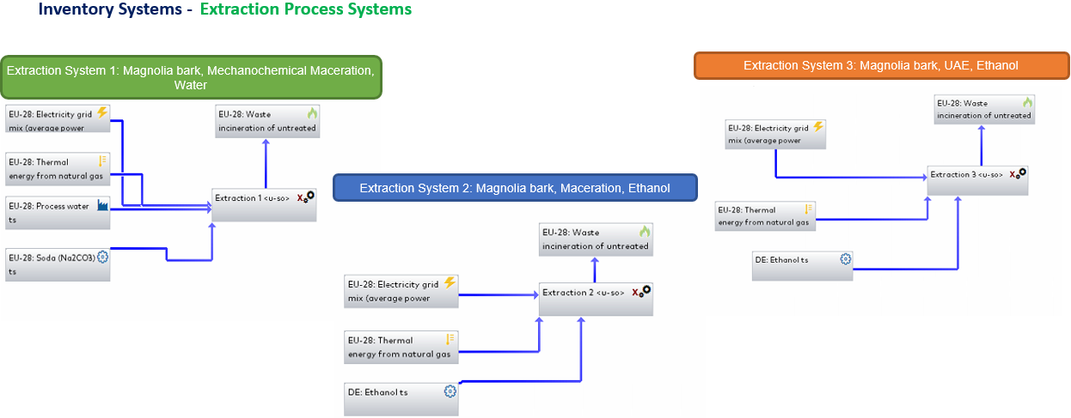
Figure 1a: BACs extraction.

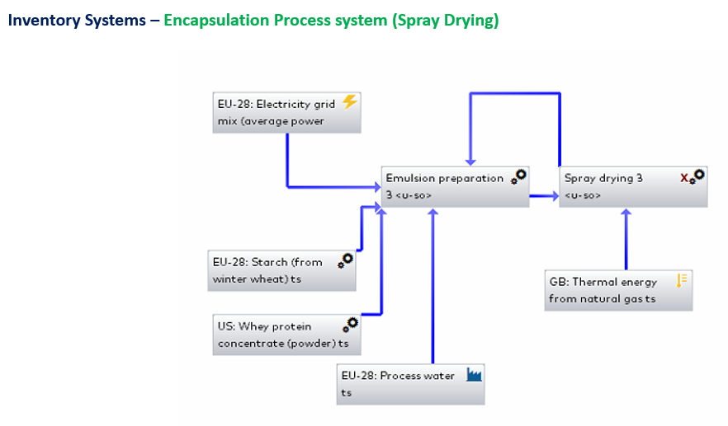
Figure 1b: BACs extraction.

Figure 2: Encapsulation product system.
The extraction process systems examined as seen in Figure 1a & 1b are also presented below in Table 1.
Table 1: Extraction systems examined
Nº | Raw Material | Extraction Method | Solver
1 | Magnolia bark | Mechanochemical Maceration | Water
2 | Magnolia bark | Mechanochemical Maceration | Ethanol
3 | Magnolia bark | UAE | Ethanol
4 | Rosemary | UAE-MAE | Ethanol
5 | St John's wort | UAE-MAE | Ethanol
The development process of the animal feed product examined, begins with the premix production process, which is of great importance since it contains critical processes such as pretreatment of the raw material, extraction, and formulation of the feed mixture. The premix production systems and sub-systems are presented in Figure 3.
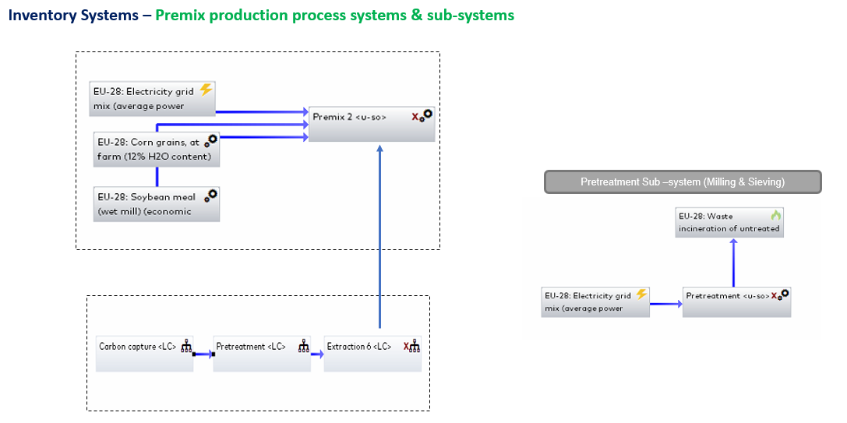
Figure 3: Premixes production systems & sub-systems.
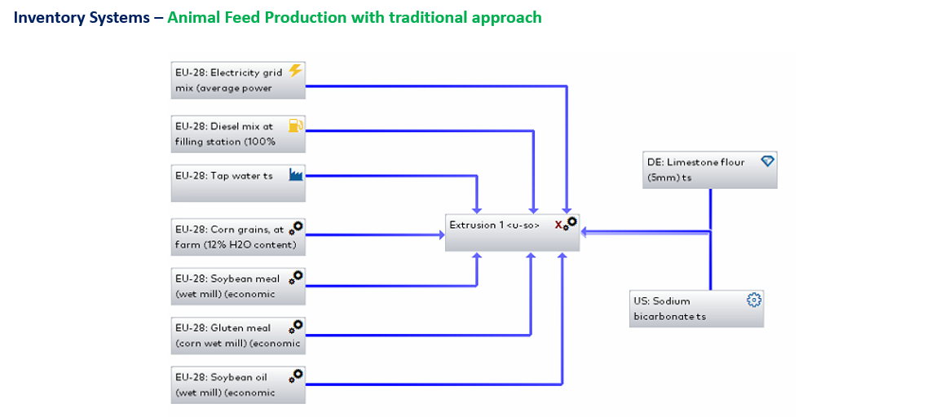
Figure 4: Animal feed production system.
Regarding the animal feed production, three final feed products were examined, namely Feed product 1 (FP1), Feed product 2 (FP2), and Feed product 3 (FP3). More specifically, FP1 corresponds to the conventional feed product, while FP2 and FP3 represent the innovative feed products enriched with bioactive compounds, that the present study investigates. However, the key difference between FP2 and FP3 that both contain magnolia extract, is related to the encapsulation process of the extract, in FP3, before its incorporation to the final product. The environmental impact of all products (FP1, FP2, FP3) and processes was evaluated by the midpoint and endpoint indicators, and results were compared. Last but not least, all feed production systems studied, contain the extrusion process, which is the final step of the procedure and is considered as a major contributor in the total LCA.
Functional unit
Depending on the examined scenario functional unit is 1 kg of produced material or 1 FRP (Feed-ration production for poultry: Total Feeding quantity (Kg) for 1 Kg broiler grow-out)
Boundaries
Depending on the examined scenario is either Cradle-to-grave (a&b) or Cradle-to-gate (c).
Impact assessment methodology
The Impact assessment methodology applied is ReCiPe 2016 (H) with 18 midpoints, 3 endpoints.
Allocation of resources
No allocation of resources was applied.
Data quality requirements
The objective of the LCA study is to examine how the environmental impacts are modified when producing an animal feed product with the herein proposed approach utilizing BACs from herbs and plants. The data concerning the conventional production obtained from respective producers in Greece and used in a confidential manner. For the proposed approach, data was obtained from the GABI databases, literature & upscaling lab experiments. All the data used were average data that reflect the types of technologies used, and are not outdated.
  - Results and Discussion
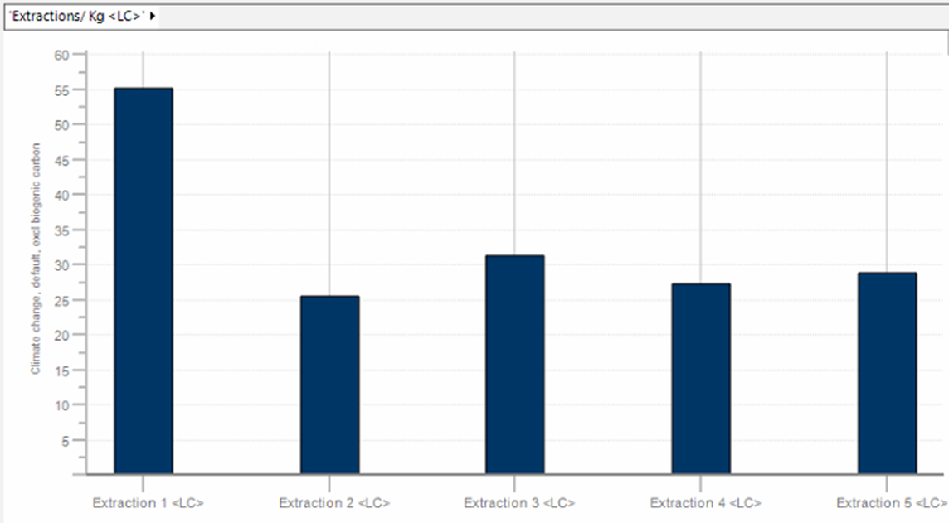
The results of the five different extraction systems per Kg extract, in the indicative midpoint impact category/ Climate Change, excl biogenic carbon [kg CO₂ eq.] presented in Figure 5. The endpoints are also presented in Figure 6. Comparison of various extraction cases (different extraction processes, different herbs & plants, different solvents), revealed no significant differences in the LCA performance of all cases, especially taking under consideration the slight amount of extract used in the final feed products. Furthermore, despite the lower LCA value of the second extraction system as seen in Figures 4 & 5, Magnolia bark under UAE extraction, using ethanol as a solver, (extraction system 3), was considered as the best of the examined scenarios, due to its less time and energy consuming extraction method, as well as the evaluated higher quality of the produced extract in comparison to the conventional extraction method (system 1, system 2) that demands high temperatures (degrading the BACs), and long extraction times.

Figure 5: Climate Change, excl biogenic carbon [kg CO₂ eq.] of the examined extraction process systems (per Kg extract).
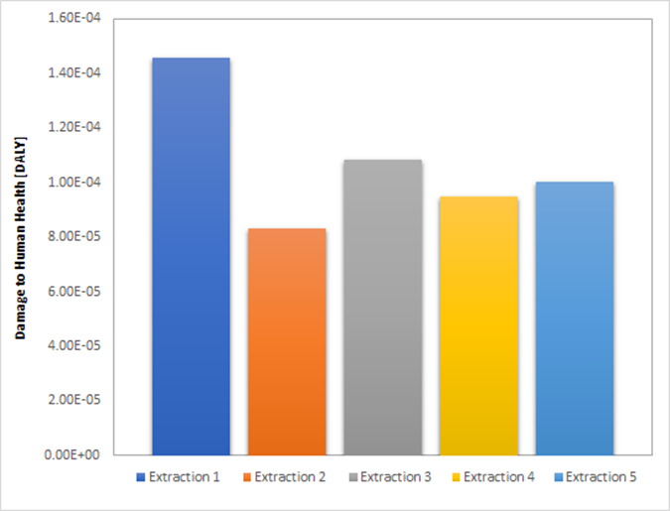 | 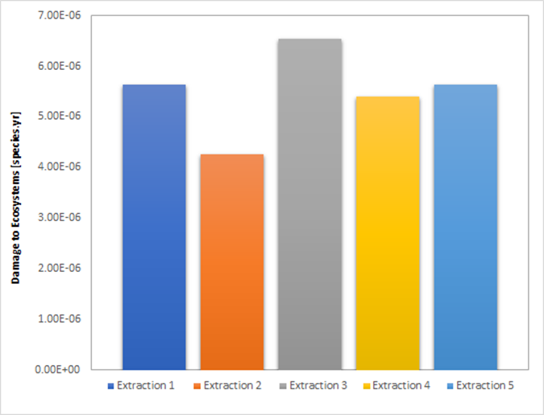 | 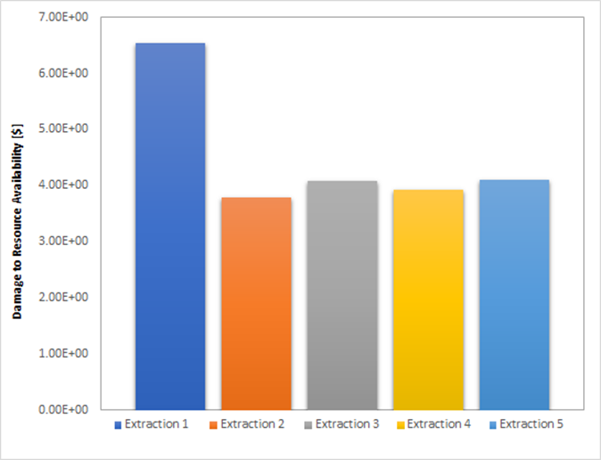
a | b | c
Figure 6: Comparison Results - Endpoint impact categories of the examined extraction process systems (per Kg extract), a. Damage to human health [DALY], b. Damage to ecosystems [species.yr], c. Damage to resource availability [$].
Regarding, the production process of new feed products (FP2, FP3), extrusion presented the greatest LCA impact, while extraction and premix production processes featured a negligible share in the total environmental footprint. Figure 7 presents the indicative midpoint impact category/ Climate Change, excl biogenic carbon [kg CO₂ eq.].
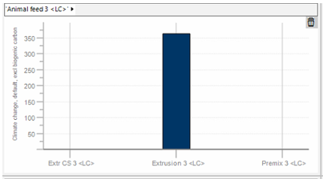
Figure 7: Climate Change, excl biogenic carbon [kg CO₂ eq.] of Final Product process containing encapsulated Magnolia extract (per 1 Kg final product)/ Final Product 3.
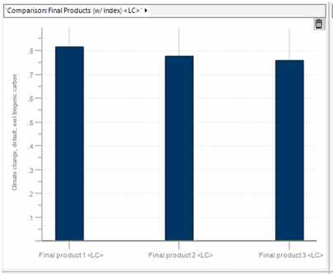
The Comparison Results of the three examined Final products (per 1 FRP (Total Feeding quantity (Kg) for 1 Kg broiler grow-out), are presented in Figure 8 through the indicative midpoint impact category/ Climate Change, excl biogenic carbon [kg CO₂ eq.].

Figure 8: Climate Change, excl biogenic carbon [kg CO₂ eq.] of the three examined final products (per 1 FRP (Total Feeding quantity (Kg) for 1 Kg broiler grow-out). The endpoints are also presented in Figure 8.
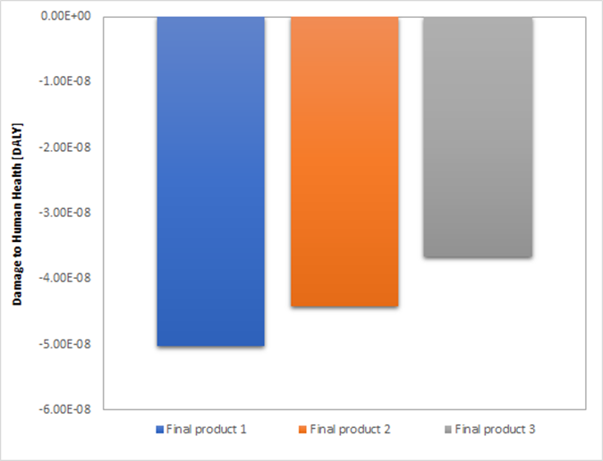 | 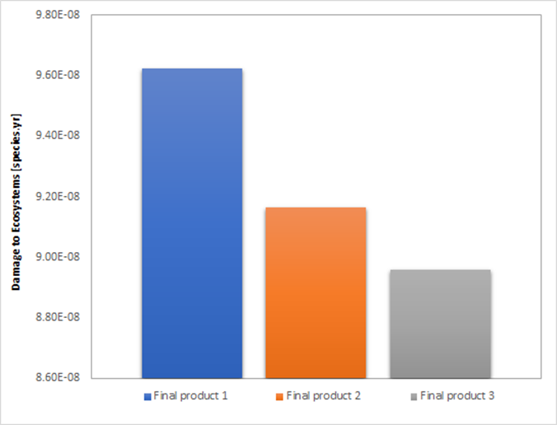 | 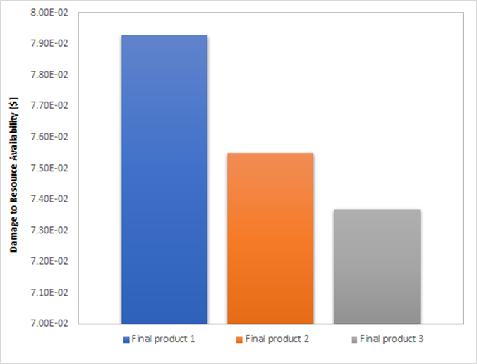
a | b | c
Figure 9: Comparison Results - Endpoint impact categories of the examined final products process systems (per Kg extract), a. Damage to human health [DALY], b. Damage to ecosystems [species.yr], c. Damage to resource availability [$].
  - Conclusions
The overall aim of this study is the Life Cycle Assessment of functional animal feeds enriched with natural bioactive compounds derived from medicinal plants and herbs, along with the comparative LCA study between the conventional processing product and the proposed herein approach. Within the limits of this study, several conclusions were drawn for each examined product system. Comparison of various extraction cases (different extraction processes, different herbs & plants, different solvents), indicated that the LCA performance of all extraction systems investigated, did not present significant differences. Magnolia bark, under UAE processing with ethanol (extraction system 3), was selected as optimal, taking into account certain critical parameters of the processes, such as extraction duration, extraction temperature, and quality of the produced extract. Regarding, the production process of the new feed products (FP2, FP3), the prominent LCA impact was attributed to the extrusion process (362 kg CO₂ eq.), whilst extraction and premix production processes corresponded to a negligible share (<5 kg CO₂ eq.). Three final feed products were examined, FP1 (conventional product), FP2 (feed containing magnolia extract), and FP3 (feed containing encapsulated magnolia extract). Comparison of the final products, using 1 FRP as the Functional Unit (Feed-ration production for poultry:Total Feeding quantity (Kg), for 1 Kg broiler grow-out), revealed lower impact values (in all endpoint impact categories) for the novel feed products with the incorporated bioactive agents (FP2, FP3), highlighting FP3, that presented the lowest environmental impact (0.76 kg CO₂ eq.). Therefore, the novel functional feed products studied (FP2, FP3), consist a very promising approach with documented sustainability regarding their total environmental impact. In conclusion, LCA has generally been used to assess and improve product systems. The performed LCA study of the feed production, despite the exclusion of the environmental impact of breeding conditions and feeding routines, has conducted reliable results to be further be applied for the identification of improvement options in animal nutrition and livestock production, without compromising the total environmental impact of the agricultural sector.
Acknowledgments
This work was financed by the project “Innovative cattle feed development with antibiotic and growth formula based on edible herbs that include high levels of biodrastic compounds” that is financed by Greek national funds through the Operational Program "Eastern Macedonia & Thrace Region" of the National Strategic Reference Framework (NSRF) - Research Funding Program.
References
14040:2006 I., 2006, ISO 14040:2006 Environmental management — Life cycle assessment — Principles and framework, Environmental management systems,
14044:2006 I., 2006, ISO 14044:2006 Environmental management — Life cycle assessment — Requirements and guidelines, Environmental management systems,
European & Commission, European Platform on Life Cycle Assessment (LCA),
González-Gaya B., García-Bueno N., Buelow E., Marin A. & Rico A., 2022, Effects of aquaculture waste feeds and antibiotics on marine benthic ecosystems in the Mediterranean Sea, Science of The Total Environment, 806, 151190.
Hyun D. & Sherburne H., 2021, Inappropriate Antibiotic Use in Food Animals Can Undercut Fight Against Superbugs Pew Charitable Trusts,
Iannone R., Riemma S. & De Marco I., 2020, A Comparative Life Cycle Assessment Study on Conservation of Semi-finished Peaches, Chemical Engineering Transactions, 79,
Krokida M., Taxiarchou M., Politis A., Peppas A. & Kyriakopoulou K., 2016, LIFE CYCLE ASSESSMENT (LCA) ON EUROPEAN SKIMMED MILK POWDER PROCESSING PRODUCTION PLANT,
Ngan S.P., Ngan S.L. & Lam H.L., 2021, An Overview of Circular Economy-Life Cycle Assessment Framework, Chemical Engineering Transactions, 88,
Stockholm Environment Institute, 2016, Antimicrobial Use in Livestock in Low-Income Countries, Swedish International Agricultural Network Initiative, SUSTAINABLE AGRICULTURAL PRODUCTION & FOOD SECURITY,
Tian M., He X., Feng Y., Wang W., Chen H., Gong M., Liu D., Clarke J.L. & van Eerde A., 2021, Pollution by Antibiotics and Antimicrobial Resistance in LiveStock and Poultry Manure in China, and Countermeasures, Special Issue Usage of Antibiotic in Agriculture and Animal Farming, 10, 539.

