CHEMICAL ENGINEERING TRANSACTIONS  VOL. 93, 2022 | A publication of
The Italian Association
of Chemical Engineering
Online at www.cetjournal.it

Guest Editors: Marco Bravi, Alberto Brucato, Antonio Marzocchella
Copyright © 2022, AIDIC Servizi S.r.l.
ISBN 978-88-95608-91-4; ISSN 2283-9216

Encapsulation of oregano essential oil for innovative feed applications, using electrohydrodynamic processing
Konstantina M. Laina*, Panagiota N. Eleni, Magdalini Krokida
National Technical University of Athens, School of Chemical Engineering, Iroon Polytechneiou 9, Zografou Campus, 15780, Athens, Greece
lainanandia@gmail.com
The present study focuses on the encapsulation process of Oregano essential oil (OEO) in biopolymeric matrices, intended to be used in functional feed applications. OEO is extracted from the Mediterranean medicinal plant Origanum vulgare, and possesses remarkable preservative, antioxidant, antimicrobial and therapeutic properties, attributed to its bioactive compounds. However, most of these substances are considered sensitive and unstable, resulting in nutritional losses and impairment of their commercialization and export. The objective of this study is to investigate an effective strategy to address these challenges, while improving bio-efficacy and stability. For this reason, OEO was primarily analyzed by GC-MS and HPLC methods in order to quantify and qualify all target compounds, and then subjected to encapsulation through the innovative electrohydrodynamic process, using biopolymeric matrices of whey protein isolate (WPI), pullulan (pul), and zein (ZN), composing structures with controlled and targeted release of OEO. Several process parameters (solution flow rate, applied voltage, tip-to-collector distance) were studied for various matrice solutions, in order to optimize the apparatus’ function and the production of the particles. The results of this investigation showed that most of the solutions were within the recommended ranges to be electrospun, except for some samples that did not exhibit stability when OEO was added. Furthermore, a morphological and structural characterization was carried out. The encapsulation efficiency of the developed structures was evaluated by detecting OEO that was not successfully encapsulated using suitable solvent systems. The indirect quantification of OEO was achieved by Total Phenolic Content (TPC) determination by the Folin–Ciocalteu method. The morphology of structures was characterized and then related to the properties of each tested solution. The optimum developed fibers of each matrice solution were further evaluated and compared. More specifically, WPI:pul (30:70)%w/w fibers, presented homogeneous morphology; smooth and continuous fibers of random orientation, and higher encapsulation efficiency than ZN structures. Microfibers produced using ZN solution 20% w/w in EtOH:H₂O (90:10 v/v), were not equally satisfactory, since agglomerates and spherical formations (beads) were observed, making the sample less desirable. The present study, demonstrates the feasibility of OEO’s encapsulation through electrohydrodynamic processing, using biopolymer matrice solutions, contributing to the effort towards the elimination of synthetic feed additives in animal diets, through a sustainable approach for both environment and industry.
  - Introduction
In the past decades, an excessive use of antibiotics as growth promoting agents in animal breeding has been noted, and linked to the increase of antimicrobial-resistant agents, concerning both animal and human health. A complete ban of AGPs in Europe in 2006 (European Commission, 2005), generated a global trend on elimination and substitution of all medication used for non-therapeutic purposes in animal agriculture, leading to the investigation of alternative solutions. Therefore, medicinal plants and their derivatives including essential oils, have developed uprising interest as a potential alternative to synthetic preservatives because of their ecofriendly nature and generally recognized as safe (GRAS) status.
Essential oils (EO) are plant derived complex mixtures of low molecular weight, that have been widely used since ancient times in many cultures for their remarkable therapeutic properties (da Silva et al., 2021). Their antibacterial (Alarcon-Rojo et al., 2017) (Semeniuc et al., 2017), antifungal (D’agostino et al., 2019), anti-inflamatory (Miguel, 2010) (Castellino et al., 2021), and antioxidant (Akdemir Evrendilek, 2015) activities, are some of their most reported ones, and are attributed to their biologically active compounds (da Silva et al., 2021). Oregano Essential oil (OEO) in particular, is extracted from the Mediterranean medicinal plant Origanum vulgare and is rich in such compounds (monoterpenes). OEO presents excellent biological activity, which is the reason of the emerging interest it has received from the food, cosmetics and biomedical industries for several applications (ex. food preservation, infection treatment, diet supplementation, active packaging, etc) (Takahashi et al., 2017) (Pirozzi et al., 2021).
OEO’s use as an animal feed additive, presents great potential in the direction of substitution or partial elimination of synthetic feed additives with naturally originated ones. Several studies have reported the safety of its use as a supplement in all animal species diets (Bampidis et al., 2019).
However, undesirable effects of adverse environmental conditions (light, moisture, oxygen), make absolutely necessary the employment of an effective processing, such as encapsulation, that will protect OEO and improve stability while promoting its controlled/targeted release. Moreover, the use of encapsulation may augment the nutritional quality of the feed, enhance the solubility or dispersibility of its lipophilic compounds, mask off-flavors without unfavorably affecting the taste, aroma, or texture as well as extend the shelf life of the product.
More specifically, electrohydrodynamic processes, namely, electrospinning and electrospraying, are the most promising encapsulation technologies for entrapping and effectively delivering bioactive compounds. Several process parameters (solution supply, applied voltage, tip-to-collector distance) were studied for different matrice solutions. The biopolymeric wall materials investigated for the encapsulation of OEO were Whey Protein isolate (WPI) and pullulan (pul) blend, as well as and zein, and were fed coaxially, in order to optimize the apparatus’ function and formulation of the encapsulated structures. All developed structures were fully characterized in terms of morphology, bioactivity and productivity/controlled release/solubility.
The present study contributes to the effort towards partial reduction or even complete elimination of the preventive use of antibiotics in animals, while at the same time supporting their health and well-being, through a sustainable approach. The use of OEO as a phytogenic feed additive, enhanced by the advanced properties given to its particles by the encapsulation process, is an extremely innovative application with great potential at the field of functional feeds and sustainable breeding.
  - Materials & Methods
2.1 Materials
Oregano Essential oil (OEO) was purchased from Natural Food Additives G.P.. Corn prolamin zein grade Z3625, was purchased from (Sigma-Aldrich, Madrid, Spain). Whey protein isolate (WPI) and pullulan (pul) powders, were supplied by NOW FOODS (Bloomingdale, IL 60108, USA) and Hayashibara Biochemical Lab. Inc. (Okayama, Japan), respectively. All reagents used for the experiments were of analytical grade.
2.2 Preparation of polymer solutions for electrospinning
Whey Protein Isolate (WPI) – Pullulan (pul) Matrice solution
Water of 478μS/cm (25ºC) conductivity was used to dissolve WPI and pullulan blends, under magnetic stirring (M 6.1, Ingenieurbüro CAT, M. Zipperer GmbH, Ballrechten-Dottingen, Germany) for 4 h and 500 min⁻¹ (Drosou et al., 2018). The two polymeric materials (WPI:pul) were blended at a 30:70w/w proportion; in a total polymer content of 20% w/w. The matrice solution was prepared at room temperature and complete solubilization of the two materials was ensured before the electrospinning process.
Zein (ZN) Μatrice solution
Zein powder was added to a blend of pure ethanol and water (EtOH:H₂O) in a ratio of 90:10v/v; in order to be dissolved, and was progressively added to the solution, under magnetic stirring (M 6.1, Ingenieurbüro CAT, M. Zipperer GmbH, Ballrechten-Dottingen, Germany) for 1 h and 500 min⁻¹. The matrice solution prepared contained 20%w/w zein. The solution was prepared at room temperature and complete solubilization of zein was ensured before the electrospinning process.
2.3 Methods
Electrohydrodynamic Processing
OEO was subjected to encapsulation through the innovative electrohydrodynamic process, using biopolymeric matrices of whey protein isolate (WPI), pullulan (pul), and zein (ZN), composing structures with controlled and targeted release of OEO. Several process parameters (solution supply, applied voltage, tip-to-collector distance) were studied for each matrice solution, in order to optimize the apparatus’ function and the production of the particles. The results of this investigation showed that most of the solutions were within the recommended ranges to be electrospun, except for some samples that did not exhibit stability when OEO was added.
The electrospinning apparatus FluidNatek®, equipped with a variable high voltage 0-30 kV power supply (BioInicia S.L., Valencia, Spain), was used for the experiments. The anode was attached to a stainless-steel needle with internal diameter 0.9 mm (orifice), that was connected through a PTFE tubing system to the biopolymer solutions, which were inside a 10 mL plastic syringe. The syringe was oriented horizontally lying on a digitally controlled syringe pump, while the needle was vertically directed towards the collector’s surface. The needle was connected to the emitting electrode of positive polarity of the high voltage power supply. The electrospun fibers, were collected on an aluminum foil sheet attached to a copper grid (collector). All the electrospinning experiments were carried out in room temperature. The collector’s surface (target) was placed between 15-25 cm from the capillary tip. The syringe pump delivered the polymer solution at a controlled feed rate between 0.5 and 1.5 mL/h, while the voltage was varied from 18 to 27 kV.
2.4 Properties
Quantification of OEO bioactive compounds
A gas chromatography−mass spectrometry (GC-MS) (qualitative and quantitative) analysis was performed for the evaluation of the biological activity of the essential oil. This procedure allowed the identification of most of the components (Figure 1). However, since essential oils represent very complex mixtures of sometimes highly similar isomeric compounds with similar mass spectra, further validation by the reliable high performance liquid chromatography (HPLC) method was required.
GC is a common method for the assay of thymol and carvacrol in essential oils and many studies have reported this technique for the quantization of the above-mentioned compounds (Gong et al., 2014). However, it has some limitations for its use for complicated samples; therefore, in this research thymol and carvacrol were further separated and quantified by a validated HPLC method (Hajimehdipoor et al., 2010). Moreover, the comparison between the results of both techniques, displayed adequate equivalence.
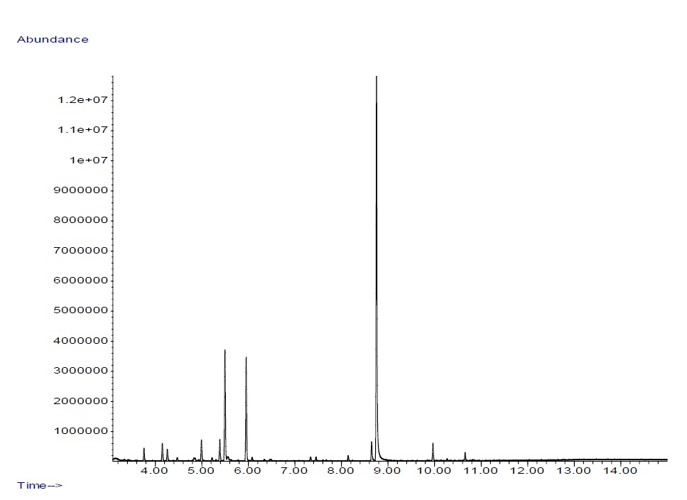

Figure 1. GC-MS chromatogram of OEO
The results of quantitative determination of the two main components of the essential oil by HPLC method demonstrated that thymol and carvacrol peaks were well resolved from each other and displayed excellent peak symmetry and separation efficiency. By using HPLC method, the concentrations of thymol and carvacrol in the essential oil were calculated to be 2.8 ± 0.04 and 52.9 ± 0.10, respectively (Table 1). The results obtained from GC and HPLC techniques showed good agreement between two methods.
Table 1. HPLC analysis of OEO’s components
Nº | Compound | Concentration | Nº | Compound | Concentration
1 | a-thujene | 2.2 | 12 | α-terpinolene | 0.3
2 | a-pinene | 1.5 | 13 | 1-borneol | 0.5
3 | camphene | 0.4 | 14 | 4-terpineol | 0.5
4 | 2-β-pinene | 0.3 | 15 | carvacrol methyl ether | 0.7
5 | β-myrcene | 2.8 | 16 | thymoquinone | 0.1
6 | I-phellandrene | 0.4 | 17 | p-thymol | 2.8
7 | δ 3-carene | 0.2 | 18 | carvacrol | 52.9
8 | α-terpinene | 2.8 | 19 | trans-caryophyllene | 2.1
9 | p-cymene | 14.6 | 20 | β-selinene | 0.3
10 | γ-terpinene | 13.0 | 21 | β-bisabolene | 0.9
11 | cis-sabinene hydrate | 0.5
Total Phenolic Content
The total phenolic content (TPC) of the herbal extracts was determined by the Folin-Ciocalteu assay (Skotti et al., 2014) (Singleton et al., 1999) with some modifications. Thus 100 μL of each tested sample, 500 μL of Folin-Ciocalteu reagent and 7.9 mL of deionized water were transferred in a 10 mL flask and mixed thoroughly. After 30 min, 1.5 mL of 7.5 % Na₂CO₃ was added in the flask, mixed thoroughly, and let standing in a heating bath (40ºC) for 30 min. Absorbance was measured by a spectrophotometer (Spectrometer 211 UV-M51, Bel Photonics) at 765 nm against a blank. The total phenolic contents were calculated on the basis of the calibration curve of gallic acid, and expressed as gallic acid equivalents (GAE) in milligrams per mL of ΟΕΟ. All measurements were performed in triplicate.
  - Results and Discussion
    - Morphological and structural characterization
Scanning Electron Microscopy (SEM)
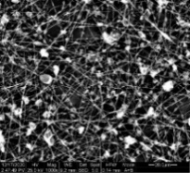  a) | 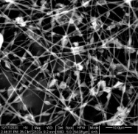  b)
Figure 2: SEM images of electrospun ZN-OEO nanofibers (process conditions: 1mL/h - 27.5kV - 17cm), in a scale of a) 20μm and b) 10μm
The observation of the inclusion of the optimum OEO sample in a 20% w/w zein matrice dissolved in a mixture of EtOH:H₂O (90:10), demonstrated not so satisfactory results. In particular, many agglomerates and spherical formations (beads) appear, attributed to the applied parameters or the choice of the matrice. Consequently the sample is characterized as less desirable compared to the WPI:pul–OEO encapsulation results.
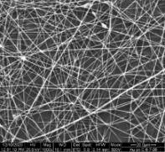  a) | 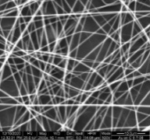  b)
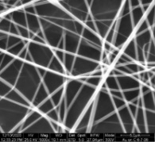  c) | 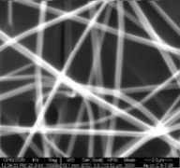  d)
Figure 3: SEM images of electrospun WPI:pul - OEO nanofibers (process conditions: 0.1mL/ h (LIQ1) - 1.5 mL/h (LIQ 2) - 25 kV - 18cm), in a scale of a) 20μm, b) 10μm, c) 5μm and d) 2μm
Contrarily, electrostatic fibrosis of the aqueous matrice WPI:pul (30:70)% w/w and OEO presented very promising results. The fibers developed, were characterized by good dispersion, homogeneity, forming a dense grid with much fewer spherical formations compared to the ones of the zein-OEO film.
    - Electrohydrodynamic Processing
Table 2 presents the selected electrohydrodynamic process parameters for both encapsulation systems.
Table 2: Optimum electrohydrodynamic process parameters for the investigated encapsulation systems
Sample | Type of Electrospinning | Inner Flow Rate (mL/h) | Outer Flow Rate (mL/h) | Voltage (kV) | Distance (cm)
Zein (ZN) | Uniaxial | - | 1.5 | 25 | 17
Ζein – OEO | Uniaxial | - | 1.5 | 25 | 17
WPI:pul (30:70w/w) | Uniaxial | - | 1.5 | 18 | 18
WPI:pul – OEO | Coaxial | 0.5 | 1.5 | 18 | 18
    - Encapsulation Efficiency (EE)
The use of suitable solvent systems (hexane, water, ethanol) to detect the OEO inside and outside of the developed fibers (successful and unsuccessful inclusion respectively), was required for the evaluation of the encapsulation efficiency of the process. The indirect quantification of OEO was achieved by Total Phenolic Content (TPC) determination by the Folin–Ciocalteu method.
The EE of OEO at the zein matrice, was calculated by the total phenolics measured by the Folin - Ciocalteau method in each sample, before and after the electrostatic fibrosis.
The results presented in Table 2 were obtained from the photometry of the optimum ZN-OEO sample.
Table 3: Encapsulation Efficiency of the optimum ZN-OEO sample
Sample | TPC (mg GAE/mL OEO) before encapsulation | TPC (mg GAE/mL OEO) encapsulated | Encapsulation Efficiency
Oregano EO | 62.7430 | 27.9406 | 44.5%
The encapsulation efficiency of the sample was calculated from the following equation.
Encapsulation Efficiency (%) = $\frac{mg GAE encapsulated OEO }{mg GAE initial OEO (before encapsulation) }\%$ | (1)
Similarly, the percentage of OEO’s encapsulation in the WPI:pul matrice was determined by quantifying the exact amount of the encapsulated and non-encapsulated substance that reached the collector after the end of the electrostatic fibrosis. After Folin-Ciocalteau method was performed, the samples were measured by a photometer. Results of the optimum WPI:pul-OEO sample, are exhibited in Table 4.
Table 4: Encapsulation Efficiency of the optimum WPI:pul-OEO sample
Sample | Encapsulated (mg GAE/mL OEO) | Not encapsulated (mg GAE/mL OEO) | Encapsulation Efficiency
Oregano EO | 21.8803 | 5.0310 | 81.3%
The encapsulation efficiency of the samples was calculated from the following equation.
Encapsulation Efficiency (%) = $\frac{mg GAE encapsulated OEO }{mg GAE total OEO (encapsulated and not encapsulated) }\%$ | (2)
The EE results, indicate that the inclusion rate of OEO in the zein matrice is significantly lower than the one corresponding to the aqueous matrice of WPI:pul. The highest EE(%) was achieved by the optimum WPI:pul-OEO blend, reaching a 81.3% of efficiency.
  - Conclusions
OEO’s most active constituents are considered to be two phenolic components, namely thymol and carvacrol. Gas chromatography (GC) is the most popular method for analysis of herbal volatile components (Gong et al., 2014), but it is not possible to determine thymol and carvacrol directly. Therefore, usage of a more precise technique for quantitative determination of plant constituents, such as High performance liquid chromatography (HPLC), for volatile and non-volatile compounds, was necessary (Hajimehdipoor et al., 2010). GC-MS spectra identified most of OEO’s components, that were further analyzed by HPLC presenting well resolved from each other carvacrol peaks, notable peak symmetry and separation efficiency. For the nanoenclosure of OEO, two types of matrices were tested. Firstly, the ethanolic-aqueous zein (ZN) matrice, safely edible for the incorporation in feed applications, and secondly, the aqueous WPI:pul one, that was chosen due to its lipophilic cavity that can be perfectly complexed with the hydrophobic components of OEO. From a variety of experiments performed, it initially emerged that the most suitable solver for OEO’s nanoencapsulation in zein, was a solution of EtOH:H₂O in a 90:10 v/v ratio. Both matrices studied, had a total polymer content of 20%w/w. The OEO-zein blends of lower concentrations, failed to form a Taylor cone and ensure a continuous infusion. Likewise, several experiments were executed in order to study the encapsulation of OEO in the aqueous WPI:pul (30:70% w/w) matrice at a total polymer content of 20% w/w. The results are in line with the literature, according to which, low concentrations of the polymeric matrice, are more likely to form nanospheres (electrospraying), instead of nanofibers (electrospinning) (Drosou et al., 2017). This phenomenon appears due to the simultaneously low viscosity and high surface tension of the solution. The optimum parameter combination (flow rate – voltage – tip to collector distance) for both encapsulation systems studied are presented in Table 2. The two values of the flow (inner flow, outer flow) correspond to flows used to achieve the coaxial electrospinning. Observing the EE of OEO in both matrices tested, zein had significantly lower results than the WPI:pul one, which reached the notable percentage of 81.3%. Regarding the morphology of the developed structures, OEO’s encapsulation in ZN composed fibers with many spherical formations, which were not compatible with the desired structure, therefore matrices with potentially better results should be investigated. On the contrary, the results obtained from the inclusion of OEO in the aqueous WPI:pul matrice, were very satisfactory as seen in Figure 3.
Overall, OEO in the WPI:pul matrice corresponds to the best encapsulated sample by the electrohydrodynamic process, and can be further integrated as an additive for the production of functional feed products. The beneficial impact on human and animal health is not limited to microbial resistance elimination, treatment of diseases and animal welfare, but expanded to residue free animal-derived products (meat, milk, eggs) with a preservative capacity attributed to the antioxidant properties of OEO. Additionally, the encapsulated particles studied, intended to be incorporated into innovative feed products, consist a sustainable approach addressing the future of animal feeds.
Acknowledgments
This work was financed by the project “Innovative cattle feed development with antibiotic and growth formula based on edible herbs that include high levels of biodrastic compounds” that is financed by Greek national funds through the Operational Program "Eastern Macedonia & Thrace Region" of the National Strategic Reference Framework (NSRF) - Research Funding Program.
References
Akdemir Evrendilek G., 2015, Empirical prediction and validation of antibacterial inhibitory effects of various plant essential oils on common pathogenic bacteria, International Journal of Food Microbiology, 202, 35-41.
Alarcon-Rojo A., Janacua-Vidales H. & Renteria A. 2017. Oregano Essential Oil in Animal Production.
Bampidis V., Azimonti G., Bastos M.d.L., Christensen H., Kouba M., Kos Durjava M., López-Alonso M., López Puente S., Marcon F., Mayo B., Pechová A., Petkova M., Ramos F., Sanz Y., Villa R.E., Woutersen R., Brantom P., Chesson A., Westendorf J., Gregoretti L., Manini P. & Dusemund B., 2019, Safety and efficacy of an essential oil from Origanum vulgare ssp. hirtum (Link) Ietsw. for all animal species, EFSA Journal, 17, e05909.
Castellino G., Mesa F., Cappello F., Benavides-Reyes C., Malfa G.A., Cabello I. & Magan-Fernandez A., 2021, Effects of Essential Oils and Selected Compounds from Lamiaceae Family as Adjutants on the Treatment of Subjects with Periodontitis and Cardiovascular Risk, Applied Sciences, 11,
D’agostino M., Tesse N., Frippiat J.P., Machouart M. & Debourgogne A., 2019, Essential Oils and Their Natural Active Compounds Presenting Antifungal Properties, Molecules, 24,
da Silva B.D., Bernardes P.C., Pinheiro P.F., Fantuzzi E. & Roberto C.D., 2021, Chemical composition, extraction sources and action mechanisms of essential oils: Natural preservative and limitations of use in meat products, Meat Science, 176, 108463.
Drosou C., Krokida M. & Biliaderis C.G., 2018, Composite pullulan-whey protein nanofibers made by electrospinning: Impact of process parameters on fiber morphology and physical properties, Food Hydrocolloids, 77, 726-735.
Drosou C.G., Krokida M.K. & Biliaderis C.G., 2017, Encapsulation of bioactive compounds through electrospinning/electrospraying and spray drying: A comparative assessment of food-related applications, Drying Technology, 35, 139-162.
European Commission, 2005, European Commission Ban on antibiotics as growth promoters in animal feed enters into effect,
Gong H.Y., Liu W.H., Lv G.Y. & Zhou X., 2014, Analysis of essential oils of Origanum vulgare from six production areas of China and Pakistan, Revista Brasileira de Farmacognosia, 24, 25-32.
Hajimehdipoor H., Shekarchi M., Khanavi M., Adib N. & Amri M., 2010, A validated high performance liquid chromatography method for the analysis of thymol and carvacrol in Thymus vulgaris L. volatile oil, Pharmacognosy magazine, 6, 154-158.
Miguel M.G., 2010, Antioxidant and anti-inflammatory activities of essential oils: a short review, Molecules (Basel, Switzerland), 15, 9252-9287.
Pirozzi A., Del Grosso V., Ferrari G., Pataro G. & Donsì F., 2021, Combination of Edible Coatings Containing Oregano Essential Oil Nanoemulsion and Pulsed Light Treatments for Improving the Shelf Life of Tomatoes Chemical Engineering Transactions, 87, 61-66.
Semeniuc C.A., Pop C.R. & Rotar A.M., 2017, Antibacterial activity and interactions of plant essential oil combinations against Gram-positive and Gram-negative bacteria, Journal of Food and Drug Analysis, 25, 403-408.
Singleton V.L., Orthofer R. & Lamuela-Raventós R.M. 1999. Analysis of total phenols and other oxidation substrates and antioxidants by means of folin-ciocalteu reagent. Methods in Enzymology. Academic Press.
Skotti E., Anastasaki E., Kanellou G., Polissiou M. & Tarantilis P.A., 2014, Total phenolic content, antioxidant activity and toxicity of aqueous extracts from selected Greek medicinal and aromatic plants, Industrial Crops and Products, 53, 46-54.
Takahashi G., Barbosa H.D., Bergamasco R., Madrona G., Tonon L.C., Yamashita F. & Scapim M., 2017, Development and Active Biodegradable Film Evaluation Incorporated with Oregano Essential Oil and Nanoclay, Chemical Engineering Transactions, 57, 403-408.

