CHEMICAL ENGINEERING TRANSACTIONS  VOL. 93, 2022 | A publication of
The Italian Association
of Chemical Engineering
Online at www.cetjournal.it

Guest Editors: Marco Bravi, Alberto Brucato, Antonio Marzocchella
Copyright © 2022, AIDIC Servizi S.r.l.
ISBN 978-88-95608-91-4; ISSN 2283-9216

The influence of kombucha starter culture storage time and temperature on its activation rate and quality of fermented beverage
Darja Pečar^{a,}*, Andreja Goršekª
ªUniversity of Maribor, Faculty of Chemistry and Chemical Engineering, Smetanova 17, SI-2000 Maribor, Slovenia
darja.pecar@um.si
Kombucha tea is produced by fermenting sweetened tea with a mixture of a symbiotic colony of bacteria and yeast. As it is consumed almost all over the world transport of the kombucha starter is very important. Besides controlled transport conditions, the storage conditions before delivery can have a significant impact on the final quality of this beverage. The aim of this study was to determine the influence of storage time and temperature of the kombucha starter on the activation rate and quality of the final product. The pH value, CO₂ and sugar concentrations in the fermentation media were monitored during the fermentation. We used starters with different ages, 1 year, half a year and fresh ones. Kombucha starter cultures were frozen, refrigerated, stored at room temperature and at 40 °C for 72 h, to investigate the impact of the storage temperature. Some differences were detected in the quality of the final product using kombucha starters with different ages. On the other hand, the results obtained after changing the storage temperature of the starter show that higher temperature accelerates the fermentation. The final product has higher CO₂ concentration, lower sugar content and lower pH value compared to the product which was produced using frozen and refrigerated starter cultures. The novel finding of this study revealed that storage time and storage temperature of a kombucha starter is important for production of this slightly alcoholic beverage. This could be useful information for distributors of that specific starter culture.
  - Introduction
Kombucha is a traditional beverage, usually obtained from the fermentation of black or green tea (sweetened with 5–8 % of sugar) by a symbiotic microbial consortium, which is composed mainly of acetic acid bacteria and osmophilic yeast (Jarrell et al., 2000). The microorganisms are embedded in a cellulose floating matrix that is produced by the acetic acid bacteria. Kombucha is rich in organic acids (acetic, glucuronic, gluconic acids), vitamins and tea polyphenols, and its low pH avoids bacterial contamination (Jayabalan et al., 2014). It has many health-promoting attributes, such as improved resistance against different types of cancers, promoting digestion, boosting the immune system, reducing inflammation, as well as the levels of total cholesterol (Sinir et al., 2019). Due to its several positive features, it is applicable to various industrial sectors, such as the food industry, biotechnological processes and biomedicine (Greenwalt et al., 2000). The fermentation process conditions have a significant impact on the bioactive compounds in kombucha. Thus, their optimization is critical for kombucha production (Villarreal-Soto et al., 2019).
According to the evidence collected in the literature many technological aspects of kombucha have already been reported (Villarreal-Soto et al., 2018). Recent consumption trends show high consumer acceptability and growing medicinal interest in the biological value of kombucha. As it is consumed almost all over the world, transport of the kombucha starter is also very important. Besides stable and controlled transport conditions, the storage conditions, including time, light and duration, can have a significant impact on the final quality of this beverage. Therefore, the aim of this study was to determine the effect of storage time and temperature of the kombucha starter on its activation rate and quality of the final product. There are many components and metabolites produced in fermented tea. The composition can differ from one fermentation to another, which indicates that the metabolic pathway does not always occur in the same way (Chen and Liu, 2000). For obtaining kombucha with fine taste and flavor 7 to 14 days of fermentation is required, which is much longer than for other milk fermented beverages (i.e. kefir, yogurt). The composition of kombucha depends on the inoculum source (Nguyen et al., 2015), sugar and tea concentration (Watawana et al., 2017), the fermentation time (Chen and Liu, 2000), and the temperature of fermentation (Lončar et al., 2006). The pH (as one of the most important environmental parameters), CO₂ (as the fermentation side-product) and sugar (it is converted by the kombucha starter, and it can be used as a measure of the fermentation rate) concentrations were monitored for the purpose of this research. Kombucha cultures of different ages were used. For investigation of the kombucha starter storage temperature on product quality the starters were frozen, refrigerated, stored at room temperature and at 40 °C for 72 h.
  - Materials and methods
    - Materials
Darjeeling black tea, crystalline organic white sugar and an organic kombucha starter are required for preparation of a fermented kombucha beverage. All the ingredients were provided by the Borgla d.o.o. company, Slovenia. A kombucha starter is composed of live bacteria and yeast cells, that are necessary for the fermentation process. The kombucha starter is a part of a fermentation media from a previous fermentation batch, and is used to start a new batch. After 3 to 5 days a layer of symbiotic culture of bacteria and yeast is formed on the top of the fermentation media. The formed starter layer can be used in a new batch to accelerate the fermentation process.
    - Analytical methods
The pH and CO₂ concentrations were determined using a Mettler Toledo SevenMulti apparatus. A pH electrode was used for the pH measurements. An iono selective electrode IES51b was used for measuring the electric potential of the fermentation media, from which the CO₂ concentration was calculated. The CO₂ concentration in the fermentation medium was determined from the calibration curve, which was prepared by measuring the potential of standard solutions. The concentrations of standard solutions were within the range of 5ˑ10⁻⁵ to 0.1 mol/L.
The values of the sugar concentrations were obtained on a high performance liquid chromatograph (HPLC) from Waters coupled to an RI detector. The separation of compounds was performed on an NH₂ chromatography column (4.6 x 250 mm). The mobile phase consisted of two solvents; A: Acetonitrile (ACN) and B: Water, (A:B=75:25). The flow rate through the column was 1 mL/min. The detection was performed at 35 °C. The samples were diluted 5 x with water and filtered through a 0.22 μm PES filter. The sugar concentration was obtained from a calibration curve constructed by determination of the peak areas of sugar solutions in water of known concentrations. The concentrations of the standard solutions were within the range of 0 to 12 g/L.
    - Experimental procedure
The experiments were divided into two parts. In the first part we studied the influence of the kombucha starter age, and in the second part the effect of kombucha starter storage temperature on the quality of the fermented beverage. All the experiments were carried out in duplicate. For the preparation of the fermented kombucha beverage 2 g of Darjeeling black tea was soaked for 4 min in 200 mL of boiling water in a covered pot. All the fermentations were conducted in Kefirko® fermentation bottles purchased from Borgla d.o.o. The black tea was transferred to the fermentation bottle, where 50 g of sugar was added afterwards. 700 mL of cold tap water was added when all the sugar was dissolved. At the end 100 mL of kombucha starter was added to start the fermentation process. The kombucha starters used in the first part of the experiments were of different ages (0.5- and 1 year-old), while the fresh one was prepared a day before usage. For the second part of the experiments fresh kombucha starters were stored at different temperatures. The kombucha starters were stored in a freezer (-12 °C), a refrigerator (9 °C), at room temperature – RT (25 °C) and at 40 °C for 72 h. The fermentation bottles were partially covered and thermostated for 14 days at 25 °C. The pH, CO₂ and sugar concentrations were determined during the fermentation process.
  - Results
    - Age of the kombucha starters
Kombucha starters of different ages were used in the first part of the experiments. The aim was to explore how the age of the starter influences the quality of the fermented beverage. The fermenters were kept at 25 °C for 14 days. The pH, CO₂ and sugar concentrations were monitored during the fermentation. The experiments were performed in duplicate, then the average values were calculated and presented as results.
The pH changes in the fermentation media prepared with kombucha starters of different ages are presented in Figure 1.
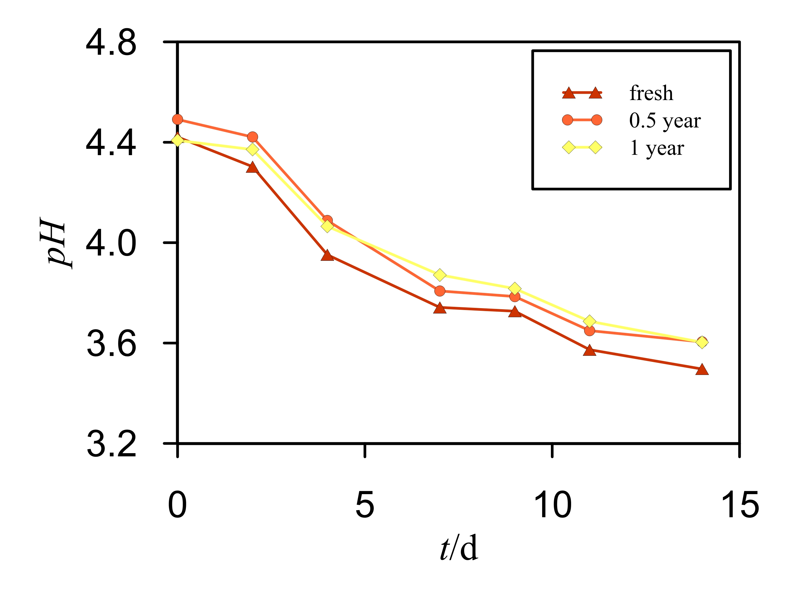
Figure 1: Dynamic pH profiles of kombucha beverages prepared with starters of different ages (MSE = 0.005)
As can be seen from Figure 1, the initial pH of the fermentation media was between 4.41 and 4.49 in all three cases. As a result of acid formation the pH values of the fermentation products decreased during the process. The times to obtain the lowest acceptable value normally differ depending on the origin of the culture. A starter of the same origin was used in our case. After 14 days of fermentation the pH reached a value between 3.49 to 3.60. The decrease of pH values in all three systems had the same trend, and there was no relation found between the pH profile and the storage time of the starter culture. However, the lowest pH value was detected in fermentation media where a fresh starter was used.
The CO₂ concentrations detected during the fermentations with kombucha starters of different ages are presented in Figure 2.
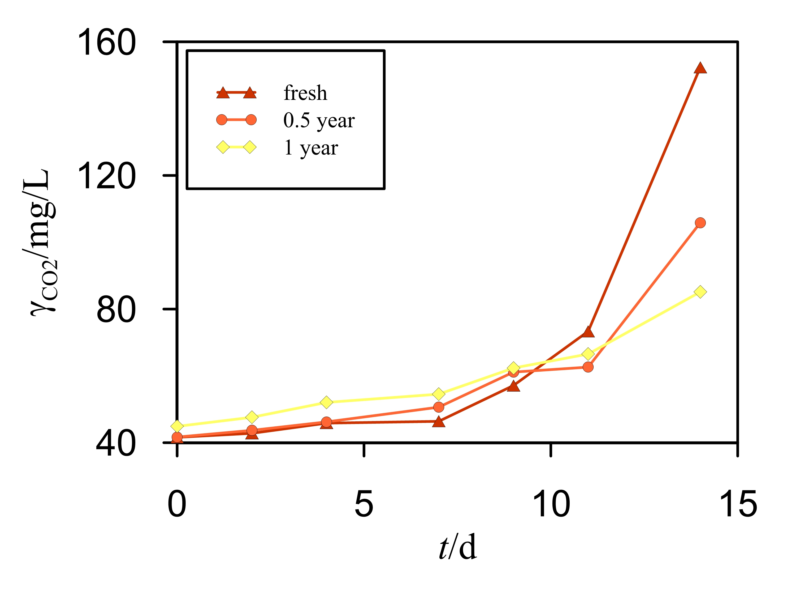
Figure 2: CO₂ concentration profiles of kombucha beverages prepared with starters of different ages (MSE = 1.302)
Within the first few days of the fermentation only insignificant differences in CO₂ concentration profiles were detected and their increase was slow. As fermentation proceeded, the CO₂ concentration increased in all fermenters. It can be seen from Figure 2 that the CO₂ concentration profiles for kombucha beverages fermented with fresh, 0.5 and 1 year old starter cultures were quite different. After 14 days the highest CO₂ concentration was observed in the case of a fresh starter, namely 152 mg/L, followed by the 0.5 year old starter (106 mg/L), and the lowest value was detected for the 1 year old starter (85 mg/L). These differences match with the observations found after the pH investigations. A significantly higher amount of CO₂ was found in the kombucha beverage prepared with the fresh starter, which might be more active, producing more acids, resulting in a lower pH value (Figure 1).
The measurement of sugar concentration can be used as measure of the rate of fermentation. The consumption of sugar during the fermentation with kombucha starters of different ages is presented in Figure 3.
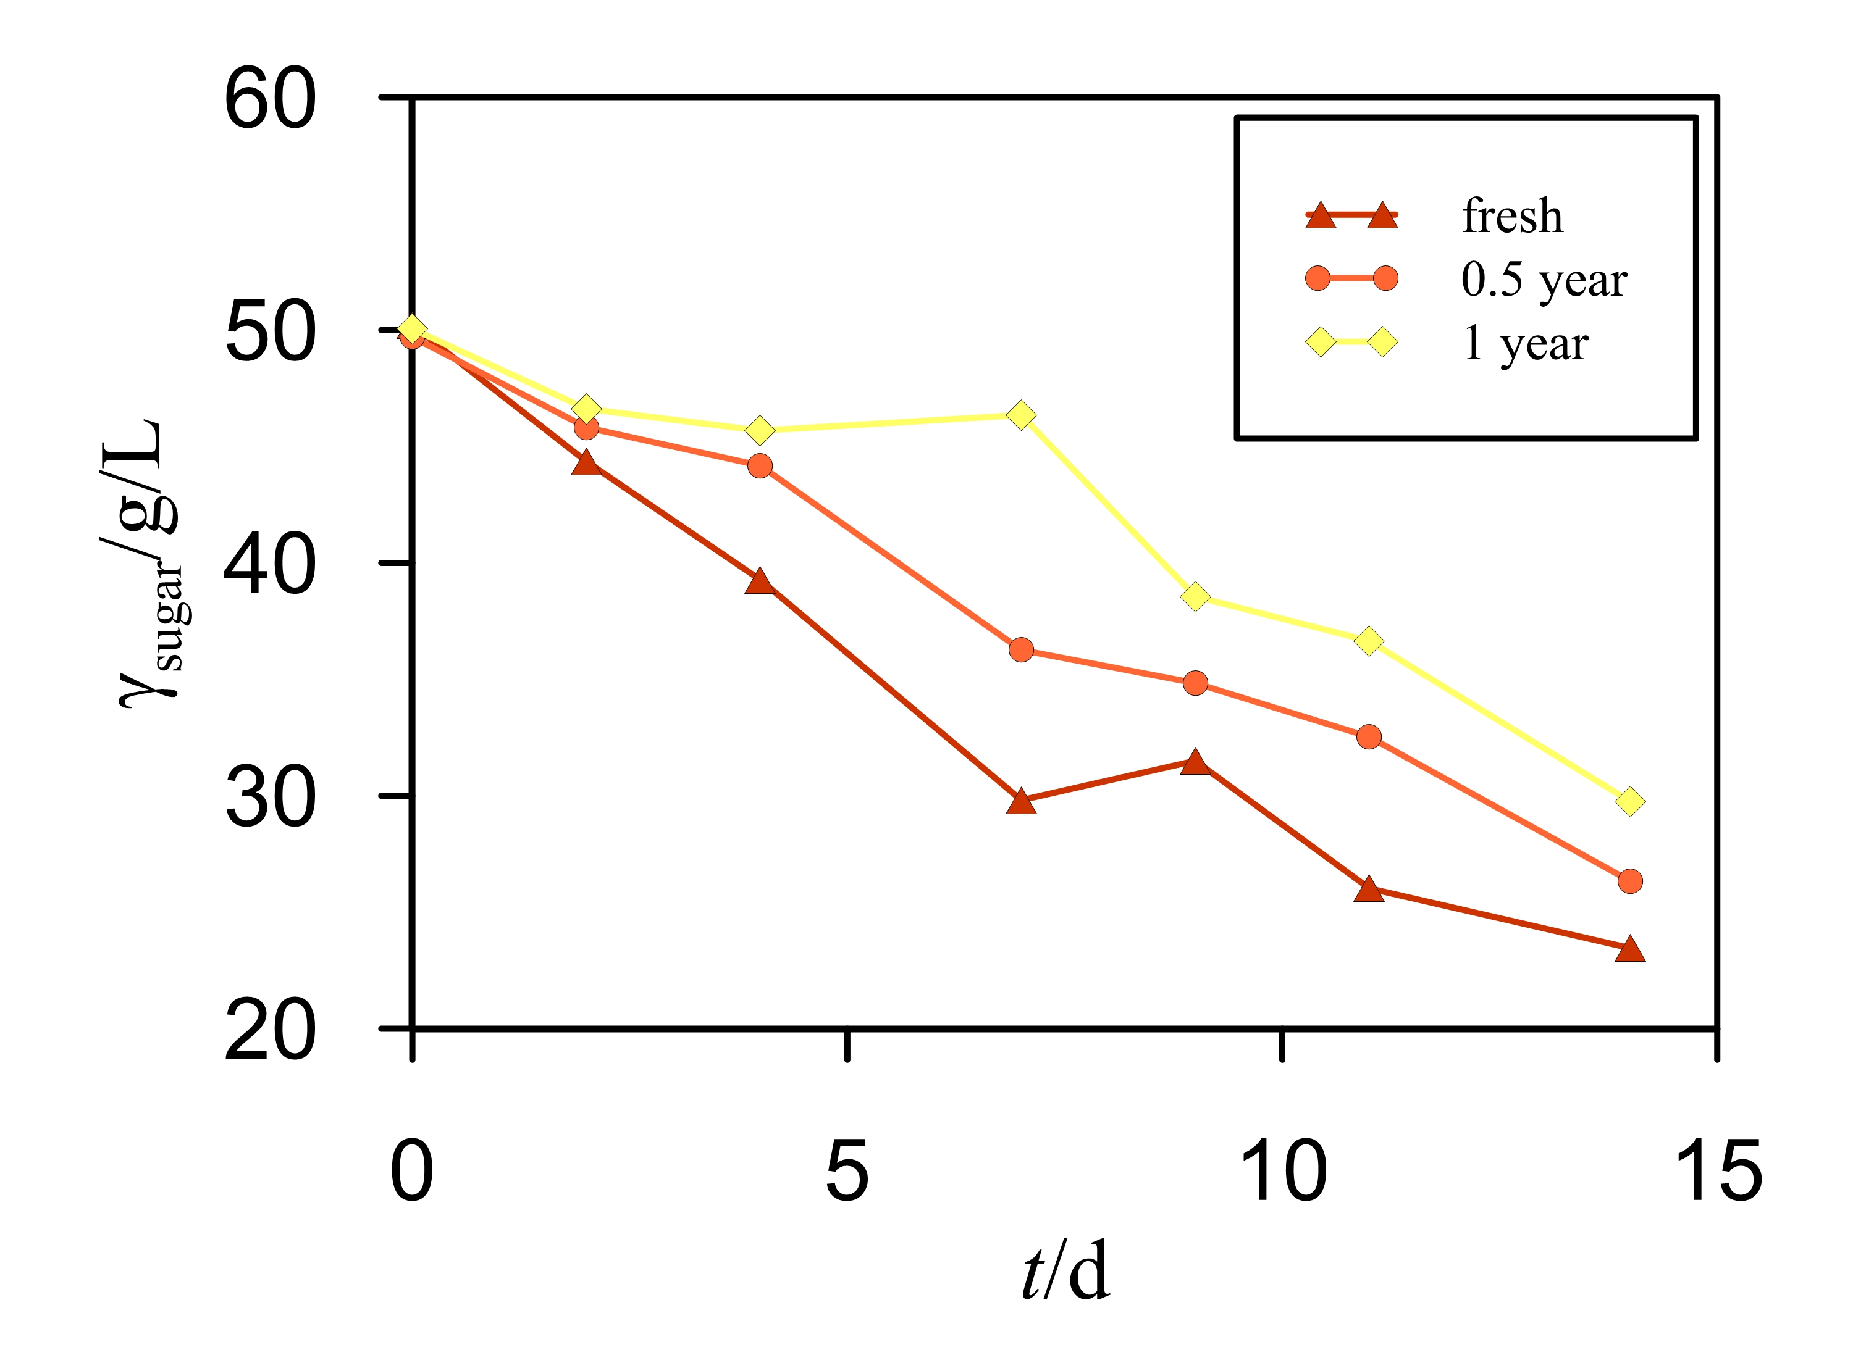
Figure 3: Sugar concentration profiles of kombucha beverages prepared with starters of different ages (MSE = 0.915)
A decrease of the sugar content during the fermentation process by the bacteria and yeast from kombucha starters is presented in Figure 3. The initial sugar concentration was the same in all fermenters, 50 g/L. The lowest decrease was observed in the case of fermentation with a 1 year old starter. The largest amount of sugar was consumed during the fermentation with the fresh starter. After 14 days the sugar concentrations were 23.5, 26.3 and 29.8 for fresh, 0.5 year old and 1 year old kombucha starters, respectively. A difference was detected, but it was not appreciable for the product quality. It is noteworthy to mention that, even when the fresh kombucha starter was used, only half of the sugar was consumed.
Finally, from Figures 1, 2 and 3, it is clear that the fresh starter is the most active, followed by the 0.5 year old and 1 year old ones. We supposed that the bacteria and yeast cells in the fresh starter need less time to adapt to the new fermentation media compared to the older ones where the cells were in a dormant stage for a longer period of time.
    - Storage temperature of kombucha starters
The effect of the storage temperature of a starter on the quality of the fermented beverage was investigated in the second part of the study. The starters were stored at -12, 9, 25 or 40 °C for 72 h. The fermenters were kept at 25 °C for 14 days. The pH, CO₂ and sugar concentrations were monitored during the fermentation. The experiments were performed in duplicate, thus, average values are presented as a result.
The pH profiles of the fermentation media prepared with starters stored at different temperatures are presented in Figure 4.
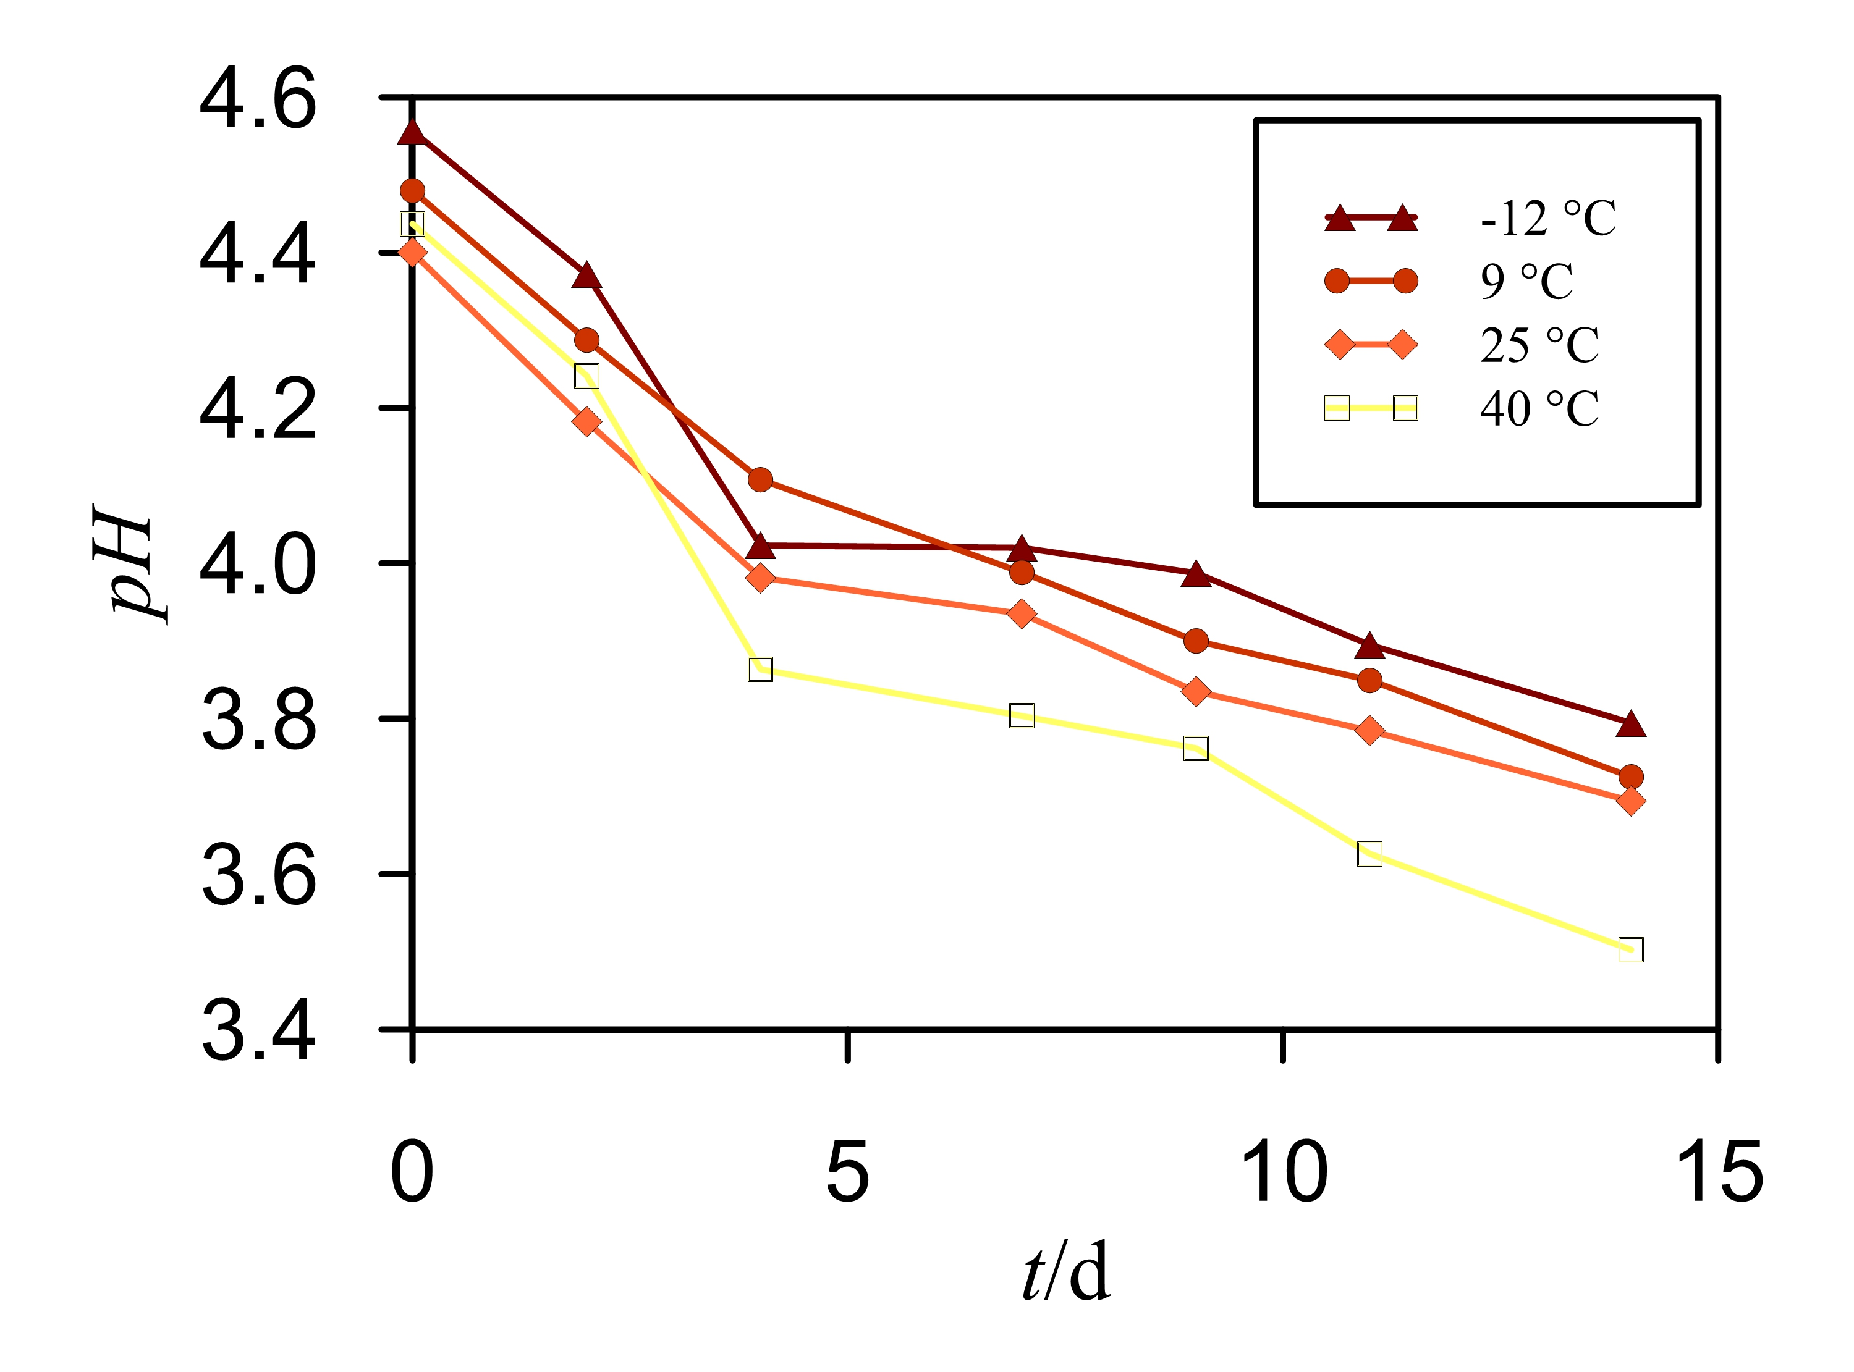
Figure 4: Dynamic pH profiles of kombucha beverages prepared with starters stored at different temperatures (MSE = 0.001)
It was found (Figure 4) that the initial pH was between 4.40 to 4.56. As the fermentation proceeded, the pH decreased in all four cases and the profiles had similar shapes. After 14 days of fermentation, the pH was between 3.50 to 3.80. Nevertheless, the highest pH drop was observed in a kombucha beverage where the starter was stored at 40 °C, which means that the highest content of total acids was formed.
The CO₂ concentrations profiles during the fermentation with kombucha starters stored at different temperatures are presented in Figure 5.
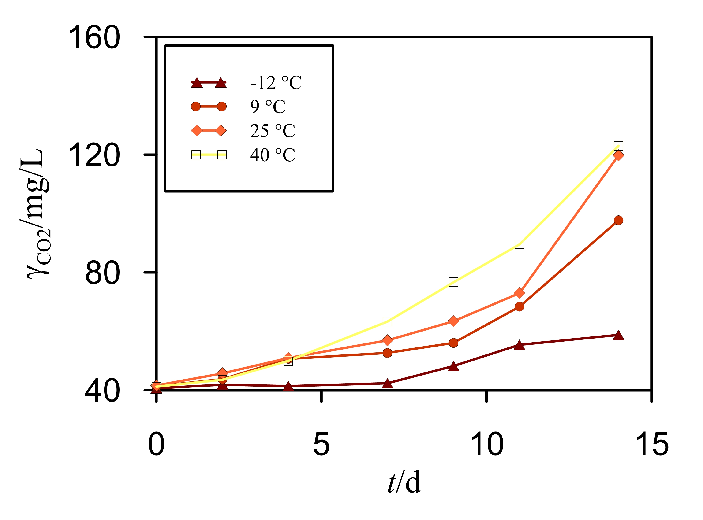
Figure 5: CO₂ concentration profiles of kombucha beverages prepared with starters stored at different temperatures (MSE = 2.510)
At the beginning of the process, the CO₂ concentration increased slowly. The only exception was the CO₂ profile representing the fermentation where the starter was stored in a freezer (-12 °C). CO₂ production started only after 7 days, and remained low even after 14 days of fermentation. Generally, it is a simple relation between the storage temperature of the starter and CO₂ production. A higher storage temperature accelerates the fermentation process. An almost 2-times higher CO₂ concentration was detected when the starter was stored at 40 °C compared to the value obtained with the starter stored in a freezer.
The sugar concentration profiles during the fermentation with starters stored at different temperatures are presented in Figure 6.
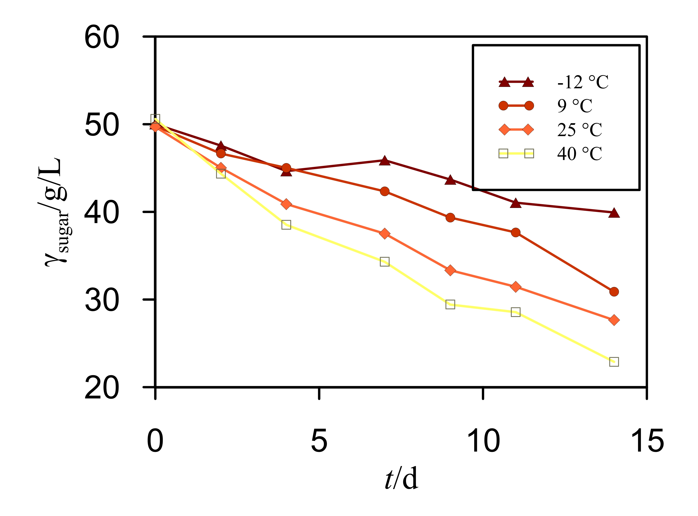
Figure 6: Sugar concentration profiles of kombucha beverages prepared with starters stored at different temperatures (MSE = 0.904)
The almost linear behavior of dynamic sugar profiles was identified from Figure 6. The initial sugar concentration was again the same in all fermenters, 50 g/L. All four sugar concentration profiles decreased during the fermentation. After 14 days, sugar concentrations were 39.9, 30.9, 27.7 and 22.9 for kombucha starters stored in a freezer, a refrigerator, at RT and 40 °C, respectively. The highest sugar consumption was determined in a system with the starter stored at 40 °C for 72 h, but still there was approximately 46 % of unconsumed sugar in the fermented beverage.
Some differences were noticed while comparing the quality of the kombucha beverages obtained after fermentation with starters stored at different temperatures (all other process parameters were unchanged),. The final concentrations of the measured components (CO₂ and sugar) differed regarding the storage temperature of the used starter culture. At higher storage temperatures the starters were more active, which is related to the lower pH, higher CO₂ content and lower sugar concentration. From an economic point of view, it is recommended that the storage temperature is at around room temperature.
  - Conclusions
Even though, nowadays, the microbial spectrum of a kombucha consortium, the health benefits of kombucha, the physicochemical properties of this beverage and the influence of process parameters on product quality are well known and understood, the storage conditions of kombucha starters has not been studied sufficiently.
Based on the results of this study it can be concluded that the dynamic profiles of pH and sugar concentrations have similar shapes, and they decrease during the fermentation when using 0.5- and 1-year or fresh kombucha starters. The difference appears in the final values of the monitored parameters, when the kombucha with the fresh starter has the lowest pH and sugar amount. The opposite is valid for the CO₂ concentration profiles. They increase with the duration of the process, and the highest final amount of this fermentation side-product was identified in the case of the fresh kombucha starter. An older starter culture takes longer to activate, which has an impact on the quality of the fermented beverage. The results of the second part of the experiments prove that the kombucha starter storage temperature has significant influence on the fermentation rate and on the quality of the fermented beverage. A higher storage temperature of the starter accelerates the fermentation process.
Nomenclature
MSE – mean squared error, /
pH – pH value, /
t – time, d
γ_{sugar} – sugar concentration, g/L
γ_{CO2} – CO₂ concentration, mg/L
Acknowledgments
The Slovenian Research Agency (ARRS) is acknowledged for financial support of the Research Program Group P2-0032: Process systems engineering and sustainable development.
References
Chen, C., Liu, B.Y., 2000, Changes in major components of tea fungus metabolites during prolonged fermentation, J Appl Microbiol, 89, 834-839.
Greenwalt, C.J., Steinkraus, K.H., Ledford, R.A., 2000, Kombucha, the fermented tea: microbiology, composition, and claimed health effects, J Food Prot, 63, 976-981.
Jarrell, J., Cal, T., Bennett, J.W., 2000, The Kombucha consortia of yeasts and bacteria, Mycologist, 14, 166-170.
Jayabalan, R., Malbaša, R.V., Lončar, E.S., Vitas, J.S., Sathishkumar, M., 2014, A Review on Kombucha Tea—Microbiology, Composition, Fermentation, Beneficial Effects, Toxicity, and Tea Fungus, Comprehensive Reviews in Food Science and Food Safety, 13, 538-550.
Lončar, E., Djurić, M., Malbaša, R., Kolarov, L.J., Klašnja, M., 2006, Influence of Working Conditions Upon Kombucha Conducted Fermentation of Black Tea, Food and Bioproducts Processing, 84, 186-192.
Nguyen, N.K., Nguyen, P.B., Nguyen, H.T., Le, P.H., 2015, Screening the optimal ratio of symbiosis between isolated yeast and acetic acid bacteria strain from traditional kombucha for high-level production of glucuronic acid, LWT - Food Science and Technology, 64, 1149-1155.
Sinir, G.Ö., Tamer, C.E., Suna, S., 2019, 10 - Kombucha Tea: A Promising Fermented Functional Beverage, in: Grumezescu, A.M., Holban, A.M. (Eds.), Fermented Beverages. Woodhead Publishing, pp. 401-432.
Villarreal-Soto, S.A., Beaufort, S., Bouajila, J., Souchard, J.-P., Renard, T., Rollan, S., Taillandier, P., 2019, Impact of fermentation conditions on the production of bioactive compounds with anticancer, anti-inflammatory and antioxidant properties in kombucha tea extracts, Process Biochemistry, 83, 44-54.
Villarreal-Soto, S.A., Beaufort, S., Bouajila, J., Souchard, J.-P., Taillandier, P., 2018, Understanding Kombucha Tea Fermentation: A Review, Journal of Food Science, 83, 580-588.
Watawana, M.I., Jayawardena, N., Ranasinghe, S.J., Waisundara, V.Y., 2017, Evaluation of the Effect of Different Sweetening Agents on the Polyphenol Contents and Antioxidant and Starch Hydrolase Inhibitory Properties of Kombucha, Journal of Food Processing and Preservation, 41, 1-10.

