CHEMICAL ENGINEERING TRANSACTIONS  VOL. 93, 2022 | A publication of
The Italian Association
of Chemical Engineering
Online at www.cetjournal.it

Guest Editors: Marco Bravi, Alberto Brucato, Antonio Marzocchella
Copyright © 2022, AIDIC Servizi S.r.l.
ISBN 978-88-95608-91-4; ISSN 2283-9216

Characterization and evaluation of solvent retention in polycaprolactone nano/microfibers obtained by electrospinning and solution blow spinning
Angela Quiroga-Vergelª, Dianney Clavijo-Grimaldo^{a,b*} , Ciro Casadiego-Torrado^{b}
ª Univerisidad Nacional de Colombia, Carrera 45 # 26 – 85, Bogotá Colombia
^{b} Fundación Universitaria Sanitas, Calle 170 # 8-41, Bogotá Colombia
dclavijog@gmail.com

The properties of polymeric nanofibers make them versatile materials with multiple applications in the health area. Electrospinning (ES) and Solution Blow Spinning (SBS) are techniques commonly used in the manufacture of nanofibers because the experimental processes are simple, replicable, inexpensive, and carried out under environmental conditions. However, both techniques require the use of solvents whose retention may limit their use in biomedical applications. The objective of this work is to compare the morphological and mechanical characteristics of polycaprolactone nano/microfibers (PCL-F) obtained by these two techniques, as well as to evaluate the retention of the solvents used. Significant differences were found in the mechanical test, morphology, diameter and orientation of the PCL-F manufactured with both techniques. No significant differences were found the persistence of both solvents. PCL-F are commonly used in biomedical applications. These results indicate that when using nano/microfibers, the technique to be used should be carefully considered according to the desired application.
  - Introduction
The properties of polymeric nano/microfibers make them versatile materials with multiple applications. In the health area, they have been used as drug-releasing systems and for the manufacture of scaffolds in tissue engineering, materials for self-repair, materials with shape memory, membranes for ultrafiltration and food packaging, among other uses. Nanofibers, in recent years, have been of special interest in the manufacture of scaffolds for tissue engineering, mainly due to the high surface area/volume ratio and porosity that simulate the structure of the extracellular matrix, facilitating the movement and adhesion of the cell and increasing the growth potential and regeneration of the tissue. Technologies more recognized for fabricated the fiber are ES, centrifugal spinning, self-assembly, synthesis and SBS (Gao et al., 2021). ES technology is one of the most popular techniques to fabricate nanofiber, it consists in applied high voltage to a polymer solution transport with a syringe pump, generating electrical forces that inducing charges on the surface and caused the formation of Taylor cone. When the solution go out of the Taylor cone, starting the evaporation of the solvent and being deposited in the fibers in collector with ground pole (Ding et al., 2018). The popularity of the ES technique is due to the versatility to produce nanofibers with diverse morphologies, using various materials. ES has advantages as a simple and low-cost technology, however, compared to other techniques it has the disadvantage of difficulty in large-scale manufacturing. SBS combines elements of ES and melt blowing technologies, allowing obtaining nano/microfibers with diameters similar to those obtained by ES but with a higher production rate. Fibers production uses a syringe pump by which the polymer solution is pumped into the inner nozzle of a coaxial needle, while a high-velocity gas flows through the outer nozzle. Shear forces at the gas-polymer interface generate the products that are deposited in a collector. Theoretically, in both ES and SBS, the solvent in which the polymer is dissolved is rapidly evaporated.(Dadol et al., 2020). PCL is a linear semicrystalline aliphatic polyester, widely used as a biomaterial because it is versatile, biocompatible and bioabsorbable. A concern that arises when manufacturing scaffolds with PCL is the toxicity of the solvents used (chloroform, dichloromethane, dimethyl carbonate with ethanol or methanol, 2,2,2-trifluoroethanol etc.) (Siddiqui et al., 2018). In this work, the morphological and mechanical characteristics of PCL-F obtained by ES and SBS will be evaluated, as well as the persistence of the solvents used.

  - Materials and methods
    - Preparation of the PCL solution
PCL(Sigma Aldrich, CAS # 134490-19-0 and molecular weight Mn=80.000 g/mol) was used in a solution with 9% W/V in a 50:50 V/V mixture of chloroform (Sigma Aldrich, 99,5 %, CAS # 67-66-3 and molecular weight Mn=119.38 g/mol) and isopropyl alcohol (Sigma Aldrich, 99,7 % CAS # 67-66-3 and molecular weight Mn=60 g/mol). Solution was agitated in an ultrasonic bath (50 Hz) for 1 h and stored for 7 d. At the time of manufacturing the fibers, the solution was again placed in an ultrasonic bath (50 Hz) for 1 h.

    - SBS process
The process was carried out with a custom coaxial nozzle (Figure 1), compressed air, syringe pump (New Era Instruments) and rotational collector (ESD30s). The PCL solution was supplied with a syringe pump at a constant flow rate of 15 ml/h into the inner nozzle of a coaxial needle. Compressed air was used as the working gas and supplied through the outer nozzle with an inlet pressure of 0.2 MPa using an air pump. A cylindrical rotational stainless-steel collector with a diameter of 14 mm was used, with the rotational speed of 2000 rpm. The distance from the nozzle to the collector surface and the plate face was 15 cm. The fibers were collected for 3 min. The process was performed at 21,9 °C room temperature and 54% RH.

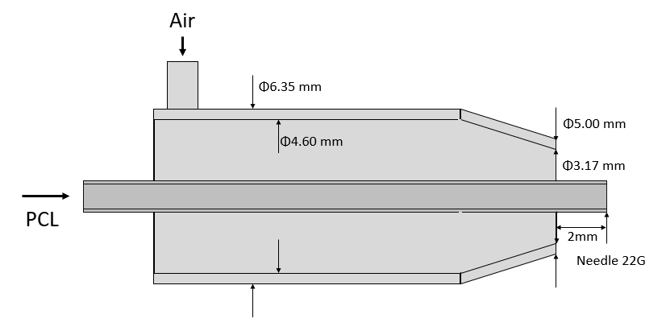
Figure 1. Custom built coaxial nozzle dimensions.

    - ES process
The fibers were developed into an ES equipment composed by a high voltage source (CZE1000R, Spellman), a dosing pump (New Era Instruments), a syringe, a needle, and a rotary collector (ESD30s). The ES process parameters were: voltage (15 kV), distance between the needle tip and the collector (15 cm), collector rotational speed (2000 rpm), solution flow (1 ml/h) and deposition time (45 min). The collection of fibers was done on aluminium sheets placed on the collector. The process was performed at 20,8 °C room temperature and 57% RH. The parameters were calculated to use equivalent amounts of polymer in the ES and SBS processes.

    - Characterization
Morphology of fibers was studied by scanning electron microscopy (SEM – VEGA3 TESCAN). Images were obtain using an accelerating voltage of 15 kV, working distance to focal plane of 8 mm and magnification 500 x. Statistical distribution of a diameter was determined with a sample amplified at 5,000 x and using image analysis software (Image J).
The tensile strength test of the samples was performed using a universal testing machine (AG-IS 5KN, Shimadzu). The tests were carried out according to the ASTM D882 with a preload of 50 N and at a speed of 50 mm/min at room temperature (20,8 °C). The orientation of the samples (120 x 10 x 0.0342 mm) for the mechanical tests was longitudinal. Chemical properties were determined with a FTIR machine (Shimadzu Prestige-21 spectrophotometer, adapted to the ATR module using 32 scans and a resolution of 4.0 cm⁻¹ in the range of 700 to 4000 cm⁻¹). Specimens of (2 x 2) cm were fabricated 48 h before testing and hermetically sealed. Spectra of fibers obtained by ES and SBS were obtained.
  - Results and discussion
    - Scanning electron microscopy
PCL-F were successfully obtained by SBS and ES solution spinning (Figure 2). In the PCL-F obtained by SBS, are observed randomly distributed, with rectilinear and spiral morphology and some pearls (Figures 2a and 2b) caused by the polymer splashes in the nozzle and dragged by the radial air currents. These currents could be caused by the perpendicular direction of the air flow which is a finding similar to that observed by other works. Large raw polymer beads were found using commercial and custom nozzles, evidencing a direct correlation between bead area and polymer concentration (Tutak et al., 2015). The PLC-F obtained by ES are observed without defects and more regular, rectilinear, and aligned (Figures 2c and 2d).

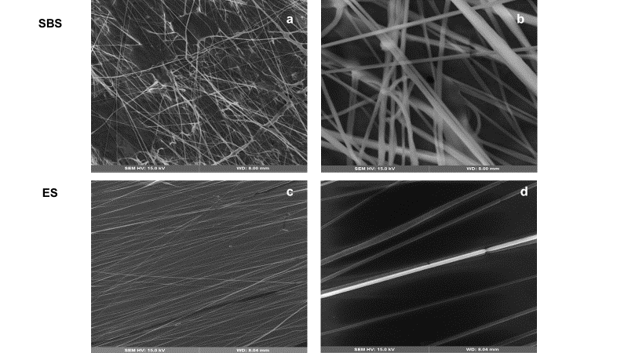

Figure 2. PCL-F in SEM. A (500 x) and b (5,000 x) show the fibers obtained by SBS. C (500 x) and d (5,000 x) show the fibers obtained by ES
Figure 3 shows the distribution of the diameters of the fibers obtained. The fibers obtained by ES have an average diameter of (997 ± 410) nm, like that obtained in previous studies where the same polymeric solution was used (Clavijo-Grimaldo et al., 2019). The PCL-F obtained by SBE and an average diameter of (1365 ± 554) nm. Researchers found similar diameters (1380 ± 406) nm using a commercial air brush (Li et al., 2020).
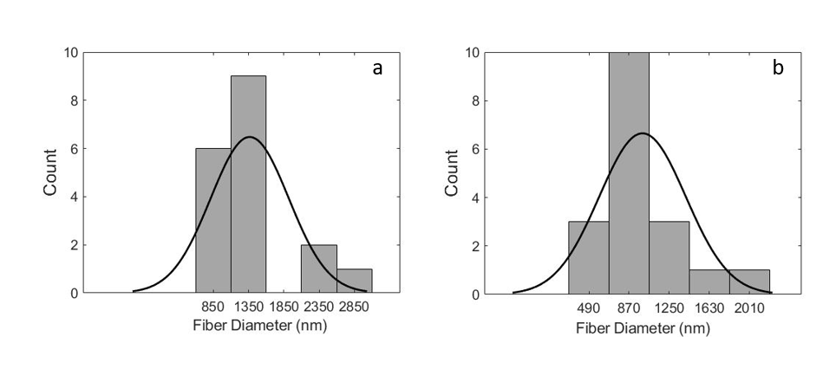
Figure 3. Histogram of fibers diameter of PCL prepared by SBS (a) and ES (b).
Implement analysis of variance (ANOVA) for experimental data of diameter fiber, was found a F-statistic factor of 5.12 and p-value of 0.0302, as it is less than 0.05 indicates a difference significant between the fiber diameter of SBS and ES.

    - Mechanical tests
Figure 4 shows the stress-strain curves for the PCL-F obtained by ES and SBS.

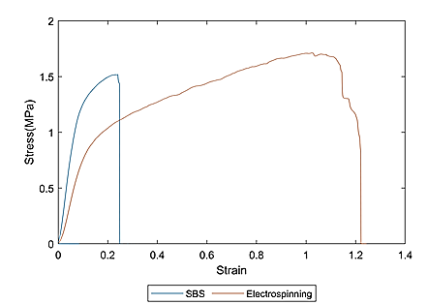
Figure 4. Stress - strain curve for tensile test of PCL films fabricated by solution blow spinning (SBS) and electrospinning (ES)
Table 1 summarizes the mechanical properties found in the tensile test. The SBS film showed less elongation to break (0.36±0.18) ε versus the ES film (1.76±0.63) ε, which could be due to the uniformity and alignment of the fibers, giving them the property of storing more energy, as shown in Figure 3 where the area under the ES curve is greater than that obtained in SBS. Young's modulus is higher for the SBS film (15.23 ± 2.62) MPa compared to the ES film 10.49 ± 1.02 MPa). One possible cause is the difference in the orientation of the fibers. Tensile test specimens were cut parallel to rotation to apply tension in the same direction as fibers alignment. If any fiber for the SBS film were oriented perpendicular to the stress and with bends, it would dissipate the stresses towards the x-axes of the specimen. The tensile strength is almost the same for both methods, around 1.5 MPa.
Table 1: Mechanical tests result
Method |  | Young’s Modulus  (MPa) | Tensile Strength  (MPa) | Elongation to break  (ε)
SBS |  | 15.23 ±2,62 | 1.48±0.24 | 0.36±0.18
ES |  | 10.49±1.02 | 1.55±0.16 | 1.76±0.63
    - FTIR result
FTIR Spectrum results were compilated in the Figure 4. As expected, SBS and ES have similar peaks than PCL SpectraBase (John Wiley & Sons, 2022), because it is the main component of the samples. The peaks for PCL are in 2940 and 2865 cm⁻¹ correspondent to bond CH2, 1724 cm⁻¹ for ketone bond and a series of peaks in the fingerprint region 1200 - 700 cm⁻¹. Those result were similar to characteristic peaks reported in (Li et al., 2020).
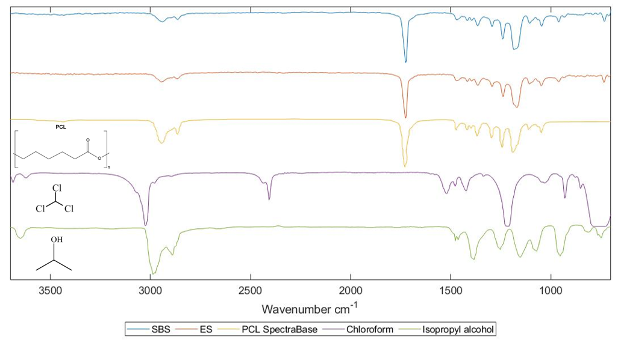

Figure 4. FTIR results for PCL fiber fabricated by SBS and ES. Comparing with a PCLSpectraBase (John Wiley & Sons, 2022), chloroform (COBLENTZ SOCIETY, 2018b), and isopropyl alcohol (COBLENTZ SOCIETY, 2018a) reference spectra IR.
On another hand, due to the characteristic peaks of the solvents chloroform and isopropyl alcohol don’t be recognized briefly in the spectrum of the SBS and ES, was subtracted the PCL spectrum of the specimen results and those are shown in Figure 5. These reveal a very low concentration of isopropyl alcohol in both specimens.

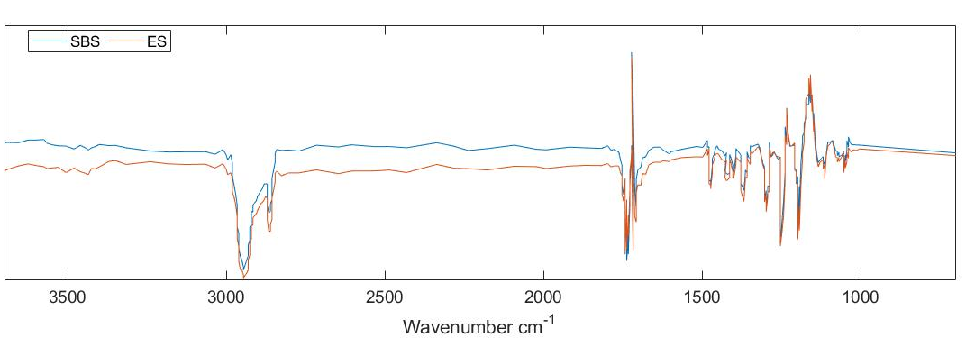
Figure 5. FTIR spectrum of specimen SBS and ES with subtraction of PCLSpectraBase spectrum.
  - Conclusions
PCL fibers oriented were fabricated successfully by solution blow spinning (SBS) and ES. Morphologically the ES fibers were more uniform and constant, SBS generate fibers with large beads, fibers with curves and oriented perpendicularly at the movement of rotary collector. In addition, the microstructure observed in the SEM images, was reflected in the mechanical result, because the uniform and oriented fiber from ES could storage more energy, producing a film with more elongation to break for a similar ultimate stretch comparing with SBS film. Traces of solvent was found in the SBS and ES in the IR spectrum in a low concentration. These techniques of are simple, replicable, inexpensive, and carried out under environmental conditions. The persistence of only trace amounts of solvents makes them suitable for biological applications and from an environmental point of view.
The difference between SBS and ES film suggests that depending on the final application of the scaffold is possible to choose one technic from another. Mainly because using the same polymer (as PCL), concentration, solvent, distance to the collector, equivalent time-flow and change the method is possible to obtain fibers with properties that improve a particular kind of research tissue. Oriented and uniform ES fibers have the potential to research for example cartilage, tendon, and nerve tissue; and more disperse SBS fibers could be applied for example to bone and skin research. Finally, is important to consider which is the most suitable fabrication technique according to tissue engineer application.
Acknowledgments
This research was funded by the Universidad Nacional de Colombia and the Fundación Universidad Sanitas. The authors express their acknowledgments to the staff of the Electrospray and Electrospinning Laboratory, Faculty of Medicine, Universidad Nacional de Colombia

Nomenclature
ES – Electrospinning
PCL - F – Polycaprolactone fibers
SBS – Solution Blow Spinning
Φ– Diameter, mm
References
Clavijo-Grimaldo, D., Ponce-Zapata, N., & Casadiego-Torrado, C., 2019, Control of Bacterial Proliferation and Formation of Biofilm in Membranes for Food Packaging Manufactured by Electrospinning, Chemical Engineering Transactions, 75, 241-246.
COBLENTZ SOCIETY, 2018, Isopropyl Alcohol. National Institute of Standards and Technology <https://webbook.nist.gov/cgi/cbook.cgi?ID=C67630&Type=IR-SPEC&Index=2> accessed 22.01.2022.
COBLENTZ SOCIETY, 2018, Trichloromethane. National Institute of Standards and Technology <https://webbook.nist.gov/cgi/cbook.cgi?ID=C67663&Type=IR-SPEC&Index=2> accessed 22.01.2022.
Dadol, G. C., Kilic, A., Tijing, L. D., Lim, K. J. A., Cabatingan, L. K., Tan, N. P. B., Stojanovska, E., & Polat, Y., 2020, Solution blow spinning (SBS) and SBS-spun nanofibers: Materials, methods, and applications, Materials Today Communications, 25, 101656.
Ding, B., Wang, X., & Yu, J., 2018, Electrospinning: Nanofabrication and applications, Micro & Nano Technologies Series, Elsevier Inc., Waltham, MA.
Gao, Y., Zhang, J., Su, Y., Wang, H., Wang, X.-X., Huang, L.-P., Yu, M., Ramakrishna, S., & Long, Y.-Z. , 2021, Recent progress and challenges in solution blow spinning, Materials Horizons, 8, Vol 2, 426-446.
John Wiley & Sons,., 2022, SpectraBase Compound ID=DReJiCKiDTF SpectraBase Spectrum ID=FdPg9tn4xup <https://spectrabase.com/spectrum/FdPg9tn4xup> accessed 22.01.2022.
Li, R., Li, Z., Yang, R., Yin, X., Lv, J., Zhu, L., & Yang, R., 2020, Polycaprolactone/poly(L-lactic acid) composite micro/nanofibrous membrane prepared through solution blow spinning for oil adsorption, Materials Chemistry and Physics, 241, 122338.
Siddiqui, N., Asawa, S., Birru, B., Baadhe, R., & Rao, S., 2018, PCL-Based Composite Scaffold Matrices for Tissue Engineering Applications, Molecular Biotechnology, 60, Vol 7, 506-532.

