CHEMICAL ENGINEERING TRANSACTIONS  VOL. 93, 2022 | A publication of
The Italian Association
of Chemical Engineering
Online at www.cetjournal.it

Guest Editors: Marco Bravi, Alberto Brucato, Antonio Marzocchella
Copyright © 2022, AIDIC Servizi S.r.l.
ISBN 978-88-95608-91-4; ISSN 2283-9216

Generation of GnIH Hormone/Pluronic F-127 Systems by Supercritical Antisolvent Process
Diego Valorª*, Antonio Montesª, Paula Fernández, José A. Paullada-Salmerón^{b}, Clara Pereyraª, José A. Muñoz-Cueto^{b}

ª Department of Chemical Engineering and Food Technology, Faculty of Sciences, International Excellence Agrifood Campus (CeiA3). University of Cadiz, Campus Universitario Río San Pedro, 11510, Puerto Real (Cadiz), Spain.
^{b} Department of Biology, Faculty of Marine and Environment Sciences, International Excellence Marine Campus (CEIMAR) and European University of the Seas (SEA-EU). University of Cadiz, Campus Universitario Río San Pedro, 11510, Puerto Real (Cadiz), Spain.
diego.valor@uca.es

GnIH seems to represents a pleiotropic neuropeptide exerting not only inhibitory effects on reproduction, but it is also related to stress and growth. Research has been carried out to develop encapsulation technologies for GnIH, which permit their dietary incorporation into the feed. In this work, microparticles of GnIH were generated using supercritical antisolvent process (SAS) and subsequently the process of encapsulation of the compound with a biodegradable polymer, Pluronic F-127, was studied. The use of supercritical fluids and particularly SAS process to prepare microparticles removes the problems of the conventional techniques such as thermal degradation, excessive use of solvent, residual solvent concentration, and principally the challenge of controlling particle size throughout processing. In this preliminary work, the influence of the pressure and ratio hormone/polymer on the particle size, morphology, and elemental composition of these particles have been investigated. Most of the experiments led to successful precipitation of a white powder of particles in the micrometer range. The initial morphology of the GnIH was modified, resulting in a generally spherical particle form. The smallest particle size (0.16 µm) and the highest amount of precipitated GnIH in composites was obtained using 100 bar and 1/9 ratio, which were considered the best conditions in this preliminary study.
  - Introduction
In recent years, a new neuropeptide known as gonadotrophin inhibitory hormone (GnIH) has gained prominence as a brain factor inhibiting the reproductive process in vertebrates(Ubuka et al., 2012, 2016). Also, studies in birds and mammals have shown that the GnIH system may be mediating the stress response (Kirby et al., 2009) and is implicated in the control of reproductive and aggressive behaviour, through its action on neurosteroid biosynthesis in the brain (Bentley, 2006; Piekarski et al., 2013; Ubuka et al., 2012). Therefore, both new methods of administration of this hormone in animals and the study of its encapsulation or impregnation are of great interest.

Supercritical fluid technology is presented as a clean and innovative technology with the capacity to provide solutions for the incorporation of active ingredients in the diet, encapsulating and impregnating them in the animal feed. Among the supercritical fluids, CO₂ is the most widely used in general. Compared to other supercritical fluids, scCO₂ has a low critical temperature (Tc) and pressure (Pc), 31.1 ºC and 7.3 MPa, respectively. It is a non-toxic, inert and non-flammable compound, so many of its uses in industry are considered "green technologies". Nanoparticles obtained by the SAS process are usually produced by working at low temperatures (in the range of 35-50 ºC), which is key to be able to work with thermolabile compounds such as those present in many natural extracts, and pressures equal to or mostly above 90 bar. (Franco and De Marco, 2021; Ramsey et al., 2009; Vezzú et al., 2010). The supercritical antisolvent (SAS) technique is proving to be a promising technology in the field of compound precipitation, given the possibility of generating particles with a controlled particle size and homogeneous size distribution. If it is also desired to protect or carry the active ingredient, it can be coated with a biodegradable polymer, which gives the active ingredient specific and controllable surface, physical, chemical and biochemical properties, allowing the fluid dynamics, dissolution rate, dispersibility, chemical reactivity, bioefficacy and hydrophilic character of the particles to be modified, depending on the desired use (Baldino and Reverchon, 2021; Prosapio et al., 2015).

In this regard, there are numerous works in the literature on the encapsulation of active ingredients with biodegradable polymers, with a particle size in the order of microns or nanometres. Several studies have been carried out using supercritical fluids, more specifically with the supercritical antisolvent process (SAS) technique, which has the ability to encapsulate thermosensitive substances by choosing the appropriate antisolvent; the feasibility of adapting the technique for continuous operation and, therefore, its favorability for large-scale production of encapsulated systems. Examples include the encapsulation of food compounds such as β-carotene or quercetin (Fraile et al., 2014; Martín et al., 2007) among others, or the development of drug-polymer delivery systems such as paclitaxel (Lee et al., 2008) or folic acid (Prosapio et al., 2015). However, its application in the encapsulation of active substances with complex biological functions such as the hormone GnIH has not been widely studied.

In biopolymeric drug delivery systems, the interaction of the polymer with supercritical CO₂ plays an important role in the selection of the supercritical process. As an encapsulating agent, a biodegradable polymer that is resistant to gastric, but not intestinal, juices should be used, allowing the release of GnIH and its incorporation into the circulatory system. In this case, the polymer chosen for this preliminary study, Pluronic F-127, fulfils these characteristics (Swain, 2016).

In the present work, the direct influence of pressure and ratio of drug/polymer on the morphology, size and distribution of micro-nanoparticles were studied. Precipitates of GnIH isolated and encapsulated together with the biodegradable polymer Pluronic F-127 were obtained by supercritical antisolvent process. The morphological change of the active substance and the decrease in the mean particle size, resulting in a solvent-free product, make this technique a very useful method to precipitate and encapsulate microparticles.

  - Materials and methods
    - Materials
Pluronic F-127 and ethanol absolute were supplied by Sigma-Aldrich (Spain). Gonadotropin-inhibitory hormone (GnIH) was purchased from Innovagen. Carbon dioxide (99.8%) was purchased from Abello-Linde S.A. (Barcelona, Spain).

    - Supercritical antisolvent precipitation
A pilot plant built by Iberfluid (Barcelona, Spain) was employed in this study. The SAS pilot plant includes two high-pressure pumps to pump the CO₂ and the solution; a stainless-steel precipitator vessel; an electric heat exchanger to control the temperature in all the system, with jackets and controllers in various parts of the plant; an automated high-precision back-pressure regulator; a jacketed stainless steel cyclone separator where the CO₂ is separated from the used solvent. A diagram of the described plant is shown in Figure 1.

An organic solution containing the solute of interest was sprayed through a nozzle (diameter of 100 μm) to generate drops of solution into a vessel containing CO₂ at supercritical (sc) conditions. During mixing, scCO₂ was quickly dissolved in the organic solution, causing the precipitation of solutes by antisolvent effect. Subsequently, scCO₂ efficiently extracted the organic solvent, allowing to obtain completely solvent-free products.
In this work, firstly, the precipitation of gonadotropin-inhibitory hormone (GnIH) has been carried out separately using ethanol as solvent. The conditions of pressure at 140 bar, temperature 40 ºC, flow rate of CO₂ at 30 g/min and an injection rate of the solution at 5 mL/min were kept constant. Two hormone precipitation tests were carried out with the same conditions, varying only the concentration of the hormone solution (10 - 20 mg/mL).
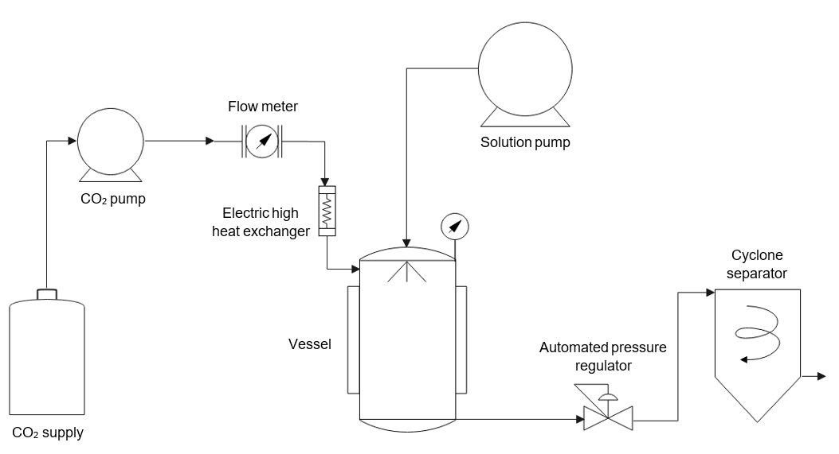
Figure 1: Schematic diagram of SAS pilot plant.
Subsequently, the hormone was encapsulated with Pluronic F-127 polymer. Experiments were conducted at pressures of 100 -180 bar and hormone/polymer ratios of 1:3 – 1:9. The temperature was set at 40 °C in order to avoid damaging the hormone during the process. In all tests a CO₂ washing time of 1 hour was left, in which a new CO₂ flow is able to remove the residual solvent. For the characterisation of the sample, further analyses of electron microscopy, elemental analysis and X-ray photoelectron spectroscopy were carried out. Tests were performed in duplicate.
    - Scanning electron microscopy
In order to analyse the morphology and size of the precipitated particles scanning electron microscopy (SEM) was carried out (Nova NanoSEM 450). Prior to analysis, the samples were coated with a 12 nm gold layer to obtain a better image quality. The particle size was analysed using the digital image processing program ImageJ.

    - Elemental analyses
In order to know the composition of the encapsulates, quantitative elemental analysis was used to determine the % of nitrogen present in the sample, since this element is only found in the encapsulating polymer. The elemental analyser worked up to 1050 °C. The mass fraction of C, H, N and S in each sample was determined. Two replicates were carried out for each sample.
  - Results and discussion
As an initial experiment, the isolated precipitation of the GnIH hormone was carried out due to the total lack of literature on the precipitation of GnIH, and more specifically with supercritical fluids. In order to work above the critical point of the CO₂ + ethanol mixture, the experiments were carried out at a fixed pressure and temperature of 140 bar and 40 °C, respectively. The test was performed under the same conditions only varying the concentration of GnIH hormone.

Ethanol was used as the organic solvent for particle precipitation in this work. While for the concentration of 10 mg/mL no precipitate was obtained at the end of the test, a white powder precipitate was obtained increasing to 20 mg/mL. Figure 1 shows a comparative between raw untreated GnIH (left) and SAS-precipitated particles (right).

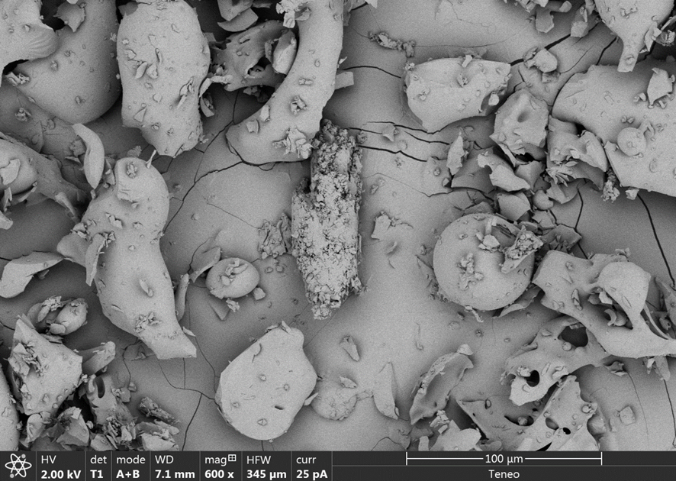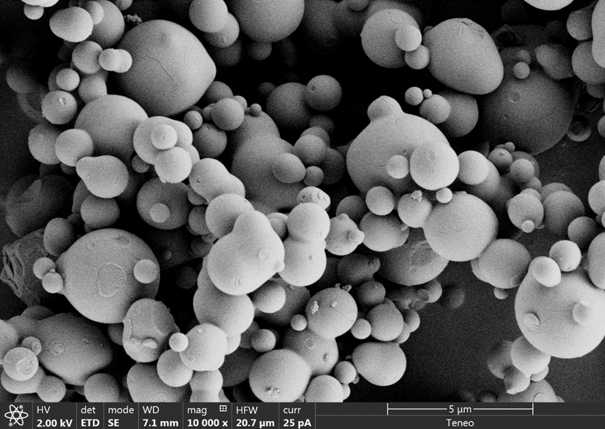
Figure 2: SEM images of raw GnIH (left) and microparticles of GnIH (right) after SAS process (concentration of 20 mg/mL).
The morphology of the sample was successfully modified, obtaining mostly spherical particles, with an average particle size of 1.32 µm, while the commercial hormone presented an average particle size of 20 microns. This decrease in size in pharmaceuticals or complex molecules allows these molecules to move more freely in the human body as compared to bigger materials and higher oral bioavailability (Patra et al., 2018).
On the other hand, after isolated precipitation of the GnIH hormone was achieved, five experiments were carried out to study the effect of the pressure and ratio hormone/polymer in the formation of GnIH Hormone/Pluronic F-127 Systems, which are summarised in Table 1. All experiments were performed at a total concentration of 20 mg/mL, combining the concentration of polymer and GnIH. The particles show an average size between 0.16 - 1.92 µm. It was observed that in the two pairs of experiments (1-2, 3-4), each pair at the same conditions, varying only the pressure, shows that with decreasing pressure, both the precipitate production and the average size of the particles decreases. Furthermore, no precipitate was obtained using high pressure in run 3.
With regard to the coprecipitation, it is apparent that the active substance/polymer ratio plays a crucial role in the attainment of composite particles. In addition, the polymer content strongly affects the dissolution rate; in general, the generation of the active compound is mainly modified by increasing the polymer/drug ratio (Jung et al., 2012). Under the tested conditions for GnIH encapsulation, generally better results were obtained by using higher amounts of polymer in the initial solution.
Table 1: Summary of conditions for SAS process, particle size and % of nitrogen present in the encapsulates.
Run | Pressure  (bar) | Ratio GnIH/Pluronic | Particle Size  (µm) | % N
1 | 100 | 1/9 | 0.16 ± 0.04 | 15.48
2 | 180 | 1/9 | 1.92 ± 1.25 | 3.39
3 | 180 | 1/3 | - | -
4 | 100 | 1/3 | 0.69 ± 0.24 | 0.26
5 | 140 | 1/6 | 0.59 ± 0.33 | 1.70
Figure 3 shows scanning electron microscopy images of the experiments where co-precipitate was obtained. Generally, the SAS process was able to modify the morphology of the initial material, resulting in spherical particles also for the polymer encapsulated samples.
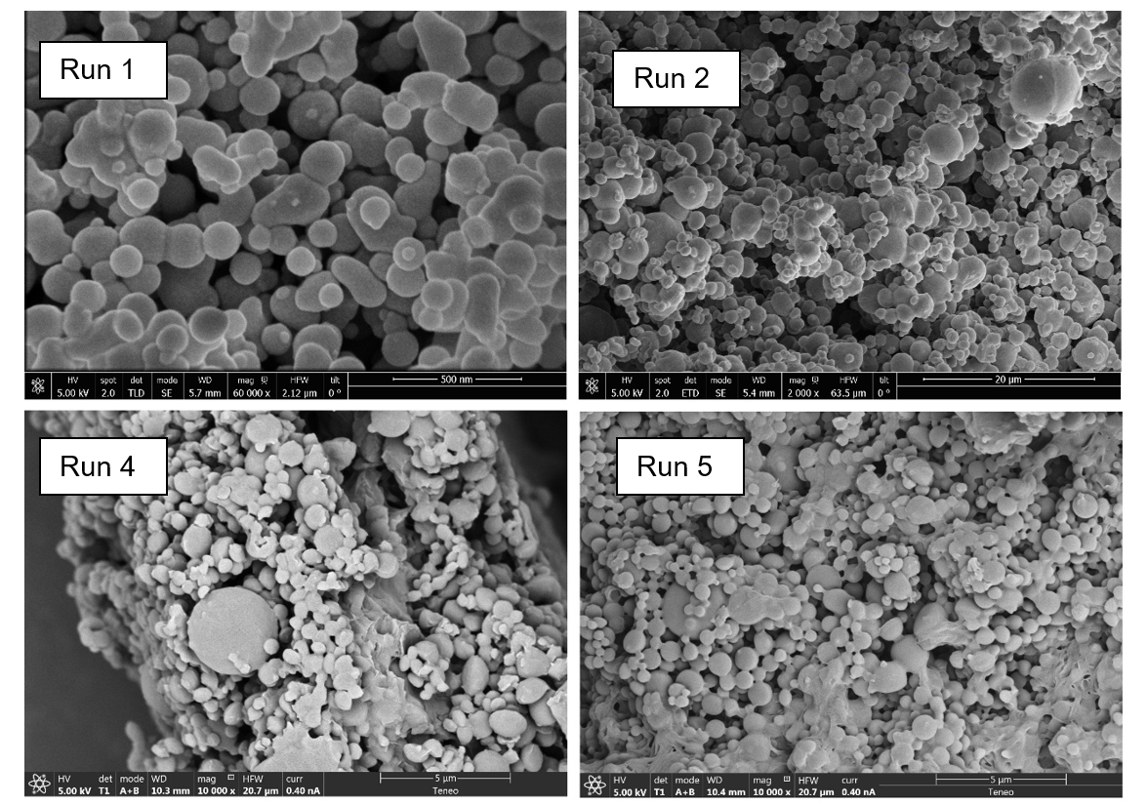
Figure 3: SEM images of encapsulated samples 1,2,4 and 5.
The sample with the most stable size distribution was sample 1 with a particle size of 0.16 ± 0.04 µm. To confirm the presence of the hormone in the co-precipitates obtained, an elemental analysis was carried out by taking the samples to 1050 ºC to analyse the presence of nitrogen in the samples, an element only present in GnIH and not in the polymer used as encapsulant. A trend can be observed indicating that the use of higher ratios with a higher amount of polymer favours the precipitation of the hormone by the antisolvent process, considering that in runs 1-2 the highest amount of precipitated hormone can be found, with a maximum of 15.48 % nitrogen present in the sample.
  - Conclusions
In this preliminary work the formation of GnIH particles using the SAS technique and the influence of pressure and ratio drug/polymer on the average size of the obtained nanoparticles was achieved with a wide range of conditions, always under supercritical conditions. Precipitation of the isolated GnIH hormone together with an encapsulating polymer by supercritical technology was achieved. These microparticles showed a decrease in the average size by decreasing the pressure, with an increase of precipitated hormone obtained by increasing the polymer ratio. Mean particle sizes of 0.16 microns were obtained under the best conditions, which were 100 bar pressure and 1/9 active substance/polymer ratio. Precipitation with supercritical CO₂ proved to be an effective technique for the precipitation of the treated substances both in size and morphology of the samples obtained.

Acknowledgments
We gratefully acknowledge the Regional Ministry for Economic Transformation, Industry, Knowledge and Universities of the Junta de Andalucía and FEDER Andalucía 2014-2020 Program for financial support (FEDER-UCA18-107538 Grant).

References

Baldino L., Reverchon E., 2021, Supercritical CO₂ assisted strategy for acetic acid elimination from industrial cellulose acetate–water mixtures, Chemical Engineering Research and Design, 172, 127–134.
Bentley K. L., et al., 2006, Interactions of Gonadotropin-ReleasingHormone (GnRH) and Gonadotropin-Inhibitory Hormone (GnIH) in Birds and Mammals, Journal of Experimental Zoology Part A-Comparative Experimental Biology, 305A(10), 807–814.
Fraile M., Buratto R., Gómez B., Martín Á., Cocero M. J., 2014, Enhanced delivery of quercetin by encapsulation in poloxamers by supercritical antisolvent process, Industrial and Engineering Chemistry Research, 53(11), 4318–4327.
Franco P., De Marco I. 2021, Nanoparticles and nanocrystals by supercritical CO₂-assisted techniques for pharmaceutical applications: A review, Applied Sciences (Switzerland), 11(4), 1–27.
Jung I. Il, Haam S., Lim G., Ryu J. H., 2012, Preparation of peptide-loaded polymer microparticles using supercritical carbon dioxide, Biotechnology and Bioprocess Engineering, 17(1), 185–194.
Kirby E. D., Geraghty A. C., Ubuka T., Bentley G. E., Kaufer, D, 2009, Stress increases putative gonadotropin inhibitory hormone and decreases luteinizing hormone in male rats, Proceedings of the National Academy of Sciences of the United States of America, 106(27), 11324–11329.
Lee L. Y., Wang C. H., Smith K. A., 2008, Supercritical antisolvent production of biodegradable micro- and nanoparticles for controlled delivery of paclitaxel, Journal of Controlled Release, 125(2), 96–106.
Martín A., Mattea F., Gutiérrez L., Miguel F., Cocero M. J., 2007, Co-precipitation of carotenoids and bio-polymers with the supercritical anti-solvent process, Journal of Supercritical Fluids, 41(1), 138–147.
Patra J. K., Das G., Fraceto L. F., Campos E. V. R., Rodriguez-Torres M. D. P., Acosta-Torres L. S., Diaz-Torres L. A., Grillo R., Swamy M. K., Sharma S., Habtemariam S., Shin H. S., 2018, Nano based drug delivery systems: Recent developments and future prospects, Journal of Nanobiotechnology, 16(1), 1–33.
Piekarski D. J., Zhao S., Jennings K. J., Iwasa T., Legan S. J., Mikkelsen J. D., Tsutsui K., Kriegsfeld L. J., 2013, Gonadotropin-inhibitory hormone reduces sexual motivation but not lordosis behavior in female Syrian hamsters (Mesocricetus auratus), Hormones and Behavior, 64(3), 501–510.
Prosapio V., De Marco I., Scognamiglio M., Reverchon E., 2015, Folic acid-PVP nanostructured composite microparticles by supercritical antisolvent precipitation, Chemical Engineering Journal, 277, 286–294.
Prosapio V., Reverchon E., De Marco I., 2015, Control of powders morphology in the supercritical antisolvent technique using solvent mixtures, Chemical Engineering Transactions, 43(2003), 763–768.
Ramsey E., Sun Q., Zhang Z., Zhang C., Gou W, 2009, Mini-Review: Green sustainable processes using supercritical fluid carbon dioxide, Journal of Environmental Sciences, 21(6), 720–726.
Swain J., 2016, Molecular level investigation on the interaction of pluronic F127 and human intestinal bile salts using excited state prototropism of 1-naphthol, Journal of Photochemistry and Photobiology B: Biology, 160, 61–67.
Ubuka T., Son Y. L., Tobari Y., & Tsutsui K., 2012, Gonadotropin-inhibitory hormone action in the brain and pituitary, Frontiers in Endocrinology, 3(NOV), 1–13.
Ubuka T., Son Y. L., Tsutsui K., 2016, Molecular, cellular, morphological, physiological and behavioral aspects of gonadotropin-inhibitory hormone, General and Comparative Endocrinology, 227, 27–50.
Vezzú K., Borin D., Bertucco A., Bersani S., Salmaso S., Caliceti P., 2010, Production of lipid microparticles containing bioactive molecules functionalized with PEG, Journal of Supercritical Fluids, 54(3), 328–334.

