CHEMICAL ENGINEERING TRANSACTIONS  VOL. 93, 2022 | A publication of
The Italian Association
of Chemical Engineering
Online at www.cetjournal.it

Guest Editors: Marco Bravi, Alberto Brucato, Antonio Marzocchella
Copyright © 2022, AIDIC Servizi S.r.l.
ISBN 978-88-95608-91-4; ISSN 2283-9216

Biodegradation Potential of White Rot Fungus in Waste Tire Rubber
Juliana Puello-Mendez^{a,}*, Jose D. Marin-Batistaª, Carmine Fusaroª, Henry A. Lambis-Miranda^{b}, Nestor E. Ramirez-Cuadroª, Jefferson A. Teheran-Romeroª
ªGICI Research Group, Chemical Engineering Department, Universidad de San Buenaventura Cartagena, Diag. 32 # 30-966, Cartagena, Colombia
^{b}Processes and Systems Program, CIPTEC Research Group, Fundación Universitaria Tecnológico Comfenalco, Cartagena, Colombia
jpuello@usbctg.edu.co
Vehicle tires are high demand inputs in the transportation sector, however, at the end of their useful life they become a technical, economic, environmental and public health problem, due to their complex structure made up of various materials, especially vulcanized rubber. One possible way to mitigate the environmental impact of waste tires is to biodegrade rubber through the enzymatic action of fungi. The present study evaluated the biodegradation potential of waste rubber tires by enzymatic action of a white rot fungus (Pleurotus Ostreatus). Initially, the effect of the enzymatic action of the fungus on the mechanical structural and chemical properties of the rubber was evaluated. Sterilized tire rubber cuts of 1 cm² were innoculated with the fungus. After 16 and 40 days, surface changes were evaluated by environmental scanning electron microscopy (ESEM). It was detected that the enzymatic action on the molecular bonds caused material erosion; changes in chemical structure by Fourier transform infrared spectroscopy (FTIR) were evaluated after 40 days. Also, potential of the scrap tire material to produce fungi biomass was analyzed, by preparing different concentrations of pulverized waste tire material in Agar Sabourad, and innoculating them with a suspension of the fungus mycelia. After 21 days, the germinated biomass at each substrate concentration was gravimetrically analyzed and modeled. Results showed a proportional dependence of the biomass growth as a function of the substrate concentration, and a potential of the white rot fungus to help biodegradation of waste tires.
  - Introduction
Natural rubber production worldwide in 2020 amounted to almost 13 million metric tons, showing an important increase since 2000, when a total of around 6.8 million metric tons of natural rubber was produced globally (Tiseo, 2021a). In the case of synthetic rubber around 10.9 million metric tons were produced in 2000, while in 2020 this amount reached over 14.4 million metric tons (Tiseo, 2021b). A large part of the rubber production is destined to the manufacture of tires for airplanes, heavy and light vehicles (Ruibal Villaseñor et al., 2017). Worldwide, millions of tires are discarded annually in landfills, generating problems of both environmental pollution at the time of burning them, which disintegrates the rubber, releasing not only carbon monoxide and dioxide, but also sulfur dioxide, which in the atmosphere can be converted into acid rain. The accumulation of waste tires is also associated with public health problems when they are buried, stored or destroyed by incineration, due to the fire hazards (Mohamed et al., 2017). Bioremediation has attracted the attention of researchers for its minimal energy consumption, efficient abatement and reduced production of toxic by-products (Srivastava et al., 2015). Fungal bioremediation represents a promising alternative within the biological treatment of tires due to the implementation of dry media for fermentation. Dry media lead to bioreactor designs with low operation volume and economical, as they do not require water consumption, generate a low volume of effluent. The biodegradation of tires by fungi has been studied for Aspergillus sp and Penicillium sp, showing a 40% reduction in the weight and mechanical properties of rubber due to surface erosion. Additionally, fungi have a high potential for the generation of enzymes, which, when recovered, would represent an added value for bioremediation (Shah et al., 2013).
White-rot fungi (WRF), belonging to the Basidiomycetes group, are considered suitable microorganisms for the production of enzymes through solid state fermentation, due to the similarity between their natural environment and the conditions of the fermentation process (Ellouze and Sayadi, 2016). This fungus has an enzymatic system made up of the enzymes Lignin peroxidase, Manganese peroxidase and laccase, capable of decomposing ligninolytic compounds. Additionally, WRF are known for their feasibility in the degradation of pesticides, aromatic hydrocarbons and some colorants. Taking into account the versatility of WRF to biodegrade polluting organic compounds, it enables the study window towards the search for new applications in bioremediation. The fungus used in this research was Pleurotus Ostreatus. This type of mushroom is characterized by growing in climates with tropical and subtropical forests, and can also be cultivated artificially (Andler et al., 2021). According to the bibliographic review, no bioremediation studies are reported that evaluate the biodegradation feasibility of tires by enzymatic action of Pleurotus Ostreatus. The main component of tires is poly-cis-1,4-isoprene (2-methyl-1,3-butadiene) which, being an organic molecule, represents a carbon source available for obtaining energy (Andler, 2020). Poly-cis-1,4-isoprene is naturally extracted from the bark of trees during logging processes for rubber production (Singh et al., 2017). Given its lignocellulosic origin, poly-cis-1,4-isopropene has characteristics similar to lignin, making its polymeric structure and molecular bonds susceptible to decomposition by the WRF enzymatic complex. The intrinsic ability of rubber to be transformed into a simpler chemical structure by microbial means defines the biodegradation potential (Stevenson et al., 2008). However, the measurement of the biodegradative potential of a vulcanized rubber is a non-standard parameter since the metabolic route in the decomposition of poly-cis-1,4-isoprene has not been fully identified; this makes it difficult to determine a quantitative value that expresses the potential of the white rot fungus to transform poly-cis-1,4-isopropene to reusable metabolic products. The biodegradative potentials of solid substrates can be measured indirectly from the changes in the physicochemical, mechanical and structural properties of the material. Likewise, the mathematical models allow to carry out kinetic characterizations of the bioprocess from the identification of biodegradative parameters, cell growth, yields in the formation of products and consumption of substrate. In this way, biodigesters can be designed that lead to studies under controlled operating conditions, substrate formulation, inhibition control, optimization of nutritional requirements and process scaling.
  - Methods and materials
The waste tire rubber sample was obtained from an industrial waste dump, this tire rubber was washed with distilled water and dried in an oven at 105 °C. Subsequently, the tire fraction was crushed until obtaining a fine rubber powder with a particle size of 2-4 mm in diameter. The elemental composition of the tire was determined by Energy Dispersive Spectroscopy (EDS) at 25°C and 1 atm pressure, in order to evaluate the amount of carbon (C) that is potentially available as a nutrient for the fungus.
    - Preparation of the inoculum
A white rot fungus (Pleurotus ostreatus) sample was recovered from a rotting wooden log under local meteorological conditions. The fungus sample was cut into 1 cm² pieces, and surface cultured in 20 ml of solid Sabouraud Agar using 9 cm diameter Petri dishes. The culture was kept at a constant temperature of 37±2 °C for 10 days in an incubator.
The mycelia resulting from the culture were transferred to a previously sterilized mixer, together with 60 ml of sterilized water to obtain a complete homogenized spore suspension.
    - Fungus germination kinetics
Six concentrations of tire powder (2.5, 5, 7.5, 10, 12.5 mg/L) were prepared, each one in 20 ml of Sabouraud Agar in Petri dishes of 9 cm in diameter. Each preparation was inoculated with 2 ml of the spore suspension described in section 2.1) and kept at 37 ± 2 °C in a Memmert incubator, Model 600. The mycelia obtained after 21 days of incubation were collected and dried at 105°C in an oven and weighed on an analytical balance. A blank test consisting of 20 ml of Agar and 2 ml of inoculum was performed in triplicate to discount the weight of germinated biomass by the consumption of nutrients provided by the Agar.
    - Inspection by electronic microscope
The structural changes during the biodegradation of the rubber by the enzymatic action of the fungus were evaluated in a Quanta 650 FEG scanning electron microscopy (SEM). For this, 1 cm² tire cuts were impregnated with the mycelia of the fungus and incubated at a constant temperature of 37 ± 2 °C. The samples were analyzed in their initial state (without impregnation), and after 16 and 40 days of impregnation. The samples were covered in gold and morphologically analyzed by Environmental Scanning Electron Microscope (ESEM), in a FEG Quanta 650 equipment at 15 KV.
    - Fourier Transform Infrared Spectroscopy (FTIR)
To evaluate molecular changes, an uninoculated tire sample was analyzed together with tire samples obtained after 45 days of inoculation, by Fourier Transform infrared analysis. The analysis was performed using a Perkin Elmer Infrared equipment, Spectrum 100 model, DTGS detector. A KBr pellet was made from each sample in an approximate ratio of 100:1mg KBr-Sample. Subsequently, the pellet-shaped samples were analyzed in the spectrometer at 22°C, resolution of 4 cm⁻¹, number of scans of 16 and a wavenumber range of 400-4500 cm⁻¹.
  - Results
    - Tire composition
Table 1 shows the elemental composition detected by EDS. The waste tire rubber sample is composed of around 88.13% w/w carbon; due to the organic nature of carbon in vulcanized rubber, it becomes a biodegradable substrate for the fungus (Tsuchii and Tokiwa, 2001).
Table 1: Waste tire rubber composition (% w/w)
Element | C | O | Na | S
% w/w | 88.13 | 6.50 | 2.50 | 2.79

On the other hand, the sodium content detected was 2.50% w/w. Sodium concentrations greater than 3% affect transport through the membrane, causing significant losses in the metabolic performance of the fungus. However, the substrate used presented favorable nutritional conditions for the growth of microorganisms, as can be seen in results showed in section 3.4.
    - SEM inspection of the biodegradation process
Figure 1 shows the changes in the surface of the scrap tire before and after 16 and 40 days of enzymatic biodegradation with the white-rot fungus.

(a) | (b) | (c)

Figure 1: Electron microscopy analysis for the rubber surface (a) before biodegradation and after (b) 16 and (c) 40 days of enzymatic action of the fungus.

In Figure 1a, a previous deterioration of the material surface caused by the metabolic activity of native rubber bacteria is observed. Figure 1b shows the tire after 16 days of continuous biodegradation. Figure 1b shows that the fungus was fixed to the surface of the tire, generating erosion of the material, which is probably due to the enzymatic action of the fungus that broke the sulfur bridges in poly-cis-1,4-isopropene. Therefore, structural damages similar to those presented in wood by fracture of the ductile material were generated, creating cavities and fissures. After 40 days of biodegradation, the fissure of the material was visually greater, indicating that the erosion is progressive as the material is exposed to the enzymatic action of the fungus. Therefore, the superficial inspection of the material showed that the white rot fungus has biodegradative activity and affinity for the hydrocarbons that make up the polymeric material of the tire (Rodrigues da Luz et al., 2019).

    - Inspection by FTIR analysis
Figure 2 shows the transmittance vs wave number spectrum for the waste tire rubber sample without inoculation (black spectrum) and the wave spectrum of the sample after being exposed to 45 days of biodegradation (blue spectrum).

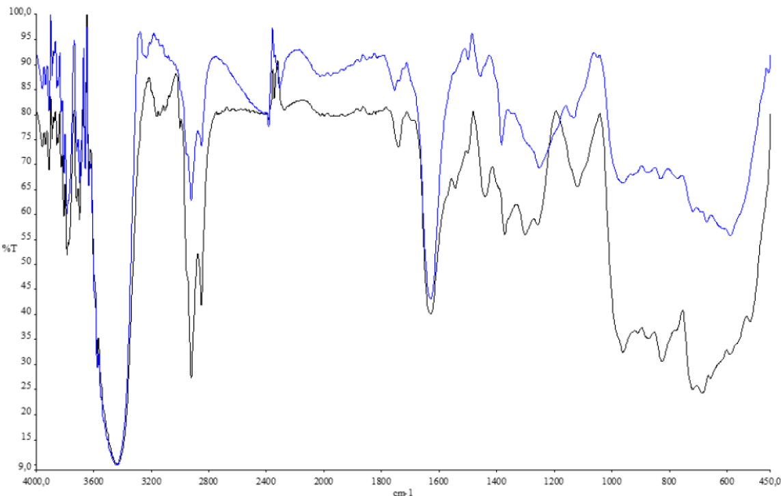
Figure 2: FTIR spectra of rubber samples before inoculation with fungi (black spectrum) and after 45 days of biodegradation (blue spectrum)
Figure 2 shows a decrease in the peaks of the spectrum in the region from 400 cm⁻¹ to 1200 cm⁻¹, which indicates breakage of some functional groups in the polymeric chain of poly-cis-1,4-isopropene such as C=C, carbonyl, methyl, and ester bonds. Changes in the stretch band between the 1400 cm-1 and 1200 cm-1 peaks indicate the formation of alkaloids. Additionally, there was a decrease in the stretching band between the 3200 cm⁻¹ peak and the 2800 cm⁻¹ peak, lengths where the vibration of the CH₂ radical occurs. However, the presence of biological activity by the white rot fungus on the surface of the used tire is confirmed by changes in the chemical structure of the rubber surface. These results are consistent with the studies conducted by Shah et al. (2013), who reported variations in the 834 cm⁻¹ peak, where there is stretching of the cis-1.4 double bond. As well as the appearance of ketones and alkaloids as metabolites of the enzymatic decomposition process of rubber. Based on the changes mentioned above, it is suggested that the biodegradation mechanism is oxidative.
    - Effect of substrate concentration on biomass production
Figure 3 shows the growth of the fungus for substrate concentrations in the range of 0 mg/L to 15 mg/L.

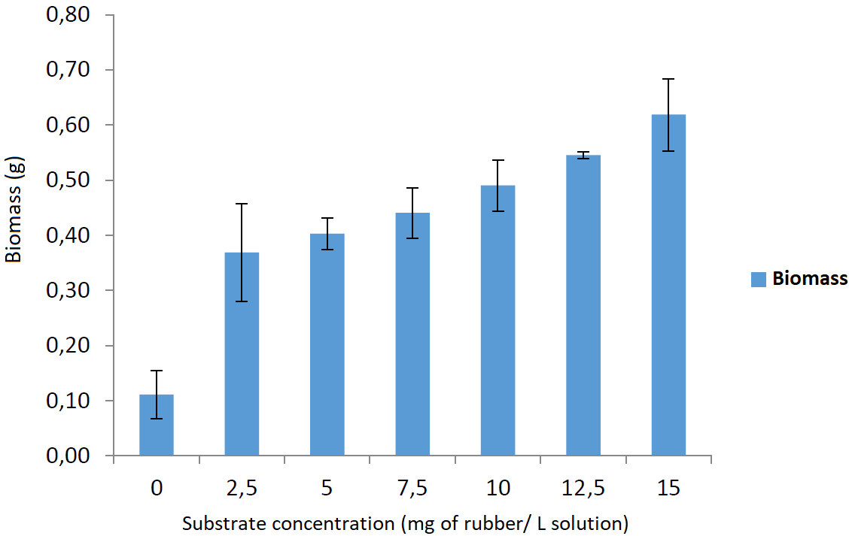
Figure 3: Germination of white rot fungus at different concentrations of rubber
The substrate concentration of 0 mg/L corresponds to the blank tests, which allowed discounting the amount of 110 ± 4 mg of dry biomass obtained from the nutrients present in the medium. The highest amount of dry biomass (619 mg) was obtained at tire concentrations of 15 ± 0.07 mg/L. On the other hand, the lowest amount of dry biomass of 365 mg was obtained for the tire concentration of 2.5 ± 0.07 mg/L. This result is consistent with the statements of Monod's law, which describes microbial growth as an exponential function of substrate concentration (Cavaleiro, 2016).
    - Modeling of the germination process
For the determination of the biodegradative potential of the fungus, three germination models were considered for a kinetic analysis of the process. The kinetic parameters of each model were calculated by using the curve fitting toolbox of the MATLAB® software. The description of each of these models is found below (Cavaleiro, 2016)

Monod equation
$$f\left(x\right)=u_{max}\left(\frac{x}{k_{m}+x}\right)$$ | (1)
𝑢_{𝑚𝑎𝑥} = maximum specific growth rate (h⁻¹)
𝑘_{𝑚} = average saturation coefficient (g/L)
𝑥 = substrate concentration

Haldane equation
$$f\left(x\right)=u_{max}\left(\frac{x}{k_{m}+x+k_{1}}\right)$$ | (2)
𝑘₁ = Haldane’s growth kinetic inhibition coefficient (g/L)

Hinshelwood equation
$$f\left(x\right)=u_{max}\left(\frac{x}{k_{m}+x}\right)\left(1-k_{p}P\right)$$ | (3)
𝑘_{p} = Propagation coefficient (g/L)

According to the results, the three models showed a good fit, with R² values ​​between 0.90 and 0.97 (see Table 2). The Monod model showed greater predictive capacity with R² = 0.97, which indicates that this model is adequate to predict the parameters calculated based on the real data obtained. The main advantage of the Monod model is its ability to satisfactorily fit the curved forms of fungus germination. Based on these results, it is possible to affirm that there is an affinity of the fungus towards the tire and, in turn, the growth of the fungus is due to a greater consumption of substrate.
Table 2: Mathematical model fit values
Model | R² | Adjusted R² | RMSE | SSE
Monod | 0.97 | 0.83 | 0.06 | 0.02
Haldane | 0.90 | 0.88 | 0.05 | 0.01
Hinshelwood | 0.97 | 0.72 | 0.08 | 0.02

Table 3 presents the coefficients of the models, which have in common the coefficient of 𝜇_{𝑚𝑎𝑥} defined as the maximum specific growth rate or maximum speed of biomass generation. The values ​​of the constant 𝜇_{𝑚𝑎𝑥} are indicators of the potential of the tire to generate Fungi biomass. Since the saturation coefficient (𝑘_{𝑚}) is lower than the substrate concentration, this suggests that as the fungus grows, it will consume more substrate.
Table 3: Parameters of the microbial germination models
Model | µ_{max} | k_{m} | k_{p} | k₁ | P
Monod | 0.66 | 2.65 | - | - | -
Haldane | 0.34 | 0.03 | - | - 0.03 | -
Hinshelwood | 0.82 | 2.65 | 0.92 | - | 0.21
  - Conclusions
In this research, a qualitative evaluation of the changes in the structural and chemical properties of waste tire rubber was carried out, evaluating the tolerant and biodegradation potential of the white rot fungus Pleurotus Ostreatus. It was found that the amount of biomass formed (fungal growth) is proportional to the concentration of waste tire rubber in the culture medium. According to the SEM and FTIR analyses, it was observed that the enzymatic action of the fungus caused erosion on the rubber surface. The germination modeling of the fungus allowed us to conclude that there is an affinity of the fungus towards the tire and that, as the fungus grows there will be greater consumption of substrate, since the saturation constant (𝑘_{𝑚}) is lower than the substrate concentrations. The models showed that germination data were predicted with confirmed accuracy at R² > 94%.
References
Andler R., 2020, Bacterial and Enzymatic Degradation of Poly(cis-1,4-isoprene) Rubber: Novel Biotechnological Applications, Biotechnology Advances, 44(3):107606.
Andler R., D’Afonseca V., Pino J., Valdés C., Salazar-Viedma M., 2021, Assessing the Biodegradation of Vulcanised Rubber Particles by Fungi Using Genetic, Molecular and Surface Analysis, Frontiers in Bioengineering and Biotechnology, 9, 761510.
Cavaleiro S., 2016, Evolutionary Algorithms for the Modeling of Bioreactors, M.Sc. Thesis, Universidade of Évora Escola de Cîencia e Tecnologia, Évora, Portugal.
Ellouze M., Sayadi S., 2016, White-Rot Fungi and their Enzymes as a Biotechnological Tool for Xenobiotic Bioremediation, Management of Hazardous Wastes, Chapter in: HEDM Saleh, ROA Rahman (Ed.), IntechOpen, UK, 64145.
Mohamed N.H., Ismail M.A., Abdel-Mageed W.M., Shoreit A.A.M., 2017, Biodegradation of Natural Rubber Latex of Calotropis Procera by Two Endopytic Fungal Species, Journal of Bioremediation and Biodegradation, 8(1), 380.
Rodrigues da Luz J.M., Soares da Silva M.D.C., Ferreira dos Santos L., Megumi Kasuya M.C., 2019, Plastics Polymers Degradation by Fungi, Chapter in: M Blumenber, M Shaaban, A Elgaml (Ed.), IntechOpen, UK, 70336.
Ruibal Villaseñor C., García A.M., Moreno Gómez D.A., Benavides, E., 2017, Process of Fungal Biodegradation on Ground Tires, In: Industriales Research Meeting 2017, Madrid, España, Conference Proceedings, p.168.
Shah A.A., Hasan F., Shah Z., Kanwal N., Zeb S., 2013, Biodegradation of Natural and Synthetic Rubber: A Review, International Biodeterioration & Biodegradation, 83, 145-157.
Singh S., Farooq D., Thakur R., 2017, Screening of Natural Rubber Degradation by Fungi; Aspergillus and Plebia Sp. and Bacteria Pseudomonas and Streptomyces sp., Research Journal of Pharmacy and Technology, 10(11), 3939-3944.
Srivastava N., Shukla A.K., Singh R.S., Upadhyay S.N., Dubey S.K., 2015, Characterization of Bacterial Isolates from Rubber Dump Site and their Use in Biodegradation of Isoprene in Batch and Continuous Bioreactors, Bioresource Technology, 188, 84-91.
Stevenson K., Stallwood B., Hart A.G., 2008, Tire Rubber Recycling and Bioremediation: A Review, Bioremediation Journal, 12(1), 1-11.
Tiseo I., 2021a, Global Production of Natural Rubber 2000-2020, Statista <www.statista.com/statistics/275387/global-natural-rubber-production/> accessed 18.01.2022.
Tiseo I., 2021b, Synthetic Global Production 2000-2020, Statista <https://www.statista.com/statistics/280536/global-natural-rubber-production/> accessed 18.01.2022.
Tsuchii A., Tokiwa Y., 2001, Microbial Degradation of Tyre Rubber Particles, Biotechnology Letters, 23(12), 963-969.

