CHEMICAL ENGINEERING TRANSACTIONS  VOL. 93, 2022 | A publication of
The Italian Association
of Chemical Engineering
Online at www.cetjournal.it

Guest Editors: Marco Bravi, Alberto Brucato, Antonio Marzocchella
Copyright © 2022, AIDIC Servizi S.r.l.
ISBN 978-88-95608-91-4; ISSN 2283-9216

Inoculation of compost biofilter for the simultaneous removal of H₂S and NH₃ under transient conditions of gas concentration
Diana G. Vela-Aparicio^{a,}*, Carlos J. Bautistaª, Daniel F. Forero^{b}, Paola Acevedo^{b}, Pedro F.B. Brandãoª, Iván O. Cabeza^{c,}*
ªUniversidad Nacional de Colombia, Facultad de Ciencias, Departamento de Química, Bogotá D.C.
^{b}Universidad Santo Tomás, Facultad de Ingeniería Ambiental, Bogotá D.C., Colombia
^{c}Universidad de la Sabana, Facultad de Ingeniería, Bogotá D.C., Colombia

*dgvelaa@unal.edu.co; ivan.cabeza@unisabana.edu.co

Biofiltration is economic biotechnology of high efficiency for the removal of odorous gases, such as hydrogen sulphide (H₂S) and ammonia (NH₃), produced in different activities such as wastewater treatment plants (WWTP). However, in the case of H₂S and NH₃ treatment, the fluctuations in the concentration of gases found in industrial emissions and the accumulation of oxidation products in the biofilter bed can affect the elimination efficiency. Considering this disadvantage, in this work, we evaluated the performance of compost biofilters inoculated or uninoculated with a microbial culture enriched in nitrifying and sulphur-oxidizing bacteria (SOB) for the removal of H₂S and NH₃ under transient conditions of concentration, simulating industrial operation. The compost bed was made from chicken manure and sugar cane bagasse, and the biofilter operating conditions were: 1) empty bed residence time of 25 s and 2) bed moisture of 40%. The gas concentration and transient conditions simulated the emissions of H₂S and NH₃ in the pre-treatment zone of a WWTP during the dry and rainy season in Bogota, Colombia. The biofiltration performance was evaluated considering the removal efficiency and oxidation products (sulphate, nitrate and ammonium). The biofilters had a 100% removal efficiency for both gases during the rainy season and transition stages. However, the H₂S and NH₃ oxidation was affected by the daily changes in gas concentration. The increase of gases concentration at the last week of the dry season resulted in a gradual decrease of H₂S and NH₃ removal efficiency for both biofilters. However, the reduction in the removal efficiency was higher in the uninoculated biofilter. In addition, there was a higher increase in nitrate concentration in the inoculated biofilter. These results indicate that the inoculated biofilter could adapt better to the transient conditions of gas concentration.
  - Introduction
Offensive odours are considered a form of air pollution since they affect the life quality of exposed people and cause damage to health and the environment. These odours are produced in different activities such as wastewater treatment and waste management by the emission of low detection threshold compounds such as hydrogen sulphide (H₂S), ammonia (NH₃) and volatile organic compounds (VOCs) (Barbusinski et al., 2017). Biofiltration offers a low investment, environmentally friendly, and high removal efficiency alternative to remove these pollutants and comply with air quality regulations. In a biofilter, the gases pass through a wet porous bed that contains microorganisms for contaminant degradation. The use of compost as a biofilter bed is frequent because this material is affordable, has an intrinsic availability of nutrients, has optimal water retention capacity and contains a diverse microbial community. The performance of a biofilter depends mainly on the filter bed and gas emissions properties. In industrial conditions, gas emissions usually have fluctuations in the concentration or even in the composition that could affect the biofiltration performance in the long term (Rene et al., 2013). In the biofiltration of H₂S and NH₃, the decrease in ammonia removal efficiency has been reported at high H₂S concentrations, a common situation in WWTP emissions (Kim et al., 2002). Also, the decrease in pH and the accumulation of ammonium, sulphate or elemental sulphur, products from the biological gas oxidation, can cause bed compaction problems and decrease the useful life of the biofilter (Le Borgne & Baquerizo, 2019). The accumulation of these compounds may reduce the area available for biofilm formation, inhibiting microbial growth and activity, thus causing a decrease in the elimination efficiency for one or more compounds (Tsang et al., 2015). These problems pose a challenge for the full-scale implementation of biofiltration with high long-term efficiency under often variable operating conditions. An option to overcome these disadvantages is the enrichment of the biofilter bed with nitrifying and sulphur-oxidizing bacteria (SOB) that can oxidise ammonium and sulphide, respectively, to recover the microbial activity of the biofilter. A similar strategy was applied in the biofiltration of volatile organic sulphur compounds by the inoculation of a compost biofilter with specific microorganisms that convert methylated sulphur compounds into sulphate and carbon dioxide (Smet & Van Langenhove, 1998) but has not been applied in the H₂S and NH₃ elimination by compost biofilters. Thus, this work evaluated the performance of a compost biofilter inoculated with an enriched microbial culture for H₂S and NH₃ removal under transient conditions of concentration that simulate gases emissions from a WWTP.
  - Materials and Methods
  - Enrichment of microbial culture
The microbial culture used as inoculum was obtained by dilution of digested sludge from the WWTP-El Salitre, Bogotá, Colombia, in a mineral medium with NH₄Cl, phosphate buffer, NaHCO₃, CaCl₂, MgCl₂ and metal trace solution at pH 8 (Beristain-Cardoso, Gómez and Méndez-Pampín, 2010; Bollmann & Laanbroek, 2001);. The culture was incubated at 30 ºC and 100 rpm in the darkness. 50% of the culture was transferred to a new medium when the ammonium was consumed. This step was repeated until the ammonium was consumed in 2-3 days.
Then, the culture was transferred to the same medium with an addition, every two days of sodium sulphide solution to reach 15 mg S/L in 5 L of culture. This transfer step was made each ten days for six months. Ammonium oxidation was confirmed in a culture aliquot by qualitative tests: ammonium consumption was verified by Nessler's reagent (no yellow colour appearance) and nitrite production by Griess' reagent (pink to purple colour appearance). Sulphate production was confirmed by BaSO₄ precipitation when BaCl₂ solution was added to a culture aliquot. The microbial culture was centrifuged, and cell biomass was washed with water and resuspended in 500 mL of saline solution for its use as inoculum.
  - Biofiltration system
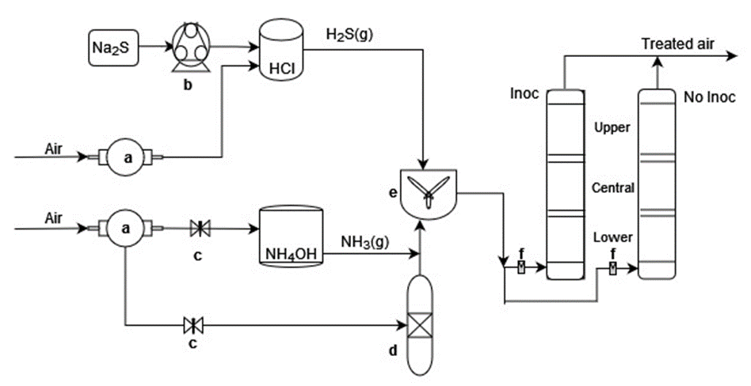

Figure 1. Gas generation system and laboratory-scale biofilters. a. Vacuum pump; b. Peristaltic pump; c. Valves; d. Humidifier; e. Mixing chamber; f. Flowmeters; Inoc. inoculated biofilter; No inoc, Uninoculated biofilter.
The packing material was obtained previously from the composting of sugarcane bagasse and two-year-old chicken manure in a 1:1 volume ratio. This material previously demonstrated high efficiency in the biofiltration of H₂S and NH₃ under steady conditions (Vela-Aparicio et al., 2021a).
The compost bed used in this work comes from two biofilters previously employed in biofiltration assays to evaluate transient operative conditions (Vela-Aparicio et al., 2021b). Thus, each section of the new biofilter was prepared from a mixture of compost from each section of those two biofilters. Then, half of the mixed compost was inoculated with the microbial culture and packed in the corresponding section of the new biofilter. The uninoculated biofilter was used as a control to verify the effect of the inoculation on the gases elimination.
The biofiltration system in a laboratory scale (Figure 1) consisted of two biofilters constructed with PVC pipes with a diameter of 10 cm, a height of 81 cm, and a total volume of 6.6 L. The biofilters had three sections of 27 cm in height and a sampling port to measure pollutant concentration.
H₂S and NH₃ were volatilized from an acidic solution (HCl) of Na₂S (0.005-0.035 M), and from a solution of NH₄OH 1%, respectively (Figure 1). Then, the gases were mixed with humidified air in a mixing chamber. Air from a vacuum pump was used to apply an ascending gaseous stream through the biofilters and to assure the desired gas inlet flow rate. This mixed stream was finally distributed into the biofiltration system.

  - Operation conditions of biofilters
The biofilters were operated at an empty bed residence time (EBRT) of 25s and moisture content bed of 40%. These conditions allowed the maximum elimination capacity for both gases (Vela-Aparicio et al., 2021b). The bed moisture content was monitored every two days and adjusted with water when necessary. The gas concentration and transient conditions applied during the evaluation were based on previous analysis of emissions in the pre-treatment zone of the WWTP-El Salitre, during the dry and rainy season in Bogota, Colombia (D G Vela-Aparicio et al., 2019)(Table 1). The gases concentration was increased weekly during the rainy season stage. In the transition and dry season stages, the gases concentration was changed daily to simulate the emission peaks reported during the night periods at the plant.
Table 1: H₂S and NH₃ concentrations at different stages of transient conditions. In parenthesis is indicated the daily duration of each concentration.
Stage | Day | [H₂S], mg/m³ | [NH₃], mg/m³
Rainy season | 1-22 | 5-20 | 0.5-2.0
Transition | 30-34 | 30 (2h)  12 (22h) | 3
 | 35-37 | 50 (3h)  20 (21h) | 3
Dry season | 37-42 | 20 (14h)  35 (10 h) | 1
 | 43-50 | 30 (14h) | 2 (14h)
 |  | 45 (10h) | 4 (10 h)
 | 51-59 | 50 (14h) | 3 (14h)
 |  | 75 (10h) | 5 (10 h)

2.3. Analytical methods
Gas concentration was measured in the inlet and outlet of the biofilters with a portable multi-gas monitor MultiRAE (PGM-6228 RAE Systems). The measurements were taken once the gas concentration was steady. Gases sampling was made three times per day, obtaining a daily average of gases removal data. The removal efficiency percentage (%RE) was calculated for each gas using the following equation:
$$\%RE=\frac{{(C}_{i}-C_{o})*100}{C_{i}}$$ | (1)
where, C_{i} is the gas inlet concentration (mg/m³), and C_{o} is the gas outlet concentration (mg/m³).

Compost samples were taken from the three sections of the bed before changing stages. The samples were mixed with KCl 0.01 M (weight ratio 1:10) and shaken for 30 min. Then, the supernatant was centrifuged at 5000 rpm for 10 min and filtered through a 0.22 µm membrane. This solution was used to analyse pH and ammonium concentration by the spectrophotometric method of Berthelot (reaction of ammonium with salicylate and hypochlorite) (Mulvaney, 1996). Nitrite, nitrate and sulphate ions quantification were carried out by anionic chromatography in a Dionex ICS 900 equipped with an IonPac AS22 column. The abundance of sulphur-oxidizing bacteria (SOB) and ammonia-oxidizing bacteria(AOB) was verified in a serial tenfold dilution of compost samples at the beginning and end of the assay by the plate count method in agar plates with sodium thiosulphate 10 g/L for SOB and ammonium sulphate 0.5 g/L for AOB (Kim et al., 2002; Kim & Ivanov, 2000).
  - Results and discuss
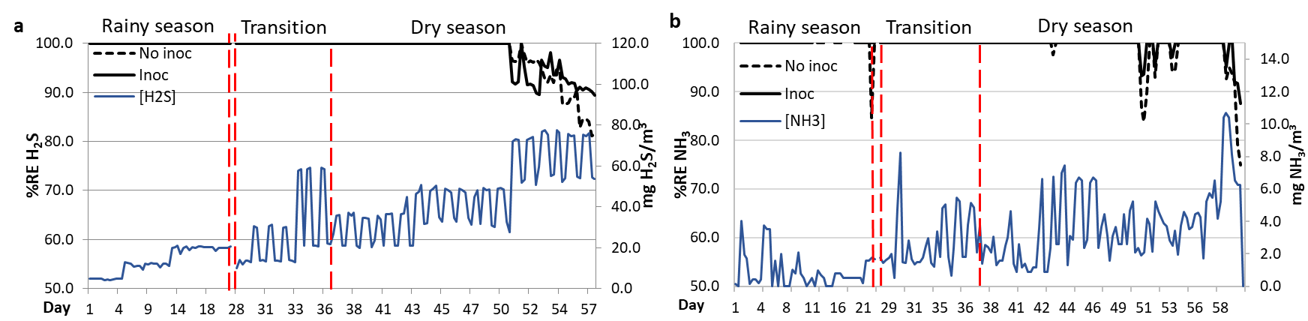
Figure 2. Biofiltration of (a) H₂S and (b) NH₃ under transitory conditions of gas concentration. Black lines represent the removal efficiency (%ER) of inoculated (Inoc) and not inoculated biofilters (No inoc). The continuous blue line indicates the inlet gas concentration. Dotted red vertical lines indicate the change in the type of transient condition applied. From day 25 to day 30 there was a stabilisation period at low gas concentration after a biofilter bed washing.
The removal efficiency for H₂S and NH₃ was 100% in both biofilters during the stage corresponding to the rainy season (Figure 2). However, the removal efficiency of NH₃ decreased and there was not a significant increase in the nitrate concentration after 21 days of operation at a low concentration of gases (Figure 3d). Besides, the sulphate concentration in the lower section of both biofilters decreased despite the reduction in pH, indicating that H₂S was possibly partially oxidised to elemental sulphur (Figure 3a, b). These results suggested that the biological oxidation of H₂S and NH₃ was probably affected by the high concentration of sulphate and ammonium accumulated in the bed from the previous test. Therefore, each section of the biofilters was washed with water to reduce the concentration of accumulated products.

After washing the biofilter beds, a low and constant gas concentration (stabilisation) was applied. In this stage, %RE was 100% for both gases, while nitrate concentration increased significantly, as well as sulphate concentration, in the low and central sections of both biofilters (Figure 3). These results suggest that the washing allowed the recovery of the microbial activity.

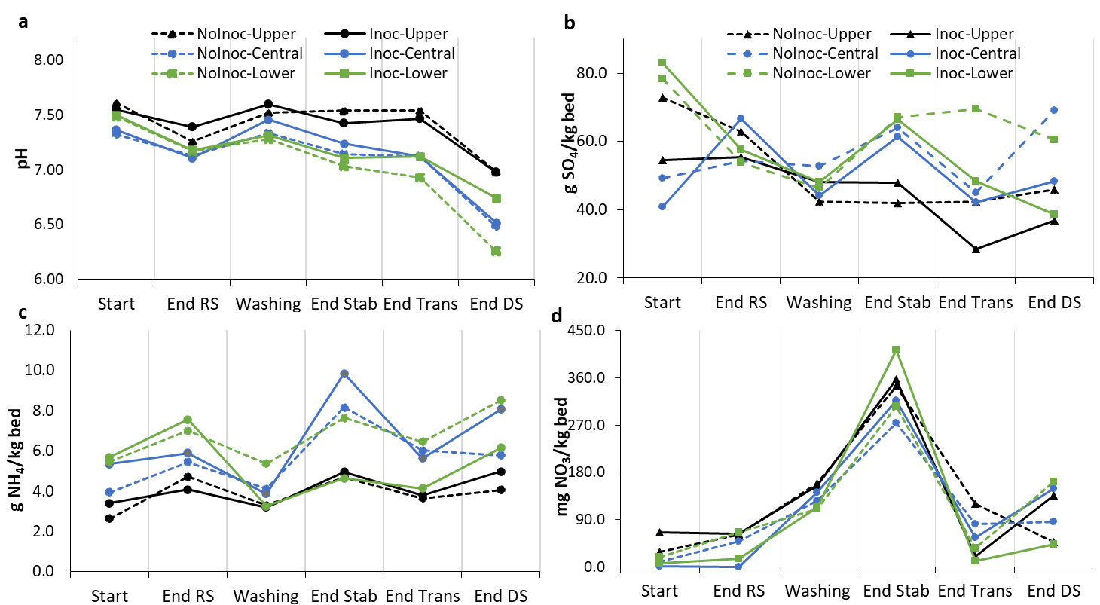
Figure 3. Monitoring of H₂S and NH₃ elimination products in upper, central and lower sections of uninoculated (NoInoc) and inoculated (Inoc) biofilters. (a) pH variation; (b) concentration of produced sulphate; (c) accumulated ammonium concentration; (d) concentration of produced nitrate. RS, Rainy season; Washing: sample was taken after bed washing; Stab, stabilisation stage; Trans, transition stage; and DS, dry season.
The removal efficiency was 100% for H₂S and NH₃ in both biofilters during the transition stage. However, the sulphate concentration again decreased along the inoculated biofilter and in the central section of the uninoculated biofilter (Figure 3b). This decrease could be caused by bacterial sulphate assimilation to synthesize organic sulphur compounds such as methionine and cysteine (Kawano et al., 2018). The differences in the sulphate concentration in the biofilters could be associated with a different microbial community in the inoculated bed. On the other hand, the NH₃ oxidation was similarly affected in both biofilters as nitrate concentration decreased even though ammonium concentration decreased and NH₃ removal efficiency was 100%. This result indicates that nitrite and nitrate, produced by ammonia oxidation, were reduced to nitrogen or nitrous oxide, a situation that has been reported previously in NH₃ biofiltration (Yang et al., 2014). These results suggest H₂S and NH₃ oxidation in both biofilters was affected by the daily changes in gas concentration.

Finally, in the first weeks of the dry season, the removal efficiency remained high for both gases (>98%). However, the removal efficiency of the two biofilters gradually decreased when the gases concentration was increased at 75 mg H₂S/m³ and 5 mg NH₃/m³ on day 51. Nevertheless, at the end of the evaluation, the inoculated biofilter showed higher removal of both gases than the uninoculated biofilter (Figure 2a). Also, sulphate concentration increased in the middle and upper sections of both biofilters but not in the lower one (Figure 3b), even though the reduction in pH suggested that the oxidation was taking place. On the other hand, nitrate concentration increased in the inoculated biofilter. However, its concentration was approximately 20 times lower than ammonium concentration (Figure 3c,d), indicating that nitrification was not the main pathway for NH₃ removal but ammonium accumulation.
The evaluation of bacterial abundance at the end of the assay showed a higher abundance of SOB and AOB in the inoculated biofilter, especially in the lower section (Figure 4), indicating the inoculum was able to adapt to the daily change in inlet gas concentration and could achieve H₂S and NH₃ oxidation. However, in the case of SOB, bacteria abundance decreased in the lower and central sections. This suggests a growth inhibition due to the high concentration of H₂S at the end of the process. Omri et al.(2013) reported similar results in the biofiltration of gases emitted in a WWTP.

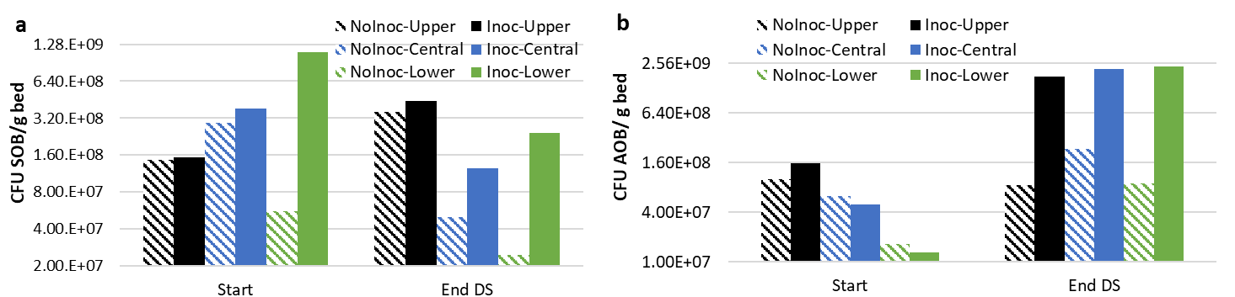
Figure 4. Bacterial abundance in upper, central and lower sections of uninoculated (NoInoc) and inoculated (Inoc) biofilters. (a) sulphur-oxidizing bacteria (SOB); (b)ammonia-oxidizing bacteria (AOB).
  - Conclusions
The implementation of full-scale biofiltration of H₂S and NH₃ has challenges in the long term as the efficiency decreases under variable operating conditions and changes in the bed. In this work, a compost biofilter was inoculated with an enriched culture with nitrifying and sulphur-oxidizing bacteria to improve H₂S and HN₃ elimination under these transient conditions. When the gases concentrations were increased and changed daily, the inoculated biofilter had 90-100% removal efficiency for H₂S, and 85-100% for NH₃, while the uninoculated biofilter had lower removal efficiency (80-95% for H₂S and 75-100% for NH₃). Furthermore, this efficiency was maintained at high concentrations of sulphate and ammonium in both biofilter beds. The results show the benefit of inoculating the biofilter bed under stress conditions during operation, such as changes in the gas concentration and product accumulation. However, the oxidation of NH₃ to nitrate is not the main elimination mechanism. Thus, strategies to avoid the reduction of nitrite and nitrate produced to avoid NO₂ emission are still required.
Acknowledgements
This work was financially supported by the Dirección de Investigación de la Sede Bogotá, Universidad Nacional de Colombia (DIB 34885), and by the Research Unit from the Universidad Santo Tomás (FODEIN 2021), Bogotá, Colombia. D. G. Vela-Aparicio acknowledges Minciencias for a doctoral fellowship (727 - Support to National Doctoral Program) and financial support to the work (Fondo Nacional de Financiamiento para la Ciencia, la Tecnología y la Innovación “Francisco José de Caldas”; DIB 42130).
References
Barbusinski, K., Kalemba, K., Kasperczyk, D., Urbaniec, K., & Kozik, V. (2017). Biological methods for odor treatment – A review. In Journal of Cleaner Production (Vol. 152, pp. 223–241). Elsevier Ltd. https://doi.org/10.1016/j.jclepro.2017.03.093
Beristain-Cardoso, R., Gómez, J., & Méndez-Pampín, R. (2010). The behavior of nitrifying sludge in presence of sulfur compounds using a floating biofilm reactor. Bioresource Technology, 101(22), 8593–8598. https://doi.org/10.1016/j.biortech.2010.06.084
Bollmann, A., & Laanbroek, H. J. (2001). Continuous culture enrichments of ammonia-oxidizing bacteria at low ammonium concentrations. FEMS Microbiology Ecology, 37(3), 211–221. https://doi.org/10.1016/S0168-6496(01)00163-5
Kawano, Y., Suzuki, K., & Ohtsu, I. (2018). Current understanding of sulfur assimilation metabolism to biosynthesize l-cysteine and recent progress of its fermentative overproduction in microorganisms. Applied Microbiology and Biotechnology, 102(19), 8203–8211. https://doi.org/10.1007/s00253-018-9246-4
Kim, H. S., Kim, Y. J., Chung, J. S., & Xie, Q. (2002). Long-term operation of a biofilter for simultaneous removal of H2S and NH3. Journal of the Air & Waste Management Association, 52(12), 1389–1398. https://doi.org/10.1080/10473289.2002.10470871
Kim, I. S., & Ivanov, V. N. (2000). Detection of nitrifying bacteria in activated sludge by fluorescent in situ hybridization and fluorescence spectrometry. World Journal of Microbiology and Biotechnology, 16(5), 425–430. https://doi.org/10.1023/A:1008949821236
Le Borgne, S., & Baquerizo, G. (2019). Microbial ecology of biofiltration units used for the desulfurization of biogas. ChemEngineering, 3(3), 1–26. https://doi.org/10.3390/chemengineering3030072
Mulvaney, R. L. (1996). Nitrogen—Inorganic Forms. In Methods of Soil Analysis Part 3—Chemical Methods (pp. 1123–1184). Soil Science Society of America, American Society of Agronomy. https://doi.org/10.2136/sssabookser5.3.c38
Omri, I., Aouidi, F., Bouallagui, H., Godon, J., & Hamdi, M. (2013). Performance study of biofilter developed to treat H 2 S from wastewater odor. Saudi Journal of Biological Sciences, 169–176. https://doi.org/10.1016/j.sjbs.2013.01.005
Rene, E. R., Kennes, C., & Veiga, M. C. (2013). Biofilters. In C. Kennes & M. C. Veiga (Eds.), Air Pollution Prevention and Control: Bioreactors and Bioenergy (First, pp. 60–72). John Wiley & Sons, Ltd.
Smet, E., & Van Langenhove, H. (1998). Abatement of volatile organic sulfur compounds in odorous emissions from the bio-industry. Biodegradation, 9(3–4), 273–284. https://doi.org/10.1023/a:1008281609966
Tsang, Y. F., Wang, L., & Chua, H. (2015). Simultaneous hydrogen sulphide and ammonia removal in a biotrickling filter: Crossed inhibitory effects among selected pollutants and microbial community change. Chemical Engineering Journal, 281, 389–396. https://doi.org/10.1016/j.cej.2015.06.107
Vela-Aparicio, D., Forero, D. F., Hernández, M. A., Brandão, P. F. B., & Cabeza, I. O. (2021). Simultaneous biofiltration of H₂S and NH₃ using compost mixtures from lignocellulosic waste and chicken manure as packing material. Environmental Science and Pollution Research, 28(19), 24721–24730. https://doi.org/10.1007/s11356-020-10817-w
Vela-Aparicio, Diana G., Forero, D. F., Fernandez, A., Hernandez, M. A., Brandão, P. F. B., & Cabeza, I. O. (2021). Operational parameters analysis for the removal of H₂S and NH₃ under transient conditions by a biofiltration system of compost beds. Chemical Engineering Transactions, 85(March), 163–168. https://doi.org/10.3303/CET2185028
Yang, L., Kent, A. D., Wang, X., Funk, T. L., Gates, R. S., & Zhang, Y. (2014). Moisture effects on gas-phase biofilter ammonia removal efficiency, nitrous oxide generation, and microbial communities. Journal of Hazardous Materials, 271(2), 292–301. https://doi.org/10.1016/j.jhazmat.2014.01.058

