CHEMICAL ENGINEERING TRANSACTIONS  VOL. 93, 2022 | A publication of
The Italian Association
of Chemical Engineering
Online at www.cetjournal.it

Guest Editors: Marco Bravi, Alberto Brucato, Antonio Marzocchella
Copyright © 2022, AIDIC Servizi S.r.l.
ISBN 978-88-95608-91-4; ISSN 2283-9216

Initial Rate of Hydrolysis of Coffee Silverskin by a Commercial Cellulase Cocktail
Adriana Posilipo ª, Maria E. Russo^{b}
ª Dipartimento di Ingegneria Chimica dei Materiali e della Produzione Industriale, Università degli Studi di
Napoli Federico II, P.le V. Tecchio 80, 80125 Napoli, Italy,
^{b} Istituto di Scienze e Tecnologie per l’Energia e la Mobilità Sostenibili, Consiglio Nazionale delle Ricerche,
P.le V. Tecchio 80, 80125 Napoli, Italy
adriana.posilipo@unina.it
The biorefinery of lignocellulosic wastes allows decreasing the emission of greenhouse gases by the introduction of eco‐friendly alternatives such as biofuels and bioproducts, reducing the cost of waste disposal and overcoming the environmental problems related to the production of first-generation biofuels by dedicated cultures. The enzymatic hydrolysis of waste biomasses is one of the crucial steps of the biorefinery process; it is aimed at obtaining fermentable sugars starting from the complex carbohydrates (cellulose and hemicellulose). Among the biomasses classified as lignocellulosic wastes, Coffee Silverskin (CSS) is one of the most abundant residues from the roasting process of the coffee industry. CSS is the external layer protecting the coffee beans and is composed almost by carbohydrates (≈40% w/w) and lignin (≈30% w/w).
The present contribution is part of a study focused on the characterization of enzymatic hydrolysis kinetics of real wastes biomass. In particular, the initial rate of glucose production has been characterized in a bench scale stirred reactor (0.5 L) using a commercial cellulase cocktail (Cellic® CTec2). The experimental procedure included an enzyme adsorption step on CSS followed by the hydrolysis step. Initial glucose production rate was assessed at 10 and 15 min at different stirring rates, the results shows that the initial rate increased at increasing stirring speed with a more evident variability than that observed for initial hydrolysis rates assessed after 60 min in previous work (Procentese et al., 2020). This result agrees with the literature (Hou et al., 2016) because is likely due to the early changes in morphology and size of biomass granules occurring during the first hour of enzymatic conversion. Further investigation of the effect of biomass morphology and size on the initial rate of glucose production has been carried out by laser scatter analysis of particle size and scanning electron microscopy.
  - Introduction
The climate change crisis asks for an urgent reduction of the use of fossil resources and the emission of greenhouse gases (Parajuli et al., 2015). One of the main strategies proposed so far to replace these resources with green alternatives is the development of biorefinery for the production of fuels and bio-based chemicals. This strategy allows to recover valuable products from lignocellulosic biomass. Biorefinery lignocellulosic biomass includes the sugar-based platform that is mainly performed through three steps: (I) the pre-treatment of the raw biomass to remove/transform the lignin fraction and make the cellulose and hemicellulose accessible to (II) the hydrolytic enzymes that convert the polysaccharides into monomeric sugars that, in the end, (III) are used as substrate for engineered microorganism’s cultivation allowing the production of bio-commodities.
The enzymatic hydrolysis is an heterogenous process in which the solid biomass is dispersed in the liquid phase containing the enzymes (Zhang et al., 2021). During this process the cellulase enzymes are transferred from the liquid phase to the solid surface, adsorbed on the biomass surface where the cellulose binding domains can bind the polysaccharide chains and then start the hydrolysis (Jeoh et al., 2017). These steps control the overall rate of sugar release in the liquid together with the intrinsic kinetic of the cellulase (e.g. affected by product inhibition). Operating conditions such as pH, stirring speed, biomass concentration, and enzyme related factors (loading, specific activity and stability) can influence each of the phenomena involved in the heterogeneous enzymatic hydrolysis of biomass particles (Arora et al., 2018; Olivieri et al., 2021). In the framework of kinetic characterization of heterogeneous enzymatic hydrolysis of lignocellulosic biomass feedstock, the assessment of initial sugars production rate is important to describe the early step of the biomass conversion that can be quantified by proper kinetic models (Russo et al., 2022) and to understand the decrease in slurry viscosity that is typically observed in the early part of the batch industrial process. The present work aims to investigate the effect of the stirring speed on the initial glucose production rate over 60 min of enzymatic hydrolysis of alkali pre-treated CSS and to analyse the biomass modifications occurring along the first 24h of the enzymatic conversion process.
  - Materials and methods
    - Feedstock
The lignocellulosic biomass used was Coffee Silverskin (CSS) (IllyCaffè S.P. A., Trieste, Italy). CSS is the tegument of the coffee bean and results as waste after the coffee bean-roasting process. CSS was milled in a steel blade mill (MF 10, IKA, Staufen, Germany) and sieved in the rage 0.5-1 mm, then stored in boxes at room temperature until use.
    - Cellulases
A commercial enzyme cocktail, Cellic® Ctec2 (Novozymes Latin America, Araucária, PR, Brazil) was selected as biocatalyst for the biomass hydrolysis. This cocktail contains high concentration of cellulases, hemicellulases, and β-glucosidases. The total enzymes concentration was determined through Bradford’s assay (Bradford, 1976) and the activity was determined in terms of Filter Paper Units (FPU) according to Adney and Baker (1996).

    - Biomass pre-treatment
Alkali delignification was selected according to previous studies (Russo et al., 2022). The delignification pre-treatment of CSS was carried out in 100 mL glass bottles. Milled CSS was mixed with 0.5 M NaOH solution at 10% (w/v) biomass concentration. The suspension was kept in autoclave (Nuve NC 40M, Turkey) for 30 min at 2 atm and 121°C. Pre-treated samples were centrifuged, and the solid residues were recovered and washed with distilled water and 1 M HCl solution until pH 5 was reached. The solid was then vacuum filtered and dried in oven at 50°C until constant weight was reached. The biomass composition of raw CSS and pre-treated CSS was assessed according to Sluiter et al. (2008) and is reported in table 1.
Table 1. Biomass composition.
 | Moisture, % | Glucans, % | Xylans, % | Arabinans, % | Acid soluble lignin, % | Acid insoluble residue, %
Raw CCS | 1.45±0.52 | 19.5 ± 0.008 | 7.72 ± 0.001 | 1.90 ± 0.001 | 0.983 ± 0.021 | 27.3 ± 0.58
Pre-treated CSS | 3.93±1.18 | 32.0 ± 0.004 | 13.6 ± 0.004 | 0.673 ± 0.0004 | 0.577 ± 0.052 | 57.3 ± 0.60
    - Enzymatic hydrolysis
The hydrolysis tests of alkali pre-treated CSS were carried out in 500 mL jacketed reactor (inner diameter 5 cm, height 10 cm), with 10% wt biomass, 1g/L Cellic® Ctec2 (810 FPU/L) in 0.05M sodium citrate buffer at pH 4.8. An overhead stirrer (CAT, M. Zipperer GmbH, Germany) (Rushton turbine) was used and stirring rate was changed in the range 0-500 rpm. The procedure included two subsequent steps: i) enzyme adsorption, ii) enzymatic hydrolysis. In the first step the biomass (10% w/v) was kept for 15 minutes at 25°C in presence of 1 g/L of Cellic® Ctec2 at fixed stirring speed 300 rpm to allow the adsorption of the cellulases on the biomass surface. In the second step, enzymatic hydrolysis of polysaccharides was initiated by increasing the temperature up to 50°C that is the optimal conditions for cellulase activity. The second step was repeated at different stirring speed namely 0, 100, 200, 300, and 500 rpm. The second step was stopped at 1h by adding 2M NaOH. Long-term tests (with second step lasting 24 h) were also performed to investigate the structural modifications of the biomass granules at fixed stirring speed (200 rpm).
    - Determination of sugars concentration
The hydrolysis of polysaccharides was assessed by monitoring the release of monomeric sugars in the liquid. During the enzymatic hydrolysis tests, samples were withdrawn at fixed times (0-5-10-15-30-60 min), centrifuged at 13000 rpm (Minispin, Eppendorf) to recover the liquid. The sugars concentration in the liquid was assessed by HPLC (Agilent 1100 Series, with Rezex RHM-Monosaccharide H⁺ Column) after samples filtration (PVDF 13 mm, 0.22 μm, Millex).
    - Characterization of biomass structural modifications
The biomass granules structural modifications due to the enzymatic hydrolysis were analyzed on samples withdrawn at fixed times (0-1-4-24h) through laser scatter granulometer (Mastersizer2000, Malvern Panalytical, Malvern UK) and Scanning Electron Microscopy (SEM) (FEI Inspect S, Oregon, United States). The control sample was prepared as the tests samples except for the enzymes replaced by citrate buffer, and analyzed following the same procedure.
The samples recovered during the enzymatic hydrolysis have been inactivated adding 2M NaOH to stop reactions before structural analysis. Laser scatter granulometry was performed with and without ultrasounds to assess the presence of particles aggregates. CSS slurries were used for SEM analysis. At this purpose, the samples were diluted 1:50 in 0.05M sodium citrate buffer at pH 4.8, and a single drop was put on the specimen, air-dried, sputtered with a gold layer, and then analyzed.
  - Results and discussions
    - Effects of stirring speed on the initial glucose production rate
The enzymatic hydrolysis of real biomasses is a heterogeneous process affected by different parameters. Among these, the stirring speed has been investigated by measuring the initial glucose production rate during the first 10 and 15 minutes of the hydrolysis.
The results are reported in Figure 1 and show how the initial glucose production rate r₀ changes with the increasing stirring speed. An almost constant r₀(60 min) is observed approaching 0.2 g/Lmin, while a scattered increase up to 0.6 and 0.7 g/L min is observed for r₀(15 min) and r₀(10 min), respectively. More evident increase on initial glucose production rate at 60 min was reported by Pratto et al. (2016), Procentese et al. (2020), and Russo et al. (2022) for sugarcane straw, apple pomace, and CSS respectively. The reported values referred to lower enzyme loading and showed lower values of initial rate r₀(60 min) suggesting a more marked impact of stirring rate on biomass slurry poorly saturated with enzymes.

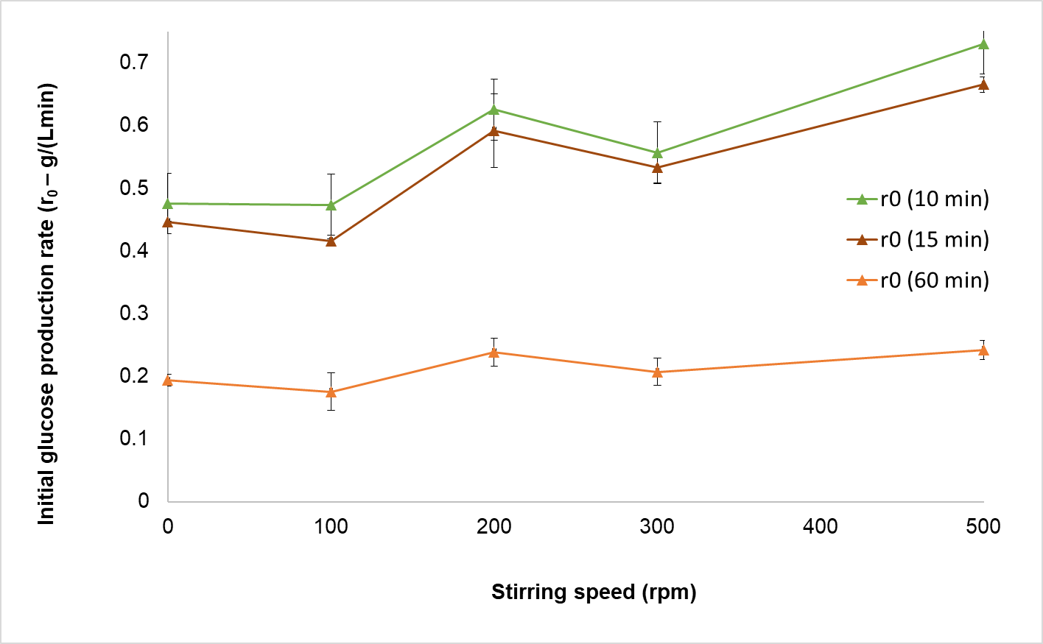
Figure 1. Initial glucose production rate (r₀) assessed at 10 (green), 15 minutes (brown) and 60 minutes (orange) of alkali pre-treated CSS enzymatic hydrolysis at different stirring speed.
The modification of biomass structure occurring in the first hours of batch enzymatic hydrolysis processes are documented in the literature and causes remarkable reduction of slurry viscosity indeed this part of the process is referred as ‘liquefaction’ (Gonzales Quiroga et al., 2015). The occurrence of structural modification in the early enzymatic conversion has been also reported (Hou et al. 2016) with no further modifications after the first 60 min, while the maximum polysaccharides conversion is achieved after 12 h.
Due to structural modification of biomass granules taking place for time lower than 1h, the more evident effect of stirring speed on initial rates r0(10 min) and r0(15 min) is expected since granules modification (e.g. size reduction and disaggregation) may be favored by increasing stirring speed. On the basis of the reported data and of studies by Gonzales Quiroga et al. (2015) and by Hou et al. (2016) further assessment on the CSS granules size and morphology were performed to investigate any potential influence on r₀.
    - Characterization of CSS granules size during the enzymatic hydrolysis
Laser scatter granulometry analysis was performed to assess how the particle size distribution varies during the conversion of polysaccharides. To this purpose, the enzymatic hydrolysis was carried out for 24h and the samples were taken at fixed times (0-1-4-24 h). The values of initial glucose production rate assessed during the hydrolysis test were r₀(10 min) = 0.62 g/L min and r₀(15 min) = 0.61 g/L min. The particle size distributions are reported in Figure 2a-d for hydrolyzed and control samples of CSS.
At the beginning of the hydrolysis test the biomass particle size has the highest dominant length (423 µm) slightly affected by the aggregates (shift to 336 µm with sonication). The dominant particle size decreased with time and approached an almost constant value (106 µm) between 4 and 24 hours (Figure 2a). The glucose concentration increased between 4 and 24 hours from 30.2 to 35 g/L. The control test showed a nearly constant particle size distribution results over 24 hours (Figure 2c and d) due only to the stirring applied to the biomass slurry in the absence of enzyme hydrolytic activity. These results confirm that the change observed in the biomass granules size are mainly due to the hydrolytic action of cellulases. In addition, stirring can reasonably affecting initial rates r₀(10-15 min) since over this incipient conversion of biomass granules modifies their size, on the contrary the size of granules approaches an almost constant size distribution over 1h hydrolysis, thus negligible effect of stirring on r₀(60 min) is expected.

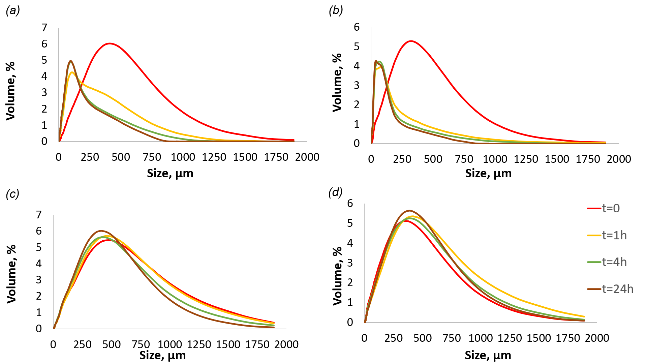
Figure 2. Particle size distribution during alkali pre-treated CSS hydrolysis with 1 g/L Cellic ® CTec2 at 200 rpm. Hydrolysis samples analysed (a) without and (b) with ultrasound, control sample analysed (c) without and (d) with ultrasound.
    - Characterization of CSS granules morphology during the enzymatic hydrolysis
Further assessments on the biomass morphology have been made through Scanning Electron Microscopy in (SEM). Samples of CSS slurries corresponding to fixed hydrolysis times (0-1-4-24h) have been analyzed at 800x magnification. The SEM images are reported in Figure 3 together with the control sample kept in the same conditions in the absence of enzymes.
The pre-treated CSS biomass is made by both lamellar and amorphous regions. The latter covers in some points the lamellar fractions. This microstructure did not result much altered over 24 h in the control sample (Figure 3a-d). As expected, the images of the hydrolysed CSS samples (Figure 3e-h) show morphological changes over 24 h of the analysed samples. In particular, the cellulase catalysis is mostly active on the microstructure of the amorphous fraction since no relevant changes can be detected on the lamellar portions. So, the hydrolytic process induces an alteration of the amorphous regions that appear to be more extended and fragmented. Differences in surface morphology between hydrolyzed CSS and control samples suggest the presence of adsorbed enzymes on the hydrolyzed biomass according to Russo et al. (2022). These results suggest that the disaggregation of the amorphous region due to the hydrolytic activity of cellulases support the size reduction of biomass particles reported in the previous section.

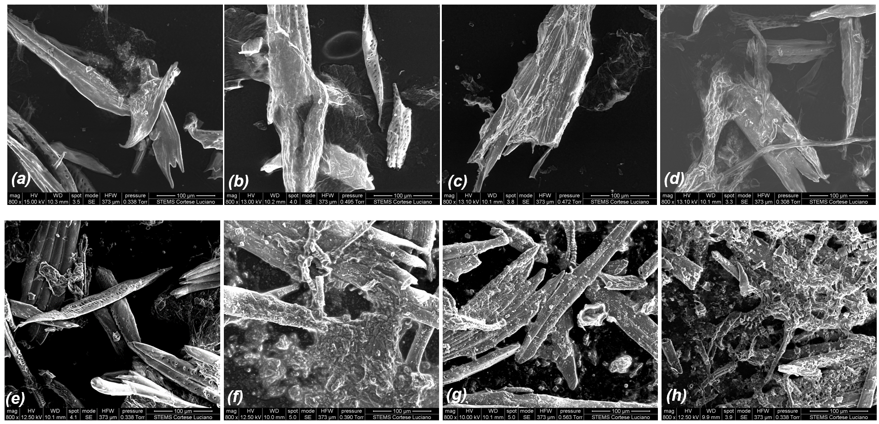
Figure 3. SEM images of CSS samples after 0-1-4-24 h incubation at 50°C under stirring at 200 rpm and citrate buffer (see section 2.4). Control samples (a-d), CSS hydrolysed with Cellic® CTec2 (e-h).
  - Conclusions
The enzymatic hydrolysis of coffee silverskin is relevant in the framework of second generation biorefineries development. This work reports the assessment of CSS granules morphology changes occurring during hydrolysis with the commercial cocktail CelliCtec2®. This phenomenon has been investigated in terms of the effect of stirring on the initial (10-60 min) glucose production rate, the size reduction of biomass particles, and the microstructure modifications occurring over 24h hydrolysis. The effect of increasing stirring speed was evident on initial glucose production rate assessed up to 15 min while it was negligible on the hydrolysis rate assessed over 60 min. These results were confirmed by the analysis of CSS particle size distribution. Indeed, the CSS particles underwent size reduction due to polysaccharide hydrolysis in the first 60 min, then no further size reduction was observed even the enzymatic conversion was still ongoing until 24h. Also microstructural analysis provided a qualitative indication of the effect of cellulolytic enzymes over the CSS particles, because showed the fragmentation of the amorphous regions from 1 to 24 h hydrolysis.
In conclusion, this investigation proposed further insight of the heterogeneous hydrolysis process of a real biomass feedstock by commercial enzymes cocktail and the quantitative results (initial rate of glucose production as well as particle size distribution) may be used to develop tools for bioreactor rational design.
Acknowledgements
The study has been funded by the Italian ‘Ministero dell’Università e della Ricerca’ within the Programma Operativo Nazionale -PON project ARS01_00985 ‘Biofeedstock - Sviluppo di piattaforme tecnologiche integrate per la valorizzazione di biomasse residuali.
Mr. Luciano Cortese and Dr. Paolo Trucillo are gratefully acknowledged for assistance in performing granulometry and SEM analysis.
References
Adney B., Baker J., 1996, Measurement of Cellulase Activities: Laboratory Analytical Procedure (LAP).
Arora A., Banerjee J., Vijayaraghavan R., MacFarlane D., and Patti A. F., 2018, Process Design and Techno-Economic Analysis of an Integrated Mango Processing Waste Biorefinery, Industrial Crops and Products 116 (June), 24–34.
Bradford, M. 1976, A Rapid and Sensitive Method for the Quantitation of Microgram Quantities of Protein Utilizing the Principle of Protein-Dye Binding, Analytical Biochemistry, 72 (1–2).
Hou W., An R., Zhang J., Bao J., 2016, On-Site Measurement and Modeling of Rheological Property of Corn Stover Hydrolysate at High Solids Content, Biochemical Engineering Journal, 107, 61–65.
Jeoh T., Cardona M. J, Karuna N., Mudinoor A. R., Nill J., 2017, Mechanistic Kinetic Models of Enzymatic Cellulose Hydrolysis-A Review, Biotechnol. Bioeng, 114, 1369–85.
Olivieri G., Wijffels R. H., Marzocchella A., Russo M.E., 2021, Bioreactor and Bioprocess Design Issues in Enzymatic Hydrolysis of Lignocellulosic Biomass, Catalysts, 11 (6).
Parajuli R., Dalgaard T., Jørgensen U., Adamsen A.P.S., Trydeman Knudsen M., Birkved M., GyllingM., Schjørring J.K., 2015, Biorefining in the Prevailing Energy and Materials Crisis: A Review of Sustainable Pathways for Biorefinery Value Chains and Sustainability Assessment Methodologies, Renewable and Sustainable Energy Reviews, 43, 244–63.
Pratto B., Beraldo Alencar de Souza R., Sousa R., Gonçalves da Cruz A.J., 2016, Enzymatic Hydrolysis of Pretreated Sugarcane Straw: Kinetic Study and Semi-Mechanistic Modeling, Applied Biochemistry and Biotechnology, 178 (7), 1430–44.
Procentese A., Russo M.E., Di Somma I., Marzocchella A., 2020, Kinetic Characterization of Enzymatic Hydrolysis of Apple Pomace as Feedstock for a Sugar-Based Biorefinery, Energies, 13 (5).
Russo M.E., Procentese A., Montagnaro F., Marzocchella A., 2022, Effect of enzymes adsorption on enzymatic hydrolysis of coffee silverskin: kinetic characterization and validation. Biochemical Engineering Journal, 180, 108364.
Sluiter A, Hames B, Ruiz R, Scarlata C., Sluiter J, Templeton D., 2008, Determination of Structural Carbohydrates and Lignin in Biomass - Laboratory Analytical Procedure.
Talebnia F., Karakashev D., Angelidaki I., 2010, Production of Bioethanol from Wheat Straw: An Overview on Pretreatment, Hydrolysis and Fermentation, Bioresource Technology, 101 (13), 4744–53.
Zhang H., Han L., Dong H., 2021, An Insight to Pretreatment Enzyme Adsorption and Enzymatic Hydrolysis of Lignocellulosic Biomass: Experimental and Modeling Studies, Renewable and Sustainable Energy Reviews, 140, 110758.

