CHEMICAL ENGINEERING TRANSACTIONS  VOL. 93, 2022 | A publication of
The Italian Association
of Chemical Engineering
Online at www.cetjournal.it

Guest Editors: Marco Bravi, Alberto Brucato, Antonio Marzocchella
Copyright © 2022, AIDIC Servizi S.r.l.
ISBN 978-88-95608-91-4; ISSN 2283-9216

Valuable routes for sewage sludge utilization: effect of temperature and hydraulic retention time in the acidogenic fermentation process
F. Valentinoª , A.C. Parmarª , F. Micolucci^{b} , J. Dosta^{c} , P. Pavanª, M. Gottardoª
ªDepartment of Environmental Sciences, Informatics and Statistics, Cà Foscari University of Venice, Via Torino 155, 30170 Mestre-Venice, Italy;
^{b}Department of Biological and Environmental Sciences, University of Gothenburg, & Swedish Mariculture Research Center (SWEMARC), P.O. Box 463, SE-405 30, Gothenburg, Sweden;
^{c}Department of Chemical Engineering and Analytical Chemistry, University of Barcelona, C/Marti i Franquès 1, Barcelona, Spain.
francesco.valentino@unive.it
The disposal of sewage sludge potentially reaches the 50-60% of WWTP’s total operation cost. Such stream can be considered a renewable carbon source to produce added-value products. Different pre-treatment methods have been applied on thickened sewage sludge (SS) coming from the domestic wastewater treatment plant (WWTP) of Treviso (northeast Italy) to favour its acidogenic fermentability. Alkaline (pH 9-11) and thermal (50-70°C) hydrolysis were applied separately and in combination The following fermentation process was addressed to the recovery of volatile fatty acids (VFA) as valuable building blocks substances. Batch fermentation tests were conducted at lab-scale under controlled temperature (T): 20, 37, 55 and 70°C by using an available mixed fermentative consortium as inoculum. Thermophilic T (55°C) was chosen in the following semi-continuous fermentation process (fill and draw), carried out with three different hydraulic retention time (HRT; 4-5-6 days). In terms of organic matter solubilisation, the thermal hydrolysis (70°C) allowed to obtain a soluble chemical oxygen demand (COD_{SOL}) concentration around 10.0 g/L, with no additional benefits from the combined alkaline treatment. The batch acidogenic fermentation tests highlighted the T effect on acidification performances; thermophilic trials (55°C) showed the highest COD_{VFA}/COD_{SOL} ratio (0.81). The three semi-continuous tests (HRT 4-5-6 days) were followed for 45 days (roughly), under the chosen thermophilic condition (55°C). The highest fermentation rate was obtained at 4.0 d as HRT (22 mgCOD_{VFA}/gVS d); on the contrary, the highest fermentation yield (0.30 gCOD_{VFA}/gVS) and COD_{VFA}/COD_{SOL} ratio (0.73) were obtained at 6.0 d as HRT. In practice, low HRT selected for a mixed consortium with high fermentation rate, but less efficient in the conversion of the organic matter into VFA. No HRT’s effect was instead observed in the VFA composition, always rich in acetic (29-31% COD basis) and butyric acid (31-32%), and poorer in propionic (14-15%), valeric (12-13%) and caproic acid (11-12%).
  - Introduction
The volume of sewage sludge (SS) from wastewater treatment plants (WWTP) has increased in recent years due to population expansion and subsequent urbanization (Li et al. 2018). The disposal of these sludges, which accounts for 50-60% of overall WWTP running costs, must be completed (Liu et al., 2018). These sludges are abundant in protein and carbohydrates, and they are readily available as urban resources (from WWTPs). Anaerobic fermentation, for example, produces volatile fatty acids (VFA) from numerous types of organic waste (Liu et al., 2018). As a result, WWTPs are now evaluated not only on effluent quality, but also on materials recovered and wastewater resources to increase water sector sustainability towards circular economy. Anaerobic fermentation is a phase of anaerobic digestion when organic matter is digested in different organisms without oxygen, converting the organic substrate mainly into CO₂ and H₂ (Zhang et al., 2019), via three process steps: hydrolysis, acidogenesis and acetogenesis. In the acetogenesis phase, fermentative bacteria metabolize soluble chemicals derived from the hydrolysis phase to produce VFA. Due to their functional groups, (VFA) are frequently employed in the chemical industry. They are usually recovered from petroleum fuels, increasing greenhouse gases and pollutants. VFA are short-chain linear mono aliphatic molecules (2-6 carbon atoms) that may be used to make biofuels (like methane and hydrogen), remove nutrients from wastewater, and synthetize microbial biopolymers (such as polyhydroxyalkanoates, PHA; Moretto et al. 2020). A thermoplastic biodegradable polymer like PHA is a sustainable alternative to the petroleum-derived polymers, which have been in high demand for decades, due to their low cost and durability and despite of the environmental concerns. VFA can also be used as carbon sources for biological nutrient elimination (nitrogen and phosphorus) in WWTPs. Methanol is commonly utilized for this purpose, however VFA can be similarly effective and less costly if produced from sludges within the same WWTP (Zhang et al., 2019). Other applications have also their commercial interest; to name a few, acetic acid is used in chemical manufacturing, esters production, and food colorant and additive solvents; butyric acid is used as an aromatic, pharmaceutic, or animal nutrition ingredient. A critical aspect for waste derived VFA is the extraction from fermentation broth, which may affect the production costs (Braguglia et al., 2018). Methods that have been developed include liquid-liquid extraction, membrane process, adsorption, ion-exchange and distillation and evaporation. Some are more costly or efficient than others and must be selected based on the broth's chemical and physical properties, as well as the desired VFA.
Anaerobic fermentation in urban scenario, where organic substrate is constantly accessible could represent a way for more sustainable waste management (Moretto et al., 2020). This research evaluated thermal and alkaline SS pre-treatment (isolated and in combination) for the solubilisation of the organic matter and its utilisation in a following acidogenic fermentation process, addressed to the synthesis of VFA. Fermentation batch tests were performed in a wide range of temperature (20-70°C), by using the pre-treated sludge collected before. Finally, a single and fixed T was chosen and applied to the semi-continuous fermentation tests, where three different hydraulic retention time (HRT; 4-5-6 days) were applied to compare the VFA production (maximal VFA concentration, fermentation rates and yields) and VFA composition (from acetic to caproic acids).
  - Materials and Methods
2.1 Configuration and process set up
The pre-treatment step was conceived to solubilize the organic matter (volatile solids; VS) and, therefore, to increase the soluble chemical oxygen demand (COD_{SOL}) in the liquid phase. Alkaline tests were carried out at pH 9.0 (A1) and 11.0 (A2) by adding 3.0 M NaOH solution. Thermal pre-treatment tests were performed at 70°C (T1) and 90°C (T2), controlled in the oven. In the combined pre-treatment, the pH value was equal to 11.0, and the T was controlled at 70°C (A2-T1) and 90°C (A2-T2). Each test was conducted in duplicate, in a 2.0 L glass bottles for 24 h.
Batch fermentation tests were carried out for up to 7 days with sludge obtained from T1 pre-treated test, at four different T (from mesophilic to hyperthermophilic conditions) by using an available mixed fermentative consortium as inoculum: 20°C, 37°C, 55°C and 70°C. Daily, a liquid sample was taken for VFA analysis and pH measurements. Ammonium, phosphate and COD_{SOL} was analyzed at the end of the test. Each test was conducted in duplicate, in a 2.0 L glass bottle. After evaluation of fermentation performances in batch tests, a semi-continuous fermentation process was performed at 55°C. Such experiment was conducted in 0.8 L (working volume) glass bottle, kept at a constant T in an oven for nearly 35 days. Three different HRTs were examined i.e., 4-5-6 days. The slurry was mixed with magnetic stirrer and periodically, a small aliquot of sample was taken for COD_{SOL} and VFA analysis, and pH measurements. For the sampling, the bottles were opened and maintained under N₂ flux for 15 min to re-establish anaerobic conditions.

2.2 Analytical methods.
For the quantification of total and volatile solids (TS; VS), COD_{SOL}, ammonia, phosphate, total kjeldahl nitrogen (TKN) and total phosphorus (P_{TOT}), the analyses were performed in accordance with Standard Methods (APHA et al. 1998). An Agilent 6890 N gas chromatograph (GC) equipped with a flame ionization detector (FID) (T = 250 °C) was used to analyze VFA. Hydrogen was used as gas-carrier; filtered liquid samples were run over an Agilent J&W DB-FFAP fused silica capillary column (15 m length, 0.53 mm i.D., 0.5 mm film). The inlet was in split mode, with a 20:1 split ratio. The instrument was set to ramp temperature from 80°C to 100°C (10°C/min). Before GC analysis, samples were centrifuged for ten minutes at 4,500 rpm, and the supernatant was filtered at 0.2 μm using acetate cellulose syringe filters (Whatman).

  - Results and Discussion
The sludge utilized in this study was available at the Treviso WWTP, directly from the static thickener. This SS had a content of total and volatile solids (TS and VS) equal to 29.8 ± 0.5 gTS/kg and 22.6 ± 0.2 gVS/kg respectively. The other parameters are summarized as it follows: 0.9 ± 0.1 gCOD_{SOL}/L, 163 ± 22 mgN-NH₄⁺/L, 65 ± 9 mgP-PO₄³⁻/L, TKN equal to 34 ± 3 gN/kgTS and P_{TOT} of 16 ± 1 gP/kgTS.

    - Sewage sludge pre-treatment and hydrolysis
The results shown in Table 1 summarize the characteristics of the sewage sludge after the application of a 24 h pre-treatment. In general, thermal pre-treatment (T1 and T2) caused a larger reduction in the TS and VS concentration, compared to the performances of alkaline treatment (A1 and A2). According to these results, the COD_{SOL} values were higher in T1 and T2 tests. In fact, the higher solubilisation of solids with thermal pre-treatment increased the COD_{SOL} from 0.9 g O₂/L to around 10 g O₂/L, with no remarkable difference between 70°C (T1) and 90°C (T2). Alkaline treatment was efficient in solids solubilisation only at pH 11.0 (A2). When treated at pH 9.0, the COD_{SOL} increased 0.9 to 4.2 g O₂/L, in practice more than 50% lower if compared to A2, T1 and T2 data. The combination of alkaline (pH 11.0) and thermal (70°C) pre-treatment did not make a significant difference in either parameter (solids or COD_{SOL}). At least for these conditions tested, it seemed that the COD_{SOL} cannot be increased more than 10-11 g O₂/L. Hence, thermal pre-treatment alone can accomplish solubilization without the need of additional chemicals, under both 70°C and 90°C. In terms of nutrients release, accordingly, alkaline treatment showed lower values of ammonia (350-521 mg N-NH₄⁺/L) and phosphate (85-188 mg P-PO₄³/L) compared to the values of thermal and combined pre-treatment, where ammonia was close/higher than 1000 mg N-NH₄⁺/L, and phosphate was always higher than 200 mg P-PO₄³/L. Given the high solubilisation grade without the use of chemicals, the thermal pre-treatment was chosen as method to enhance the following acidification process. Also, in Morgan-Sagastume et al. (2015), the physical-thermal pretreatments were indicated as the best options to sustain the acidification process of sludge since it allows to produce high VFA concentration. Regarding the nutrients release, high level of ammonia and phosphate could be not recommendable if pre-treated fermented sludges are utilised for microbial polymer synthesis (PHA), since high level of nutrients may shift the substrate utilisation mechanism to the cellular growth, more than storage PHA response (Villano et al., 2010).
Table 1: Summary of the main characteristics (average data and standard deviation) of the thickened sludge after the different applied pre-treatment.
Parameter | Unit | Pre-treatment test
 |  | A1 | A2 | T1 | T2 | A2-T1 | A2-T2
TS | g/kg | 28.1 ± 0.3 | 27.8 ± 0.4 | 25.1 ± 0.2 | 22.3 ± 0.3 | 25.7 ± 0.5 | 25.4 ± 0.6
VS | g/kg | 22.3 ± 0.4 | 20.9 ± 0.3 | 18.8 ± 0.2 | 17.6 ± 0.2 | 17.9 ± 0.1 | 18.1 ± 0.1
COD_{SOL} | g/L | 4.2 ± 0.1 | 9.3 ± 0.2 | 10.4 ± 0.2 | 9.9 ± 0.2 | 10.8 ± 0.2 | 11.1 ± 0.2
N-NH₄⁺/L | mg/L | 350 ± 36 | 521 ± 44 | 1264 ± 78 | 1136 ± 78 | 960 ± 102 | 1195 ± 87
P-PO₄³⁻ | mg/L | 85 ± 10 | 188 ± 15 | 241 ± 22 | 231 ± 22 | 222 ± 17 | 219 ± 18

    - Acidogenic fermentation in batch tests
The batch test was performed to monitor the fermentation of thermally pre-treated (T1) sewage sludge to evaluate the maximum VFA concentration achievable and the requested time. The VFA reported in Table 2 indicates the sum of each VFA generated and measured at the end of the tests. Generally, in all the batch tests the VFA concentration increased in the first 4-5 days, with a slight increase or a complete stabilisation afterwards. The stabilization of the signal was an indication of the maximum acidification achieved; such values were compared to the COD_{SOL} values, which were measured at the end of each test. A successful process has a high VFA/COD_{SOL} ratio; the temperature has a remarkable effect since the highest value was observed in thermophilic condition (55°C), being VFA/COD_{SOL} ratio equal to 0.81 ± 0.03. This value already suggested the optimal temperature for the maximization of the VFA concentration and acidification yield (calculated with respect to initial VS). The latter was also the highest observed compared to the other tested temperature and equal to 0.29 ± 0.04 gCOD_{VFA}/gVS₀. Mesophilic condition also appeared favourable for the acidification of pre-treated sludge (0.70 ± 0.04 COD_{VFA}/COD_{SOL}; 0.18 ± 0.02 gCOD_{VFA}/gVS₀), even though with lower performances compared to thermophilic one. Low temperature (20°C) gave acceptable results, since VFA represented the 60% of the COD_{SOL}; the low T may imply low energy consumption in the perspective of full-scale application. However, given the relatively low fermentation yield achieved, this condition can be considered feasible or not in a larger discussion where mass and energy balances are assessed (out of the scope of this work). Hyperthermophilic condition (70°C) appeared not feasible for the acidogenic fermentation process, according to the data reported in Table 2. Based on such considerations, thermophilic condition was the best option for the acidogenic fermentation process; among others, it showed the highest VFA concentration achieved (7.8 ± 0.4 gCOD_{VFA}/L).
Table 2: Summary of the main parameters (average data and standard deviation) of the acidogenic fermentation batch tests with thermally pre-treated thickened sludge.
Parameter | Unit | Temperature (°C) of the batch tests
 |  | 20 | 37 | 55 | 70
COD_{SOL} | g O₂/L | 9.0 ± 0.2 | 8.8 ± 0.2 | 9.5 ± 0.3 |  | 10.0 ± 0.3
COD_{VFA} | g O₂/L | 5.4 ± 0.4 | 6.1 ± 0.3 | 7.8 ± 0.4 |  | 4.4 ± 0.2
COD_{VFA}/COD_{SOL} | g/g | 0.60 ± 0.04 | 0.70 ± 0.04 | 0.81 ± 0.03 |  | 0.44 ± 0.02
Yield^{batch} | g COD_{VFA}/gVS₀ | 0.15 ± 0.02 | 0.18 ± 0.02 | 0.29 ± 0.04 |  | 0.09 ± 0.01

    - Acidogenic fermentation in semi–continuous stirred tank reactor (sCSTR)
Semi-continuous tests have been made at three different HRT of 4, 5, and 6 days, at the chosen thermophilic temperature (55 °C). All these tests revealed that the biomass typically requires a minimal amount of time to acclimate and to reach stability for VFA synthesis. Such period can be considered quite short, since the mixed consortium consisted in an already fermentative microorganisms taken from a batch reactor filled with primary sludge. The length of the start-up periods was almost the same in all three conditions (roughly 10-14 days), as shown in figure 1A-B-C. After such periods, the fermentative activities of the selected bacteria appeared stable and the trends of VFA concentration showed stable values under the three tested HRTs. The COD_{SOL} was also observed to be approximately similar in all three cases, with values of 10.0 ± 0.5 g O₂/L at 4 and 5 days as HRT, and 9.4 ± 0.3 g O₂/L at 6 days as HRT. The effect of the HRT on the fermentation activity was remarkable: a significant quantity of VFA was created in the run conducted at HRT 6 days (7.3 ± 0.3 mg COD_{VFA}/L) in comparison to HRT 5 (6.5 ± 0.2 mg COD_{VFA}/L) and HRT 4 (5.7 ± 0.3 mg COD_{VFA}/L). Therefore, the COD_{VFA}/COD_{SOL} ratio was greatest at longer HRT of 6 days (0.72 ± 0.02), followed by 0.66 ± 0.04 and 0.56 ± 0.05 at HRT 5 and 4 days respectively.
In terms of rate and yield, the obtained results showed an opposite trend as a function of the HRT (figure 2). Higher HRT selected for a mixed consortium characterized by lower specific activity. Therefore, the hydraulic regime strongly affected the biomass kinetics, being the highest fermentation rate observed at 4 days as HRT (39 ± 2 mg COD_{VFA}/g VS₀ h). By increasing the HRT up to 6 days, a net decreasing of the specific fermentation rate was observed (33 ± 2 mg COD_{VFA}/g VS₀ h). On the contrary, the fermentation yield showed an opposite behaviour: the highest acidification performance was obtained at 6 days as HRT, 0.30 ± 0.02 mg COD_{VFA}/g VS₀. These results suggested that low HRT selected for a mixed consortium with high fermentation rate, but less efficient in the conversion of the organic matter into VFA. In these sCSTR experiments, according to the highest fermentation yield observed, a maximum COD_{VFA}/COD_{SOL} ratio of 0.72 ± 0.02 was obtained. This result is promising for a further improvement, since almost 30% of the solubilised COD remained unconverted. This is quite typical when dealing with sewage sludge, since it is rich in organic matter usually more difficult to be fermented to VFA compared to other putrescible substances such as primary sludge and/or food waste (Morgan-Sagastume et al., 2015). A previous work demonstrated the importance of the thermal pre-treatment for increasing the COD_{SOL} content and VFA (Zhang et al., 2019); however, the thermal hydrolysis at more than 150°C could be a high-cost technology with no substantial benefits in acidification performances (the obtained yield was comparable to this study and the VFA in the range 7.5-9.5 g COD_{VFA}/L). On the other hand, the absence of a pre-treatment could limit the potential of the acidogenic fermentation: Presti et al. (2021) obtained a fermented stream with VFA content slightly higher than 2.0 g COD_{VFA}/L, with acidification yield similar to those obtained in this study.
There was no substantial change in the composition of the VFA generated in the three sCSTR runs during the stability periods. Also, in all the tested HRT, the start-up phase was characterized by a gradual increase of the acetic acid, in parallel to a progressive decrease of the caproic acid. This behaviour was likely due to the adaptation of the culture and to the progressive establishment of the fermentation pathways towards the typical products of the acetogenesis (i.e. acetic acid, hydrogen and carbon dioxide). Once the stability periods were reached, both acetic and caproic acids showed stable trends. A certain stability was also observed for propionic, butyric, and valeric acids, which showed negligible differences in the three sCSTR. In general, an important and significant observation was that the acids generated were stable not only in terms of concentration, but also in terms of composition.
Figure 1: Trends of VFA and COD_{SOL} in three runs carried out at HRT of 4 (A), 5(B) and 6(C) days.
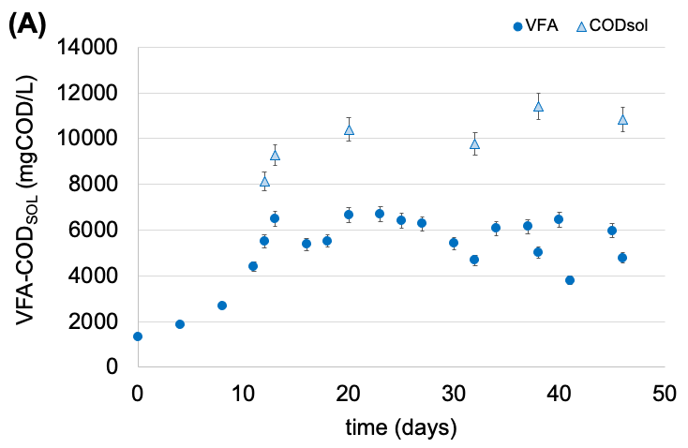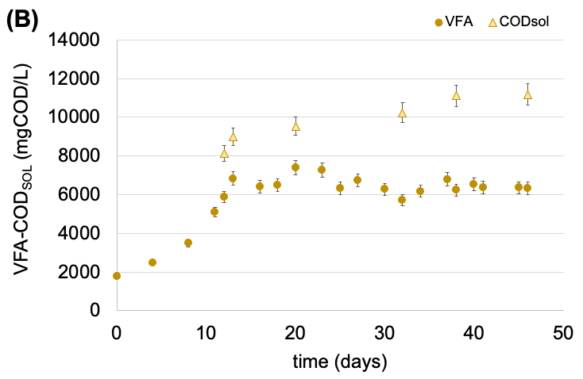
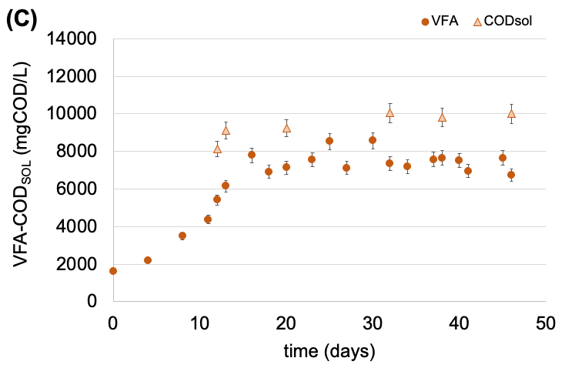

The literature is poor about the description of the HRT effect on the fermentation performances and/or fermentation products. Other carbon source has been subjected more often in past works, where the effect of the HRT was deeply investigated. As an example, Strazzera et al. (2018) explained the possibility to increase the concentration of acetic acid at lower HRT (4 and 8 days) and the selective production of propionic acid at higher HRT (12 days), in thermophilic fermentation of food waste.
Figure 2: Fermentation rate and yield observed in the three acidogenic fermentation runs performed at 4, 5 and 6 as HRTs.
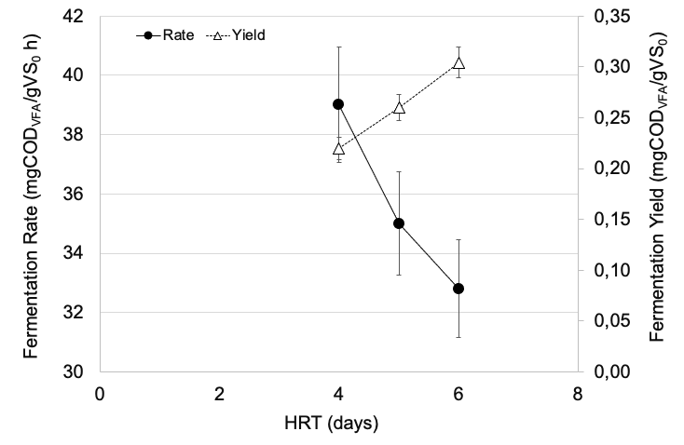

The following table 3 summarizes the main results (with average data and standard deviation) of the three sCSTR runs conducted in thermophilic conditions. Besides the parameters discussed above, the VFA distribution of the stability periods clearly highlighted a net predominance of VFA with even carbon’s atoms (acetic and butyric acids) compared to the others. The VFA spectrum is particularly relevant because each VFA has its market scenario and application as building blocks for the chemical industry or precursors for the synthesis of reduced chemicals in conventional organic chemistry.
Table 3: Summary of the main parameters obtained in the three thermophilic sCSTR runs at different HRT.
Parameter | Unit | HRT
 |  | 4 | 5 | 6
COD_{SOL} | g O₂/L | 10.0 ± 0.5 | 10.0 ± 0.5 | 9.4 ± 0.3
COD_{VFA} | g O₂/L | 5.7 ± 0.3 | 6.5 ± 0.2 | 7.3 ± 0.3
COD_{VFA}/COD_{SOL} | g/g | 0.56 ± 0.05 | 0.66 ± 0.04 | 0.72 ± 0.02
Acetic acid | g O₂/L | 1.8 ± 0.1 | 1.9 ± 0.1 | 2.2 ± 0.1
Propionic acid | g O₂/L | 0.8 ± 0.06 | 1.0 ± 0.07 | 1.1 ± 0.1
Butyric acid | g O₂/L | 1.8 ± 0.1 | 2.0 ± 0.1 | 2.3 ± 0.2
Valeric acid | g O₂/L | 0.7 ± 0.07 | 0.8 ± 0.04 | 0.9 ± 0.03
Caproic acid | g O₂/L | 0.7 ± 0.08 | 0.8 ± 0.06 | 0.8 ± 0.05
Specific Rate^{sCSTR} | mg COD_{VFA}/(gVS₀ h) | 39 ± 2 | 35 ± 2 | 33 ± 2
Yield^{sCSTR} | g COD_{VFA}/gVS₀ | 0.22 ± 0.01 | 0.26 ± 0.02 | 0.30 ± 0.02

  - Conclusion
Thermal, alkaline, and combined pre-treatment of sewage sludge were compared on solubilisation and potential increase of the COD_{SOL} to enhance thermophilic VFA production. Optimal solubilisation was obtained at 70°C (no alkaline conditions required), being the COD_{SOL} increased ten times (roughly) compared to raw sludge. The following acidification process was conducted at three different HRTs (4, 5 and 6 days). Despite of the lower specific rate at HRT of 6 days, this condition appeared more suitable for the COD_{SOL} conversion into VFA, having the highest VFA concentration (7.3 g O₂/L), acidification yield (0.30 g COD_{VFA}/gVS₀) and COD_{VFA}/COD_{SOL} ratio (0.72). These results open the discussion for further investigation in a perspective of sewage sludge utilisation within the WWTPs facilities, for the enhancement of nutrients removal from municipal wastewater or biopolymer production in a biorefinery technology chain.
Acknowledgments
This work was partially supported by DAIS - Ca’ Foscari University of Venice, within the IRIDE program.
References
Braguglia C., Gallipoli A., Gianico A., Pagliaccia P., 2018, Anaerobic bioconversion of food waste into energy: A critical review, Bioresource Technology, 248, 37-56.
Li X., Liu G., Liu S., Ma K., Meng L., 2018, The relationship between volatile fatty acids accumulation and microbial community succession triggered by excess sludge alkaline fermentation, Journal of Environmental Management, 223, 85-91.
Liu He, Han P., Liu H., Zhou G., Fu B., Zheng Z., 2018, Full-scale production of VFAs from sewage sludge by anaerobic alkaline fermentation to improve biological nutrients removal in domestic wastewater, Bioresource Technology, 260, 105-114.
Moretto G., Russo I., Bolzonella D., Pavan P., Majone M., Valentino F., 2020, An urban biorefinery for food
waste and biological sludge conversion into polyhydroxyalkanoates and biogas, Water Research, 170,
115371.
Morgan-Sagastume F., Hjort M., Cirne D., Gérardin F., Lacroix S., Gaval G., Karabegovic L., Alexandersson T., Johansson P., Karlsson A., Bengtsson S., Arcos-Hernández M.V., Magnusson P., Werker A., 2015, Integrated production of polyhydroxyalkanoates (PHAs) with municipal wastewater and sludge treatment at pilot scale, Bioresource Technology, 181, 78-89.
Presti D., Cosenza A., Capri F.C., Gallo G., Alduina R., Mannina G., 2021, Influence of volatile solids and pH for the production of volatile fatty acids: Batch fermentation tests using sewage sludge, Bioresource Technology 342, 125853.
Strazzera G., Battista F., Garcia N.H., Frison N., Bolzonella D., 2018, Volatile fatty acids production from food
wastes for biorefinery platforms: A review, Journal of Environmental Management, 226, 278-288.
Villano M., Lampis S., Valentino F., Vallini G., Majone M., Beccari M., 2010, Effect of hydraulic and organic loads in Sequencing Batch Reactor on microbial ecology of activated sludge and storage of polyhydroxyalkanoates, Chemical Engineering Transactions, 20, 187-192.
Zhang D., Jiang H., Chang J., Sun J., Tu W., Wang H., 2019, Effect of thermal hydrolysis pretreatment on volatile fatty acids production in sludge acidification and subsequent polyhydroxyalkanoates production, Bioresource Technology, 279, 92-100.

