CHEMICAL ENGINEERING TRANSACTIONS  VOL. 93, 2022 | A publication of
The Italian Association
of Chemical Engineering
Online at www.cetjournal.it

Guest Editors: Marco Bravi, Alberto Brucato, Antonio Marzocchella
Copyright © 2022, AIDIC Servizi S.r.l.
ISBN 978-88-95608-91-4; ISSN 2283-9216

Repurposing Tempeh Fermentation: a Promising Protein Source Using Food Residues and Edible Filamentous Fungi
Carlos E. Gómez-Camacho*, Chiara Mollea, Italo Mazzarino, Bernardo Ruggeri, Francesca Bosco*
Politecnico di Torino, Dep. of Applied Science and Technology (DISAT), C/so Duca degli Abruzzi 24, 10129 Torino.
carlos.gomezcamacho@polito.it and francesca.bosco@polito.it
Brewers' spent grains (BSG) are the main by-product of the brewery industry, accounting for more than 80 % of total produced by-products. Although this matrix is primarily composed of hemicellulose, cellulose, protein and lignin, the current end-of-life scenario for BSG is as livestock feed. In the present study, a valorisation approach for BSG that uses an edible fungus (Rhizopus oligosporus) in solid state fermentations (SSF) is proposed. First, a microbiological characterization is performed, to shed light on the indigenous microorganisms that are present in the BSG matrix. Then, an appropriate technology approach is used for the SSF that can be conducted both at laboratory and household levels. In the SSF experiments, different temperature (30-35 °C), mass of BSG substrate, inoculum ratio (10 and 15 % v/m) and drilling patters for the aeration of the systems are investigated. The fermentation products were characterized by preparing homogenized samples; it was registered an increase in protein content (5-64%), a slight acidification (ΔpH=0.1-1.2), a decrease of °Brix and the loss of organic matter (and water). The formation of the tempeh cakes was variable, and the differences are analyzed in terms of the operational parameters of each studied batch.
  - Introduction
The increase in the world population, with the consequent increase in the demand for food requires multidisciplinary solutions that do not destabilize and compromise the carrying capacity of natural ecosystems. In particular, the management of the elements of the Water-Energy-Food-Waste nexus is crucial for sustainable development (Gómez-Camacho, Bosco and Ruggeri, 2020). The food production industry presents a high water, energy, land utilization and waste production footprints, which together pose a colossal challenge in environmental terms. Ecologically, humans are considered omnivores feeding on a mixture of first and second level trophic organisms; the human trophic level (HTL) being close to 2.2 (Bonhommeau et al., 2013). However, depending on the type of protein (e.g., of animal or plant origin) different nutritional profiles can be found (i.e., micronutrients, macronutrients, digestibility, bioactive compounds). Human diets resulting in high HTL are believed to have an increased environmental burden compared to vegetal proteins-based diets, since the livestock industry has been identified as one of the main contributors to the anthropogenic emissions. Besides vegetal proteins, Single Cell Proteins (SCP) have been recently gaining ground as means to decrease the HTL and to cope with environmental issues. SCP can be produced through microbial cultures, using eukaryotic or prokaryotic microorganisms, such as yeasts, molds, microalgae and bacteria (i.e., ideally containing >30% protein in their biomass). Additionally, SCP can also be grown on complex biomass (residual) substrates, thus offering the possibility to upgrade the protein content, to enhance the quality of fermented foods and/or to modulate the amino acids profile (Bratosin et al., 2021).
Residues and by-products from the brewing industry, such as brewery wastewater (BWW), brewers’ spent yeast (BSY), and brewers’ spent grain (BSG) are produced in large quantities. In particular, the latter is estimated to represent 85 % of the total by-products, with an approximate yield of 0.2 kg _{BSG}/L _{beer}. BSG is a heterogeneous matrix, and its main constituents are the seed coat–pericarp–husk layers, starchy residues from the endosperm and debris from aleurone cells of barley grains. BSG is primarily of lignocellulosic nature, being fiber (i.e., hemicellulose and cellulose), protein and lignin the main fractions; the fiber fraction is estimated around 50 % (on a dry weight basis) while the protein fraction can reach up to 30%. These high fiber and protein fractions could be of interest for BSG valorization processes, particularly for the production of SCP.
Tempeh is an Indonesian traditional food, its production is based on a fermentation process that binds the chosen substrate (e.g., soybeans, lentils, faba, chickpeas) into mold-covered cakes. Tempeh is known as a low-cost, health promoting fermented food product that has been a green source of protein as well as of other macronutrients and micronutrients. In traditional tempeh production processes, the final properties depend on how the process is carried out and on the bacterial and fungal communities that act on the fermentation process (Radita et al., 2018)(Seumahu et al., 2013). Nevertheless, the formation of the white tempeh cake is mainly due to the action of the key microorganism in play, the genus Rhizopus and, in particular, the Rhizopus oligosporus species. The formation of the tempeh cake occurs due to the ability of this filamentous fungus to colonize solid substrate matrices by continuously growing an expanding the mycelium, i.e. the interconnected network of hyphae (and hyphal apexes) that undergo branching and fusion (anastomosis). In Tempeh production, the mycelium growth occurs superficially (at the more external layers of the substrate matrix), and the fungal hyphae also penetrate inside the matrix. Hence, tempeh fermentations are driven by the concomitantly mycelium growth (superficial and penetrative) and the enzymes production and diffusion within the matrix that serve for further growth. Fungal biotechnology expands beyond tempeh production, it is essential in different industrial processes besides food production, such as enzymes, vitamins, polysaccharides, alcohols, pigments, lipids, as well as in bioremediation processes and it has also been proposed as key facilitator towards circular economic models (Meyer et al., 2020). One valuable technique for fungal cultivation is to resemble the natural environment in which fungi naturally grow (and from which they are isolated), which is called solid-state-fermentation (SSF). SSF processes can take place at low water activity conditions (i.e., A_{w} >0.6), and SSF typically reaches higher productivity, uses low-cost substrates, and it requires less upstream processing steps compared to submerged fermentation (SmF). However, SSF processes still face difficulties for process control (e.g. pH, moisture, substrate consumption, biomass growth) and scale-up, to maintain efficient spatial homogeneity, and additionally, more downstream steps might be required if high purity products are targeted. Lately, SSF is gaining ground as suitable option for the transformation of agro-industrial wastes and by-products into value-added products, either using molds or mushrooms.
In this study, a microbiological characterization of BSG is done. Subsequently, SSF were performed inoculating Rhizopus oligosporus on BSG-packed plastic bags and cultivated for 5 days using a home fermenter. The effects of some process parameters such as temperature, inoculum percentage, mass of BSG and the interface area are assessed. After the SSF tests, homogenized liquid samples are prepared to characterize the fermentation products and to measure the protein content compared to the raw BSG.
  - Materials and Methods
    - Substrate
The substrate for the solid-state fermentation (SSF) tests was the Brewer’s Spent Grain (BSG), supplied by a local brewery company (Birrificio Leumann, Collegno, ltaly). Immediately upon receipt, untreated fresh samples were stored in plastic containers, at -20 °C. Prior to the experiments, a thawing step was performed allowing the BSG to defrost at room temperature for about 2 hours.
    - Microbiological characterization of BSG
A preliminary microbial characterization was carried out on malt extract agar medium, MEA (20 g/L malt extract, 20 g/L glucose, 2 g/L peptone and 20 g/L agar); aliquots, 20 mL, of steam sterilized (at the temperature 121 °C and pressure of 2 atm, for 20 min) MEA were poured into Petri dishes, Ø 9 cm. Freshly thawed BSG, 0.2 g, was mixed with 500 µl of sterile distilled water and directly spread over the surface of the solid medium. Two different conditions were tested: substrate as it is or grounded for 1 minute in a laboratory mill. Sealed plates were incubated, in the dark, at room temperature, for ten days. Every 24 hours, the plates were inspected, and the microbial growth was detected by the naked eye. At the end of the incubation, isolated colonies were also observed at the optical microscope (x60).
    - Inoculum
The inoculum for the SSF tests was prepared suspending in sterile distilled water: i) 3.3% m/v powdered commercial tempeh starter (Tempehtation, Edinburgh, United Kingdom), which comprises spores of Rhizopus oligosporus and traces of organic rice flour, supplemented with ii) 0.3 % m/v of rice flour. The concentration of Rhizopus oligosporus spores in the suspension was evaluated by means of a 10-µm depth bacteria counting chamber (Hawksley, Lancing, UK) and adjusted to 1·10⁸ spores/mL
    - SSF Fermentation tests
The SSF tests were performed using a small-scale fermenter (MVPower, Guangdong, China) equipped with time and temperature controls. The design of experiment consisted in 4 batches (I-IV), and different key parameters were varied in each case. In brief, a portion of thawed BSG (two different packing masses were tested, 50 or 70 g of BSG) was packed into LDPE bags of 175 mL capacity (dimensions: 12x8 cm), and the BSG was inoculated with the inoculum suspension (i.e., two different ratios were tested, 10 and 15 % v/m).
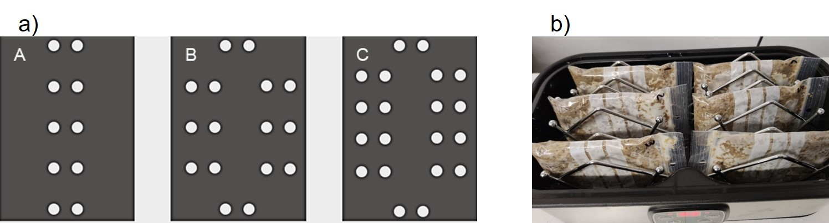
Figure 1. a) Blueprint of the drilling patterns (A, B and C) used in the SSF tests and b) photography of the fermenter used for the SSF tests.
The LDPE bags were then perforated following different drilling patterns (see Figure 1a). The temperature for the SSF experiments was in the 30-35 ° C range, and the fermentation lasted for 5 d. Ad-hoc aluminum supports were used for each sample, allowing the horizontal placement of six samples per batch (see Figure 1b) within the fermenter chamber (368x190x145 mm).
    - Analytical measurements
Proximate analysis
The fresh and fermented BSG matrices were characterized through a simplified proximate analysis by measuring the dry matter (DM), the volatile solids (VS) and the ash fractions (AF). The DM fraction was calculated by gravimetrical difference, placing the samples in crucibles, and recording the mass loss after a drying step (105 °C) for 24 h (until constant weight), while the VS and AF fractions were determined after a subsequent drying step at 550 °C for 6 hours.
pH, titratable acidity (TA), degree Brix (°Bx) and protein content
Homogenized liquid samples were prepared using fresh BSG and fermented BSG, for the measurement of pH, titratable acidity (TA), degree Brix (°Bx), and the protein content. For these homogenized samples, 10 gr of the BSG samples (either fresh BSG or SSF-BSG) were suspended 1:3 m/w in deionized water, they were blended for 10 min at 700 rpm using a laboratory mixer (RW 20 IKA WERKE, Staufen, Germany), and then centrifuged at 4000 rpm for 10 min. The measurements were performed on the resulting supernatant from the centrifugation. The pH measurements were performed using a micropH 2001 pHmeter (Crison Instruments SA, Barcelona, Spain). TA titrations were conducted on 5 mL of the supernatant (diluted 1:3 v/v) using a standardized 0.1 N NaOH solution as titrant and phenolphthalein (c. 100 μL) as visual endpoint indicator under constant mixing conditions; the TA of the samples is expressed as mL of NaOH/mL homogenized samples. The °Bx were measured using a Brix refractometer (LAISS Apparecchiature Scientifiche, Torino, Italy). A drop of the supernatant of fresh and fermented BSG samples was placed into the reading chamber of the refractometer; the °Bx readings were collected in duplicates. Lastly, the protein content was estimated by means of the direct reading of the absorbance values at 280 nm (A₂₈₀). Protein concentration was calculated by means of a calibration line, defined in the 0-1 g/L range, using commercial Whey Proteins (BULK POWDERS™, Colchester, United Kingdom).
Visual estimation of growth
Visual assessments of fungal growth were performed after the fermentation time elapsed in the SSF tests. Operator-based estimates were made by using a qualitative scale (from 1 to 4), in which 1 indicates barely detectable growth (i.e., without cake formation) and 4 indicates proper cake formation and dense appreciable mycelium, as shown in Figure 2.

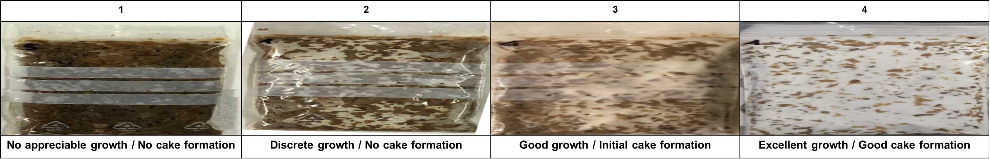
Figure 2. Reference (visual) scale used for the visual assessments after the SSF tests.
  - Results and discussion
    - Microbiological characterization
The incubation, at room temperature, of BSG using MEA medium led to the formation of unicellular microorganism colonies. In Figure 3, it can be seen the microbial growth, at different incubation time (72 h, 144 h and 240 h), of the raw sample (A) and the shredded ones (B and C). Samples at 240 h of incubation were also observed by means of optical microscopy, it was confirmed that appreciable colonies growth can be attributed to bacteria and yeasts (note for example orange colonies in Figure 3 for the sample C at 240 h); the growth of filamentous fungi was not observed. This type of microbiological characterization is considered non-selective, the prevalence of bacteria and yeasts is consistent with the type of matrix under analysis and its production environmental conditions (i.e., the mashing step within breweries). The lack of growth of filamentous fungi indicate that there are rather low competition chances against the selected fungus (Rhizopus oligosporus) for the SSF tests in the BSG matrix.
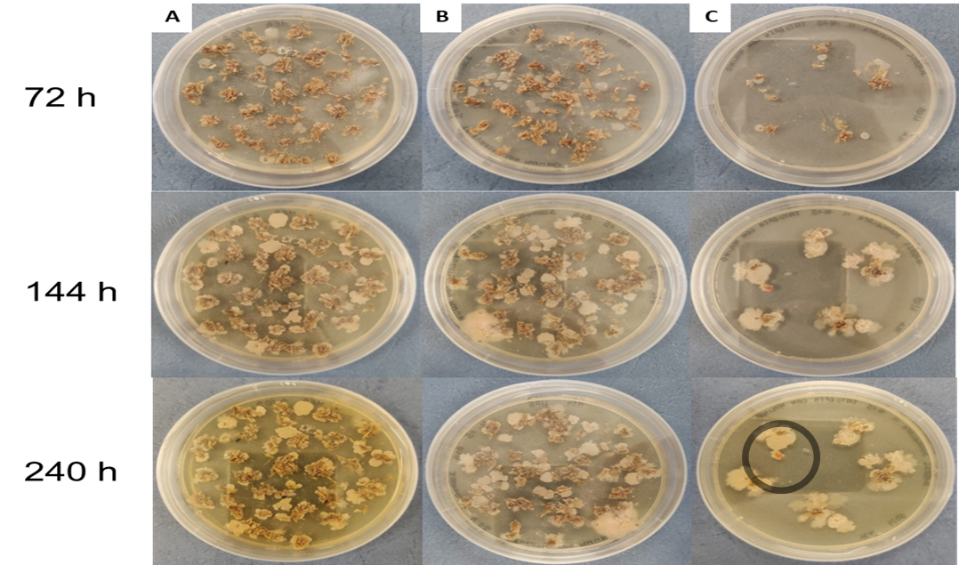
Figure 3. Raw (A) and shredded samples (B and C) of BSG plated on MEA.
    - SSF fermentation
In Table 1 are reported the proximate analysis of the initial raw BSG, of the fermented samples and the qualitative evaluation of the mycelium growth in each case. Based on the moisture content and the gravimetric analysis of the samples, it can be seen that weight loss accounts for 12.26±3.03 % of the initial weight, while water loss roughly represents half of the weight loss on average. The difference can be attributed to loss of organic matter, due to the aerobic fungal metabolism (i.e. CO₂ evolution and evaporation losses of volatile compounds). Moreover, an initial sugar content of 2.0 °Bx was measured in the BSG matrix, while after the SSF tests lower values were obtained (i.e., 0.95-1.55) in each case. Although the consumption of sugars (°Bx) did not fully occur, this shows that the metabolism of Rhizopous oligosporus partially uses simple sugars as C-source for its initial growth on BSG. However, it should not be ruled out that the hydrolytic activity of the fungus on the complex sugars of the BSG can also generate simple sugars that might serve to support growth from the residual starch contained in BSG. Protein measurements suggested that, after the SSF fermentations, the protein content in the homogenized samples increases (i.e., 5-64 %) for all the cases compared to the initial protein content in the BSG. Similar results can be found in the literature (Canedo et al., 2016), where the crude protein content of BSG was reported to increase 46 % in SSF carried out with R. oligosporus without exogenous N-source supplementation and up to 83 % increase when ammonium sulphate was supplied. However, the chosen simplified method for protein estimates (A₂₈₀) serves primarily for the quantification of certain aromatic aminoacids (i.e., containing tryptophan, tyrosine and phenylalanine residues which have been demonstrated to be present in BSG) (Essien et al., 2010) without the use of additional reagents or processing steps.
Table 1. Measured parameters in the raw BSG and SSF-BSG samples.
Batch |  | Raw BSG | I |  | II |  | III |  | IV
Temperature | [°C] | - | 30 - 32 |  | 30 - 32 |  | 30 - 32 |  | 33 - 35
Nom. BSG mass (S) | [g] | - | 50 | 50 | 50 | 70 | 70 | 70 | 70 | 70
Inoculum (I) | [% v/m] | - | 10% | 10% | 10% | 10% | 10% | 10 % | 10% | 15%
Drilled pattern | [-] | - | A | B | B | B | A | C | B | C
Samples | n | - | 3 | 3 | 3 | 3 | 3 | 3 | 3 | 3
Initial mass (S+I) | [g] | - | 55.80 ±  0.61 | 56.61 ± 0.47 | 55.20 ±  0.91 | 79.46 ±  0.76 | 78.41 ±  0.75 | 78.81 ± 0.43 | 79.04 ±  0.48 | 82.29 ± 0.45
Final mass | [g] | - | 49.05 ±  0.88 | 48.93 ± 1.05 | 48.71 ±  1.10 | 71.84 ±  1.52 | 71.41 ±  2.03 | 67.67 ± 0.98 | 64.69 ±  3.40 | 74.18 ± 1.72
Initial Moisture | [% w/w] | 76.18 ± 0.73 | 78.31 ±  1.20 | 78.28 ± 1.44 | 78.34 ±  0.34 | 78.28 ±  1.36 | 78.31 ±  1.12 | 78.30 ± 0.90 | 78.29 ±  0.70 | 79.22 ± 0.45
Final Moisture | [% w/w] | - | 81.37 ±  0.28 | 80.07 ± 1.65 | 81.01 ±  0.78 | 82.43 ±  0.27 | 80.90 ±  1.51 | 82.89 ± 0.56 | 80.49 ±  0.27 | 81.59 ± 0.33
Ash Fraction | [%] | 2.31 ± 0.41 | 4.52 ±  0.08 | 4.27 ±  0.14 | 4.44 ±  0. 32 | 4.18 ±  0.35 | 4.48 ±  0.33 | 4.73 ±  0.19 | 3.52 ±  0.31 | 4.33 ±  0.29
Sugars | [° BX] | 2.00 ± 0.10 | 1.10 ±  0.10 | 0.95 ±  0.05 | 1.00 ±  0.10 | 1.15 ±  0.05 | 0.90 ±  0.10 | 1.25 ±  0.10 | 1.55 ±  0.20 | 1.25 ±  0.10
pH | [-] | 5.9 ± 0.1 | 5.6 ± 0.1 | 5.3 ± 0.1 | 5.6 ± 0.1 | 5.8 ± 0.1 | 5.6 ± 0.1 | 5.3 ± 0.1 | 4.7 ± 0.1 | 5.6 ± 0.1
TA | [mL_{NaOH} /mL] | 0.35 ± 0.05 | 0.75 ±  0.07 | 0.50 ±  0.01 | 0.80 ±  0.01 | 0.50 ±  0.01 | 0.70 ±  0.01 | 1.60 ±  0.05 | 1.20 ±  0.50 | 0.65 ±  0.20
Protein | [g/L] | 4.77 ± 0.02 | 7.13  ± 0.02 | 5.29 ±  0.02 | 6.77 ±  0.02 | 5.87 ±  0.01 | 6.25 ±  0.01 | 7.85 ±  0.02 | 5.03 ±  0.03 | 7.49 ±  0.03
Mycelium Growth | [-] | - | 4 3 2 | 2 2 1 | 3 3 3 | 4 4 3 | 4 4 3 | 3 3 2 | 2 2 1 | 3 2 1
Codified Name | [-] | - | I/32/50/10/A | I/32/50/10/B | II/32/50/10/B | II/32/70/10/B | III/32/70/10/A | III/32/70/10/C | IV/35/70/10/B | IV/35/70/15/B

Hence, this method provides a suggestive approximate value of the total protein concentration for the complex matrices containing mixtures of different proteins (Metsämuuronen et al., 2011). In any case, the protein enrichment obtained in the homogenized samples may be due to the proteolytic fungal activity, which further makes the complex proteins in BSG more available in the liquid phase and also due to the growth of biomass (i.e., enrichment in fungal SCP) and its (partial) disruption during the homogenization step. Measurements of pH and titratable acidity followed consistent trends; starting from a pH of c. 5.9 of the BSG then a slight acidification was obtained in the SSF systems with final pH values in the 4.7-5.8 range. The TA parameter indicated that the production of titratable acids with respect to the initial condition considerably increased, the final values that increased from 42 - 350% compared to the starting values.
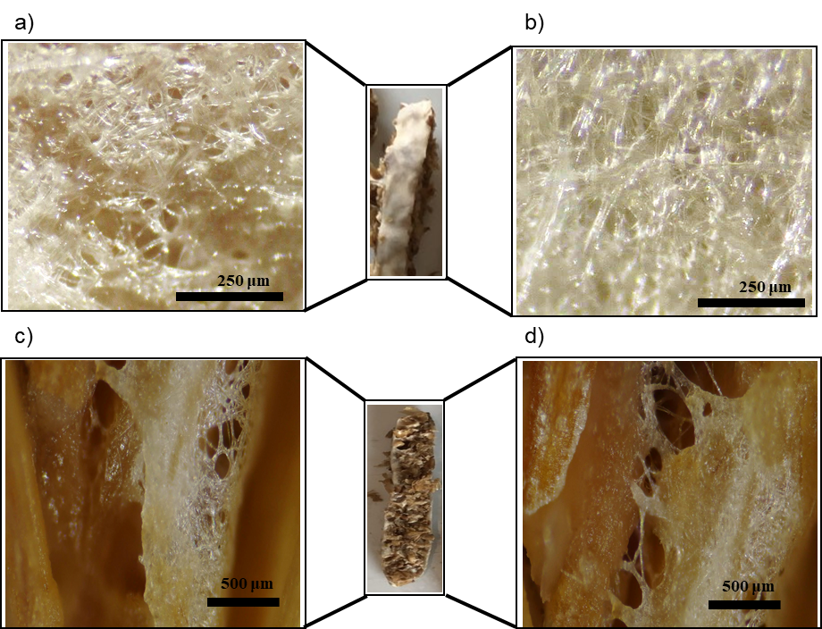
Figure 4. Epi-illuminated micrographs of a) initial surface mycelium growth, b) increased surface mycelium density, and focus-stacked micrographs of transversal cuts showing the penetrative mycelium and the cake formation (c and d).
The growth of R. oligosporus has been widely described as a two-stage process: a first one, consisting of spore germination and initial mycelium formation (see Figure 4a), while the second stage consists in the increase of the surface mycelium density (Figure 4b) coupled to further penetrative (Figure 4c and 4d) growth. In general, the results demonstrated that the growth of R. oligosporus on BSG is possible in open SSF. However, not all the tested conditions resulted in the formation of the well-formed compact cakes of BSG tempeh, although protein enrichment in the homogenized samples was found for all systems. As shown in Table 1, there were differences in the final mycelium growth (visual assessments) within the same batch and between batches. The qualitative visual evaluation is presented for each sample within batches to serve as homogeneity indicator. The best mycelium growth with proper cake formation and the greater homogeneity within the batch corresponded to operating conditions of temperature 30-32 °C, 70 g of packed BSG in the 175 mL bags, inoculation with the suspension (10% v/m) and using perforation patterns A and B (i.e., II /32/70/10/B and III/32/70/10/A). For these batches, only slight acidification occurred (final pH in the 5.6-5.8), weight losses lied in the 8.9-9.6 % of the initial weight and water losses represent 30-40 % of the overall weight losses. Comparing both BSG nominal packing masses, the 50 g systems showed less visible growth, while the 70 g packed systems exhibited better growth probably due to better compacting conditions of the bed. However, the protein enrichment, in the homogenized samples, did not significantly differ based on the nominal mass packed in each case. In contrast, the higher investigated temperatures (IV/35/70/10/B and IV/35/70/15/B) resulted in lower growth, either using the medium or high drilling patterns (B and C). These systems also presented higher water losses compared to the mean values ​​(probably due to the higher heat produced in the systems, which is a critical parameter in SSF). Rhizopus oligosporus is widely known for its strong protease and lipase activities; as well as for its limited amylolytic capacity (Shurtleff and Aoyagi, 2001). These metabolic properties explain the good compatibility between the BSG matrix and the mold under study.
  - Conclusions
In this study, a new approach for the valorization of an important residue of the brewing industry (BSG) was studied. It was determined that the BSG matrix has an autochthonous flora that is predominantly represented by bacteria and yeasts, the presence of filamentous fungi was not evidenced on MEA plates (10 days). The selected commercially available strain of Rhizopus oligosporus was capable to grow on BSG under open (non-sterile) solid-state fermentation conditions. The present SSF procedure constitutes a good case study of appropriate technology, which can be applied to improve (home) tempeh fermentations and/or preliminary studies at the laboratory scale and to shed light on scale-up possibilities. The obtained results suggest that the BSG matrix is ​​compatible with R. oligosporus, which could be useful to cultivate SCP (i.e., formulating, for example, food products such as the shown cakes and combining the BSG with other substrates and/or pre-treatments) or to produce protein-enriched extracts. This would be of great interest to modify the current end-of-life scenario that BSG undergoes and ideally valorize it for human nutrition, thus reducing the HTL. Further research is needed to assess other sensory properties of BSG tempeh, to investigate its proteomic profile in this type of SSF, and to characterize potential mycotoxins that might be produced during the fungal growth.
Acknowledgements
The authors kindly thank Andrea Manzini for his valuable support in the experimental tests and data compilation, as well as the Birrificio Leumann for supplying the BSG used in this study.
References
Bonhommeau S. et al., 2013, Eating up the world’s food web and the human trophic level, PNAS, 110(51), 2t0617–20620
Bratosin B. C., Darjan S., Vodnar D. C., 2021, Single cell protein: A potential substitute in human and animal nutrition, Sustainability, 13(16), 1–24.
Canedo M. S. et al., 2016, Protein enrichment of brewery spent grain from Rhizopus oligosporus by solid-state fermentation, Bioprocess and Biosystems Engineering, 39(7), 1105–1113.
Essien J. and Udotong I., 2010, Amino Acid Profile of Biodegraded Brewers Spent Grains (BSG), Journal of Applied Sciences and Environmental Management, 12(1), 7–9.
Gómez-Camacho C. E., Bosco F., and Ruggeri B., 2020, The role of microbial community engineering (MCE) in the Water-Energy-Food-Waste (WEFW) nexus, Chemical Engineering Transactions, 79, 397–402.
Metsämuuronen S., Mänttäri M., and Nyström M., 2011, Comparison of analysis methods for protein concentration and its use in UF fractionation of whey, Desalination, 283, 156–164.
Meyer V. et al., 2020, Growing a circular economy with fungal biotechnology: A white paper, Fungal Biology and Biotechnology, 7(1), 1–23.
Radita R. et al., 2018, Firmicutes is the predominant bacteria in tempeh, International Food Research Journal, 25(6), 2313–2320.
Seumahu C. A. et al., 2013, Bacterial and Fungal Communities in Tempeh as Reveal by Amplified Ribosomal Intergenic Sequence Analysis, Journal of Biosciences, 20(2), 65–71.
Shurtleff W. and Aoyagi A., 2001, The Book of Tempeh, 2nd ed, Canada: Harper Colophon Books.

