CHEMICAL ENGINEERING TRANSACTIONS  VOL. 93, 2022 | A publication of
The Italian Association
of Chemical Engineering
Online at www.cetjournal.it

Guest Editors: Marco Bravi, Alberto Brucato, Antonio Marzocchella
Copyright © 2022, AIDIC Servizi S.r.l.
ISBN 978-88-95608-91-4; ISSN 2283-9216

Measurements of Protein Content in Aqueous and Alkaline Extracts from Brewer's Spent Grains (BSG): Insights into the Extraction Kinetics and Energy Consumption
Carlos E. Gómez-Camacho*, Chiara Mollea, Francesca Bosco, Bernardo Ruggeri, Italo Mazzarino*
Politecnico di Torino, Dep. of Applied Science and Technology (DISAT), C/so Duca degli Abruzzi 24, 10129 Torino.
carlos.gomezcamacho@polito.it and italo.mazzarino@polito.it
The brewers’ spent grain (BSG) is a rich biomass matrix containing several compounds of interest that require urgent and suitable valorisation strategies, due to its high production volume in the brewing industry. Among the most widespread approaches is the preparation of extracts, targeting particular compounds or soluble and/or insoluble fractions, after operating pre-treatment processes. In the present study, extraction experiments are carried out with fresh untreated BSG, under very gentle extraction conditions (room temperature and moderate agitation, in the 0-5 h interval), and using different solvents: deionized water, 0.1 M NaOH and 0.5 M NaOH in a 1:5 m/v solid-to-solvent ratio. The extraction dynamics were followed by monitoring the dry matter (DM) content obtained in the extracts after a centrifugation step. The protein content is estimated in each case by means of two different methods: direct measurements of absorbance at 280 nm (using bovine serum albumin, BSA, and commercial whey protein isolate as standards) as well as using the Bradford colorimetric method and BSA standard; the consistency of these measurements is contrasted against the DM values. The apparent extraction kinetics were studied, using a saturation model; the coefficients and their range of uncertainty were obtained. Extraction efficiencies in the range 14.24%-53.60% g_{DM ext}/g_{DM BSG} are achieved, which correspond to extraction yields of 38.88-150.09 g_{DM} _{ext}/kg _{fresh BSG}. In addition, the energy footprint of the process is estimated at laboratory scale.
  - Introduction
The global beer industry has grown over the past 20 years, beer production has increased from 1.390 to 1.820 million hectoliters in the last twenty years (i.e., a 30 % increase) (STATISTA, 2021). Besides beer, certain residues and by-products are also generated during the brewing process, such as brewery wastewater (BWW), brewers’ spent yeast (BSY), and brewers’ spent grain (BSG). In particular, the latter is estimated to represent c. 85 % of the total by-products, with an approximate yield of 0.2 kg _{BSG}/L _{beer} (Lynch et al., 2016).
Barley (Hordeum vulgare L.) is a very adaptable crop, which is extensively used in the brewing industry. The grain structure is composed of the embryo, a starchy endosperm, an aleurone layer and the grain covering (i.e., the seed coat, the pericarp layers and the husk). After the malting stage in breweries, the mashing process takes place under suitable conditions (e.g., pH, temperature, water hardness, time, addition of exogenous enzymes). During mashing, malted barley grains are hydrated, certain enzymes are activated/deactivated (i.e., amylases, proteolytic enzymes, glucanases, debranching enzymes), and the original grain starches are converted into fermentable and unfermentable sugars. Successful mashing requires optimal pH, sufficient resting times during the protein and conversion rests as well as temperature conditions and ramps that allow the activation and deactivation of the desired enzymes. After the mashing step, the phases are separated into the soluble liquid fraction (the brewer’s wort) and the insoluble residues of the initial barley grain, this latter fraction is termed BSG. BSG then mainly contains the seed coat–pericarp–husk layers that covered the original barley grain and, depending on the efficiency of mashing, residues from the starchy endosperm, and cell wall residues from the (partially) empty aleurone cells can also be found. Therefore, BSG is thus a highly variable matrix, which can greatly differ between breweries depending on the grain and the process followed. This heterogeneity also makes its characterization complex, since there are no dedicated methods to quantify the components of interest in the variable range where they can be expected (Mata et al., 2015).
The dry matter in BSG is composed of fiber (i.e., hemicellulose and cellulose), proteins and lignin; the fiber and protein fraction account for more than 80 % (on a dry weight basis). These high fiber and protein fraction could be of interest for BSG valorization. Indeed, BSG has been primarily used as livestock feed, although other applications are intended for human nutrition, such as the manufacture of bakery products as reported in (Lynch et al., 2016). In particular, BSG potential functional properties such as emulsifying/stabilizing capacity, water holding capacity, elasticity could serve as a food additive. Especially barley proteins have been reported to contain both, essential and non-essential amino acids, such as threonine, valine, phenylalanine, and arginine (Houde et al., 2018).
One of the commonly found methods in the literature for the valorization of BSG is through extraction processes. Based on the complex nature of the BSG and exploiting its great richness as biomass, different compounds of interest can be targeted by extraction processes (Houde et al., 2018). However, even though BSG constitutes retrieved biomass, the choice of pre-treatments, the extraction solvent, the solvent-to-solid ratio, the extraction temperature and the downstream steps required might influence the feasibility of the overall process and, its economic and environmental viability.
In this study, a first characterization on the BSG was performed. Exploratory extraction tests were then carried out, using deionized water and dilute alkaline solutions (0.1 and 0.5 M NaOH) under continuous agitation, monitoring the extraction process over a 5-h interval. After the extraction, a centrifugation step was performed to separate the soluble and insoluble products resulting from the extraction. The extracts were characterized in terms of the dry matter content, in addition different methods for the quantitative estimation of the protein content were tested. In addition, the dynamics of extraction process was described using a second order saturation model by fitting the experimental data. Finally, laboratory-scale energy consumption for the extraction process in each case is calculated.
  - Materials and Methods
    - Brewer’s Spent Grains (BSG) and pre-treatments
The Brewer’s Spent Grain (BSG) was supplied by a local brewery company (Birrificio Leumann, Collegno, ltaly). Immediately upon receipt, untreated fresh samples were stored in plastic containers at -20 °C. Prior to the extraction tests, a thawing step was performed allowing the BSG to defrost at room temperature for about 2 h.
    - Extraction
For the extraction tests, two different types of solvents are tested: i) deionized water and ii) mild alkaline solutions at 0.1 and 0.5 M NaOH. The extraction step was performed in 250 mL flasks, mixing 15 g of BSG with each solvent (75 mL), hence in a 1:5 w/v proportion. The systems were kept at room temperature under continuous magnetic stirring (c. 500 rpm) conditions for 5 h, and measurements were conducted after each hour elapsed. Collected samples were ultracentrifuged at 15000 rpm (Centrikon T-42K Kontron Instruments) at 25°C. The volume of the supernatants was measured and then the samples were stored at +4°C until their utilization.
    - Analytical measurements
Proximate analysis, pH measurements and titratable acidity
The fresh BSG matrix and the BSG extracts were characterized through a simplified proximate analysis by measuring the dry matter (DM), the volatile solids (VS) and the ash fractions (AF). The DM was calculated by gravimetrical difference, placing the samples in crucibles, and recording the mass loss after a drying step (65 ° C) for 24 h (until constant weight), while the VS and AF fractions were determined after a subsequent drying step at 550 °C for 6 hours. For the pH measurements, 20 g of BSG were suspended in 50 mL of three different solutions: i) deionized water, ii) 1 M KCl and iii) 0.01 M CaCl₂. Then, these suspensions were homogenized for 5 min at 10000 rpm and the pH measurements were performed (micropH 2001 Crison Instruments SA, Barcelona, Spain). TA titrations were conducted on 5 mL of the homogenized samples (diluted 1:3 v/v) using a standardized 0.1 N NaOH solution as titrant and phenolphthalein (c. 100 μL) as visual endpoint indicator under constant mixing conditions; the TA of the samples is expressed as mL of NaOH/mL.
Protein content
The protein content was estimated in the extract samples using three different methods (Ahmed, 2017): i) the direct UV-absorbance (A₂₈₀) method using bovine serum albumin (BSA-A₂₈₀) or ii) the direct UV-absorbance (A₂₈₀) method using whey protein isolate (BULK POWDERS™, Colchester, United Kingdom) (WPI-A₂₈₀) as standards and iii) the Bradford colorimetric method using bovine serum albumin (BSA-Bradford) as standard. For the protein measurements, aliquots of well homogenized samples were opportunely diluted (in a 1:100 proportion) with deionized water for the absorbance readings (Lambda 465 Pelkin Elmer, Waltham, USA).
    - Kinetic modelling
The faithful modeling of S-L extraction kinetics has the drawback of measuring the concentration in the solid phase, and to follow its evolution over time. Due to these difficulties, one of the most used approaches is to monitor the concentration in the liquid phase (solvent) and, to calculate (pseudo)kinetic coefficients, which are mainly valid almost exclusively under the conditions in which the process is carried out. The extraction data was modelled following a saturation model of the form, based on the concentration in the extraction solvent, C(t) :
$C\left(t\right)=C_{Max} \frac{t}{k+t}$ | (1)
To obtent the kinetic coefficients, and their relative uncertainty range, three linearization approaches of the model are used; the following is the first linearized model:
$\frac{1}{C\left(t\right)}=\frac{k }{C_{Max}}· \frac{1}{t}+\frac{1 }{C_{Max}}$ | ( 2)
the second is taken as:
$\frac{t}{C\left(t\right)}=\frac{k }{C_{Max}}+\frac{ 1}{C_{Max}}·t$ | (3)
finally, the last considered linearization is:
$C\left(t\right)=C_{Max}-k·\frac{C\left(t\right) }{t}$ | (4)
The experimental data of the DM concentration in the extracts as well as the protein content at the tested intervals (C_{t}), in g_{DM}/L and g_{protein}/L, respectively, were used to fit eq. 2, 3, 4, by best-fitting procedure, from which the saturation concentration in the extracts (C_{Max}) and the half saturation time constant (k) are obtained, and the mean values and the uncertainty ranges were calculated from the three linearization models.
    - Energy consumption estimation
Energy consumption was estimated during the preparation of the extracts, under the experimental conditions, on the laboratory scale. A simplified inventory step was carried out, considering only the direct energy expenses as the electrical energy and the energy embedded in the chemicals expenses used, as reported in Table 1.
Table 1. Direct and chemicals energy expenses considered for the analysis
Chemicals |  | Direct Energy
Deionized water | Caustic Soda | Mixing | Centrifugation
0.103 [MJ/kg] | 15.900 [MJ/kg] | 0.0072 [MJ/h] | 0.036 [MJ/cycle]

The direct energy expenses are based on the electricity consumption of the laboratory equipment, while the gross energy requirements (GER) of the chemicals are taken from Simapro 9.1.1.1, using the USLCI database and the Cumulative Energy Demand (LHV) impact method. The reference unit for the analysis is the gram of dry matter extracted (g_{DM ext}) and the energy footprints are expressed as MJ/g_{DM} _{ext}.
  - Results
    - BSG characterization
Before the extraction tests, an initial characterization of the BSG was carried out. The proximity analysis (% w/w fresh matter) resulted in a DM content of 28.02±1.18, 71.98±1.18 (MC), 26.62±0.17 (VM), 1.40±0.01 (AF), and TA of 0.75±0.05 mL NaOH/g BSG. The DM lumped parameter gives a first idea of the potentially extractable matter within the matrix. The AF is low (<2%), while the starting pH is consistent with the mashing phase, which typically takes place in a narrow range (pH=5.1-5.6); it resulted in 5.95±0.06 (DI H₂O, pH=6.02±0.12), 6.34±0.10 (1 M KCl, pH=6.45±0.0.09) and 5.24±0.07 (0.01 M CaCl₂, pH=5.33±0.20). However, during mashing, in addition to pH, the effective hardness is also fundamental (in terms of Ca²⁺ and Mg²⁺ ions), while for the extraction tests a nearly neutral deionized water and dilute alkaline solutions were used.
    - Extraction tests and quantitative protein measurements
Figure 1 shows the concentrations of DM and protein content obtained at different extraction times, using the different tested solvents. For the systems in which deionized water was used, the DM content in the extracts remained almost constant, with non-statistically significant variations after the first hour. For the systems extracted with alkaline solutions, higher concentrations were obtained in the extracts compared to water systems, and slight increases could be observed as the extraction time increased.

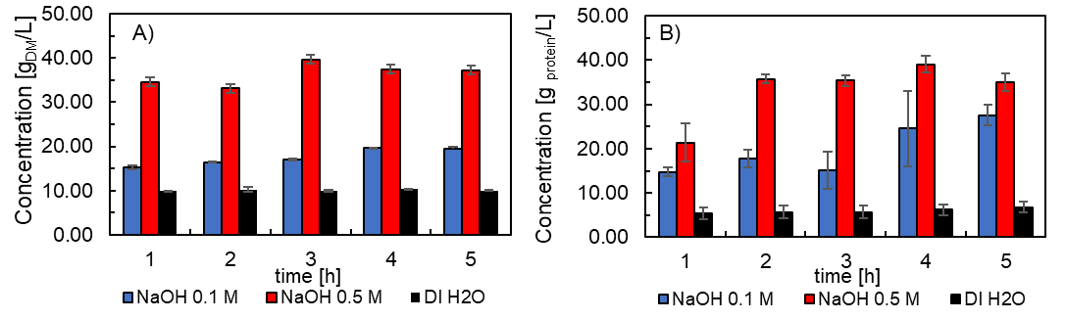
Figure 1. The extraction dynamics (0-5 h) using deionized water, 0.1 M NaOH and 0.5 M NaOH as solvents, considering A) the dry matter content and B) the protein content (WPI-A280) measured in the extract (p<0.05 among the tested solvents)
These DM concentrations in the final extracts corresponded to extraction efficiencies of 14.24%, 29.58% and 53.60% for DI H2O, 0.1 M NaOH and 0.5 M NaOH, respectively, based on the initial DM content in the BSG. These values correspond to extraction yields of 39.88, 82.81 and 150.09 g_{DM ext}/kg _{fresh BSG}, respectively. Higher concentration of the alkaline solvent was not tested, due to the concerns of nutrient and safety problems of protein isolates and the more stringent required re-acidification, which have reported in the literature for similar matrices (Hou et al., 2017) .
The extraction dynamics followed a similar trend based on the protein content in the extracts; although, these measurements exhibit a greater standard deviation due to the uncertainties in the measurement of protein content in complex biomasses. Indeed, all quantitative protein measurements methods present a wider ranges of uncertainty (compared to DM), which in the present case might be due to the complex protein mix within the BSG and to the other residues (partially soluble) that are present and that might interfere with the measurements. For example, the widely used Kjeldahl method relies on the appropriate choice of a nitrogen-to-protein factor depending on the matrix, while detailed proteomics analysis require several preparation and derivatization steps. (Haven and Jørgensen, 2014). The comparison among the tested quantitative protein measurements methods/standards (see section 2.3) is shown in Figure 2.

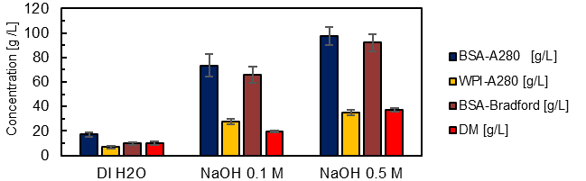
Figure 2. Comparison between the final concentration in the extracts (after 5 h of extraction) using the BSA-A₂₈₀, WPI-A₂₈₀, BSA-Bradford and the DM methods.
The presented values correspond to the final extracts (after 5h), as a reference the DM content are also presented for each case. Depending on the solvent in each case, there are statistically significant differences between calculated concentrations. That is, while in the extraction using deionized water there is an overestimation of proteins through the BSA-A₂₈₀ readings of 70% with respect to DM, the differences for WPI-A₂₈₀ vs DM are of approximately 30% less and, and the BSA-Bradford method yielded the best results with less than 5 % compared to the DM. For the systems where the alkaline solvent was used at a concentration of 0.1 M, the BSA-A₂₈₀ and BSA-Bradford readings were greater than 300% with respect to the DM measurements, while the WPI-A₂₈₀ method resulted 40% higher than the DM measurements. Finally, for the system at the highest alkaline concentration (0.5 M NaOH), it was shown that the BSA-A280 and BSA-Bradford readings are 50 - 60% higher than the DM measurements and that the WPI-A₂₈₀ only differed 5% from the DM content (in defect). These differences in protein quantification are probably also affected due to the mix of proteins that are extracted in each case. In the case of seed proteins, albumins are considered the proteins that can be extracted with water (that is why BSA-Bradford provided the best results as a standard), while for diluted alkaline systems there are mainly glutelins and, to a lesser extent, albumins (so WPI protein might perform better as a standard).
    - Kinetics Study
Due to the difficulties to accurately model the kinetics of the extraction process, a (pseudo)kinetics analysis was performed. This approach is widely used in the literature, especially for complex extraction process (Hobbi et al., 2021). The chosen saturation model (Eq. 1) was able to fit the obtained data (using the DM and protein content measurements), the parameters of the model for each case were obtained by using the three linearized models (Figure 3).

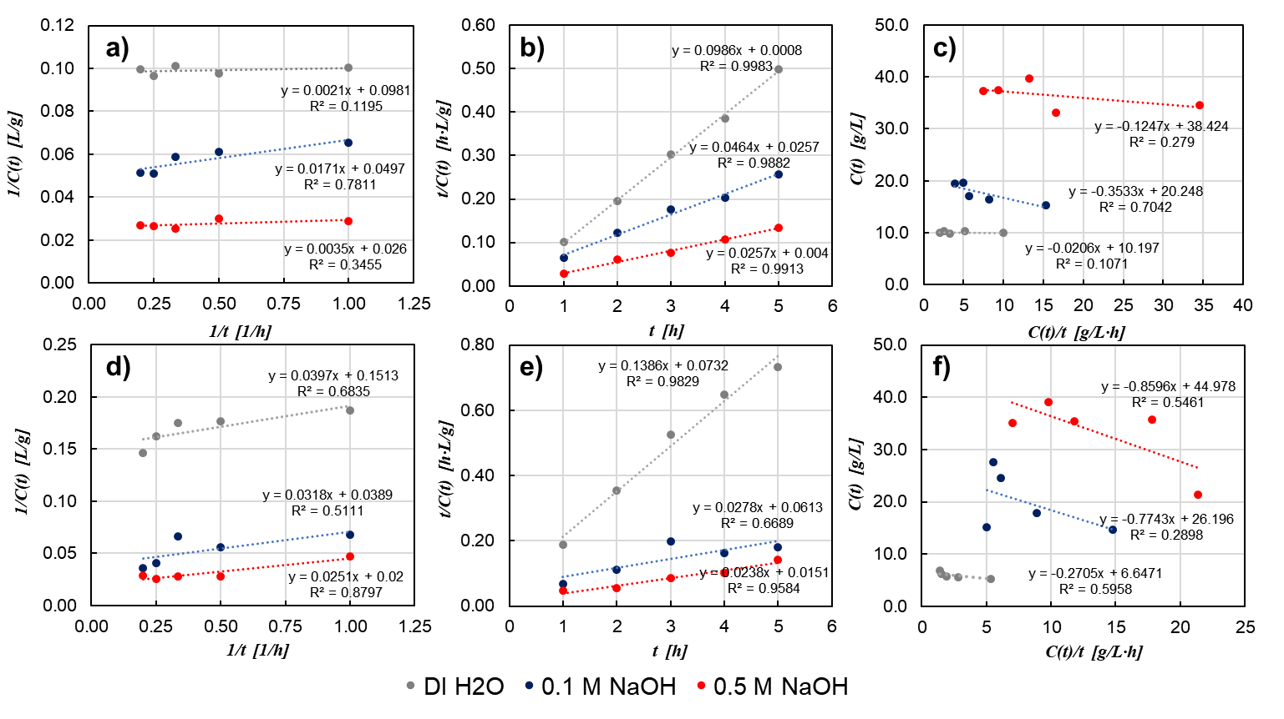
Figure 3. Experimental data fitting to the linearized kinetic model (a, d) using the DM and protein content (Eq. 2),(b, e) using the DM and protein content (Eq. 3) and (c, f) using the DM and protein content (Eq. 4).
Additionally, the uncertainty range of the parameters (given as the relative error) was calculated, using the obtained values from each linearized model (Table 2).The suitability of the pseudo-second order model to fit the experimental data suggests that the apparent extraction rate was declining over time.
Table 2. Fitting parameters for the pseudo first and second kinetic extraction models
 | Dry Matter content |  |  |  | Protein content
 | C_{max} | δ | k | δ* | C_{max} | δ | k | δ*
 | [g_{DM}/L] | [%] | [h] | [%] | [g_{prot.}/L] | [%] | [h] | [%]
DI H₂O | 10.178 | 0.303 | 0.017 | 44.610 | 6.824 | 4.972 | 0.354 | 42.735
0.1 M NaOH | 20.640 | 3.837 | 0.417 | 28.426 | 29.291 | 19.767 | 1.266 | 64.306
0.5 M NaOH | 38.599 | 0.701 | 0.138 | 11.423 | 45.665 | 8.838 | 0.720 | 69.139
*Overall uncertainty based on the obtained parameters of each linearized model

The saturation concentration (C_{max}) obtained of each solvent amounted to 10.2, 20.6 and 38.6 g_{DM}/L for the DI H₂O, the 0.1 M NaOH and the 0.5 M NaOH systems, while the half saturation time constants (k) resulted in 1.0, 28.2 and 8.3 min, respectively. Given these results, and considering the intervals tested, experimental data is required for extraction times of less than 1 h to further validate the proposed (pseudo)kinetic models. The fittings, in terms of protein concentrations, followed very similar trends to the DM data, however, they are characterized by a greater range of uncertainty (Table 2), probably due to the data reported in section 3.2.
    - Energy Consumption
In Table 3 the obtained results from the energy expenses in each case are presented. The DI H2O systems resulted in the highest energy consumption, since the protein yield is lower than the alkaline systems and the processing chain is similar (with the exception of the expenses for NaOH). For the alkaline systems, it was obtained that the system at 0.1 M presents a higher energy footprint than the 0.5 M one, a figure which is driven by the lower achieved yield. For the system at 0.5 M NaOH, the lowest energy footprint was attained. These results are preliminary, since the boundary for the analysis is the laboratory; for more thorough analyses other important aspects must be considered (e.g., transportation of the feedstock, further downstream processing steps, neutralization of the alkaline extracts, and the management of waste). In any case, the obtained results 89.8 for the DI H2O system, 47.1 for the 0.1 M NaOH and 34.5 MJ/Kg_{DM ext} for the 0.5 M NaOH systems are in line with reference values ​​for protein extracts, e.g., 38.4 MJ/kg for soybean protein isolate, 39.0 MJ/kg for lupins protein isolate (although these figures correspond to larger scales, where certain energy expenses are probably optimized) (Agri-footprint-5, 2021).
Table 3. Energy consumption at the laboratory scale for the tested extraction processes.
 | Chemicals |  | Direct Energy |  | Total*
Solvent | Deionized water | NaOH | Mixing | Centrifugation | Total Energy | Total Energy
 | [MJ/g_{DM ext}] | [MJ/g_{DM ext}] | [MJ/g_{DM ext}] | [MJ/g_{DM ext}] | [MJ/g_{DM ext}] | [MJ/kg_{DM ext}]
DI H₂O | 1.29E-02 | - | 6.02E-02 | 1.67E-02 | 8.98E-02 | 8.98E+01
0. 1 M NaOH | 6.22E-03 | 3.84E-03 | 2.90E-02 | 8.05E-03 | 4.71E-02 | 4.71E+01
0.5 M NaOH | 3.43E-03 | 1.06E-02 | 1.60E-02 | 4.44E-03 | 3.45E-02 | 3.45E+01
*The overall uncertainty quantification resulted in less than 30 % for each case.
  - Conclusions
Preliminary tests on BSG showed that under minimal processing conditions it is possible to obtain extracts with a high dry matter content. Quantitative measurements of protein content in the extracts suggest the extracted dry matter corresponds mostly to proteins. The achieved extraction yields are 39.88, 82.81 and 150.09 g _{DM}/kg _{fresh BSG} for the system with DI H₂O, 0.1 M NaOH and 0.5 M NaOH, respectively. The chosen saturation model was suitable to adjust the extraction data, considering the phenomenology as the (pseudo)kinetics of the time-evolution concentration in the extracts. The energy costs were calculated at laboratory scale and energy footprints were obtained in the same order of magnitude of other reference protein extracts. Further experimental investigations are required to fully characterize the obtained extracts, to establish a protocol for accurate quantification of the protein share in BSG extracts as well as other residual (valuable) compounds (e.g., bioactive compounds); while the kinetics and energy-consumption insights provided in this study might be useful for scale-up purposes.
Acknowledgements
The authors kindly thank Thomas Piccolo for his valuable support in the experimental tests and data compilation and the Birrificio Leumann for supplying the BSG which was used in this study.
References
Agri-footprint-5, 2021, Understanding the impact of food - database’, SimaPro 9.1.1.1.
Ahmed H., 2017, Estimation of Proteins, in Principles and Reactions of Protein Extraction, Purification, and Characterization, New York: CRC Press, p. 36.
Haven M. Ø. and Jørgensen, 2014, The challenging measurement of protein in complex biomass-derived samples, Applied Biochemistry and Biotechnology, 172(1), pp. 87–101.
Hobbi P. et al., 2021, Kinetic modelling of the solid–liquid extraction process of polyphenolic compounds from apple pomace: influence of solvent composition and temperature, Bioresources and Bioprocessing, Springer Singapore, 8(1).
Hou, F. et al., 2017, Alkali solution extraction of rice residue protein isolates: Influence of alkali concentration on protein functional, structural properties and lysinoalanine formation, Food Chemistry, 218, pp. 207–215.
Houde M. et al, 2018, Barley protein concentrates: Extraction, structural and functional properties, Food Chemistry, p. 367–376.
Lynch K. M et al, 2016, Brewers ’ spent grain :a review with an emphasis on food and health’, JIB, pp. 553–568.
Mata T. M. et al, 2015, Bioethanol from brewers’ spent grain: Pentose fermentation, Chemical Engineering Transactions, 43, pp. 241–246.
STATISTA, 2021, World beer production, https://www.statista.com/statistics/270275/worldwide-beer-production, accessed: 7 January 2022.

