CHEMICAL ENGINEERING TRANSACTIONS  VOL. 93, 2022 | A publication of
The Italian Association
of Chemical Engineering
Online at www.cetjournal.it

Guest Editors: Marco Bravi, Alberto Brucato, Antonio Marzocchella
Copyright © 2022, AIDIC Servizi S.r.l.
ISBN 978-88-95608-91-4; ISSN 2283-9216

Cancer-on-a-chip platform to study metastatic microenvironments
Sara Micheli^{1,2}, Caterina Piunti^{1,2}, Marco Sorgato¹, Giovanni Lucchetta¹, Elisa Cimetta*^{1,2}
¹ Department of Industrial Engineering. University of Padua, Via Francesco Marzolo 9 35131, Padua, Italy
² Fondazione Istituto di Ricerca Pediatrica Città della Speranza, Corso Stati Uniti 4 35127, Padua, Italy
elisa.cimetta@unipd.it
Nowadays, increasing research efforts are focused on the development and production of integrated devices for biomedical analysis. Besides being typically disposable, these devices should ideally be compatible with a mass-production scale and have relatively low costs, while maintaining their biocompatibility. In this context, Additive Manufacturing (AM) is a very advantageous technology to produce inserts for the Injection Molding (IM) of thermoplastic devices. We here present a cancer-on-a-chip platform mimicking Neuroblastoma (NB) progression. NB, an embryonal malignancy of early childhood, has a grim prognosis also determined by its high tendency to form metastases. The device was thus designed and configured to allow performing different biological studies for a better understanding of cancer biology, with a particular focus on metastatic spread. The chip was produced by IM using the 3D mold technique for the fabrication of structured inserts. Ultimately, our system can be used as an in vitro tool to help elucidate fundamental mechanisms of cancer metastasis, as well as a platform for drug screening in biomimetic microenvironments.
  - Introduction
Despite great progresses in the understanding of cancer biology, metastases are still synonymous of terminal illness in several tumors, including Neuroblastoma (NB), an embryonal malignancy of early childhood. Recent studies highlighted the importance of multicellular, biochemical, and biophysical microenvironmental stimuli during carcinogenesis, treatment, and metastasis. There is thus an unmet need for devices that mimic these features, surpassing the limitations of conventional cultures. Engineering approaches are instrumental for the development of such on-chip cancer models that, when scaled down to biologically relevant sizes, better recapitulate their complexity. Micro- and meso-scaled devices offer several advantages over conventional size systems(Yeo et al. 2011); in particular they: i. allow the analysis and use of lower volume of samples, chemicals and reagents reducing the global costs of the experiments, ii. increase the experimental parallelization and throughput since many operations can be executed at the same time, and iii. can shorten experimental times. The key geometrical features vary from micrometers to millimeters, typically reaching an overall size of a few square centimeters. Given the great potential of these devices, research aims at simultaneously satisfying two goals: the possibility of obtaining a product with good customization, and the creation of standardized and economically sustainable production processes. The technology standing at the meeting point between these needs is Injection Molding (IM). IM is the gold standard for device manufacturing, enabling high-throughput production (hundreds, to thousands or even millions of pieces) at low per-device costs, while maintaining tight tolerances and high reproducibility(Lee et al. 2018). Furthermore, this technique is compatible with production in polymeric materials, whose characteristics and manufacturing processes make them ideal for biomedical needs(Fiorini 2005). In recent years, Additive Manufacturing (AM), also known as three-dimensional (3D) printing, has proved to be an excellent alternative to traditional techniques for producing the inserts required for IM both in terms of costs and processing times. We here present a cancer-on-a-chip platform designed to capture key elements of the complex process of cancer progression and produced via a novel combined AM-IM rapid prototyping method. We believe that our approach could bring significant technological and practical advances aiding biomedical research.
  - Material and methods
2.1 Design of the platform
The device was designed with a geometry that would allow for reliable AM features reproduction, while also optimizing the study of cancer cells behavior and their interactions with other tissues. The chip’s basic concept was to create a central square chamber radially connected to four outer wells via separate channels: this design allowed to seed cancer cells in the central chamber and different cell types from metastatic target tissues in the other wells. The connecting channels allowed selective communication between the different compartments, thus enabling to perform combined studies of cells behavior and their specific interactions. The entire device had a rectangular surface equal to 75 × 50 mm². The sides of the square central chamber measured 10 mm, the circular wells had a diameter of 10 mm, while the channels were 9 mm long and 2 mm wide. It was decided to set a nominal height for all elements of 0.6 mm (Figure 1(a)).
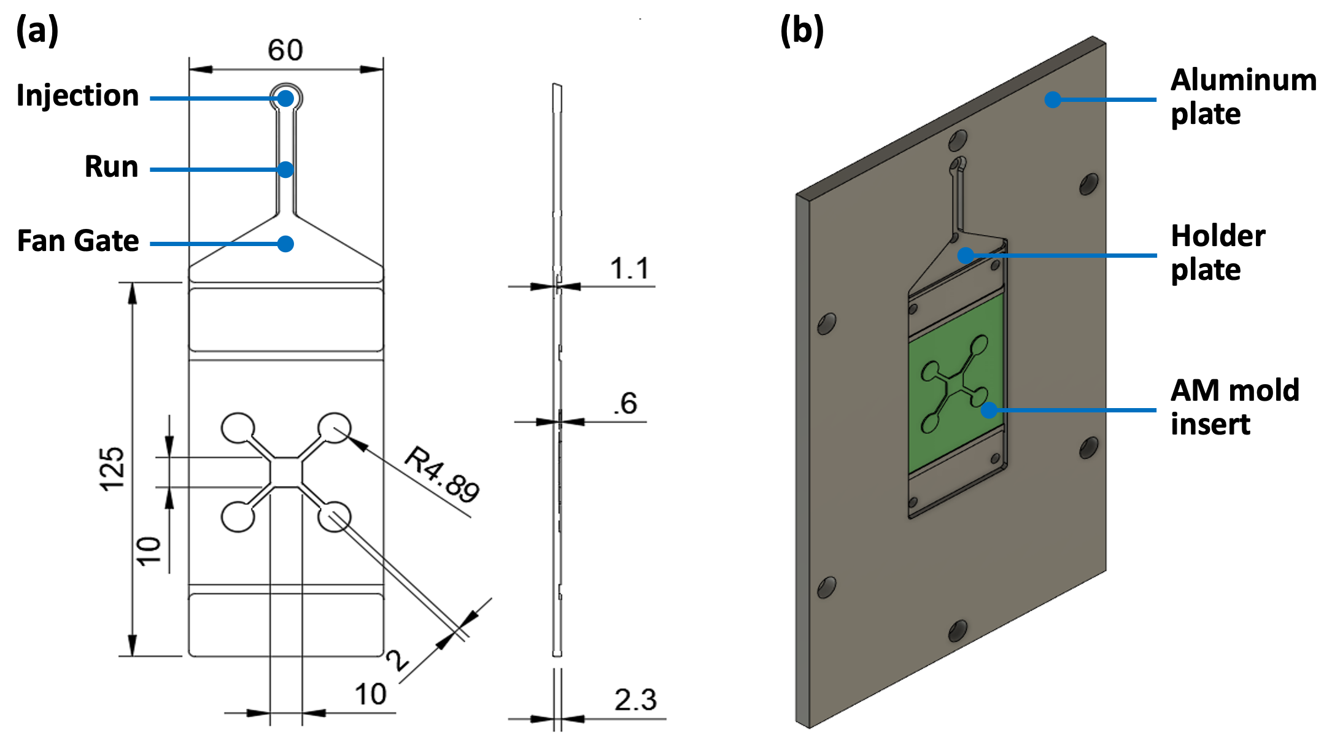
Figure 1. Manufacturing components and device design. (a) Detail of the holder plate and molded insert with the device geometry (top and side views); dimensions in mm. (b) Schematic of the assembled plate.
2.2 Injection Molding
The first step for the IM process was the production of the inserts with the designed features using an AM 3D printer (Stratasys PolyJet Object350 - Connex3TM) and using Digital ABS as material. For the molding of the devices, the Battenfeld HM 110/525H/210S IM machine was used. The machine is composed of a screw that moves inside a cylinder, heated by electric resistances, and equipped of a hydraulic clamping unit. A parallel integrated locking cylinder with a quick-stroke cylinder provides a short design and central power transmission. The insert was fixed in the movable plate of the mold, housing another ad hoc feed system manufactured trough standard milling (Figure 1(b)). The cavity was then filled trough a rectangular runner system, connected to a fan gate to ensure unidirectional polymer flow and thus reducing part warpage. The molded part was cooled by circulating water (T=40 °C) in conventional cooling lines drilled in both the movable and the fixed mold plate. Polystyrene (PS) was selected as molding material thanks to its mechanical properties, optical transparency, biocompatibility, resistance to chemical products, ease of processing and compatibility with the Digital ABS insert, and cost-effectiveness. Table 1 summarizes the key parameters that were set in the molding machine.
2.3 Metrological characterization of the device
This analysis was performed using the Sensofar SNeox profilometer to assess the performance of the machine in recreating the CAD model of the device. To validate the entire production process, the insert was also measured after molding to 500 pieces. As for the polystyrene chips, of the 500 printed, one device every 50 pieces was analyzed. The scanned areas were the same for both the insert and the chips and included all the critical features that were considered of particular interest.

Table 1: Process parameters set for injection molding.
Parameter | Value
Cylinder temperature close to the mold | 240 °C
Temperature under the hopper | 50 °C
Injection flow | 10 cm³/s
Injection pressure | 1100 bar
Holding pressure | 308 bar
Holding time | 30 s
Cooling time | 10 s
Clamping force | 550 KN
Dosing volume | 12 cm³
2.4 Biological validation
To assess the biocompatibility of the PS microdevices and test the capability of the chip to recreate complex multi-tissue environments, different cell types were simultaneously used. Two Neuroblastoma cell lines (SKNAS and SKNDZ) were seeded to recreate the main cancer microenvironment. These cells were maintained in culture in 75 cm² flasks in Dulbecco’s Modified Eagle Medium (DMEM) supplemented with 10% fetal bovine serum (FBS), 1% glutamine, and 1% antibiotics (Penicillin/Streptomycin). To mimic target organ microenvironments, umbilical vein endothelial cells (HUVEC), BJ fibroblasts, and mesenchymal stem cells from bone marrow (MSC) were selected. These cell lines required the following culture media: MSC were maintained in MesenCult™ MSC Basal Medium (Human) supplemented with 10% MesenCult™ MSC Stimulatory Supplement (Human); BJ in Dulbecco’s Eagle’s Minimum Essential Medium (EMEM) supplemented with 10% fetal bovine serum and 1% Penicillin/Streptomycin; HUVEC in EGM™ BulletKit™ Medium containing Endothelial Basal Medium-PLUS and growth supplements (Bovine Brain Extract, 2.0 ml; Ascorbic Acid, 0.5 ml; Hydrocortisone, 0.5 ml; human Epidermal Growth Factor, 0.5 ml; FBS, 10.0 ml; Gentamicin/Amphotericin-B, 0.5 ml). The device was first sterilized with UV treatment for 30 min, and the surface of the culture wells coated with 25 μg/ml Fibronectin (Thermo Fisher Scientific) for 1h at room temperature to favor cell attachment. Table 2 summarizes all the key parameters set for the seeding of a single PS chip. The cells could then be kept in culture for up to 7 days, replacing culture medium every 24 hours. For biocompatibility studies 24 hours from seeding, cells were stained with a Phosphate Buffer Saline (PBS) solution of Hoechst marking all cell nuclei in blue, and Calcein-AM marking the cytoplasm of living cells in green (both at 1:1000 dilution, Sigma-Aldrich, St. Louis, MO, USA) for 30 minutes. Images were acquired on a fluorescence microscope (EVOS Flois Imaging System).
Table 2: Main properties for cell seeding in the wells of a PS device.
Properties | Circular wells | Central well
Surface | 78.5 mm² | 100 mm²
Cell density | 500 cells/mm² | 500 cells/mm²
Number of cells | 40,000 | 50,000
Volume of culture medium | 47 μL | - μL
Results
3.1 Injection molding
Figure 2(a) shows the aluminum plate and the holder plate with the mold insert correctly placed, while Figure 2(b) gives an example of a printed PS chip. The inserts were produced at three inclinations: 0°, 45° and 90° with respect to the axes of the 3D printing machine. Since metrological analyses did not highlight significant differences between the 3, the 45° insert was chosen for its best performance in respecting the nominal widths of the connecting channels. The injection molding process proceeded as scheduled with the rapid prototyping of 500 pieces. The produced platform was transparent in appearance, with a slight curvature resulting from internal tensions developed during the solidification phase due to the low thermal conductive properties of the AM-produced insert. A non-uniform cooling phase results in differential shrinkage and thus part warpage. The 45° lines visually appreciable in the PS chip, derive from the nozzle sweeps for the insert production.

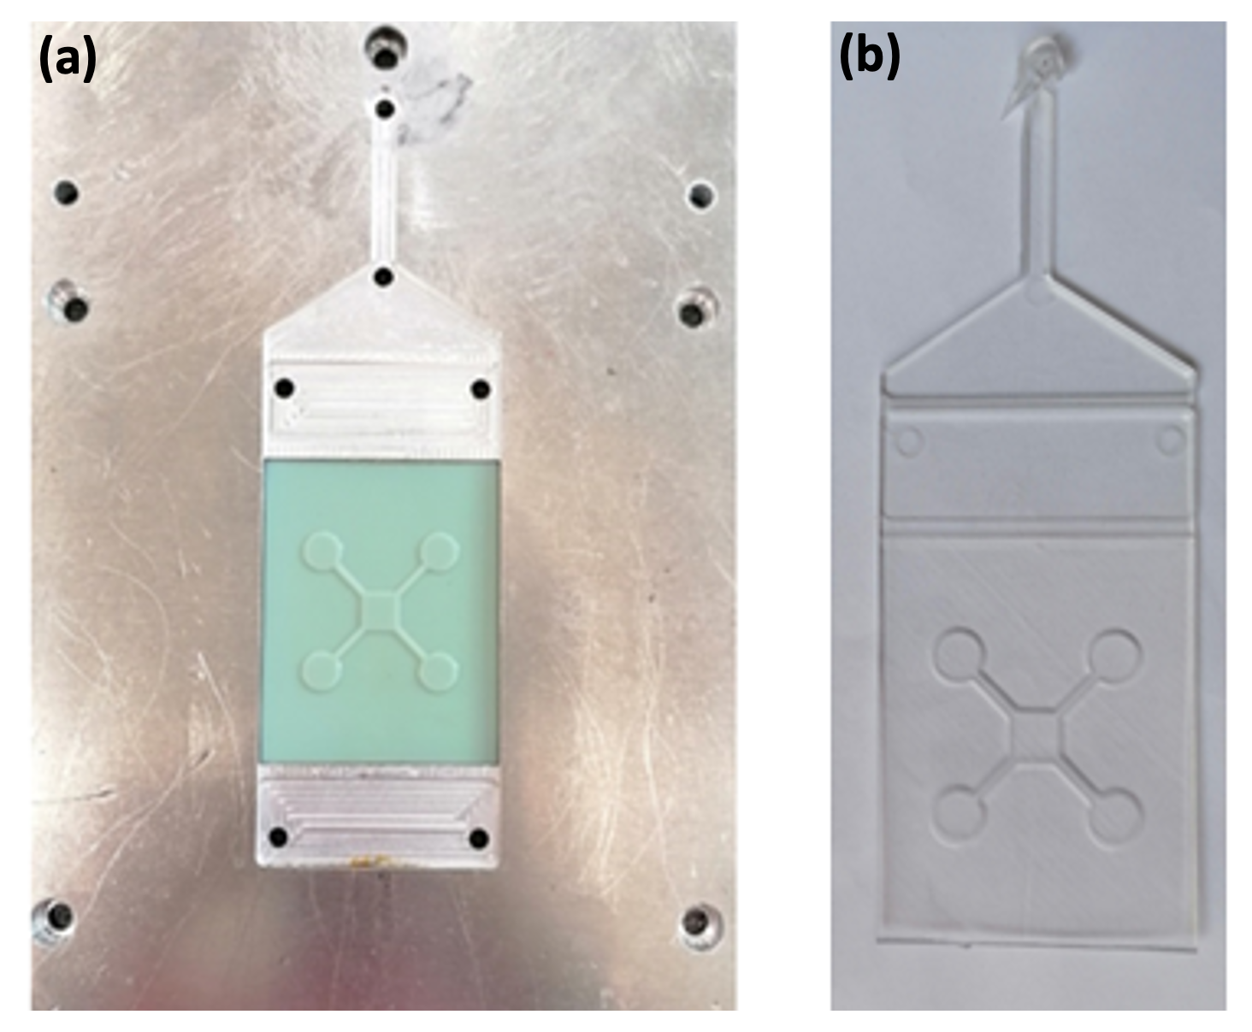
Figure 2. Molding components and device design. (a) Insert holder plate and (b) example of a PS device.
3.2 Profilometer results
The profiles of the chip replicas examined were extracted and reconstructed to yield the curves reported in Figure 3, comparing the devices at the selected molding cycles (100, 300 and 500). First, we observed that the measured features were very similar across all replicas, and that the heights of all profiles were the closest to the nominal ones. We recorded a slight inclination in the profiles from the graphs relating to the two wells. The slight curvature of the chip from the injection molding could slightly affect the measurements at the profilometer, but we could however conclude that the reproducibility of the original CAD dimensions were well maintained after 3D printing of the insert and final injection molding for the PS chip PS chip even after 500 cycles.
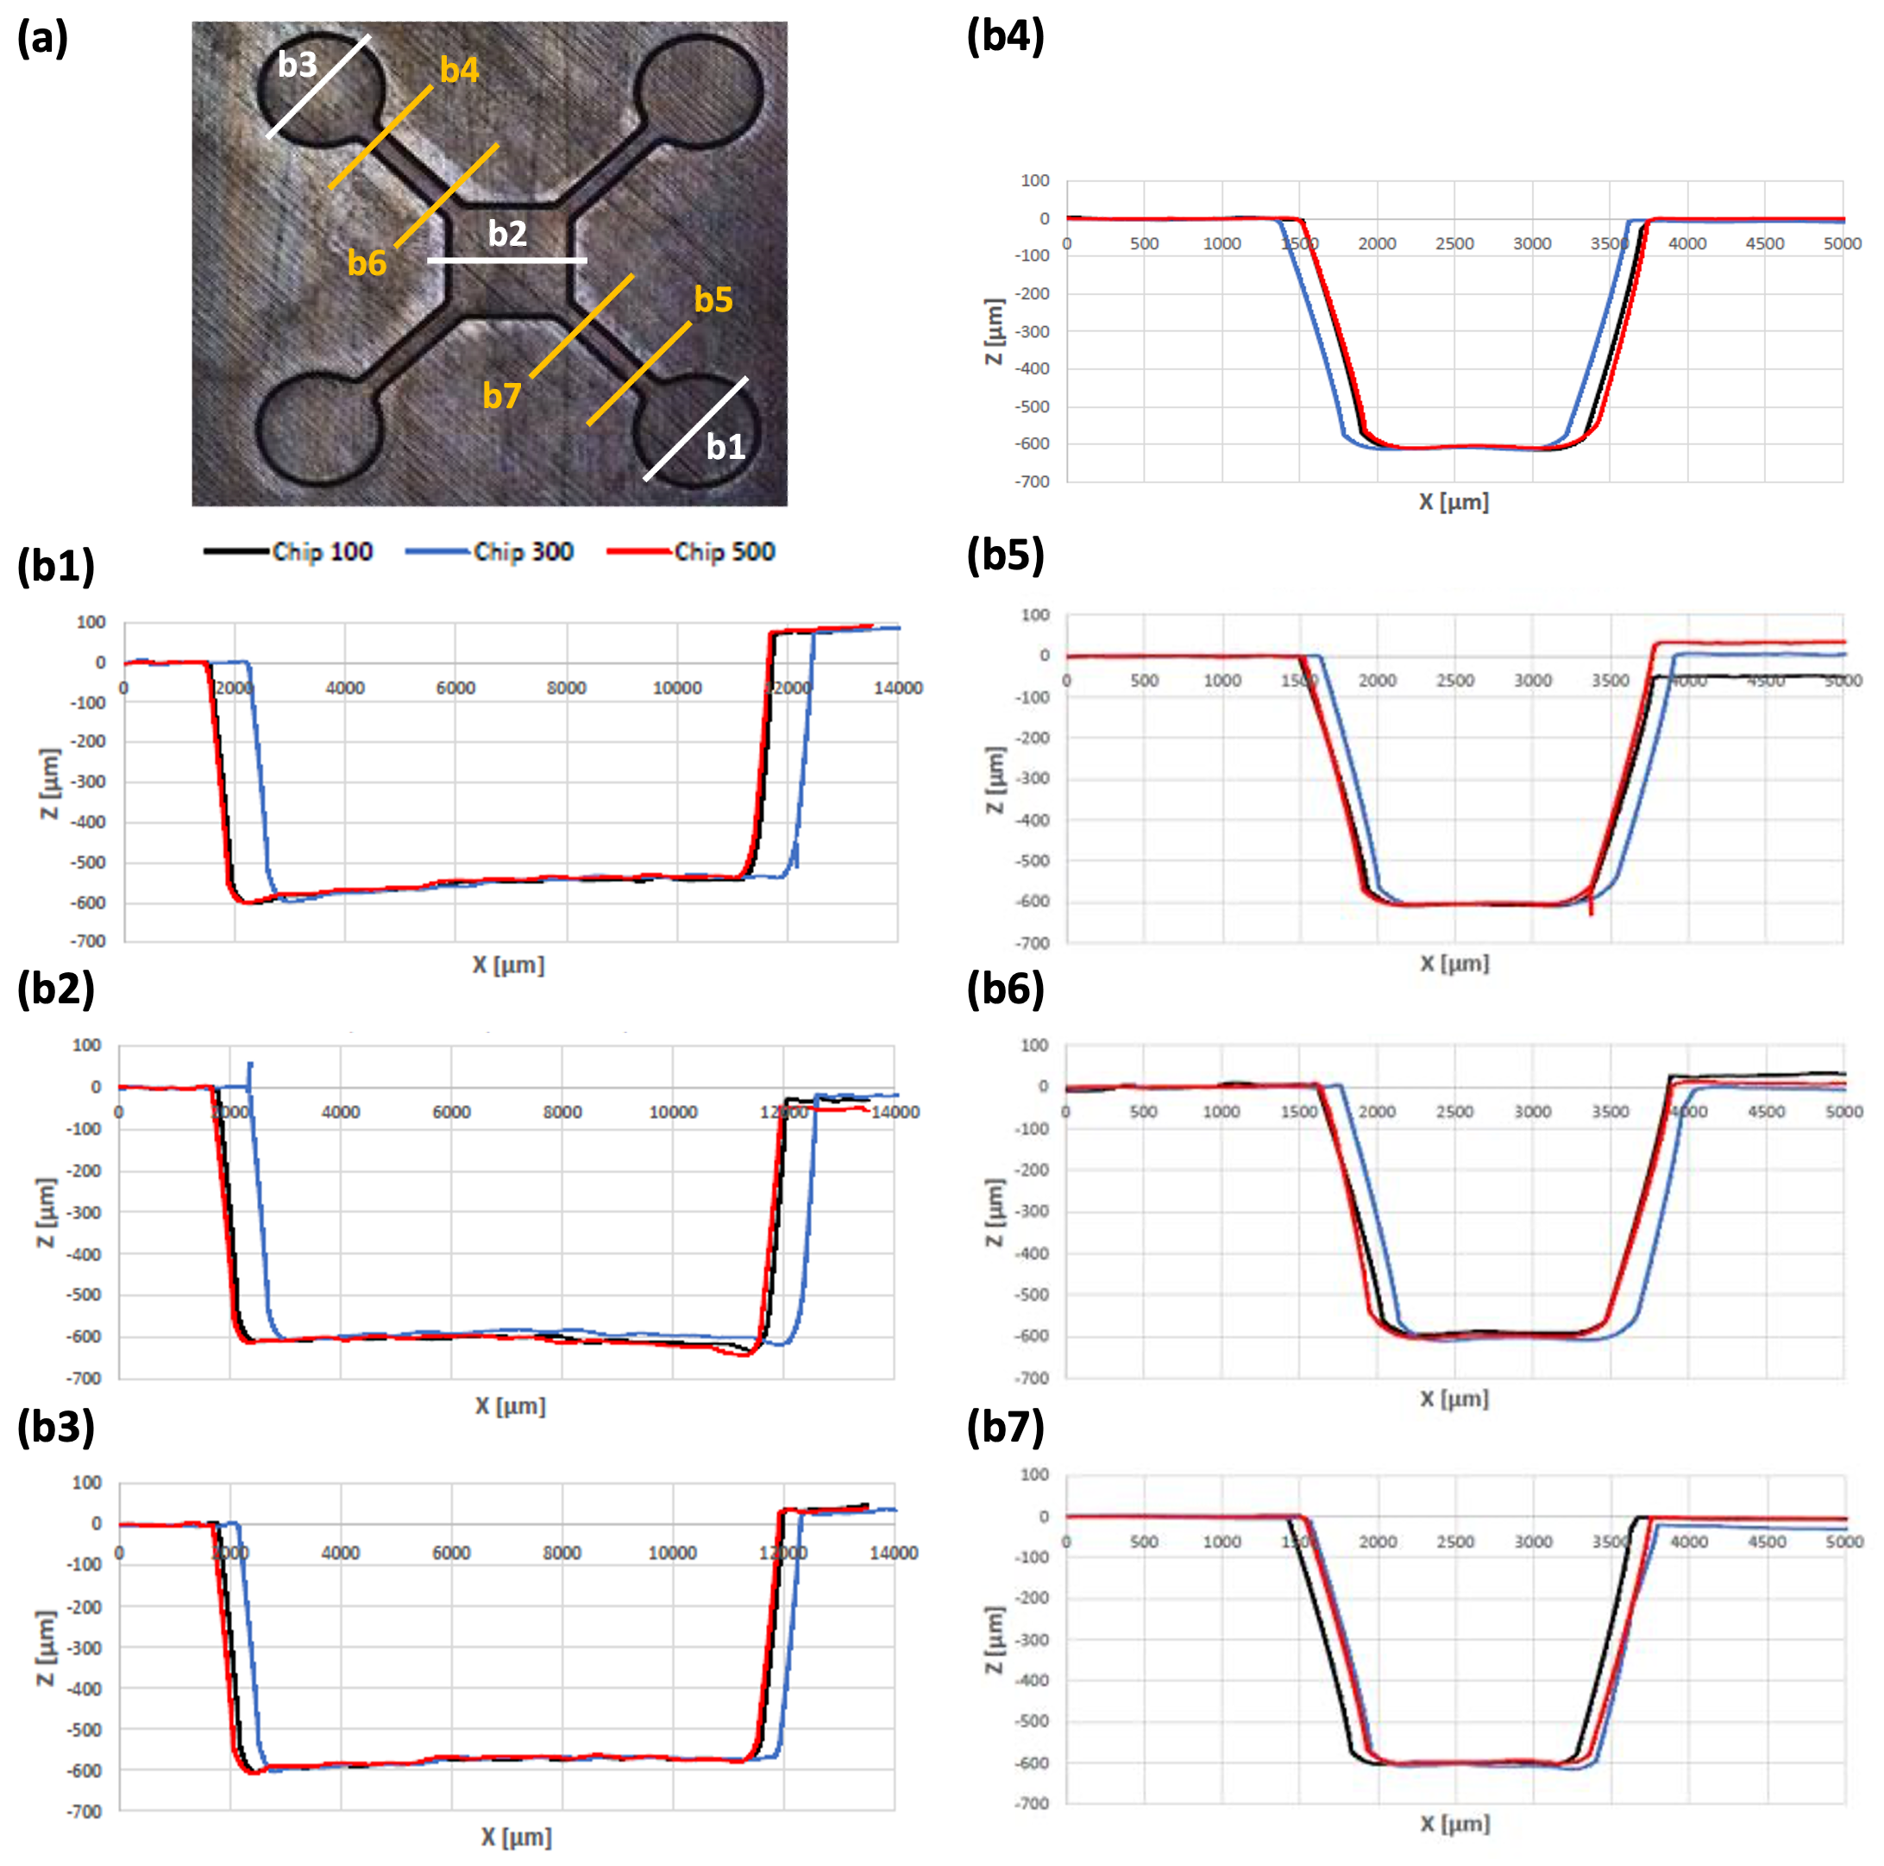
Figure 3. Profilometer analysis. (a) Detail of the PS chip with profilometer traces marked and numbered. (b1-7) Comparison of geometrical features of replicas number 100, 300, and 500 (black, blue, and red traces respectively). (b1-3) scan the central chamber e 2 outer wells, while (b4-7) analyze the connecting channels.
3.2 Biological validation
The fluorescence tests to verify the viability of cells cultured in the platform were carried out using the Hoechst 33258 and Calcein-AM markers after 24 hours after seeding. Figure 4 reports representative images obtained using a fluorescence microscope and demonstrate that optimal cell viability is maintained for all the different cell lines tested (for SKNAS 73.8 ± 4.6 %, for SKNDZ 78.7 ± 3.2 %, for MSC 84.2 ± 4.1 %, for HUVEC 88.3 ± 5.5 % and for BJ 90.8 ± 6.7 %). Moreover, the PS platform did not show autofluorescence when observed under the microscope.
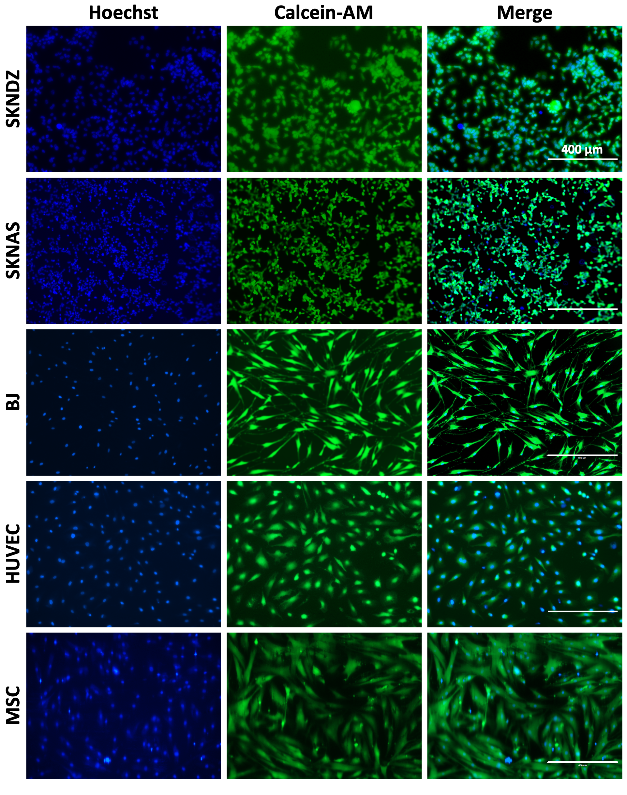
Figure 4. Cell viability analysis. Analyses were performed 24 h post seeding inside the PS device. Hoechst marks all cell nuclei in blue, while Calcein AM marks the cytoplasm of live cells in green. Scale bars: 400 µm.
Conclusions
Rapid prototyping enabled obtaining hundreds of replicas of the desired thermoplastic device with great precision and repeatability. Additive Manufacturing was used to fabricate the inserts in Digital ABS carrying the design of the platform and required for the injection molding machine. The validation of the entire production process consisted of the metrological characterization of the insert before and after Injection Molding, to evaluate possible wear phenomena of the tool following the molding of the devices, and of samples of the polystyrene chips representative of the 500 replicas. Our results confirmed that: i. the 3D printed insert maintained a high degree of replication of the CAD model features, and ii. revealed no signs of wear after molding 500 PS devices, ensuring good resistance to high injection and mold temperatures. The PS platforms prototyped using Injection Molding are consistent in replicating the channels and wells geometries with great fidelity with respect to those of the insert. The device was also produced with good optical transparency, and a slight inward curvature which was anyway irrelevant for the purposes of cellular experiments. As for biological evaluations, the device provided a good performance enabling excellent adhesion of cells to the bottom surface of the wells and maintenance of ideal cell viability during culture.
The use of polymeric materials in the fabrication on micro-to-meso scaled devices represents an excellent alternative to glass-based ones and PDMS for several reasons, the most important being: i. their cost-effectiveness, ii. the possibility to be produced in large quantities via rapid prototyping, iii. their optical, mechanical and permeability properties, very interesting from the biomedical point of view. Furthermore, the combined use of Additive Manufacturing for the production of tools required for Injection Molding in a very short time and with a high level of customization, provided an additional degree of freedom and flexibility in design. Finally, our advanced on-chip technology proved successful in enabling simultaneous culture of viable and physiologically active cell populations constituting the main tumor and its metastatic target sites. These devices will enable future integrated studies of multiple aspects of metastatic microenvironments, including physicochemical cues from the tumor associated stroma, heterocellular interactions that drive trans-endothelial migration and angiogenesis, and the physicochemical gradients that direct cell motility and invasion.
Acknowledgments
The work was supported by ERC Starting grant (ERC-StG) MICRONEX project (UERI17, PI E. Cimetta).
References
Fiorini, G.S., Chiu D.T., 2005, Disposable Microfluidic Devices: Fabrication, Function, and Application, Biotechniques, 38, 429–46.
Lee U.N., Xiaojing S., et al., 2018, Fundamentals of Rapid Injection Molding for Microfluidic Cell-Based Assays, Lab on a Chip, 18, 496–504.
Yeo L.Y., et al., 2011, Microfluidic Devices for Bioapplications, Small, 7, 12-48.

