|  |  |
| --- | --- |
| cetlogo ***CHEMICAL ENGINEERING TRANSACTIONS***  ***VOL. , 2024*** | A publication of  aidiclogo_grande |
| The Italian Association  of Chemical Engineering  Online at www.cetjournal.it |
| Guest Editors: Marco Bravi, Antonio Marzocchella, Giuseppe Caputo  Copyright © 2024, AIDIC Servizi S.r.l. **ISBN** 979-12-81206-10-6; **ISSN** 2283-9216 | |

Process Analysis of Furan Dicarboxylic Acid Production from Lignocellulose Biomass

Dang Saebeaa\*, Prathak Jienkulsawadb, Soipatta Soisuwana, Yaneeporn Patcharavorachotc

aInterdisciplinary Centre for Decarbonisation & Green Energy, Department of Chemical Engineering, Faculty of Engineering, Burapha University, Chonburi, 20131, Thailand

bCenter of Innovative Materials for Sustainability (iMatS), Mae Fah Luang University, Chiang Rai, 57100, Thailand

cDepartment of Chemical Engineering, School of Engineering, King Mongkut's Institute of Technology Ladkrabang, Bangkok, 10520, Thailand

dangs@eng.buu.ac.th

Furan dicarboxylic acid (FDCA) has gained significant attention due to its use as a precursor in the production of polyethylene furanoate (PEF). PEF is a bio-based plastic that can be used as a sustainable alternative in the production of plastics to replace PET derived from petroleum. In the FDCA production from biomass, there are three main steps: conversion of biomass to glucose, conversion of glucose to 5-hydroxy-methylfurfural (HMF), and oxidation of HMF to FDCA. The HMF production processes use high amounts of solvents such as dimethyl sulfoxide (DMSO), dichloromethane (DCM), and acetic acid, etc., to enhance the solubility, assist in the separation, and increase the production yield. The HMF and FDCA productions require the purification process and solvent recovery process. To assess the performance and improve the system efficiency of FDCA production from biomass, this work aims to design the integrated processes of HMF synthesis from biomass, FDCA production from HMF, HMF purification, and solvent recovery. The result indicates that the pressure and temperature of the evaporator for HMF separation affect the purity of HMF. The solvent recovery process of DMSO and DCM can enhance HMF yield by 21.6% and FDCA yield by 36.71%.

* 1. Introduction

Polyethylene terephthalate (PET) is a type of plastic that is known for its strength and flexibility. It is commonly used to create packaging materials and textiles. One of the significant problems with PET plastic is that it takes a long time to decompose, which can harm the environment as it breaks down into tiny particles. This puts humans at risk as well because we can ingest these particles through the food chain. Overcoming the challenges posed by PET plastic waste requires developing sustainable alternatives.

One potential alternative is polyethylene 2,5-furandicarboxylate (PEF). PEF is made from biomass and has many advantages over PET. It is lighter and stronger, and it resists water and gas permeation. This makes PEF ideal for packaging materials, as it has a longer shelf life and can be made with less material than PET. PEF is also completely recyclable, making it an environmentally friendly option (Saebea et al., 2023).

PEF can be synthesized from 2,5-furandicarboxylic acid (FDCA). This process involves an oxidation reaction of 5-hydroxy-methylfurfural (HMF) under highly alkaline conditions with air and through different catalytic reactions, such as metal-based and conventional metal-free catalysis (Deshan et al., 2020). The synthesis of HMF is largely derived from cellulose, which can be obtained from biomass residues generated in agricultural processing, such as almond shells, bagasse, corn cobs, and wood bark. In the process of synthesizing HMF from cellulose, the reaction involves the hydrolysis of cellulose to glucose, followed by the dehydration reaction of glucose to form HMF (Wang et al., 2014). The hydrolysis reaction, to convert cellulose to glucose, takes place under acidic conditions (Zeng & Pan, 2020). For the dehydration reaction to convert glucose to HMF, the choice of solvent plays a crucial role in the product yield (Zunita et al., 2021). Among all the available solvents, Dimethylsulfoxide (DMSO) is the most effective. This is because DMSO can efficiently prevent the formation of by-products and reduce the incidence of hydrogenation reactions (Hu et al., 2015). Moreover, it can promote the stable furanose form of fructose, which accelerates the formation of high-yield HMF product in dehydration reactions (Amarasekara et al., 2008).

The majority of research work on HMF and FDCA synthesis involves studying the development of catalysts and selecting suitable solvents to enhance the yield of products on a laboratory scale. As previously mentioned, the production process of FDCA from lignocellulose biomass involves various steps. Investigating the incorporation of the process of HMF synthesis from cellulosic biomass and the production of FDCA from the oxidation of HMF is essential. Moreover, HMF must undergo a purification process before being sent to the FDCA production process. In the process of purifying HMF, the solute DMSO is separated from HMF through an extraction process using dichloromethane (DCM). Subsequently, DCM is separated from HMF through a three-step evaporator process in the solvent recovery unit. In the solvent extraction process, a substantial amount of solvent DCM is required. Reusing the solvent DCM can significantly reduce the cost of the solvent. The recovery process of the solvent is crucial for the overall efficiency of the system. The purification process of HMF should be carried out under suitable conditions to achieve the maximum quantity of purified HMF for FDCA production. Modeling and process simulation of FDCA production can aid in analyzing and improving the overall efficiency of the integration process for manufacturing FDCA on an industrial scale. Santiago & Guirardello (2020) studied the techno-economic analysis of HMF production process from lignocellulosic. Their results indicated that the HMF production process is the minimum selling price of HMF is 3.18 US$/mol, which is not economically feasible. Therefore, the HMF production process needs to be developed to make the industrial scale. Moreover, there are limitations in simulating the production process of FDCA from biomass in current studies. This work aims to investigate the FDCA production from lignocellulose biomass by integrating the HMF synthesis, FDCA synthesis from oxidation of HMF, purification, and solvent recovery through the process simulation. The suitable operating condition of the HMF purification process is also studied.

* 1. Process simulation

The FDCA production from lignocellulose biomass is composed of four main processes, i.e., glucose production, HMF production, HMF purification, and FDCA production, as shown in Figure 1. The biomass considered in this study was the almond shell and its components are illustrated in Table 1. In the first step, biomass is converted to glucose through the hydrolysis process. The biomass and a solution of sulfuric acid (0.75 vol%) in a 1:9 ratio were introduced into the hydrolysis reactor at the operating temperature of 175 °C (Kougioumtzis et al., 2018). After the hydrolysis process, the product was cooled and separated from the biotar composed of lignin by filtration. The glucose-rich liquid product mixed with the DMSO solution (80 vol%) was heated to 150 °C and sent to the dehydration reactor. The dehydration reactor with a catalyst as Sn20/γ-Al2O3 was operated at 150 °C and 8.2 atm (Marianou et al., 2018). In the dehydration reaction, glucose was converted at 82.46 wt% into a main product as HMF and byproducts, i.e., glycolic acid, acetic acid, formic acid, lactic acid, levulinic acid, and humins. For the HMF purification, the liquid product from the dehydration process was sent to liquid-liquid extraction with DCM. The ratio of DCM solvent to liquid product from the HMF production of 10/1 is used for the liquid-liquid extraction. In the liquid-liquid extraction, the DMSO-rich liquid phase and DCM-rich liquid phase were separated. The DCM-rich liquid phase was sent to a three-stage evaporator to separate the HMF product and DCM solvent. The HMF-rich stream was introduced to the FDCA production process. The HMF-rich stream mixed with an acetic acid solution (60 wt%) was pumped and heated before feeding to the FDCA production reactor. The air was compressed to the FDCA production reactor. The FDCA production via HMF oxidation reactions using Pt/ZrO2 as catalyst operated at 10 atm and 100 °C. FDCA was purified through a crystallization process. To separate the FDCA solid, the outlet crystallizer stream was sent to a rotary vacuum drum filter. The liquid discharged from the rotary vacuum drum filter was recirculated for reuse in the FDCA production process, as it still contains the remaining components of HMF and acetic acid.

Table 1: Components of biomass

|  |  |
| --- | --- |
| Component | Value (%) |
| Hemicellulose | 4.65 |
| Cellulose | 40.48 |
| Lignin | 53.05 |
| Unidentified | 1.85 |

The simulation of the FDCA production system from lignocellulose biomass is conducted using the Aspen Plus program. The equation of state of this system employs the NRTL property method. The yields of the hydrolysis process for the conversion of biomass to glucose and the dehydration process for the conversion of glucose to HMF are referenced from Kougioumtzis et al. (2017). For the FDCA production, the conversion of HMF oxidation reactions is referenced from Saebea et al. (2022). The operating conditions of the HMF purification process significantly impact the overall efficiency of the HMF and FDCA production. Therefore, an investigation into the optimal conditions for purifying HMF to produce FDCA is first considered.

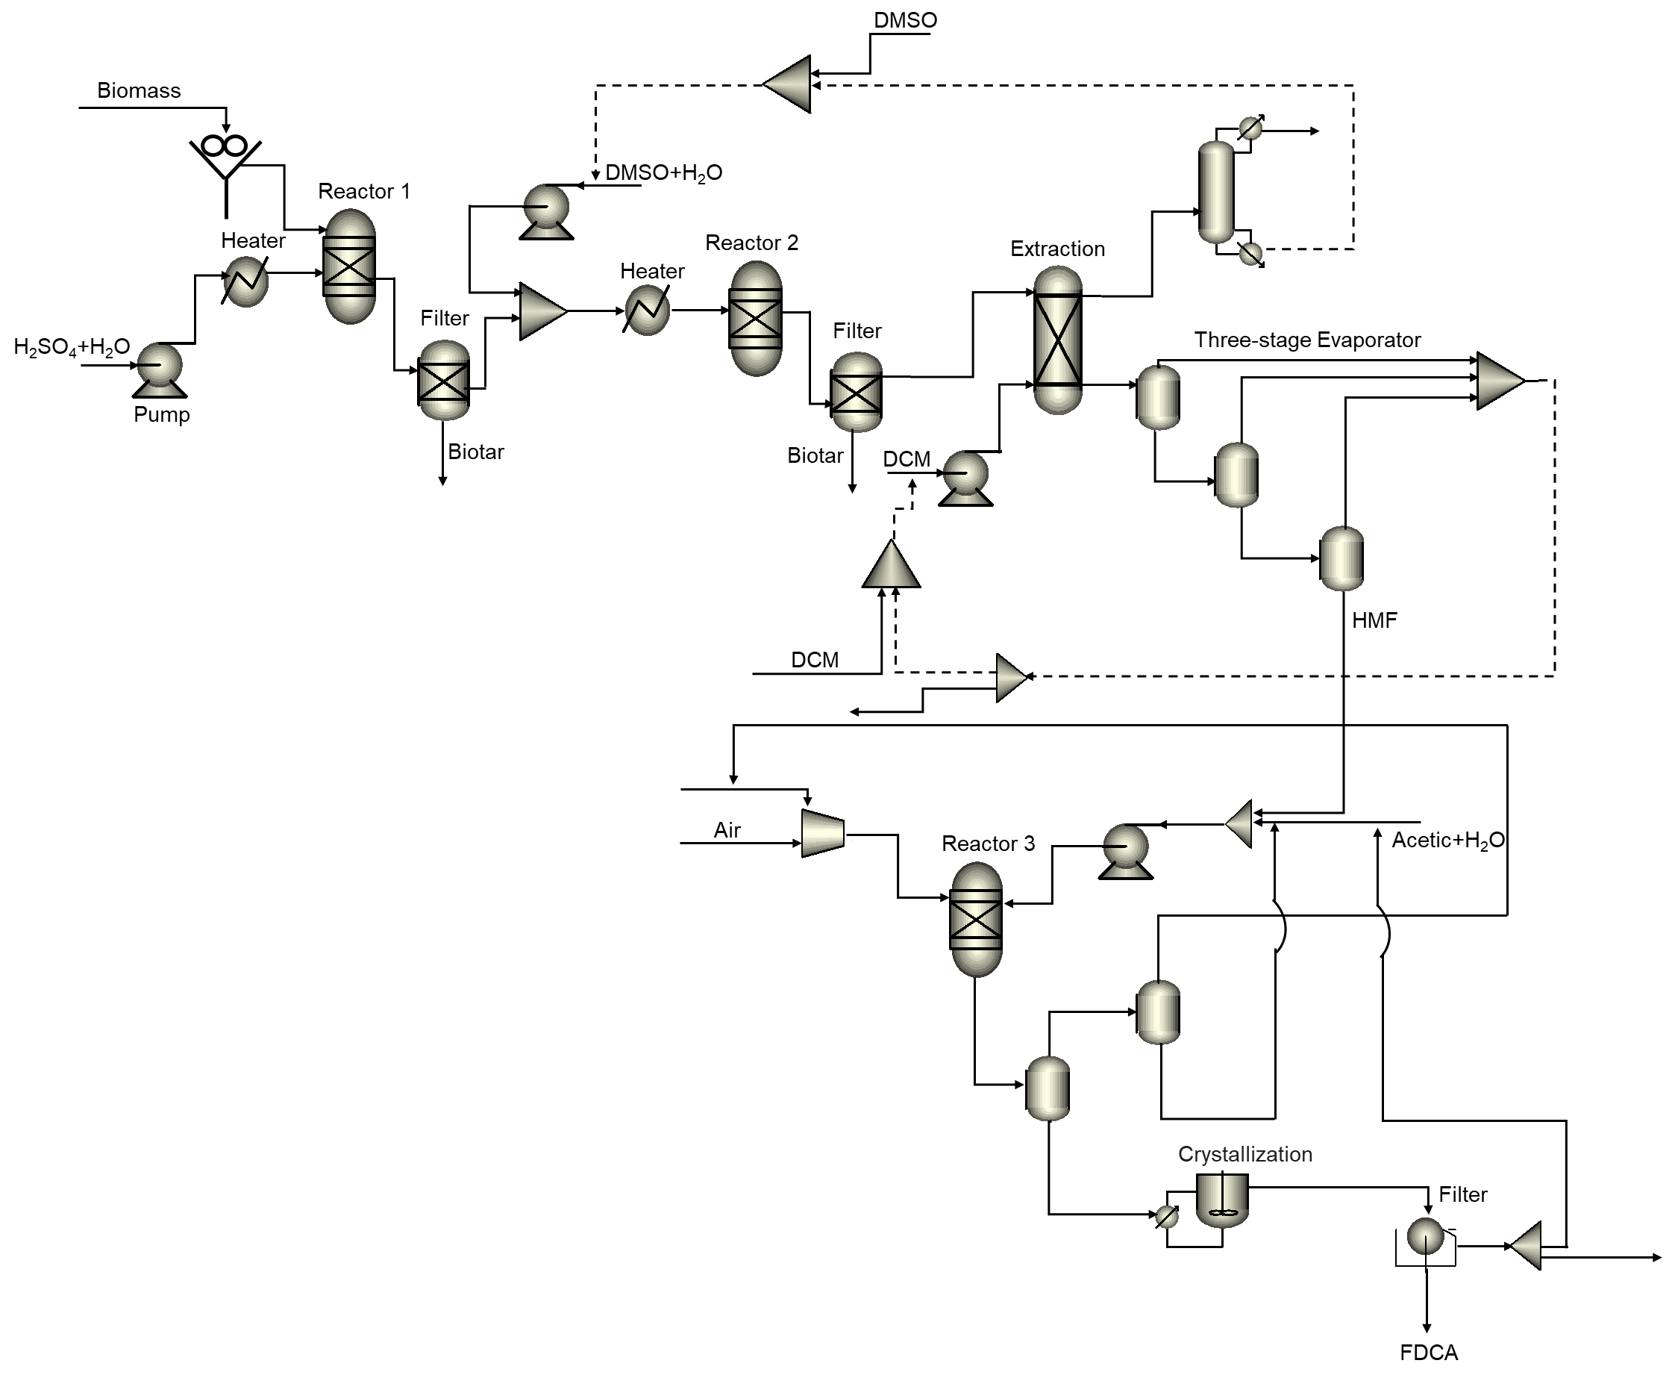

*Figure 1: FDCA production system from* lignocellulose biomass.

* 1. Results and discussion
     1. Purification process of HMF

After undergoing the dehydration process, the obtained HMF was blended with DMSO and other substances such as glycolic acid, acetic acid, formic acid, and lactic acid. A liquid-liquid extraction unit utilizing DCM solvent is required for the HMF purification process. The stream from liquid-liquid extraction was fed to a multi-step evaporation process to separate the HMF and DMC, where the majority of component HMF typically exists in a liquid state, while DMC solvent is separated as a gaseous phase. The evaporation operations significantly influence the purification and quantity of HMF. Additionally, this process has an impact on the quantity of DMC solvent, which can be recycled and reused in the process. Thus, the operating condition of the three-step evaporation process, i.e., temperature and pressure were first investigated.

The molar flow rate and mole fraction of HMF in a liquid stream from the first evaporator at various temperatures are shown in Figure 2(a). From Figure 2(a), it can be observed that as the temperature increases, the mass flow rate of HMF decreases, while the mole fraction of HMF increases. This is because, at higher temperatures, HMF is more likely to evaporate into the gas stream, resulting in a decrease in the flow rate of HMF in the liquid product stream. At the same time, the concentration of HMF increases due to more evaporation of other components that are lighter than HMF in the vapor phase during the separation process. For the gas phase, Figure 2(b) shows the influence of operating temperature on the mass flow rate and mass fraction of DCM at 1 bar. The increase in the temperature range of 40 to 44 °C enhances the mass flow rate and mole fraction of DCM. This is because DCM solvent has a boiling point of 40 °C, leading to increased evaporation of DCM solvent into the gas stream. As a result, both the flow rate and molar fraction of DMC solvent increase. The concentration of DMC solvent in the mixture attains its maximum value at 46 °C and slightly declines as the temperature increases due to a higher evaporation rate of other compounds, i.e., water, lactic acid, and glycolic acid, than that of DCM in the vapor phase. Also, beyond 46 °C, the mass flow rate of DCM solvent shows a slight increase and remains relatively constant. It was found that a temperature of 46 °C is the most suitable condition for the operation of the first evaporator, as temperatures ranging from 45 to 50 °C showed minimal changes in the molar ratio and mass flow rate of the DMC. Furthermore, the first evaporator should avoid operating at high temperatures to prevent a decrease in the mass flow rate of HMF.

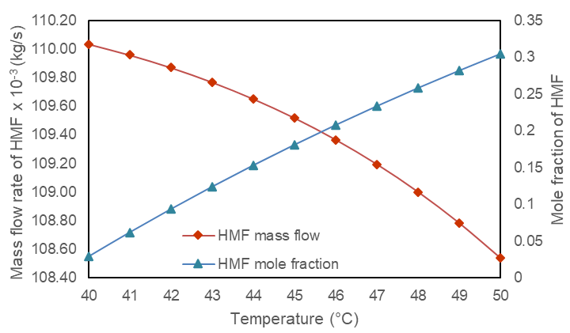

(a)

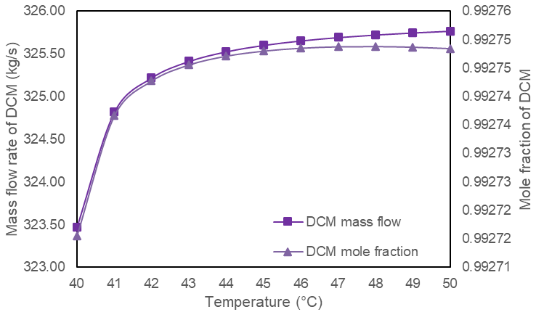

(b)

*Figure 2: Effect of operating temperature in the first evaporator on (a) mass flow rate and mole fraction of HMF in the liquid stream and (b) mass flow rate and mole fraction of DMC in the gas stream at 1 bar.*

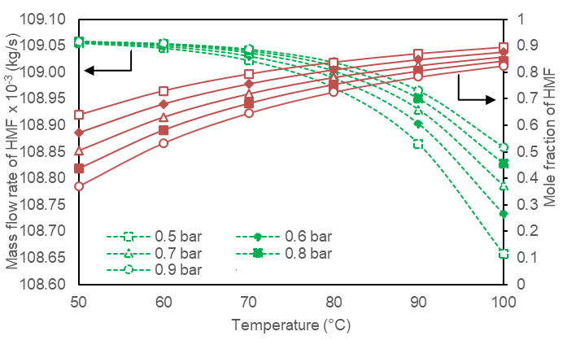

*Figure 3: Effects of operating temperature and pressure in the second evaporator on mass flow rate (dashed line) and mole fraction of HMF (solid line) in the liquid stream.*

To purify HMF, the liquid stream from the first evaporator is introduced to the second evaporator at a lower pressure. The temperature and pressure of the second evaporator have a significant impact on the concentration and flow rate of HMF but have minimal effects on the concentration and flow rate of DMC in the gas phase. Figure 3 displays the influences of temperature and pressure in the second evaporator on the mass flow rate and mole fraction of HMF in the liquid phase, with the first evaporator operating at 46°C and 1 bar. The concentration of HMF in the liquid stream exiting the second evaporator increases with temperature. This is because as the temperature rises, other components tend to vaporize more than HMF, leading to a decrease in their concentration in the liquid stream. However, increasing the temperature also causes HMF to vaporize more into the gas stream, resulting in a significant decrease in the mass flow rate of HMF in the liquid stream, particularly in the temperature range of 80 to 100°C. When the pressure of the second evaporator is reduced between the range of 0.5-0.9 bar, it causes an increase in HMF concentration. However, the mass flow rate of HMF in the liquid stream decreases. The reduction in system pressure leads to an increase in the evaporation rate of the substance, which ultimately results in a decrease in the mass flow rate of HMF in the liquid phase. Despite this, the evaporator rate of other substances in the mixture is higher than that of HMF, which causes an increase in HMF concentration. Therefore, in the operational condition of the second evaporator, the chosen state was set at 0.7 bar and 70°C.

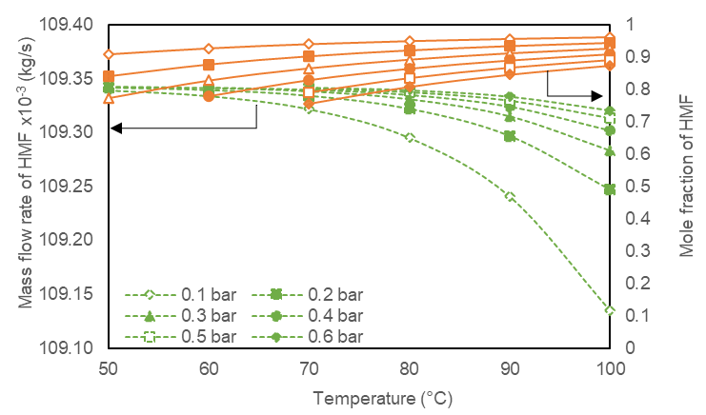

*Figure 4: Effects of operating temperature and pressure in the third evaporator on mass flow rate (dashed line) and mole fraction of HMF (solid line) in the liquid product.*

The influences of the temperature and pressure of the third evaporator on the mass flow rate and mole fraction of HMF in the liquid stream are shown in Figure 4. At a low-temperature range (50-70 °C), reducing the pressure significantly enhances the HMF concentration, while increasing the pressure has minimal effect on reducing the mass flow rate of HMF. On the other hand, for a temperature range (80-100 °C), decreasing the pressure results in a decrease in the HMF concentration, while concurrently leading to a clear reduction in the mass flow rate of HMF. Thus, the optimal condition of the third evaporator is 70 °C and 0.1 bar.

* + 1. Effect of recycling DMSO and DCM solvents

*Figure 5: Comparison of mass flow rate of HMF and FDCA between systems without and with recycling DMSO and DCM solvents.*

The effect of recycling DMSO and DCM solvents on the yield of product was investigated by specifying the optimal condition of the HMF purification process from the previous section. Figure 5 displays a comparison of HMF and FDCA products in the FDCA production system, with and without recycling DMSO and DCM solvents. The mass flow rate of HMF in the system with recycling DMSO and DCM solvents is enhanced by 21.6 % in comparison to the system without recycled solvents. The recycled DMSO and DCM solvents contain residual glucose and fructose that contribute to the conversion of HMF. Additionally, the remaining HMF in DCM solvent leads to an increase in the mass flow rate of HMF. The higher HMF in the system with recycled solvents directly affects a 36.71% increase in FDCA product yield compared to the system without recycled solvents. Recycling DMSO and DCM solvents not only increase product yield but also reduces the input quantity of DMSO solvent by 58.28% and DCM solvent usage by 79.11%.

* 1. Conclusion

This work aims to simulate and design the integrated processes of HMF synthesis from biomass, FDCA production from HMF, HMF purification, and solvent recovery. The purification process of HMF significantly affects the performance of the FDCA production process. To achieve high HMF concentration and purify the DCM solvent, a three-stage evaporator should be operated at optimal conditions. The effect of pressure and temperature in a three-stage evaporator on the purifying of HMF was first investigated. The results indicate that an increase in temperature in the three evaporators resulted in a significant rise in the HMF concentration, while the amount of HMF in the liquid stream marginally decreased. Moreover, DCM concentration and mass flow rate in the vapor stream increase at higher temperatures in the first evaporator but the second and third evaporators have minimal effects. For the reduction of the pressure in the second and third evaporators, the HMF concentration in the liquid stream increases while the mass flow rate of HMF decreases. The optimal conditions of the three evaporators are 46 °C and 1 bar for the first evaporator, 70°C and 0.7 bar for the second evaporator, and 70 °C and 0.1 bar for the third evaporator, which achieved the HMF concentration in the liquid stream of 94.06 %mol and the DCM concentration in the vapor stream of 99.28 %mol. When comparing the system with and without DMSO and DCM solvent recovery, the system with recycled solvents was found to enhance the HMF and FDCA product by 21.6% as compared to the system without recycled solvents. Based on the simulation results and the findings from this study, these insights can be extrapolated to inform future research on energy management and economic analysis of the FDCA production system from biomass.

Acknowledgments

This work was financially supported by (i) Burapha University (BUU), (ii) Thailand Science Research and Innovation (TRSI), and (iii) National Science Research and Innovation Fund (NSRF) (Fundamental Fund: Grant no. 432/2566). Additional thanks to the Research and Innovation Administration Division and Faculty of Engineering, Burapha University.

References

Amarasekara A.S., Williams L.T.D., Ebede C.C., 2008, Mechanism of the dehydration of d-fructose to 5-hydroxymethylfurfural in dimethyl sulfoxide at 150°C: an NMR study. Carbohydrate Research, 343, 3021–3024.

Deshan A.D.K., Atanda L., Monghaddam L., Rackemann D.W., Beltramini J., Doherty W., 2020, Heterogeneous catalytic conversion of sugars into 2,5-Furandicarboxylic acid, Frontiers in Chemistry, 8, 659.

Hu L., Tang X., Wu Z., Lin L., Xu J., Xu N., 2015, Magnetic lignin-derived carbonaceous catalyst for the dehydration of fructose into 5-hydroxymethylfurfural in dimethylsulfoxide. Chemical Engineering Journal, 263, 299–308.

Kougioumtzis M. A., Marianou A., Atsonios K., Michailof C., Nikolopoulos N., Koukouzas N., Triantafyllidis K., Lappas A. & Kakaras E., 2018 Production of 5-HMF from Cellulosic Biomass: Experimental Results and Integrated Process Simulation. Waste and Biomass Valorization, 9, 2433–2445.

Wang T., Nolte M.W., Shanks B.H., 2014, Catalytic dehydration of C6 carbohydrates for the production of hydroxymethylfurfural (HMF) as a versatile platform chemical, Green Chemistry, 16(2), 548-572.

Saebea D., Soisuwat S., Arpornwichanop A., Patcharavorachot Y., 2023, Simulation-based Assessment of 2,5 Furandicarboxylic Acid Production from Oxidation of 5-Hydroxymethylfurfural, Chemical Engineering Transaction, 98, 87-92.

Santiago B.L.S., Guirardello R., 2020, 5-Hydroxymethylfurfural Production in a Lignocellulosic Biorefinery: Techno-economic Analysis, Chemical Engineering Transaction, 80, 139-144.

Zunita M., Wahyuningrum D., Buchari B., Bundjali B., Wenten I.G., Boopathy R., 2021, Conversion of Glucose to 5-Hydroxymethylfurfural, Levulinic Acid, and Formic Acid in 1,3-Dibutyl-2-(2-butoxyphenyl)-4,5-diphenylimidazolium Iodide-Based Ionic Liquid. Applied Sciences, 11(3):989.

Zeng M., Pan X., 2020, Insights into solid acid catalysts for efficient cellulose hydrolysis to glucose: progress, challenges, and future opportunities. Catalysis Reviews, 64 (3), 445-490.